E
International Union for the Protection of New Varieties of Plants

Council  Fifty-Third Ordinary Session  Geneva, November 1, 2019 | C/53/10  Original: English  Date: November 1, 2019
Draft Press release
Document prepared by the Office of the Union
Disclaimer: this document does not represent UPOV policies or guidance
The Annex to this document contains a draft press release on the fifty-third ordinary session of the Council.

2. The Council is invited to consider the draft press release, contained in the Annex to this document, subject to developments in the Council.

[Annex follows]

C/53/10

ANNEX

UPOV Press Release 122

Geneva, November 1, 2019

UPOV Council Holds its Annual Session

The Council of the International Union for the Protection of New Varieties of Plants (UPOV) held
its fifty-third ordinary session on November 1, 2019.

Round-up of key developments:

Examination of Laws

Positive decision on the Draft Law of Mongolia

The Council took a positive decision on the conformity of the “Draft Law of Mongolia on Crop Seed and Variety” (“Draft Law”) with the provisions of the 1991 Act of the UPOV Convention, which allows Mongolia, once the Draft Law is adopted, with no changes and the Law is in force, to deposit its instrument of accession to the 1991 Act.

Positive decision on the Draft Law of Afghanistan

The Council took a positive decision on the conformity of the “Draft Plant Variety Protection Act of Afghanistan” (“Draft Law”) with the provisions of the 1991 Act of the UPOV Convention, which allows Afghanistan, once the Draft Law is adopted, with no changes and the Law is in force, to deposit its instrument of accession to the 1991 Act.

Reaffirmed decision on the Law of Egypt

The Council noted the developments on the Law on Plant Variety Protection of Egypt and reaffirmed its 2015 decision on conformity with the 1991 Act of the UPOV Convention, allowing Egypt to become a UPOV member.

Reaffirmed decision on the Law of Myanmar

The Council noted the developments on the Law on Plant Variety Protection of Myanmar and reaffirmed its 2017 decision on conformity with the 1991 Act of the UPOV Convention, allowing Myanmar to become a UPOV member.

Events

On October 30, 2019, UPOV organized a “Seminar on the Impact of Policy on Essentially Derived Varieties (EDVs) on Breeding Strategy”. The Seminar was attended by 180 participants.
(see https://www.upov.int/meetings/en/details.jsp?meeting_id=50787)

Abstract

The concept of Essentially Derived Varieties (EDVs) was introduced in the 1991 Act of the UPOV Convention with the aim of providing an effective incentive for plant breeding that would maximize progress in the development of new, improved varieties for the benefit of society.

The purpose of the Seminar is to consider the impact of EDV policy on breeding strategies and the consequences for the development of new, improved varieties of plants. The Seminar will provide perspectives covering various breeding methods and different types of plants. The Seminar is expected to assist the Administrative and Legal Committee (CAJ) in its review of the guidance on EDV provided in document UPOV/EXN/EDV/2.

In his closing remarks, the Moderator, Mr. Anthony Parker, Chair of the Administrative and Legal Committee of UPOV, concluded that:

- Evidence that the current UPOV guidance does not reflect the practice amongst breeders in the understanding of essentially derived varieties;
- Evolution of breeding technologies has created new opportunities/incentives for predominantly deriving varieties from initial varieties, more rapidly and at a lower cost;
- Clear indication from presentations and discussions that the understanding and implementation of the EDV concept influences breeding strategy – therefore, it is important that UPOV guidance is tuned to maximize benefits to society in terms of maximizing progress in breeding.

Program and Budget

The Council approved the Program and Budget for the 2020-2021 Biennium, including the maximum ceiling of expenditure in the regular budget of 7,347,285 Swiss francs compared to the 2018­2019 budget of 6,940,000 Swiss francs (5.9% increase).

UPOV PRISMA

The UPOV Council agreed to introduce a fee of 90 Swiss francs for UPOV PRISMA starting from January 2020.

UPOV PRISMA is an on-line, multi-lingual tool for making plant breeders’ rights’ applications in participating UPOV members. UPOV PRISMA currently has 35 participating UPOV members, covering 74 countries (see http://www.upov.int/upovprisma/en/index.html).

PLUTO database

The Council agreed the following approach for the PLUTO database from November 2020:

(i) free option: the PLUTO database with a search function will be free to all users. Search results will be limited to an on-screen display of a single page of results. There will be no facility to download search results or data from the PLUTO database;

(ii) premium option: users paying a fee will have access to all PLUTO database features and will be able to download data without restrictions. The fee will be CHF 750 per annum;

(iii) members of the Union and data contributors: access to all PLUTO database “premium” features will be free to all members of the Union and data contributors (i.e. OECD); and

(iv) access to PLUTO data may also be granted in cases approved by the Consultative Committee.

Revised FAQ on the benefits of new varieties of plants for society

The Council adopted the following revised FAQ:

WHAT ARE THE BENEFITS OF NEW VARIETIES OF PLANTS FOR SOCIETY?

Feeding the World

New, improved varieties of plants are an important and sustainable means of achieving food security in the context of population growth and climate change. New varieties that are adapted to the environment in which they are grown increase the choice of healthy, tasty and nutritious food while generating a viable income for farmers.

Improving lives in rural and urban areas and providing economic development

Innovation in agriculture and horticulture is important for economic development. Production of diverse, high quality varieties of fruit, vegetables, ornamentals and agricultural crops provides increased income for farmers and employment for millions of people around the world. New varieties can be the key to accessing global markets and improving international trade for developing countries. At the same time, new varieties can support the development of urban agriculture and the growing of ornamental plants, shrubs and trees that contribute to improving the lives of people in the expanding urban environment.

Respecting the natural environment

Increasing productivity whilst respecting the natural environment is a key challenge in the context of population growth and climate change. Breeding plant varieties with improved yield, more efficient use of nutrients, resistance to plant pests and diseases, salt and drought tolerance and better adaptation to climatic stress can sustainably increase productivity and product quality in agriculture, horticulture and forestry, whilst minimizing the pressure on the natural environment.

Observers in UPOV bodies

Observer status was granted to:

- Lao People’s Democratic Republic in the Council, the Administrative and Legal Committee, the Technical Committee and the Technical Working Parties;

- Liechtenstein in the Council.

Adoption of documents

The Council adopted revised versions of the following documents:

UPOV/INF/5 UPOV Model Plant Breeders’ Rights Publication
UPOV/INF/22 Software and Equipment Used by Members of the Union
TGP/7 Development of Test Guidelines
TGP/8 Trial Design and Techniques Used in the Examination of Distinctness, Uniformity and Stability (Revision)
TGP/10 Examining Uniformity
TGP/14 Glossary of Terms Used in UPOV Documents
TGP/15 Guidance on the Use of Biochemical and Molecular Markers in the Examination of Distinctness, Uniformity and Stability (DUS)
All adopted documents will be published in the UPOV Collection (see http://www.upov.int/upov_collection/en/).

Award of medals

Mr. Raimundo Lavignolle (Argentina) was awarded a UPOV Gold Medal on completing his term as President of the Council, from October 29, 2016 to November 1, 2019.

Mr. Anthony Parker (Canada) was awarded a UPOV Silver Medal on completing his term as Chairman of the Administrative and Legal Committee, from 2017 to 2019.

Mr. Kees van Ettekoven (Netherlands) was awarded a UPOV Silver Medal on completing his term as Chairman of the Technical Committee, from 2017 to 2019.

Election of the new Chairpersons

The Council elected, in each case for a term of three years ending with the fifty-sixth ordinary session of the Council, in 2022:

(a) Mr. Marien Valstar (Netherlands)
President of the Council

(b) Mr. Yehan Cui (China)
Vice-President of the Council

(c) Mr. Patrick Ngwediagi (United Republic of Tanzania)
Chair of the Administrative and Legal Committee

(d) Mr. Manuel Antonio Toro Ugalde (Chile)
Vice-Chair of the Administrative and Legal Committee

(e) Mr. Nik Hulse (Australia)
Chair of the Technical Committee

(f) Ms. Beate Rücker (Germany)
Vice-Chair of the Technical Committee

Cooperation in the Examination of New Plant Varieties

In 2018, the number of plant genera and species for which there were agreements between members of the Union for cooperation in the examination of distinctness, uniformity and stability totaled 2,132 (5.7 percent increase).

Plant Variety Protection Statistics

The number of applications for plant variety protection increased from 18,306 in 2017 to 20,031 in 2018 (8.6% percent increase).

The number of titles granted increased from 12,685 in 2017 to 13,288 in 2018 (4.5 percent increase).

The total of 132,403 titles in force in 2018 represented a 4.6 percent increase on figures for 2017 (126,322).

The following graphs indicate trends in applications filed and titles granted since 1986. Information is also provided on the 10 members of the Union receiving the largest number of applications in 2008, 2017 and 2018 and an analysis of applications by residence of breeders for the same years:

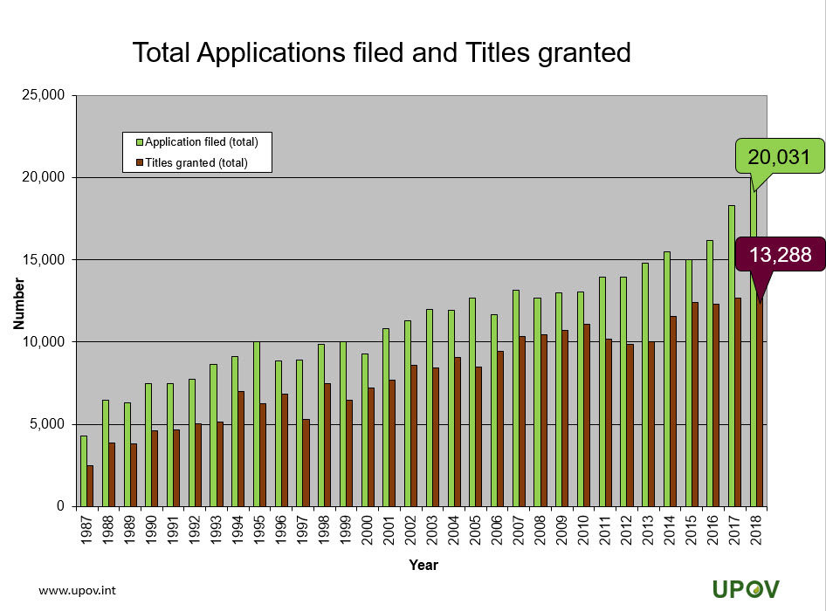

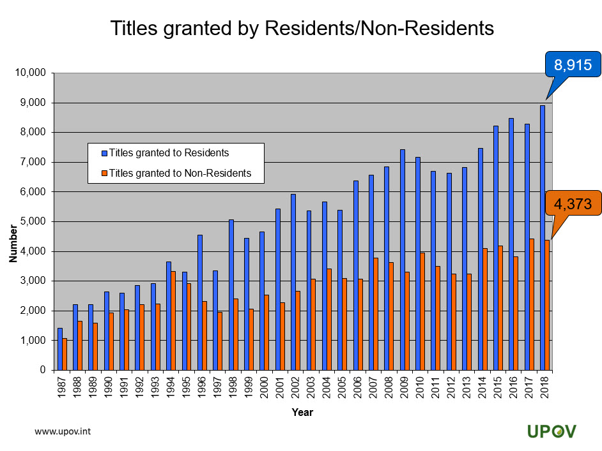

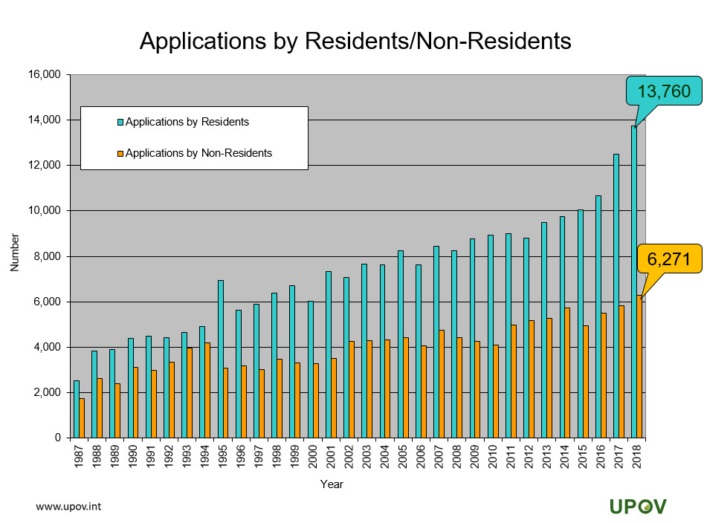

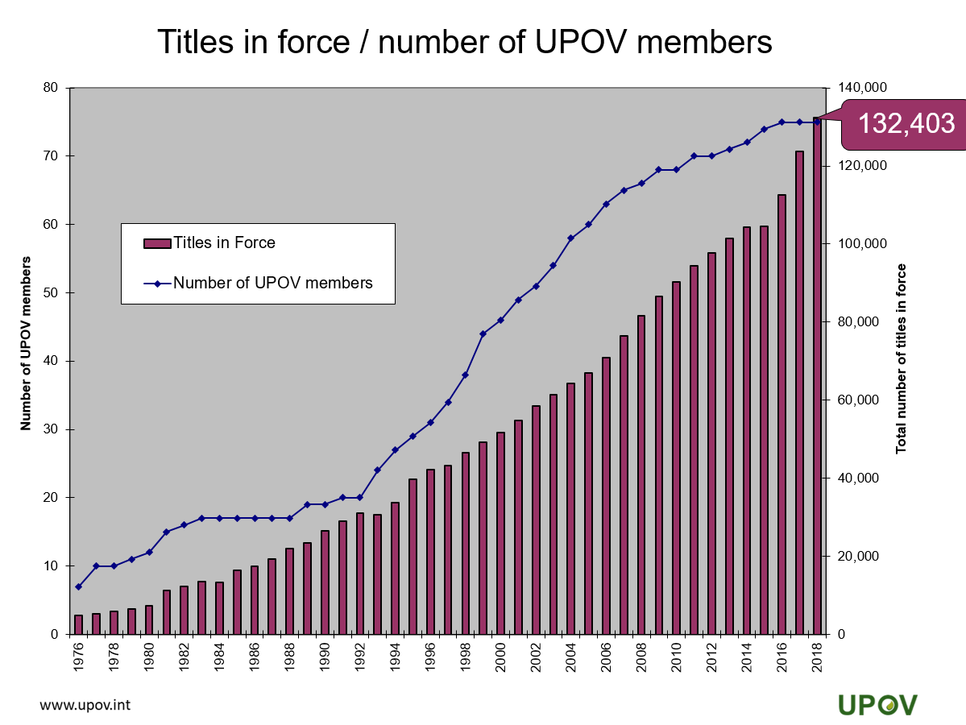

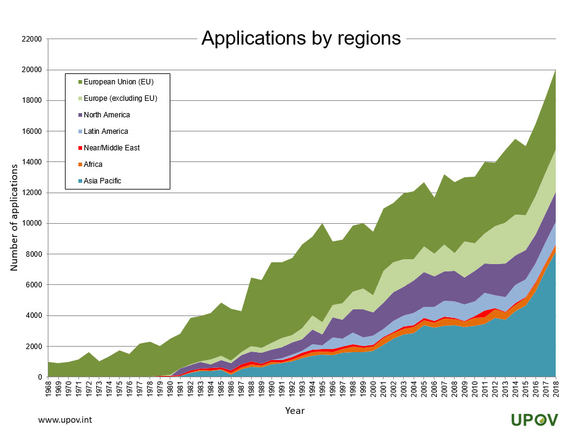

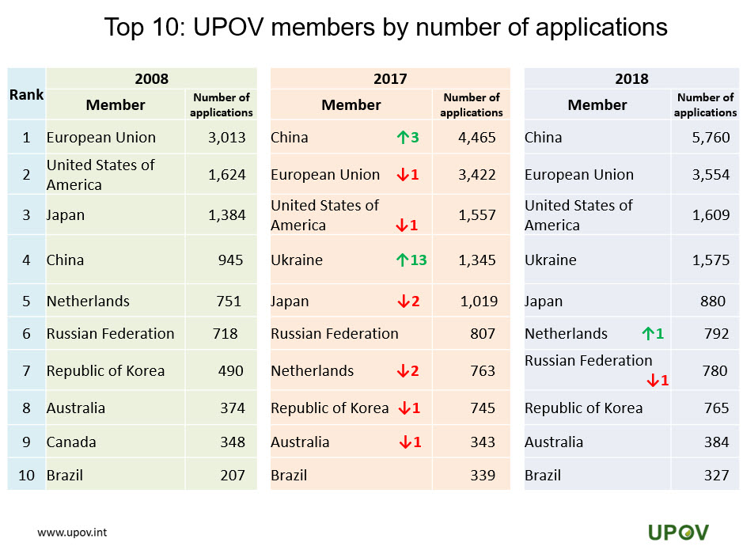

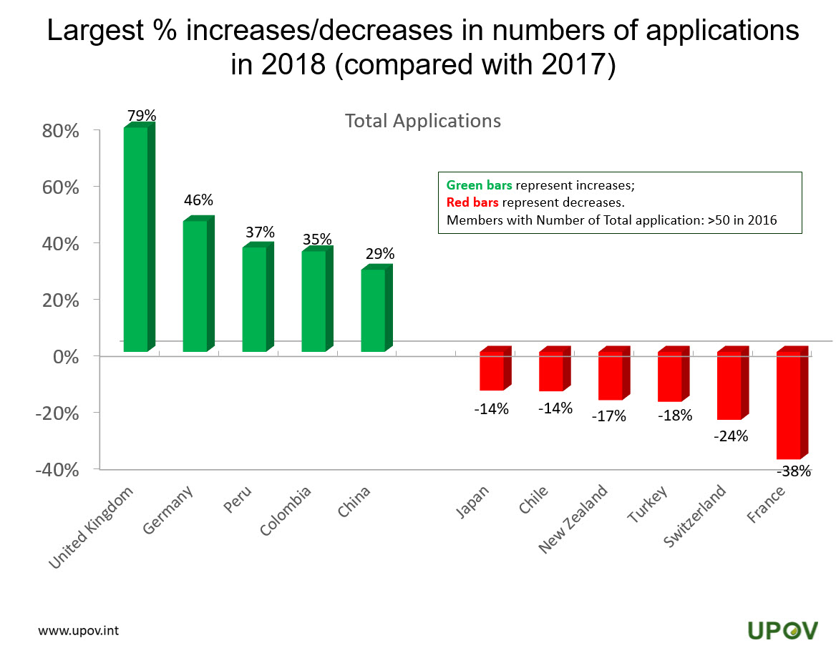

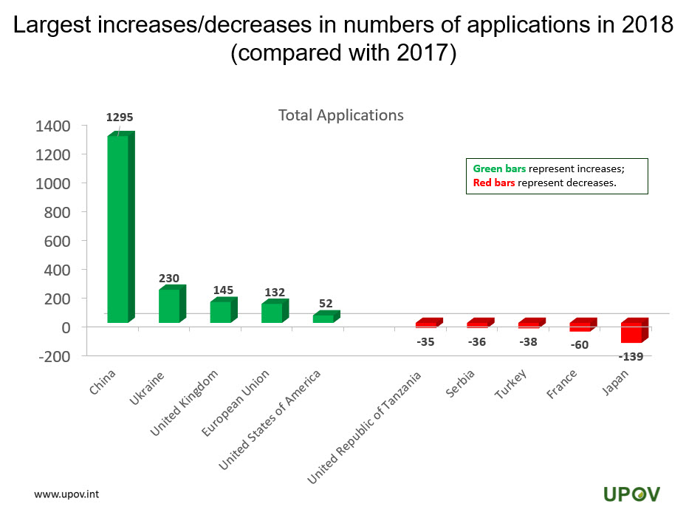

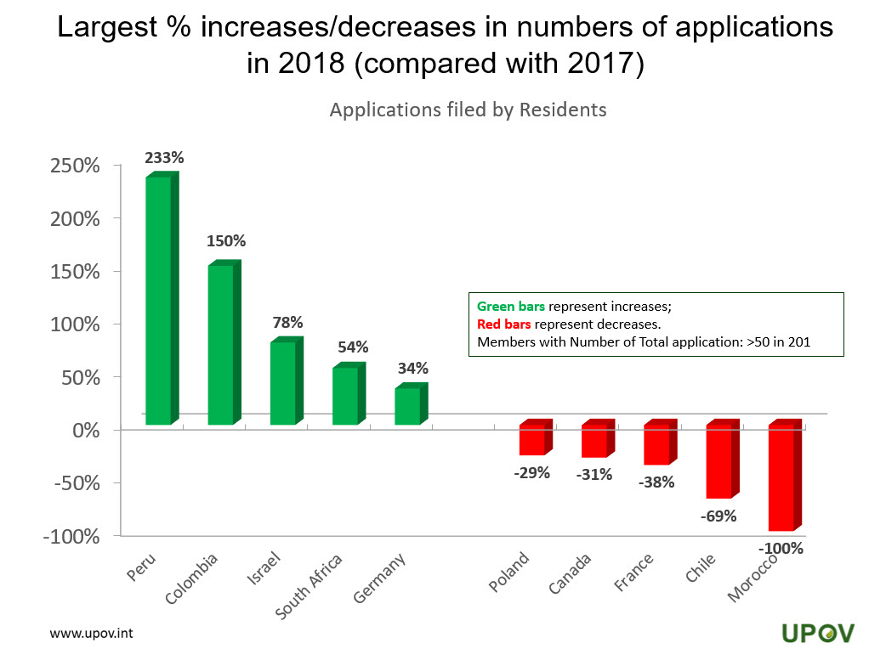

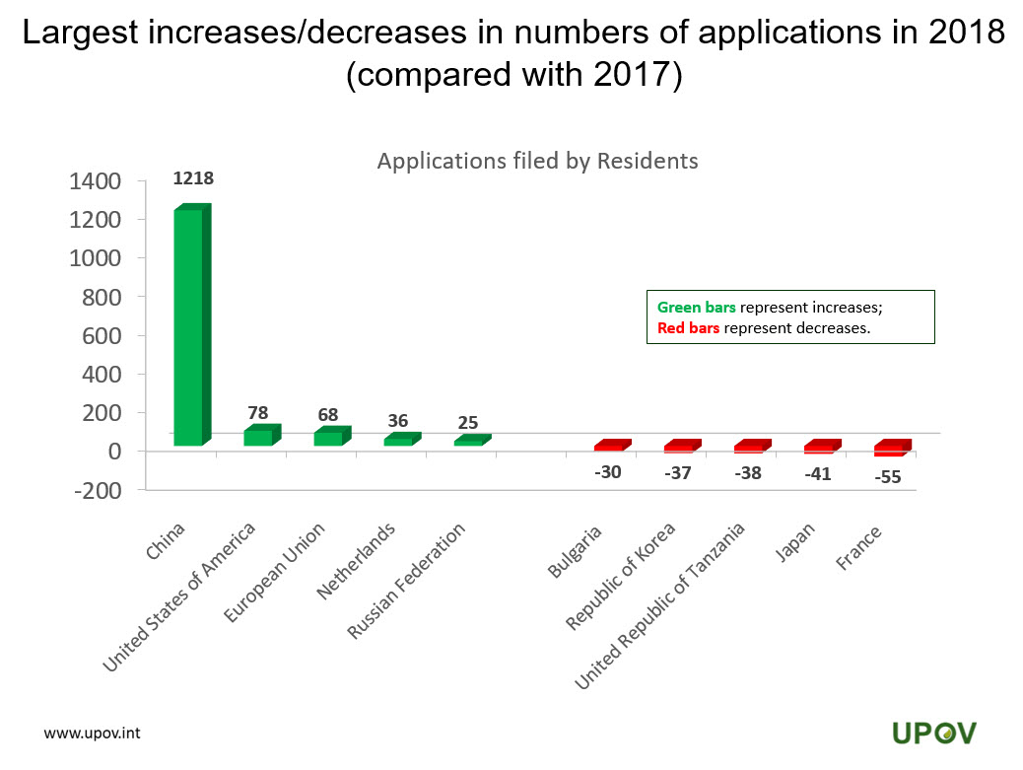

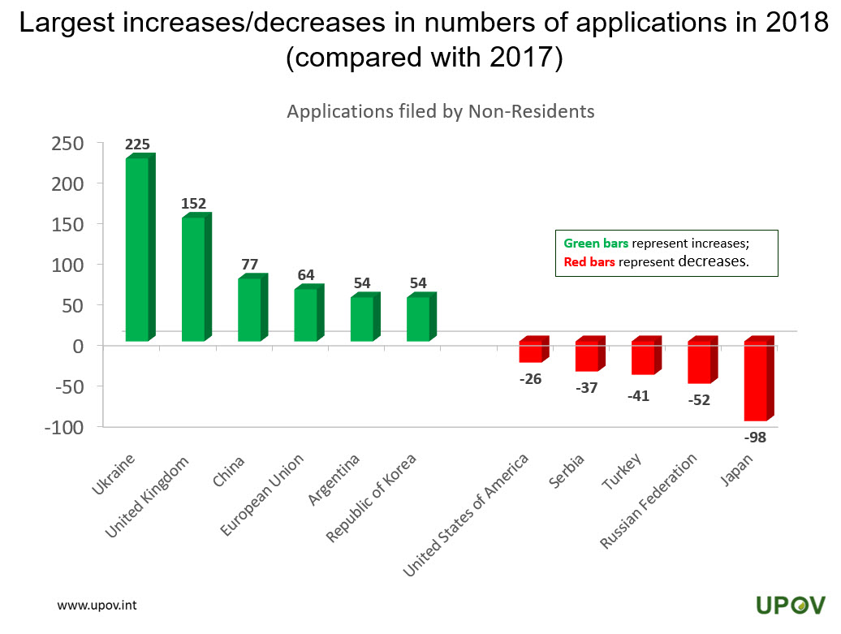

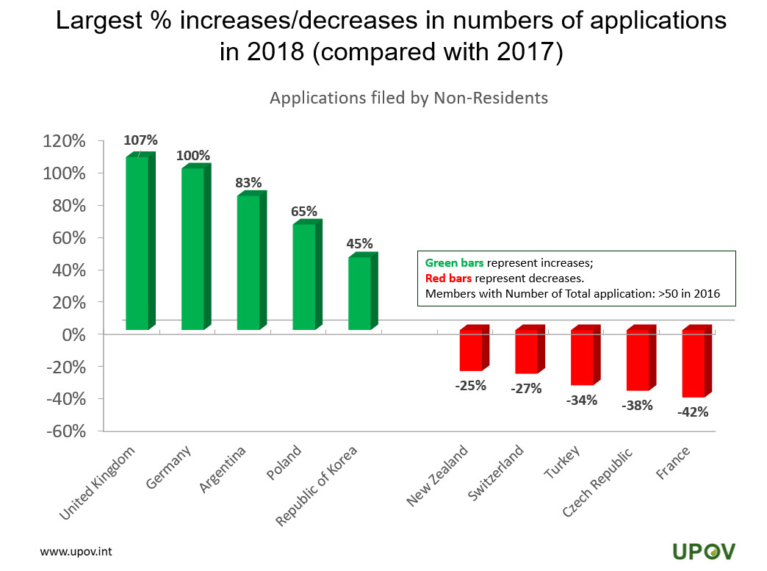

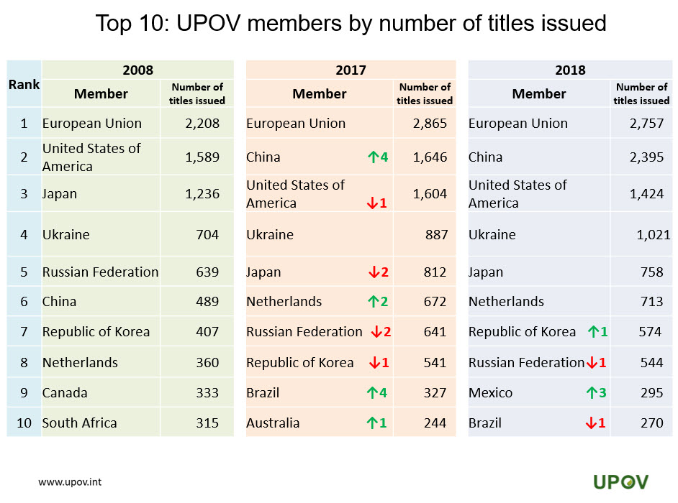

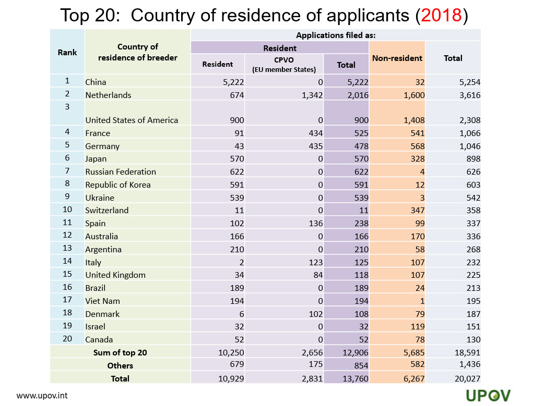

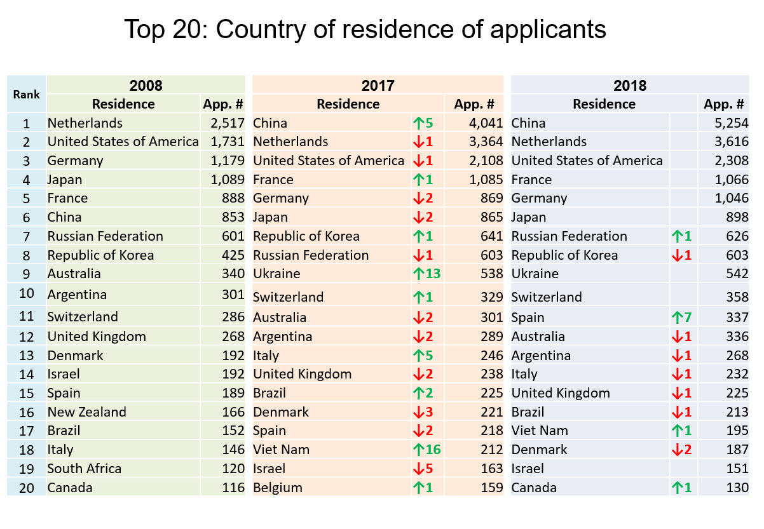

[End of document]

