|  |  |
| --- | --- |
|  | E |
| International Union for the Protection of New Varieties of Plants |  |

|  |  |
| --- | --- |
| Council  Fifty-Second Ordinary Session Geneva, November 2, 2018 | C/52/4  Original: English  Date: August 29, 2018 |

**FINANCIAL MANAGEMENT REPORT FOR THE 2016-2017 BIENNIUM**

Document prepared by the Office of the Union

Disclaimer: this document does not represent UPOV policies or guidance

The Annex to this document contains the Financial Management Report (FMR) of the International Union for the Protection of New Varieties of Plants (UPOV) for the 2016-2017 Biennium, in accordance with Regulations 6.6 and 6.7 of the Financial Regulations and Rules of UPOV (FRR) (see document UPOV/INF/4/4 “Financial Regulations and Rules of UPOV”), for approval by the Council.

The FMR is not subject to an external audit.

Regulations 6.6 and 6.7 of the FRR state as follows:

“**Regulation 6.6**

“[…]

“Rule 106.12

“[…]

“(b) Within eight months after the end of each financial period, the Secretary‑General shall submit to the Council the financial management report prepared in accordance with Regulation 6.6.

“**Regulation 6.7**

“After the annual audit and examination by the Council, the annual financial statements and the report of the External Auditor shall be transmitted to all the interested members of UPOV. Every two years following the end of the biennium, the financial management report shall also be transmitted to all the interested members of UPOV.”

*The Council is invited to approve the Financial Management Report for the 2016-2017 Biennium.*

[Annex follows]

**INTERNATIONAL UNION FOR THE PROTECTION OF NEW VARIETIES OF PLANTS**

Financial Management Report for the 2016-2017 Biennium

**TABLE OF CONTENTS page**

SUMMARY and analysis OF BUDGETARY RESULT 2

Table 1. 2016-2017 Income, Expenditure and Reserve and Working Capital Funds (RWCF) 2

Table 2. 2016-2017 Budgeted and Actual Income by Source 3

Table 3. 2016-2017 Approved Budget and Expenditure by Object of Expenditure 4

Table 4. 2016-2017 Approved Budget and Expenditure by Sub-Programs 5

Table 5. 2016-2017 Expenditure Details by Sub-Programs 6

Table 6. 2016-2017 Budgeted and Actual Posts 7

Table 7. Evolution of Actual Income and Expenditure during 2008-2017 7

INVESTMENTS 8

FINANCIAL STATEMENTS 9

Statement I Statement of Financial Position 10

Statement II Statement of Financial Performance 11

Statement III Statement of Changes in Net Assets 12

Statement IV Statement of Cash Flow 13

Statement V Statement of Comparison of Budget and Actual Amounts 14

Analysis of the Statement of Financial Position 15

Analysis of Statement of Financial Performance 19

WORKING CAPITAL FUND AND CONTRIBUTIONS 20

Working Capital Fund as at December 31, 2017 20

Contributions of Members of the Union 21

Contribution Payments Received in Advance 23

Amounts of the Contributions Due and Unpaid Working Capital as at December 31, 2017 24

Extrabudgetary funds (funds in trust) 26

# SUMMARY and analysis OF BUDGETARY RESULT

Table 1 below presents the overall budgetary result for UPOV in the 2016-2017 Biennium as well as the Reserve and Working Capital Funds (RWCF) as at the end of 2017. The total income (before IPSAS adjustments) amounted to 6.85 million Swiss francs, and the total budgetary expenditure amounted to 6.83 million Swiss francs, resulting in a budgetary surplus of 26,162 Swiss francs for the 2016-2017 Biennium.

At the end of 2017, the total RWCF amounted to 630 thousand Swiss francs, comprising 970 thousand Swiss francs in the Reserve Fund, 14 thousand Swiss francs in the Special Project Fund, 547 thousand Swiss francs in the Working Capital Fund and Actuarial losses through Net Assets of 901 thousand Swiss francs.

## Table 1. 2016-2017 Income, Expenditure and Reserve and Working Capital Funds (RWCF)

*(in thousands of Swiss francs)*



*\* In 2015, 183,824 Swiss francs, representing the amount of the reserve fund exceeding 15 per cent of the total income for the 2012-2013 Biennium, were transferred to a Special Project Fund for specific projects. Of this amount, 114,151 Swiss francs and 55,716 Swiss francs were expensed in 2015 and respectively in 2016, leaving a balance of 13,957 Swiss francs as at December 31, 2017.*



The actual budgetary income amounted to 6.85 million Swiss francs in the 2016-2017 Biennium, i.e. 28 thousand Swiss francs higher than the budgeted target (Table 2 below). Income from contributions continued to be the single largest source of income representing 98 per cent of the total income, in line with the approved 2016-2017 Program and Budget. In the 2016-2017 Biennium, actual contributions were slightly higher than budgeted, corresponding to two additional 0.2 contribution units. No income was generated from publications in the 2016-2017 Biennium because all publications are available free of charge. No interest was earned on funds placed with the Swiss Federal Finance Administration (AFF) due to the change in the interest rate policies of the AFF. Other income amounted to 117 thousand Swiss francs, i.e. 29 thousand Swiss francs more than the budgeted figure. Other income included revenue generated from administrative support costs under the extra-budgetary funds i.e. Funds-in-Trusts (FITs), fee income from participants in the UPOV distance learning program and accounting adjustments for previous years. Higher than budgeted contributions, (6,731,924 Swiss francs instead of 6,710,000 Swiss francs), higher income from administrative fees for FITs (75,361 Swiss francs instead of 57,000 Swiss francs) and a credit note for an overcharge for agency staff in 2016 (10,773 Swiss francs) compensated for lower than budgeted income from Electronic Application Form fees (1,841 Swiss francs instead of 25,000 Swiss francs).

## Table 2. 2016-2017 Budgeted and Actual Income by Source

*(in thousands of Swiss francs)*



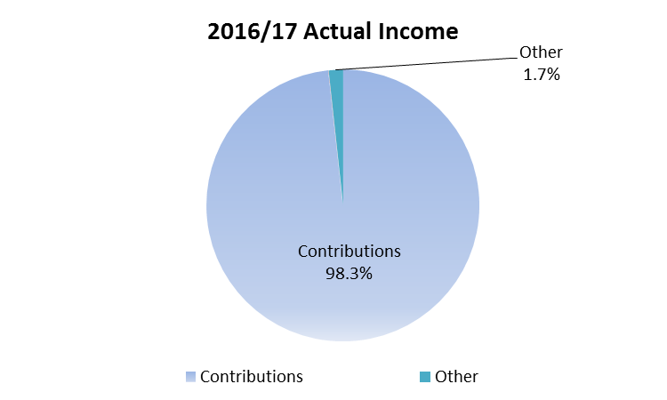

Actual expenditure in 2016-2017 compared to the approved 2016-2017 Program and Budget is presented below by cost categories in Table 3 and by sub-programs in Table 4.

## Table 3. 2016-2017 Approved Budget and Expenditure by Object of Expenditure

*(in thousands of Swiss francs)*



* Any differences in numbers between this table and subsequent tables from the Financial Statements are due to rounding.

## Table 4. 2016-2017 Approved Budget and Expenditure by Sub-Programs

*(in thousands of Swiss francs)*



Personnel Resources

Personnel expenditure (before IPSAS adjustments) amounted to 4.25 million Swiss francs in 2016-2017, 107,826 Swiss francs less than the approved 2016-2017 Program and Budget. This reduction was due to lower expenditure under posts, offset partly by higher expenditure under temporary staff. Expenditure on posts was lower than expected, due to a post in the professional category being filled by a temporary staff in 2017 and one staff member working on a part-time basis.

Non-Personnel Resources

Total non-personnel expenditure (before IPSAS adjustments) amounted to 2.58 million Swiss francs in 2016-2017, 109,371 Swiss francs, or four per cent higher than the budgeted target. Explanations by cost categories are provided below.

*Interns*

For the Biennium 2016-2017, expenditure on internships, of 12,343 Swiss francs, was significantly lower than the budgeted amount (38,000 Swiss francs). The savings were used to fund an additional agency staff.

*Travel*

Total expenditure on Travel amounted to 491,226 Swiss francs, i.e. 41,226 Swiss francs higher than the budget. The higher expenditure was primarily due to the higher than budgeted income from FITs, which resulted in additional activities requiring travel by UPOV staff.

*Contractual Services*

Total Contractual Services amounted to 834,714 Swiss francs, i.e. 142,714 Swiss francs higher than the budget, which is the net result of higher than budgeted expenditure under Other Contractual Services offset by lower expenditure under other objects of expenditure. Higher expenditure on Other Contractual Services was primarily due to: (i) additional expenditure related to agency staff costs to provide cover for the general service staff member on a part-time working arrangement and for additional administrative work associated with new travel administration procedures, (ii) expenses related to a video production and (iii) staff training. IT development costs for the EAF and for the TG Template were broadly as anticipated. Individual contractual services amounted to 25,193 Swiss francs, which were significantly lower than anticipated (70,000 Swiss francs) mainly because the administrative work on distance learning courses was not out-sourced.

*Operating Expenses*

Operating Expenses of 1.24 million Swiss francs were slightly lower than the budget due to the containment of the costs of services provided by WIPO to UPOV.

*Equipment and Supplies*

Equipment and Supplies amounted to 1,814 Swiss francs, i.e. 18,186 Swiss francs lower than the budget.

The breakdown of the 2016-2017 expenditure by sub-programs and cost categories is shown below in Table 5.

## Table 5. 2016-2017 Expenditure Details by Sub-Programs

*(in thousands of Swiss francs)*



* Any differences in numbers between this table and subsequent tables from the financial statements are due to rounding.

Table 6 below provides a summary of the number of posts by category.

## Table 6. 2016-2017 Budgeted and Actual Posts



As indicated in Table 6, there was no change in the biennium in the total number of posts. The 2016-2017 Program and Budget anticipated three posts in the Director category, four posts in the Professional category and four posts in the General Service category. However, the actual number of posts was three in the Director category, three in the Professional category and five in the General Service category. The higher number of posts in the General Service category resulted from the reclassification of a post from General Service to Professional not being completed during the biennium. The post of the Secretary-General is included within the post count, but at no cost, because the current Director General of WIPO has declined any salary or allowance from his functions as Secretary-General of UPOV.

Finally, the overall evolution of actual income and expenditure (before IPSAS adjustments) for the period from 2008 to 2017 is shown below in Table 7.

## Table 7. Evolution of Actual Income and Expenditure during 2008-2017

*(in thousands of Swiss francs)*



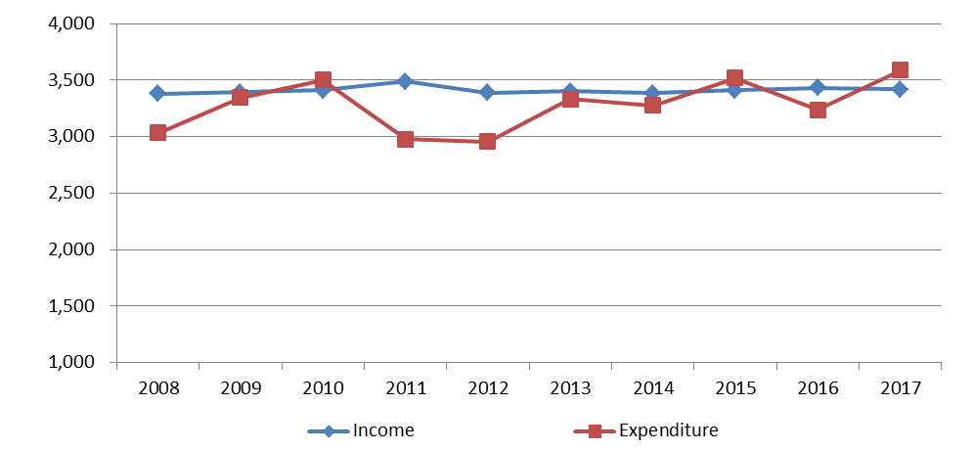

# INVESTMENTS

The authority, responsibility and policy for investments are detailed in UPOV’s Financial Regulations and Rules.

During the 2016-2017 Biennium, UPOV continued to hold its investments in deposit accounts with the Swiss Federal Finance Administration (AFF). Despite a challenging Swiss franc investment environment following the expansionary monetary policy (sub-zero interest rates) introduced by the Swiss National bank in January 2015, the return on investments for UPOV remained at zero and outperformed the 3-month Swiss franc Libor benchmark by 75 and 73 basis points in 2016 and 2017 respectively.

On December 14, 2017, UPOV withdrew all of its investment deposits before the expiry of the deposit arrangement with the AFF. The cash balances are held in bank accounts with Credit Suisse Bank and are currently protected from negative interest charges.

The table below details investments held with the AFF during the 2016-2017 Biennium.



# FINANCIAL STATEMENTS

For each of the two years of the 2016-2017 Biennium, the annual financial statements of UPOV have been prepared in accordance with the International Public Sector Accounting Standards (IPSAS).

**Accrual Accounting under IPSAS**

Under IPSAS the financial statements are prepared applying the full accrual basis of accounting. Accrual basis accounting means the recognition of transactions and events when they occur. As such they are recorded in the accounting records and reported in the financial statements of the financial periods to which they relate, and not only when cash or its equivalent is received or paid.

IPSAS requires that revenue for both contributions and extrabudgetary funds (funds in trust) is recognized when UPOV has a right to receive the contribution. Where contributions are due to UPOV, a receivable balance is recognized. Extrabudgetary fund arrangements are analyzed to see if UPOV needs to meet performance conditions, and if these are present, revenue is only recognized when the conditions are fulfilled.

The value of future employee benefits (including accumulated annual leave, repatriation grants and After-Service Health Insurance (ASHI)) that UPOV staff have earned but not yet received is recorded to capture the full cost of employing staff.

The UPOV Program and Budget is established on a modified accrual basis, which differs from the full accrual basis applied to the financial statements. Other differences between the budgetary result and the result per the financial statements are due to the inclusion in the financial statements of funds in trust and the Special Project Fund, which are not included in UPOV’s Program and Budget. A reconciliation between the budgetary result and the principal financial statements is provided in UPOV’s financial statements in accordance with the requirements of IPSAS.

**Presentation of Financial Information under IPSAS**

As IPSAS requires the preparation of annual financial statements, UPOV financial statements are prepared individually for each calendar year of the biennium. These annual financial statements are presented separately from the Financial Management Report, and for complete financial information of UPOV prepared in accordance with IPSAS requirements, reference should be made to the UPOV annual financial statements.

Under IPSAS, the financial statements include the following elements:

* + Statement I - Statement of Financial Position
  + Statement II - Statement of Financial Performance
  + Statement III - Statement of Changes in Net Assets
  + Statement IV - Statement of Cash Flow
  + Statement V - Statement of Comparison of Budget and Actual Amounts
  + Notes to the Financial Statements

In the Financial Management Report, Statements I-V are presented for the 2016-2017 Biennium. Financial information is provided to give an understanding of the differences between the result of UPOV on a budgetary basis and the result according to the IPSAS financial statements. Other extracts from the annual financial statements provide further details of UPOV’s assets and liabilities.

Certain balances from 2016 and 2015 are presented as restated following the implementation of *IPSAS 39 Employee Benefits* during 2017. Under IPSAS 39, actuarial gains and losses for the ASHI liability, which were previously unrecognized, have been accounted for directly through net assets. Accumulated annual leave for fixed, continuing and permanent posts has been reclassified from short-term to other long-term employee benefits, requiring the remeasurement of this liability by an independent actuary utilizing the projected unit credit methodology of valuation. The effect of these changes in accounting policy was recognized retrospectively, requiring a restatement of the 2016 and 2015 numbers previously presented.

### Statement I Statement of Financial Position

**as at December 31, 2017**

*(in Swiss francs)*



### Statement II Statement of Financial Performance

**for the Biennium ended December 31, 2017**

*(in Swiss francs)*



### Statement III Statement of Changes in Net Assets

**for the Biennium ended December 31, 2017**

*(in Swiss francs)*



### Statement IV Statement of Cash Flow

**for the Biennium ended December 31, 2017**

*(in Swiss francs)*



### Statement V Statement of Comparison of Budget and Actual Amounts

**for the Biennium ended December 31, 2017**

*(in thousands of Swiss francs)*



1. represents the approved 2016-2017 Program and Budget;
2. represents the difference between the final (revised) budget and actual expense on a comparable basis (before IPSAS adjustments).

### Analysis of the Statement of Financial Position

**Movement in Net Assets**

As at December 31, 2017, UPOV has net assets on an IPSAS basis of 629,830 Swiss francs. Following the implementation in 2017 of IPSAS 39, which requires the recognition of actuarial gains and losses, the net assets of 2015 and 2016 were restated. The restated 2015 net assets total 1,215,453 Swiss francs, compared to the figure of 1,663,834 Swiss francs presented in the Financial Management Report for the 2014-2015 Biennium. Between 2015 and 2016, net assets decreased by 469,678 Swiss francs, due to the impact of actuarial losses from the ASHI valuation. In 2017, net assets fell again by 115,945 Swiss francs following the deficit of the year of 290,363 Swiss francs, partly offset by actuarial gains from the ASHI valuation. The table below summarizes the decrease in net assets during the 2016-2017 Biennium:

Movement in Net Assets 2016-2017



**Summary of Assets and Liabilities**

The chart below provides a summary of the Statement of Financial Position of UPOV as at December 31, 2017:

Summary of Assets and Liabilities December 31, 2017



As at December 31, 2017, UPOV has cash balances of 4,115,186 Swiss francs, representing 97.9 per cent of total assets. This balance includes amounts classified as restricted under IPSAS, and also strategic cash representing funds allocated for the future financing of UPOV’s ASHI liability. The remaining assets are accounts receivable totaling 86,196 Swiss francs.

The most significant liability of UPOV is employee benefits of 2,456,705 Swiss francs, including primarily the ASHI liability of 2,209,461 Swiss francs. Advance receipts of 387,594 Swiss francs include contributions paid in advance (260,063 Swiss francs) and deferred revenue from extrabudgetary funds (127,531 Swiss francs). Payables and other liabilities (727,253 Swiss francs) are almost entirely comprised of the amount payable to the World Intellectual Property Organization (WIPO).

**Cash and Cash Equivalents**



Total cash and cash equivalent balances have decreased over the biennium by 8.6 per cent between December 31, 2015 and December 31, 2017. For the purposes of IPSAS presentation, cash balances are split between unrestricted, restricted and strategic. Cash balances relating to the Working Capital Fund or extrabudgetary funds (funds in trust) are considered to be restricted. At its thirty-third extraordinary session on March 17, 2016, the Council of UPOV decided to hold in a separate account the funds allocated for the future financing of UPOV’s ASHI liability, and these funds are classified as strategic cash.

**Accounts Receivable**



Total accounts receivable at December 31, 2017 are 86,196 Swiss francs, compared to 195,399 Swiss francs as at December 31, 2015. The balance of receivables from extrabudgetary funds (funds in trust) at the end of 2015 totaled 148,955 Swiss francs, whereas at the end of 2017 there were no receivables from these funds.

**Employee Benefits**



As can be seen from the table above, by far the most significant employee benefit liability for UPOV is ASHI, which represents 89.9 per cent of the total employee benefit liability as at December 31, 2017. Following the implementation of IPSAS 39, the ASHI liability at the end of 2015 was restated from 1,070,019 Swiss francs to 1,577,193 Swiss francs. Over the period of the 2016-2017 Biennium the ASHI liability increased by 632,268 Swiss francs, and this movement is detailed in the table below:



The liability is calculated by an independent actuary, and reflects the total future cost of UPOV’s share of collective medical insurance premiums for both existing UPOV retirees and the projected number of active UPOV staff who will retire in the future. The current service cost in the table above is the net impact of employee service performed for the 2016-2017 Biennium. The interest cost is the result of each member of the active staff moving closer to the age of eligibility for ASHI participation. The benefits paid out by UPOV during the biennium are the monthly contributions (currently 65.0 per cent of premiums) that UPOV makes for retirees participating in ASHI. Actuarial gains and losses result from changes to actuarial assumptions, including the discount rate, medical cost trend rates, staff turnover rates and mortality rates.

**Advance Receipts**



Contributions received in advance are recorded as advance receipt liabilities and are recognized as revenue in the year to which they relate. Extrabudgetary funds from donors to funds in trust containing conditions related to performance are treated as deferred revenue until the conditions are fulfilled, whereupon revenue is recognized.

**Payables and Other Liabilities**



Payables and other liabilities totaled 727,253 Swiss francs as at December 31, 2017. These are almost entirely comprised of amounts payable to WIPO.

**Financial Position by Segment**



In accordance with IPSAS, UPOV discloses its assets and liabilities by each of the segments of which it is comprised.Segment information is based on the principal activities and sources of financing of UPOV. UPOV reports separate financial information for three segments: the Program and Budget, funds in trust (extrabudgetary funds) and the Special Project Fund. Funds in trust represent amounts administered by UPOV on behalf of individual donors to carry out programs consistent with the policies, aims and activities of UPOV. The Special Project Fund was established to complete specific projects, following the transfer of the amount of the reserve fund exceeding 15 per cent of the total income for the 2012-2013 Biennium. The Program and Budget, funds in trust and the Special Project Fund are accounted for separately in the financial accounting system.

### Analysis of Statement of Financial Performance

**Revenue**



Contributions under the Program and Budget represent amounts payable at the start of each year of the biennium. Extrabudgetary funds under funds in trust represent revenue received in connection with contributions made by donors to individual projects not included in the Program and Budget. Revenue from extrabudgetary funds (funds in trust) is deferred until earned through the fulfillment of the performance conditions included in the donor agreement. During 2017, UPOV launched the UPOV PRISMA PBR online application tool, and this generated revenue of 1,841 Swiss francs from fees.

**Expenses**



Personnel expenditure includes employee benefits such as base salary, post adjustment, dependents’ allowance, pension contributions, health and other insurance contributions, home leave and other entitlements. Under IPSAS, personnel expenditure also includes certain amounts for the movements in after-service employee benefit liabilities.

Travel and fellowships includes the costs of airfare, daily subsistence allowances, terminal allowances and other travel costs for staff on official business and travel for participants, lecturers and fellows in connection with training activities. Contractual services include translators, interpreters and other non-staff service agreements. Operating expenses include items such as premises rent, maintenance and bank charges.

Expenses for the Special Project Fund were incurred in 2016, and correspond to travel expenditure for participants and lecturers for two training events and agency worker expenditures.

# WORKING CAPITAL FUND AND CONTRIBUTIONS

## Working Capital Fund as at December 31, 2017

Under Regulation 4.2 of the Financial Regulations, UPOV has a Working Capital Fund (see document UPOV/INF/4/4). According to the Statement of Financial Position as at December 31, 2017, the Working Capital Fund stands at 546,679 Swiss francs. The share of each member of the Union, calculated in accordance with the decisions taken by the Council at its sessions in November 1972 (document UPOV/C/VI/12, paragraph 57), October 1992 (document C/26/15, paragraph 14) and April 2006 (document C(Extr.)/23/4, paragraph 10), and document UPOV/INF/13/1, Annex, is as follows:



## Contributions of Members of the Union

*(Swiss francs)*





## Contribution Payments Received in Advance



## Amounts of the Contributions Due and Unpaid Working Capital as at December 31, 2017





# Extrabudgetary funds (funds in trust)

The extrabudgetary funds (including funds in trust) allocated by donor are presented below as independent accounts.



**Income and expenditure for the 2016-2017 Biennium**



*Note*: Funds in trust in the form of an extrabudgetary fund from the Government of Japan intended for regional seminars and workshops on the protection of new plant varieties in the Asian region.



*Note*: Extrabudgetary fund from the Government of the United States of America, intended for education in intellectual property protection in the area of plant variety protection. The accounts and financial reports for this trust fund are kept in US dollars.



*Note*: Extrabudgetary fund from the Netherlands intended to provide and promote the UPOV system of plant variety protection.



*Note*: Extrabudgetary fund from various organizations, communities and federations to promote the UPOV PRISMA PBR application tool. This online application tool enables applicants to submit application data to participating Plant Variety Protection Offices around the world.

[End of Annex and of document]