E
International Union for the Protection of New Varieties of Plants

Council  Fifty-Second Ordinary Session  Geneva, November 2, 2018 | C/52/16  Original: English  Date: October 2, 2018
Performance report for the 2016-2017 Biennium
Document prepared by the Office of the Union
Disclaimer: this document does not represent UPOV policies or guidance
This document presents the Performance Report for the 2016-2017 Biennium on the basis of the Program and Budget for the 2016-2017 Biennium adopted by the Council (see document C/49/4 Rev. “Program and Budget for the 2016-2017 Biennium”).

The performance report for the 2016-2017 Biennium provides information on expenditure, total number of posts for the Office of the Union and results and performance indicators by subprogram on the basis of the program and budget adopted by the Council. This document also provides a view of trends over time.

EXECUTIVE SUMMARY

The following map provides a graphic overview of developments concerning the status in relation to UPOV during the 2016-2017 Biennium.

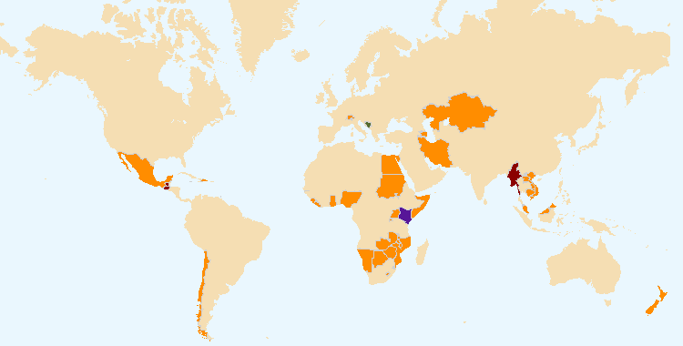
The boundaries shown on this map do not imply the expression of any opinion whatsoever on the part of UPOV concerning the legal status of any country or territory
States and organizations that became members of the Union during 2016-2017 (Bosnia and Herzegovina)
States and organizations that acceded or ratified the 1991 Act of the UPOV Convention during 2016-2017 (Kenya and Bosnia and Herzegovina)
States and organizations that initiated with the Council of UPOV the procedure for becoming members of the Union during 2016-2017 (Brunei Darussalam, Guatemala and Myanmar)
States and organizations that contacted the Office of the Union for assistance in the development of legislation on plant variety protection during 2016-2017 (ARIPO, Azerbaijan, Barbados, Cambodia, Chile, Dominican Republic, Egypt, Iran (Islamic Republic of), Guatemala, Jamaica, Kazakhstan, Lao People’s Democratic Republic, Liechtenstein, Malaysia, Mauritius, Mexico, Myanmar New Zealand, Nigeria, Switzerland, Trinidad and Tobago and Viet Nam)
Overall Policy on Plant Variety Protection (Sub-program UV.1)

This sub-program provides the framework for policy making, management and coordination of the activities within UPOV’s overall program, as established by the Council with the guidance of the Consultative Committee. In the 2016-2017 Biennium, the Council and the Consultative Committee took a number of important decisions concerning the direction and policy of the Union, including: establishment of the Working Group on a Possible International System of Cooperation (WG-ISC); introduction of the new UPOV logo on the UPOV website, in conjunction with the introduction of the stakeholder-focused features, and launch of the UPOV YouTube Channel; approval of a Strategic Business Plan to diversify UPOV’s revenue portfolio to maintain and enhance the sustainability of existing activities and services; organization of a single, annual set of UPOV sessions in Geneva; launch of the Electronic Application Form (UPOV PRISMA PBR Application Tool); inter-relations with the ITPGRFA, including the organization of a “Symposium on possible interrelations between the International Treaty on Plant Genetic Resources for Food and Agriculture (ITPGRFA) and the International Convention for the Protection of New Varieties of Plants (UPOV Convention)”, held in Geneva in October 2016; adoption of an FAQ on how the UPOV system of plant variety protection contributes to the United Nations Sustainable Development Goals (SDGs); and approval of a program for the use of the Russian language in UPOV.

Services to the Union for enhancing the Effectiveness of the UPOV System (Sub-program UV.2)

This sub-program covers the provision of guidance, information and resources for the operation of the UPOV system of plant variety protection, support for cooperation between members of the Union, the work of the relevant UPOV bodies and measures to facilitate applications for plant breeders’ rights. A key development in the 2016-2017 Biennium was the launch of the Electronic Application Form, now known as the UPOV PRISMA PBR Application Tool. From 2016, the web-based Test Guidelines Template (TG Template) was used for the preparation of draft Test Guidelines for all TWP sessions. The TG Template also enabled the rapid expansion of UPOV PRISMA to cover all crops and species for those members of the Union that use the UPOV Test Guidelines as the basis for the technical questionnaires in their application forms. The introduction of UPOV PRISMA highlights the ongoing and increasing importance of UPOV Test Guidelines for DUS examination. In 2017, the 321 adopted Test Guidelines covered 94% of all PBR-related entries in the Plant Variety Database. The integration of the UPOV PRISMA, TG Template, GENIE database and PLUTO database information will be an important means of providing more efficient and effective services in the future. The adoption of revised explanatory notes on essentially derived varieties and new explanatory notes on propagating material was important for improved understanding of these provisions.

Assistance in the Introduction and Implementation of the UPOV System (Sub-Program UV.3)

This sub-program covers the assistance provided in response to requests by members of the Union and potential members of the Union. Satisfying the demand for assistance in the introduction and implementation of the UPOV system within available resources relies on the use of distance-learning courses, training of trainers, the prioritization of assistance by the Office of the Union and the use of external resources for administration, training and assistance according to available finances. This sub-program is supported by the regular budget, but extra-budgetary funds and support in kind provide a substantial proportion of the resources deployed for assistance. In order to utilize the available resources in the most effective way, the Office of the Union continued to prioritize its activities and to explore synergies in its activities with members of the Union and other partners. The Training and Assistance Strategy provides the direction and the basis for overall coordination of this work. The Office of the Union organized or participated in 199 missions/events in the 2016-2017 Biennium, at which 119 States and 15 organizations were provided with information about the UPOV system. A total of 1,240 students participated in UPOV’s distance learning courses. At the end of 2017, 16 States and 1 organization were provided with assistance in the development of PVP legislation and 3 States initiated the procedure to become a member of the Union. The UPOV distance learning courses had participants from 75 States and 5 organizations.

External Relations (Sub-Program UV.4)

UPOV’s mission is to provide and promote an effective system of plant variety protection, with the aim of encouraging the development of new varieties of plants, for the benefit of society. The aim of this Sub-program is to explain how the UPOV system encourages the development of new varieties of plants, how new varieties benefit society and the role of the UPOV system in relation to agriculture and economic policy. Notable developments in the 2016-2017 Biennium included the launch of the UPOV YouTube channel, the introduction of stakeholder features on the UPOV website, the adoption of an FAQ on how the UPOV system of plant variety protection contributes to the United Nations Sustainable Development Goals (SDGs) and the publication on the UPOV website of the following material: “The socio-economic benefits of UPOV membership in Viet Nam; An ex post assessment on plant breeding and agricultural productivity after 10 years” (Corresponding author: Steffen Noleppa) by HFFA Research GmbH”; a video on PVP in Ecuador “The role of PVP in the development of a new blackberry variety that improves farmers’ working conditions”; a video on PVP in Uruguay “How PVP enabled a public breeder to ensure a supply of high quality onion seed to farmers”; and a video on “Using the UPOV system to benefit custodians of native wild germplasm in Argentina”.

RESULTS TABLE FOR THE 2016-2017 BIENNIUM

Table of contents

1. INTRODUCTION 7
Figure 1 - Changes of status in relation to UPOV during the 2016-2017 Biennium 7
Figure 2 - Status in relation to UPOV at the end of the 2017 8
2. PROGRAM PERFORMANCE 10
2.1 Sub-program UV.1: Overall Policy on Plant Variety Protection 10
Objectives 10
Results Achieved: Selected Performance Indicators 10
1. ORGANIZATION OF COUNCIL AND CONSULTATIVE COMMITTEE SESSIONS 10
(a) Participation in the sessions of the Council and the Consultative Committee 10
Figure 3. Participation in Ordinary Sessions of the Council (October sessions) 10
Figure 4. Participation* in Extraordinary Sessions of the Council (April sessions) 10
Figure 5. Participation* in Consultative Committee Sessions 11
2. Coordination, monitoring and performance assessment of Program and Budget for the 2016-2017 Biennium 11
(a) Delivery of program within budget for the 2016-2017 Biennium 11
3. Preparation and adoption of the Program and Budget for the 2018-2019 Biennium 11
(a) Preparation and adoption of the Program and Budget for the 2018-2019 Biennium in accordance with the “Financial Regulations and Rules of UPOV” 11
4. Review of developments concerning applications and grants of plant breeders’ rights 12
(a) Number of applications for plant breeders’ rights 12
(b) Number of titles granted 12
(c) Number of titles in force 12
Figure 6. Applications for Plant Breeders’ Rights 12
Figure 7. Plant Breeders’ Rights Titles in Force 12
Figure 8. Applications for Plant Breeders’ Rights by Resident/Non-Resident 12
Figure 9. Plant Breeders’ Rights Titles Granted by Resident/Non-Resident 12
(d) Number of genera/species protected by members of the Union 13
Figure 10. Protection to plant genera and species in 2017 13
Figure 11. Evolution of protection to plant genera and species 13
(e) Number of genera/species for which varieties have been protected 13
(f) Analysis by crop type 14
5. Council policy 14
(a) Recommendations by the Consultative Committee, and decisions by the Council 14
(b) Other decisions by the Council 15
(c) Other work of the Consultative Committee 15
(d) Adoption of information and position papers by the Council 15
2.2 Sub-program UV.2: Services to the Union for Enhancing the Effectiveness of the UPOV System 16
Objectives 16
Results Achieved: Selected Performance Indicators 16
1. Participation by members of the Union and observers in the work of the UPOV bodies 16
(a) Participation in the Administrative and Legal Committee 16
Figure 12. Number of Participating Members and Observer States/Organizations in the CAJ 16
(b) Participation in the Technical Committee 17
Figure 13. Number of Participating Members and Observer States/Organizations in the TC 17
(c) Participation in Technical Working Party Sessions 17
Figure 14. Number of Participating Members and Observer States/Organizations in the TWPs 17
(d) Participation in Preparatory Workshops for the Technical Working Party Sessions 18
Figure 15 18
(i) Number of individual participants in the Preparatory Workshops: members and observers 18
(ii) Number of individual participants in the Preparatory Workshops by Technical Working Party 18
2. Guidance on the UPOV Convention and its implementation and information on its application 19
(a) Adoption of new or revised information materials concerning the UPOV Convention 19
(b) Publication of the UPOV Gazette and Newsletter 19
(c) Inclusion of laws of members of the Union in UPOV Lex database 19
UPOV Lex database: visits to the UPOV Website in 2017 19
(d) Availability of UPOV documents and materials in languages other than the UPOV languages (English, French, German and Spanish) 20
3. Guidance on the examination of varieties 20
(a) Adoption of new or revised TGP documents and information materials 20
(b) Adoption of new or revised Test Guidelines 21
Test Guidelines: visits to the UPOV Website in 2017 21
Figure 16. Adoption of Test Guidelines 22
Figure 17. Draft Test Guidelines discussed in TWPs 22
(c) Number of PBR applications covered by adopted Test Guidelines 22
Figure 18. Plant Breeders’ Rights Entries in Plant Variety Database covered by Test Guidelines 22
(d) Participation in the development of Test Guidelines 23
Figure 19. Total number of Test Guidelines adopted (by Technical Working Party) 23
Figure 20. Total number of Test Guidelines under development (by Technical Working Party) 23
Figure 21. Total number of Test Guidelines adopted (by region of the leading expert) 23
Figure 22. Total number of Test Guidelines under development (by region of the leading expert) 23
Figure 23. Number of members of the Union involved in drafting Test Guidelines 23
(f) Development of web-based Test Guidelines Template (TG Template) with facility for: 24
1. Translation in UPOV languages 24
2. Use by members of the Union in the preparation of individual authorities’ test guidelines 24
4. Cooperation IN DUS examination 24
GENIE Database: visits to the UPOV Website in 2017 24
(a) Plant genera and species for which members of the Union have practical experience 25
Figure 24. Plant Genera/Species with Cooperation Agreements, Practical Experience and Plant Breeders’ Rights Entries in Plant Variety Database 25
(b) Plant genera and species for which members of the Union cooperate in DUS examination, as indicated in GENIE database 25
5. Cooperation IN examination of variety denominations 26
PLUTO Database: visits to the UPOV Website in 2017 26
(a) Quantity and quality of data in PLUTO database 26
1. Number of contributors 26
2. Number of new submissions 26
3. Number of records 26
6. Facilitating applications for plant breeders’ rights 27
(a) Development and approval by the Council of an electronic application system for selected species and languages, enabling breeders to provide information for PBR applications for participating members of the Union, via the UPOV website 27
Introduction of the UPOV PRISMA PBR Application Tool 27
Use of UPOV PRISMA in 2017 27
(b) Allocation of crop type(s) for UPOV codes and modification of the GENIE and PLUTO databases to enable statistics to be provided by crop type (agriculture, fruit, ornamentals, vegetables and forest trees) 27
2.3 Sub-Program UV.3: Assistance in the Introduction and Implementation of the UPOV System 28
Objectives 28
Results Achieved: Selected Performance Indicators 28
1. Raising awareness of the role of plant variety protection in accordance with the UPOV Convention 28
(a) States and organizations provided with information at UPOV activities 28
Figure 25. States provided with information at UPOV activities 29
Figure 26. Location of UPOV activities 29
(b) States and organizations that contacted the Office of the Union for assistance in the development of legislation on plant variety protection 30
(c) States and organizations that initiated with the Council of UPOV the procedure for becoming members of the Union 30
Figure 27. States and organizations that contacted the Office of the Union for assistance in the development of legislation on plant variety protection and States and organizations that initiated with the Council of UPOV the procedure for becoming members of the Union 30
(d) Participation in UPOV awareness-raising activities, or activities involving UPOV staff or UPOV trainers on behalf of UPOV staff 31
Figure 28. Location of activities/meetings where UPOV made presentations 31
2. Assistance in drafting legislation on plant variety protection in accordance with the 1991 Act of the UPOV Convention 31
(a) States and organizations provided with comments on laws 31
(b) States and organizations which received a positive advice from the Council of UPOV 31
(c) Meetings with government officials 32
Figure 29. Assistance provided in drafting legislation on plant variety protection 32
3. Assistance to States and organizations in the accession to the 1991 Act of the UPOV Convention 32
(a) States that acceded to or ratified the 1991 Act of the UPOV Convention 32
(b) States and organizations that became members of the Union 32
Figure 30. States/Organizations provided with comments on laws 33
Figure 31. States/Organizations which received positive advice from the Council 33
Figure 32. New members of the Union 33
Figure 33. Accession to/ratification of the 1991 Act 33
4. Assistance in implementing an effective plant variety protection system in accordance with the UPOV Convention 34
(a) Participation in distance learning courses 34
Figure 34. UPOV DL-205, DL-305, DL-305A and DL-305B Courses: 2016 and 2017 participation 34
Figure 35. Participants in the main sessions of the DL-205 Course by registration category 35
Figure 36. Participants in the main sessions of the DL-205 Course by language 35
Figure 37. Participants in the main sessions of the DL-305, 305A, 305B Courses by registration category 35
Figure 38. Participants in the main sessions of the DL-305, 305A, 305B Courses by language 35
(b) Training of trainers 37
(c) Training activities developed in conjunction with UPOV 37
(d) Participation by observer States and organizations in the CAJ, TC, TWPs and the associated preparatory workshops 37
(e) Participation in UPOV activities 37
(f) Participation in activities involving UPOV staff or UPOV trainers on behalf of UPOV staff 37
(g) Academic courses featuring the UPOV system of plant variety protection 38
(f) Implementation of projects with partner organizations and donors 38
2.4 Sub-Program UV.4: External Relations 39
Objectives 39
Results Achieved: Selected Performance Indicators 39
1. Broaden public understanding of UPOV’s role and activities 39
(a) Availability of suitable information and materials for the general public, on UPOV website and through other media 39
(b) Visits to UPOV website 39
2. Enhance understanding of UPOV’s role and activities for stakeholders 41
(a) Availability of suitable information and materials for breeders, seed producers / plant propagators, farmers, processors/wholesalers/retailers and policy-makers, on UPOV website and through other media 41
(b) Articles in relevant publications to which UPOV has contributed 41
(c) Stakeholder-focused features on the UPOV website 42
Visits to the stakeholder-focused features on the UPOV Website in 2017 42
(d) Participation by stakeholders in seminars and symposia 42
(e) Participation at meetings of, and with, relevant stakeholders 42
3. Enhance understanding of UPOV’s role and activities with other organizations 42
(a) Participation at meetings of, and with, relevant organizations 42
3. FINANCIAL PERFORMANCE 43

Appendix Acronyms and abbreviations

1. INTRODUCTION

This document presents the Performance Report for the 2016-2017 Biennium on the basis of the Program and Budget for the 2016-2017 Biennium adopted by the Council at its forty-ninth ordinary session, held in Geneva on October 29, 2015 (see document C/49/4 Rev. “Program and Budget for the 2016-2017 Biennium”).

The Performance Report for the 2016-2017 Biennium provides an overview of UPOV’s performance based on information from the following documents, which contain further detailed information:

(a) document C/49/4 Rev. “Program and Budget of the Union for the 2016-2017 Biennium;
(b) document C/51/2 “Annual Report of the Secretary-General for 2016”;
(c) document C/52/2 “Annual Report of the Secretary-General for 2017”; and
(d) document C/52/4 “Financial Management Report for the 2016-2017 Biennium”.

Section 2 “Program Performance”, provides a brief summary of the progress made towards the achievements of objectives at the level of sub-programs, followed by performance tables summarizing information on objectives, expected results and performance indicators. Section 3 “Financial Performance”, provides an overview of the financial performance, in relation to the Program and Budget for the 2016­2017 Biennium.

The following map provides a graphic overview of developments concerning the status in relation to UPOV during the 2016-2017 Biennium.

Figure 1 - Changes of status in relation to UPOV during the 2016-2017 Biennium
The boundaries shown on this map do not imply the expression of any opinion whatsoever on the part of UPOV concerning the legal status of any country or territory
States and organizations that became members of the Union during 2016-2017 (Bosnia and Herzegovina)
States and organizations that acceded or ratified the 1991 Act of the UPOV Convention during 2016-2017 (Kenya and Bosnia and Herzegovina)
States and organizations that initiated with the Council of UPOV the procedure for becoming members of the Union during 2016-2017 (Brunei Darussalam, Guatemala and Myanmar)
States and organizations that contacted the Office of the Union for assistance in the development of legislation on plant variety protection during 2016-2017 (ARIPO, Azerbaijan, Barbados, Cambodia, Chile, Dominican Republic, Egypt, Iran (Islamic Republic of), Guatemala, Jamaica, Kazakhstan, Lao People’s Democratic Republic, Liechtenstein, Malaysia, Mauritius, Mexico, Myanmar New Zealand, Nigeria, Switzerland, Trinidad and Tobago and Viet Nam)

The following map provides a graphic overview of the status in relation to UPOV at the end of 2017.

Figure 2 - Status in relation to UPOV at the end of the 2017
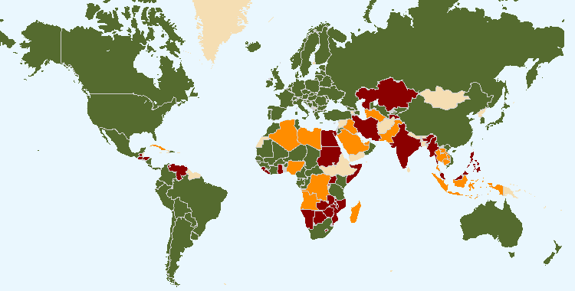
The boundaries shown on this map do not imply the expression of any opinion whatsoever on the part of UPOV concerning the legal status of any country or territory
75 members of UPOV covering 94 States at the end of 2017
16 States and 1 intergovernmental organization had initiated the procedure for acceding the UPOV Convention at the end of 2017
24 States and 1 intergovernmental organization which had been in contact with the Office of the Union for assistance in the development of laws based on the UPOV Convention at the end of 2017

The following table provides detailed information on the status in relation to UPOV.

UPOV members

African Intellectual Property Organization^{3, 5}
Albania³
Argentina2
Australia³
Austria3
Azerbaijan³
Belarus³
Belgium1
Bolivia (Plurinational State of)²
Bosnia and Herzegovina³
Brazil²
Bulgaria³
Canada3
Chile²
China²
Colombia²
Costa Rica³
Croatia³
Czech Republic³
Denmark3
Dominican Republic³
Ecuador²
Estonia³
European Union^{3, 4}
Finland3
France3
Georgia³
Germany3
Hungary3
Iceland3
Ireland3
Israel³
Italy2
Japan³
Jordan³
Kenya³
Kyrgyzstan³
Latvia³
Lithuania³
Mexico²
Montenegro³
Morocco3
Netherlands³
New Zealand2
Nicaragua²
Norway2
Oman³
Panama³
Paraguay²
Peru³
Poland3
Portugal²
Republic of Korea³
Republic of Moldova³
Romania³
Russian Federation³
Serbia³
Singapore³
Slovakia³
Slovenia³
South Africa2
Spain3
Sweden³
Switzerland³
The former Yugoslav Republic of Macedonia³
Trinidad and Tobago²
Tunisia³
Turkey³
Ukraine³
United Kingdom³
United Republic of Tanzania³
United States of America³
Uruguay²
Uzbekistan³
Viet Nam³

(Total 75)

_________
¹ 1961 Convention as amended by the Additional Act of 1972 is the latest Act by which 1 State is bound.
² 1978 Act is the latest Act by which 17 States are bound.
³ 1991 Act is the latest Act by which 55 States and 2 organizations are bound.
⁴ Operates a plant breeders’ rights system which covers the territory of its 28 member States (Austria, Belgium, Bulgaria, Croatia, Cyprus, Czech Republic, Denmark, Estonia, Finland, France, Germany, Greece, Hungary, Ireland, Italy, Latvia, Lithuania, Luxembourg, Malta, Netherlands, Poland, Portugal, Romania, Slovakia, Slovenia, Spain, Sweden, United Kingdom).
⁵ Operates a plant breeders’ rights system which covers the territory of its 17 member States (Benin, Burkina Faso, Cameroon, Central African Republic, Chad, Comoros, Congo, Côte d’Ivoire, Equatorial Guinea, Gabon, Guinea, Guinea Bissau, Mali, Mauritania, Niger, Senegal, Togo).

States and intergovernmental organizations which had initiated the procedure
for acceding to the UPOV Convention

Armenia, Brunei Darussalam, Egypt, Ghana, Guatemala, Honduras, India, Iran (Islamic Republic of), Kazakhstan, Malaysia, Mauritius, Myanmar, Philippines, Tajikistan, Venezuela (Bolivarian Republic of), Zimbabwe, as well as the African Regional Intellectual Property Organization (ARIPO).

States and intergovernmental organizations which had been in contact with the Office of the Union
for assistance in the development of laws based on the UPOV Convention

Afghanistan, Algeria, Bahrain, Barbados, Cambodia, Cuba, Cyprus, El Salvador, Indonesia, Iraq, Jamaica, Lao People’s Democratic Republic, Libya, Liechtenstein, Mongolia, Mozambique, Namibia, Nigeria, Pakistan, Saudi Arabia, Sudan, Thailand, Tonga, Turkmenistan, United Arab Emirates, Zambia, as well as the Southern African Development Community (SADC).

2. PROGRAM PERFORMANCE

2.1 Sub-program UV.1: Overall Policy on Plant Variety Protection

This sub-program provides the framework for policy making, management and coordination of the activities within UPOV’s overall program, as established by the Council with the guidance of the Consultative Committee. In the 2016-2017 Biennium, the Council and the Consultative Committee took a number of important decisions concerning the direction and policy of the Union, including: establishment of the Working Group on a Possible International System of Cooperation (WG-ISC); introduction of the new UPOV logo on the UPOV website, in conjunction with the introduction of the stakeholder-focused features, and launch of the UPOV YouTube Channel; approval of a Strategic Business Plan to diversify UPOV’s revenue portfolio to maintain and enhance the sustainability of existing activities and services; organization of a single, annual set of UPOV sessions in Geneva; launch of the Electronic Application Form (UPOV PRISMA PBR Application Tool); inter-relations with the ITPGRFA, including the organization of a “Symposium on possible interrelations between the International Treaty on Plant Genetic Resources for Food and Agriculture (ITPGRFA) and the International Convention for the Protection of New Varieties of Plants (UPOV Convention)”, held in Geneva in October 2016; adoption of an FAQ on how the UPOV system of plant variety protection contributes to the United Nations Sustainable Development Goals (SDGs); and approval of a program for the use of the Russian language in UPOV.

Objectives | - Policy direction and executive management.  - Planning, implementation and evaluation of program and budget.

Results Achieved: Selected Performance Indicators

1. ORGANIZATION OF COUNCIL AND CONSULTATIVE COMMITTEE SESSIONS

(a) Participation in the sessions of the Council and the Consultative Committee
(see Figures 3 to 5)

Figure 3. Participation* in Ordinary Sessions of the Council (October sessions) | Figure 4. Participation* in Extraordinary Sessions of the Council (April sessions)

Figure 5. Participation* in Consultative Committee Sessions

2. Coordination, monitoring and performance assessment of Program and Budget for the 2016-2017 Biennium

(a) Delivery of program within budget for the 2016-2017 Biennium
See Section 3 “Financial Performance”

3. Preparation and adoption of the Program and Budget for the 2018-2019 Biennium

(a) Preparation and adoption of the Program and Budget for the 2018-2019 Biennium in accordance with the “Financial Regulations and Rules of UPOV”
The Program and Budget for the 2018-2019 Biennium was adopted by the Council at its fifty-first ordinary session, on October 26, 2017 (see document C/51/4 Rev.).

4. Review of developments concerning applications and grants of plant breeders’ rights

(a) Number of applications for plant breeders’ rights
(see Figures 6 and 8)

(b) Number of titles granted
(see Figure 9)

(c) Number of titles in force
(see Figure 7)

Figure 6. Applications for Plant Breeders’ Rights  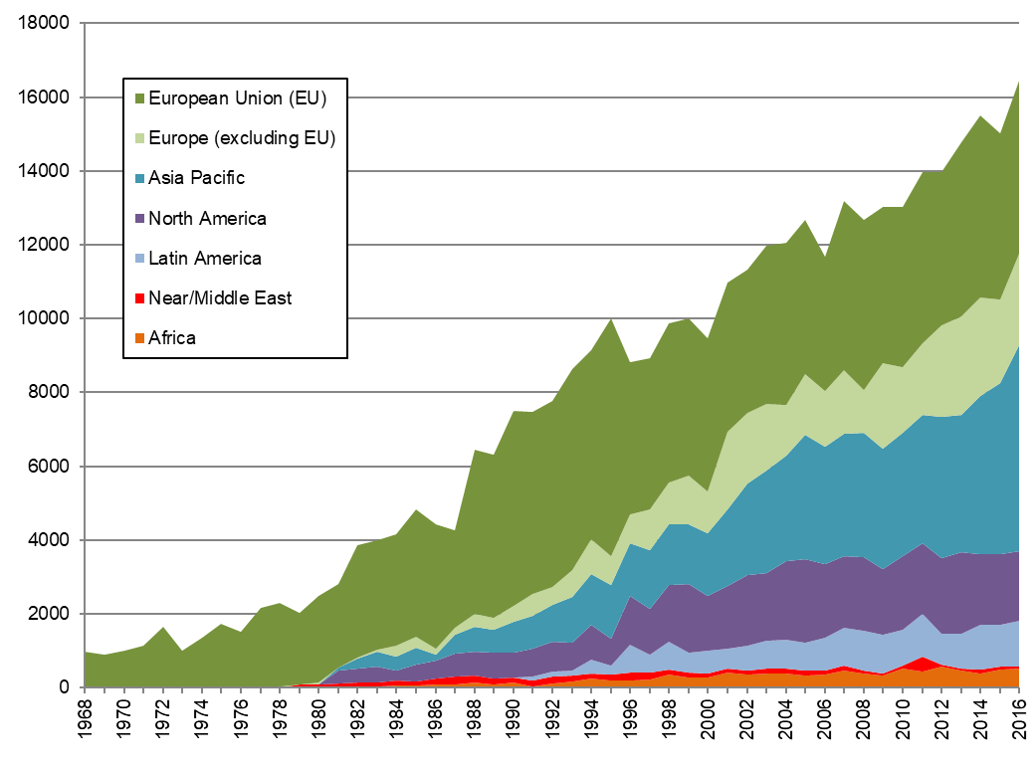 | Figure 7. Plant Breeders’ Rights Titles in Force  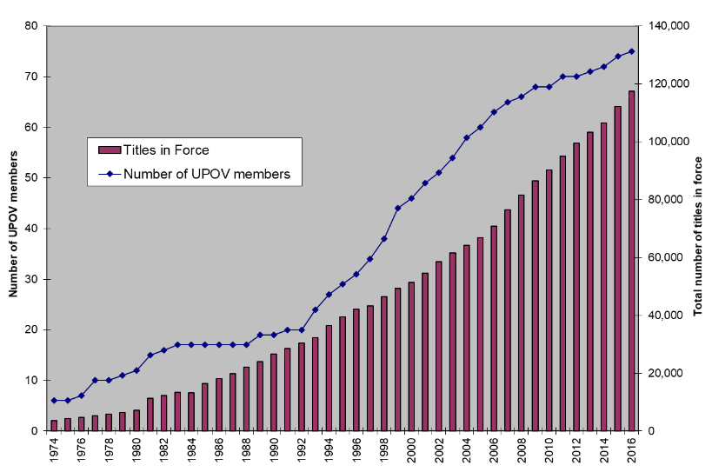
Figure 8. Applications for Plant Breeders’ Rights by Resident/Non-Resident  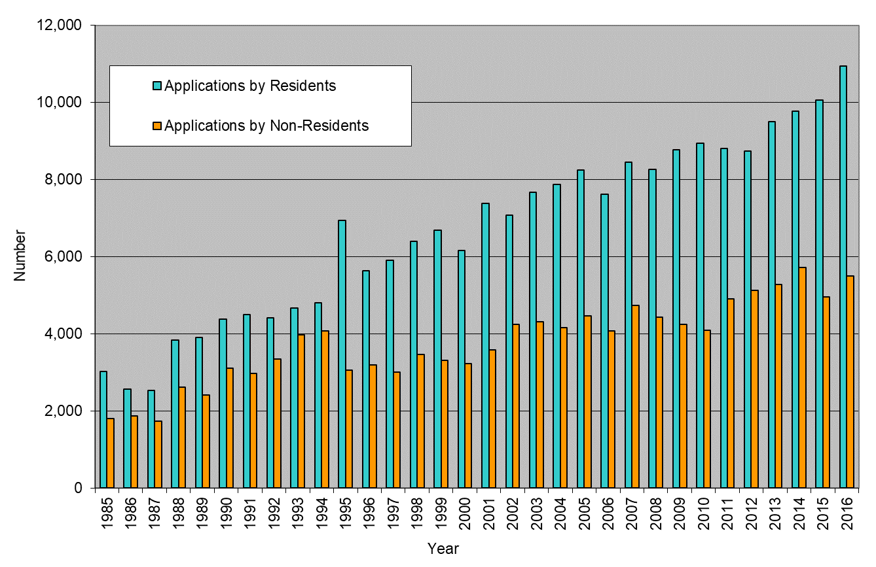 | Figure 9. Plant Breeders’ Rights Titles  Granted by Resident/Non-Resident  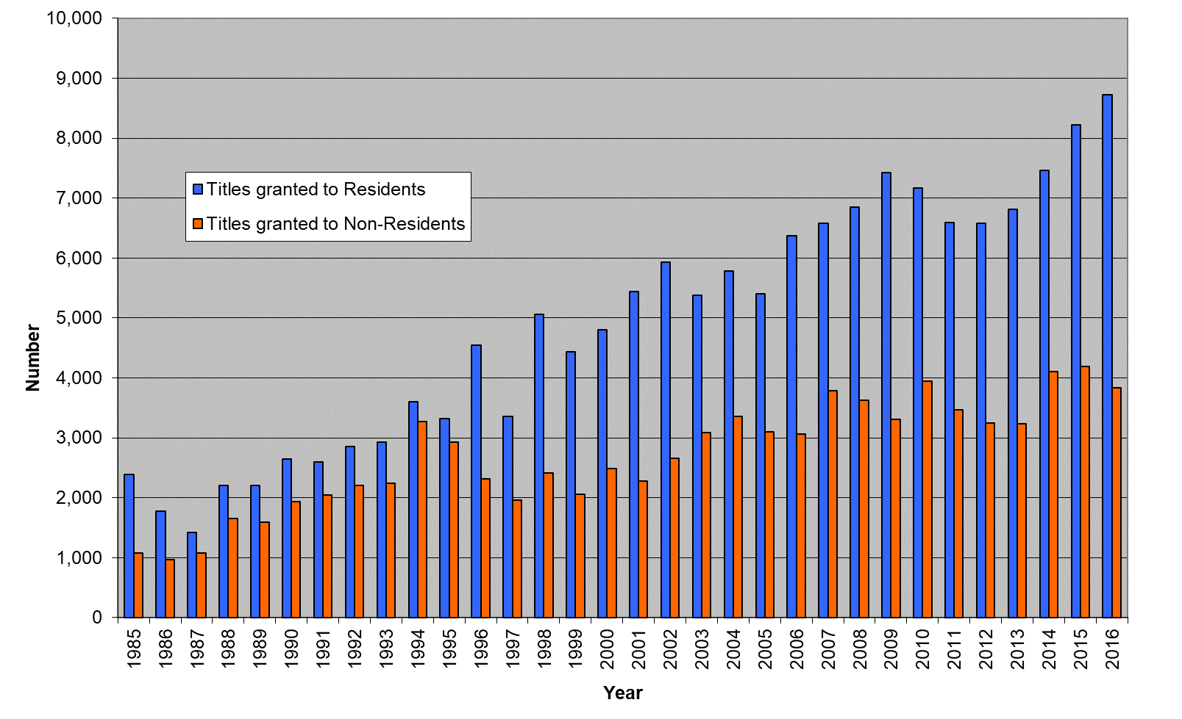

(d) Number of genera/species protected by members of the Union
(see Figures 10 and 11)

Figure 10. Protection to plant genera and species in 2017
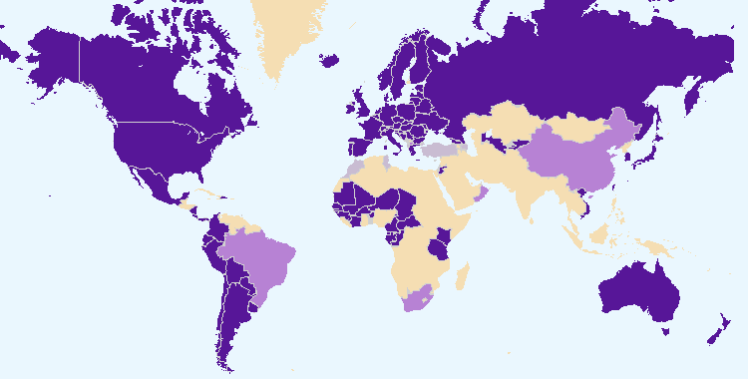
The boundaries shown on this map do not imply the expression of any opinion whatsoever on the part of UPOV concerning the legal status of any country or territory.
Members of the Union offering protection for all plant genera and species
Members of the Union offering protection for a limited number of plant genera and species
Members of the Union who had not notified the extension of protection to all genera and species

Figure 11. Evolution of protection to plant genera and species
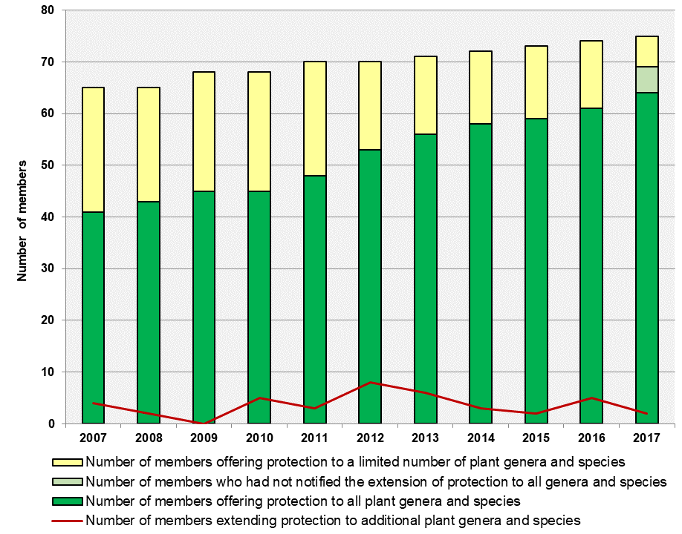

(e) Number of genera/species for which varieties have been protected
See Figure 18 “Plant Genera/Species with Cooperation Agreements, Practical Experience and Plant Breeders’ Rights Entries in Plant Variety Database”

(f) Analysis by crop type
Data from PLUTO database:

Applications filed by crop type:  Crop type  Year Agri-culture Forest trees Fruit Orna-mental Vege-tables  2012 27% 0.9% 12% 48% 12%  2013 25% 1.0% 12% 49% 11%  2014 30% 0.8% 11% 47% 10%  2015 33% 0.5% 14% 36% 16%  2016 37% 0.6% 11% 34% 18%  2017 33% 0.5% 11% 38% 17% | Titles issued by crop type:  Crop type  Year Agri-culture Forest trees Fruit Orna-mental Vege-tables  2012 26% 0.7% 9% 48% 15%  2013 34% 0.7% 10% 42% 13%  2014 35% 0.6% 10% 43% 12%  2015 32% 0.9% 10% 44% 13%  2016 32% 1.1% 9% 40% 18%  2017 27% 0.4% 12% 45% 16%

5. Council policy

(a) Recommendations by the Consultative Committee, and decisions by the Council
The Council took decisions, based on recommendations by the Consultative Committee, concerning the following:
- to establish a separate UPOV bank account to hold funds allocated for financing UPOV’s After-Service Health Insurance (ASHI) liability, and that the amount represented by the provisions for ASHI obligations at the end of the 2014-2015 biennium, together with the balance from the 6 per cent charge after deduction of the respective biennium’s payments, if any, be transferred to that account starting from the 2016-2017 biennium and to apply to that account the investment policy that WIPO applied to the account for financing WIPO’s ASHI liability;
- to retain the amount exceeding 15 percent of the total income for the 2014-2015 Biennium (i.e. 31,860 Swiss francs) in the Reserve Fund;
- to organize a single set of sessions from 2018, and to adopt the proposals of the TC, at its fifty third session, on contingency measures;
- to take a positive decision on the conformity of:
- the Plant Varieties Protection Order of Brunei Darussalam;
- the “Draft Law for the Protection of New Varieties of Plants” of Guatemala;
- the “Draft Law on New Plant Variety Protection” of Myanmar;
- to launch the Electronic Application Form (EAF) in January 2017 for rose, soya bean, lettuce, apple fruit varieties and potato;
- approved the name PRISMA and the logo for the electronic application form (EAF);
- approved the UPOV charge for the EAF at CHF150 per application for the 2018-2019 biennium, but agreed that the EAF could be made free of charge for an introductory period if the budgeted costs of the EAF were funded by means other than the regular budget;
- approved the draft FAQ on how the UPOV system of plant variety protection contributes to the United Nations Sustainable Development Goals (SDGs) and recommended its approval by the Council at its fifty-first session; it further agreed that the Office of the Union should seek the assistance of a professional communication expert to prepare a new draft for consideration at its ninety-fifth session;
- to adopt an FAQ concerning information on the situation in UPOV with regard to the use of molecular techniques for a wider audience (“FAQ on molecular techniques”), including the public in general;
- to introduce the new UPOV logo on the UPOV website, in conjunction with the introduction of the stakeholder-focused features on the UPOV website and the launch of the UPOV YouTube Channel, on November 8, 2016;
- agreed that proposals for increasing UPOV’s use of social media, including a timetable in accordance with the resourcing strategy, should be presented for consideration at its ninety-fifth session;
- to approve the draft program for the “Seminar on Propagating and Harvested Material in the context of the UPOV Convention,” to be held in Geneva on October 24, 2016;
- to organize a “Symposium on possible interrelations between the International Treaty on Plant Genetic Resources for Food and Agriculture (ITPGRFA) and the International Convention for the Protection of New Varieties of Plants (UPOV Convention)”, to be held at UPOV Headquarters in Geneva, on October 26, 2016;
- agreed the following concerning interrelations with the International Treaty on Plant Genetic Resources for Food and Agriculture (ITPGRFA):
(i) to review the FAQ on the interrelations between the UPOV Convention and the ITPGRFA; and
(ii) exchange of experience and information on the implementation of the UPOV Convention and the ITPGRFA, with the involvement of stakeholders.
As a next step, the Consultative Committee would consider the need for a revision of the current guidance in the “Explanatory Notes on Exceptions to the Breeder’s Right under the 1991 Act of the UPOV Convention” (document UPOV/EXN/EXC/1);
The Council further agreed to report the decision above at the Seventh Session of the Governing Body of the ITPGRFA to be held in Kigali, Rwanda, from October 30 to November 3, 2017, accordingly;
- approved the program for use of the Russian language in UPOV and proposed resourcing;
- 4 press releases;
- Draft Program and Budget of the Union for the 2018-2019 Biennium;
- adoption of information materials (the adoption of information materials by the Council is reported under Sub-Program UV.2).

(b) Other decisions by the Council
The Council also took decisions concerning the following:
- work programs of the Administrative and Legal Committee (CAJ), the Technical Committee (TC), the Technical Working Parties (TWPs) and the Working Group on Biochemical and Molecular Techniques, and DNA-Profiling in Particular (BMT);
- election of the:
– President and Vice-President of the Council
– Chair and Vice-Chair of the CAJ
– Chair and Vice-Chair of the TC
– Chair and Vice-Chair of the TWA
– Chair and Vice-Chair of the TWC
– Chair and Vice-Chair of the TWF
– Chair and Vice-Chair of the TWO
– Chair and Vice-Chair of the TWV
– Chair and Vice-Chair of the BMT
- extension of the appointment of the Vice Secretary-General from December 1, 2018, until November 30, 2021;
- with the agreement of the Director General of WIPO (see Article 8(1) of the WIPO/UPOV Agreement), to make an exception for Ms. Hend Madhour, in relation to Staff Regulation 4.16 (a), to provide for a maximum additional two-year extension of the temporary appointment of Ms. Madhour in order for her to continue her functions in relation to the “Electronic application form project” (EAF Project).

(c) Other work of the Consultative Committee
The Consultative Committee:
- agreed the draft mandate and terms of reference for a Working Group on a Possible International System of Cooperation (WG-ISC);
- in response to the recommendation of the IOD Evaluation Report, approved the proposal of the Office of the Union to prepare a draft Strategic Business Plan to be presented to the Consultative Committee in October/November 2017;
- agreed the inclusion of the regular item “Internal oversight and the WIPO Independent Advisory Oversight Committee (IAOC)” in the agenda of the October/November sessions of the Consultative Committee;
- approved a Strategic Business Plan to diversity UPOV’s revenue portfolio to maintain and enhance the sustainability of existing activities and services;
- decided to extend the observer status of the International Commission for the Nomenclature of Cultivated Plants (ICNCP) to the Administrative and Legal Committee (CAJ) and the Technical Committee (TC).

(d) Adoption of information and position papers by the Council
The adoption of information materials by the Council is reported under Sub-Program UV.2.

2.2 Sub-program UV.2: Services to the Union for Enhancing the Effectiveness of the UPOV System

This sub-program covers the provision of guidance, information and resources for the operation of the UPOV system of plant variety protection, support for cooperation between members of the Union, the work of the relevant UPOV bodies and measures to facilitate applications for plant breeders’ rights.

A key development in the 2016-2017 Biennium was the launch of the Electronic Application Form, now known as the UPOV PRISMA PBR Application Tool. From 2016, the web-based Test Guidelines Template (TG Template) was used for the preparation of draft Test Guidelines for all TWP sessions. The TG Template also enabled the rapid expansion of UPOV PRISMA to cover all crops and species for those members of the Union that use the UPOV Test Guidelines as the basis for the technical questionnaires in their application forms. The introduction of UPOV PRISMA highlights the ongoing and increasing importance of UPOV Test Guidelines for DUS examination. In 2017, the 321 adopted Test Guidelines covered 94% of all PBR-related entries in the Plant Variety Database. The integration of UPOV PRISMA, TG Template, GENIE database and PLUTO database information will be an important means of providing more efficient and effective services in the future. The adoption of revised explanatory notes on essentially derived varieties and new explanatory notes on propagating material was important for improved understanding of these provisions.

Objectives | - To maintain and improve the effectiveness of the UPOV system.  - To provide and develop the legal, administrative and technical basis for international cooperation in plant variety protection according to the UPOV Convention.

Results Achieved: Selected Performance Indicators

1. Participation by members of the Union and observers in the work of the UPOV bodies

(a) Participation in the Administrative and Legal Committee
(see Figure 12)

Figure 12. Number of Participating Members and Observer States/Organizations in the CAJ

(b) Participation in the Technical Committee
(see Figure 13)

Figure 13. Number of Participating Members and Observer States/Organizations in the TC
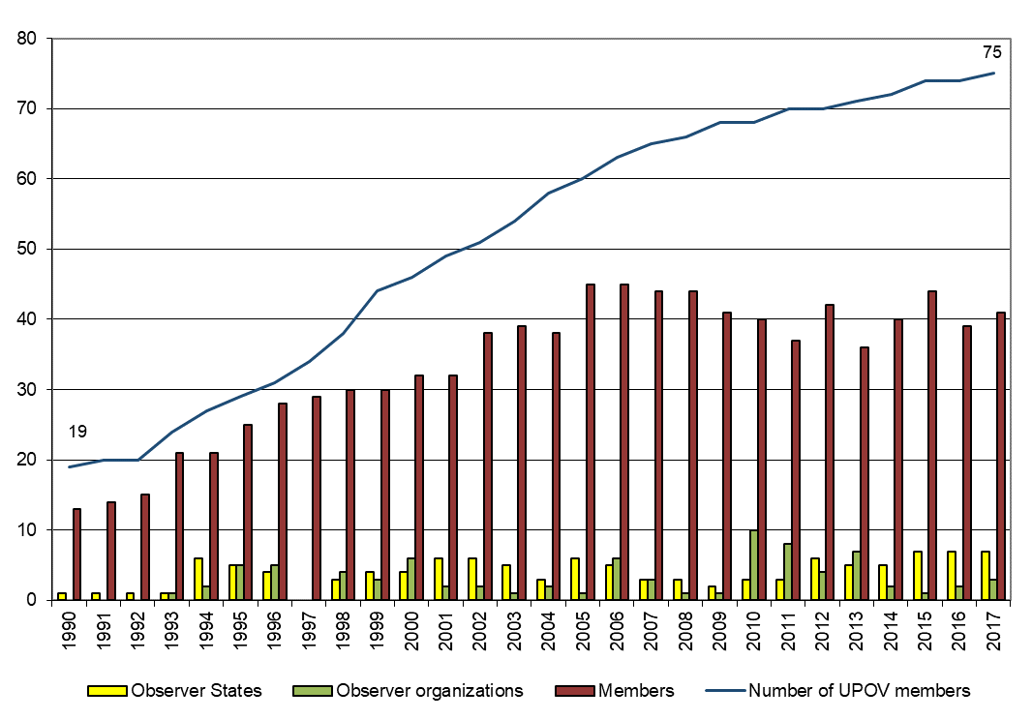

(c) Participation in Technical Working Party Sessions
(see Figure 14)

Figure 14. Number of Participating Members and Observer States/Organizations in the TWPs
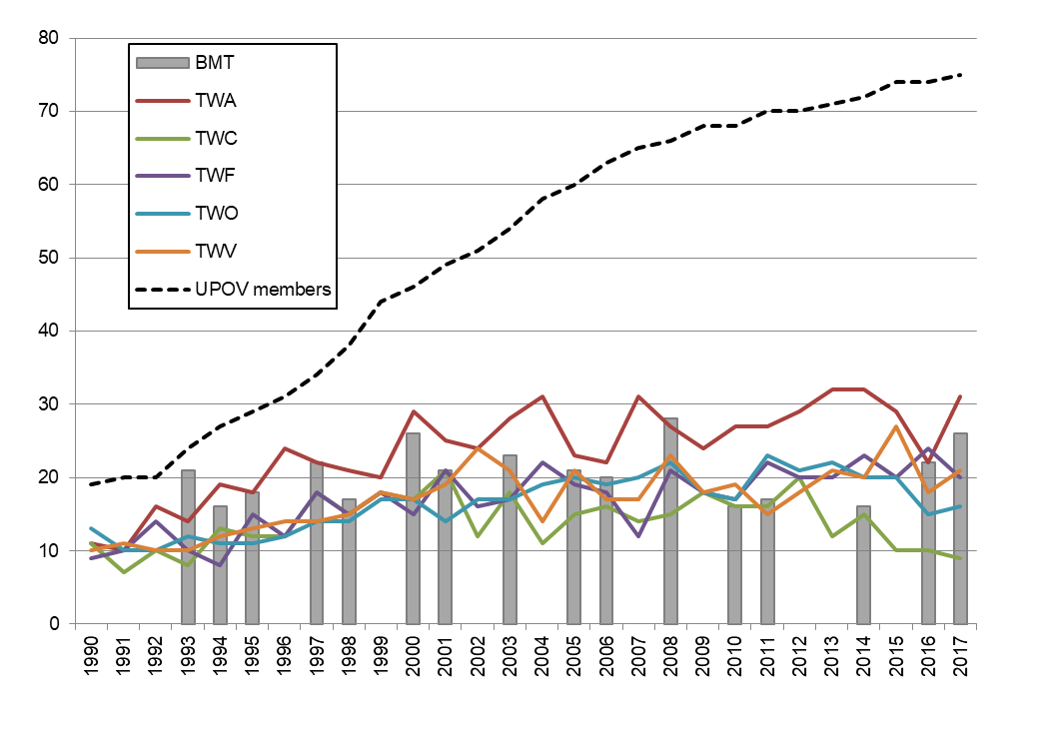

(d) Participation in Preparatory Workshops for the Technical Working Party Sessions
(see Figure 15)

Figure 15

(i) Number of individual participants in the Preparatory Workshops: members and observers
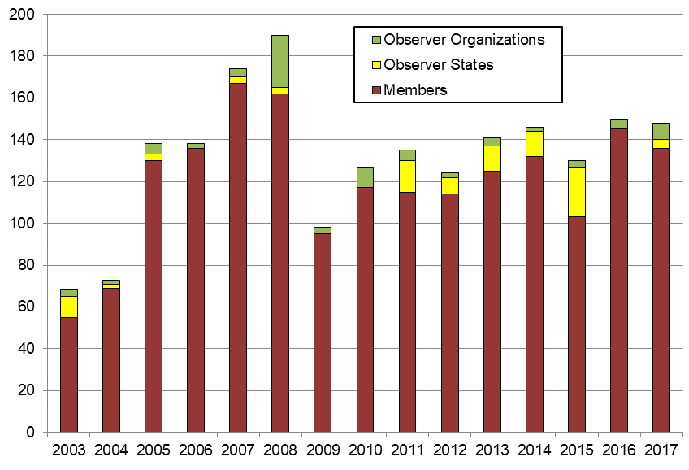

(ii) Number of individual participants in the Preparatory Workshops by Technical Working Party
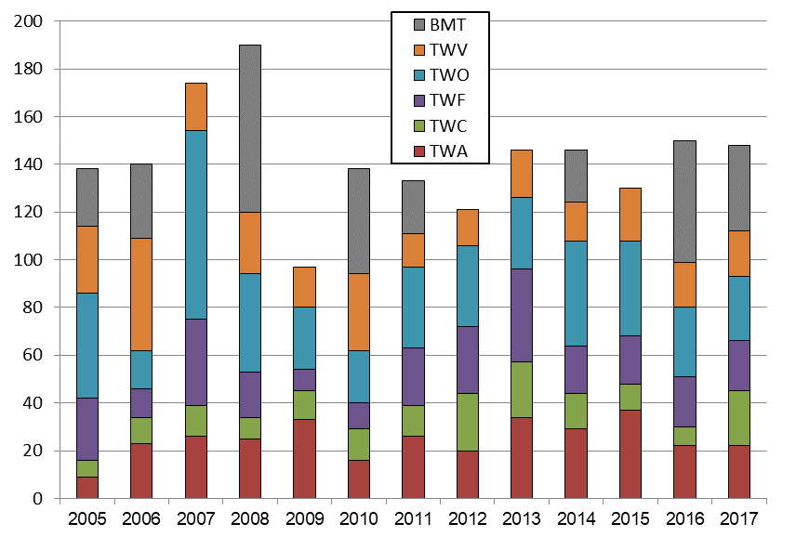

2. Guidance on the UPOV Convention and its implementation and information on its application

(a) Adoption of new or revised information materials concerning the UPOV Convention
The Council adopted:
- 8 revisions to previously adopted information documents
UPOV/INF/6/5 Guidance for the preparation of laws based on the 1991 Act of the UPOV Convention (Revision)
UPOV/INF/16/6 Exchangeable Software (Revision)
UPOV/INF/16/7 Exchangeable Software (Revision)
UPOV/INF/22/3 Software and equipment used by members of the Union (Revision)
UPOV/INF/22/4 Software and equipment used by members of the Union (Revision)
UPOV/INF-EXN/9 List of INF-EXN Documents and Latest Issue Dates (Revision)
UPOV/INF-EXN/10 List of INF-EXN Documents and Latest Issue Dates (Revision)
UPOV/INF-EXN/11 List of INF-EXN Documents and Latest Issue Dates (Revision)
- 1 new explanatory note
UPOV/EXN/PPM/1 Explanatory Notes on Propagating Material under the UPOV Convention
- 1 revision to previously adopted explanatory notes
UPOV/EXN/EDV/2 Explanatory Notes on Essentially Derived Varieties under the 1991 Act of the UPOV Convention (Revision)

The CAJ and TC, as appropriate, considered drafts of the following:
- 4 revisions to previously adopted information documents
UPOV/INF/16/6 Exchangeable Software (Revision)
UPOV/INF/16/7 Exchangeable Software (Revision)
UPOV/INF/22/3 Software and equipment used by members of the Union (Revision)
UPOV/INF/22/4 Software and equipment used by members of the Union (Revision)
- 1 new explanatory note
UPOV/EXN/PPM/1 Explanatory Notes on Propagation and Propagating Material under the UPOV Convention
- 1 revision to previously adopted explanatory notes
UPOV/EXN/EDV/2 Explanatory Notes on Essentially Derived Varieties under the 1991 Act of the UPOV Convention (Revision)
- for TGP documents, see Section 2.2 “Sub-Program UV.2”, expected result “2. Guidance on the examination of varieties” and “(a) Adoption of new or revised TGP documents and information materials”

(b) Publication of the UPOV Gazette and Newsletter
There was no issue of UPOV Publication No. 438 “Plant Variety Protection Gazette and Newsletter” in the 2016-2017 Biennium.

(c) Inclusion of laws of members of the Union in UPOV Lex database
- 10 laws concerning the following 10 members of the Union were included in the UPOV Lex database
Belarus, France (English translation), Kenya, Montenegro, Panama, Peru, Poland, Republic of Korea, United Republic of Tanzania, Viet Nam

UPOV Lex database: visits to the UPOV Website in 2017
Language | Pageviews | Unique pageviews
English | 56,661 | 40,492
Spanish | 17,633 | 12,279
French | 6,331 | 4,563
German | 2,197 | 1,807
Total: | 82,822 | 59,141

Evolution of visits

Year | Pageviews | Unique pageviews
2017 | 82,861 | 59,166
2016 | 85,374 | 60,294
2015 | 80,460 | 55,991
2014 | 88,305 | 60,439
2013 | 88,533 | 61,230
2012 | 91,245 | 62,411
2011 | 19,269 | 12,575

(d) Availability of UPOV documents and materials in languages other than the UPOV languages (English, French, German and Spanish)
- The 1991 Act of the UPOV Convention and document UPOV/INF/6 “Guidance for the Preparation of Laws Based on the 1991 Act of the UPOV Convention” were translated into Khmer and published on the UPOV website.
- The 1991 Act of the UPOV Convention was translated into Vietnamese and published on the UPOV website.

(see http://www.upov.int/about/en/languages.html)

3. Guidance on the examination of varieties

(a) Adoption of new or revised TGP documents and information materials
TGP documents adopted and published on the UPOV website:
- 3 revisions to previously adopted TGP documents
TGP/7/5 Development of Test Guidelines (Revision)
TGP/8/3 Trial Design and Techniques Used in the Examination of Distinctness, Uniformity and Stability (Revision)
TGP/0/9 List of TGP Documents and Latest Issue Dates (Revision)
- Drafts of TGP documents advanced in the CAJ, TC and/or the TWPs
- 4 revisions to previously adopted TGP documents
TGP/7 Development of Test Guidelines (Revision)
TGP/8 Trial Design and Techniques Used in the Examination of Distinctness, Uniformity and Stability (Revision)
TGP/10 Examining Uniformity (Revision)
TGP/0 List of TGP Documents and Latest Issue Dates (Revision)
- Drafts of information materials advanced in the CAJ, TC and/or the TWPs
- 3 revisions to previously adopted information materials
UPOV/INF/16 Exchangeable Software (Revision)
UPOV/INF/17 Guidelines for DNA-Profiling: Molecular Marker Selection and Database Construction (“BMT Guidelines”) (Revision)
UPOV/INF/22 Software and equipment used by members of the Union (Revision)
- Revision of the following document considered in the Working Variety Denominations (WG-DEN):
UPOV/INF/12 Explanatory Notes on Variety Denominations under the UPOV Convention (Revision)

(b) Adoption of new or revised Test Guidelines
Adopted Test Guidelines
- In 2016, 15 Test Guidelines were adopted by the TC, comprising:
– 5 new Test Guidelines
– 2 revised Test Guidelines
– 8 partially revised Test Guidelines
- In 2017, 19 Test Guidelines were adopted by the TC, comprising:
– 5 new Test Guidelines
– 10 revised Test Guidelines
– 4 partially revised Test Guidelines
(see Figure 16)

Test Guidelines advanced in the Technical Working Parties
- In 2016, 49 draft Test Guidelines were advanced by the TWPs, comprising:
– 21 new Test Guidelines
– 25 revisions
– 3 partial revisions
- In 2017, 54 draft Test Guidelines were advanced by the TWPs, comprising:
– 23 new Test Guidelines
– 21 revisions
– 10 partial revisions
(see Figure 17)

Test Guidelines: visits to the UPOV Website in 2017
Language | Pageviews | Unique pageviews
English | 53,266 | 31,116
Spanish | 9,175 | 4,970
French | 2,806 | 1,726
German | 1,301 | 793
Total: | 66,548 | 38,605

Evolution of visits

Year | Pageviews | Unique pageviews
2017 | 66,567 | 38,621
2016 | 61,966 | 38,054
2015 | 64,425 | 38,144
2014 | 67,900 | 40,102
2013 | 68,479 | 38,979
2012 | 65,471 | 37,227
2011 | not available | not available

Figure 16. Adoption of Test Guidelines  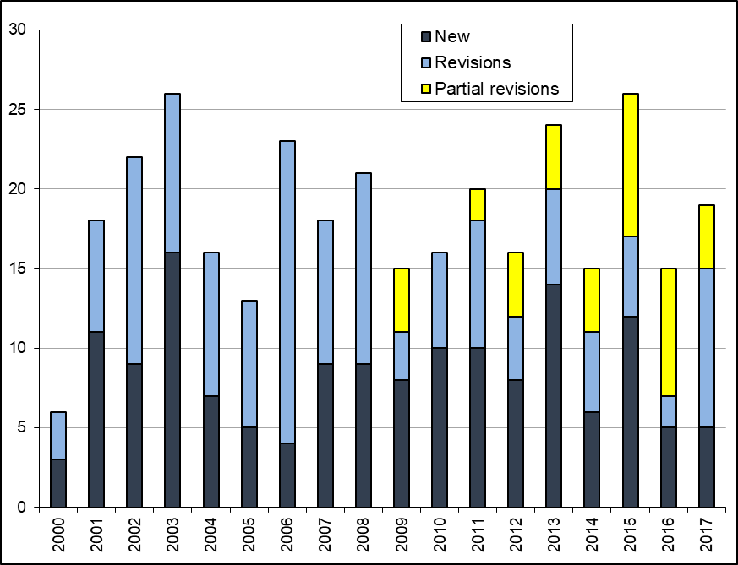 | Figure 17. Draft Test Guidelines  discussed in TWPs  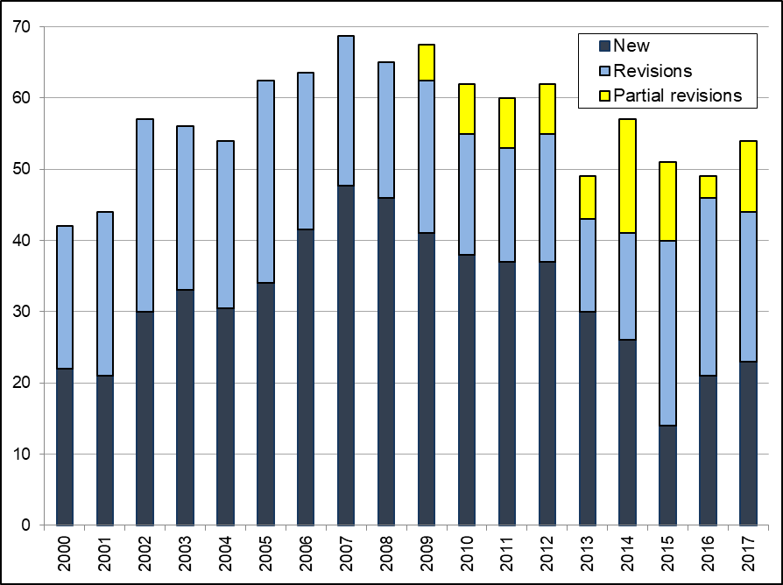

(c) Number of PBR applications covered by adopted Test Guidelines
At the end of 2017, the adopted Test Guidelines covered 94% of all PBR-related entries in the PLUTO Plant Variety Database (280,687 of 299,031) (92% at the end of 2015 (246,890 of 267,550))
(see Figure 18)

Figure 18. Plant Breeders’ Rights Entries in Plant Variety Database covered by Test Guidelines
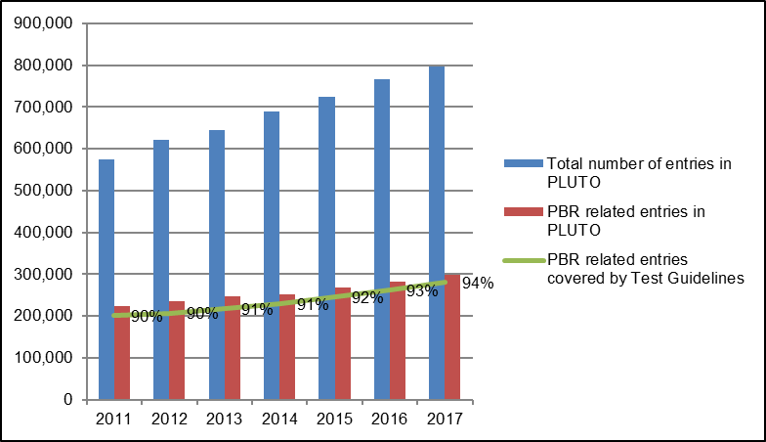

(d) Participation in the development of Test Guidelines
An overview of participation in the development of Test Guidelines by TWPs and by region of the leading expert is provided in Figures 19 to 22.

Figure 19. Total number of Test Guidelines adopted (by Technical Working Party)  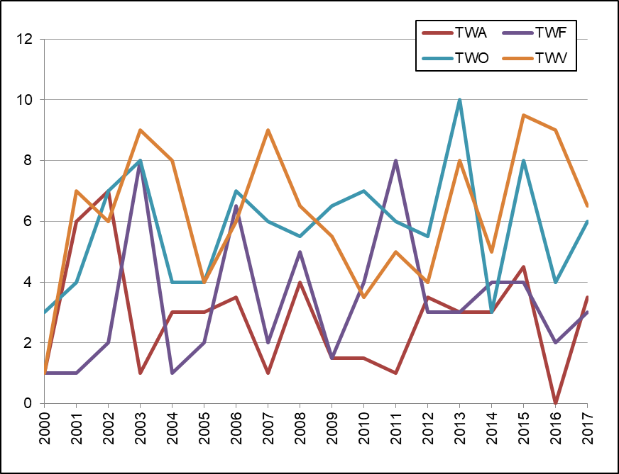 | Figure 20. Total number of Test Guidelines  under development  (by Technical Working Party)  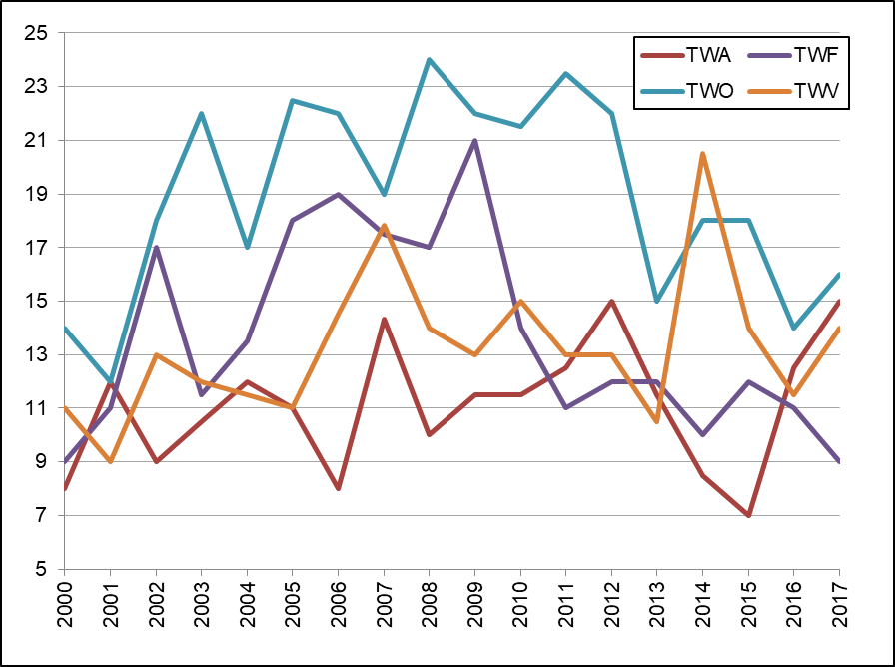
Figure 21. Total number of Test Guidelines  adopted  (by region of the leading expert)  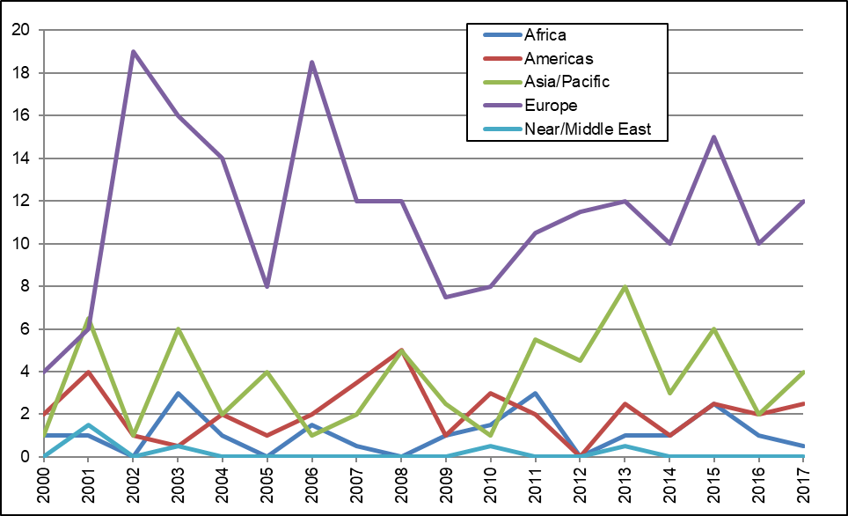 | Figure 22. Total number of Test Guidelines  under development  (by region of the leading expert)  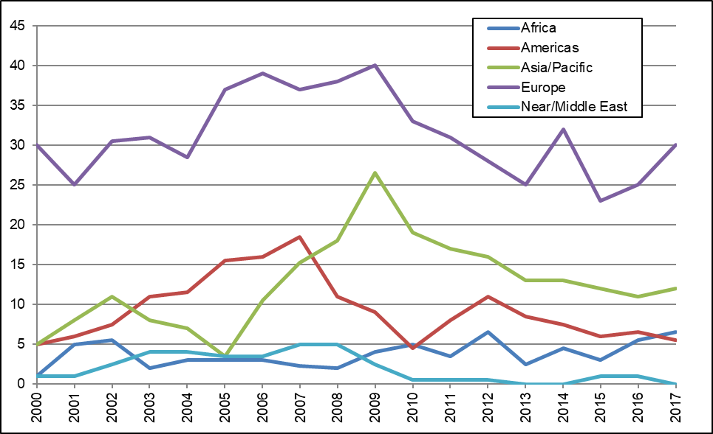

Total of 21 members of the Union involved in drafting Test Guidelines in the biennium (AR, AU, BR, CN, DE, DK, ES, FR, GB, IT, JP, KE, KR, MA, MX, NL, NZ, OM, PL, QZ, ZA).
(see Figure 23)

Figure 23. Number of members of the Union involved in drafting Test Guidelines
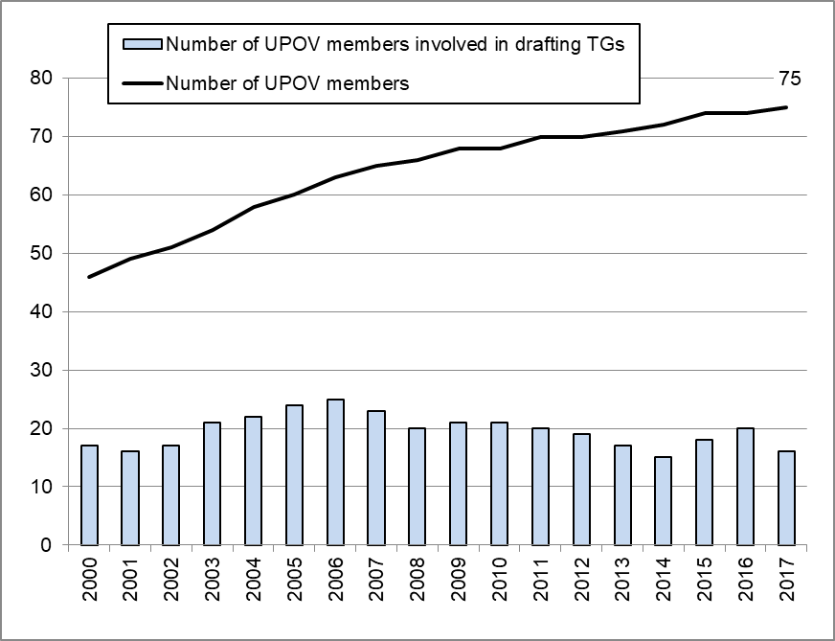

(f) Development of web-based Test Guidelines Template (TG Template) with facility for:
The web-based TG Template was used for the preparation of draft Test Guidelines for the TWPs at their sessions in 2016 and 2017.

1. Translation in UPOV languages
In 2017, a translation interface was developed to allow exporting and importing translation content in Excel format. This interface was also used to insert adopted TG characteristics and corresponding states of expression in UPOV languages and in Chinese, Georgian, Japanese, Romanian and Turkish.

The reporting tool was extended to support French, German and Spanish in order to produce TG documents in those languages.

2. Use by members of the Union in the preparation of individual authorities’ test guidelines
No developments.

4. Cooperation IN DUS examination

GENIE Database: visits to the UPOV Website in 2017

Sessions 14,861  Users 9,991  Pageviews 72,756  New Visitors 69.8%  Returning Visitors 30.2% | Language Pageviews Unique pageviews  English 50,811 28,534  Spanish 12,750 6,540  French 4,910 3,024  German 2,818 1,858  Total: 71,289 39,956

Top 10 countries visiting the GENIE database in 2017

Country / Territory | Sessions | New Users
France | 1,027 | 439
Spain | 986 | 472
Japan | 813 | 195
Germany | 796 | 571
United States of America | 691 | 491
India | 603 | 447
Mexico | 589 | 307
Switzerland | 589 | 318
Australia | 503 | 127
Turkey | 463 | 261

Evolution of visits

Year | Pageviews | Unique pageviews
2017 | 72,756 | 40,830
2016 | 76,990 | 42,886
2015 | 67,175 | 39,165
2014 | 72,018 | 40,027
2013 | 84,306 | 49,280
2012 | 85,149 | 46,122
2011 | 59,735 | 32,839
2010 | 51,457 | 28,565
2009 | 11,474 | 5,337
2008 | 14,063 | 5,763
2007 | 5,357 | 2,530

(a) Plant genera and species for which members of the Union have practical experience
On March 28, 2017, there were 3,416 genera and species (3,561 taxa including subspecies) for which members of the Union had reported practical experience in DUS examination (see document TC/53/4).
There were 3,326 genera and species in 2016 (3,461 taxa including subspecies) and 3,255 genera and species in 2015 (3,382 taxa including subspecies).
(see Figure 24)

Figure 24. Plant Genera/Species with Cooperation Agreements, Practical Experience and Plant Breeders’ Rights Entries in Plant Variety Database
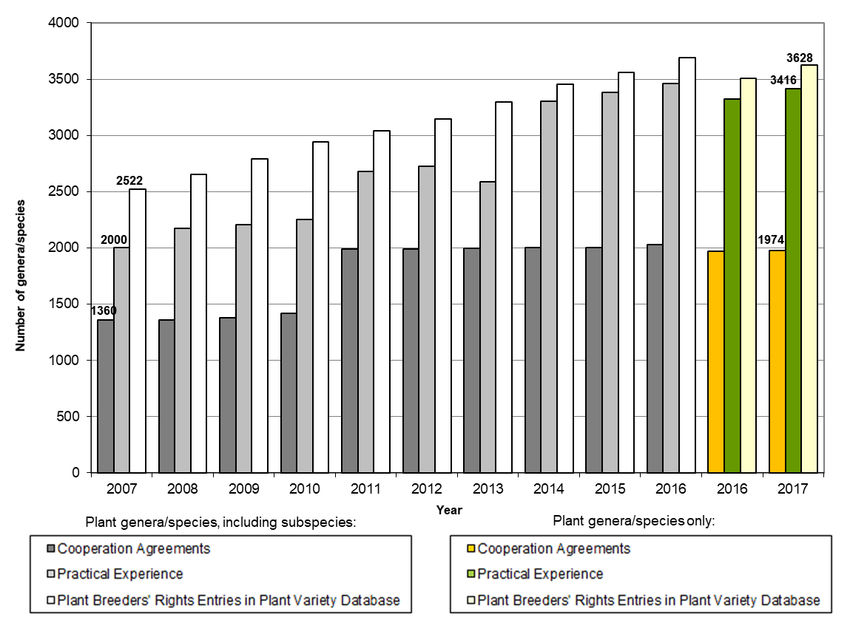

(b) Plant genera and species for which members of the Union cooperate in DUS examination, as indicated in GENIE database
On October 25, 2017, there were 1,974 genera and species (2,038 taxa including subspecies) for which there were agreements between members of the Union for cooperation in DUS examination (see document C/51/5).
There were 1,968 genera and species in 2016 (2,031 taxa including subspecies) and 2,002 taxa including subspecies in 2015.
(see Figure 18 and document C/52/5)

5. Cooperation IN examination of variety denominations

PLUTO Database: visits to the UPOV Website in 2017

Sessions 45,638  Users 15,875  Pageviews 69,457  New Visitors 67.4%  Returning Visitors 32.6% | Language Pageviews Unique pageviews  English 59,551 41,560  Spanish 5,089 3,169  French 3,529 2,525  German 1,288 854  Total: 69,457 48,108

Top 10 countries visiting the PLUTO database in 2017

Country / Territory | Sessions | New Users
United States of America | 6,340 | 1,726
France | 3,389 | 925
Netherlands | 3,352 | 651
Brazil | 2,431 | 615
Ukraine | 2,290 | 324
Australia | 2,131 | 386
Japan | 2,031 | 301
Germany | 1,863 | 625
United Kingdom | 1,455 | 299
Switzerland | 1,440 | 347

Evolution of visits

Year | Pageviews | Unique pageviews
2017 | 69,457 | 48,108
2016 | 90,630 | 63,359
2015 | 80,382 | 57,159
2014 | 74,226 | 50,203
2013 | 70,739 | 44,370
2012 | 255,108 | 51,111
2011 | 30,226 | 6,316

(a) Quantity and quality of data in PLUTO database

1. Number of contributors
- Number of contributors included in the PLUTO database at the end of 2016 and 2017:
62 in 2017 (60 in 2016; 58 in 2015; 58 in 2014)
- Number of members of the Union that contributed data in 2016 and 2017:
48 in 2017 (48 in 2016; 44 in 2015; 48 in 2014)

2. Number of new submissions
- Number of submissions of new data in 2016 and 2017:
222 in 2017 (255 in 2016; 211 in 2015; 175 in 2014)
- Number of members of the Union that contributed data for the first time in 2016 and 2017:
2 in 2017 (2 in 2016; 0 in 2015; 2 in 2014)

3. Number of records
- Total number of records included in the PLUTO database at the end of 2017:
797,669 (765,070 at the end of 2016; 723,783 at the end of 2015)

6. Facilitating applications for plant breeders’ rights

(a) Development and approval by the Council of an electronic application system for selected species and languages, enabling breeders to provide information for PBR applications for participating members of the Union, via the UPOV website
See Sub-Program UV.1, performance indicator 7 “Policy on facilitating applications through the development of an electronic application system and enhancing cooperation in the examination of varieties”, section (b)

Introduction of the UPOV PRISMA PBR Application Tool
Version 1.0 (Launched in January 2017)

 |  | Total
Crops | Soya Bean, Lettuce, Apple fruit varieties, Rose, Potato | 5
Members of the Union | Argentina, Australia, Chile, France, Kenya, Netherlands, New Zealand, Norway, Switzerland, Tunisia,  United States of America, Uruguay | 12
Languages  - Navigation languages: | English, French, German, Spanish | 4
- Output form languages: | English, French, German, Spanish, Norwegian | 5

Version 1.1 (Launched in July 2017)

 |  | Total
Crops | Soya Bean, Lettuce, Apple fruit varieties, Rose, Potato | 5
Members of the Union | Argentina, Australia, Chile, China, Colombia, France, Kenya, Netherlands, New Zealand, Norway, Republic of Moldova, Switzerland, Tunisia, Turkey, United States of America, Uruguay | 16
Languages  - Navigation languages: | English, French, German, Spanish, Chinese | 5
- Output form languages: | English, French, German, Spanish, Chinese, Norwegian, Romanian, Turkish | 8

Use of UPOV PRISMA in 2017
Number of applications received in 2017 | 14
Number of countries in which applications were submitted | 6 (AU, CH, CL, NO, NL, NZ)
Number of applicants | 4
Number of crops | 3 (apple, lettuce, potato)
Number of breeder administrators registered | 7

(b) Allocation of crop type(s) for UPOV codes and modification of the GENIE and PLUTO databases to enable statistics to be provided by crop type (agriculture, fruit, ornamentals, vegetables and forest trees)
See Sub-Program UV.1, performance indicator 6 “Review of developments concerning applications and grants of plant breeders’ rights”, section (e)

2.3 Sub-Program UV.3: Assistance in the Introduction and Implementation of the UPOV System

This sub-program covers the assistance provided in response to requests by members of the Union and potential members of the Union. Satisfying the demand for assistance in the introduction and implementation of the UPOV system within available resources relies on the use of distance-learning courses, training of trainers, the prioritization of assistance by the Office of the Union and the use of external resources for administration, training and assistance according to available finances. This sub-program is supported by the regular budget, but extra-budgetary funds and support in kind provide a substantial proportion of the resources deployed for assistance. In order to utilize the available resources in the most effective way, the Office of the Union continued to prioritize its activities and to explore synergies in its activities with members of the Union and other partners. The Training and Assistance Strategy provides the direction and the basis for overall coordination of this work.

The Office of the Union organized or participated in 199 missions/events in the 2016-2017 Biennium, at which 119 States and 15 organizations were provided with information about the UPOV system. A total of 1,240 students participated in UPOV’s distance learning courses. At the end of 2017, 16 States and 1 organization were provided with assistance in the development of PVP legislation and 3 States initiated the procedure to become a member of the Union. The UPOV distance learning courses had participants from 75 States and 5 organizations.

The priority for providing assistance by the Office of the Union is as follows:

(i) assistance to existing members of the Union;

(ii) assistance to States and certain organizations that are not members of the Union, particularly governments of developing countries and countries in transition to a market economy, in the development of legislation in line with the 1991 Act of the UPOV Convention and their accession to the UPOV Convention; and

(iii) assistance to States and certain organizations that are not members of the Union, in the implementation of legislation that has received a positive decision of the Council, according to their commitment to accede to the UPOV Convention.

Objectives

- To raise awareness of the role of plant variety protection according to the UPOV Convention.
- To assist States and organizations, particularly governments of developing countries and countries in transition to a market economy, in the development of legislation in accordance with the 1991 Act of the UPOV Convention.
- To assist States and organizations in their accession to the 1991 Act of the UPOV Convention.
- To assist States and organizations in implementing an effective plant variety protection system in accordance with the UPOV Convention.

Results Achieved: Selected Performance Indicators

1. Raising awareness of the role of plant variety protection in accordance with the UPOV Convention

(a) States and organizations provided with information at UPOV activities
States provided with information at UPOV activities:

Antigua and Barbuda, Argentina, Armenia, Australia, Austria, Bahrain, Bangladesh, Barbados, Belarus, Belgium, Belize, Benin, Bhutan, Bolivia (Plurinational State of), Bosnia and Herzegovina, Brazil, Brunei Darussalam, Burkina Faso, Cambodia, Canada, Chile, China, Colombia, Costa Rica, Côte d’Ivoire, Cuba, Cyprus, Czech Republic, Denmark, Djibouti, Dominican Republic, Ecuador, Egypt, Estonia, Ethiopia, Finland, France, Georgia, Germany, Ghana, Grenada, Guatemala, Guinea, Guinea-Bissau, Guyana, Hungary, India, Indonesia, Iran (Islamic Republic of), Iraq, Ireland, Israel, Italy, Jamaica, Japan, Kazakhstan, Kenya, Kyrgyzstan, Lao People’s Democratic Republic, Latvia, Liberia, Lithuania, Malaysia, Mali, Mauritania, Mauritius, Mexico, Montenegro, Morocco, Myanmar, Nepal, Netherlands, New Zealand, Nigeria, Norway, Oman, Panama, Paraguay, Peru, Philippines, Poland, Portugal, Republic of Korea, Republic of Moldova, Romania, Russian Federation, Rwanda, Saint Kitts and Nevis, Saint Lucia, Saint Vincent and the Grenadines, Saudi Arabia, Senegal, Serbia, Sierra Leone, Slovakia, South Africa, Spain, Sri Lanka, Sudan, Suriname, Sweden, Switzerland, Thailand, Timor-Leste, Togo, Trinidad and Tobago, Tunisia, Turkey, Uganda, Ukraine, United Arab Emirates, United Kingdom, United Republic of Tanzania, United States of America, Uruguay, Vanuatu, Viet Nam, Zambia (119 States) (see Figure 25)

Figure 25. States provided with information at UPOV activities
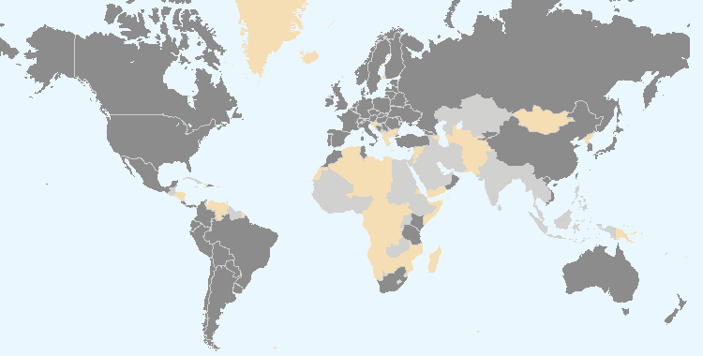
The boundaries shown on this map do not imply the expression of any opinion whatsoever on the part of UPOV concerning the legal status of any country or territory.
Members of the Union Non-members of the Union

Intergovernmental organizations provided with information at UPOV activities:

ARIPO, CPVO (European Union), OAPI, OECD, WTO

Non-governmental organizations provided with information at UPOV activities:

AIPH, APBREBES, APSA, CIMMYT, CIOPORA, CropLife International, ECVC, ESA, ISF, SAA

Location of UPOV activities:

Argentina, Barbados, Brunei Darussalam, Cambodia, Canada, China, France, Germany, Guatemala, Iran (Islamic Republic of), Italy, Japan, Kazakhstan, Kenya, Malaysia, Myanmar, Netherlands, Peru, Republic of Korea, Senegal, Switzerland, Thailand, Trinidad and Tobago, United Republic of Tanzania, Uruguay, Viet Nam
(see Figure 26)

Figure 26. Location of UPOV activities
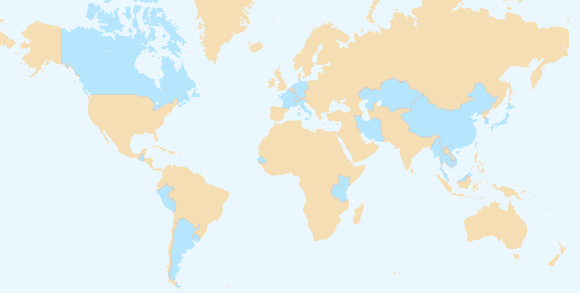
The boundaries shown on this map do not imply the expression of any opinion whatsoever on the part of UPOV concerning the legal status of any country or territory.

(b) States and organizations that contacted the Office of the Union for assistance in the development of legislation on plant variety protection
Members of the Union: Azerbaijan, Chile, Dominican Republic, Mexico, New Zealand, Switzerland, Trinidad and Tobago and Viet Nam

Non-members of the Union: ARIPO, Barbados, Cambodia, Egypt, Iran (Islamic Republic of), Guatemala, Jamaica, Kazakhstan, Lao People’s Democratic Republic, Liechtenstein, Malaysia, Mauritius, Myanmar and Nigeria

(see Figure 27)

(c) States and organizations that initiated with the Council of UPOV the procedure for becoming members of the Union
Brunei Darussalam, Guatemala and Myanmar

(see Figure 27)

Figure 27. States and organizations that contacted the Office of the Union for assistance in the development of legislation on plant variety protection and States and organizations that initiated with the Council of UPOV the procedure for becoming members of the Union
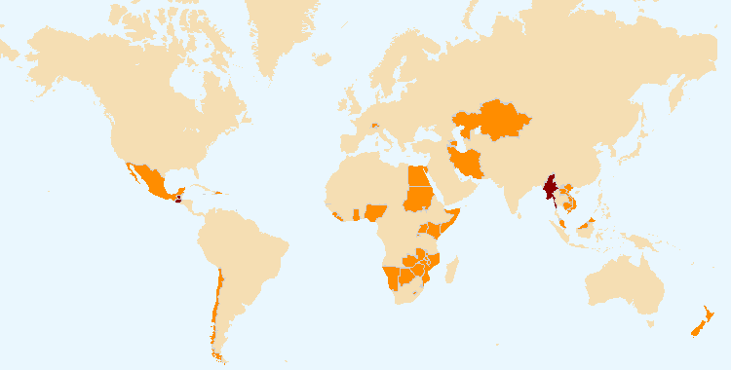
The boundaries shown on this map do not imply the expression of any opinion whatsoever on the part of UPOV concerning the legal status of any country or territory.
States and organizations that initiated with the Council of UPOV the procedure for becoming members of the Union

States and organizations that contacted the Office of the Union for assistance in the development of legislation on plant variety protection

(d) Participation in UPOV awareness-raising activities, or activities involving UPOV staff or UPOV trainers on behalf of UPOV staff
(i) Activities organized by, or with, UPOV: see (b) above

(ii) Activities/meetings in which UPOV participated: see Figure 28

Location of activities/meetings where UPOV made presentations:

Australia, Belgium, Bolivia (Plurinational State of), Cameroon, China, Côte d'Ivoire, Denmark, France, Ghana, Japan, Kenya, Morocco, Myanmar, Netherlands, Paraguay, Peru, Republic of Korea, Russian Federation, Rwanda, Serbia, Sierra Leone, Spain, Switzerland, Togo, United Kingdom, United States of America, Uruguay, Viet Nam, Zimbabwe

Figure 28. Location of activities/meetings where UPOV made presentations
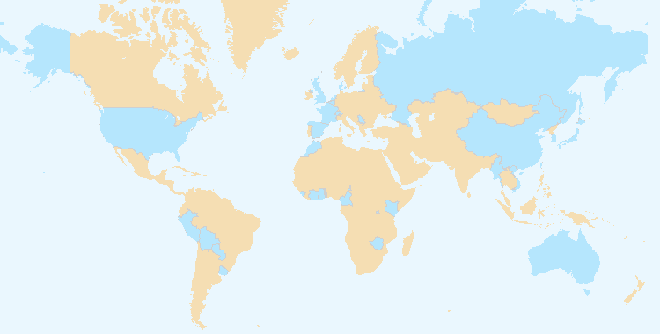
The boundaries shown on this map do not imply the expression of any opinion whatsoever on the part of UPOV concerning the legal status of any country or territory.

2. Assistance in drafting legislation on plant variety protection in accordance with the 1991 Act of the UPOV Convention

(a) States and organizations provided with comments on laws
Members of the Union: Azerbaijan, Chile, Mexico, Switzerland, Trinidad and Tobago, and Viet Nam

Non-members of the Union: ARIPO, Barbados, Cambodia, Egypt, Iran (Islamic Republic of), Jamaica, Kazakhstan, Lao People’s Democratic Republic, Liechtenstein, Malaysia, Mauritius, Myanmar and Nigeria

(see Figure 30)

(b) States and organizations which received a positive advice from the Council of UPOV
Brunei Darussalam, Guatemala and Myanmar

(see Figure 31)

(c) Meetings with government officials
Members of the Union: Chile, Dominican Republic, Mexico, New Zealand, Trinidad and Tobago, and Viet Nam

Non-members of the Union: ARIPO, Barbados, Brunei Darussalam, Cambodia, Côte d’Ivoire, Cuba, Egypt, Ghana, Guatemala, Indonesia, Iran (Islamic Republic of), Jamaica, Kazakhstan, Kuwait, Lao People’s Democratic Republic, Liechtenstein, Malaysia, Mauritius, Myanmar, Nepal, Nigeria, Saudi Arabia, Thailand, United Arab Emirates, Zambia and Zimbabwe

(see Figure 29)

Figure 29. Assistance provided in drafting legislation on plant variety protection
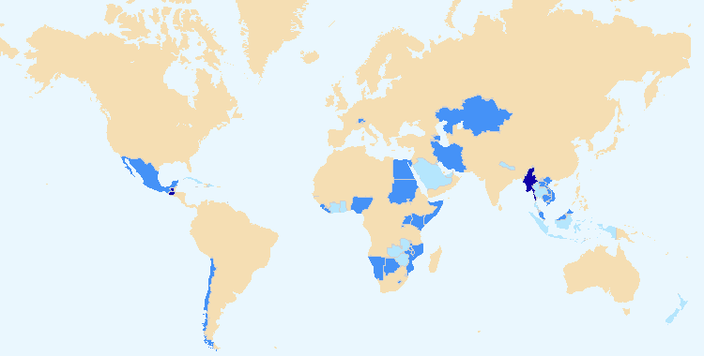
The boundaries shown on this map do not imply the expression of any opinion whatsoever on the part of UPOV concerning the legal status of any country or territory.

States and organizations which received a positive advice from the Council of UPOV
States and organizations provided with comments on laws
Meetings with government officials

3. Assistance to States and organizations in the accession to the 1991 Act of the UPOV Convention

(a) States that acceded to or ratified the 1991 Act of the UPOV Convention
Kenya, Bosnia and Herzegovina

(see Figure 33)

(b) States and organizations that became members of the Union
Bosnia and Herzegovina

(see Figure 32)

Figure 30. States/Organizations provided with  comments on laws  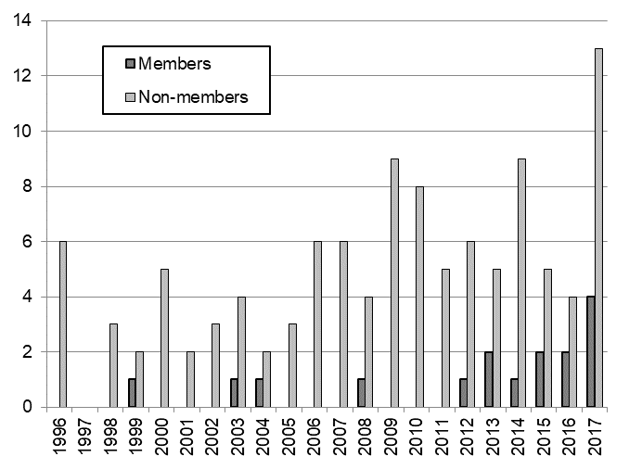 | Figure 31. States/Organizations which received  positive advice from the Council  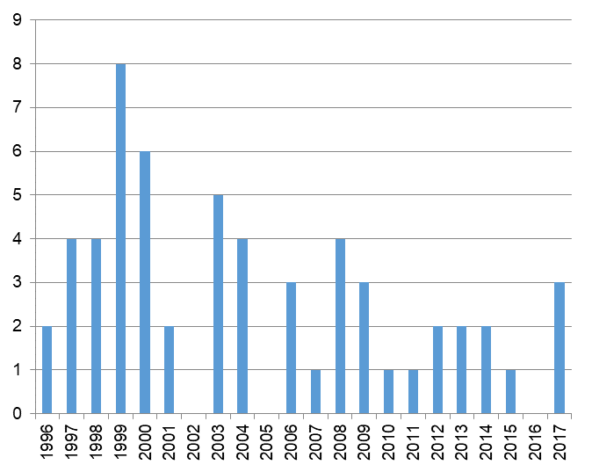

Figure 32. New members of the Union
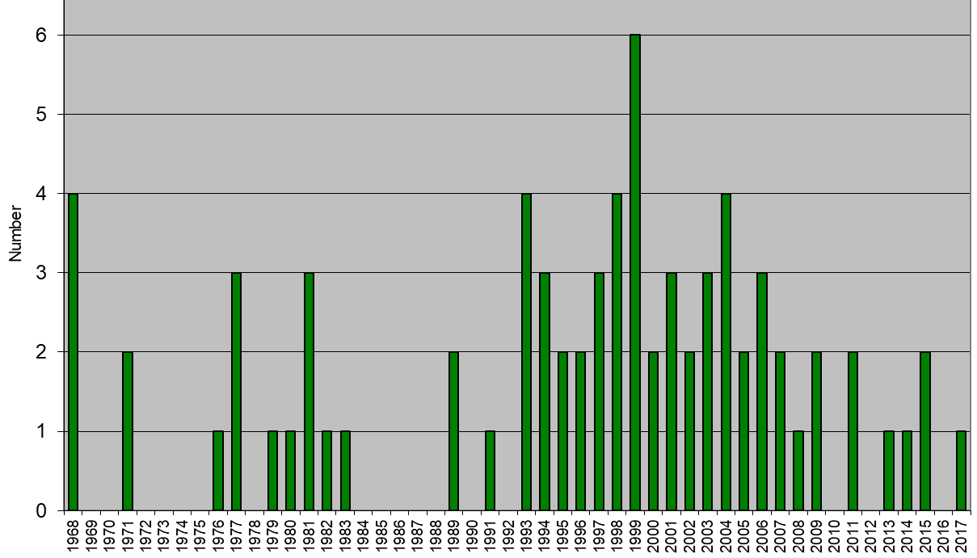

Figure 33. Accession to/ratification of the 1991 Act
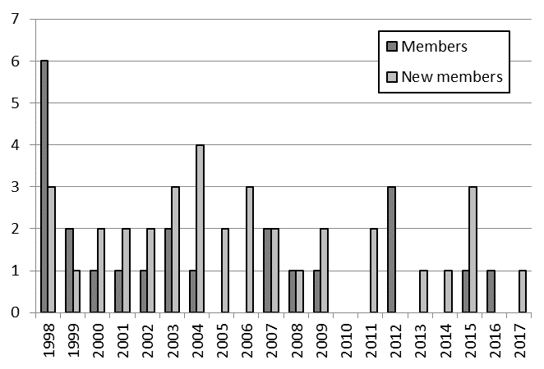

4. Assistance in implementing an effective plant variety protection system in accordance with the UPOV Convention

(a) Participation in distance learning courses
Number of participants in main sessions of UPOV distance learning courses in 2016 and 2017
by category

Category | Number of students
 | DL-205 | DL-305 | DL-305A | DL-305B | Total
Category 1: Government officials of members of the Union | 490 | 217 | 168 | 155 | 1,030
Category 2: Officials of observer States / intergovernmental organizations | 73 | 19 | 19 | 9 | 120
Category 3: Others (Fee: CHF1,000) | 22 | 4 | 1 | 1 | 28
Category 4: Discretionary waiving of fee for selected students | 14 | 39 | 4 | 5 | 62
Total: | 599 | 279 | 192 | 170 | 1,240

List of countries and organizations from which there were participants
in all distance learning sessions in 2016 and 2017

Argentina, Australia, Austria, Azerbaijan, Bangladesh, Barbados, Belarus, Belgium, Benin, Bhutan, Bolivia (Plurinational State of), Brazil, Bulgaria, Burkina Faso, Cameroon, Canada, Central African Republic, Chad, Chile, China, Colombia, Costa Rica, Côte d’Ivoire, Croatia, Cuba, Czech Republic, Denmark, Ecuador, Egypt, El Salvador, Estonia, France, Gabon, Gambia, Germany, Ghana, Greece, Guatemala, Guinea, Guyana, Hungary, India, Indonesia, Iran (Islamic Republic of), Italy, Jamaica, Japan, Jordan, Kenya, Latvia, Lebanon, Madagascar, Malawi, Malaysia, Mali, Mauritania, Mexico, Morocco, Myanmar, Nepal, Netherlands, New Zealand, Nicaragua, Niger, Nigeria, Norway, Pakistan, Panama, Paraguay, Peru, Philippines, Poland, Portugal, Republic of Korea, Republic of Moldova, Romania, Russian Federation, Rwanda, Senegal, Serbia, Slovakia, Slovenia, South Africa, Spain, Sri Lanka, Sweden, Switzerland, Togo, Trinidad and Tobago, Tunisia, Turkey, Ukraine, United Kingdom, United Republic of Tanzania, United States of America, Uzbekistan, Viet Nam, Zambia, Zimbabwe, ARIPO, CPVO (European Union), EPO, FAO, OAPI, WTO

(total: 99 countries and 6 organizations)

Figure 34. UPOV DL-205, DL-305, DL-305A and DL-305B Courses:
2016 and 2017 participation
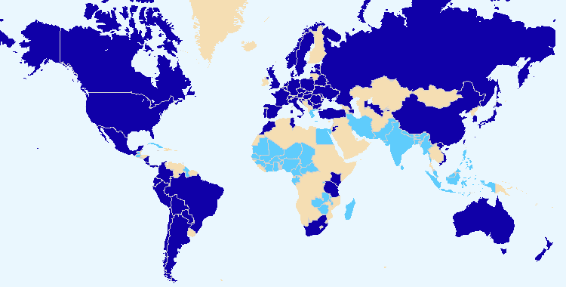
The boundaries shown on this map do not imply the expression of any opinion whatsoever on the part of UPOV concerning the legal status of any country or territory.
Members of the Union Non-members of the Union

Total number of participants by category in regular DL-205 sessions since 2006

Category | Number of students
Category 1: Government officials of members of the Union nominated by the relevant representative to the UPOV Council | 3,415
Category 2: Officials of observer States / intergovernmental organizations nominated by the relevant representative to the UPOV Council | 267
Category 3: Others | 229
Category 4: Discretionary waiving of fee for selected students | 87
Total: | 3,998

Figure 35. Participants in the main sessions of the  DL-205 Course by registration category  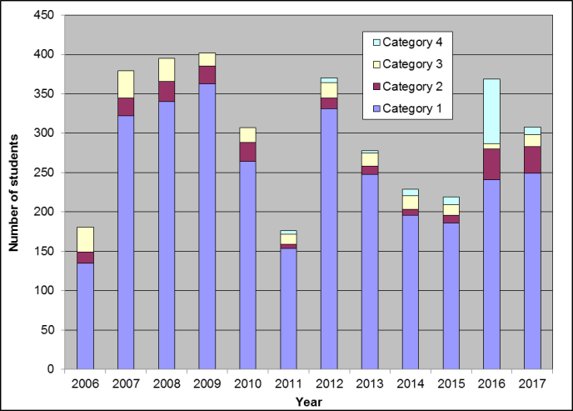 | Figure 36. Participants in the main sessions of the DL-205 Course by language  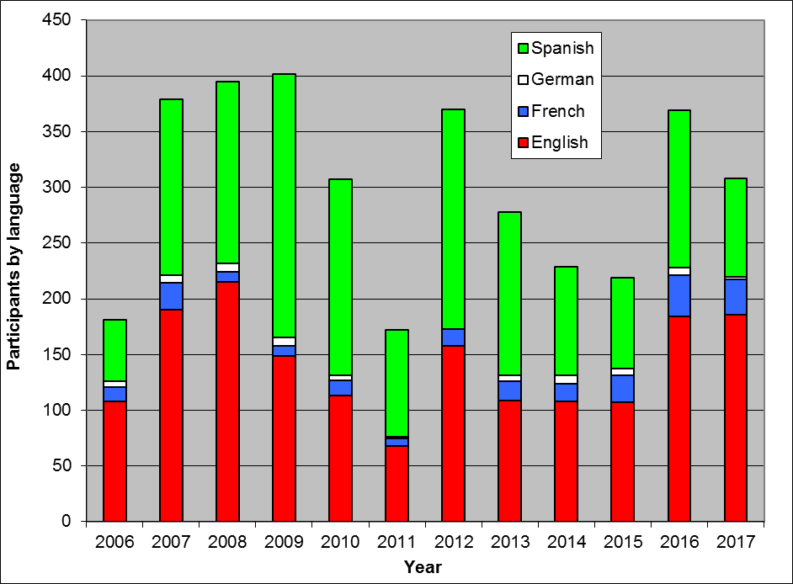

Figure 37. Participants in the main sessions of the  DL-305, 305A, 305B Courses by registration category  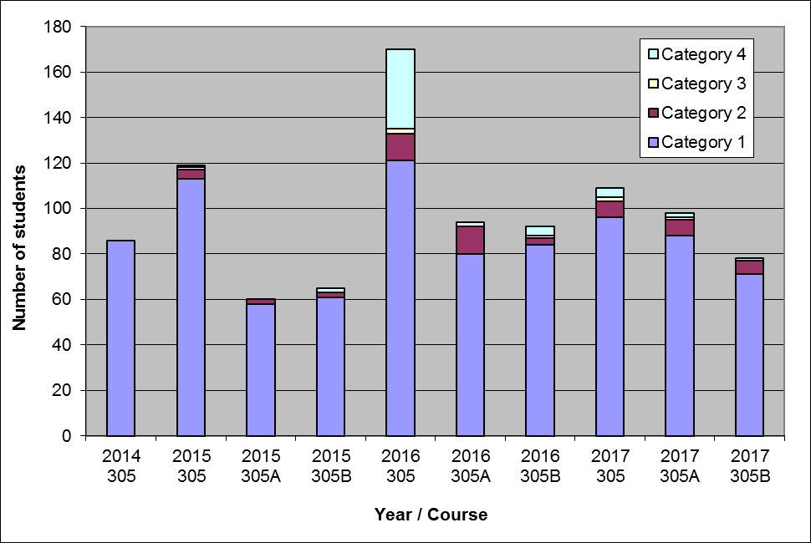 | Figure 38. Participants in the main sessions of the  DL-305, 305A, 305B Courses by language  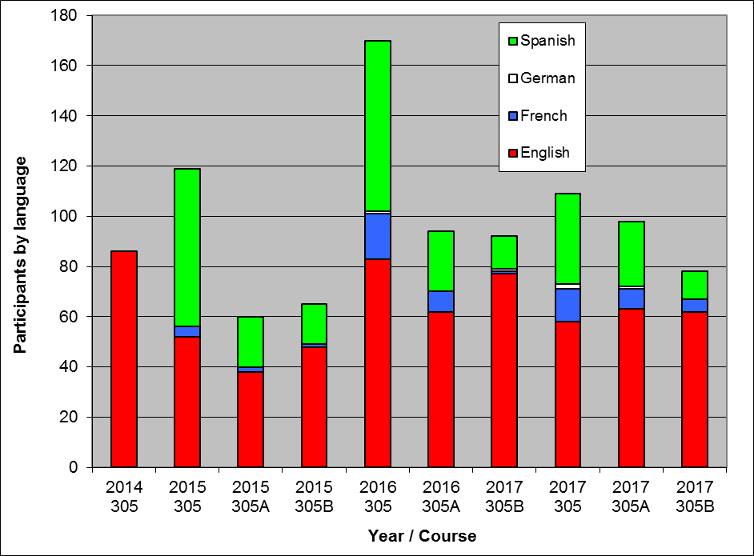

Special sessions of DL-205 in 2016 and 2017

Month/  Year | Name of Course | Language | Number of participants
May 2016 | Train the Trainer Course on Plant Variety Protection under the UPOV Convention, Geneva | EN | 11
May 2016 | OAPI Masters IP Training Course | FR | 6
June 2016 | La Salle Beauvais University - IP Plant Breeding Master Programme | EN, ES, FR | 35
June 2016 | KOICA Training Course on Plant Variety Protection (Republic of Korea) | EN | 4
June 2016 | Naktuinbouw International Course on Plant Variety Protection Course (Netherlands) | EN | 8
June 2016 | JICA Training Course on “Internationally Harmonized Plant Variety Protection System” (Japan) | EN | 11
September 2016 | Train the Trainer Course on Plant Variety Protection under the UPOV Convention, Geneva (French) | FR | 9
December 2016 | Train the Trainer Course on Plant Variety Protection under the UPOV Convention, Geneva (Spanish) | ES | 3
March-April 2017 | OAPI Masters IP Training Course | EN, ES, FR | 29
March-April 2017 | Naktuinbouw International Course on Plant Variety Protection Course (Netherlands) | EN, ES, FR | 13
April 2017 | Train the Trainer Course on Plant Variety Protection under the UPOV Convention, Geneva | EN, ES, FR | 4
May 2017 | KOICA Training Course on Plant Variety Protection | EN | 8
May 2017 | JICA Training Course on “Internationally Harmonized Plant Variety Protection System” | EN | 7
September-October 2017 | Máster Lvcentinvs in Plant Variety Protection, Alicante University, Spain | EN, ES, FR | 42
 |  | TOTAL | 195

(b) Training of trainers
- Train-the-Trainer Course on Plant Variety Protection under the UPOV Convention, Geneva, Switzerland (May 2016)
- Train-the-Trainer Course on Plant Variety Protection under the UPOV Convention (in French), Geneva, Switzerland (November 2016)
- Train-the-Trainer Course on Plant Variety Protection under the UPOV Convention, Geneva, Switzerland (May 2017)

(c) Training activities developed in conjunction with UPOV
- KEPHIS Training Workshop on plant variety protection, Nairobi, Kenya (March 2016)
- International Seminar on Plant Variety Protection under the UPOV Convention, Lima, Peru (May 2016)
- Training Course on Plant Variety Protection under the UPOV Convention and Technology Transfer, Cuzco, Peru (May 2016)
- Workshop on Essentially Derived Varieties, Shanghai, China (June 2016)
- Seminar on the Enforcement of Plant Breeders’ Rights under the UPOV Convention, Hanoi, Viet Nam (September 2016)
- UPOV-WIPO-USPTO-AECID Workshop on the benefits of the 1991 Act of the UPOV Convention for policies related to agriculture and food security, Montevideo, Uruguay (December 2016)
- DUS Training Course on Watermelon, Quang Ngai city, Viet Nam (April 2017)
- International Workshop on DNA Techniques and Variety Identification, Roelofarendsveen, Netherlands (May 2017)
- Train-the-Trainer Course on Plant Variety Protection under the UPOV Convention, Geneva, Switzerland (May 2017)
- KOICA Training Course on Plant Variety Protection, Gimcheon, Republic of Korea (May 2017)
- JICA Training Course, Tsukuba, Japan (June 2017)
- TWA/46 Preparatory Workshop, Hanover, Germany (June 2017)
- 20th International Course on Plant Variety Protection, Wageningen, Netherlands (June 2017)
- TWV/51 Preparatory Workshop, Roelofarendsveen, Netherlands (July 2017)
- Training course on Plant Variety Protection under the UPOV Convention, Lima, Peru (August 2017)
- TWO/50 Preparatory Workshop, Victoria, Canada (September 2017)
- Meeting with JICA officials and participation in JICA Training Course, Tokyo and Tsukuba, Japan (September 2017)
- TWF/48 Preparatory Workshop, Kelowna, Canada (September 2017)
- BMT/16 Preparatory Workshop, La Rochelle, France (November 2017)
- TWC/35 Preparatory Workshop, Buenos Aires, Argentina (November 2017)
- Workshop on drafting legislation in accordance with the 1991 Act of the UPOV Convention, Geneva, Switzerland (December 2017)

(d) Participation by observer States and organizations in the CAJ, TC, TWPs and the associated preparatory workshops
See Sub-Program UV.2, Section 1 “Participation by members of the Union and observers in the work of the UPOV bodies”, sub-sections (a) to (d)

(e) Participation in UPOV activities
- Seminar on propagating and harvested material in the context of the UPOV Convention, Geneva, Switzerland (October 2016)
- Maximizing benefits for farmers through the 1991 Act of the UPOV Convention, Geneva, Switzerland (December 2017)

(f) Participation in activities involving UPOV staff or UPOV trainers on behalf of UPOV staff
- Expert Review Meeting for the Finalization of the Draft Regulations of the Arusha Protocol, Harare, Zimbabwe (June 2016)
- Meeting with officials from the Seed Management Bureau, Ministry of Agriculture and from the State Forestry Administration, Beijing, China (June 2016)
- Experience-sharing roundtable on feasibility of China’s accession to UPOV’ 91, Brussels, Belgium (July 2016)
- Training Course for DUS Test of Corn, Vung Tau, Viet Nam (August 2016)
- TAIEX Workshop on importance and value of plant breeders' rights for farmers and growers, Belgrade, Serbia (October 2016)
- Seminar on Protection of New Varieties of Plants and Celebration of the twentieth Anniversary of China’s PVP Regulations, Beijing, China (April 2017)
- IP Key Roundtable Seminar entitled “Impact Study of UPOV’91 on the Protection of New Varieties of Agricultural and Forestry Plants in China”, Beijing, China (April 2017)
- International Workshop on DNA Techniques and Variety Identification, Roelofarendsveen, Netherlands (May 2017)
- Training course on Plant Variety Protection under the UPOV Convention, Lima, Peru (August 2017)
- Seminar on UPOV Membership and PBR system in the United Republic of Tanzania, Arusha, United Republic of Tanzania (August 2017)
- Visit of a Mexican delegation to the Netherlands - Practice in the Netherlands with Plant Breeders’ Rights under the UPOV 91 Convention, The Hague, Netherlands (August 2017)
- International Workshop on DNA Techniques and Variety Identification, Roelofarendsveen, Netherlands (September 2017)
- OAPI National Seminar on Awareness raising on PVP within the OAPI region, Dakar, Senegal (September 2017)
- KSVS/KSHS International Symposium on Plant Variety Protection, Incheon, Republic of Korea (October 2017)
- International Seminar on Agricultural IP Rights, Beijing, China (November 2017)

(g) Academic courses featuring the UPOV system of plant variety protection
- WIPO-WTO Advanced Course on Intellectual Property for Government Officials, Geneva, Switzerland (March 2016)
- UPOV lecture at Institut Polytechnique LaSalle, Beauvais, France (April 2016)
- OAPI Programme Master II en Propriété Intellectuelle, Yaoundé, Cameroon (May 2016)
- WIPO-WTO Colloquium for Teachers of Intellectual Property, Geneva, Switzerland (June 2016)
- WIPO-UNIGE Summer School on Intellectual Property, Geneva, Switzerland (July 2016)
- Master of IP Law, Queensland University of Technology, Brisbane, Australia (July 2016)
- Master of Laws (LL.M.) in Intellectual Property (WIPO/University of Turin/ITC-ILO), Geneva, Switzerland (October 2016)
- UPOV lecture at Institut Polytechnique LaSalle, Beauvais, France (October 2016)
- III Plant Variety Rights Intensive Module on Plant Variety Protection, Master of Intellectual Property (Magister Lvcentinvs) of the University of Alicante, Alicante, Spain (November 2016)
- WIPO-WTO Advanced Course on Intellectual Property for Government Officials, Geneva, Switzerland (March 2017)
- OAPI/WIPO IP Masters Program II, Yaoundé, Cameroon (May 2017)
- WIPO-WTO Colloquium for Teachers of Intellectual Property, Geneva, Switzerland (June 2017)
- WIPO-UNIGE Summer School on Intellectual Property, Geneva, Switzerland (June 2017)
- UPOV speaker at Master of IP Law, Queensland University of Technology, Brisbane, Australia (July 2017)
- WIPO/Tongji University Master Degree Program in Intellectual Property Law (MIP) with Specialization in Design, Shanghai, China (October 2017)
- Master of Laws (LL.M.) in Intellectual Property (WIPO/University of Turin/ITC-ILO), Geneva, Switzerland (October 2017)
- IV Plant Variety Rights Intensive Module on Plant Variety Protection, Master of Intellectual Property (Magister Lvcentinvs) of the University of Alicante, Spain (November 2017)

(f) Implementation of projects with partner organizations and donors
World Seed Partnership:
- In 2016: 8 electronic meetings, 2 face-to-face meetings of the Steering Committee
- In 2017: 7 electronic meetings, 1 face-to-face meeting of the Steering Committee

2.4 Sub-Program UV.4: External Relations

UPOV’s mission is to provide and promote an effective system of plant variety protection, with the aim of encouraging the development of new varieties of plants, for the benefit of society. The aim of this Sub-program is to explain how the UPOV system encourages the development of new varieties of plants, how new varieties benefit society and the role of the UPOV system in relation to agriculture and economic policy.

Notable developments in the 2016-2017 Biennium included the launch of the UPOV YouTube channel, the introduction of stakeholder features on the UPOV website, the adoption of an FAQ on how the UPOV system of plant variety protection contributes to the United Nations Sustainable Development Goals (SDGs) and the publication on the UPOV website of the following material: “The socio-economic benefits of UPOV membership in Viet Nam; An ex post assessment on plant breeding and agricultural productivity after 10 years” (Corresponding author: Steffen Noleppa) by HFFA Research GmbH”; a video on PVP in Ecuador “The role of PVP in the development of a new blackberry variety that improves farmers’ working conditions”; a video on PVP in Uruguay “How PVP enabled a public breeder to ensure a supply of high quality onion seed to farmers”; and a video on “Using the UPOV system to benefit custodians of native wild germplasm in Argentina”.

Objectives | - To broaden and enhance the understanding of the UPOV system of plant variety protection.  - To provide information on the UPOV Convention to other intergovernmental organizations, with the aim of achieving mutual supportiveness with other international treaties.

Results Achieved: Selected Performance Indicators

1. Broaden public understanding of UPOV’s role and activities

(a) Availability of suitable information and materials for the general public, on UPOV website and through other media
- Introduction of the stakeholder features on the UPOV website
(see Sub-Program UV.4, performance indicator 2 “Enhance understanding of UPOV’s role and activities for stakeholders”, section (c))
- Launch of the UPOV YouTube Channel, on November 8, 2016
- Video on PVP in Ecuador “The role of PVP in the development of a new blackberry variety that improves farmers’ working conditions”
- Video on PVP in Uruguay “How PVP enabled a public breeder to ensure a supply of high quality onion seed to farmers”
- Video on “Using the UPOV system to benefit custodians of native wild germplasm in Argentina”
- FAQ concerning information on the situation in UPOV with regard to the use of molecular techniques for a wider audience, including the public in general: “Does UPOV allow molecular techniques (DNA profiles) in the examination of Distinctness, Uniformity and Stability (‘DUS’)?”
- FAQ on how the UPOV system of plant variety protection contributes to the United Nations Sustainable Development Goals (SDGs)
- Publication on the UPOV website of “The socio-economic benefits of UPOV membership in Viet Nam; An ex post assessment on plant breeding and agricultural productivity after 10 years” (Corresponding author: Steffen Noleppa) by HFFA Research GmbH”
- Updated editions of the information leaflet “What it is, What it does” on UPOV and plant variety protection in English, French, German and Spanish (Publication No. 437)
- 9 press releases

(b) Visits to UPOV website
 | 2017 | 2016 | 2015 | 2014 | 2013 | 2012
Number of sessions: | 177,469 | 200,539 | 191,534 | 187,125 | 178,732 | 151,914
Unique users: | 84,393 | 88,906 | 86,366 | 86,291 | 84,336 | 71,506
Number of pageviews: | 857,442 | 1,153,307 | 1,087,382 | 1,127,786 | 1,129,052 | 1,139,570
Number of pages/visit: | 4.83 | 5.75 | 5.68 | 6.03 | 6.32 | 7.50
Average visit duration: | 00:04:30 | 00:05:13 | 00:05:15 | 00:06:00 | 00:06:35 | 00:07:19
Percentage of new visits: | 79.4% | 42.70% | 43.21% | 44.19% | 54.6% | 45.05%

Website Overview: Global Coverage in 2017  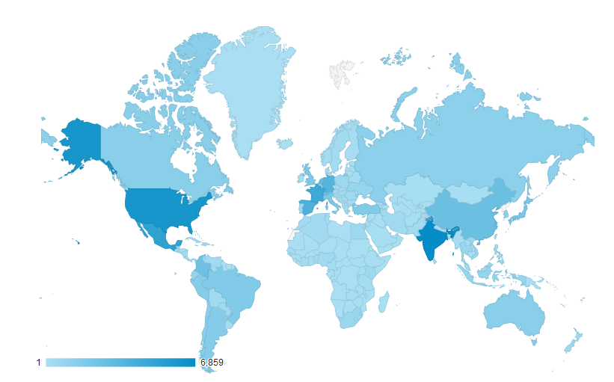 | Sessions by country:  1. United States of America (7.30%)  2. France (6.16%)  3. India (5.11%)  4. Mexico (4.88%)  5. Japan (4.71%)  6. Netherlands (4.42%)  7. Spain (4.05%)  8. Germany (3.99%)  9. Switzerland (3.29%)  10. China (2.87%)

Language of  visitor’s browser | 2017 |  | 2016 |  | 2015 |  | 2014 |  | 2013
 | Sessions | % | Sessions | % | Sessions | % | Sessions | % | Sessions | %
- en-us | 48,128 | 27.12 | 60,689 | 42.11 | 66,347 | 39.58 | 72,248 | 38.61 | 70,706 | 39.56
- es | 16,708 | 11.64 | 18,164 | 58.21 | 17,765 | 59.03 | 18,154 | 9.70 | 18,669 | 10.45
- en-gb | 10,062 | 5.78 | 8,639 | 45.87 | 6,743 | 3.52 | 4,508 | 2.41 | 3,028 | 1.69
- fr | 9,471 | 5.34
- ru | 6,768 | 3.81 | 7,292 | 19.83 | 6,608 | 3.45 | 6,824 | 3.65 | 6,596 | 3.69
- ja-jp | 6,545 | 3.69 | 6,915 | 24.09 | 5,277 | 2.76 | 5,729 | 3.06 | 6,444 | 3.61
- es-419 | 6,542 | 3.69 | 5,605 | 57.38
- es-es | 6,091 | 3.43 | 7,273 | 49.06 | 7,972 | 4.16 | 9,180 | 4.91 | 9,234 | 5.17
- zh-cn | 5,349 | 3.01
- fr-fr | 5,185 | 2.92 | 5,502 | 42.31

1. en-us: American English; 2. es: Spanish; 3. en-gb: British English; 4. fr: French 5. ru: Russian; 6. ja-jp: Japanese (Japan);
7. es-419: Spanish (Latin America and the Caribbean); 8. es-es: Castilian Spanish; 9. zh-cn: Chineses; 10. fr-fr (France);

Website Overview for 2017: Where are the users going?

Number of sessions and users of the UPOV site since 2007

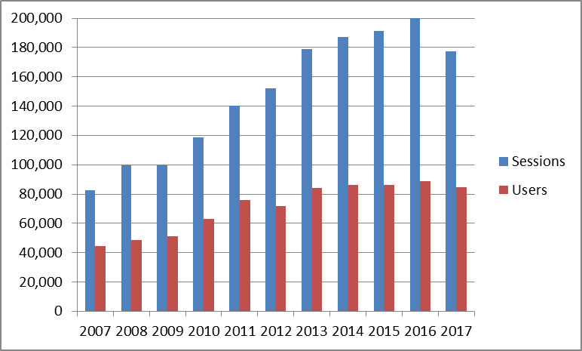

Summary of most popular website features for the past five years (Pageviews)

 | 2017 | 2016 | 2015 | 2014 | 2013
UPOV LEX | 82,861 | 85,374 | 80,382 | 88,305 | 88,533
GENIE | 72,756 | 76,990 | 67,175 | 72,018 | 84,306
PLUTO | 69,457 | 90,630 | 80,283 | 74,226 | 70,739
Test Guidelines | 66,567 | 61,966 | 64,425 | 67,900 | 68,479

Devices used to consult the UPOV Website between 2015 and 2017 (sessions)

 | 2017 | 2016 | 2015
Desktop | 155,520 (88%) | 178,284 (89%) | 175,755 (92%)
Mobile | 18,499 (10%) | 17,971 (9%) | 11,645 (6%)
Tablet | 3,450 (2%) | 3,848 (2%) | 4,134 (2%)

2. Enhance understanding of UPOV’s role and activities for stakeholders

(a) Availability of suitable information and materials for breeders, seed producers / plant propagators, farmers, processors/wholesalers/retailers and policy-makers, on UPOV website and through other media
See Sub-Program UV.4, performance indicator “1. Broaden public understanding of UPOV’s role and activities”, section (a)

(b) Articles in relevant publications to which UPOV has contributed
- Contribution by the UPOV Office to ICARDA’s Newsletter “Seed Info”, Issue No 52 of January 2017 (see https://apps.icarda.org/wsInternet/wsInternet.asmx/DownloadFileToLocal?filePath=Tools_and_guidelines/SeedInfo_52.pdf&fileName=SeedInfo_52.pdf)
- Contribution by the UPOV Office to ICARDA’s Newsletter “Seed Info”, Issue No 53 of July 2017 (see http://www.icarda.org/sites/default/files/Seed_Info_53.pdf)
- Interview during the SAA Sixth Seed Congress of the Americas, from September 5 to 7, 2017, in Cartagena de Indias, Colombia, for Seed World online magazine. The video is available on the following link: http://seedworld.com/leontino-rezede-taveira-upov-farmers-benefit-variety-protection-facilitating-breeders/
- Interview during ASTA Annual Meeting, held in Chicago, United States of America, from December 4 to 8, 2017. The video is available on the following link:
http://seedworld.com/ben-rivoire-upov-world-seed-partnership-pbr-application-tool-75-countries-growing/
- Contribution by the UPOV Office to “Chapter 11: Plant Varieties: The International Convention for the Protection of New Varieties of Plants (1991 Act)” to the book by WIPO “Introduction to Intellectual Property: Theory and Practice”, Wolters Kluwer, Second Edition, 2017, 624 pages ISBN: 978-90-411-6093-5

(c) Stakeholder-focused features on the UPOV website
Redesigned UPOV website with the following stakeholder features:

- Breeders
- Farmers
- Policy-makers
- General public

Visits to the stakeholder-focused features on the UPOV Website in 2017
Language | Pageviews | Unique pageviews
English | 1,546 | 1,199
Spanish | 796 | 580
French | 372 | 284
German | 99 | 66

2,813 pageviews (0.33% of total pageviews on UPOV website (857,442 pageviews))

(d) Participation by stakeholders in seminars and symposia
- Seminar on Propagating and Harvested Material in the Context of the UPOV Convention, October 24, 2016
(101 participants)
- Symposium on Possible Interrelations between the International Treaty on Plant Genetic Resources for Food and Agriculture (ITPGRFA) and the International Convention for the Protection of New Varieties of Plants (UPOV Convention), October 26, 2016
(119 participants)

(e) Participation at meetings of, and with, relevant stakeholders
- AFSTA, AOHE, APSA, ASTA, CIOPORA, CORAF/WECARD, DanSeed, EIPIN, ESA, IPAN, ISF, SAA, USDA and WFO.

3. Enhance understanding of UPOV’s role and activities with other organizations

(a) Participation at meetings of, and with, relevant organizations
- APEC-IPEG, ARIPO, CGRFA, European Union (CPVO), EPO, FAO, ISTA, ITPGRFA, OAPI, OECD, United Nations, WIPO and WTO.

3. FINANCIAL PERFORMANCE

This section provides an overview of financial performance of the Office of the Union on a budgetary basis, using the “actual” figures as stated in the Program and Budget documents for relevant biennia (e.g. document C/51/4 Rev. provides the actual figures on a budgetary basis for 2014-2015). Further detailed information and the number of posts are provided in documents C/52/4 “Financial Management Report for the 2016-2017 Biennium” and C/52/12 “Financial Statements for 2017”.

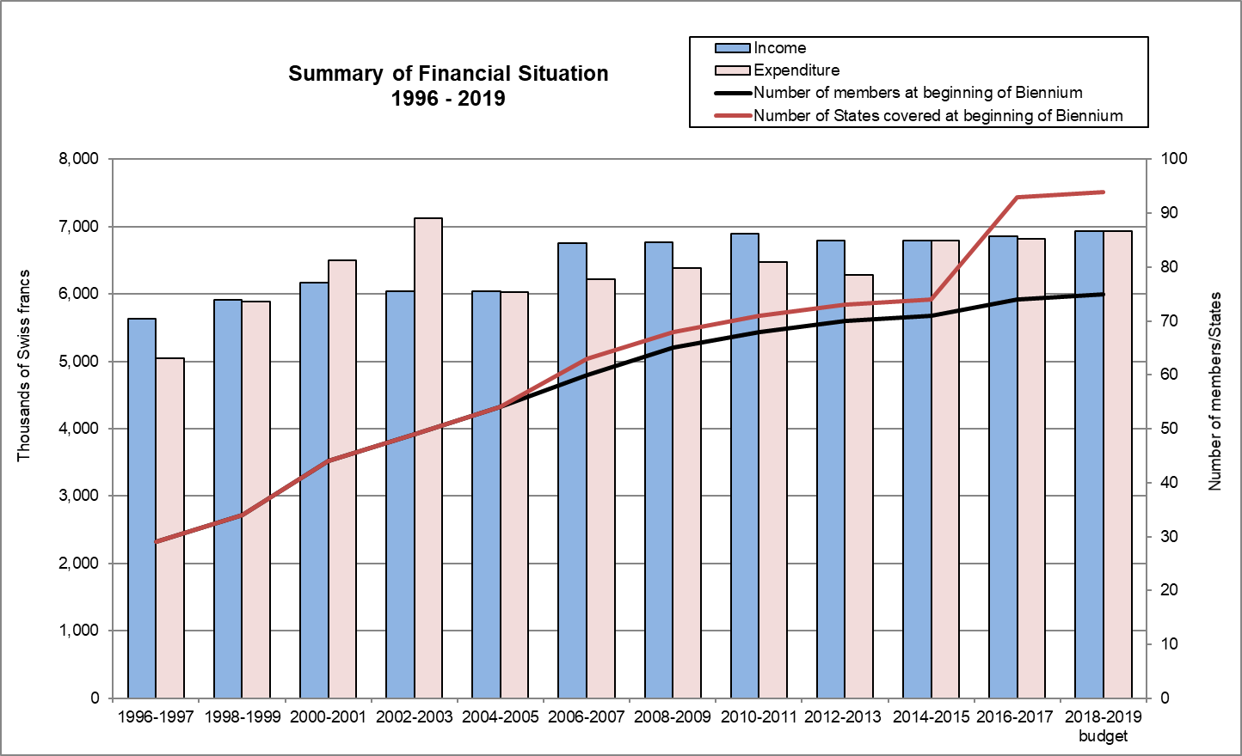

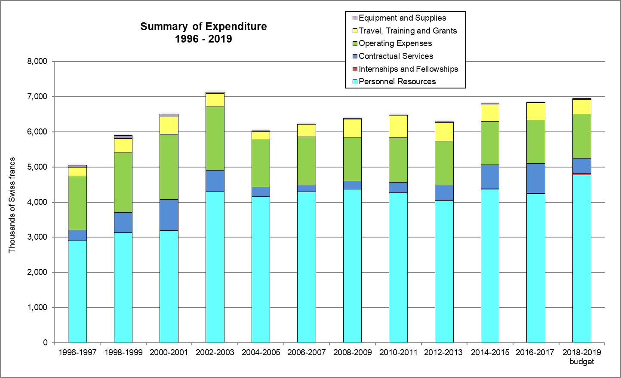

The following table and graph summarizes, at the end of each biennium, the evolution of posts of the Office of the Union.

Post Category | 2000-2001 | 2002-2003 | 2004-2005 | 2006-2007 | 2008-2009 | 2010-2011 | 2012-2013 | 2014-2015 | 2016-2017
Directors* | 4 | 3 | 3 | 3 | 3 | 3 | 2 | 2 | 3
Professionals | 4 | 6 | 4 | 4 | 3 | 3 | 4 | 4 | 3
General Service | 6 | 5 | 4 | 4 | 5 | 5 | 5 | 5 | 5
Total | 14 | 14 | 11 | 11 | 11 | 11 | 11 | 11 | 11

* The posts of the Secretary-General and Vice Secretary-General are included in this count.

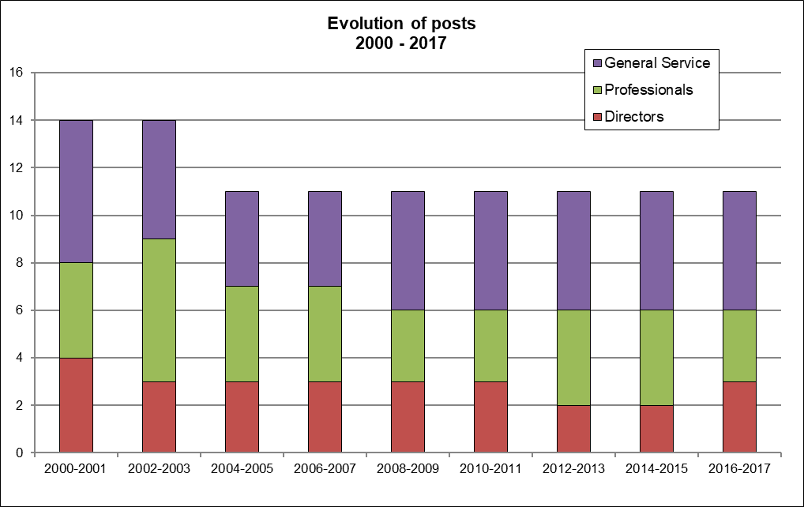

[Appendix follows]

C/52/16

APPENDIX

ACRONYMS AND ABBREVIATIONS

UPOV terms

BMT | Working Group on Biochemical and Molecular Techniques, and DNA-Profiling in Particular
CAJ | Administrative and Legal Committee
DL-205 | UPOV distance learning course “Introduction to the UPOV System of Plant Variety Protection under the UPOV Convention”
DL-305 | UPOV distance learning course “Examination of Applications for Plant Breeders’ Rights”
DL-305A | UPOV distance learning course “Administration of Plant Breeders’ Rights”  (part A of DL-305)
DL-305B | UPOV distance learning course “DUS Examination”  (part B of DL-305)
DUS | Distinctness, Uniformity and Stability
EAF (see also UPOV PRISMA) | UPOV Electronic Application Form
EDV | essentially derived variety
Office | Office of the Union
PBR | Plant Breeder’s Right
TC | Technical Committee
TC-EDC | Enlarged Editorial Committee
TWA | Technical Working Party for Agricultural Crops
TWC | Technical Working Party on Automation and Computer Programs
TWF | Technical Working Party for Fruit Crops
TWO | Technical Working Party for Ornamental Plants and Forest Trees
TWP(s) | Technical Working Party(ies)
TWV | Technical Working Party for Vegetables
UPOV PRISMA | UPOV PRISMA PBR Application Tool
WG-DEN | Working Group on Variety Denominations
WG-ISC | Working Group on a Possible International System of Cooperation
WSP | World Seed Partnership

Acronyms

AFSTA | African Seed Trade Association
AECID | Spanish Agency for Cooperation and Economic Development
AOHE | Association of European Horticultural Breeders
APBREBES | Association for Plant Breeding for the Benefit of Society
APEC | Asia Pacific Economic Cooperation
APEC-IPEG | Intellectual Property Rights Experts Group of the Asia-Pacific Economic Cooperation
APSA | Asia and Pacific Seed Association
ARIPO | African Regional Intellectual Property Organization
CGRFA | Commission on Genetic Resources for Food and Agriculture
CIMMYT | International Consortium for the Improvement of Maize
CIOPORA | International Community of Breeders of Asexually Reproduced Ornamental and Fruit Varieties
CORAF (see also WECARD) | Conseil Ouest et Centre Africain pour la Recherche et le Développement Agricoles
CPVO | Community Plant Variety Office of the European Union
DanSeed | Danish Centre for Seed Science and Technology
EIPIN | European Intellectual Property Institutes Network
EPO | European Patent Office
ESA | European Seed Association
FAO | Food and Agriculture Organization of the United Nations
ICARDA | International Center for Agricultural Research in the Dry Areas
IP Key | IP Key is co-financed by the European Union and the European Intellectual Property Office (EUIPO). It is implemented by EUIPO in cooperation with EPO.
IPAN | Intellectual Property Awareness Network
ISF | International Seed Federation
ISTA | International Seed Testing Association
ITC | International Trade Center
ITC-ILO | International Training Centre of the International Labour Organization
ITPGRFA | International Treaty on Plant Genetic Resources for Food and Agriculture
JICA | Japan International Cooperation Agency
KEPHIS | Kenya Plant Health Inspectorate Service
KOICA | Korea International Cooperation Agency
KSHS | Korean Society for Horticultural Science
KSVS | Korea Seed and Variety Service
Naktuinbouw | The Netherlands Inspection Service for Horticulture
OAPI | African Intellectual Property Organization
OECD | Organisation for Economic Co-Operation and Development
SAA | Seed Association of the Americas
TAIEX | Technical Assistance and Information Exchange Instrument (TAIEX) of the European Union
UNIGE | University of Geneva
USDA | United States Department of Agriculture
USPTO | United States Patent and Trademark Office
WECARD (see also CORAF) | West and Central African Council for Agricultural Research and Development
WFO | World Farmers’ Organization
WIPO | World Intellectual Property Organization
WTO | World Trade Organization

* Participation is assessed on the basis of the number of participating members and observer States/organization, rather than the number of individual participants.
Provision of detailed comments on laws and/or assistance in the development of laws.
Meetings and/or consultations for the provision of advice and information on legislative matters.
The methodology in google analytics for calculating the exclusion of internal traffic & ‘bots’ changed in January 2017. The new methodology was used to produce the website statistics for 2017.
Definitions used in Website statistics in this report: - “Users” are individuals who have had at least one session within the selected date range. - A “session” is the period of time a user is actively engaged with your website. “Sessions” are the total number of sessions within the given date range. - “Unique Pageviews” are the number of visits during which the specified page was viewed at least once. - “Pageviews” are the total number of times that a page was viewed. Repeated views of a single page by the same user during the same session are counted [End of appendix and of document]

