E
International Union for the Protection of New Varieties of Plants

Council  Fifty-First Ordinary Session  Geneva, October 26, 2017 | C/51/19 Rev.  Original: English  Date: October 26, 2017
REVISED draft Press release
prepared by the Office of the Union
Disclaimer: this document does not represent UPOV policies or guidance
The Annex to this document contains a draft press release on the fifty-first ordinary session of the Council.

2. The Council is invited to consider the draft press release, contained in the Annex to this document, subject to developments in the Council.

[Annex follows]

C/51/19 Rev.

ANNEX

UPOV Press Release 112

Geneva, October 26, 2017

UPOV Council Holds its Fifty-First Ordinary Session

The Council of the International Union for the Protection of New Varieties of Plants (UPOV) held
its fifty-first ordinary session on October 26, 2017.

Round-up of key developments:

Bosnia and Herzegovina - 75th UPOV member

The Council welcomed Bosnia and Herzegovina as the 75th member of UPOV. Bosnia and Herzegovina deposited its instrument of accession to the 1991 Act of the UPOV Convention on October 10, 2017, and will become bound by the 1991 Act on November 10, 2017. The UPOV Convention now covers 94 States.

FAQ on the United Nations Sustainable Development Goals (SDGs)

The Council adopted an FAQ on how the UPOV system of plant variety protection contributes to the United Nations Sustainable Development Goals (SDGs), a copy of which is attached as an Annex to this press release.
./.

Interrelations with the International Treaty on Plant Genetic Resources for Food and Agriculture (ITPGRFA)

The Council agreed the following actions concerning interrelations with the ITPGRFA:

(i) to review the FAQ on the interrelations between the UPOV Convention and the ITPGRFA (see http://www.upov.int/about/en/faq.html#QR10); and

(ii) exchange of experience and information on the implementation of the UPOV Convention and the ITPGRFA, with the involvement of stakeholders.

Program and Budget

The Council approved the Program and Budget for the 2018-2019 Biennium, including the maximum ceiling of expenditure in the regular budget of 6,940,000 Swiss francs compared to the 2016­2017 budget of 6,823,000 Swiss francs (1.7% increase) and an increase in the number of staff posts from 11 to 12.

Russian language

The Council agreed a program for use of the Russian language in UPOV, including a full resourcing plan. The program includes:

- provision of interpretation services in the Russian language at UPOV sessions in Geneva, to be financed by an increase in the number of units of contribution by the Russian Federation;
- translation of key UPOV materials into Russian (e.g. key documents in the UPOV Collection, UPOV Distance Learning Courses and standard UPOV presentation materials);
- Russian-speaking professional at the Office of the Union, financially supported by the Russian Federation;
- participation by Russian-speaking members of the Union in the UPOV PBR Application Tool (Electronic Application Form) (see http://www.upov.int/upoveaf/en/index.html) and introduction of Russian as a navigation language; and
- development of a training center hosted by a relevant institute in the Russian Federation, to be funded by interested members of the Union.

Examination of Laws

Positive decision on the Law of Brunei Darussalam

The Council took a positive decision on the conformity of the “Plant Varieties Protection Order” (Law) of Brunei Darussalam with the provisions of the 1991 Act of the UPOV Convention, which allows Brunei Darussalam to deposit its instrument of accession to the 1991 Act.

Positive decision on the Draft Law of Guatemala

The Council took a positive decision on the conformity of the “Draft Law for the Protection of New Varieties of Plants” (“Draft Law”) of Guatemala with the provisions of the 1991 Act of the UPOV Convention, which allows Guatemala once the Draft Law is adopted with no changes and the Law is in force, to deposit its instrument of accession to the 1991 Act.

Positive decision on the Draft Law of Myanmar

The Council took a positive decision on the conformity of the “Draft Law on New Plant Variety Protection” (“Draft Law”) of Myanmar with the provisions of the 1991 Act of the UPOV Convention, which allows Myanmar once the Draft Law is adopted with no changes and the Law is in force, to deposit its instrument of accession to the 1991 Act

Extension of the appointment of the Vice Secretary-General

The Council extended the appointment of the Vice Secretary-General from December 1, 2018, until November 30, 2021.

Election of the new Chairpersons

The Council elected, in each case for a term of three years ending with the fifty-fourth ordinary session of the Council, in 2020:

(a) Ms. Cheryl Turnbull (United Kingdom)
Chairperson of the Technical Working Party for Agricultural Crops (TWA)

(b) Mr. Christophe Chevalier (France)
Chairperson of the Technical Working Party on Automation and Computer Programs (TWC)

(c) Mr. Jean Maison (European Union)
Chairperson of the Technical Working Party for Fruit Crops (TWF)

(d) Mr. Henk de Greef (Netherlands)
Chairperson of the Technical Working Party for Ornamental Plants and Forest Trees (TWO)

(e) Ms. Romana Bravi (Italy)
Chairperson of the Technical Working Party for Vegetables (TWV)

(f) Mr. Nik Hulse (Australia)
Chairperson of the Working Group on Biochemical and Molecular Techniques and DNA-Profiling in Particular (BMT)

Adoption of documents

The Council adopted revised versions of the following documents:

UPOV/INF/16 Exchangeable Software
UPOV/INF/22 Software and Equipment Used by Members of the Union
UPOV/INF-EXN/11 List of UPOV/INF-EXN Documents and Latest Issue Dates

All adopted documents will be published in the UPOV Collection (see http://www.upov.int/upov_collection/en/).

Plant Variety Protection Statistics

The number of applications for plant variety protection increased from 15,017 in 2015 to 16,455 in 2016 (9.6 percent increase).

The number of titles granted increased from 12,409 in 2015 to 12,550 in 2016 (1.1 percent increase).

The total of 117,427 titles in force in 2016 represented a 4.6 percent increase on figures for 2015 (112,215).

The following graph indicates trends in applications filed and titles granted since 1985. Information is also provided on the 10 members of the Union receiving the largest number of applications in 2007, 2015 and 2016 and an analysis of applications by country of residence of breeders for the same years:

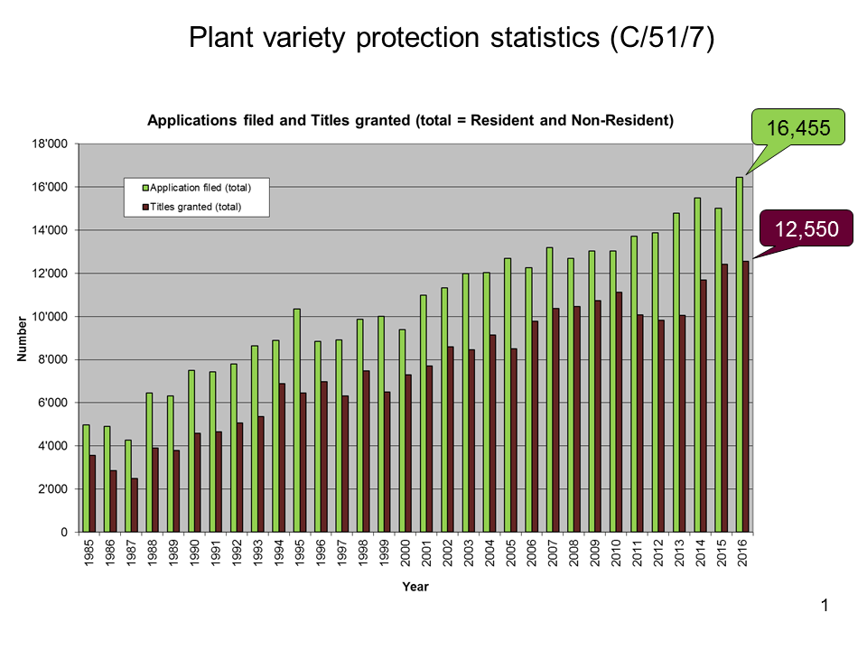
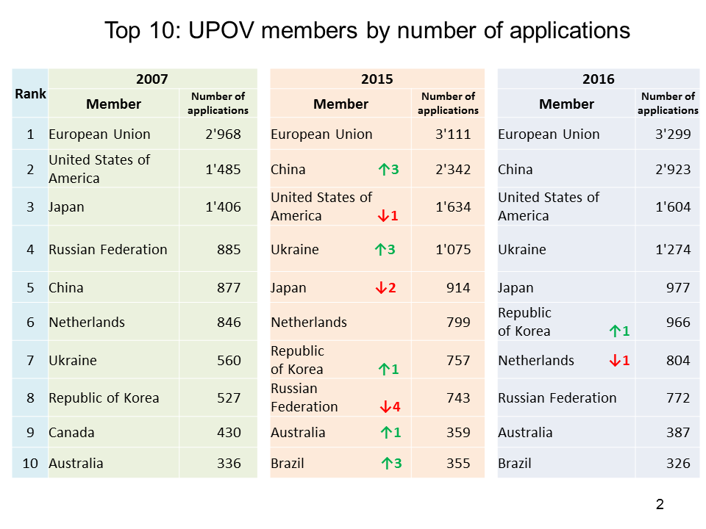
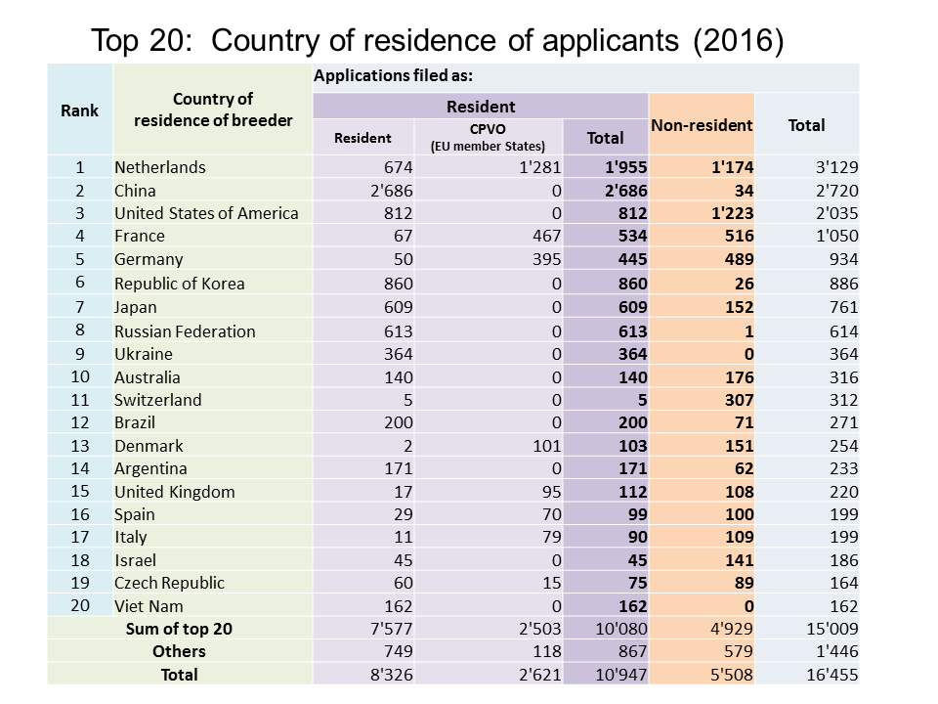
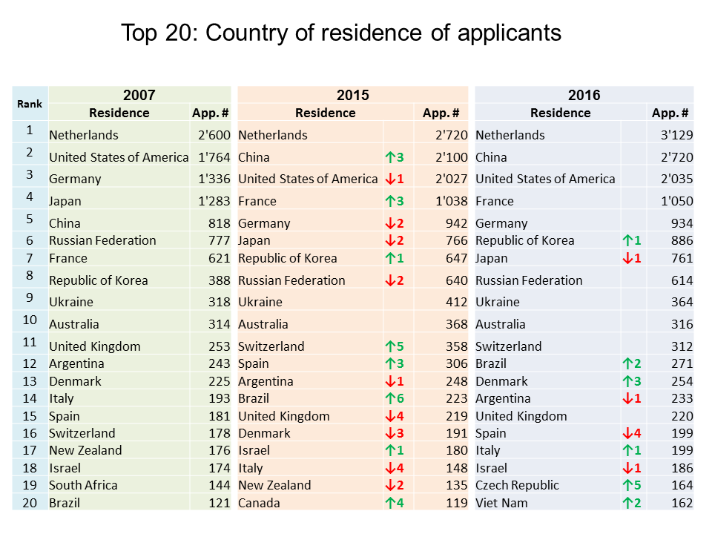

Cooperation in the Examination of New Plant Varieties

In 2016, the number of plant genera and species for which there were agreements between members of the Union for cooperation in the examination of distinctness, uniformity and stability totaled 1,971.

Background

UPOV is an intergovernmental organization based in Geneva, with 75 members, covering 94 States.

The purpose of UPOV is to provide and promote an effective system of plant variety protection, with the aim
of encouraging the development of new varieties of plants, for the benefit of society.

The members of UPOV are:

African Intellectual Property Organization (OAPI), Albania, Argentina, Australia, Austria, Azerbaijan, Belarus, Belgium, Bolivia (Plurinational State of), Bosnia and Herzegovina, Brazil, Bulgaria, Canada, Chile, China, Colombia, Costa Rica, Croatia, Czech Republic, Denmark, Dominican Republic, Ecuador, Estonia, European Union, Finland, France, Georgia, Germany, Hungary, Iceland, Ireland, Israel, Italy, Japan, Jordan, Kenya, Kyrgyzstan, Latvia, Lithuania, México, Morocco, Montenegro, Netherlands, New Zealand, Nicaragua, Norway, Oman, Panama, Paraguay, Peru, Poland, Portugal, Republic of Korea, Republic of Moldova, Romania, Russian Federation, Serbia, Singapore, Slovakia, Slovenia, South Africa, Spain, Sweden, Switzerland, the former Yugoslav Republic of Macedonia, Trinidad and Tobago, Tunisia, Turkey, Ukraine, United Kingdom, United Republic of Tanzania, United States of America, Uruguay, Uzbekistan, Viet Nam.

For further information about UPOV, please contact the UPOV Secretariat:

Tel: (+41-22) 338 9111 E-mail: upov.mail@upov.int
Fax: (+41-22) 733 0336 Website: www.upov.int
[Appendix to Press Release 112 follows]

APPENDIX TO PRESS RELEASE 112

FAQ on the United Nations Sustainable Development Goals (SDGs)

Question:

How does the UPOV system contribute to the United Nations Sustainable Development Goals (SDGs)?

The vision of the 2030 Agenda for Sustainable Development (see http://www.un.org/sustainabledevelopment/sustainable-development-goals/) includes a world where “food is sufficient, safe, affordable and nutritious”, there is “sustained and inclusive economic growth, social development, environmental protection and the eradication of poverty and hunger” and one in “which development and the application of technology are climate-sensitive, respect biodiversity and are resilient”. The mission of UPOV is to provide and promote an effective system of plant variety protection, with the aim of encouraging the development of new varieties of plants, for the benefit of society. The benefits that the UPOV system provides to society will be an important component in realizing the vision of the 2030 Agenda for Sustainable Development.

UPOV's mission is to provide and promote an effective system of plant variety protection, with the aim of encouraging the development of new varieties of plants, for the benefit of society. In particular, new varieties of plants are an important means of responding to the challenges of a growing and increasingly urbanized population, climate change, parallel demands for food and energy production and evolving human needs.

The tremendous progress in agricultural productivity in various parts of the world is largely based on improved varieties, together with improved farming practices, and future food security depend on them. There is also a need to further increase food production in the years leading up to 2030. World population is anticipated to grow until 2050, and urbanization will continue. Therefore, the need for increased productivity in sustainable agricultural production will continue for the foreseeable future. New varieties of plants with features such as improved yield, resistance to plant pests and diseases, salt and drought tolerance, or better adaptation to climatic stress are a key element in increasing productivity and product quality in agriculture, horticulture and forestry, whilst minimizing the pressure on the natural environment. Due to the continuous evolution of new pests and diseases as well as changes in climatic conditions and users’ needs, there is a continuous demand by farmers/growers of new plant varieties and development by breeders of such new plant varieties.

Diversity of breeders and breeding is needed to develop new varieties that are able to respond to such a wide range of challenges. The UPOV system of plant variety protection provides an effective mechanism for breeders in both the public and private sectors, and facilitates public-private partnerships. It is a system that is equally relevant for individual breeders, SMEs and larger breeding institutes/enterprises. Plant variety protection supports long-term investment in breeding and provides a framework for investment in the delivery of seed and other propagating material of varieties suited to farmers’ needs.

The UPOV system encourages the development of new varieties of plants, therefore adding to diversity. The “breeder’s exemption” in the UPOV Convention enables plant diversity to be available for further breeding activities because acts done for the purpose of breeding other varieties are not subject to any restriction by the breeder. This reflects the fact that access to protected varieties contributes to sustain greatest progress in plant breeding and, thereby, to maximize the use of genetic resources for the benefit of society.

The UPOV Report on the Impact of Plant Variety Protection (Impact Study) (see http://www.upov.int/edocs/pubdocs/en/upov_pub_353.pdf) notes that membership of UPOV provide important technical assistance and facilitate opportunities for cooperation, which enables PVP to be extended to the widest range of plant genera and species in an efficient way thereby enabling the benefits to be maximized.

The UPOV system has particular relevance in relation to the following United Nations Sustainable Development Goals (SDGs):

- Goal 1. End poverty in all its forms everywhere (Targets 1.1, 1.4, 1.5, 1.a, 1.b)
- Goal 2. End hunger, achieve food security and improved nutrition and promote sustainable agriculture (Targets 2.1, 2.2, 2.3, 2.4, 2.5, 2.a)
- Goal 9. Build resilient infrastructure, promote inclusive and sustainable industrialization and foster innovation (Target 9.5)
- Goal 12. Ensure sustainable consumption and production patterns (Targets 12.2, 12.3, 12.4, 12.a)
- Goal 15. Protect, restore and promote sustainable use of terrestrial ecosystems, sustainably manage forests, combat desertification, and halt and reverse land degradation and halt biodiversity loss (Target 15.3)
- Goal 17. Strengthen the means of implementation and revitalize the global partnership for sustainable development: Systemic issues: Multi-stakeholder partnerships (Target 17.17)”.

[End of Annex and of document]

http://www.upov.int/about/en/faq.html (Why do farmers and growers need new plant varieties?)
http://www.upov.int/about/en/faq.html (Why does UPOV require varieties to be uniform and stable; doesn’t that lead to a loss of diversity?)
http://www.upov.int/edocs/pubdocs/en/upov_pub_353.pdf

