E
C/48/12
ORIGINAL: English
DATE: September 17, 2014
INTERNATIONAL UNION FOR THE PROTECTION OF NEW VARIETIES OF PLANTS
Geneva
COUNCIL
Forty-Eighth Ordinary Session
Geneva, October 16, 2014
Performance report for the 2012-2013 Biennium
prepared by the Office of the Union
Disclaimer: this document does not represent UPOV policies or guidance

This document presents the Performance Report for the 2012-2013 Biennium on the basis of the Program and Budget for the 2012-2013 Biennium adopted by the Council (see document C/45/4 Rev.2 “Program and Budget for the 2012-2013 Biennium”).

RESULTS TABLE FOR THE 2012-2013 BIENNIUM

Table of contents

1. INTRODUCTION 5
2. PROGRAM PERFORMANCE 7
2.1 Sub-program UV.1: Overall Policy on Plant Variety Protection 7
Objectives 7
Results Achieved: Selected Performance Indicators 7
1. ORGANIZATION OF COUNCIL AND CONSULTATIVE COMMITTEE SESSIONS 7
(a) Participation in the sessions of the Council and the Consultative Committee 7
Figure 1. Participation in Ordinary Sessions of the Council (October sessions) 7
Figure 2. Participation* in Extraordinary Sessions of the Council (April sessions) 7
Figure 3. Participation* in Consultative Committee Sessions 7
2. Coordination, monitoring and performance assessment of Program and Budget for the 2012-2013 Biennium 8
(a) Delivery of program within budget for the 2012-2013 Biennium 8
3. Preparation and adoption of the Program and Budget for the 2014-2015 Biennium 8
(a) Preparation and adoption of the Program and Budget for the 2014-2015 Biennium in accordance with the “Financial Regulations and Rules of UPOV” 8
4. Council policy 8
(a) Recommendations by the Consultative Committee, and decisions by the Council 8
(b) Other decisions by the Council 8
(c) Other work of the Consultative Committee 9
(d) Adoption of information and position papers by the Council 9
2.2 Sub-program UV.2: Services to the Union for enhancing the Effectiveness of the UPOV System 10
Objectives 10
Results Achieved: Selected Performance Indicators 10
1. Guidance on the UPOV Convention and its implementation and information on its application 10
(a) Adoption of new or revised information materials concerning the UPOV Convention 10
(b) Publication of the UPOV Gazette and Newsletter 11
(c) Inclusion of laws of members of the Union in UPOV Lex database 11
UPOV Lex database: visits to the UPOV Website in 2013 11
(d) Participation in seminars and symposia held in Geneva in conjunction with UPOV sessions 11
2. Guidance on the examination of varieties 12
(a) Adoption of new or revised TGP documents and information materials 12
(b) Adoption of new or revised Test Guidelines 12
Test Guidelines: visits to the UPOV Website in 2013 13
Figure 4. Adoption of Test Guidelines 13
Figure 5. Draft Test Guidelines discussed in TWPs 13
Figure 6. Plant Breeders’ Rights Entries in Plant Variety Database covered by Test Guidelines 13
(c) Participation in seminars and symposia held in Geneva in conjunction with UPOV sessions 14
3. Cooperation for the examination of plant breeders’ rights 14
GENIE Database: visits to the UPOV Website in 2013 14
(a) Plant genera and species for which members of the Union have practical experience 15
Figure 7. Plant Genera/Species with Cooperation Agreements, Practical Experience and Plant Breeders’ Rights Entries in Plant Variety Database 15
(b) Plant genera and species for which members of the Union cooperate in DUS examination, as indicated in GENIE database 15
- General cooperation 15
- Number of specific bilateral and regional arrangements on plant variety protection 15
(c) Participation in the development of Test Guidelines 16
Figure 8. Total number of Test Guidelines adopted (by Technical Working Party) 16
Figure 9. Total number of Test Guidelines under development 16
Figure 10. Total number of Test Guidelines adopted (by region of the leading expert) 16
Figure 11. Total number of Test Guidelines under development 16
Figure 12. Number of members of the Union involved in drafting Test Guidelines 17
(d) Quality and completeness of data in the Plant Variety Database and quality of search facility; and facilities for access to other relevant data 17
PLUTO Database: visits to the UPOV Website in 2013 18
(e) Exchangeable software included in document UPOV/INF/16 “Exchangeable Software” 19
4. Participation by members of the Union and stakeholders in the work of the UPOV bodies 19
(a) Participation in the Administrative and Legal Committee 19
Figure 13. Number of Participating Members and Observer States/Organizations in the CAJ 19
(b) Participation in the Technical Committee 20
Figure 14. Number of Participating Members and Observer States/Organizations in the TC 20
(c) Participation in Technical Working Party Sessions 20
Figure 15. Number of Participating Members and Observer States/Organizations in the TWPs 20
(d) Participation in Preparatory Workshops for the Technical Working Party Sessions 21
Figure 16. 21
(i) Number of individual participants in the Preparatory Workshops: members and observers 21
(ii) Number of individual participants in the Preparatory Workshops by Technical Working Party 21
(e) Measures to improve the effectiveness of the TC, TWPs and Preparatory Workshops 21
5. UPOV documents and materials in additional languages 22
(a) Availability of UPOV documents and materials in languages other than the UPOV languages (English, French, German and Spanish) 22
6. Facilitating applications for plant breeders’ rights 22
(a) Number of applications for plant breeders’ rights 22
(b) Number of titles granted 22
(c) Number of titles in force 22
Figure 17. Applications for Plant Breeders’ Rights 22
Figure 18. Plant Breeders’ Rights Titles in Force 22
Figure 19. Applications for Plant Breeders’ Rights by Resident/Non-Resident 22
Figure 20. Plant Breeders’ Rights Titles Granted by Resident/Non-Resident 22
(d) Number of genera/species protected by members of the Union 23
Figure 21. Protection to plant genera and species in 2013 23
Figure 22. Evolution of offering protection to plant genera and species 23
(e) Number of genera/species for which varieties have been protected 24
(f) Use by members of the Union of standard UPOV references in application forms 24
(g) Use of linear blank forms corresponding to the “UPOV Model Form for the Application for Plant Breeders’ Rights” 24
7. Provision of information on the UPOV Convention for stakeholders (breeders, farmers, growers, seed-merchants, etc.) 24
(a) Stakeholder-orientated information on the UPOV website 24
2.3 Sub-Program UV.3: Assistance in the Introduction and Implementation of the UPOV System 25
Objectives 25
Results Achieved: Selected Performance Indicators 25
1. Raising awareness of the role of plant variety protection in accordance with the UPOV Convention 25
(a) Publications on the role of plant variety protection, including material on UPOV website 25
(b) States and organizations provided with information at UPOV activities 25
Figure 23. States provided with information at UPOV activities 25
Figure 24. Location of UPOV activities 26
(c) States and organizations that contacted the Office of the Union for assistance in the development of legislation on plant variety protection 26
(d) States and organizations that initiated with the Council of UPOV the procedure for becoming members of the Union 26
Figure 25. States and organizations that contacted the Office of the Union for assistance in the development of legislation on plant variety protection and States and organizations that initiated with the Council of UPOV the procedure for becoming members of the Union 27
(e) Participation in UPOV awareness-raising activities, or activities involving UPOV staff or UPOV trainers on behalf of UPOV staff 27
Figure 26. Location of activities/meetings where UPOV made presentations 27
2. Assistance in drafting legislation on plant variety protection in accordance with the 1991 Act of the UPOV Convention 28
(a) States and organizations provided with comments on laws 28
(b) States and organizations which received a positive advice from the Council of UPOV 28
(c) Meetings with government officials 28
Figure 27. Assistance provided in drafting legislation on plant variety protection 28
3. Assistance to States and organizations in the accession to the 1991 Act of the UPOV Convention 29
(a) States that acceded to or ratified the 1991 Act of the UPOV Convention 29
(b) States and organizations that became members of the Union 29
Figure 28. States/Organizations provided with comments on laws 29
Figure 29. States/Organizations which received positive advice from the Council 29
Figure 30. New members of the Union 29
Figure 31. Accession to/ratification of the 1991 Act 29
4. Assistance in implementing an effective plant variety rights system in accordance with the 1991 Act of the UPOV Convention 30
(a) Participation in distance learning courses 30
Figure 32. UPOV DL-205 Course: 2012 and 2013 participation 30
Figure 33. Participants in the main sessions of the DL-205 Course by registration category 31
Figure 34. Participants in the main sessions of the DL-205 Course by language 31
(b) Participation by observer States and organizations in the CAJ, TC, TWPs and the associated preparatory workshops 32
(c) Participation in UPOV activities 32
(d) Participation in activities involving UPOV staff or UPOV trainers on behalf of UPOV staff 32
(e) Training provided by UPOV trainers in non-UPOV activities 32
(f) Implementation of projects with partner organizations and donors 32
(g) Use of assistance web-page to obtain project support 32
2.4 Sub-Program UV.4: External Relations 33
Objectives 33
Results Achieved: Selected Performance Indicators 33
1. Increased public understanding of UPOV’s role and activities 33
(a) Availability of public-orientated information and materials on UPOV Website 33
(b) Visits to website 33
2. Provision of information to other organizations 35
Participation at meetings and/or activities with relevant organizations 35
3. FINANCIAL PERFORMANCE 36
3.1 Income, expenditure and reserves 36
3.2 Structure of budget 36
3.3 Budget variation by object of expenditure 37
Figure 35. Income and expenditure (between 2002 and 2013) 39
3.4 Budget 2010-2011: Posts by category 39
3.5 Income: Variation by source 40
3.6 Income, expenditure and reserves 41
Figure 36. Income, expenditure and reserves for 2003-2013 (in thousands of Swiss francs) 42

Appendix Acronyms and abbreviations

1. INTRODUCTION

1. This document presents the Performance Report for the 2012-2013 Biennium on the basis of the Program and Budget for the 2012-2013 Biennium adopted by the Council at its forty-fifth ordinary session, held in Geneva on October 20, 2011 (see document C/45/4 Rev.2 “Program and Budget for the 2012-2013 Biennium”).

2. The Performance Report for the 2012-2013 Biennium provides an overview of UPOV’s performance based on information from the following documents, which contain further detailed information:

(a) document C/45/4 Rev.2 “Program and Budget of the Union for the 2012-2013 Biennium;
(b) document C/47/2 “Annual Report of the Secretary-General for 2012”;
(c) document C/48/2 “Annual Report of the Secretary-General for 2013”; and
(d) document C/48/4 “Financial Management Report for the 2012-2013 Biennium”.

3. Section 2 “Program Performance”, provides a brief summary of the progress made towards the achievements of objectives at the level of sub-programs, followed by performance tables summarizing information on objectives, expected results and performance indicators. Section 3 “Financial Performance”, provides an overview of the financial performance and the number of posts for the Office of the Union, in relation to the Program and Budget for the 2012­2013 Biennium.

4. The following map provides a graphic overview of the status in relation to UPOV at the end of the 2012-2013 Biennium.

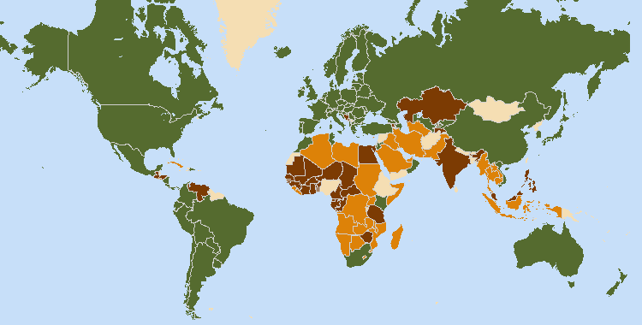
The boundaries shown on this map do not imply the expression of any opinion whatsoever on the part of UPOV concerning the legal status of any country or territory
- 71 members of UPOV

- 16 States and 1 intergovernmental organization which had initiated the procedure for acceding the UPOV Convention

- 24 States and 2 intergovernmental organization which had been in contact with the Office of the Union for assistance in the development of laws based on the UPOV Convention

5. The following table provides detailed information on the status in relation to UPOV.

UPOV members

Albania³ | China² | Germany3 | Morocco3 | Republic of Moldova³ | The former Yugoslav
Argentina2 | Colombia² | Hungary3 | Netherlands³ | Romania³ | Republic of Macedonia³
Australia³ | Costa Rica³ | Iceland3 | New Zealand2 | Russian Federation³ | Trinidad and Tobago²
Austria3 | Croatia³ | Ireland3 | Nicaragua² | Serbia³ | Tunisia³
Azerbaijan³ | Czech Republic³ | Israel³ | Norway2 | Singapore³ | Turkey³
Belarus³ | Denmark3 | Italy2 | Oman³ | Slovakia³ | Ukraine³
Belgium1 | Dominican Republic³ | Japan³ | Panama³ | Slovenia³ | United Kingdom³
Bolivia | Ecuador² | Jordan³ | Paraguay² | South Africa2 | United States of America³
(Plurinational State of)² | Estonia³ | Kenya² | Peru³ | Spain3 | Uruguay²
Brazil² | European Union^{3,4} | Kyrgyzstan³ | Poland3 | Sweden³ | Uzbekistan³
Bulgaria³ | Finland3 | Latvia³ | Portugal² | Switzerland³ | Viet Nam³
Canada2 | France3 | Lithuania³ | Republic of Korea³
Chile² | Georgia³ | Mexico² |  |  | (Total 71)

¹ 1961 Convention as amended by the Additional Act of 1972 is the latest Act by which 1 State was bound.
² 1978 Act is the latest Act by which 19 States were bound.
³ 1991 Act is the latest Act by which 50 States and 1 organization were bound.
⁴ Operates a (supranational) Community plant variety rights system which covers the territory of its 28 member States.

States and intergovernmental organizations which had initiated the procedure
for acceding to the UPOV Convention

Armenia, Bosnia and Herzegovina, Egypt, Ghana, Guatemala, Honduras, India, Kazakhstan, Malaysia, Mauritius, Montenegro, Philippines, Tajikistan, United Republic of Tanzania, Venezuela (Bolivarian Republic of), Zimbabwe, as well as the African Intellectual Property Organization (OAPI).

States and intergovernmental organizations which had been in contact with the Office of the Union
for assistance in the development of laws based on the UPOV Convention

Algeria, Bahrain, Barbados, Brunei Darussalam, Cambodia, Cuba, Cyprus, El Salvador, Indonesia, Iran (Islamic Republic of), Iraq, Lao People’s Democratic Republic, Libya, Mozambique, Myanmar, Namibia, Pakistan, Saudi Arabia, Sudan, Thailand, Tonga, Turkmenistan, United Arab Emirates, Zambia, as well as the African Regional Intellectual Property Organization (ARIPO) and the Southern African Development Community (SADC).

2. PROGRAM PERFORMANCE

2.1 Sub-program UV.1: Overall Policy on Plant Variety Protection

The sessions of the Council and the Consultative Committee provided the basis for policy making, management and coordination of the activities within UPOV’s overall program.

Objectives | - Policy direction and executive management.  - Planning, implementation and evaluation of program and budget.

Results Achieved: Selected Performance Indicators

1. ORGANIZATION OF COUNCIL AND CONSULTATIVE COMMITTEE SESSIONS

(a) Participation in the sessions of the Council and the Consultative Committee
(see Figures 1 to 3)

Figure 1. Participation* in Ordinary Sessions of the Council (October sessions) | Figure 2. Participation* in Extraordinary Sessions of the Council (April sessions)

Figure 3. Participation* in Consultative Committee Sessions

2. Coordination, monitoring and performance assessment of Program and Budget for the 2012-2013 Biennium

(a) Delivery of program within budget for the 2012-2013 Biennium
See Section 3 “Financial Performance”

3. Preparation and adoption of the Program and Budget for the 2014-2015 Biennium

(a) Preparation and adoption of the Program and Budget for the 2014-2015 Biennium in accordance with the “Financial Regulations and Rules of UPOV”
The Program and Budget for the 2014-2015 Biennium was adopted by the Council at its forty seventh ordinary session, on October 24, 2013 (see document C/47/4 Rev.).

4. Council policy

(a) Recommendations by the Consultative Committee, and decisions by the Council
The Council took decisions, based on recommendations by the Consultative Committee, concerning the following:
- examination of the conformity of two draft laws and one law with the provisions of the 1991 Act of the International Convention for the Protection of New Varieties of Plants;
- adoption of information materials (the adoption of information materials by the Council is reported under
Sub-Program UV.2);
- calendars of meetings;
- press releases;
- extension of the appointment of the Vice Secretary-General;
- revision of the rules governing the granting of observer status to States, intergovernmental organizations and international non-governmental organizations in UPOV bodies;
- revision of the rules governing access to UPOV documents;
- financial situation of the International Union for the Protection of New Varieties of Plants as at December 31, 2011;
- arrears in contributions as of September 30, 2012;
- accounts for the 2010-2011 financial period;
- Draft Program and Budget of the Union for the 2014-2015 Biennium;
- financial statements for 2012;
- arrears in contributions as of September 30, 2013;
- creation of a special UPOV account that would be used to finance extra budgetary projects agreed by the Council, in a situation where the amount of the reserve fund exceeds 15 percent of the total income for the 2012­2013 Biennium;
- copying the Technical Committee (TC) designated persons in the request for information concerning cooperation in examination, e.g. see C/xx/5.

(b) Other decisions by the Council
The Council also took decisions concerning the following:
- work programs of the Administrative and Legal Committee (CAJ), the Technical Committee (TC), the Technical Working Parties (TWPs) and the Working Group on Biochemical and Molecular Techniques, and DNA-Profiling in Particular (BMT)
- election of:
  - the President and Vice-President of the Council
  - the Chair and Vice-Chair of the CAJ
  - the Chair and Vice-Chair of the TC

(c) Other work of the Consultative Committee
The Consultative Committee:
- granted observer status to the African Seed Trade Association (AFSTA) for the Council, the Administrative and Legal Committee (CAJ), the Technical Committee (TC) and the Technical Working Parties (TWPs);
- agreed the following with regard to the “Symposium on the benefits of plant variety protection for farmers and growers”, to be held in Geneva on November 2, 2012,
  - to be open for attendance to the public, subject to room capacity, with priority being given to participants from members of the Union, observer States and observer organizations
  - approved the webcasting of the Symposium
  - agreed the explanation of the aim of the Symposium
- endorsed the plans for the draft program of the Symposium and agreed to the inclusion of one speaker from those recommended by APBREBES to give a presentation in accordance with the aim of the Symposium;
- approved the participation of the Office of the Union in the World Intellectual Property Organization (WIPO) Framework for Designing National Intellectual Property Strategies for Development;
- approved the participation of the Office of the Union in the development of the WIPO Questionnaire “A tool to assess the current status of the national intellectual property system, strategic objectives and needs in line with national development priorities”;
- approved the use of web conferencing by UPOV bodies, as considered appropriate by the UPOV body concerned, to facilitate participation by members of the Union and observers in accordance with the existing procedures;
- approved the use of web conferencing by the Office of the Union to facilitate participation by invited participants to its meetings, as considered appropriate by the Office of the Union;
- approved the use of webcasting of sessions of UPOV bodies for viewing by members of the Union and observers in accordance with the existing procedures, as considered appropriate by the UPOV body concerned and agreed that, in all other cases of webcasting, the Consultative Committee would be invited to approve any arrangements for a possible webcast;
- agreed that the webcast of the “Symposium on the benefits of plant variety protection for farmers and growers”, to be held in Geneva on November 2, 2012, be made available on the UPOV website after a suitable broadcast delay;
- approved the launch of the “Assistance” webpage, on the basis of the prototype, on an area of the UPOV website that would be accessible via the restricted area and via a separate link and password that would be issued to the representative and alternate of each member of the Union to the Council;
- approved the publication of a document in the UPOV website with the list of UPOV members, list of States and intergovernmental organizations which had initiated the procedure for acceding to the UPOV Convention and the list of States and intergovernmental organizations which had been in contact with the Office of the Union for assistance in the development of laws based on the UPOV Convention;
- approved the issue of an invitation to Georgia to make a presentation on progress and possible areas of assistance in the implementation of the UPOV system at the eighty-sixth session of the Consultative Committee, to be held in October 2013;
- approved the participation of the Office of the Union in the International Treaty on Plant Genetic Resources for Food and Agriculture (ITPGRFA) Platform for the Co-Development and Transfer of Technologies;
- noted the report provided by the Office of the Union to the Sixth Session of the Intergovernmental Technical Working Group on Plant Genetic Resources for Food and Agriculture of the Commission on Genetic Resources for Food and Agriculture (CGRFA) and approved the provision of similar reports to future sessions, which would relate to all Acts of the UPOV Convention;
- approved the participation of UPOV in the WIPO initiative on sustainable wheat production in the
United Republic of Tanzania.

(d) Adoption of information and position papers by the Council
The adoption of information materials by the Council is reported under Sub-Program UV.2.

2.2 Sub-program UV.2: Services to the Union for enhancing the Effectiveness of the UPOV System

UPOV has continued to adopt new and revised information and guidance documents that enhance the understanding and the implementation of the provisions of the Convention in an internationally harmonized and effective way, thereby reinforcing the quality of protection and helping to reduce the cost of obtaining protection. Such measures continue to gain importance for new members of the Union with the increasing number of members of the Union that offer protection for all plant genera and species. In 2013, the adopted Test Guidelines covered 91% of all PBR-related entries in the Plant Variety Database. In order to explore possible measures to improve the effectiveness of the TC, TWPs and Preparatory Workshops, the TC has endorsed a series of surveys. To enhance cooperation between members of the Union, the information provided in the GENIE database, Plant Variety Database (PLUTO database) and database of laws of members of the Union (UPOV Lex) has been enhanced, with further measures taken in relation to the program for improvements to the PLUTO Database. The project for the development of a UPOV electronic application form has made significant progress, including the creation of a “mock-up” for demonstration purposes.

Objectives | - To maintain and improve the effectiveness of the UPOV system.  - To provide and develop the legal, administrative and technical basis for international cooperation in plant variety protection according to the UPOV Convention.

Results Achieved: Selected Performance Indicators

1. Guidance on the UPOV Convention and its implementation and information on its application

(a) Adoption of new or revised information materials concerning the UPOV Convention
The Council adopted:
- 1 new information document
UPOV/INF/21/1 Alternative Dispute Settlement Mechanisms
- 11 revisions to previously adopted information documents
UPOV/INF/4/2: Financial Regulations and Rules of UPOV (Revision)
UPOV/INF/4/3: Financial Regulations and Rules of UPOV (Revision)
UPOV/INF/6/3 Guidance for the preparation of laws based on the 1991 Act of the UPOV Convention (Revision)
UPOV/INF/15/2 Guidance for Members of UPOV on Ongoing Obligations and Related Notifications and on the Provision of Information to Facilitate Cooperation (Revision)
UPOV/INF/16/3 Exchangeable Software (Revision)
UPOV/INF/19/1 Rules governing the granting of observer status to States, intergovernmental organizations and international non-governmental organizations in UPOV bodies (Revision)
UPOV/INF/20/1 Rules governing access to UPOV documents (Revision)
UPOV/INF-EXN/2: List of INF-EXN Documents and Latest Issue Dates (Revision)
UPOV/INF-EXN/3 List of INF-EXN Documents and Latest Issue Dates (Revision)
UPOV/INF-EXN/4 List of INF-EXN Documents and Latest Issue Dates (Revision)
UPOV/INF-EXN/5 List of INF-EXN Documents and Latest Issue Dates (Revision)
- 2 new explanatory notes

UPOV/EXN/BRD/1 Explanatory Notes on the Definition of Breeder under the 1991 Act of the UPOV Convention
UPOV/EXN/HRV/1 Explanatory Notes on Acts in Respect of Harvested Material under the 1991 Act of the UPOV Convention
- 1 revision to previously adopted explanatory notes
UPOV/INF/12/4 Explanatory Notes on Variety Denominations under the UPOV Convention (Revision)

The CAJ, in conjunction with the Administrative and Legal Committee Advisory Group (CAJ-AG) and TC, as appropriate, considered drafts of the following:
- 2 new information documents
UPOV/INF/15 Guidance for members of UPOV on ongoing obligations and related notifications and on the provision of information to facilitate cooperation
UPOV/INF/ADS Alternative Dispute Settlement Mechanisms
- 1 revision to previously adopted information documents
UPOV/INF/16 Exchangeable Software (Revision)
- 3 new explanatory notes
UPOV/EXN/BRD Explanatory Notes on the Definition of Breeder under the 1991 Act of the UPOV Convention
UPOV/EXN/HRV Explanatory Notes on Acts in Respect of Harvested Material under the 1991 Act of the UPOV Convention
- 1 revision to previously adopted explanatory notes
UPOV/EXN/EDV Explanatory Notes on Essentially Derived Varieties under the 1991 Act of the UPOV Convention (Revision)
- for TGP documents, see Section 2.2 “Sub-Program UV.2”, expected result “2. Guidance on the examination of varieties” and “(a) Adoption of new or revised TGP documents and information materials”

(b) Publication of the UPOV Gazette and Newsletter
Two issues of UPOV Publication No. 438 “Plant Variety Protection Gazette and Newsletter” (English only) were published in the 2012-2013 Biennium.

(c) Inclusion of laws of members of the Union in UPOV Lex database
- 11 laws concerning 9 members of the Union were included in the UPOV Lex database
(Australia, Croatia, France, Ireland, Panama, Poland, Serbia, United States of America and Viet Nam)

UPOV Lex database: visits to the UPOV Website in 2013
Language | Pageviews | Unique pageviews
English | 58,442 | 40,221
Spanish | 20,246 | 14,057
French | 7,216 | 5,152
German | 2,629 | 1,800

Evolution of visits

Year | Pageviews | Unique pageviews
2013 | 88,533 | 61,230
2012 | 91,245 | 62,411
2011 | 19,269 | 12,575

(d) Participation in seminars and symposia held in Geneva in conjunction with UPOV sessions
- Symposium on the Benefits of Plant Variety Protection for Farmers and Growers, November 2, 2012:
118 participants
- Seminar on essentially derived varieties (EDVs), October 22, 2013: 177 participants

2. Guidance on the examination of varieties

(a) Adoption of new or revised TGP documents and information materials
- TGP documents adopted and published on the UPOV website:
- 1 new TGP document
TGP/15/1 Guidance on the Use of Biochemical and Molecular Markers in the Examination of Distinctness, Uniformity and Stability (DUS)
- 4 revisions to previously adopted TGP documents
TGP/12/2 Guidance on Certain Physiological Characteristics (Revision)
TGP/14/2 Glossary of Terms Used in UPOV Documents (Revision)
TGP/0/5 List of TGP Documents and Latest Issue Dates (Revision)
TGP/0/6 List of TGP Documents and Latest Issue Dates (Revision)
- Drafts of TGP documents advanced in the CAJ, TC and/or the TWPs
- 3 revisions to previously adopted TGP documents
TGP/7 Development of Test Guidelines
TGP/8 Trial Design and Techniques Used in the Examination of Distinctness, Uniformity and Stability
- Drafts of information materials advanced in the CAJ, TC and/or the TWPs
- 2 revisions to previously adopted information materials
UPOV/INF/12 Explanatory Notes on Variety Denominations under the UPOV Convention (Revision)
UPOV/INF/16 Exchangeable Software (Revision)

(b) Adoption of new or revised Test Guidelines
Adopted Test Guidelines
- 42 Test Guidelines were adopted by the TC, comprising:
– 23 new Test Guidelines
– 11 revised Test Guidelines
– 8 partially revised Test Guidelines
(see Figure 4)
At the end of 2013, the adopted Test Guidelines covered 91% of all PBR-related entries in the Plant Variety Database (217,298 of 247,818) (90% at the end of 2011 (201,873 of 224,189))
(see Figure 6)
Test Guidelines advanced in the Technical Working Parties
- In 2012, 59 draft Test Guidelines were advanced by the TWPs, comprising
– 36 new Test Guidelines
– 16 revisions
– 7 partial revisions
- In 2013, 49 draft Test Guidelines were advanced by the TWPs, comprising
– 30 new Test Guidelines
– 13 revisions
– 6 partial revisions
(see Figure 5)

Test Guidelines: visits to the UPOV Website in 2013
Language | Pageviews | Unique pageviews
English | 55,559 | 31,498
Spanish | 8,591 | 4,802
French | 3,071 | 1,898
German | 1,258 | 781

Evolution of visits

Year | Pageviews | Unique pageviews
2013 | 68,479 | 38,979
2012 | 65,471 | 37,227
2011 | not available | not available

Figure 4. Adoption of Test Guidelines | Figure 5. Draft Test Guidelines  discussed in TWPs

Figure 6. Plant Breeders’ Rights Entries in Plant Variety Database covered by Test Guidelines

(c) Participation in seminars and symposia held in Geneva in conjunction with UPOV sessions
- In 2012, discussion on experiences of members of the Union on measures to improve the efficiency and effectiveness of DUS testing:
89 participants representing 42 members of the Union, 4 observer States, and 5 observer organizations

3. Cooperation for the examination of plant breeders’ rights

GENIE Database: visits to the UPOV Website in 2013

Sessions 16,545  Users 8,913  Pageviews 84,306  New Visitors 48%  Returning Visitors 52% | Language Pageviews Unique pageviews  English 61,335 35,992  Spanish 10,610 6,074  French 7,050 4,252  German 2,360 1,072

Top 10 countries visiting the GENIE database in 2013

Country / Territory | Sessions | % New Sessions | New Users
France | 1,637 | 55,65% | 911
Switzerland | 1,070 | 25,79% | 276
United States | 914 | 68,27% | 624
Germany | 857 | 70,36% | 603
Japan | 754 | 21,75% | 164
Spain | 748 | 67,38% | 504
India | 662 | 74,17% | 491
Mexico | 633 | 52,13% | 330
Netherlands | 541 | 31,98% | 173
Australia | 535 | 34,39% | 184

Evolution of visits

Year | Pageviews | Unique pageviews
2013 | 84,306 | 49,280
2012 | 85,149 | 46,122
2011 | 59,735 | 32,839
2010 | 51,457 | 28,565
2009 | 11,474 | 5,337
2008 | 14,063 | 5,763
2007 | 5,357 | 2,530

(a) Plant genera and species for which members of the Union have practical experience
Practical experience in examination of DUS reported for approximately 2,589 genera or species in 2013 (2,726 in 2012; 2,679 in 2011; 2,254 in 2010) (see Figure 7)

Figure 7. Plant Genera/Species with Cooperation Agreements, Practical Experience and
Plant Breeders’ Rights Entries in Plant Variety Database

(b) Plant genera and species for which members of the Union cooperate in DUS examination, as indicated in GENIE database

- General cooperation
Number of authorities which would provide existing DUS reports to any member of the Union:
2 in 2013 (1 in 2011)

Number of authorities which would, for any species for which they have experience in DUS examination, provide existing DUS reports to any member of the Union:
6 in 2013 (5 in 2011)

Number of authorities which would accept DUS reports from any other member of the Union:
1 in 2013 (1 in 2011)

Number of authorities which would accept DUS reports from any other member of the Union under certain circumstances:
2 in 2013 (2 in 2011)

- Number of specific bilateral and regional arrangements on plant variety protection
Agreement for cooperation in variety testing extended to approximately 1,997 genera or species (1,991 in 2012;
1,990 in 2011; 1,417 in 2010) – excluding general cooperation (see Figure 7 and document C/48/5)

(c) Participation in the development of Test Guidelines
An overview of participation in the development of Test Guidelines by TWPs and by region of the leading expert is provided in Figures 8 to 11

Figure 8. Total number of Test Guidelines  adopted  (by Technical Working Party) | Figure 9. Total number of Test Guidelines  under development  (by Technical Working Party)
Figure 10. Total number of Test Guidelines  adopted  (by region of the leading expert) | Figure 11. Total number of Test Guidelines  under development  (by region of the leading expert)

Total of 20 members of the Union involved in drafting Test Guidelines (AR, AU, BR, CA, CN, CO, DE, ES, FR, GB, IL, JP, KE, KR, MX, NL, NZ, PL, QZ, ZA).
(see Figure 12)

Figure 12. Number of members of the Union involved in drafting Test Guidelines

(d) Quality and completeness of data in the Plant Variety Database and quality of search facility; and facilities for access to other relevant data
- Total number of records included in the PLUTO database at the end of 2013:
645,068 (620,517 at the end of 2012; 575,378 at the end of 2011)
- Number of submissions of new data in 2012 and 2013 (each contributor was invited to make six submissions in 2013):
163 in 2013; 167 in 2012 (164 in 2011; 161 in 2010)
- Number of contributors included in the PLUTO database at the end of 2012 and 2013:
56 in 2013; 52 in 2012 (48 in 2011; 41 in 2010)
- Number of members of the Union that contributed data in 2012 and 2013:
45 in 2013; 45 in 2012 (41 in 2011; 41 in 2010)
- Number of members of the Union that contributed data for the first time in 2012 and 2013:
4 in 2013 (GE, KE, PE, RS) (4 in 2012; 3 in 2011; 0 in 2010)
- Number of other contributors of data in 2012 and 2013:
1 in 2013 and 2012 (OECD) (1 in 2011; 1 in 2010)

PLUTO Database: visits to the UPOV Website in 2013

Sessions 41,957  Users 12,145  Pageviews 70,739  New Visitors 27.4%  Returning Visitors 72.6% | Language Pageviews Unique pageviews  English 41,058 25,785  Spanish 3,528 2,045  French 3,850 2,525  German 971 603

Top 10 countries visiting the PLUTO database in 2013

Country / Territory | Sessions | % New Sessions | New Users
France | 4,225 | 29.35% | 1,240
United States | 4,054 | 23.36% | 947
Netherlands | 3,613 | 21.87% | 790
Australia | 2,513 | 12.06% | 303
Brazil | 2,359 | 33.36% | 787
Ukraine | 2,180 | 13.12% | 286
Russia | 1,583 | 15.41% | 244
Germany | 1,579 | 34.07% | 538
Japan | 1,506 | 27.56% | 415
Switzerland | 1,338 | 22.94% | 307

Evolution of visits

Year | Pageviews | Unique pageviews
2013 | 70,739 | 44,370
2012 | 255,108 | 51,111
2011 | 30,226 | 6,316

Improvements in relation to the Plant Variety Database (PLUTO database) included:

In 2012:
- New features:
- Page for searching variety denominations;
- Options to save search settings for the PLUTO database;
- Requirement for users of the PLUTO Database to register to use the database, with a view to using that information for future improvements;
- Introduction of arrangements for the inclusion of data in the original alphabet, in addition to the data being provided in Roman alphabet; and
- Introduction of the possibility for contributors to the Plant Variety Database to provide information on dates on which a variety was commercialized for the first time in the territory of application and other territories.
- Solutions developed to allow the contribution of data in non-TAG format for Kenya and South Africa.
- Method for providing missing UPOV codes for data submitted for the Plant Variety Database developed by the WIPO Brand Database Unit. On that basis, UPOV codes were allocated for virtually all entries in the Plant Variety Database.
- Development of UPOV’s “in-house” version of the UPOV-ROM.

In 2013:
- Contributors requested to provide data as soon as possible after it is published by the authority concerned.
- Procedure for the allocation and correction of UPOV codes amended to minimize delays in updates of the database.
- To assist the users of PLUTO database, an English version of the video tutorial was developed and made available on the PLUTO webpage (https://www3.wipo.int/pluto/user/en/index.jsp).
- The disclaimer for PLUTO was amended to reflect the content of the Program for Improvements.
- A working group to develop proposals for a UPOV similarity search tool for variety denomination purposes was established.

(e) Exchangeable software included in document UPOV/INF/16 “Exchangeable Software”
The following software was included in document UPOV/INF/16:

Program name | Category | Proposing country
ZAJVKA | DUS trial design and data analysis | Russian Federation
AIM | Image analysis | France

4. Participation by members of the Union and stakeholders in the work of the UPOV bodies

(a) Participation in the Administrative and Legal Committee
(see Figure 13)

Figure 13. Number of Participating Members and Observer States/Organizations in the CAJ

(b) Participation in the Technical Committee
(see Figure 14)

Figure 14. Number of Participating Members and Observer States/Organizations in the TC

(c) Participation in Technical Working Party Sessions
(see Figure 15)

Figure 15. Number of Participating Members and Observer States/Organizations in the TWPs

(d) Participation in Preparatory Workshops for the Technical Working Party Sessions
(see Figure 16)

Figure 16.

(i) Number of individual participants in the Preparatory Workshops: members and observers

(ii) Number of individual participants in the Preparatory Workshops by Technical Working Party

(e) Measures to improve the effectiveness of the TC, TWPs and Preparatory Workshops
The TC, at its forty-ninth session, received presentations by the Office of the Union on a survey of participants in the TWO, at its forty-fifth session (held in 2012), and in the TWF, at its forty-third session, (held in 2012), and an analysis of participation in the TC and the TWPs.

5. UPOV documents and materials in additional languages

(a) Availability of UPOV documents and materials in languages other than the UPOV languages (English, French, German and Spanish)
- The 1991 Act of the UPOV Convention was translated into Khmer and Serbian languages (the translations will be verified before publication on the UPOV website).

Web pageviews for languages other than English, French, German and Spanish of the UPOV site in 2013

Language | Pageviews
Russian | 586
Chinese | 304
Arabic | 273
Khmer | 64

6. Facilitating applications for plant breeders’ rights

(a) Number of applications for plant breeders’ rights
(see Figures 17 and 19)

(b) Number of titles granted
(see Figure 20)

(c) Number of titles in force
(see Figure 18)

Figure 17. Applications for Plant Breeders’ Rights | Figure 18. Plant Breeders’ Rights Titles in Force
Figure 19. Applications for Plant Breeders’ Rights by Resident/Non-Resident | Figure 20. Plant Breeders’ Rights Titles Granted by Resident/Non-Resident

(d) Number of genera/species protected by members of the Union
(see Figures 21 and 22)

Figure 21. Protection to plant genera and species in 2013
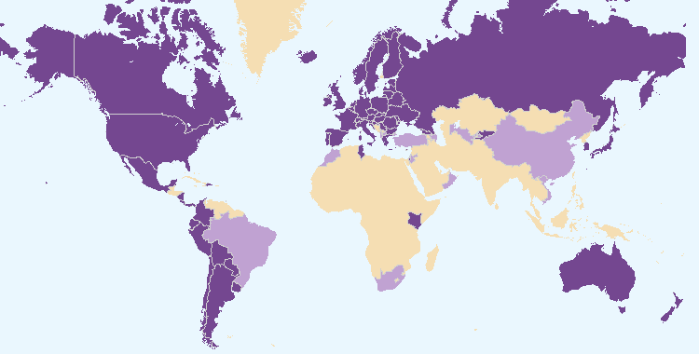

Members of the Union offering protection for all plant genera and species
Members of the Union offering protection for a limited number of plant genera and species

Figure 22. Evolution of offering protection to plant genera and species

(e) Number of genera/species for which varieties have been protected
See Figure 7 “Plant Genera/Species with Cooperation Agreements, Practical Experience and Plant Breeders’ Rights Entries in Plant Variety Database”

(f) Use by members of the Union of standard UPOV references in application forms
In 2012, 13 members of the Union indicated that the standard references of the UPOV Model Application Form were included in their application forms.

(g) Use of linear blank forms corresponding to the “UPOV Model Form for the Application for Plant Breeders’ Rights”
In 2012, the CAJ endorsed the development of a prototype electronic form for interested members of the Union and agreed on the form content, status, data format, languages, and the crop/species. The following members of the Union, including the continued participation of the European Union, indicated their interest to be participating members of the Union in the prototype: Australia, Brazil, Canada, Colombia, Dominican Republic, Mexico, New Zealand, Paraguay, Republic of Korea, United States of America and Viet Nam. Other partners were the CPVO, ISF, CIOPORA, WIPO Internet Services Section, WIPO Standards Section and WIPO Global Database Service.

The UPOV electronic form is planned to enable data to be transferred to participating members of the Union in Word, Excel, PDF or XML format. The participating members of the Union would decide in which format(s) to accept data. In the case of XML format, a standard format is planned to be developed, based on WIPO standard ST.96.

In 2013, an illustrative “mock-up” of parts of the prototype electronic form was presented. It was agreed that the prototype would be developed in English only and the Technical Questionnaire would be for Lettuce (Lactuca sativa L.). Argentina, Japan and Switzerland requested to participate in the development of the prototype.

7. Provision of information on the UPOV Convention for stakeholders (breeders, farmers, growers, seed-merchants, etc.)

(a) Stakeholder-orientated information on the UPOV website
The following material was produced in 2012-2013:

- Symposium on the Benefits of Plant Variety Protection for Farmers and Growers
  - presentations and closing remarks posted on the UPOV website at: http://www.upov.int/meetings/en/details.jsp?meeting_id=26104
- UPOV Trilogy Box Set (in English only), also available on the UPOV website at http://www.upov.int/about/en/benefits_upov_system.html, containing the following publications:
  - Executive Summary (UPOV Publication 357.1E)
  - Symposium on Plant Breeding for the Future (UPOV Publication 357.2E)
  - Seminar on Plant Variety Protection and Technology Transfer: the Benefits of Public-Private Partnership (UPOV Publication 357.3E)
  - Symposium on the Benefits of Plant Variety Protection for Farmers and Growers (UPOV Publication 357.4E)
- Seminar on Essentially Derived Varieties:
  - materials and video posted on the UPOV website at:
http://www.upov.int/meetings/en/details.jsp?meeting_id=29782

2.3 Sub-Program UV.3: Assistance in the Introduction and Implementation of the UPOV System

UPOV has assisted a number of States in the implementation of plant variety protection based on the UPOV Convention and has provided advice to governments in the preparation of legislation. Cooperation with members of the Union, particularly with regard to training courses, has provided substantial benefits for outreach. The use of the distance learning course “Introduction to the UPOV System of Plant Variety Protection under the UPOV Convention” and training of trainers have been of increasing importance in providing assistance to a wide range of experts.

Objectives

- To raise awareness of the role of plant variety protection according to the UPOV Convention.
- To assist States and organizations, particularly governments of developing countries and countries in transition to a market economy, in the development of legislation in accordance with the 1991 Act of the UPOV Convention.
- To assist States and organizations in their accession to the 1991 Act of the UPOV Convention.
- To assist States and organizations in implementing an effective plant variety protection system in accordance with the 1991 Act of the UPOV Convention.

Results Achieved: Selected Performance Indicators

1. Raising awareness of the role of plant variety protection in accordance with the UPOV Convention

(a) Publications on the role of plant variety protection, including material on UPOV website
See section 2.2 “Sub-Program UV.2”, expected result “7. Provision of information on the UPOV Convention for stakeholders”, “(a) Stakeholder-orientated information on the UPOV website”

(b) States and organizations provided with information at UPOV activities
States provided with information at UPOV activities:

Afghanistan, Antigua and Barbuda, Argentina, Austria, Bahamas, Barbados, Belgium, Bolivia (Plurinational State of), Botswana, Brazil, Brunei Darussalam, Cambodia, Canada, Chile, China, Colombia, Costa Rica, Croatia, Cuba, Czech Republic, Dominican Republic, Ecuador, El Salvador, Estonia, Finland, France, Gambia, Germany, Ghana, Grenada, Guatemala, Guyana, Honduras, Hungary, India, Indonesia, Ireland, Israel, Italy, Jamaica, Japan, Kenya, Lao People’s Democratic Republic, Latvia, Lesotho, Liberia, Lithuania, Malawi, Malaysia, Maldives, Mexico, Morocco, Mozambique, Myanmar, Namibia, Netherlands, New Zealand, Nicaragua, Norway, Oman, Pakistan, Panama, Paraguay, Peru, Philippines, Poland, Republic of Korea, Republic of Moldova, Romania, Russian Federation, Rwanda, Saint Kitts and Nevis, Saint Lucia, Saint Vincent and the Grenadines, Sierra Leone, Singapore, Slovakia, Somalia, South Africa, Spain, Sri Lanka, Swaziland, Switzerland, Thailand, Trinidad and Tobago, Tunisia, Uganda, United Kingdom, United Republic of Tanzania, United States of America, Uruguay, Viet Nam, Zambia, Zimbabwe (see Figure 23)

Figure 23. States provided with information at UPOV activities
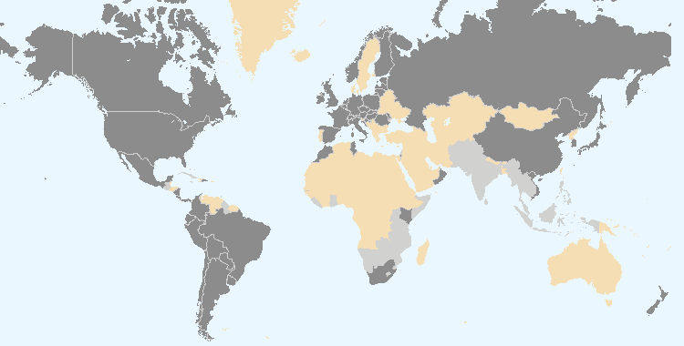

Members of the Union Non-members of the Union

Intergovernmental organizations provided with information at UPOV activities:

ARIPO, European Union, IDLO

Non-governmental organizations provided with information at UPOV activities:

AOHE, APBREBES, APSA, ASTA, Berne Declaration, CIAT, CIOPORA, ESA

Location of UPOV activities:

Argentina, Cambodia, China, Ecuador, Japan, Lao People’s Democratic Republic, Malawi, Malaysia, Oman, Peru, Sri Lanka, Switzerland, Thailand, Trinidad and Tobago, United States of America, Uruguay, Zimbabwe
(see Figure 24)

Figure 24. Location of UPOV activities
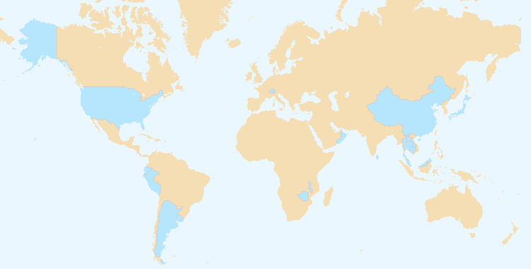

(c) States and organizations that contacted the Office of the Union for assistance in the development of legislation on plant variety protection
Members of the Union: Azerbaijan, Canada, Colombia, Nicaragua, Panama, Singapore and South Africa

Non-members of the Union: ARIPO, Bahamas, Bahrain, Bosnia and Herzegovina, Botswana, Brunei Darussalam, Egypt, Ghana, Honduras, Lao People's Democratic Republic, Malaysia, Myanmar, Namibia, Pakistan, Philippines, Rwanda, Saint Kitts and Nevis, Seychelles, Thailand, United Arab Emirates, United Republic of Tanzania and Zimbabwe (see Figure 25)

(d) States and organizations that initiated with the Council of UPOV the procedure for becoming members of the Union
Ghana, United Republic of Tanzania

Figure 25. States and organizations that contacted the Office of the Union for assistance in the development of legislation on plant variety protection and States and organizations that initiated with the Council of UPOV the procedure for becoming members of the Union
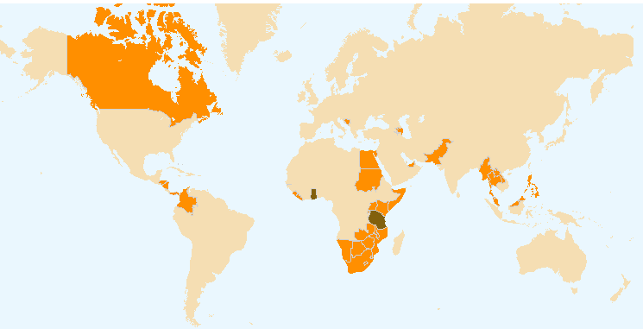

States and organizations that initiated with the Council of UPOV the procedure for becoming members of the Union
States and organizations that contacted the Office of the Union for assistance in the development of legislation on plant variety protection

(e) Participation in UPOV awareness-raising activities, or activities involving UPOV staff or UPOV trainers on behalf of UPOV staff
(i) Activities organized by, or with, UPOV: see (b) above

(ii) Activities/meetings in which UPOV participated: see Figure 26

Location of activities/meetings where UPOV made presentations:

Australia, Azerbaijan, Belgium, Bolivia (Plurinational State of), Brazil, Brunei Darussalam, China, Côte d’Ivoire, Equatorial Guinea, France, Germany, Greece, Indonesia, Italy, Japan, Jordan, Mauritius, Mozambique, Myanmar, Netherlands, Oman, Poland, Republic of Korea, Serbia, Sri Lanka, Sweden, Switzerland, Turkey, Uganda, United Republic of Tanzania, United States of America, Uruguay, Zambia

Figure 26. Location of activities/meetings where UPOV made presentations
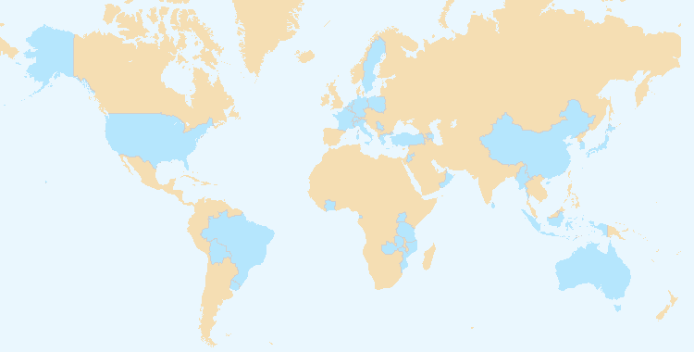

2. Assistance in drafting legislation on plant variety protection in accordance with the 1991 Act of the UPOV Convention

(a) States and organizations provided with comments on laws
Members of the Union: Nicaragua, Panama and Singapore.

Non-members of the Union: ARIPO, Bosnia and Herzegovina, Botswana, Brunei Darussalam, Egypt, Ghana, Honduras, Lao People's Democratic Republic, Malaysia, Myanmar, Namibia, Pakistan, Rwanda, Thailand, United Arab Emirates, United Republic of Tanzania and Zimbabwe.
(see Figure 28)

(b) States and organizations which received a positive advice from the Council of UPOV
Ghana, United Republic of Tanzania (Plant Breeders’ Rights Bill for Mainland Tanzania and Plant Breeders’ Rights Bill for Zanzibar).
(see Figure 29)

(c) Meetings with government officials
Members of the Union: Azerbaijan, Canada, Colombia, Nicaragua, Singapore and South Africa.

Non-members of the Union: ARIPO, Bahamas, Bahrain, Bosnia and Herzegovina, Botswana, Brunei Darussalam, Equatorial Guinea, Ghana, Lao People's Democratic Republic, Malaysia, Myanmar, Namibia, Pakistan, Philippines, Rwanda, Saint Kitts and Nevis, Seychelles, Thailand, United Republic of Tanzania and Zimbabwe.
(see Figure 27)

Figure 27. Assistance provided in drafting legislation on plant variety protection

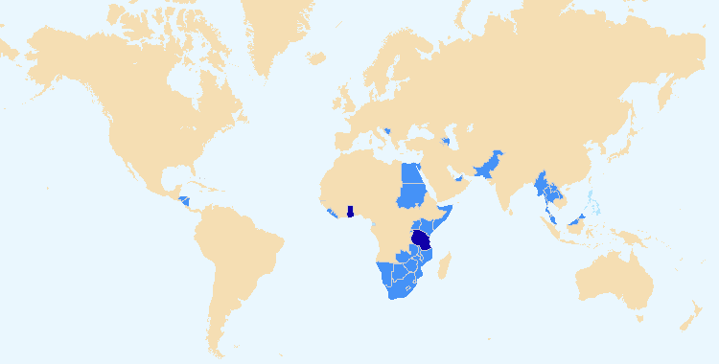

States and organizations which received a positive advice from the Council of UPOV
States and organizations provided with comments on laws
Meetings with government officials

3. Assistance to States and organizations in the accession to the 1991 Act of the UPOV Convention

(a) States that acceded to or ratified the 1991 Act of the UPOV Convention
France, Ireland, Panama
(see Figure 31)

(b) States and organizations that became members of the Union
Serbia
(see Figure 30)

Figure 28. States/Organizations provided with comments on laws | Figure 29. States/Organizations which received positive advice from the Council
Figure 30. New members of the Union | Figure 31. Accession to/ratification of the 1991 Act

4. Assistance in implementing an effective plant variety rights system in accordance with the 1991 Act of the UPOV Convention

(a) Participation in distance learning courses
UPOV DL-205 “Introduction to the UPOV System of Plant Variety Protection under the UPOV Convention”

Number of participants in regular DL-205 sessions in 2012 and 2013

Category | Number of students
Category 1: Government officials of members of the Union nominated by the relevant representative to the UPOV Council | 579
Category 2: Officials of observer States / intergovernmental organizations nominated by the relevant representative to the UPOV Council | 24
Category 3: Others | 36
Category 4: Discretionary waiving of fee for selected students | 9
Total: | 648

List of States from which there were participants in the regular DL-205 sessions in 2012 and 2013:

Algeria, Argentina, Australia, Austria, Belgium, Bolivia, Brazil, Bulgaria, Cambodia, Canada, Chile, China, Colombia, Costa Rica, Côte d’Ivoire, Croatia, Ecuador, Egypt, Estonia, Finland, France, Germany, Greece, Honduras, Hungary, India, Indonesia, Iran (Islamic Republic of), Israel, Italy, Japan, Kenya, Lao People's Democratic Republic, Latvia, Lebanon, Lithuania, Mexico, Morocco, Netherlands, New Zealand, Nicaragua, Nigeria, Norway, Oman, Pakistan, Paraguay, Peru, Philippines, Poland, Republic of Korea, Republic of Moldova, Russian Federation, Serbia, Singapore, Slovakia, South Africa, Spain, Sri Lanka, Sweden, Switzerland, Thailand, Tunisia, Turkey, Ukraine, United Kingdom, United Republic of Tanzania, United States of America, Uruguay, Viet Nam, Zimbabwe (total: 70 States).
(see Figures 32 to 34)

Figure 32. UPOV DL-205 Course: 2012 and 2013 participation

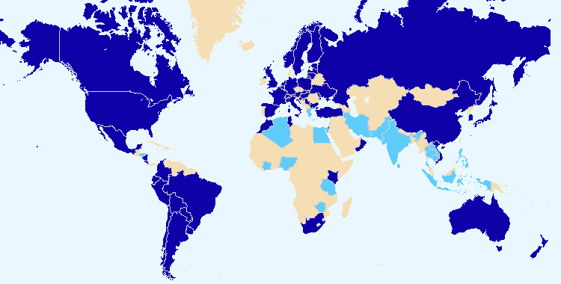

Members of the Union Non-members of the Union

Total number of participants by category in regular DL-205 sessions since 2006

Category | Number of students
Category 1: Government officials of members of the Union nominated by the relevant representative to the UPOV Council | 2,157
Category 2: Officials of observer States / intergovernmental organizations nominated by the relevant representative to the UPOV Council | 138
Category 3: Others | 180
Category 4: Discretionary waiving of fee for selected students | 13
Total: | 2,488

Figure 33. Participants in the main sessions of the  DL-205 Course  by registration category | Figure 34. Participants in the main sessions of the  DL-205 Course  by language

Special sessions of DL-205 in 2012 and 2013

Month/  Year | Name of Course | Language | Number. of participants
Feb. 2012 | WIPO “Master II en droit de la propriété industrielle” | FR | 20
April 2012 | USPTO/UPOV Training Course “Plant Variety Protection under the UPOV Convention” (United States of America) | EN | 10
June 2012 | Naktuinbouw International Course on Plant Variety Protection Course (Netherlands) | EN | 18
July 2012 | KOICA Training Course on Plant Variety Protection (Republic of Korea) | EN | 14
Sept. 2012 | JICA Training Course on “Internationally Harmonized Plant Variety Protection System” (Japan) | EN | 9
Dec. 2012 | XI Training Course for Ibero-American Countries on the Protection of New Varieties of Plants (Uruguay) | ES | 12
June 2013 | Naktuinbouw International Course on Plant Variety Protection Course (Netherlands) | EN | 30
July 2013 | KOICA Training Course on Plant Variety Protection (Republic of Korea) | EN | 12
 | JICA Training Course on “Internationally Harmonized Plant Variety Protection System” (Japan) | EN | 9
October 2013 | XII Training Course for Ibero-American Countries on the Protection of New Varieties of Plants (Uruguay) | ES | 11

(b) Participation by observer States and organizations in the CAJ, TC, TWPs and the associated preparatory workshops
See Sub-Program UV.2, Section 2.2, performance indicator 4 “Participation by members of the Union and stakeholders in the work of the UPOV bodies”, sections (a) to (d)

(c) Participation in UPOV activities
See Sub-Program UV.3, Section 2.3, performance indicator 1 “Raising awareness of the role of plant variety protection in accordance with the UPOV Convention”, section (b)

(d) Participation in activities involving UPOV staff or UPOV trainers on behalf of UPOV staff
See Sub-Program UV.3, Section 2.3, performance indicator 1 “Raising awareness of the role of plant variety protection in accordance with the UPOV Convention”, section (e)

(e) Training provided by UPOV trainers in non-UPOV activities
2012

Training Venue (State) | Participants by State/Organization
Philippines | Philippines, International Rice Research Institute (IRRI)

2013

Training Venue (State) | Participants by State/Organization
Azerbaijan, Cambodia, China, Indonesia, Japan, Lao People’s Democratic Republic, Philippines, Spain, Sri Lanka, Ukraine, Uruguay, Viet Nam | Afghanistan, Algeria, Argentina, Azerbaijan, Bolivia, Brazil, Cambodia, China, Colombia, Costa Rica, Cuba, Dominican Republic, Ecuador, Egypt, Guatemala, Honduras, India, Indonesia, Lao People’s Democratic Republic, Maldives, Mexico, Morocco, Nicaragua, Paraguay, Peru, Philippines, Senegal, Spain, Sri Lanka, Thailand, Tunisia, Uganda, Ukraine, Uruguay, Viet Nam

(f) Implementation of projects with partner organizations and donors
World Seed Project:
- In 2012, 18 electronic meetings and 5 meetings of the Steering Committee
- In 2013, 12 electronic meetings, 4 meetings of the Steering Committee and one meeting of the Steering Committee with potential resource partners

(g) Use of assistance web-page to obtain project support
- The assistance web-page was made available on the restricted area of the UPOV website in 2012.

2.4 Sub-Program UV.4: External Relations

The UPOV website continues to be the focal point for dissemination of information, with an increasing number of visits and visitors (15% increase compared to 2012). In 2013, the UPOV Trilogy, comprising an Executive Summary and the proceedings of the “Symposium on Plant Breeding for the Future”, the “Seminar on Plant Variety Protection and Technology Transfer: the Benefits of Public-Private Partnership” and the “Symposium on the Benefits of Plant Variety Protection for Farmers and Growers”, was published in printed and electronic form (English only). The regular publication of press releases, including those highlight developments in the Council of UPOV, provide a valuable means of disseminating information to the general public. A further important development in 2013 was the establishment of a communication strategy with the aim of improving the level of understanding of the UPOV system. One of the priorities of the workplan would be the development of stakeholder-focused features on the UPOV website, with a focus on breeders, seed producers / plant propagators, farmers and policy-makers. As part of the strategy, a first set of answers to frequently asked questions was agreed.

A number of intergovernmental organizations have invited UPOV to contribute to their work. UPOV has participated in meetings with other relevant organizations.

Objectives | - To enhance the understanding of the UPOV system of plant variety protection by the public and non-governmental organizations.  - To provide information on the UPOV Convention to other intergovernmental organizations, with the aim of achieving mutual supportiveness with other international treaties.

Results Achieved: Selected Performance Indicators

1. Increased public understanding of UPOV’s role and activities

(a) Availability of public-orientated information and materials on UPOV Website
- Symposium on the Benefits of Plant Variety Protection for Farmers and Growers
  - presentations and closing remarks posted on the UPOV website at: http://www.upov.int/meetings/en/details.jsp?meeting_id=26104
- UPOV Trilogy Box Set (in English only), also available on the UPOV website at http://www.upov.int/about/en/benefits_upov_system.html, containing the following publications:
  - Executive Summary (UPOV Publication 357.1E)
  - Symposium on Plant Breeding for the Future (UPOV Publication 357.2E)
  - Seminar on Plant Variety Protection and Technology Transfer: the Benefits of Public-Private Partnership (UPOV Publication 357.3E)
  - Symposium on the Benefits of Plant Variety Protection for Farmers and Growers (UPOV Publication 357.4E)
- Seminar on Essentially Derived Varieties:
  - materials and video posted on the UPOV website at:
http://www.upov.int/meetings/en/details.jsp?meeting_id=29782
- Seven press releases (http://www.upov.int/news/en/pressroom/)

(b) Visits to website
 | 2013 | 2012 | 2011 | 2010
Number of sessions: | 178,732 | 151,914 | 140,371 | 118,895
Unique users: | 84,336 | 71,506 | 75,673 | 62,758
Number of pageviews: | 1,129,052 | 1,139,570 | 798,942 | 656,722
Number of pages/visit: | 6.32 | 7.50 | 5.69 | 5.52
Average visit duration: | 00:06:35 | 00:07:19 | 00:04:41 | 00:04:12
Percentage of new visits: | 54.6% | 45.05% | 51.91% | 50.57%

Website Overview: Global Coverage in 2013  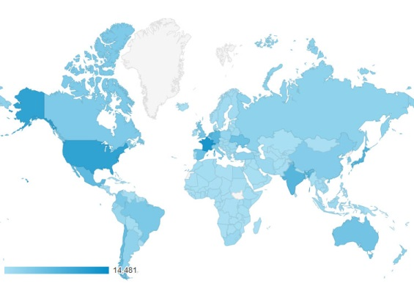 | Sessions by country:  1. Switzerland (8%)  2. France (7%)  3. United States of America (6%)  4. Japan (4%)  5. Netherlands (4%)  6. India (4%)  7. Germany (4%)  8. Mexico (4%)  9. Chile (3%)  10. Spain (3%)

Language of visitor’s browser | 2013 |  | 2012 |  | 2011 |  | 2010
 | Visits | % | Visits | % | Visits | % | Visits | %
- en-us: English (US) | 70,706 | 39.56 | 57,341 | 37.75 | 50,571 | 36.03 | 46,527 | 39.13
- es: Spanish | 18,669 | 10.45 | 19,001 | 12.51 | 23,605 | 16.82 | 16,141 | 13.58
- fr: French | 13,876 | 7.76 | 14,212 | 9.36 | 10,670 | 7.60 | 11,169 | 9.39
- es-es: Spanish (Spain) | 9,234 | 5.17 | 5,698 | 3.75 | 9,124 | 6.50 | 4,104 | 3.45
- ru: Russian | 6,596 | 3.69 | 3,630 | 2.39 | 3,168 | 2.26 | 2,509 | 2.11
- ja: Japanese | 6,444 | 3.61 | 7,562 | 4.98 | 6,387 | 4.55 | 5,349 | 4.50
- nl: Dutch | 4,347 | 2.43 | 4,152 | 2.73 | 2,742 | 1.95 | 2,671 | 2.25
- de: German | 3,998 | 2.24
- pt-br: Portuguese (Brazil) | 4,014 | 2.25
- de-de: German | 4,065 | 2.27 | 4,562 | 3.00 | 5,577 | 3.97 | 7,068 | 5.94

Website Overview: Where are the users going?

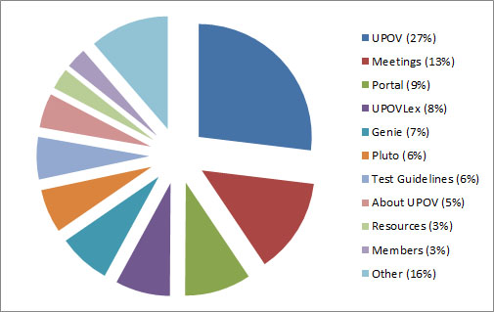

Number of sessions and users of the UPOV site since 2007

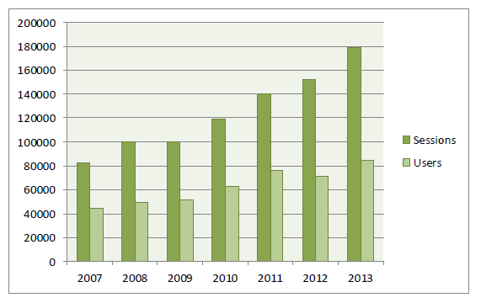

Summary of selected website features for the past three years (Pageviews):

 | 2013 | 2012 | 2011
GENIE | 84,306 | 85,149 | 59,735
PLUTO | 70,739 | 255,108 | 30,226
Test Guidelines | 68,479 | 65,471 | not available
UPOV LEX | 88,533 | 91,245 | 19,269

Devices used to consult the UPOV Website in 2013

Desktop | 170,856 (96%)
Mobile | 4,797 (3%)
Tablet | 3,079 (2%)

2. Provision of information to other organizations

Participation at meetings and/or activities with relevant organizations
Intergovernmental organizations:

- ARIPO, European Union (CPVO), ECO, FAO, IDLO, ISTA, OAPI, OECD, WIPO and WTO.

Other organizations:

- AFSTA, APSA, CIOPORA, ESA, FELAS, ISF, IUBS Commission and SAA.

3. FINANCIAL PERFORMANCE

This section provides an overview of financial performance and the number of posts of the Office of the Union. Further detailed information is provided in documents C/48/4 “Financial Management Report for the 2012-2013 Biennium” and C/48/13 “Financial Statements for 2013”.

3.1 Income, expenditure and reserves

Table 1: Income, expenditure and reserves 2008-2009, 2010-2011 and 2012-2013
(in thousands of Swiss francs)

* Actual income/expenditure on a budgetary basis
(see document C/48/4 "Financial Management Report for the 2012-2013 Biennium", Statement V)

3.2 Structure of budget

Table 2: Structure of budget 2012-2013 as compared to 2008-2009 and 2010-2011
(in thousands of Swiss francs)

3.3 Budget variation by object of expenditure

Table 3: Budget variation by object of expenditure
(in thousands of Swiss francs)

* Expenses under that grouping are no longer reported separately in the 2012-2013 Biennium.
Personnel Resources

Personnel resources amounted to 4.1 million Swiss francs in 2012/13, 0.5 million Swiss francs less than the 2012/13 Approved Budget. This reduction was the result of one of the posts in the professional category being vacant and changes of grade due to personnel changes. The reduction under Posts of 1.0 million Swiss francs was offset by an increase by 0.5 million Swiss francs under Temporary staff. Two staff members, previously employed at 80%, returned to work at 100% during the 2012/13 Biennium.

Non-Personnel Resources

Total Non-Personnel expenditure amounted to 2.2 million Swiss francs, in line with the budgeted target (99% of the budget). Explanations by cost categories are provided below.

Travel

Travel costs were broadly in line with budgeted costs in the 2012/13 Biennium.

Contractual Services

Total Contractual Services were in line with budgeted costs (102% of the budget). Conference costs were significantly below the budgeted figure at 175 thousand Swiss francs compared to 250 thousand Swiss francs (70% of the budget). The remaining Contractual Services costs were significantly above the budgeted figure at 262 thousand Swiss francs compared to 180 thousand Swiss francs (146% of the budget). Most of the costs initially budgeted under “Experts” were categorized under “Other Contractual Services” as a result of changes in the cost categories. The expenditure for “Other Contractual Services” includes the expenditure on information technology (IT) experts in relation to the development of an electronic application form and an electronic template for Test Guidelines, experts to supplement the work of the UPOV staff in the development of the advanced distance learning training course “Examination of applications for plant breeders’ rights” (DL­305) and the administration of the DL-205 course “Introduction to the UPOV System of Plant Variety Protection under the UPOV Convention”.

Operating Expenses

Operating Expenses were in line with budgeted costs for the 2012/13 Biennium (101% of the budget).

Equipment and Supplies

Expenditure on Equipment and Supplies for the 2012/13 Biennium was broadly in line with budgeted costs.

Figure 35. Income and expenditure (between 2002 and 2013)
(in thousands of Swiss francs)

3.4 Budget 2010-2011: Posts by category

As indicated in Table 4 below, there was no change in the total number of Posts and their breakdown by categories in the 2012-2013 Biennium. The Program and Budget for the 2012-2013 Biennium anticipated three posts in the director category and three posts in the professional category. However, due to unforeseen personnel changes, the actual number of posts was two in the director category and four in the professional category.

Table 4: Posts by Category

3.5 Income: Variation by source

The actual budgetary income amounted to 6.8 million Swiss francs in the 2012-2013 Biennium, in line with the budgeted target (Table 5 below). Income from contributions, which makes up the single largest source of income (98% of the total), was 11 thousand Swiss francs less than the budgeted figure. The 2012-2013 Approved Budget anticipated one new member of the Union per year. However, there was only one new member of the Union in the 2012-2013 Biennium. Income from publications was 6 thousand Swiss francs less than the budgeted figure. The shortfall is explained by the replacement of the UPOV-ROM Plant Variety Database, which had paying subscribers, by the PLUTO database, which is free to all users. Income from interest was 41 thousand Swiss francs less than the budgeted figure because the interest rates on the funds deposited with the Swiss National Bank were lower than expected. Other income was 52 thousand Swiss francs more than the budgeted figure. Other income includes administrative support costs under Funds in Trust, income from participants’ fees in the UPOV distance learning program and accounting adjustments for previous years.

Table 5: Income: Variation by source
(in thousands of Swiss francs)

3.6 Income, expenditure and reserves

Table 6: Income, Expenditure and Reserve and Working Capital Funds (RWCF)
(in thousands of Swiss francs)

Figure 36. Income, expenditure and reserves for 2003-2013
(in thousands of Swiss francs)

C/48/12

APPENDIX

ACRONYMS AND ABBREVIATIONS

UPOV terms

BMT | Working Group on Biochemical and Molecular Techniques, and DNA-Profiling in Particular
CAJ | Administrative and Legal Committee
DL-205 | UPOV distance learning course “Introduction to the UPOV System of Plant Variety Protection under the UPOV Convention”
DL-305 | UPOV distance learning course “Examination of Applications for Plant Breeders’ Rights”
DUS | Distinctness, Uniformity and Stability
EDV | essentially derived variety
Office | Office of the Union
PBR | Plant Breeder’s Right
TC | Technical Committee
TC-EDC | Enlarged Editorial Committee
TWA | Technical Working Party for Agricultural Crops
TWC | Technical Working Party on Automation and Computer Programs
TWF | Technical Working Party for Fruit Crops
TWO | Technical Working Party for Ornamental Plants and Forest Trees
TWP | Technical Working Party
TWV | Technical Working Party for Vegetables

Acronyms

AATF | African Agricultural Technology Foundation
AECID | Spanish Agency for Cooperation and Economic Development
AFSTA | African Seed Trade Association
AIPPI | International Association for the Protection of Intellectual Property
AOHE | Association of European Horticultural Breeders
APBREBES | Association for Plant Breeding for the Benefit of Society
APSA | Asia and Pacific Seed Association
ARIPO | African Regional Intellectual Property Organization
ASEAN | Southeast Asian Nations
ASTA | American Seed Trade Association
BSPB | British Society of Plant Breeders
CBD | Convention on Biological Diversity
CDIP | WIPO Committee on Development and Intellectual Property
CGRFA | Commission on Genetic Resources for Food and Agriculture
CIOPORA | International Community of Breeders of Asexually Reproduced Ornamental and Fruit Varieties
CPVO | Community Plant Variety Office of the European Union
EAPVP Forum | East Asia Plant Variety Protection Forum
ECO | Economic Cooperation Organization
ECOSA | ECO Seed Association
ECOSOC | United Nations Economic and Social Council
EMBRAPA | Brazilian Research Corporation
ESA | European Seed Association
FAO | Food and Agriculture Organization of the United Nations
FELAS | Latin American Federation of Seed Associations
FWCC | Friends World Committee for Consultation
GEVES | Groupe d'étude et de contrôle des variétés et des semences of France
GRIP Course | Genetic Resources and Intellectual Property Rights Course
GRUR | Deutsche Vereinigung für gewerblichen Rechtsschutz und Urheberrecht
IAOC | WIPO Independent Advisory Oversight Committee
ICARDA | International Centre for Agricultural Research in Dry Areas
ICNCP | International Code of Nomenclature for Cultivated Plants
ICNP | Open-ended Ad Hoc Intergovernmental Committee for the Nagoya Protocol on Access and Benefit-sharing
IDLO | International Development Law Organization
IGC | WIPO Intergovernmental Committee on Intellectual Property and Genetic Resources, Traditional Knowledge and Folklore
IPSAS | International Public Sector Accounting Standards
IRRI | International Rice Research Institute
ISF | International Seed Federation
ISHS | International Society for Horticultural Sciences
ISTA | International Seed Testing Association
ITPGRFA | International Treaty on Plant Genetic Resources for Food and Agriculture
IUBS Commission | International Commission for the Nomenclature of Cultivated Plants of the International Union for Biological Sciences
JICA | Japan International Cooperation Agency
KEPHIS | Kenya Plant Health Inspectorate Services
KOICA | Korea International Cooperation Agency
KSVS | Korea Seed and Variety Service
OAPI | African Intellectual Property Organization
OECD | Organisation for Economic Co-Operation and Development
OEVV | Spanish Plant Variety Office
PCT | WIPO Patent Cooperation Treaty
QUNO | Quaker UN Office
QUT | Queensland University of Technology
SAA | Seed Association of the Americas
Sida | Swedish International Development Agency
TAIEX | Technical Assistance and Information Exchange Instrument of the European Union
TRIPS | Trade Related Aspects of Intellectual Property Rights
UN | United Nations
UNDP | United Nations Development Programme
UNIDO | United Nations Industrial Development Organization
UNIGE | University of Geneva
USPTO | United States Patent and Trademark Office
WFO | World Farmers’ Organization
WIPO | World Intellectual Property Organization
WTO | World Trade Organization

[End of appendix and of document]

* Participation is assessed on the basis of the number of participating members and observer States/organization, rather than the number of individual participants.
Provision of detailed comments on laws and/or assistance in the development of laws.
Meetings and/or consultations for the provision of advice and information on legislative matters.
Definitions used in Website statistics in this report: - “Users” are individuals who have had at least one session within the selected date range. - A “session” is the period of time a user is actively engaged with your website. “Sessions” are the total number of sessions within the given date range. - “Unique Pageviews” are the number of visits during which the specified page was viewed at least once. - “Pageviews” are the total number of times that a page was viewed. Repeated views of a single page by the same user during the same session are counted. [Appendix follows]

