E
International Union for the Protection of New Varieties of Plants

Working Group on Biochemical and Molecular Techniques  and DNA-Profiling in Particular  Nineteenth Session  Alexandria, United States of America, September 23 to 25, 2020 | BMT/19/6  Original: English  Date: August 19, 2020
vmDUS - VALUE-MOLECULAR LINKED DISTINCTNESS DETERMINATION
Document prepared by experts from France, Italy and the United Kingdom
Disclaimer: this document does not represent UPOV policies or guidance

1. Introduction

1.1 UPOV's stated mission is to “provide and promote an effective system of plant variety protection, with the aim of encouraging the development of new varieties of plants, for the benefit of society” and these two elements are regarded as complementary. Unfortunately, if the DUS methodology fails to distinguish between a candidate variety with superior end-user value and a lower-value existing registered variety, the protection for the older variety holds precedence. This, unfortunately, results in the breeding progress within the new candidate being discarded. Although the initial breeder’s IPR is correctly prioritised, it is an unsatisfactory outcome for UPOV as it contravenes a major aspect of its mission statement.

1.2 Over a number of years, concerns have been rising in certain species, that the diversity in the classical UPOV morphophysiological characters is progressively becoming captured by the increasing numbers of registered varieties. There is evidence of this from the United Kingdom, where a 20% candidate rejection rate in Lolium spp. and white clover (Trifolium repens L.), comprises 12% not distinct and 8% not uniform (Gilliland and Gensollen 2010; Gilliland, pers. comm., 2019). Likewise, in France, the overall rejection rate for grass and lucerne (Medicago sativa L.) candidates peaked at 20-25% after a standard three-year examination. What is disconcerting is that around a third of these French rejections were overturned following extra testing when breeders appealed the initial refusal because they believed their candidates had market value (Gensollen, GEVES, pers. comm., 2015). Furthermore, in both territories, some varieties of improved end-use value were still rejected for absence of distinctness.

1.3 Test records show that non-distinctions are more frequent between varieties from the same breeding programme or with contemporary market leaders. This later aspect does not indicate any malpractice. This is because breeders are permitted to exploit positive genes in any registered variety they do not own, by using plants from that variety as parents in crosses with their own germplasm. If, during the subsequent selective crossings and evaluations, the new candidate does not sufficiently diverge from the protected source variety, then it correctly fails the DUS test. Arguably, however, if the candidate has a statistically significant greater value to a registered variety, and is shown not to be predominately derived from that variety, the DUS system should be sufficiently adaptive to award PBR.

1.4 The remainder of this paper uses examples from outbreeding herbage species to demonstrate the principles and practicality of this value-molecular linked ‘vmDUS’ concept (vmDUS) system which is also suitable for wider use in DUS testing of other species, where appropriate.

2. The value-molecular linked ‘vmDUS’ concept

2.1 High throughput genotyping has proven capability for diversity analyses (Byrne et al, 2013) and major gene identification (Liu and Yu, 2017) and its efficacy as a discriminating tool has previously been presented to the BMT (eg among lucerne varieties; BMT/16/17, 2017). Hence, BMT has produced proposals for how this technology could be applied to certain variety protection functions (TGP/15/2 Draft 1, 2018). These proposals include using markers for combining phenotypic and molecular distances to manage reference collections, for identifying similar varieties within the reference collection and as proxies for major genes.

2.2 While recognising the IPR position of principle incumbent on UPOV, the vmDUS proposal seeks to implement a molecular discrimination subject to the fulfilment of precisely defined evidence of ‘improved value’. Consequently, marker testing would only be undertaken when a candidate variety has a statistically significant improvement in a value trait compared to the registered variety for which the existing DUS procedures cannot provide a distinction (eg at a probability of p<0.01 or as a discrete character state). The source of this evidence could be from a formal ‘Value of Cultivation and Use’ scheme, but equally any statistically valid evidence of greater candidate value could be used. Some UPOV guidelines would be required to define what form of evidence was acceptable. If a direct comparison between the candidate and registered varieties does not exist, indirect statistical comparisons can provide the necessary standard errors for variety pair comparison using linkage controls (for example the long standing fitted constant analyses of Silvey, 1978). If this cannot be achieved then the evidence for improved value does not exist and the marker-based vmDUS test cannot be initiated.

2.3 The concept underpinning vmDUS is that there are basically two fundamentally different reasons why a registered and a candidate variety are indistinguishable. This is either due to non-divergence or to convergence during breeding. These juxtaposing scenarios (A and B below) have differing implications for the protection of existing varieties:

Scenario A: Candidate is indistinguishable using current DUS tests as it has not sufficiently diverged in its DUS morphophysiological identity from a genepool it shares with the registered variety, (ie due to the registered variety having provided the genetic base or parental material used in synthesising the candidate).
Scenario B: Candidate is indistinguishable using current DUS tests as it has converged in its DUS morphophysiological identity to a registered variety, (ie despite being from a genepool that is effectively independent of that registered variety).

Therefore, the vmDUS molecular assessment would require a statistically valid test of variety distinctness (e.g. based on hundreds or thousands of SNP markers), to verify whether the candidate variety was bred from a sufficiently diversified genepool rather than being essentially derived from a protected variety.

2.4 The diagrams on the following two pages further explain pictorially the logic underpinning the vmDUS decision process, with associated descriptions of how candidates with different genetic backgrounds and performance values would be judged.

In Scenario A, the candidates (Regan, Reggie and Regina) have all been bred from a genepool largely provided by the registered variety Reg. Therefore, they must sufficiently diverge in DUS characters from the source variety Reg to gain PBR.

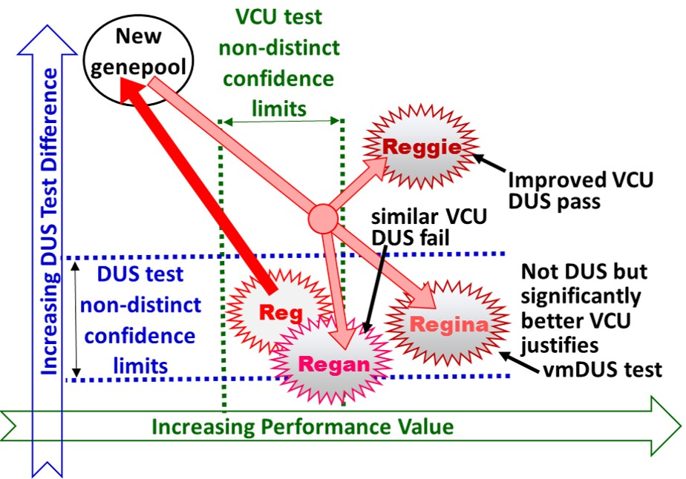
Figure 1. Scenario A: ‘Divergence’ - candidate and registered variety DUS and performance
value relationships.
Reg is the registered variety that has contributed entirely or largely to the new genepool to produce candidate varieties Regan, Reggie and Regina.
[Broad arrows show germplasm source; dotted lines represent significant difference limits for ‘performance value’ and DUS differences].

As shown in Figure 1:
- Reggie is both DUS distinct and has an improved VCU compared to Reg and so automatically passes DUS without any need of a vmDUS test.
- Regan does not have an improved VCU compared to Reg and is not significantly different in DUS from Reg and therefore would correctly be refused registration, with no justification for a vmDUS test.
- Regina is not DUS distinct from Reg but has a significantly better VCU performance which would justify a vmDUS examination. As Regina was bred out of a genepool largely provided by Reg, the molecular markers would be expected to reveal the degree of relatedness to Reg and would determine if Regina passed the vmDUS test or failed for being too closely constructed out of Reg.

In Scenario B, all candidates (Starter, Fresh and Initial) are new synthetics from an independent genepool to that of Reg.

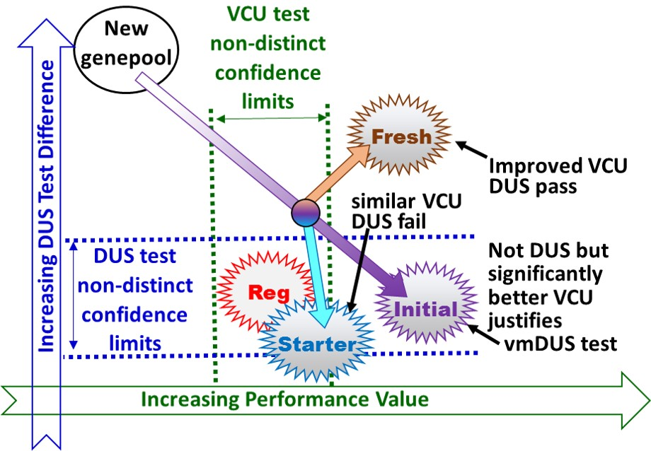
Figure 2. Scenario B: convergence—candidate and registered variety DUS and performance
value relationships.
Reg is the registered variety; Fresh, Starter and Initial are candidates bred from a largely independent gene pool.
[Broad arrows show candidate germplasm source; dotted lines represent significant difference limits for ‘performance value’ and DUS differences]

As shown in Figure 2:
Fresh is DUS distinct (and higher performing than Reg) and so automatically passes DUS without any need of a vmDUS test.
Starter has converged with Reg as it is not DUS distinct from it and has a similar value performance. So, it correctly fails DUS with no justification for a vmDUS test (even if its value was sufficient to justify it being marketed).
Initial is not DUS distinct from Reg but has a significantly higher value. Similar to Regina in Scenario A, evidence of superior value compared to the blocking variety would justify a vmDUS test.

In this scenario the molecular markers would be expected to reveal a large genetic distance between Initial and Reg and thus evidence of phenotypic convergence from a distinct genepool. If so, Initial would pass the vmDUS test and get registered. This would correctly reward the breeder for achieving a significant genetic improvement by a valid breeding activity and ensure it could be marketed to benefit users.

3. Implementation of the vmDUS Proposal

3.1 The vmDUS molecular examination would need to have a UPOV approved pass/fail threshold. Therefore, in a process that matches the morphophysiological trait-based distinctness, vmDUS distinctness could assess the whole set of available markers and using a statistical test to express a Type 1 error probability, apply a p<0.01 pass threshold. For allogamous species, this could be based on 3-4 independent bulked DNA samples each from a separate set of plants, applying ANOVA of variety scores on principal components axes or discriminant analysis. A similarly stringent approach could be applied to species of different genetic construction

3.2 As an alternative, distinctness could be granted on the grounds of a minimal threshold of a genetic distance measure, without statistical tests. The proposal would be to explore methods that follow similar principles to previously published guidance on marker use to differentiate between convergent and divergent pairings (UPOV 2018). Indeed, for species where there is an agreed molecular threshold for EDV, an approved pass standard for the vmDUS test could be set beyond the EDV threshold, based on the same research evidence. So, for example, the EDV threshold for perennial ryegrass (L. perenne L.) established by Roldan-Ruiz et al (2000), which lead to the microsatellite methodology adopted by ISF (2009, 2020), could be directly adapted to this new function. Therefore, when a genetic distance between a registered variety and a candidate variety exceeded an agreed point beyond this EDV threshold, they would be regarded as being from independent genepools.

3.3 In species without any thresholds or comprehensive data sets of variety molecular diversity, implementing vmDUS will require the prior genotyping of the entire reference collection and the provision of an easy-to-use marker tool to Registration Offices. This will likely comprise of some hundred highly-discriminating SNP markers (such as a small array or a RAD capture tool). Currently two EU Horizon 2020 projects, INVITE (H2020-SFS-2018-2, www.h2020 -invite.eu) and InnoVar (H2020-SFS-2018-29, https://cordis.europa.eu/proje ct/rcn/22322 3/facts heet/en) are scoping the definition of such a tool for several species, including lucerne and perennial ryegrass. A more detailed description of the vmDUS concept has been peer-review published by Gilliland et al (2020).

4. Summary

4.1 First and foremost, the vmDUS proposal accepts that PBR must protect the commercial investment imbedded in existing registered varieties and so candidates that are not ‘unique’ and ‘improved’ are correctly barred from registration. However, when the currently approved morphophysiological DUS tests reject the registration of significantly higher performing candidates, the UPOV process is infringing its own core objective of promoting genetic improvement. Therefore, it is vital that UPOV acts to remove any unjust impediments to genetic gain that penalise breeders, growers and end-users.

4.2 As morphophysiological DUS character testing can’t differentiate divergence from convergence, molecular markers are currently the only option to resolve the present anomaly. As described, the vmDUS decision processes are designed to differentiate between true breeding and plagiaristic exploitation of a protected variety. If adopted, vmDUS would be the first time that evidence of a statistical improvement in a variety’s ‘value’ was used to justify a specific test for awarding PBR. Once a vmDUS distinction is achieved, that molecular identity would form part of the description of the newly registered variety. However, due to the safety lock requirement for evidence of a statistically significant improvement in value, vmDUS can be implemented without setting a prescient that automatically leads to a wider use of molecular markers in distinctness testing.

5. References

BMT/16/17. (2017). Use of GBS for lucerne variety distinctness. Julier, B., Barre, P., Lambroni, P., Delaunay, S., Thomasset, M., Lafaillette, F., & Gensollen, V. (authors), Working Group on Biochemical and Molecular Techniques and DNA Profiling in Particular. La Rochelle, France, November 7 to November 10, 2017. Retrieved from http://www.upov.int/edocs/mdocs/upov/en/bmt_16/bmt_16_17.pdf

Byrne, N., Gilliland, T. J., McHugh, N., Delaby, L., Geoghegan, A., & O'Donovan, M. (2017). Establishing phenotypic performance of grass varieties on Irish grassland farms. Journal of Agricultural Science, 155, 1633–1645. https://doi.org/10.1017/S0021 85961 7000740

Gilliland, T. J., & Gensollen, V. (2010). Review of the protocols used for assessment of DUS and VCU in Europe-perspectives. In C. Huyghe (Ed.), Sustainable use of genetic diversity in forage and turf breeding (pp. 261–275). Dordrecht, The Netherlands: Springer.

Gilliland, T. J., Annicchiarico, P., Julier, B. and Ghesquière, M. (2020). A proposal for enhanced EU herbage VCU and DUS testing procedures. Grass and Forage Science, Accepted: 31 May 2020 and published online at https://doi.org/10.1111/gfs.12492
ISF. (2009). International seed federation, guidelines for handling a dispute on essential derivation in ryegrass. Retrieved from www.worldseed.org/wp-content/uploads/2015/10/Guide lines_EDV_Ryegrass_Nov_2009.pdf.

Liu, X. P., & Yu, L. X. (2017). Genome-Wide Association Mapping of Loci Associated with Plant Growth and Forage Production under Salt Stress in Alfalfa (Medicago sativa L.). Frontiers in Plant Science, 8, 1–13. https://doi.org/10.3389/fpls.2017.00853BMT/16/17,2017

Roldan-Ruiz, I., Calsyn, E., Gilliland, T. J., Coll, R., Van Eijk, M. J. T., & De Loose, M. (2000). Estimating Genetic conformity between related ryegrass (Lolium) varieties, II. AFLP-based markers. Molecular Breeding, 6, 593–602. https://doi.org/10.1023/A:1011398124933

Silvey, V. (1978). Methods of analysing NIAB variety trials over many sites and several seasons. Journal of the National Institute of Agricultural Botany, 14, 385–400.

TGP/15/2 Draft 1. (2018). Guidance on the Use of Biochemical and Molecular Markers in the Examination of Distinctness, Uniformity and Stability (DUS). Retrieved from https://www.upov.int/meetings/en/topic.jsp?group_id=261

UPOV (2013). Guidance of the use of biochemical and molecular markers in the examination of distinctness, uniformity and stability (DUS). Document TGP/15, Geneva, pp 1–10. Retrieved from https://www.upov.int/meetings/en/doc_details.jsp?meeting_id=47214&doc_id=415191

¹Gilliland, T. J., ²Annicchiarico, P., ³Julier B. and ³Ghesquière M.

¹Institute of Global Food Security, Queens University Belfast, Northern Ireland, UK
²Council for Agriculture Research and Economics (CREA), Research Centre for Animal Production and Aquaculture, viale Piacenza 29, 26900 Lodi, Italy
³INRAE, P3F, RD 150 Le Chêne, CS 80006, 86600 Lusignan, France

[End of document]

The denominations are fictitious and do not correspond to any existing varieties or candidate varieties
The denominations are fictitious and do not correspond to any existing varieties or candidate varieties

