|  |  |
| --- | --- |
|  | E |
| International Union for the Protection of New Varieties of Plants |  |

|  |  |
| --- | --- |
| Working Group on Biochemical and Molecular Techniques  and DNA-Profiling in Particular  Nineteenth Session Alexandria, United States of America, September 23 to 25, 2020 | BMT/19/15 Corr.  Original: English  Date: October 8, 2020 |

REPORT

prepared by the Office of the Union

Disclaimer: this document does not represent UPOV policies or guidance

## Opening of the session

The Working Group on Biochemical and Molecular Techniques and DNA-Profiling in Particular (BMT) held its nineteenth session, hosted by the United States of America and organized by electronic means, from September 23 to 25, 2020. The list of participants is reproduced in Annex I to this report.

The opening of the BMT session was held on Monday, September 21, in conjunction with the opening of the Technical Working Party on Automation and Computer Programs (TWC), which was held from September 21 to 23, 2020. The session was opened by Mr. Nik Hulse (Australia), Chairperson of the BMT, who welcomed the participants and thanked the United States of America for hosting the BMT session. The BMT was co-chaired by Ms. Beate Rücker (Germany), Vice-Chairperson of the Technical Committee.

The BMT was welcomed by Ms. Ruihong Guo, Deputy Administrator, AMS, Science & Technology Program, United States Department of Agriculture (USDA) and received a presentation on Plant Variety Protection in the United States of America from Mr. Jeffery Haynes, Commissioner, Plant Variety Protection Office, USDA. A copy of the presentation is provided in Annex II to this report.

## Adoption of the agenda

The BMT adopted the agenda as reproduced in document BMT/19/1 Rev.

## Reports on developments in UPOV concerning biochemical and molecular techniques

The BMT received a presentation from the Office of the Union on developments in UPOV concerning biochemical and molecular techniques, a copy of which is provided in document BMT/19/2.

## Short presentations on new developments in biochemical and molecular techniques by DUS experts, biochemical and molecular specialists, plant breeders and relevant international organizations

No documents were received for this agenda item.

## Report of work on molecular techniques in relation to DUS examination

### vmDUS: Value-molecular linked distinctness determination (document BMT/19/6)

The BMT received a presentation on “vmDUS: Value-molecular linked distinctness determination” from Mr. Trevor Gilliland (Queen’s University Belfast, United Kingdom), a copy of which is reproduced in documents BMT/19/6 and BMT/19/6 Add..

### CPVO report on IMODDUS: Update on R&D projects (document BMT/18/4)

The BMT received a presentation on “CPVO report on IMODDUS: Update on R&D projects” from Ms. Cécile Collonnier (European Union), a copy of which is reproduced in document BMT/19/4.

### Developing a strategy to apply SNP molecular markers in the framework of winter oilseed rape DUS testing (document BMT/19/11)

The BMT received a presentation by Mr. Marc Delêtre (France), a copy of which is reproduced in document BMT/19/11.

### French strategy for access to molecular data and proof of concept for combining phenotype and genotype (document BMT/19/12)

The BMT received a presentation by Ms. Valerie Cadot (France), a copy of which is reproduced in document BMT/19/12.

## Review of document UPOV/INF/17 “Guidelines for DNA-Profiling: Molecular Marker Selection and Database Construction” (documents BMT/19/3 and UPOV/INF/17/2 Draft 3)

The BMT considered documents BMT/19/3 Rev. and UPOV/INF/17/2 Draft 3.

The BMT agreed that the draft guidance presented in Annex III to this report should be proposed to the Technical Committee as the basis for a future revision of document UPOV/INF/17, subject to incorporating the amendments indicated in the text.

## Variety description databases including databases containing molecular data

No documents were received for this agenda item.

## Methods for analysis of molecular data, management of databases and exchange of data and material

No documents were received for this agenda item.

## The use of molecular techniques in examining essential derivation

No documents were received for this agenda item.

## The use of molecular techniques in variety identification

No documents were received for this agenda item.

## Confidentiality, ownership and access to molecular data

### Access to reference material and molecular data from CPVO Examination Offices (document BMT/19/5)

The BMT received a presentation by Ms. Cécile Collonnier (European Union), a copy of which is reproduced in document BMT/19/5.

### Survey on confidentiality and ownership of molecular information (document BMT/19/8)

The BMT received a presentation from Mr. Marcel Bruins on behalf of CropLife International (CLI), Euroseeds, International Community of Breeders of Asexually Reproduced Horticultural Plants (CIOPORA), International Seed Federation (ISF) and Seed Association of the Americas (SAA), a copy of which is reproduced in document BMT/19/8.

## Cooperation between international organizations (document BMT/19/9)

The BMT considered document BMT/19/9.

The BMT noted that the TC, at its fifty-fifth session, had agreed:

(a) the elements for the inventory on the use of molecular marker techniques, by crop, as set out paragraph 7 of document BMT/19/9;

(b) that a circular would be issued to request members of the Union to complete a survey as a basis to develop an inventory on the use of molecular marker techniques, by crop, in coordination with the OECD;

(c) for joint OECD, UPOV, ISTA workshops to be repeated in future, as a possible joint initiative in relation to molecular techniques;

(d) to propose a joint initiative that each organization inform the others about use of molecular markers in their work;

(e) that information from the survey on the techniques could help to clarify techniques that were considered to be biochemical or molecular; and

(f) that relevant elements from the World Seed Partnership and the FAQ on the use of molecular techniques in the examination of DUS, would be a suitable basis for the Office of the Union to develop a draft of a joint document explaining the principal features of the systems of OECD, UPOV and ISTA, in consultation with OECD.

### (a) International Organization for Standardization

The BMT received a presentation from Mr. Raymond D Shillito (International Organization for Standardization (ISO)) on “Horizontal methods for molecular biomarker analysis”, a copy of which is reproduced in document BMT/19/14.

### (b) International Seed Testing Association

The BMT received a presentation from Ms. Ana Laura Vicario (International Seed Testing Association (ISTA)) on “ISTA approach for DNA based markers”, a copy of which is reproduced in document BMT/19/13.

### (c) OECD Seed Scheme: an international seed varietal certification system

The BMT received an oral report from Ms. Sophia Gnych (Organisation for Economic Co-operation and Development (OECD)) on developments at OECD on biochemical and molecular techniques.

## Session to facilitate cooperation (document BMT/19/10)

The BMT considered document BMT/19/10.

The BMT noted that the TWPs and BMT, at their sessions in 2019, had formed discussion groups to allow participants to exchange information on their work on biochemical and molecular techniques and explore areas for cooperation.

The BMT noted the outcomes of discussions at the TWPs and BMT on facilitating cooperation in relation to the use of molecular techniques, as presented in the Annex to document BMT/19/10.

The participants at the nineteenth session of the BMT were invited to report on their work on biochemical and molecular techniques and to explore areas for cooperation. The information provided by participants is reproduced in Annex IV to this report.

The BMT noted the information by the Seed Association of the Americas about the recently released paper on "Single nucleotide polymorphisms facilitate distinctness‐uniformity‐stability testing of soybean cultivars for plant variety protection”, which was freely available via at following link:

<https://acsess.onlinelibrary.wiley.com/doi/full/10.1002/csc2.20201>

## Organization of work of the TWC and the BMT (document BMT/19/7)

The BMT considered document BMT/19/7.

The BMT considered the draft terms of reference for a possible single body to encompass the work of the TWC and BMT, as set out in document BMT/19/7, paragraph 19.

The BMT agreed with the TWC that the merger of the TWC and BMT would be an opportunity to address the topics of common interest to both groups.

The BMT noted the range of elements covered in the draft terms of reference and agreed with the TWC to caution against the reduction of depth in technical discussions. The BMT agreed with the TWC that the new body should maintain the level of relevance on discussions to avoid reducing the interest for experts to participate.

The BMT agreed with the TWC that new ways of conducting meetings could be considered to facilitate attendance by experts from different disciplines. This might incorporate the possibility to participate by remote means and creating working groups for specific topics.

The BMT agreed on the need to organize the agenda during the week for discussion on specific topics. The BMT agreed that the frequency of the meetings should be a consideration.

The BMT agreed with the TWC to propose a regular review of the creation of a single body to encompass the work of the TWC and BMT to address any issues accruing from the merger.

## Date and place of next session

At the invitation of the United States of America, the BMT agreed to hold its twentieth session in Alexandria, Virginia, jointly with the TWC, during the week of September 20, 2021.

## Future program

During its twentieth session, the BMT planned to discuss the following items:

1. Opening of the session

2. Adoption of the agenda

3. Reports on developments in UPOV concerning biochemical and molecular techniques (document to be prepared by the Office of the Union)

4. Short presentations on new developments in biochemical and molecular techniques by DUS experts, biochemical and molecular specialists, plant breeders and relevant international organizations (reports by participants)

5. Report of work on molecular techniques in relation to DUS examination (papers invited)

6. Variety description databases including databases containing molecular data (papers invited)

7. Methods for analysis of molecular data, management of databases and exchange of data and material (papers invited)

8. The use of molecular techniques in examining essential derivation[1] (papers invited)

9. The use of molecular techniques in variety identification* (papers invited)

10. Cooperation between international organizations (document to be prepared by the Office of the Union)

11. Confidentiality, ownership and access to molecular data, including model agreement template* (papers invited)

12. Session to facilitate cooperation

13. Date and place of next session

14. Future program

15. Report of the session (if time permits)

16. Closing of the session

*The BMT adopted this report at the end of its session.*

[Annexes follow]

LIST OF PARTICIPANTS

I. mEMBERS

Argentina

Ana Laura VICARIO (Ms.), Jefa del Laboratorio de Marcadores Moleculares y Fitopatología, Dirección de Calidad, Instituto Nacional de Semillas (INASE), Secretaría de Agricultura, Ganadería, Pesca y Alimentación, Buenos Aires  
(e-mail: alvicario@inase.gob.ar)

Alberto BALLESTEROS (Mr.), Examinador de variedades, Dirección de Registro de Variedades, Instituto Nacional de Semillas (INASE), Secretaría de Agricultura, Ganadería, Pesca y Alimentación, Buenos Aires  
(e-mail: aballesteros@inase.gob.ar)

Austria

Verena PETERSEIL (Ms.), Molecular Biologist, Austrian Agency for Health and Food safety (AGES), Wien   
(e-mail: verena.peterseil@ages.at)

Doris KAISER (Ms.), Austrian Agency for Health and Food safety (AGES), Wien   
(e-mail: doris.kaiser@ages.at)

AUSTRALIA

Nik HULSE (Mr.), Chief of Plant Breeders' Rights, Plant Breeder's Rights Office, IP Australia, Woden  
(e-mail: nik.hulse@ipaustralia.gov.au)

Brazil

Ricardo ZANATTA MACHADO (Mr.), Federal Agricultural Inspector, Coordinator, Serviço Nacional de Proteção de Cultivares (SNPC), Ministry of Agriculture, Livestock and Food Supply, Brasilia   
(e-mail: ricardo.machado@agricultura.gov.br)

Stefânia PALMA ARAUJO (Ms.), Federal Agricultural Inspector, National Plant Variety Protection Service (SNPC), Brasilia   
(e-mail: stefania.araujo@agricultura.gov.br)

CANADA

Marie-Claude GAGNON (Ms.), Head, Genotyping/Botany Laboratory, Canadian Food Inspection Agency, Ottawa  
(e-mail: marie-claude.gagnon@canada.ca)

Renée CLOUTIER (Ms.), Examiner, Plant Breeders' Rights Office, Canadian Food Inspection Agency (CFIA), Ottawa   
(e-mail: Renee.Cloutier@canada.ca)

Lisa LEDUC (Ms.), Examiner, Plant Breeders' Rights Office, Canadian Food Inspection Agency, Ottawa   
(e-mail: lisa.leduc@canada.ca)

CHINA

Yongqi ZHENG (Mr.), Director, Laboratory for Molecular Testing of New Plant Varieties, Office of Protection of New Varieties of Plants, National Forestry and Grassland Administration, Beijing   
(e-mail: zhengyq@caf.ac.cn)

Ruixi HAN (Mr.), Senior Examiner, Division of DUS Tests, Development Center of Science and Technology, Ministry of Agriculture and Rural Affairs, Beijing   
(e-mail: wudifeixue007@163.com)

Kun YANG (Mr.), .), Deputy Director, Associate Researcher, Beijing Sub-Center of New Plant Variety Tests (MARA) affiliated to Institute of Vegetables and Flowers under Chinese Academy of Agricultural Sciences, Beijing   
(e-mail: yangkun@caas.cn)

Chuanhong ZHANG (Ms.), Associate Researcher, Research Institute of Forestry, Chinese Academy of Forestry, Beijing   
(e-mail: zhangch@caf.ac.cn)

Shenzao FU (Mr.), Leader of DUS Section, Research Assistant, Beijing Sub-Center of New Plant Variety Tests (MARA) affiliated to Institute of Vegetables and Flowers under Chinese Academy of Agricultural Sciences, Beijing   
(e-mail: fushenzao@caas.cn)

Jun REN (Ms.), Leader of DNA Section, Research Assistant, Beijing Sub-Center of New Plant Variety Tests (MARA) affiliated to Institute of Vegetables and Flowers under Chinese Academy of Agricultural Sciences, Beijing   
(e-mail: renjun@caas.cn)

Yang YANG (Mr.), Research Assistant, Maize Research Center, Beijing Academy of Agricultural and Forestry Sciences, Beijing   
(e-mail: caurwx@gmail.com)

Czech Republic

Martin TLÁSKAL (Mr.), Biometrician specialist, Central Institute for Supervising and Testing in Agriculture, Brno   
(e-mail: martin.tlaskal@ukzuz.cz)

Katerina STANKOVA (Ms.), Molecular Genetics Diagnostician, Central Institute for Supervising and Testing in Agriculture, Brno   
(e-mail: katerina.stankova@tiscali.cz)

Jitka KLEMPOVA (Ms.), Molecular Diagnostics Analyst, Central Institute for supervising and testing in agriculture (ÚKZÚZ), Brno   
(e-mail: jitka.klempova@ukzuz.cz)

Pavla BIMOVA (Ms.), DUS Expert and Methodology Specialist, National Plant Variety Office, Brno   
(e-mail: pavla.bimova@ukzuz.cz)

Lydie CECHOVÁ (Ms.), Crop Expert, Central Institute for Supervising and Testing in Agriculture (UKZUZ), Ustredni kontrolni a zkusebni ustav zemedelsky, Hradec Nad Svitavou   
(e-mail: lydie.cechova@ukzuz.cz)

EUROPEAN UNION

Stefan HAFFKE (Mr.), Policy Officer, Directorate General for Health and Food Safety (DG SANTE), Bruxelles   
(e-mail: stefan.haffke@ec.europa.eu)

Cécile COLLONNIER (Ms.), Technical Expert, Community Plant Variety Office (CPVO), Angers   
(e-mail: collonnier@cpvo.europa.eu)

Anne WEITZ (Ms.), Technical Expert Agricultural Crops, Community Plant Variety Office (CPVO), Angers   
(e-mail: weitz@cpvo.europa.eu)

Finland

Sami MARKKANEN (Mr.), Senior Officer, Food Chain Division, Plant Production Department, Seed unit, Finnish Food Authority, Loimaa   
(e-mail: sami.markkanen@ruokavirasto.fi)

Kaarina PAAVILAINEN (Ms.), Senior Officer, Seed Unit, Finnish Food Authority, Loimaa   
(e-mail: kaarina.paavilainen@ruokavirasto.fi)

FRANCE

Virginie BERTOUX (Ms.), Secretary General, National Listing Committee (CTPS), Groupe d'étude et de contrôle des variétés et des semences (GEVES), Beaucouzé   
(e-mail: virginie.bertoux@geves.fr)

René MATHIS (Mr.), BioGEVES laboratory Director, Groupe d'étude et de contrôle des variétés et des semences (GEVES), Beaucouzé   
(e-mail: rene.mathis@geves.fr)

Arnaud REMAY (Mr.), Head, Genotyping unit, Groupe d'étude et de contrôle des variétés et des semences (GEVES), Guyancourt   
(e-mail: arnaud.remay@geves.fr)

Frédéric LAFAILLETTE (Mr.), Head of DUS Fodder plant and Turf grasses, Groupe d'étude et de contrôle des variétés et des semences (GEVES), Erdre-en-Anjou   
(e-mail: frederic.lafaillette@geves.fr)

Pascal COQUIN (Mr.), Secrétaire technique, Section CTPS espèces légumières, Directeur adjoint d'Unité expérimentale Pilote réseau ressources génétiques chicorées, Groupe d'étude et de contrôle des variétés et des semences (GEVES), Brion   
(e-mail: pascal.coquin@geves.fr)

Valerie CADOT (Ms.), Responsable Bioagresseurs VATE, Groupe d'étude et de contrôle des variétés et des semences (GEVES), Beaucouzé   
(e-mail: valerie.cadot@geves.fr)

Anne BERNOLE (Ms.), Technical Manager Molecular Biology, Groupe d'étude et de contrôle des variétés et des semences (GEVES), Surgères   
(e-mail: anne.bernole@geves.fr)

Marc DELÊTRE (Mr.), Research Engineer, BioGEVES, Pôle Génotypage / Bioanalyses, Groupe d'étude et de contrôle des variétés et des semences (GEVES), Beaucouzé   
(e-mail: marc.deletre@geves.fr)

Christelle LAVAUD (Ms.), Software developper, Groupe d'étude et de contrôle des variétés et des semences (GEVES), Surgères   
(e-mail: christelle.lavaud@geves.fr)

GERMANY

Beate RÜCKER (Ms.), Head of Departement, Bundessortenamt, Hanover   
(e-mail: beate.ruecker@bundessortenamt.de)

Swenja TAMS (Ms.), Head of Section General affairs of DUS testing, Bundessortenamt, Hanover   
(e-mail: Swenja.Tams@bundessortenamt.de)

Frauke LÜDDEKE (Ms.), Head of Biochemical, Biophysical and Molecular Variety testing, Bundessortenamt, Hanover   
(e-mail: frauke.lueddeke@bundessortenamt.de)

HUNGARY

Márton PÉCS (Mr.), IT Expert, Directorate of Plant Production and Horticulture, National Food Chain Safety Office (NÉBIH), Budapest   
(e-mail: pecsm@nebih.gov.hu)

ITALY

Maurizio GIOLO (Mr.), Senior Scientist, Research Centre for Plant Protection and Certification - CREA DC, Lonigo (VI)   
(e-mail: maurizio.giolo@crea.gov.it)

Chiara DELOGU (Ms.), Senior Researcher, CREA-DC Seed testing Station, Tavazzano   
(e-mail: [chiara.delogu@crea.gov.it](mailto:chiara.delogu@crea.gov.it))

Lorella ANDREANI (Ms.), Researcher, CREA-DC Seed testing Station, Tavazzano   
(e-mail: lorella.andreani@crea.gov.it)

Giorgia SPATARO (Ms.), Researcher, Research Centre for Plant Protections and Certification (CREA-DC), Milano  
(e-mail: giorgia.spataro@crea.gov.it)

JAPAN

Sachiko ISOBE (Ms.), Head, Laboratory of Plant Genetics and Genomics, Kazusa DNA Research Institute, Kisarazu   
(e-mail: sisobe@kazusa.or.jp)

Hiroshi SHINKAWA (Mr.), Senior staff, Nishi Nihon station, Center for Seeds and Seedlings (NCSS), National Agriculture and Food Research Organization (NARO), Okayama   
(e-mail: shinkawa59@affrc.go.jp)

Koji NAKANISHI (Mr.), Senior Staff, DUS test division, Center for Seeds and Seedlings NARO (NCSS), Tsukuba   
(e-mail: konaka@affrc.go.jp)

Kenta SHIRASAWA (Mr.), Senior Scientist, Kazusa DNA Research Institute, Kisarazu   
(e-mail: shirasaw@kazusa.or.jp)

Yoshiyuki OHNO (Mr.), Examiner, Intellectual Property Division , Food Industry Affairs Bureau, Ministry of Agriculture, Forestry and Fisheries (MAFF), Tokyo   
(e-mail: yoshiyuki_ono300@maff.go.jp)

Takeshi SUGISAWA (Mr.), Examiner, Plant Variety Protection Office, Intellectual Property Division, Food Industry Affairs Bureau, Ministry of Agriculture, Forestry and Fisheries (MAFF), Tokyo   
(e-mail: takeshi_sugisawa820@maff.go.jp)

Mariko ISHINO (Ms.), Assistant Examiner, Plant Variety Protection Office, Intellectual Property Division, Food Industry Affairs Bureau, Ministry of Agriculture, Forestry and Fisheries (MAFF), Tokyo   
(e-mail: mariko_ishino300@maff.go.jp)

KENYA

Luca's SUVA (Mr.), Senior Plant Inspector, Kenya Plant Health Inspectorate Service (KEPHIS), Nairobi   
(e-mail: lsuva@kephis.org)

Ouma Samuel OGOLA (Mr.), Biometrician, Kenya Plant Health Inspectorate Service (KEPHIS), Nairobi   
(e-mail: osamuel@kephis.org)

Josphat Mutwiri IKIAO (Mr.), Biometrician, Kenya Plant Health Inspectorate Service (KEPHIS)   
(e-mail: josphat.ikiao@kephis.org)

NETHERLANDS

Bert SCHOLTE (Mr.), Head Department Variety Testing, Naktuinbouw NL, Roelofarendsveen   
(e-mail: b.scholte@naktuinbouw.nl)

Amanda VAN DIJK-VELDHUIZEN (Ms.), Manager DUS, Naktuinbouw Rassenonderzoek (Variety Testing), Roelofarendsveen   
(e-mail: a.v.dijk@naktuinbouw.nl)

Hedwich TEUNISSEN (Ms.), Molecular Biologist - Senior scientist, Naktuinbouw, Roelofarendsveen   
(e-mail: h.teunissen@naktuinbouw.nl)

Peru

Sara Karla QUINTEROS MALPARTIDA (Sra.), Coordinadora de Conocimientos Colectivos y Variedades Vegetales, Dirección de Invenciones y Nuevas Tecnologías, Instituto Nacional de Defensa de la Competencia y de la Protección de la Propiedad Intelectual (INDECOPI), Lima   
(e-mail: squinteros@indecopi.gob.pe)

POLAND

Beata SZAL (Ms.), Head of Laboratory, Research Center for Cultivat testing (COBORU), Slupia Wielka   
(e-mail: beataszal@sdoo.net.pl)

Marcin PRZYSTALSKI (Mr.), Ph.D, Research Centre for Cultivar Testing (COBORU), Slupia Wielka   
(e-mail: m.przystalski@coboru.gov.pl)

REPUBLIC OF KOREA

HyunWoo OH (Mr.), DUS examiner, Korea Seed and Variety Service (KSVS), Jeju-do   
(e-mail: blackcow@korea.kr)

Minyoung KANG (MS.), Researcher, Plant Variety Protection Division, Korea Seed and Variety Service (KSVS), Gyeonsangbuk-do  
(e-mail: kmyjj3802@korea.kr)

Russian Federation

Anton GAYTER (Mr.), Head, Methodology and International Cooperation Department, State Commission of the Russian Federation for Selection Achievements Test and Protection, Moscow   
(e-mail: metod@gossortrf.ru)

Slovakia

Ľubomir BASTA (Mr.), National Coordinator for the Cooperation of the Slovak Republic with UPOV, Senior Officer, Department of Variety Testing, Central Control and Testing Institute in Agriculture (ÚKSÚP), Bratislava   
(e-mail: lubomir.basta@uksup.sk)

Miroslava FEKETOVA (Ms.), National Coordinator for the Cooperation of the Slovak Republic with UPOV, Senior Officer, Department of Molecular Biology NRL, Central Control and Testing Institute in Agriculture (ÚKSÚP), Bratislava   
(e-mail: miroslava.feketova@uksup.sk)

Spain

Maria Victoria COLOMBO RODRIGUEZ (Ms.), Head of department of Plant Nurseries, Oficina Española de Variedades Vegetales (MPA y OEVV), Ministry of Agriculture, Food and Environment, Madrid   
(e-mail: vcolombo@mapa.es)

Ana Patricia FERNÁNDEZ-GETINO GARCÍA (Ms.), Head, Seeds and Nursery Plants Test Station, Instituto Nacional de Investigación y Tecnología Agraria y Alimentaria (INIA), Madrid   
(e-mail: fgetino@inia.es)

Ukraine

Valentyna MATUS (Ms.), Head of sector, Ukrainian Institute for Plant Variety Examination, Kyiv   
(e-mail: matysv@ukr.net)

Maryna TAHANTSOVA (Ms.), Head of sector, Ukrainian Institute for Plant Variety Examination, Kyiv   
(e-mail: tagancova@ukr.net)

Yevhenii STARYCHENKO (Mr.), Head, Department of Scientific and Technical Information, Ukrainian Institute for Plant Variety Examination, Kyiv   
(e-mail: starychenko.e@gmail.com)

Larysa PRYSIAZHNIUK (Ms.), Head, Laboratory Molecular Genetic Analysis, Ukrainian Institute for Plant Variety Examination, Kyiv   
(e-mail: prysiazhniuk_l@ukr.net)

Olena NOCHVINA (Ms.), Senior Research officer, Ukrainian Institute for Plant Variety Examination, Kyiv   
(e-mail: elena.mikoljuk@gmail.com)

Olena SVYNARCHUK (Ms.), Senior Research officer, Ukrainian Institute for Plant Variety Examination, Kyiv   
(e-mail: olena.svunarchuk@gmail.com)

UNITED KINGDOM

Adrian ROBERTS (Mr.), Head of Operations, Biomathematics & Statistics Scotland (BioSS), Edinburgh   
(e-mail: a.roberts@bioss.ac.uk)

Alexander REID (Mr.), Head of Genotyping, Science and Advice for Scottish Agriculture (SASA), Edinburgh   
(e-mail: alex.reid@sasa.gov.scot)

Haidee PHILPOTT (Ms.), Senior Statistician, National Institute of Agricultural Botany (NIAB), Cambridge   
(e-mail: haidee.philpott@niab.com)

Margaret WALLACE (Ms.), Senior Technical Manager, (Agricultural Crop Characterisation), National Institute of Agricultural Botany (NIAB), Cambridge   
(e-mail: margaret.wallace@niab.com)

Vanessa MCMILLAN (Ms.), Technical Manager, National Institute Of Agricultural Botany (NIAB), Cambridge   
(e-mail: vanessa.mcmillan@niab.com)

UNITED STATES OF AMERICA

Ruihong GUO (Ms.), Deputy Administrator, AMS, Science & Technology Program, United States Department of Agriculture (USDA), Washington D.C.  
(e-mail: ruihong.guo@usda.gov)

Jeffery HAYNES (Mr.), Commissioner, Plant Variety Protection Office, USDA, AMS, S&T, Washington D.C.   
(e-mail: Jeffery.Haynes@usda.gov)

Mark A. HERMELING (Mr.), Plant Variety Examiner, Plant Variety Protection Office, Minnetonka, Minnesota  
(e-mail: mark.hermeling@usda.gov)

Mara SANDERS (Ms.), Plant Variety Examiner, Plant Variety Protection Office, Washington D.C.   
(e-mail: mara.sanders@usda.gov)

David CHALKLEY (Mr.), Plant Variety Examiner, Plant Variety Protection Office, Washington D.C.   
(e-mail: david.chalkley@usda.gov)

James MANTOOTH (Mr.), Plant Variety Examiner, Plant Variety Protection Office, Washington D.C.   
(e-mail: james.mantooth@usda.gov)

Kaylee LEWIS (Ms.), Plant Variety Examiner, Plant Variety Protection Office, Washington D.C.  
(e-mail: kaylee.lewis@usda.gov)

Uruguay

Mariana MENONI (Ms.), Head of Molecualar and Plant Health Laboratory, Instituto Nacional de Semillas (INASE), Canelones   
(e-mail: mmenoni@inase.uy)

II. Observers

SAUDI Arabia

Naser ALMARRI (Mr.), Director General, Seed Center, Ministry of Agriculture and Water, Riyadh   
(e-mail: almarri@mewa.gov.sa)

Thailand

Piyarat THAMMAKIJJAWAT (Ms.), Senior Expert in Agricultural Biotechnology, Ministry of Agriculture and Cooperatives, Bangkok   
(e-mail: pthammakijjawat@gmail.com)

Aroonothai SAWWA (Ms.), Agricultural Research Officer, Biotechnology Research and Development Office, Ministry of Agriculture and Cooperatives, Bangkok   
(e-mail: aroonothais@yahoo.com)

III. organizations

SEED ASSOCIATION OF THE AMERICAS (SAA)

Diego A. RISSO (Mr.), Director Ejecutivo, Seed Association of the Americas (SAA), Montevideo, Uruguay   
(e-mail: drisso@saaseed.org)

Stevan MADJARAC (Mr.), Germplasm IP Lead, Bayer Crop Science, Ankeny, United States of America   
(e-mail: stevan.madjarac@bayer.com)

Mirta ANTONGIOVANNI (Ms.), Manager Global of Regulatory Affair and Register of Varieties, Buenos Aires, Argentina   
(e-mail: mantongiovanni@gdmseeds.com)

Carlos AZAMBUJA (Mr.), Director, GENIA - Laboratory of molecular biology, Montevideo, Uruguay   
(e-mail: azambuja@genia.com.uy)

Marymar BUTRUILLE (Ms.), Germplasm IP Scientist Lead, Bayer Crop Science, Ankeny, United States of America   
(e-mail: marymar.butruille@bayer.com)

ORGANISATION FOR ECONOMIC CO-OPERATION AND DEVELOPMENT (OECD)

Csaba GASPAR (Mr.), Programme Manager, OECD Seed Schemes & OECD Forest Seed and Plant Scheme, Organisation for Economic Co-operation and Development (OECD), Paris, France   
(e-mail: csaba.gaspar@oecd.org)

Sophia GNYCH (Ms.), Senior Programme Officer, Organisation for Economic Co-operation and Development (OECD), Paris, France   
(e-mail: sophia.gnych@oecd.org)

Kristiina DIGRYTE (Ms.), Adviser, Plant Health Department, Tallinn, Estonia  
(e-mail: kristiina.digryte@agri.ee)

CROPLIFE INTERNATIONAL

Marcel BRUINS (Mr.), Consultant, CropLife International, Bruxelles, Belgium   
(e-mail: mbruins1964@gmail.com)

Frédéric ACHARD (Mr.), Varietal Germplasm Diversity Lead, Bayer, Chesterfiled, United States of America   
(e-mail: frederic.achard@bayer.com)

Paul T. NELSON (Mr.), Breeding Genomic Prediction Lead, Bayer Crop Science, Chesterfield,   
United States of America   
(e-mail: paul.nelson@bayer.com)

Davood KOLBEHDARI (Mr.), Bayer Crop Science Breeding Genomic Prediction Sr. Data Scientist, Bayer, Ankeny, United States of America   
(e-mail: davood.kolbehdari@bayer.com)

Frank MICHIELS (Mr.), global PVP manager, BASF Belgium coordination center, Gent, Belgium   
(e-mail: frank.michiels@basf.com)

INTERNATIONAL COMMUNITY OF BREEDERS OF ASEXUALLY REPRODUCED HORTICULTURAL PLANTS (CIOPORA)

Jan DE RIEK (Mr.), Molecular Genetics & Breeding - Group Leader, Plant sciences unit, ILVO-Plant, Flanders research institute for agriculture, fisheries and food, Melle, Belgium   
(e-mail: jan.deriek@ilvo.vlaanderen.be)

INTERNATIONAL SEED FEDERATION (ISF)

Szabolcs RUTHNER (Mr.), Regulatory Affairs Manager, International Seed Federation (ISF), Nyon, Switzerland   
(e-mail: s.ruthner@worldseed.org)

Judith DE ROOS-BLOKLAND (Ms.), Legal Advisor, Regulatory and Legal Affairs, Plantum NL, Gouda, Netherlands  
(e-mail: j.deroos@plantum.nl)

Barry K. NELSON (Mr.), Research Scientist, Pioneer Hi-Bred International Inc., Johnston, United States of America   
(e-mail: barry.nelson@corteva.com

Nathalie RIVIÈRE (Ms.), Head of Molecular analysis platform, Limagrain, Chappes, France   
(e-mail: nathalie.riviere@limagrain.com)

Astrid M. SCHENKEVELD (Ms.), Specialist, Plant Breeder's Rights & Variety Registration | Legal, Rijk Zwaan Zaadteelt en Zaadhandel B.V., De Lier, Netherlands   
(e-mail: a.schenkeveld@rijkzwaan.nl)

Sietske WOUDA (Ms.), Global Market Access Lead, Syngenta Crop Protection AG, Basel, Switzerland   
(e-mail: sietske.wouda@syngenta.com)

INTERNATIONAL SEED TESTING ASSOCIATION (ISTA)

Keshavulu KUNUSOTH (Mr.), Vice President, Telangana State Seed & Organic Certification Authority, Hyderabad, India  
(e-mail: keshava_72@yahoo.com)

Ana Laura VICARIO (Sra.), Jefa del Laboratorio de Marcadores Moleculares y Fitopatología, Dirección de Calidad, Instituto Nacional de Semillas (INASE), Ministerio de Agricultura, Ganadería y Pesca, Buenos Aires, Argentina   
(e-mail: alvicario@inase.gov.ar)

International Organization for Standardization (ISO)

Raymond SHILLITO (Mr.), ISO TC 34/SC 16 Chairperson, Business Support Manager, Regulatory Science Seeds and Traits, BASF Corporation, Morrisville, United States of America   
(e-mail: raymond.shillito@basf.com)

Michael SUSSMAN (Mr.), ISO TC 34/SC 16 Secretary, Senior Research Scientist, US Department of Agriculture, Agricultural Marketing Service, International Organization for Standardization (ISO), Washington D.C.   
(e-mail: michael.sussman@usda.gov)

EUROSEEDS

Szonja CSÖRGÖ (Ms.), Director, Intellectual Property & Legal Affairs, Euroseeds, Bruxelles, Belgium   
(e-mail: szonjacsorgo@euroseeds.eu)

Petra JORASCH (Ms.), Manager Plant Breeding and Innovation Advocacy, Euroseeds, Bruxelles, Belgium   
(e-mail: petrajorasch@euroseeds.eu)

IV. Other Participants

John Howard DUESING (Mr.), Consultant, Consulting EDV Project Manager, American Seed Trade Association (ASTA), West Des Moines, United States of America   
(e-mail: jhd3@mchsi.com)

Trevor GILLILAND (Mr.), Institute of Global Food Security, School of Biological Sciences, Queen’s University Belfast, United Kingdom   
(e-mail: tj.gill@hotmail.co.uk)

Jan KNOL (Mr.), Plant Variety Protection Officer, Crop Science Division, BASF Vegetable Seeds, Nunhems Netherlands B.V., Nunhem, Netherlands  
(e-mail: jan.knol@vegetableseeds.basf.com)

Monika SLAWIAK (Ms.), Senior Scientist, BASF Nunhems Netherlands BV, Nunhem, Netherlands   
(e-mail: monika.slawiak@vegetableseeds.basf.com)

V. Officers

Nik HULSE (Mr.), Chief of Plant Breeders' Rights, Plant Breeder's Rights Office, IP Australia, Woden  
(e-mail: nik.hulse@ipaustralia.gov.au)

Beate RÜCKER (Ms.), Head of Departement, Bundessortenamt, Hanover   
(e-mail: beate.ruecker@bundessortenamt.de)

VI. OFFICE OF UPOV

Peter BUTTON (Mr.), Vice Secretary-General

Yolanda HUERTA (Ms.), Legal Counsel and Director of Training and Assistance

Ben RIVOIRE (Mr.), Head of Seed Sector Cooperation and Regional Development (Africa, Arab Countries)

Leontino TAVEIRA (Mr.), Head of Technical Affairs and Regional Development (Latin America, Caribbean)

Manabu SUZUKI (Mr.), Technical/Regional Officer (Asia)

Hend MADHOUR (Ms.), IT Officer

Jessica MAY (Ms.), Secretary I

Kasumi FALQUET (Ms.), Administrative support

[Annex II follows]

*Please see Annex II in the PDF version*

[Annex III follows]

DRAFT DOCUMENT UPOV/INF/17/2

**GUIDELINES FOR DNA-PROFILING: MOLECULAR MARKER SELECTION AND DATABASE CONSTRUCTION (“BMT GUIDELINES”)**

|  |
| --- |
| Note for Draft version  **~~Strikethrough~~ (highlighted in grey)** indicates deletion from the text of document UPOV/INF/17/2 Draft 3.  **Underlining (highlighted in grey)** indicates insertion to the text of document UPOV/INF/17/2 Draft 3. |

TABLE OF CONTENTS

A. INTRODUCTION 3

B. GENERAL PRINCIPLES 3

1. Selection of Molecular Markers 3

*1.1* *Sets of varieties for the selection process 3*

*1.2*  *Molecular markers – performance criteria 3*

2. Selection of the Detection Method 4

*2.1* *DNA profiling methods - general considerations 4*

*2.2.* *Access to the Technology 5*

3. Validation and harmonization of a marker set and detection method 5

*3.1* *Validation and harmonization – general considerations 5*

*3.2* *Performance considerations - validation of markers and methods 5*

*3.3* *Consistence considerations - harmonization of markers and methods between different laboratories in case of shared database – ring test 5*

4. Construction of a Species-specific Database 6

*4.1* *Recommendations for database design 6*

*4.2* *Requirements of the plant material 6*

*4.3* *Processing of sequence data 7*

*4.4*  *Type of database 7*

*4.5*  *Database model 7*

*4.6* *Data Dictionary 8*

*4.7* *Data access – ownership 9*

5. Data Exchange 9

*5.1* *Data exchange scenarios 9*

*5.2* *Data transfer methods 9*

6. Summary 10

C. LIST OF ACRONYMS 10

A. INTRODUCTION

The purpose of this document (BMT Guidelines) is to provide guidance on harmonized principles for the use of molecular markers with the aim of generating high quality molecular data for a range of applications. Only DNA molecular markers are considered in this document.

The BMT Guidelines are also intended to address the construction of databases containing molecular profiles of plant varieties, possibly produced in different laboratories using different technologies. In addition, the aim is to set high demands on the quality of markers and on the desire for generating reproducible data using these markers in situations where equipment and/or reaction chemicals might change. Specific precautions need to be taken to ensure quality entry into a database.

B. GENERAL PRINCIPLES

For DNA profiling of a plant variety, a set of molecular markers and a method to detect them are required. Two different sets of molecular markers detected with the same method will result in two different DNA profiles for a particular variety. In contrast, two different methods to detect the specific alleles of a given molecular marker set are expected to result in identical DNA profiles. Standardization of the detection method and technology is not required as long as the performance meets the quality criteria and the resulting DNA profiles are consistent. Irrespective of the technology used to detect defined marker sets, the genotype of a particular variety should not be affected.

Molecular marker sets, marker detection methods and subsequently the database developmental process can be subdivided into 5 different phases:

1. Selection of molecular markers

2. Selection of detection method

3. Validation and harmonization of the detection method

4. Construction of the database

5. Data exchange

This document describes these different phases in more detail. It is considered that these phases are independent from ~~on~~ the stage of development of genotyping technologies and future improvements in high‑throughput sequencing.

1. Selection of Molecular Markers

*1.1 Sets of varieties for the selection process*

For DNA profiling of plant varieties and database construction, molecular markers should be selected according to the objective. To start the marker selection process an appropriate number of varieties (development set) is needed to reflect at the most the diversity observed within the group/crop/species/type for which the markers are intended to be discriminative. Further selection is performed by profiling additional varieties (validation set) to measure the performance of the markers. Criteria for the choice of the validation set could be:

(a) genetically very similar varieties or lines, NILs, RILs

(b) parental lines and offspring

(c) genetically close but morphologically distinct varieties (e.g. mutants)

(d) some morphologically close varieties with different pedigree

(e) different lots of the same variety

(f) different origins of the same variety

*1.2 Molecular markers – performance criteria*

The following general criteria for selecting a specific marker or set of markers are intended to be appropriate irrespective of the use of the markers;~~, although it is recognized that specific uses may impose certain additional considerations~~:

~~(a) Number of markers should be balanced with the accuracy of the genotype required for the objective. The number of markers to reach the necessary resolution or discriminative power depends on marker-type (dominant/co-dominant; bi-/multi-allelic), species and the quality of the marker performance;~~

(a) ~~(b)~~ Repeatability, reproducibility and robustness within and between, laboratories in terms of scoring data;

~~(c) Coverage of the genome and the linkage disequilibrium should reflect the objectives. Knowing the physical and/or genetic position of the selected markers on the genome is not essential but enables a good selection of markers;~~

(b) ~~(d)~~ Possible sources of molecular markers

- Molecular markers derived from public resources

- Molecular markers derived from non-public resources, screening and selection of commercially available species-specific chips and arrays.

- Molecular markers selected from newly generated sequence data;

(c) (~~e)~~ The avoidance, as far as possible, of markers with “null” alleles (i.e. an allele whose effect is an absence of a PCR product at the molecular level), which again is not essential, but advisable;

(d) ~~(f)~~ Allowance of easy, objective and indisputable scoring of marker profiles. These good performing markers are preferred over complex marker profiles that are sensitive to interpretation. Clear black and white answers also allows for easier harmonization;

(e) ~~(g)~~ Co-dominant markers are generally preferred over dominant markers as they have a higher discriminative power;

~~(h) Durability of the marker. When a marker is located in a genomic area that is not subject to selection by breeders, there is a better chance that the marker will be informative in a durable way;~~

(f) ~~(i)~~ Markers located in coding and/or in non-coding regions; and

(g) ~~(j)~~ The use of molecular markers is species-specific and should take into account the features of propagation of the species.

It is recognized that specific uses may impose certain additional considerations that may include (but are not limited to:

1. the number of markers should be balanced with the accuracy of the genotype required for the objective. The number of markers to reach the necessary resolution or discriminative power depends on marker-type (dominant/co-dominant; bi-/multi-allelic), species and the quality of the marker performance;
2. Coverage of the genome and the linkage disequilibrium should reflect the objectives. Knowing the physical and/or genetic position of the selected markers on the genome is not essential but enables a good selection of markers.

2. Selection of the Detection Method

*2.1 DNA profiling methods - general considerations*

2.1.1 Important considerations for choosing DNA profiling methods that generate high quality molecular data are:

(a) reproducibility of data production within and between laboratories and detection platforms (different types of equipment);

(b) repeatability over time;

(c) discrimination power ~~of the method~~;

(d) time and labor intensity ~~of the method~~;

(e) robustness of performance in time and conditions (sensitiveness to subtle changes in the protocol or condition);

(f) flexibility of the method, possibility to vary in the number of samples and/or number of markers;

(g) interpretation of the data produced is independent of the equipment;

(h) sustainability of databases;

(i) accessibility of methodology;

(j) independence of a specific machine, specific chemistry, specific supplier, particular partners or products;

(k) suitable for automation;

(l) suitable for multiplexing; and

(m) cost effective (costs, number of samples and number of markers are in balance).

*2.2. Access to the Technology*

Some molecular markers and materials are publicly available. However, a large investment is likely to be necessary to obtain high quality markers, ~~and~~ consequently markers and other methods and/or materials may be covered by intellectual property rights. UPOV has developed guidance for the use of products or methodologies which are the subject of intellectual property rights and ~~this~~ these ~~guidance~~ should be followed ~~for the purposes of these guidelines~~. It is recommended that matters concerning intellectual property rights should be addressed at the start of any developmental work.

3. Validation and harmonization of a marker set and detection method

*3.1 Validation and harmonization – general considerations*

Molecular markers ~~selection~~ and detection methods ~~descriptions are based on performance: markers and methods~~ should be robust and give rise to consistent DNA profiles. Performance of molecular markers and genotyping methods is evaluated in a validation process. In case of shared database, consistenc~~e~~y of the DNA profiles in different laboratories is evaluated in the harmonization process using different equipment and chemistries. The usage of validated markers and methods will lead to harmonized results.

*3.2 Performance considerations - validation of markers and methods*

~~It is needed to determine how suitable the~~ The selected marker set ~~is~~ should be ~~(~~fit-for-purpose~~)~~. The accuracy should be measured. To determine the ~~adequacy~~ suitability of a method and DNA marker set several points should be considered:

(a) Discriminative capacity/informativeness;

(b) Repeatability; where identical test results are obtained with the same method, on identical test items, in the same laboratory, by the same operator, using the same equipment within short intervals of time.

(c) Reproducibility; where test results are obtained with the same method, on identical test items, within the same laboratory or between different laboratories, with different operators, using different equipment.

(d) Robustness; a measure of its capacity to remain unaffected by small, but deliberate deviations from the experimental conditions described in the procedure parameters and provides an indication of its reliability during normal usage. and

(e) Error-rate.

Definitions of the performance characteristics are based on: ~~DOI:~~ [~~10.13140/RG.2.1.2060.5608~~](https://www.researchgate.net/deref/http%3A%2F%2Fdx.doi.org%2F10.13140%2FRG.2.1.2060.5608) ISO 16 577:2016

*3.3 Consistenc~~e~~y considerations –*

To achieve consistency of results, the process of harmonization of markers and methods between different laboratories in the case of a shared database (– ring test) should consider:

(a) Use of a defined collection of varieties representing a wide range of alleles as a reference in all labs to test consistency between labs

(b) Inclusion of d~~D~~uplicates, sub-samples, individual plants of a variety to check the consistency of the DNA profiles and estimate the error-rate between labs

(c) Agreements on the scoring of molecular data. The necessity to develop a protocol for allele/band scoring between labs depends on the used marker type (e.g. essential for SSR). The protocol could address how to score the following:

i. rare alleles (i.e. those at a specific locus which appear with a frequency below an agreed threshold (commonly 5-10%) in a population);

ii. null alleles (an allele whose effect is an absence of PCR product at the molecular level);

iii. “faint” bands (i.e. bands where the intensity falls below an agreed threshold of detection, set either empirically or automatically, and the scoring of which may be open to question);

iv. missing data (i.e. any locus for which there are no data recorded for whatever reason in a variety or varieties); and

v. monomorphic bands or non-informative allele scores (those alleles/bands which appear in every variety analyzed, i.e. are not polymorphic in a particular variety collection).

4. Construction of a Species-S~~s~~pecific Database

The data that is stored in a database and how it is stored should reflect the process of producing the data. Therefore, database construction should consider different levels of data processing (*i.e.* raw data, sequence data…). The database should store ~~1)~~ the end results, e.g. the DNA profile as well as how it was derived both in terms of ~~2)~~ laboratory method description and ~~3)~~ the computational steps ~~for deriving a DNA profile~~.

*4.1 Recommendations for database design*

Design of databases could consider the following aspects:

(a) The database architecture should be flexible, e.g. allow for storing both flat files as well as compressed archives.

(b) Separate tables and entries are required for laboratory experimental work, data processing and the allele scores.

~~(c) Store information at different levels (allele scores / how the allele score was called (the rules or the interpretation rules behind a decision) / (links) to the raw data (tiff files, bam files, files that came out of the machine that produced the data that were used for allele scoring and interpretation).~~

(c) Storage of information at different levels for example allele scores and any rules for interpretation behind the decision and links to the raw data (tiff files, bam files) that were produced.

(d) For sequencing data, variant call files in VCF or BCF format corresponding to the standard version 4.2 or higher. Header entries should contain the name and version of the different scripts used for both sequence read mapping, read filtering, variant calling and variant filtering in such a way that a bioinformatician can repeat the analysis.

(e) ~~In case of replicate samples, one genotype entry can be computed and stored in case the DNA profiles of the replicates match.~~ In case of replicate samples where the DNA profile does not match, ~~of non-matching replicates,~~ the record needs to be flagged or filtered out where appropriate. The rules applied for these cases need to be documented in a publicly accessible code repository that is referenced~~s~~ from the variant call file. Frequencies could also be used for heterogeneous varieties.

(f) Validation of the VCF and or BCF data against relevant specifications.

(g) Easy to share data, (e.g. API).

*4.2 Requirements of the plant material*

The source, ~~and~~ type of the material and how many samples to be stored and shared in the database should be considered ~~are the main issues with regard to the material to be analyzed~~.

4.2.1 Source of plant material

The plant material to be analyzed should be an authentic, representative sample of the variety and, when possible, should be obtained from the sample of the variety used for examination for the purposes of Plant Breeders’ Rights or for official registration. Use of these samples ~~of material submitted for examination for the purposes of Plant Breeders’ Rights or for official registration~~ will require the permission of the relevant authority, breeder and/or maintainer, as appropriate. The plant material from which the samples are taken should be traceable in case some of the samples subsequently prove not to be representative of the variety.

4.2.2 Type of plant material

The type of plant material to be sampled and the procedure for sampling the material for DNA extraction will, to a large extent, depend on the crop or plant species concerned. For example, in seed-propagated varieties, seed may be used as the source of DNA, whereas, in vegetatively propagated varieties, the DNA may be extracted from leaf material. Whatever the source of material, the method for sampling and DNA extraction should be documented. Furthermore, it should be verified that the sampling and extraction methods produce consistent results by DNA analysis.

4.2.3 Sample size and type (bulk or individual samples)

It is essential that the samples taken for analysis are representative of the variety ~~and well documented~~. ~~With regard to being representative of the variety,~~ C~~c~~onsideration should be given to the features of propagation (see the General Introduction).

4.2.4 DNA reference sample

A DNA reference ~~sample~~ collection may be created from the plant material sampled. The method for sampling should follow recommended procedures and quality criteria for DNA extraction should be set ~~fit some quality criteria~~. Both need to be documented.

The DNA samples should be stored in such a way as to prevent degradation (e.g. storing it at -80°C). The transfer of DNA reference samples is described in document TGP/5: section 1.

*4.3 Processing of sequence data*

A detailed log of the data processing pipeline may include:

(a) type and versions of tools;

(b) command line used for the tool including thresholds;

(c) reproducibility counts:

(d) possibility for sharing the data and process;

(e) raw alignment data (BAM or CRAM files) should be stored where possible;

(f) multi-sample VCF files are not suitable, one VCF file per variety must be present;

(g) if VCF files are stored, all positions (both variants & non-variants) and their depth should be stored;

(h) both heuristic and probabilistic approaches~~d~~ should be considered and compared for detection methods;

(i) databases should facilitate input and output of variant call data in standardized format (VCF or BCF);

(j) the data processing pipeline should result in a detailed log file which should be stored in conjunction to the variant call data;

(k) if possible, raw data should be stored so that data processing can be repeated with new or updated tools; and

(l) a p-value or uncertainty for a given allele should be stored.

*4.4 Type of database*

There are many ways in which molecular data can be stored, therefore, it is important that the database structure is developed to be compatible with all intended uses of the data. ~~For molecular data obtained using next generation sequencing (NGS), the variant call file standard VCFv4.2 can be used.~~

*4.5 Database model*

The database model should be defined by IT database experts in conjunction with the users of the database. As a minimum the database model should contain six core objects: Species; Variety; Marker detection method; Marker; Locus; and Allele. For variants obtained from sequencing data, VCF files can be stored in a relational or no SQL database. In this case, each database record for a variant has a defined genome version, chromosome, position, reference allele.

|  |
| --- |
|  |
|  |

*4.6 Data Dictionary*

4.6.1 In a database, each of the objects becomes a table in which fields are defined. For example:

(a) Marker type: indicates the code or name of the technique or type of marker used, e.g. SSR, SNP, etc.

(b) Reference genome position or ~~/~~ Locus code: Preferably, a genome assembly version, chromosome and position should be provided if a reference genome is available for the species concerned, e.g. SL2.50ch05:63309763 for tomato *Solanum lycopersicum* assembly version 2.50 on chromosome 5 position 63309763. If no reference genome is available or the location is unknown, a name or code of the locus for the species concerned can be used, e.g. gwm 149, A2, etc.

(c) Genotype: For SNP profiles, the allele composition of the SNP or MNP should be given, e.g. A/T or A/A. For other techniques, genotype indicates the name or code of the allele of a given locus for the species concerned, e.g. 1, 123, etc.

(d) Allele depths or ~~/~~ Data value: For SNPs obtained from next generation sequencing data this should indicate the depth of coverage for alleles e.g. 10/20 for an A/T allele in which the A is covered by 10 reads and the T by 20. Otherwise, indicates a data value for a given sample on a given locus-allele, e.g. 0 (absence), 1 (presence), 0.25 (frequency) etc.

(e) Variety: Variety denomination or breeder’s reference: the variety is the object for which the data have been obtained. ~~Type of variety: e.g. Inbred Line or Hybrid~~

(f) Type of variety: e.g. Inbred Line or Hybrid

(g) ~~(f)~~ Species: the species is indicated by the botanical name or the national common name, which sometimes also refers to the type of variety (e.g. use, winter/spring type etc.). The use of the UPOV code is recommended to ~~would~~ avoid problems of synonyms ~~and would, therefore, be beneficial for coordination~~.

4.6.2 In each table, the number of fields, their name and definition, the possible values and the rules to be followed, need to be defined in the “data dictionary”.

*4.7 Data access – ownership*

It is recommended that all matters concerning ownership of data and access to data in the database ~~should~~ be addressed at the beginning of any work.

5. Data Exchange

*5.1 Data exchange scenarios*

For cooperation purposes, the data model should allow different types of scenarios including the exchange of data produced from a standardized set of markers for a specific crop (Scenario 1), and s~~S~~earch and view data of selected varieties generated from the same standardized set of markers (Scenario 2). Technical details on both scenarios are described in the Annex: Data exchange scenarios and data transfer methods.

*5.2 Data ~~transfer~~ exchange methods*

5.2.1 Fingerprint data transmission may contain a range of information, such as loci, samples, DNA, fingerprint data and fingerprint profiles. Method of data transmission needs to be determined by the content to be transferred and should consider the following:

(a) amount of data

(b) complexity of data

(c) requirements for query or search functions

Technical details on data transfer methods are described in the Annex: Data exchange scenarios and data transfer methods.

5.2.~~1~~2 ~~Fingerprint data transmission contains a variety of information, such as loci, samples, DNA, fingerprint data and fingerprint profiles.~~ Commonly used data formats include: zip, csv, json~~,~~ and xml. ~~, and~~ T~~t~~heir respective characteristics are as follows:

(1) The zip format allows a variety of data information files in the original format and ~~,~~ due to its large data compression ratio and ease of transmission is ~~, so~~ suitable for ~~the transmission of~~ large and complex data.

(2) The csv format is more suitable for data information in simple data format, which has the advantage of having less invalid data and faster processing speeds.

(3) The json and xml formats can contain more complex character data information and more redundant information, but both offer good ~~the two formats'~~ readability ~~is very good~~.

~~5.2.2 The actual method of data transmission needs to be determined by the content of the transmission. A zip format is generally used to provide a format that contains transfer service of loci, samples, DNA, fingerprint data, and fingerprints spectrum. This method can be used to migrate data between systems; alternatively, csv, json or xml can be used to provide a transfer service that includes a basic fingerprint. The data transfer service also enables query and search functions. Therefore, it is recommended that the data transfer method be determined as needed to provide a better data transfer experience. Technical details on data transfer methods are described in the Annex: Data exchange scenarios and data transfer methods~~*~~.~~*

6. Summary

The following is a summary of the approach recommended for high quality DNA profiling of varieties including the selection and use of molecular markers as well as the construction of shared and sustainable molecular databases (i.e. databases that can be populated in the future with data from a range of sources, independent of the technology used).

(a) consider the approach on a crop-by-crop basis;

(b) agree on an acceptable marker type and source;

(c) agree on acceptable detection platforms/equipment;

(d) agree on laboratories to be included in the test;

(e) agree on quality issues ;

(f) verify the source of the plant material used ;

(g) agree which markers are to be used in a preliminary collaborative evaluation phase, involving more than one laboratory and different detection equipment ;

(h) conduct an evaluation ;

(i) develop and agree a protocol for scoring the molecular data ;

(j) agree on the plant material/reference set to be analyzed, and the source(s);

(k) analyze the agreed variety collection, in different laboratories/different detection equipment, using duplicate samples, and exchanging samples/DNA extracts if problems occur;

(l) use references (varieties, ~~/~~DNA samples and ~~/~~alleles as appropriate) in all analyses;

(m) verify all stages (including data entry) – automate as much as possible;

(n) conduct a ‘blind test’ in different laboratories using the database;

(o) adopt ~~the~~ procedures for adding new data.

C. LIST OF ACRONYMS

API Application Programming Interface

BAM Binary Alignment Map

BCF Binary Call Format

CRAM Compressed Reference-oriented Alignment Map

MNP Multiple Nucleotide Polymorphism

NGS Next Generation Sequencing

NIL Near Isogenic Line

RIL Recombinant Inbred Line

SAM Sequence Alignment Map

SNP Single Nucleotide Polymorphism

SQL Structured Query Language

SSR Simple Sequence Repeats

TIFF Tagged Image File Format

VCF Variant Call Format

[Appendix to Annex III follows]

DATA EXCHANGE SCENARIOS AND ~~DATA~~ TRANSFER METHODS

**A: Data exchange scenarios**

*Scenario 1: exchange of data produced from a standardized set of markers for a specific crop*

In order to exchange data about the marker set used for a specific crop, the following web service can be used:

https://office.org/locus?upov_code={upovcode}&type={marker type}&method={observation method}

For example, to obtain marker set information for maize using SSR and CE method, the following URL should be accessed:

https://office.org/locus?upov_code=ZEAAA_MAY&type=SSR&method=CE

The result would be:

{"techniqueid": "CN_SSR_ZEAA_MAY_CE_V_1",

"description": "Laboratory method description"

["locusid": "M01",

"alleles":

["alleleid": "238/256",

"examplevariety":

],

["alleleid": "238/271",

"examplevariety":

],

["alleleid": "246/246",

"examplevariety":

],

["alleleid": "246/248",

"examplevariety":

],

["alleleid": "246/250",

"examplevariety":

],

["alleleid": "246/254",

"examplevariety":

],

["alleleid": "246/256",

"examplevariety":

],

["alleleid": "246/260",

"examplevariety":

],

["alleleid": "246/277",

"examplevariety":

],

["alleleid": "246/284",

"examplevariety":

],

["alleleid": "246/288",

"examplevariety":

],

["alleleid": "248/250",

"examplevariety":

],

["alleleid": "248/256",

"examplevariety":

],

["alleleid": "248/271",

"examplevariety":

],

["alleleid": "248/290",

"examplevariety":

],

["alleleid": "250/250",

"examplevariety":

],

["alleleid": "250/252",

"examplevariety":

],

["alleleid": "250/256",

"examplevariety":

],

["alleleid": "250/275",

"examplevariety":

],

["alleleid": "252/256",

"examplevariety":

],

["alleleid": "252/260",

"examplevariety":

],

["alleleid": "252/271",

"examplevariety":

],

["alleleid": "252/273",

"examplevariety":

],

["alleleid": "252/282",

"examplevariety":

],

["alleleid": "254/254",

"examplevariety":

],

["alleleid": "254/271",

"examplevariety":

],

["alleleid": "254/284",

"examplevariety":

],

["alleleid": "254/286",

"examplevariety":

],

["alleleid": "256/256",

"examplevariety":

],

["alleleid": "256/264",

"examplevariety":

],

["alleleid": "256/266",

"examplevariety":

],

["alleleid": "256/271",

"examplevariety":

],

["alleleid": "256/284",

"examplevariety":

],

["alleleid": "256/286",

"examplevariety":

],

["alleleid": "258/258",

"examplevariety":

],

["alleleid": "264/284",

"examplevariety":

],

["alleleid": "271/292",

"examplevariety":

]

],

["locusid"="M02”.

"alleles": […]

]} vi

*Scenario 2: search and view data of selected varieties generated from the same standardized set of markers*

In order to search and view molecular data of a variety, the following web service can be used:

https://office.org/variety?id={irn}&techniqueid={technique_code} vi

For example,

https://office.org/variety?id=XU_30201800000140 &techniqueid= CN_SSR_ZEAA_MAY_CE_V_1 vi

The result would be:

{"techniqueid": "CN_SSR_ZEAA_MAY_PAGE ",

"varietyid": " XU_30201800000140 ",

"computationalsteps": "xxxxxxxxxxxx"

"data":

[

"id": "M01",

"value" : "254/254"

],

[

"id": "M02",

"value" : "347/347"

],

[

"id": "M03",

"value" : "292/292"

],

[

"id": "M04",

"value" : "361/361"

],

…

} vi

**B: Data transfer methods**

The following provides an example of constructing a fingerprint packet in a zip format for data transmission. This method first needs to use independent IDs to identify samples, DNA, fingerprint data and fingerprint atlas. After that, the json format data file contains all the loci, samples and DNA information. Each fingerprint data is stored independently in its own json format file. The fingerprint ID will be bound to the corresponding locus of the fingerprint data, and all fingerprint data files and fingerprint spectrum files will be stored independently in the corresponding directory. So the format structure of the fingerprint data packet is as follows:

zip/markers.json

zip/samples.json

zip/dnas.json

zip/genes/gene_id_1.json

zip/genes/gene_id_2.json

......

zip/genes/gene_id_n.json

zip/maps/map_id_1.png

zip/maps/map_id_2.png

......

zip/maps/map_id_m.png

The zip format fingerprint packet can be extended to include more information. The core of the packet is the fingerprint data file, which is the core of the correlation, so that the correlation between the parts can be correctly parsed, allowing data transmission across different systems.

[Annex IV follows]

INFORMATION PROVIDED BY PARTICIPANTS AT THE BMT/19 SESSION

1. Where do you work?

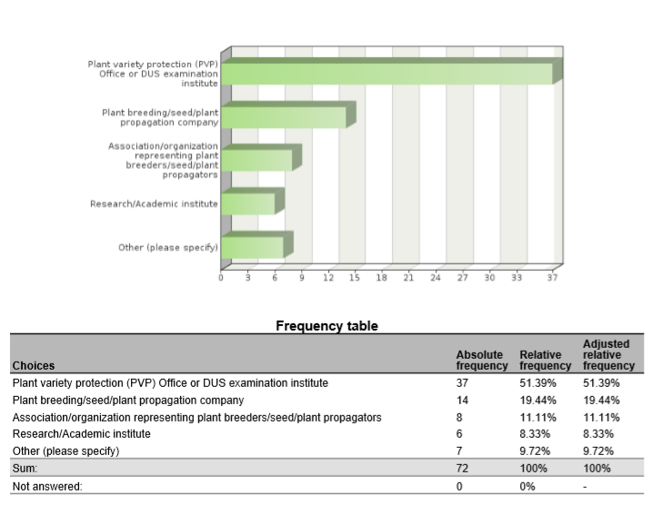

1. Are you cooperating with (other) UPOV members in the use of biochemical and molecular techniques?



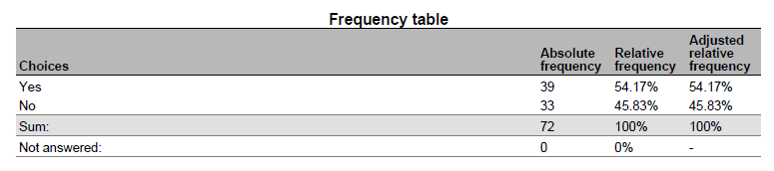

1. Please indicate which UPOV members you are cooperating on biochemical and molecular techniques

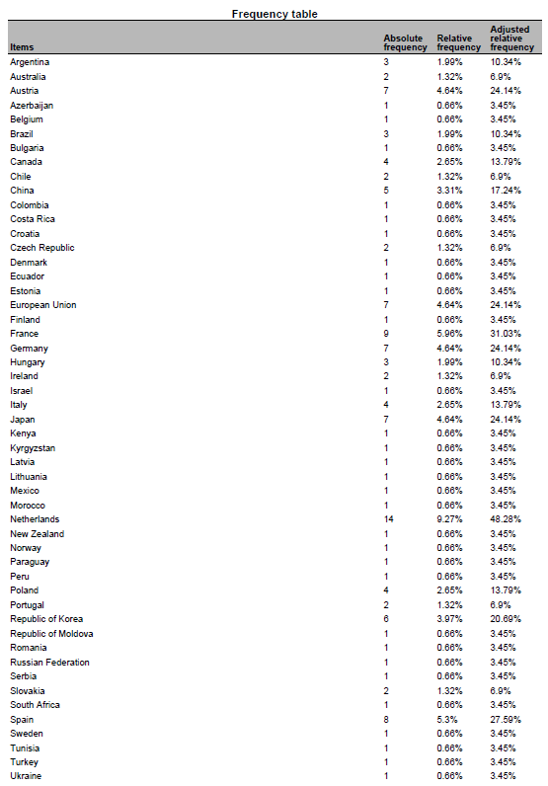

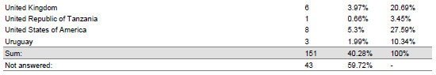

1. What are the objectives of the cooperation with the indicated UPOV members?

* validation and harmonization of crop-specific SNP sets My colleagues are also involved in projects to help with setting up a DUS examination procedures and facilities
* data base of tomato and wheat to improve the choose of comparators for DUS test
* Partner in Tomato project.
* tomato SNP project
* Associated partner in the OSR SNP research project.
* Use of SNP to varietal description
* Development of molecular tools for management of reference collection and assessment of specific traits
* gain knowledge
* Tomato SNP project
* Management of Reference collection; Quality management
* International harmonisation and validation of a SNP set for the management of tomato reference collection
* molecular markers panel and method validation, molecular marker selection to describe varieties collection
* IMODDUS project of Tomato
* selection and validation of a molecular markers panel for genotyping core collection and varieties
* We are a member of the group involved in the use of SSR markers for potato DUS in Europe
* CPVO project
* Some research project are crop specific and are looking at identifying markers, some are more horizontal such as exchange on possible ideas for the use of molecular markers in DUS (within the IMODDUS group).
* expand use of SNP markers in DUS for soybeans
* developing SNP panels for soybean and barley
* Harmonization of marker sets
* identification of BMTs which can be applied in varietal identity and purity certification
* Build capacity for establishing distinction among varieties, based on genotype parameters.
* DUS, Infringements

5. Have you presented a paper on your cooperation with UPOV members at this BMT?

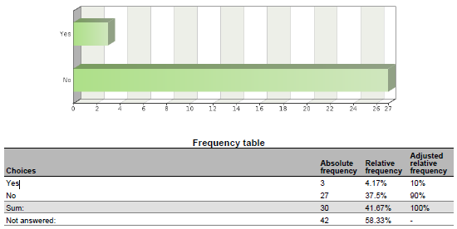

6. If you have not presented the paper, why not?

* I did in previous BMT sessions to introduce these cooperations. The projects we are working on are not yet in the phase to report on the results. Hopefully next year.
* The work is in progress and we are no acting as coordinators
* United Kingdom have not presented because France presented earlier in today.
* Because the work is in progress
* This project just starts from this year.
* This project just starts from this year.
* Because the project is not progressing.
* work is in progress
* There have been no significant changes in the work since the last BMT.
* involved with INVITE project
* I'm DUS expert
* Because the CPVO made a presentation, not necessary for breeders to do. ISF will present the outcome of a survey to which we (Euroseeds) also contributed.
* I have presented many in the past, but did contribute to a presentation this year.
* Cooperation with OECD was included into the Secretariat’s document on cooperation with IOs

7. In what areas would cooperation with UPOV members be valuable to you?

* harmonization of MM sets and also harmonized use of these MM sets in DUS examination. Common databases with variety descriptions and genotyping data to be used by all Examination offices world wide.
* fruit varieties
* Share markers used and platforms, and experience on the species.
* Interested in the development of a DNA reference database for potato.
* The use of DNA markers in DUS testing
* The use of biochemical and molecular techniques for management of reference collections
* Molecular techniques in variety identification, Variety description databases including databases containing molecular data
* Development of molecular tools to support DUS testing. Exploration of new markers (e.g. NGS) and new models (e.g. vmDUS)
* Obtaining information details on some specific procedures, if needed; Exchange of data; etc
* MODEL 1
* methods for analysis of molecular data and data management in database , molecular technique for varieties identification
* Share experience, platforms used and marker's set.
* Language barriers and general contact introductions.
* Developing new markers, sharing research cost, ring test to harmonize protocol between offices
* not main part of my work so wouldn't lead in this area
* Use of markers in creating efficiencies in DUS testing, organization of reference collection.
* standardized method, agreed marker sets agreement on molecular data access rules
* Standardization of methods and markers
* We perform variety identification by using SSR markers for grapevine, wheat and maize. 1) In future we would like to perform variety identification for rye, triticale and soybean - if someone has experience with applicable method. 2) DUS examination office is interested in molecular technique in relation to DUS for more effective management of ref. coll. for barley and wheat.
* Expand use of markers in DUS
* exchange of DUS examination reports, PVP statistics
* Exchange information on techniques/methods, molecular data of specific varieties.
* ISO seeks UPOV input for their use of ISO standards in Agriculture
* cannabis and hemp SNP panel development. Soybean and Barley.
* Give input from industry point of view
* Harmonization of MM techniques, including marker sets and distinctness thresholds.
* varietal identity
* Molecular techniques for identifying plant varieties
* Build capacity
* Representing ISTA
* DUS, Infringements

8. Please indicate which UPOV members you would wish to cooperate on biochemical and molecular techniques

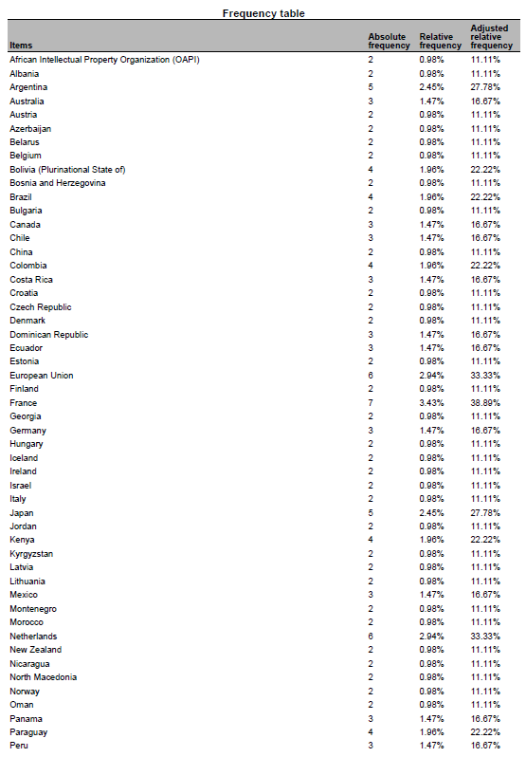

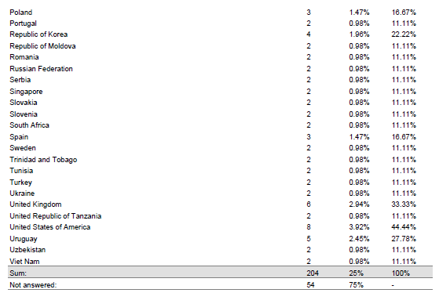

9. Please indicate the crops for which you would like to develop cooperation with UPOV members

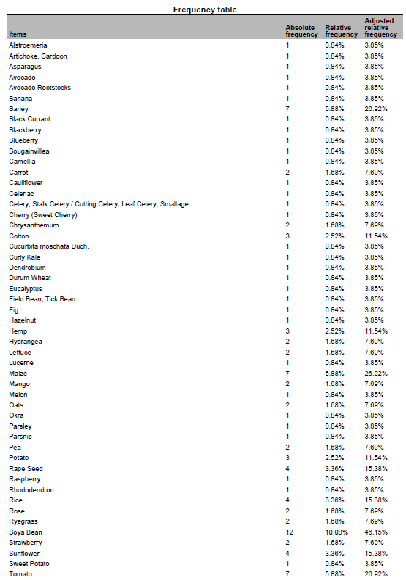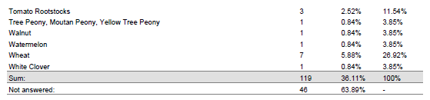

10. Please indicate the techniques for which you would like to develop cooperation with UPOV members

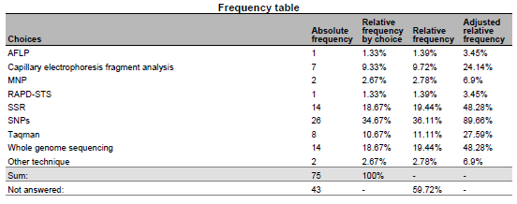

11. Please indicate the objectives of the cooperation:

* harmonization of SNP sets; common DNA databases
* To develop a potato reference collection including morphological and molecular info
* The use DNA markers in DUS testing
* A possibility to buy testing/pre-screening services from a reliable testing authority
* Varietal description, Validation of protocols for the use of molecular markers in varietal description, collaboration to facilitate the exchange of knowledge in the use of new methodologies, Facilitate the acquisition of innovative processes
* Explore new approaches to solve Distinctness issues or test the potentialities of new markers
* To obtain a common database of MM for interested species in order to have better quality in the analysis of DUS (specially model 1)
* gathering information
* Varieties description, exchange of data and material, molecular technique in DUS examination, methods for integrating molecular and DUS and VCU data
* For DUS testing
* We have a lot of experience in potato but wish to broaden our work into other avenues particularly sweet potato, raspberry, strawberry, blackberry, pea
* sharing research cost, harmonization of methods
* harmonization of methods
* Standardisation of methods and open source markers
* to have an overview of available methods, ring trials participation if it's within the capabilities of our lab
* Expand use of markers in DUS
* Speed up DUS examination
* ISO provides methods across business and government. The methods provide a clear platform for their use.
* developing services useful for commercial protection
* Harmonization of MM techniques, including marker sets and distinctness thresholds.
* To train molecular techniques
* Build capacity
* Representing ISTA

12. What are the main obstacles to cooperation with UPOV members?

* Money; the agreement of the breeders to use their varieties for these purposes
* financing
* Development of internal and external MoU for accessing or generating DNA profiles
* The main obstacles are lack of experiences in introducing promised technologies to plant examination and some disadvantages in national legislation
* Lack of resources available for this kind of work
* Funding of non-EU members
* harmonization of methods and selected markers
* we do not have the clear vision
* Different level of expertise and available resources (technical and financial)
* lack of mechanisms and procedures to do so.
* UPOV acceptance of expanded marker use
* Not accepting to take over an existing DUS examination report
* UPOV is legislative, ISO is voluntary
* lack of contact information
* Time. Mutual interest. Organization/facilitation of interaction.
* Shared platform

13. What could UPOV do to help you to cooperate with UPOV members?

* research funds (similar to the IMODDUS by CPVO) agreement of the breeding industry
* For Canada to participate in any exercise for the development of an Agreement template
* We would like to participate in international projects and methodology testing
* Provide opportunities to exchange and establish concrete contacts.
* These forums at the BMT are a great way of putting researchers form different countries in contact. Maybe some kind of database with common interest could be created to facilitate new co-operation.
* Funding research project. Give information on the uses of Upov models by other members
* Provide agreed standards and protocols, alignment among PVP offices on the used methods, capacity building.
* establish liaison with ISO/TC34/SC16
* Make sure that a DUS examination report is accepted by another country. This would save both the applicant and the DUS offices time & money
* Save time in screening primers and share data on varieties
* Continue to observe ISO proceedings
* Cooperation between PVPOs and Breeders allows for expedited validation of MM use for PVP/PBR
* introducing upov members interested in the crops pointed above
* Organization/facilitation of interaction.
* Facilitate sharing methodology

[End of Annex IV and of document]

1. Breeders’ Day