|  |  |
| --- | --- |
|  | E |
| International Union for the Protection of New Varieties of Plants |  |

|  |  |
| --- | --- |
| Working Group on Biochemical and Molecular Techniques  and DNA-Profiling in Particular  Seventeenth Session Montevideo, Uruguay, September 10 to 13, 2018 | BMT/17/7  Original: English  Date: September 7, 2018 |

REVISION OF DOCUMENT TGP/15 “Guidance on the Use of Biochemical and Molecular Markers in the Examination of Distinctness, Uniformity and Stability (DUS)”

Document prepared by the Office of the Union

Disclaimer: this document does not represent UPOV policies or guidance

# Executive summary

The purpose of this document is to report developments concerning document TGP/15 “Guidance on the Use of Biochemical and Molecular Markers in the Examination of Distinctness, Uniformity and Stability (DUS)”.

The BMT is invited to consider:

(a) Annex II to this document as a basis for revision of Section 2.2 of document TGP/15/1 in conjunction with the comments by the TWA presented in paragraphs 10 to 15 of this document; and

(b) document TGP/15/2 Draft 1 as a basis for inclusion of a new Section 2.3.

The following abbreviations are used in this document:

BMT: Working Group on Biochemical and Molecular Techniques, and DNA-Profiling in Particular

TC: Technical Committee

TWA: Technical Working Party for Agricultural Crops

TWV: Technical Working Party for Vegetables

The structure of this document is as follows:

Executive summary 1

Proposal for revision of section 2.2 2

Background 2

Comments by the TWA in 2018 2

Revised Proposal from France 3

Proposal for inclusion of new section 2.3 3

ANNEX I REVISED PROPOSAL FROM FRANCE, OF SEPTEMBER 4, 2018 (SHOWING WITH CHANGES TO THE PROPOSAL IN DOCUMENT TGP/15/2 DRAFT 1)

ANNEX II REVISED PROPOSAL FROM FRANCE, OF SEPTEMBER 4, 2018

# Proposal for revision of section 2.2

## Background

The BMT, at its sixteenth session, held in La Rochelle, France, from November 7 to 10, 2017, considered documents BMT/16/8 “The use of molecular markers (SNP) for maize DUS testing in France (2013 to 2016)” and BMT/16/8 Add. and received a presentation by an expert from France (see document BMT/16/29 “Report”, paragraphs 8 to 10).

The BMT agreed that France should propose a revision to document TGP/15 “Guidance on the Use of Biochemical and Molecular Markers in the Examination of Distinctness, Uniformity and Stability (DUS)”, Annex II, “Example: Parent Lines in Maize”, to reflect the refinements that had been made in France on the basis of its experience in the application of the Model “Combining Phenotypic and Molecular Distances in the Management of Variety Collections”, for consideration by the Technical Committee at its fifty-fourth session .

The BMT agreed that it would be advantageous if the draft revision of document TGP/15, to be considered by the TC at its fifty‑fourth session, could be published sufficiently before the forty-seventh session of the Technical Working Party for Agricultural Crops (TWA), to be held in Naivasha, Kenya, from May 21 to 25, 2018, and before the seventeenth session of the BMT, in order that any comments of the TWA and BMT on the draft revision could be reported to the TC at its fifty-fourth session.

Document TGP/15/2 Draft 1 incorporates the proposal from France for a revision to document TGP/15.

## Comments by the TWA in 2018

The TWA, at its forty-seventh session, considered document [TWP/2/7](http://upov.int/meetings/en/doc_details.jsp?meeting_id=47206&doc_id=406439) Rev. “Molecular Techniques”.

The TWA received a presentation by an expert from France on the refinements that had been made on the basis of experience in the application of the Model “Combining Phenotypic and Molecular Distances in the Management of Variety Collections”. A copy of the presentation is provided in document BMT/16/8 Add. “Addendum to the use of molecular markers (SNP) for maize DUS testing in France (2013 to 2016)” (see document TWA/47/7 “Report”, paragraphs 44 to 49).

The TWA noted that the studies for the refinement of the model used in France were still ongoing and that a final conclusion on the threshold level to be used had not yet been reached (e.g. Rogers distance = 0.2). The TWA noted that this would mean that a new proposal would need to be presented to the BMT and TWA at future sessions as a basis to propose a revision of TGP/15 for this model.

The TWA considered document [TGP/15/2 Draft 1](http://upov.int/meetings/en/doc_details.jsp?meeting_id=47206&doc_id=405417). The TWA noted that the new slide introduced to illustrate the refinement in the approach used by France did not reflect a final decision on the genetic distance threshold to be used in parent lines of maize (below).

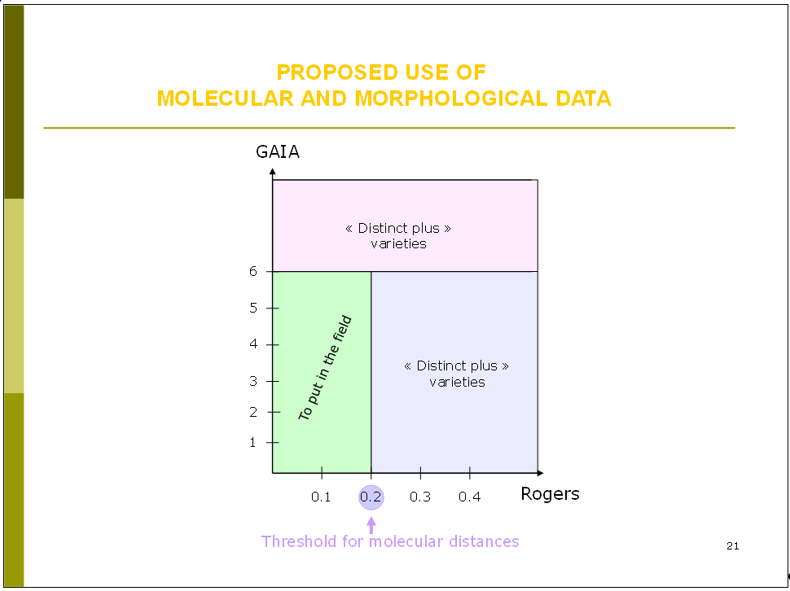

The TWA agreed that the following extract from document BMT/16/8/Add. slide 16, should be included in the proposed revision of document TGP/15:

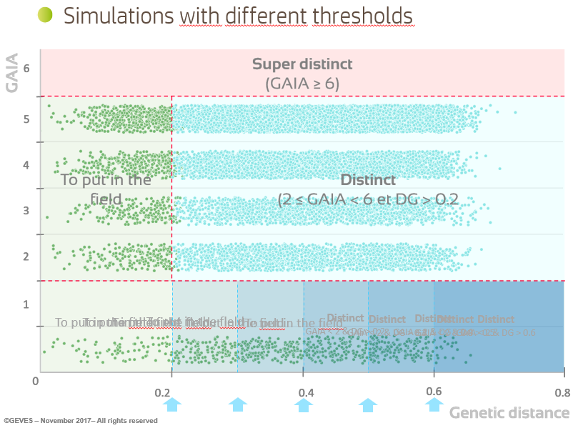

The TWA noted the refinements being made to the model used in France on the following basis:

* a “parameter setting step” analyzing several growing cycles was being used to established the threshold value;
* any threshold value would be crop-specific and should be determined by crop experts.

The TWA noted that the method used in France only rejected a candidate variety after the third growing cycle.

## Revised Proposal from France

On the basis of the comments by the TWA at its forty-seventh meeting, France developed a revised proposal as a basis for a revision of TGP/15 for this model.

Annex I to this document provides the revised proposal from France for the revision of document TGP/15. The yellow-highlighted parts in the Annex I shows the changes to the proposal contained in document TGP/15/2 Draft 1.

Annex II to this document incorporates the revised proposal from France for revision of the Section 2.2 of document TGP/15.

The BMT is invited to consider Annex II to this document as a basis for revision of Section 2.2 of document TGP/15/1 in conjunction with the comments by the TWA presented in paragraphs 10 to 15 of this document.

# Proposal for inclusion of new section 2.3

The BMT, at its sixteenth session, held in La Rochelle, France, from November 7 to 10, 2017, considered documents BMT/16/19 “Genetic selection of similar varieties for the first growing cycle: example French Bean” and BMT/16/19 Add. and received a presentation by an expert from the Netherlands (see document BMT/16/29 “Report”, paragraphs 18 to 20).

The BMT agreed that the approach presented in document BMT/16/19 “Genetic selection of similar varieties for the first growing cycle: example French bean” and BMT/16/19 Add. “Addendum to Genetic selection of similar varieties for the first growing cycle: example French bean” was a suitable use of molecular techniques in the examination of DUS and should be proposed for inclusion in document TGP/15. Therefore, it was agreed that the Netherlands should prepare an explanation of the method as a basis for a revision of document TGP/15 to be considered by the Technical Committee at its fifty-fourth session.

The BMT agreed that it would be advantageous if the draft revision of document TGP/15, to be considered by the TC at its fifty‑fourth session, could be published sufficiently before the fifty-second session of the Technical Working Party for Vegetables (TWV), to be held in Beijing, China, from September 17 to 21, 2018, and before the seventeenth session of the BMT, in order that any comments of the TWV and BMT on the draft revision could be reported to the TC at its fifty-fourth session.

Document TGP/15/2 Draft 1 incorporates the proposal from the Netherlands for revision to document TGP/15.

The BMT is invited to consider document TGP/15/2 Draft 1 as a basis for inclusion of a new Section 2.3.

[Annexes follow]

REVISED PROPOSAL FROM FRANCE, OF SEPTEMBER 4, 2018

(SHOWING WITH CHANGES TO THE PROPOSAL IN DOCUMENT TGP/15/2 DRAFT 1)

|  |
| --- |
| **DRAFT**  **(REVISION)** |

[…]

**DOCUMENT TGP/15  
  
GUIDANCE ON THE USE OF BIOCHEMICAL AND MOLECULAR MARKERS   
IN THE EXAMINATION OF DISTINCTNESS, UNIFORMITY AND STABILITY (DUS)**

[…]

Note for Draft version

**~~Strikethrough~~ (highlighted in yellow)** indicates deletion from the text of document TGP/15/2 Draft 1, introduced by revised proposal from France.

**Underlining (highlighted in yellow)** indicates insertion to from the text of document TGP/15/2 Draft 1, introduced by revised proposal from France.

**~~Strikethrough~~ (highlighted in grey)** indicates deletion from the text of document TGP/15/1.

**Underlining (highlighted in grey)** indicates insertion to from the text of document TGP/15/1.

**Footnotes** will be retained in published document.

**Endnotes** are for background information when considering this draft and will not appear in the final, published document.

[…]

**2. APPLICATION MODELS**

[…]

**2.2 Combining Phenotypic and Molecular Distances in the Management of Variety Collections (see Appedix I)**

2.2.1 A key feature of the process of eliminating varieties of common knowledge prior to the DUS growing trial is that the threshold is set with a suitable margin of safety. This threshold is termed the “Distinctness plus” threshold, which means that the distances between a candidate variety and “Distinct plus” varieties are robust enough to take a decision without direct comparison in the growing trial.

2.2.2 A combination of phenotypic differences and molecular distances can be used to identify within the variety collection, those varieties which need to be compared with candidate varieties in order to improve the selection of “Distinct plus” varieties, on the following basis:

(a) there is reliable information that the molecular distances are sufficiently related to phenotypic differences, such that

(b) the method selects varieties in the variety collection which are similar to the candidate varieties; and

1. the method does not create an increased risk of not selecting a variety in the variety collection which needs to be compared to the candidate varieties in the field.

2.2.3 Appendix I to this document “Combining Phenotypic and Molecular Distances in the Management of Variety Collections” provides an example of the use of combining phenotypic differences and molecular distances in the management of variety collections.

[…]

[Appendix follows]

MODEL: COMBINING PHENOTYPIC AND MOLECULAR DISTANCES IN  
THE MANAGEMENT OF VARIETY COLLECTIONS

EXAMPLE: PARENT LINES IN MAIZE

*prepared by experts from France*

1. Description

1.1 A key feature of the process of eliminating varieties of common knowledge prior to the DUS growing trial is that the threshold for deciding which varieties can be safely excluded (i.e. are distinct on the basis of descriptions), can be set with a suitable margin of safety, because those varieties which are eliminated, will not be included in the growing trial. This threshold, with a safety margin, is termed the “Distinctness plus” threshold which means that the distances between a candidate variety and “distinct plus” varieties are robust enough to take a decision without direct comparison in the growing trial.

1.2 The objective of this example is to develop an efficient tool, based on a combination of phenotypic and molecular distances, to identify within the variety collection, those varieties which need to be compared with candidate varieties (see Figure 1) in order to improve the selection of “distinct plus” varieties and so to limit the workload without decreasing the quality of the test. The challenge is to develop a secure system that:

(a) only selects varieties which are similar to the candidate varieties; and

(b) limits the risk of not selecting a variety in the variety collection which needs to be compared

in the field, especially when there is a large or expensive variety collection.

*Figure 1*

|  |
| --- |
|  |

1.3 The new system has been elaborated on the following background:

(a) Studies done on molecular distances in maize for DUS testing and essential derivation, which showed the link with the parentage between varieties (see documents BMT/3/6 “The Estimation of Molecular Genetic Distances in Maize or DUS and ED Protocols: Optimization of the Information and new Approaches of Kinship” and document BMT/3/6 Add.)

(b) An experiment done by GEVES on a set of maize parental lines, which showed that there is a link between the evaluation of distinctness by experts (global assessment) and a molecular distance computed on Simple Sequence Repeat (SSR) molecular data (see Figure 2).

(c) Studies done by GEVES from 2013 to 2016 on the use of molecular markers for maize DUS testing, ~~which confirmed a link between the evaluation of distinctness by experts and a molecular distance~~ show an interesting association between evaluation of distinctness by experts and molecular distance results for GAIA <2 (see Figure ~~3~~4).

1.4 Components of the system

1.4.1 GAIA distance

The GAIA distance component is computed with the GAIA software developed by GEVES. The GAIA distance is a combination of differences observed on phenotypic characteristics, where each difference contributes to the distance according to the reliability of the characteristics, especially regarding its variability and its susceptibility to environment. The larger the size of the difference and the greater the reliability of the characteristic, the more the difference contributes to the GAIA distance. Only differences that are equal or larger than the minimum distance required for each individual characteristic are included.

1.4.2 Molecular distance

The molecular distance component is computed on the differences observed on a set of markers. Different types of molecular markers and distances can be used. In the case of the study done in France on maize, 60 SSR markers and Roger’s distance have been used. It is important that sufficient markers, with a good distribution on the chromosomes, are used. The type of markers, the effect of the number of markers and the distribution of the markers need to be considered according to the species concerned.

1.4.3 Before combining these two components, an evaluation of the link between molecular distance and a global assessment of distinctness by a panel of experts needs to be done on a set of pairs of varieties. In the case of maize, that evaluation was made on the following basis:

Material: 504 pairs of varieties tested in parallel with molecular markers

Field design: pairs of varieties grown side by side   
(1 plot = 2 rows of 15 plants)

Visual assessment by maize crop experts:

Scale of similarity:

1. the two varieties are similar or very close

3. the two varieties are distinct but close

5. the comparison was useful, but the varieties are clearly distinct

7. the comparison should have been avoided because the varieties are very different

9. the comparison should have been avoided because the varieties are totally different

(“even” notes are not used in the scale)

In the case of maize, this evaluation showed that no parental lines with a molecular distance greater than 0.15 were considered as similar or very close by a DUS expert evaluation (see Figure 2).

*Figure 2*



1.4.4 On the basis of that result, the combination of morphological and molecular distances offers the possibility to establish a decision scheme as follows (see Figure 3):

Using SNP markers doesn’t modify this scheme.

*Figure 3*

*~~[to delete this figure]~~*



1.4.5 ~~GEVES applied the aforementioned decision making scheme to 4,486,001 pairs of maize varieties, which included 1,940 pairs of varieties tested in the field, in parallel with 300 SNP molecular markers.~~ No pairs of varieties with a molecular distance larger than 0.2 were visually assessed by maize crop experts as those which required another year of growing trial (see Figure ~~4~~3).

*Figure ~~4~~3*

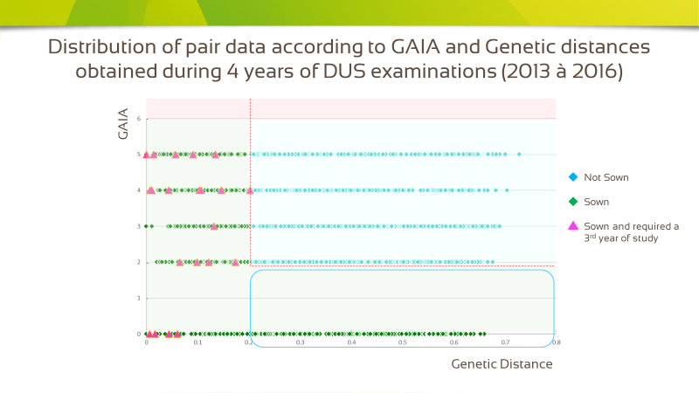

1.4.6 ~~On the basis of that result, the combination of morphological and molecular distances offers the possibility to establish a enhanced decision scheme as follows (see Figure 4):~~  This study provides empirical proof that there is presumably no risk in applying an additional molecular threshold in the zone GAIA < 2. This Additional threshold would reduce significantly the number of pairs to be compared side-by -side in the field. (fig 5).

The value of this additional threshold is not determined here. The choice of the threshold value depends on the experts by country, and on the considered species.

*Figure* 5

*[to introduce this Figure.]*

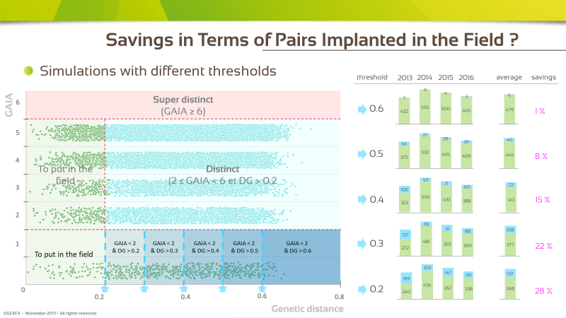

*~~Figure~~**~~4~~*

*[to delete this figure]*



1.4.5 All pairs of varieties with a GAIA distance equal to, or larger than, 6 and all varieties with a GAIA distance between 2 and 6, plus a molecular distance equal to, or larger than, 0.2 are declared “Distinct plus”.

[Pro domo: to keep yellow highlighted parts since initial Figure 3 is maintained.]

1.4.6 This scheme shows that less parental lines need to be observed in the field compared to the situation where only a GAIA distance of 6 is used on its own.

1.4.7 The robustness of this system has been studied with different GAIA and molecular distances.

2. Advantages and constraints

2.1. Advantages

(a) Improvement of the management of variety collections with less varieties needing to be compared in the field;

(b) Use of morphological and molecular distances with thresholds defined by DUS experts. GAIA was also calibrated against DUS experts’ evaluations when developed by GEVES;

(c) Use of molecular data that are not susceptible to the environment; the set of markers and the laboratory protocol are well defined;

(d) Use of only phenotypic characteristics with a good robustness and possibility to use descriptions coming from different origins under close cooperation (The maize database that has been developed in cooperation between Germany, France, Spain and the Community Plant Variety Office of the European Union (CPVO) is a good example to illustrate the value of this approach with a variety collection shared between different offices);

(e) Electrophoresis characteristics can also be replaced; and

(f) There is no influence of lack of uniformity in molecular profiles provided enough markers are used and the number of variants is low. In the case of maize parental lines, the level of molecular uniformity is high but could be a problem in some other crops.

2.2. Constraints

(a) Not efficient, or less efficient, for species with synthetic varieties or populations;

(b) Necessity to have enough good DNA markers and enough phenotypic characteristics with low susceptibility to environment; and

(c) Preliminary work with calibration in comparison with DUS expert evaluation of distinctness.

[Annex II follows]

REVISED PROPOSAL FROM FRANCE, OF SEPTEMBER 4, 2018

|  |
| --- |
| **DRAFT**  **(REVISION)** |

[…]

**DOCUMENT TGP/15  
  
GUIDANCE ON THE USE OF BIOCHEMICAL AND MOLECULAR MARKERS   
IN THE EXAMINATION OF DISTINCTNESS, UNIFORMITY AND STABILITY (DUS)**

[…]

Note for Draft version

**~~Strikethrough~~ (highlighted in grey)** indicates deletion from the text of document TGP/15/1.

**Underlining (highlighted in grey)** indicates insertion to from the text of document TGP/15/1.

**Footnotes** will be retained in published document.

**Endnotes** are for background information when considering this draft and will not appear in the final, published document.

[…]

**2. APPLICATION MODELS**

[…]

**2.2 Combining Phenotypic and Molecular Distances in the Management of Variety Collections (see Appendix II)**

2.2.1 A key feature of the process of eliminating varieties of common knowledge prior to the DUS growing trial is that the threshold is set with a suitable margin of safety. This threshold is termed the “Distinctness plus” threshold, which means that the distances between a candidate variety and “Distinct plus” varieties are robust enough to take a decision without direct comparison in the growing trial.

2.2.2 A combination of phenotypic differences and molecular distances can be used to identify within the variety collection, those varieties which need to be compared with candidate varieties in order to improve the selection of “Distinct plus” varieties, on the following basis:

(a) there is reliable information that the molecular distances are sufficiently related to phenotypic differences, such that

(b) the method selects varieties in the variety collection which are similar to the candidate varieties; and

1. the method does not create an increased risk of not selecting a variety in the variety collection which needs to be compared to the candidate varieties in the field.

2.2.3 Appendix II to this document “Combining Phenotypic and Molecular Distances in the Management of Variety Collections” provides an example of the use of combining phenotypic differences and molecular distances in the management of variety collections.

[…]

[Appendix follows]

MODEL: COMBINING PHENOTYPIC AND MOLECULAR DISTANCES IN  
THE MANAGEMENT OF VARIETY COLLECTIONS

EXAMPLE: PARENT LINES IN MAIZE

*prepared by experts from France*

1. Description

1.1 A key feature of the process of eliminating varieties of common knowledge prior to the DUS growing trial is that the threshold for deciding which varieties can be safely excluded (i.e. are distinct on the basis of descriptions), can be set with a suitable margin of safety, because those varieties which are eliminated, will not be included in the growing trial. This threshold, with a safety margin, is termed the “Distinctness plus” threshold which means that the distances between a candidate variety and “distinct plus” varieties are robust enough to take a decision without direct comparison in the growing trial.

1.2 The objective of this example is to develop an efficient tool, based on a combination of phenotypic and molecular distances, to identify within the variety collection, those varieties which need to be compared with candidate varieties (see Figure 1) in order to improve the selection of “distinct plus” varieties and so to limit the workload without decreasing the quality of the test. The challenge is to develop a secure system that:

(a) only selects varieties which are similar to the candidate varieties; and

(b) limits the risk of not selecting a variety in the variety collection which needs to be compared

in the field, especially when there is a large or expensive variety collection.

*Figure 1*

|  |
| --- |
|  |

1.3 The new system has been elaborated on the following background:

(a) Studies done on molecular distances in maize for DUS testing and essential derivation, which showed the link with the parentage between varieties (see documents BMT/3/6 “The Estimation of Molecular Genetic Distances in Maize or DUS and ED Protocols: Optimization of the Information and new Approaches of Kinship” and document BMT/3/6 Add.)

(b) An experiment done by GEVES on a set of maize parental lines, which showed that there is a link between the evaluation of distinctness by experts (global assessment) and a molecular distance computed on Simple Sequence Repeat (SSR) molecular data (see Figure 2).

(c) Studies done by GEVES from 2013 to 2016 on the use of molecular markers for maize DUS testing, show an association between evaluation of distinctness by experts and molecular distance results for GAIA <2 (see Figure 4).

1.4 Components of the system

1.4.1 GAIA distance

The GAIA distance component is computed with the GAIA software developed by GEVES. The GAIA distance is a combination of differences observed on phenotypic characteristics, where each difference contributes to the distance according to the reliability of the characteristics, especially regarding its variability and its susceptibility to environment. The larger the size of the difference and the greater the reliability of the characteristic, the more the difference contributes to the GAIA distance. Only differences that are equal or larger than the minimum distance required for each individual characteristic are included.

1.4.2 Molecular distance

The molecular distance component is computed on the differences observed on a set of markers. Different types of molecular markers and distances can be used. In the case of the study done in France on maize, 60 SSR markers and Roger’s distance have been used. It is important that sufficient markers, with a good distribution on the chromosomes, are used. The type of markers, the effect of the number of markers and the distribution of the markers need to be considered according to the species concerned.

1.4.3 Before combining these two components, an evaluation of the link between molecular distance and a global assessment of distinctness by a panel of experts needs to be done on a set of pairs of varieties. In the case of maize, that evaluation was made on the following basis:

Material: 504 pairs of varieties tested in parallel with molecular markers

Field design: pairs of varieties grown side by side   
(1 plot = 2 rows of 15 plants)

Visual assessment by maize crop experts:

Scale of similarity:

1. the two varieties are similar or very close

3. the two varieties are distinct but close

5. the comparison was useful, but the varieties are clearly distinct

7. the comparison should have been avoided because the varieties are very different

9. the comparison should have been avoided because the varieties are totally different

(“even” notes are not used in the scale)

In the case of maize, this evaluation showed that no parental lines with a molecular distance greater than 0.15 were considered as similar or very close by a DUS expert evaluation (see Figure 2).

*Figure 2*



1.4.4 On the basis of that result, the combination of morphological and molecular distances offers the possibility to establish a decision scheme as follows (see Figure 3). Use of SNP molecular markers doesn’t modify this scheme.

*Figure 3*



1.4.5 No pairs of varieties with a molecular distance larger than 0.2 were visually assessed by maize crop experts as those which required another year of growing trial (see Figure ~~4~~).

*Figure ~~4~~*



1.4.6 This study provides empirical proof that there is presumably no risk in applying an additional molecular threshold in the zone GAIA < 2. This Additional threshold would reduce significantly the number of pairs to be compared side-by -side in the field (see Figure 5). The value of this additional threshold is not determined here. The choice of the threshold value depends on the experts by country, and on the considered species.

*Figure* 5



1.4.5 All pairs of varieties with a GAIA distance equal to, or larger than, 6 and all varieties with a GAIA distance between 2 and 6, plus a molecular distance equal to, or larger than, 0.2 are declared “Distinct plus”.

1.4.6 This scheme shows that less parental lines need to be observed in the field compared to the situation where only a GAIA distance of 6 is used on its own.

1.4.7 The robustness of this system has been studied with different GAIA and molecular distances.

2. Advantages and constraints

2.1. Advantages

(a) Improvement of the management of variety collections with less varieties needing to be compared in the field;

(b) Use of morphological and molecular distances with thresholds defined by DUS experts. GAIA was also calibrated against DUS experts’ evaluations when developed by GEVES;

(c) Use of molecular data that are not susceptible to the environment; the set of markers and the laboratory protocol are well defined;

(d) Use of only phenotypic characteristics with a good robustness and possibility to use descriptions coming from different origins under close cooperation (The maize database that has been developed in cooperation between Germany, France, Spain and the Community Plant Variety Office of the European Union (CPVO) is a good example to illustrate the value of this approach with a variety collection shared between different offices);

(e) Electrophoresis characteristics can also be replaced; and

(f) There is no influence of lack of uniformity in molecular profiles provided enough markers are used and the number of variants is low. In the case of maize parental lines, the level of molecular uniformity is high but could be a problem in some other crops.

2.2. Constraints

(a) Not efficient, or less efficient, for species with synthetic varieties or populations;

(b) Necessity to have enough good DNA markers and enough phenotypic characteristics with low susceptibility to environment; and

(c) Preliminary work with calibration in comparison with DUS expert evaluation of distinctness.

[End of Annex and of document]