E
International Union for the Protection of New Varieties of Plants

Working Group on Biochemical and Molecular Techniques  and DNA-Profiling in Particular  Seventeenth Session  Montevideo, Uruguay, September 10 to 13, 2018 | BMT/17/23  Original: English  Date: September 11, 2018
new developments in biochemical and molecular techniques
CPVO report on IMODDUS: latest developments
Document prepared by an expert from the European Union
Disclaimer: this document does not represent UPOV policies or guidance
The presentation prepared by an expert from the Community Plant Variety Office (CPVO) entitled “CPVO report on IMODDUS: Latest developments” is reproduced in the Annex to this document.

[Annex follows]

CPVO REPORT ON IMODDUS: LATEST DEVELOPMENTS

Presentation prepared by an expert from the European Union

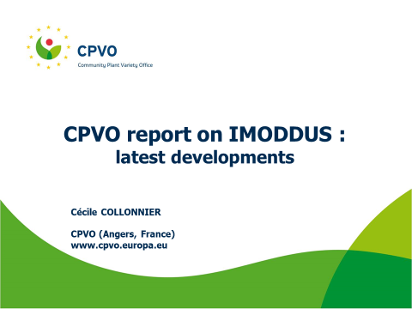
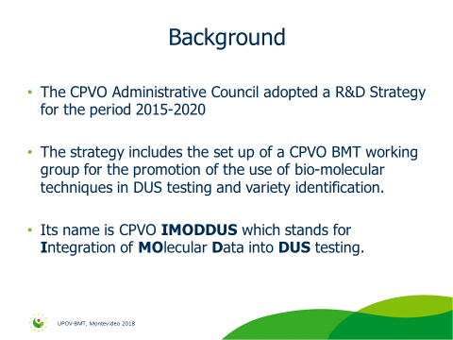
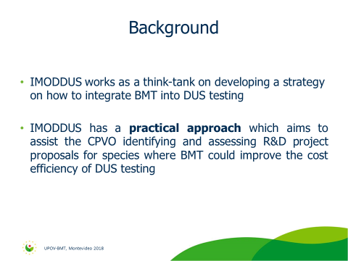
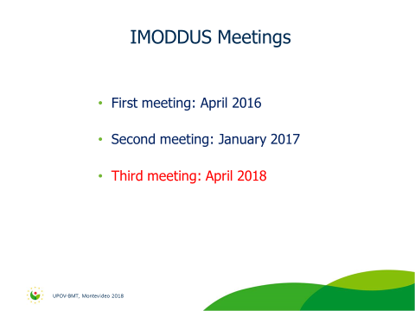
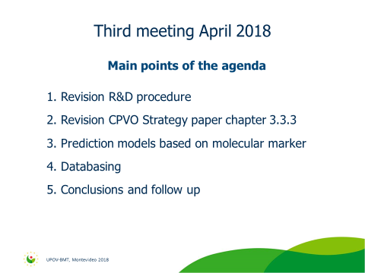
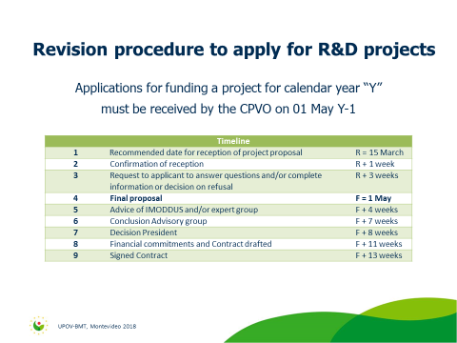
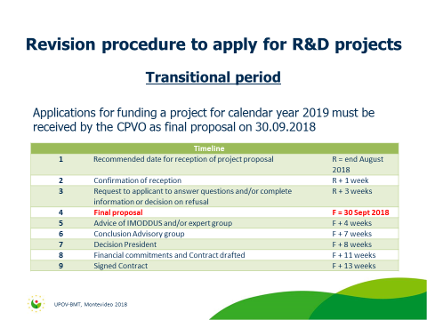
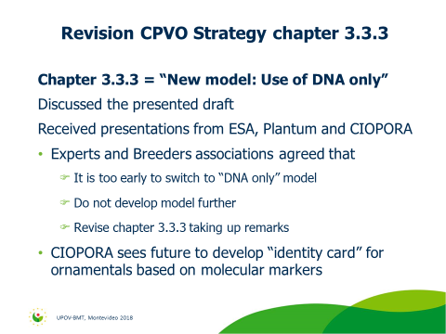
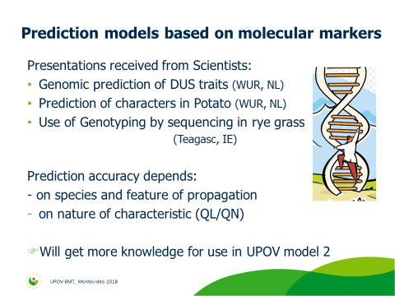
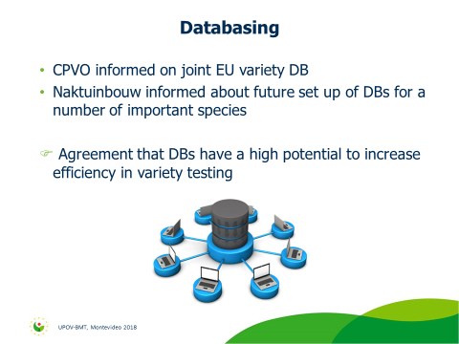
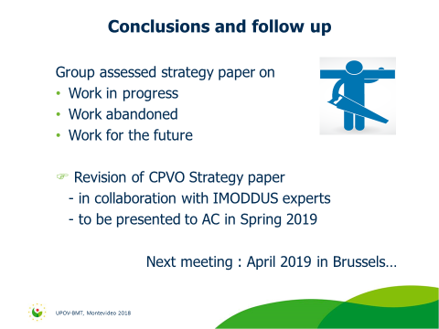

[End of Annex and of document]

