E
International Union for the Protection of New Varieties of Plants

Working Group on Biochemical and Molecular Techniques  and DNA-Profiling in Particular  Sixteenth Session  La Rochelle, France, November 7 to 10, 2017 | BMT/16/8 Add.  Original: English  Date: November 14, 2017
addendum to
THE USE OF MOLECULAR MARKERS (SNP) FOR MAIZE DUS TESTING IN FRANCE (2013 TO 2016)
prepared by an expert from France
Disclaimer: this document does not represent UPOV policies or guidance
The Annex to this document contains a copy of a presentation on “The use of SNP molecular markers for maize DUS testing in France from 2013 to 2016” to be made by an expert from France at the sixteenth session of the Working Group on Biochemical and Molecular Techniques, and DNA-Profiling in Particular (BMT).

[The Annex follows]

BMT/16/8 Add.

ANNEX

THE USE OF SNP MOLECULAR MARKERS FOR MAIZE DUS TESTING IN FRANCE
FROM 2013 TO 2016

Presentation prepared by an expert from France

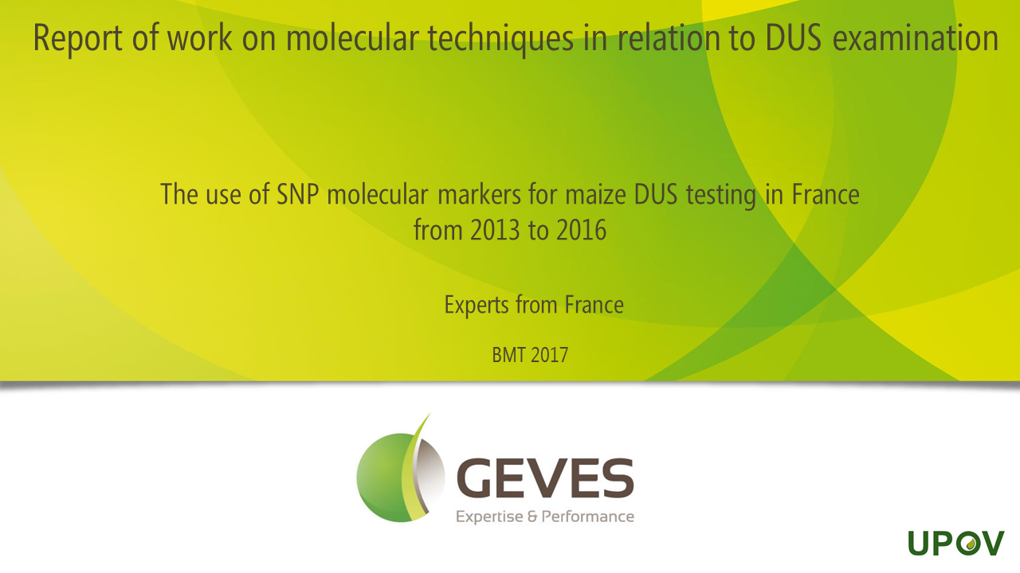

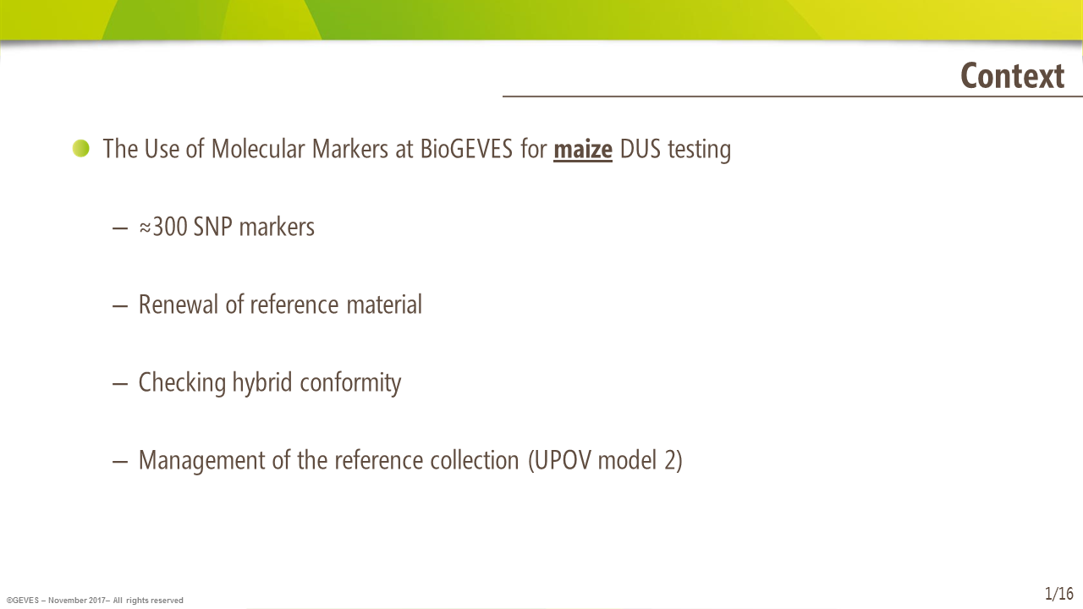

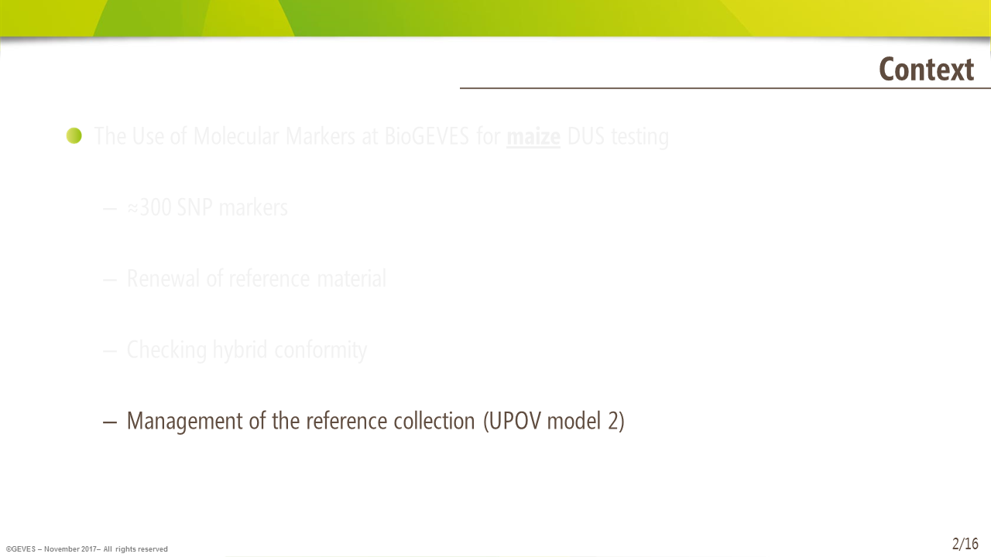

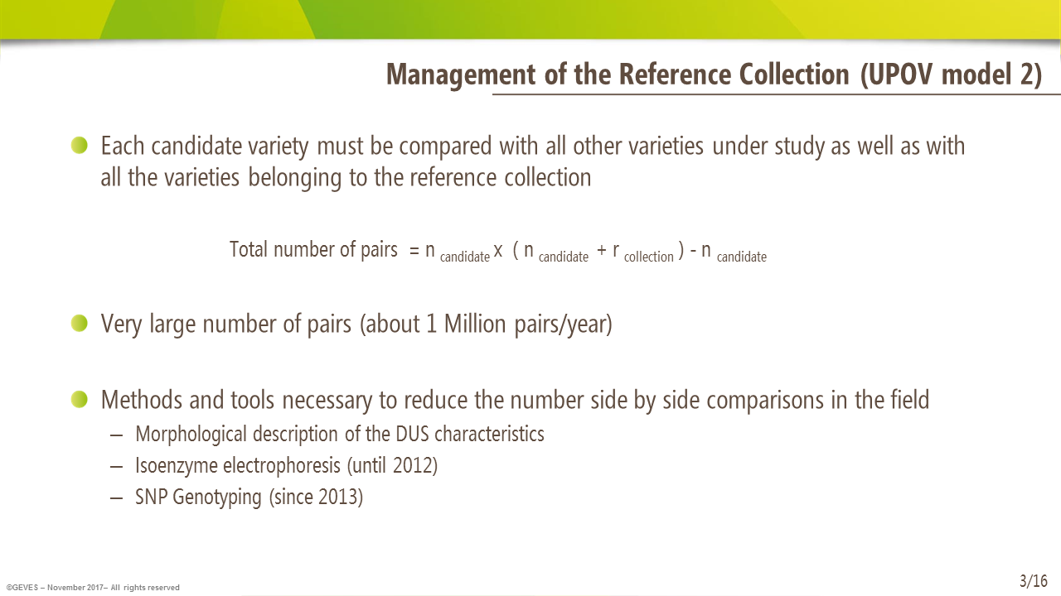

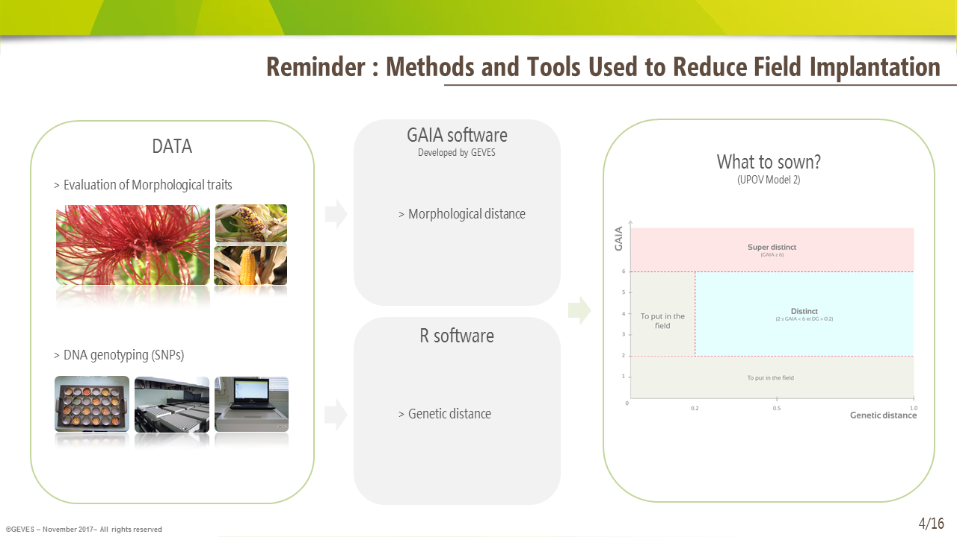

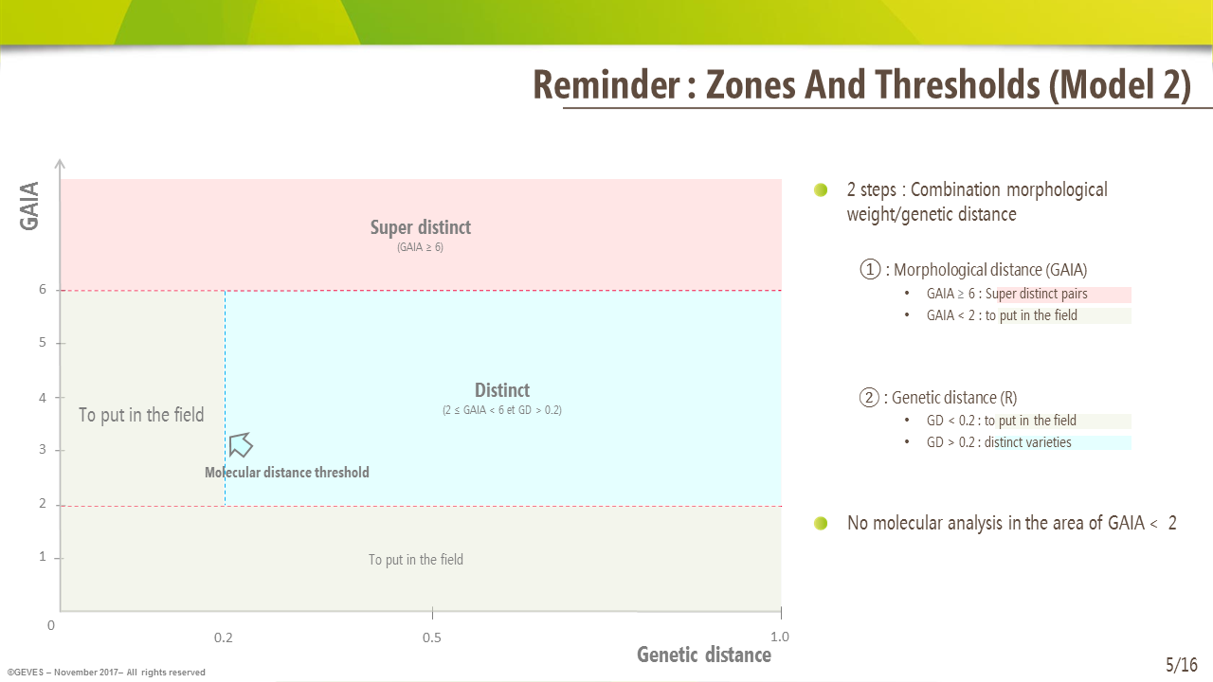

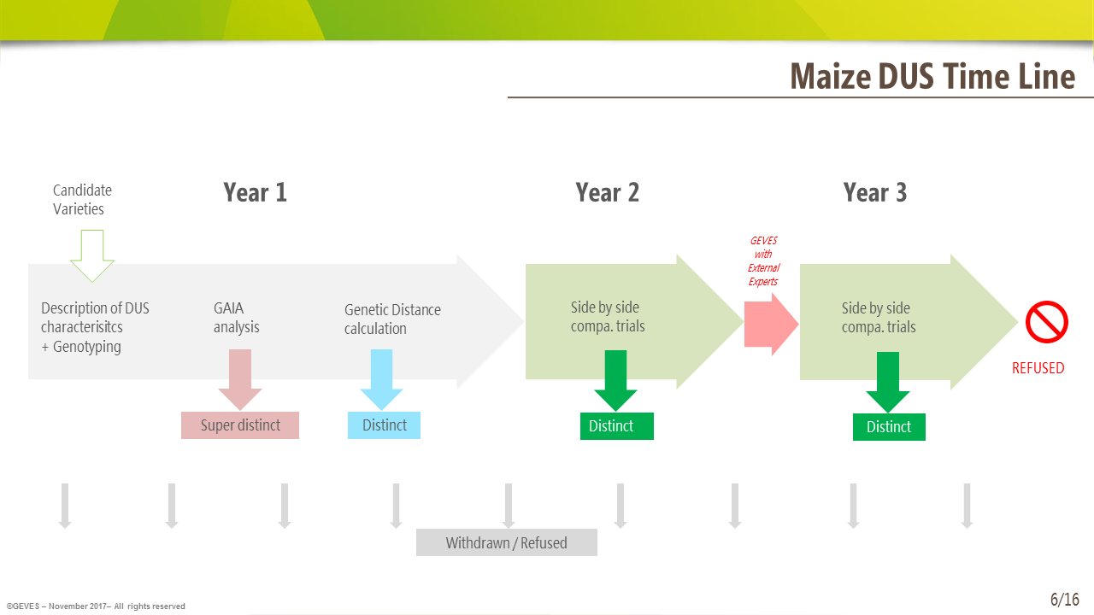

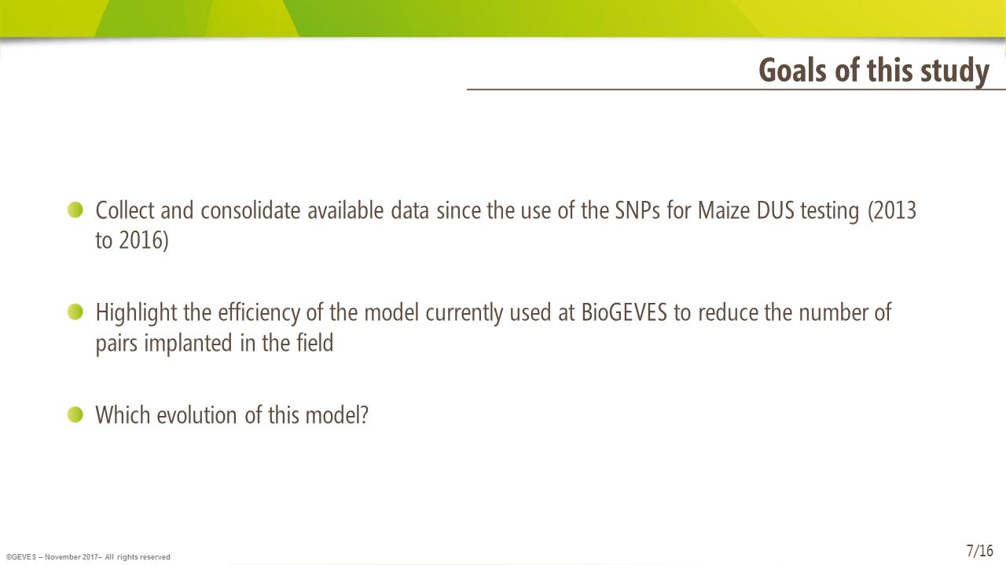

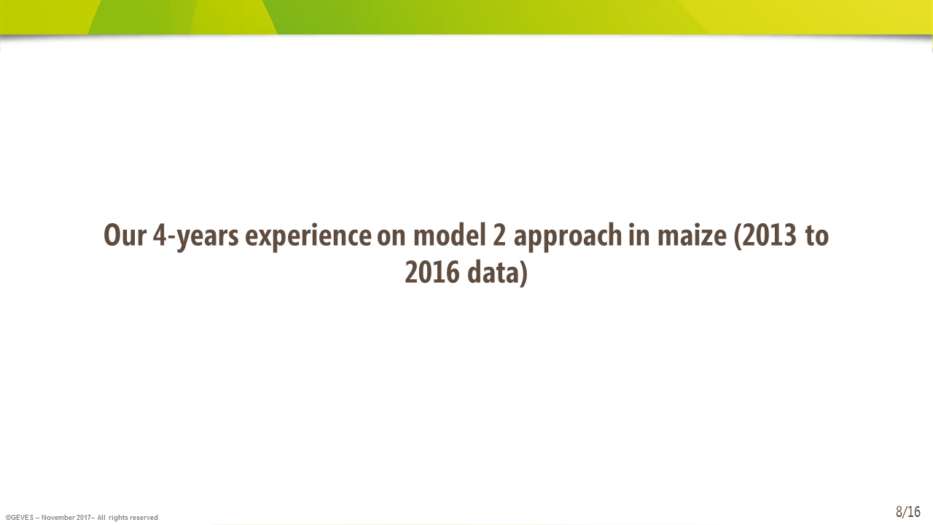

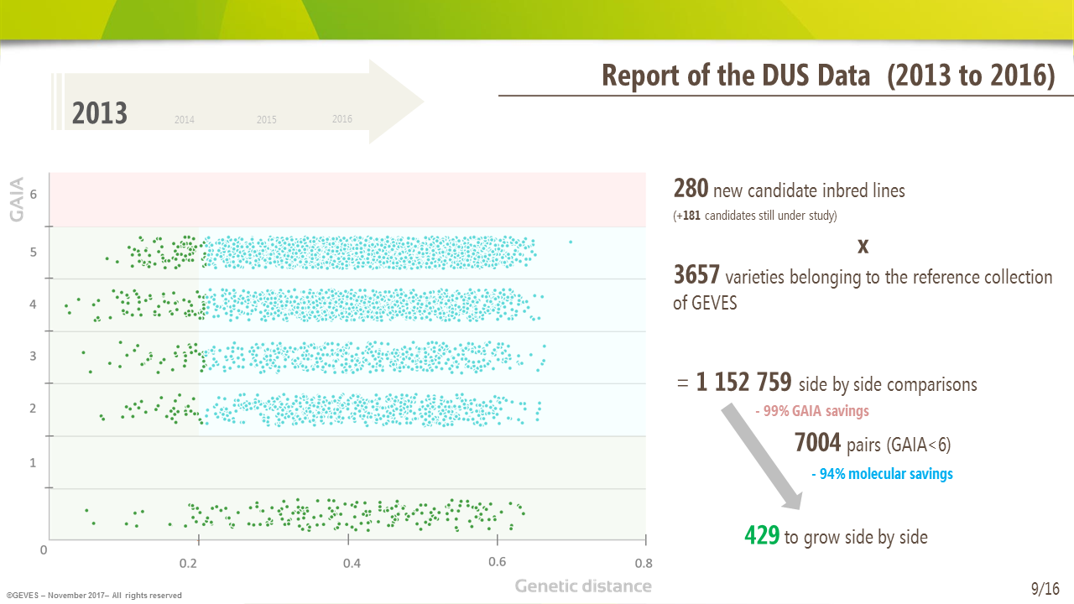

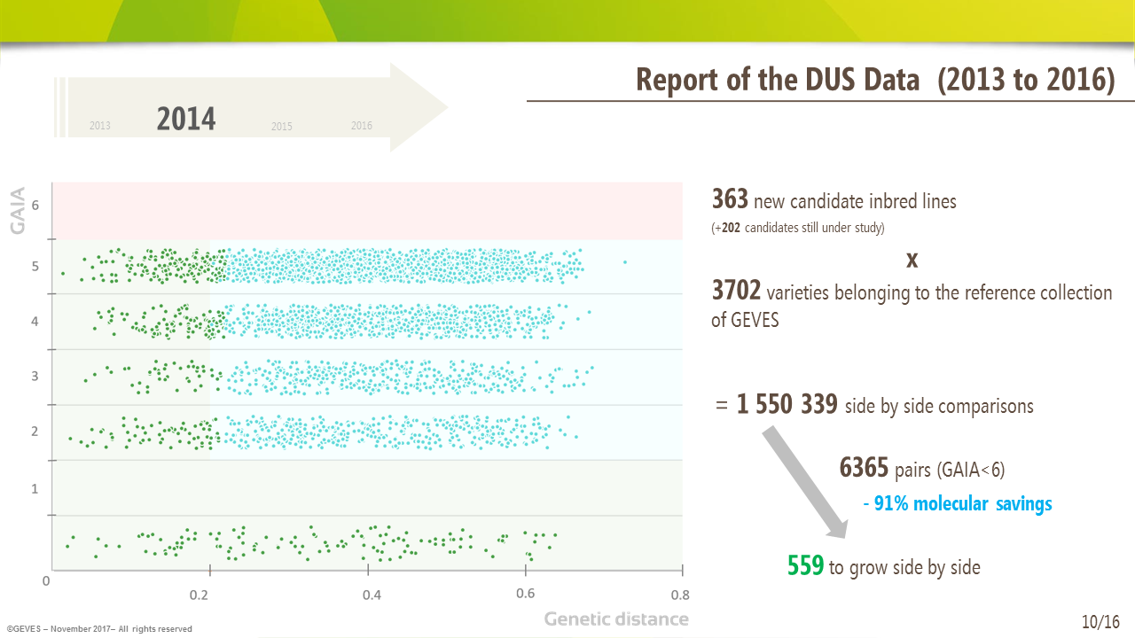

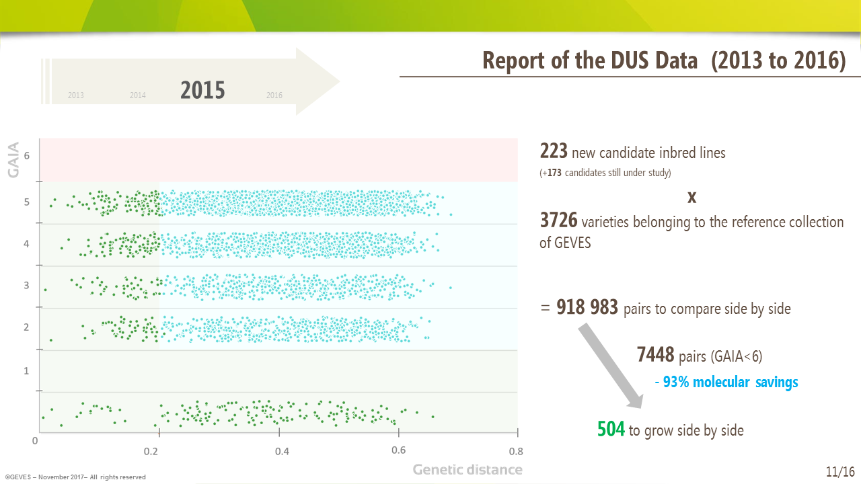

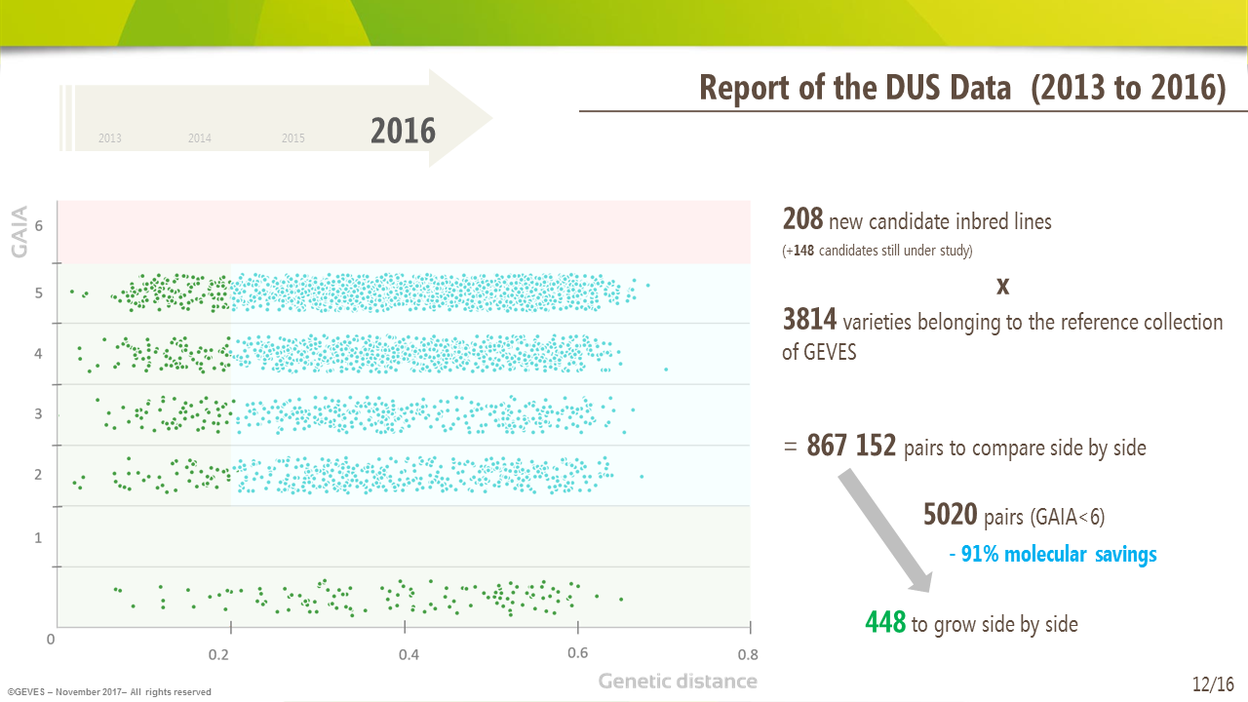

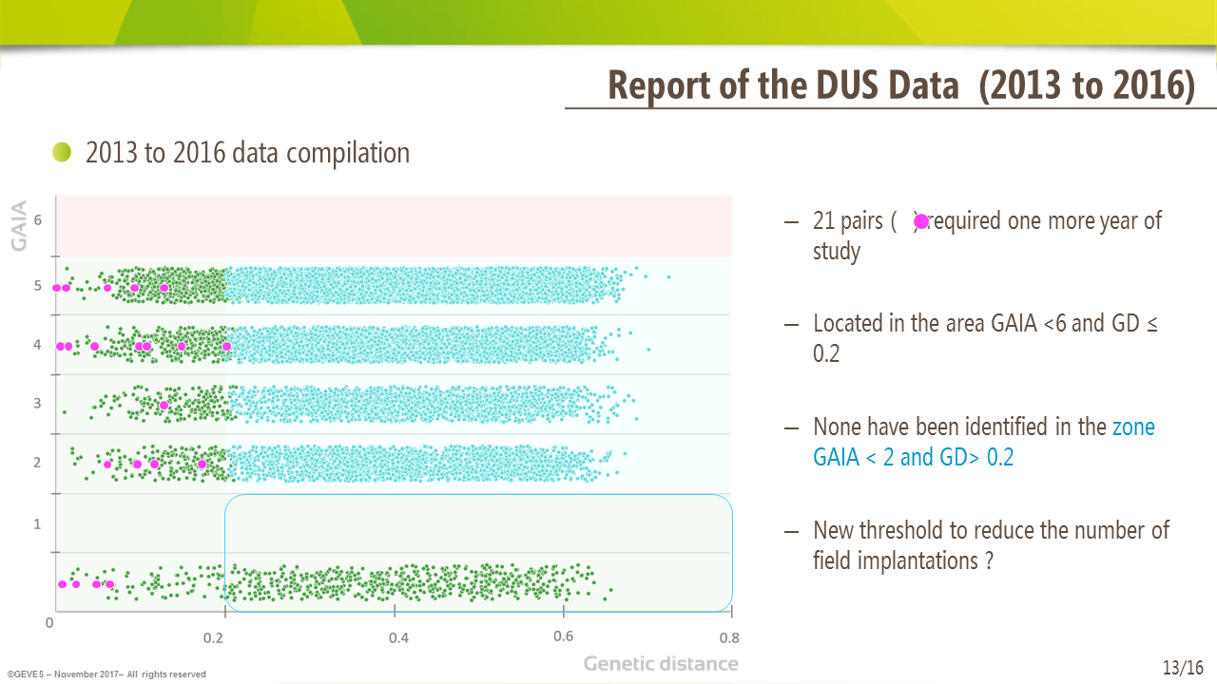

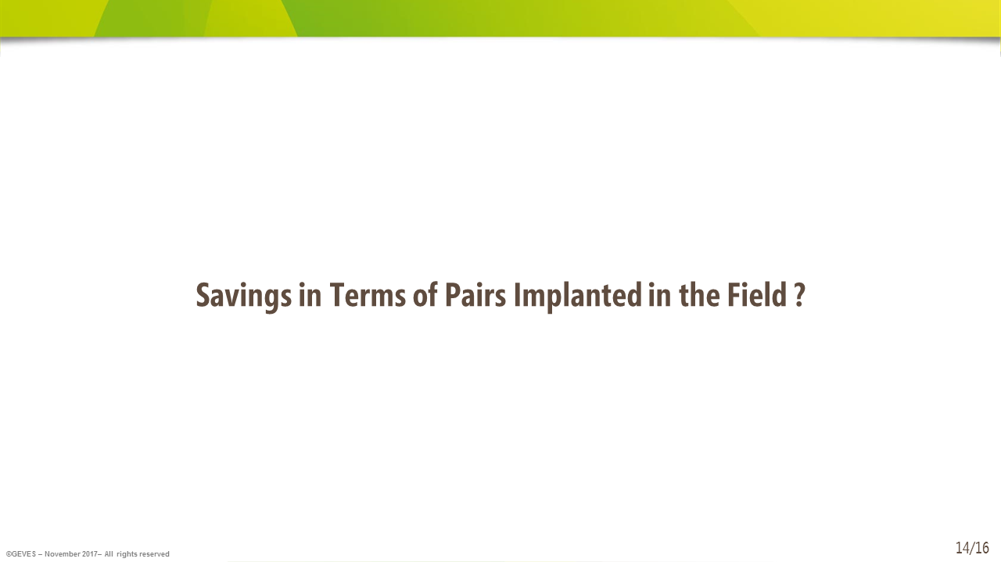

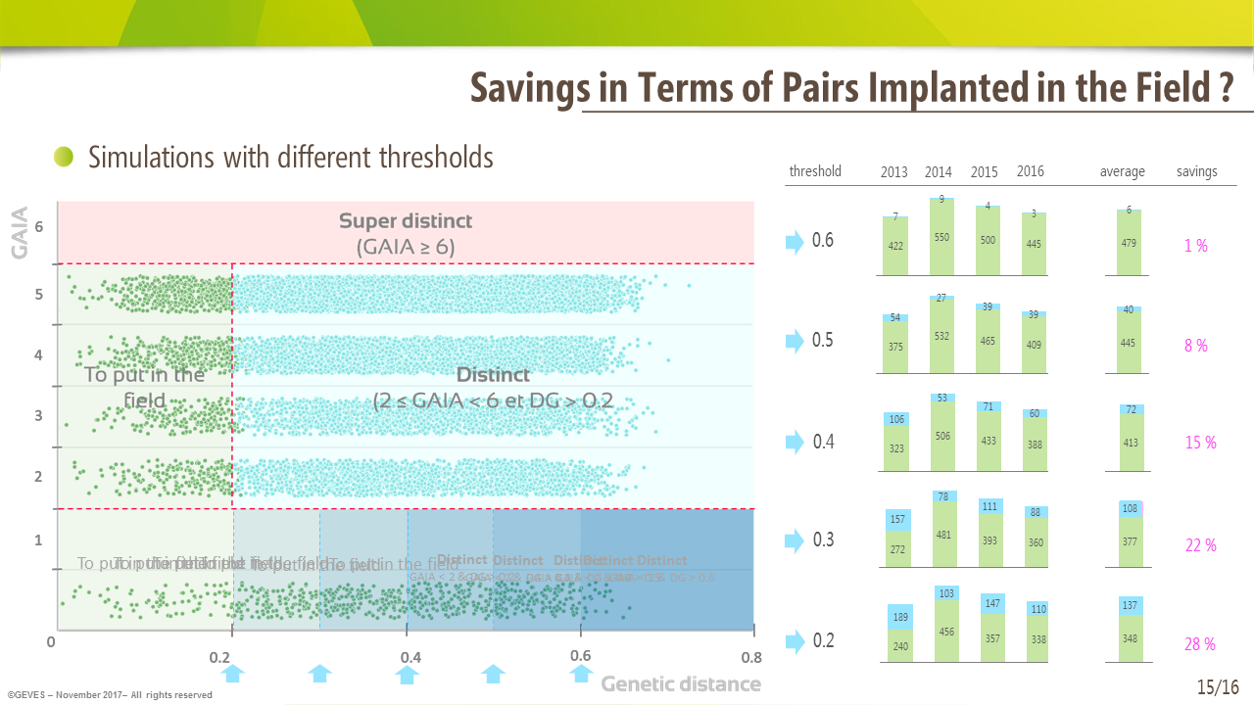

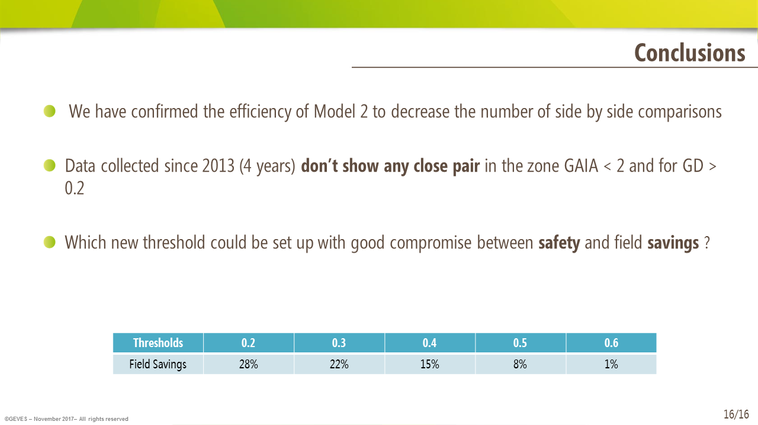

[End of Annex and of document]

