E
International Union for the Protection of New Varieties of Plants

Working Group on Biochemical and Molecular Techniques  and DNA-Profiling in Particular  Sixteenth Session  La Rochelle, France, November 7 to 10, 2017 | BMT/16/7  Original: English  Date: October 19, 2017
TEST OF THE POTENTIAL USE OF SNPS MARKERS ON OILSEED RAPE VARIETIES
Document prepared by an expert from France
Disclaimer: this document does not represent UPOV policies or guidance
The project aims to examine the potential use of SNP markers as a tool for the management of OSR reference collection. The objectives are to select and validate a suitable set of SNP markers and to asses the use of bulks of plants or seeds instead of individual plants.

This project is a collaborative project funded by the CPVO and work is carried out by GEVES and NIAB.

[Annex follows]

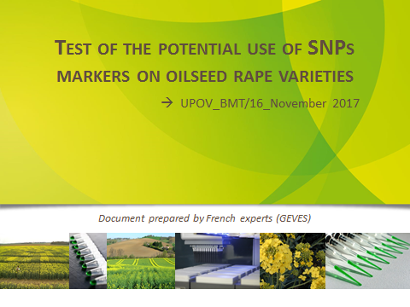

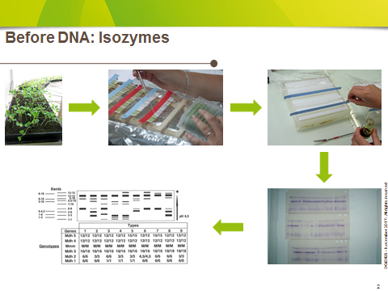

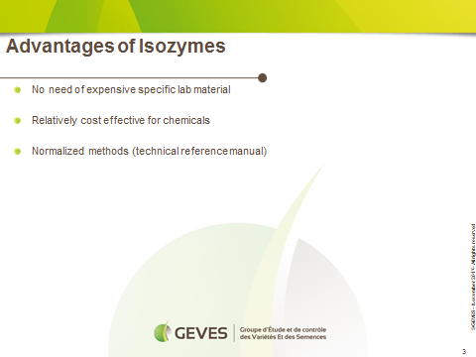

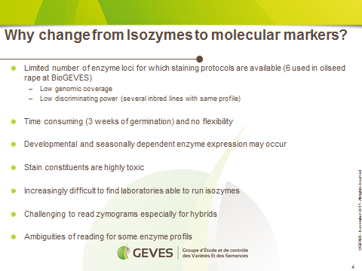

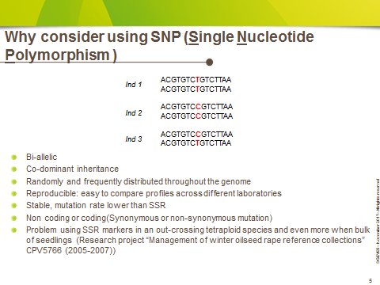

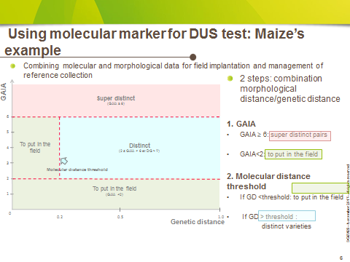

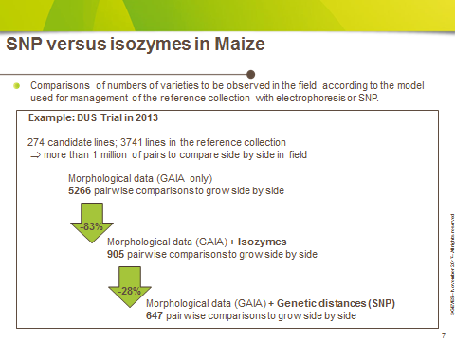

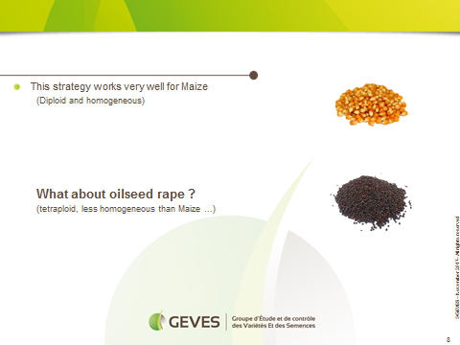

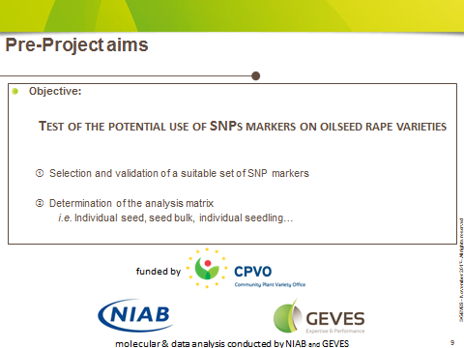

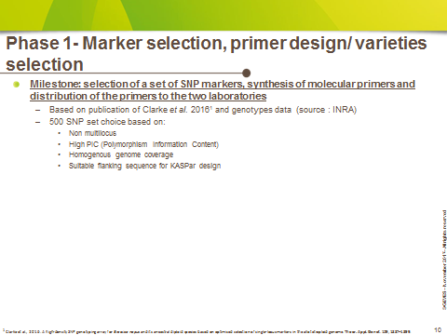

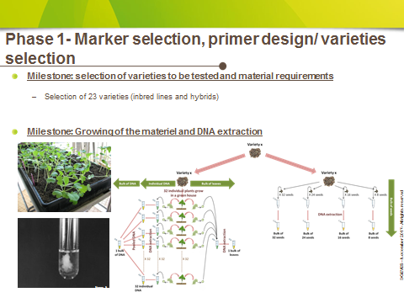

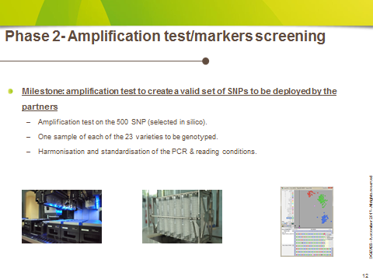

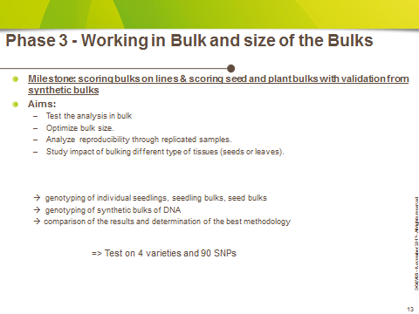

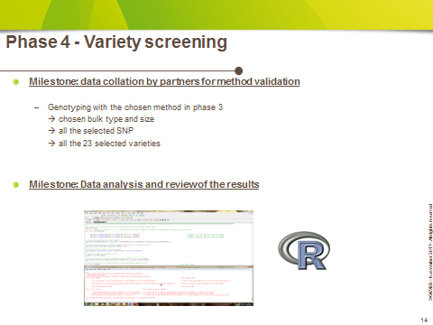

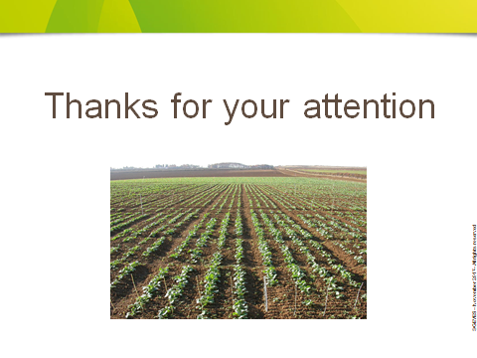

[End of Annex and of document]

