E
International Union for the Protection of New Varieties of Plants

Working Group on Biochemical and Molecular Techniques  and DNA-Profiling in Particular  Sixteenth Session  La Rochelle, France, November 7 to 10, 2017 | BMT/16/6  Original: English  Date: October 11, 2017
GENETIC DISTANCE-BASED SELECTION OF SIMILAR VARIETIES FOR WHEAT DISTINCTNESS TEST
Document prepared by experts from China
Disclaimer: this document does not represent UPOV policies or guidance

INTRODUCTION

1. Wheat is China’s third largest crop both in planted area and total output. In 2016, the planted area was 24.2 million hectares and total production 128.85 million tons, ranking second and first in acreage and total output in the world, respectively. The wheat planting regions in China are classified into ten ecological zones, among which Huanghuai is the largest ecological zone accounting for more than 60% of the total wheat planting area.

2. DUS testing started in China from 2001 with the implementation of the New Plant Varieties Protection Regulations. The number of annual new wheat applications tested at Jinan Station was around 40 before 2015. Since 2015, the revised Seed Act and other regulations have had a great impact on the scale of DUS testing. According to the new seed law, DUS report is required both for variety registration and for granting of Breeder’s Rights. As a result, the number of wheat applications increased rapidly (table 1).
Table 1 Number of annual new wheat applications tested at Jinan Station
Year | 2007 | 2008 | 2009 | 2010 | 2011 | 2012 | 2013 | 2014 | 2015 | 2016
Number | 62 | 36 | 39 | 30 | 36 | 25 | 85 | 38 | 181 | 230

3. Among the 17 DUS testing stations in operation, 10 stations are involved in wheat DUS testing. However, most of the applications for winter wheat are from Huanghuai. Until 2016, Jinan DUS Testing Station was the only station located in this region and had tested 722 winter wheat varieties.

4. In order to make a decision on distinctness, a candidate variety needs to be compared with a collection of reference varieties. There is a large reference collection for wheat in china. As present, the number of the reference varieties, including varieties registered and (or) protected (and being tested), has reached more than 3000.

5. Because of the large size of the reference collection and the fact that the grouping characteristics are mostly quantitative, selection of reference wheat varieties to be grown along candidate varieties (“similar varieties”) is the most difficult step in distinctness evaluation. In the past, selection of similar varieties was mainly based on the pedigree information of candidate varieties provided by the breeders. Generally, one or several similar varieties was (were) selected to be grown in the trials for each application. However, the selection was often inaccurate and the process inefficient. As wheat breeding is getting more profitable with the implementation of PBR laws, increasingly more private seed breeders start wheat breeding. In the meantime, the practice of “modification breeding” is getting common. The traditional methods for similar variety selection were unable to meet the new challenge. To address the problems, we have taken the UPOV Option 2 “calibrated molecular distances in the management of variety collections” approach using SSR markers (UPOV, 2011). With funding from the Ministry of Agriculture, we developed a harmonized protocol for wheat variety DNA profiling and started construction of a wheat reference variety DNA database during 2009-2012. In 2013, we began to select wheat similar varieties based on genetic distances. In 2016, software was developed to speed up the selection process and the new approach is routinely used for almost all other DUS testing stations involved in wheat DUS testing in China.

DEVELOPMENT OF A HARMONISED PROTOCOL FOR DNA PROFILING USING SSR MARKERS

6. We started to make the protocol in 2009 with the support of a project from the Ministry of Agriculture. Selection of SSR markers and detection platforms were according to the BMT guidelines (UPOV, 2010). All the SSR markers collected were from public sources (e.g. Rōder, et al., 2002; Somers, et al., 2004). The following criterions for marker selection were followed: (1) even distribution in the genome; (2) high polymorphism; (3) good reproducibility; (4) easiness of scoring. Two markers on each chromosome meeting the above criterion were chosen with a total number at 42. Capillary gel analysis was adopted as the main platform in the protocol while procedure for using ordinary sequencing gel equipment was also provided. The forward primers of the selected markers were labeled with one of the four dyes: 6-Fam, Hex, Tamra and Rox. The alleles at each locus were named in the form of “size” in base pairs. Reference variety was determined for each allele to eliminate the systematic errors that occur among different models of DNA sequencers or different sample batches (Zheng, et al., 2014). The protocol was validated using different detection platforms or models of equipment among several laboratories. In 2013, it was adopted as a standard by the Ministry of Agriculture (MOA, 2013).

CONSTRUCTION OF DNA PROFILE DATABASE OF WHEAT REFERRENCE VARIETIES

7. During 2012-2014, a DNA database mainly consisting of the Huanghuai winter wheat reference varieties was constructed. 44 SSR markers (42 markers plus 2 additional markers) were used to genotype the reference varieties following the above mentioned protocol. In 2015, wheat varieties from other ecological zones were genotyped and data entered into the database. In the meantime, DNA profiles of new candidate varieties were routinely collected and entered into the database. As of August 2017, the database is comprised of DNA data of more than 3300 varieties.

DETERMINATION OF THE THRESHOLD FOR SELECTION OF SIMILARITIES

8. There had been some reports on the setting of a threshold for wheat similar variety selection. Wang et al (2010) investigated the relationship between genotypic and phenotypic distances. They computed the Dice genetic similarity of VCU trial varieties using 122 SSR markers, and compared variety pairs characteristic by characteristic using wheat DUS testing guidelines. It was observed that (1) variety pairs with below 90% genetic similarity could be clearly distinguished; (2) a large portion of variety pairs with genetic similarity between 90-95% were similar or very close; (3) variety pairs with genetic similarity above 95% were very close or could not be distinguished from each other. Based on these findings, a threshold of 90% was set in VCU trials. We compared the molecular and phenotypic distances of 130 variety pairs from our DUS trials and similar results were obtained (Table 2). We also compared the genetic distances between 33 non-distinct candidate varieties and their corresponding most similar varieties based on 44 SSR markers. The genetic similarities varied between 90% and 100% for those variety pairs. Thus, a genetic similarity threshold of 80% was chosen for management of our wheat variety reference collection.
Table 2 Relation between genetic similarity and percentage of non-distinct varieties
Genetic similarity | GS≥95 | 90≤GS<95 | 85≤GS<90 | 80≤GS<85 | GS<80
Number of variety pairs | 35 | 15 | 9 | 10 | 61
Number of non-distinct variety pairs | 26 | 7 | 0 | 0 | 0
% of non-distinct variety pairs | 74.3 | 46.7 | 0 | 0 | 0

9. With the current amount of applications, it becomes infeasible to genotype the newly submitted applications using 44 markers in the short period (about one month) between receipt of seeds of applications and planting of first year trial. We tried using 28 SSR markers out of the 44 markers to genotype new candidate varieties before planting trials. Correlation analysis indicated that the genetic distances from using the two sets of markers were significantly correlated with a coefficient of 0.87. Comparison of the selection results showed that only varieties with low genetic similarity to the candidates more or less affected. During the 2016-2017 growing cycle, approximately 600 new candidate varieties were genotyped with the 28 markers and similar varieties were selected using the 80% threshold level.

DEVELOPMENT OF SOFTWARE FOR SIMILAR VARIETY SELECTION

10. We have started similar variety selection using genetic distance based approach since 2013. At the beginning, genetic distances were calculated using POWERMARKER3.25, and similar varieties were identified manually. In 2016, we developed software for more efficient distance calculation and similar variety selection one the basis of the DNA database of reference varieties. The software can be used to calculate the genetic similarity between a candidate variety and any other variety in the database, align the varieties in the order of the distance and display the similar varieties at any set threshold. Another feature of the database and the software is that the allele data collected according to the protocol can be used directly with no need of conversion. Both the 44 and 28 marker modes can be used with the software.

APPLICATION OF THE METHOD

11. In 2013, the genetic distance based approach was first used for candidate varieties tested at Jinan and Nanjing station (representing two ecological zones). During 2014-2015, candidate varieties from other 2 ecological zones were screened for similar varieties using the approach. Since 2017, almost all applications in the country were screened using they database.

12. The genetic distance based approach is also very efficient in term of the number of similar variety to be grown. At Jinan station, 110 candidate varieties were screened for similar varieties with the genetic similarity threshold of 80% in 2013. At this threshold, 66 applications had no similar varieties. 29 had 1 to 3 similar varieties. 6 had 4 to 6 similar varieties. 9 had more than 6 similar varieties. Similar results were obtained for applications of other years.

13. With the application of this approach, accuracy of similar variety selection has improved as well as the efficiency of DUS trials. Among the 110 applications from year 2012-2013 planted at Jinan Station, 18 were found not distinct after field trials. Another advantage of the approach is that some candidates can be found non-distinct only after one year’s field trial. For example, 2 VCU applications from 2016 were found not distinct after only one season’s DUS trial.

REFERENCES

Ministry of Agriculture (2013). NY/T 2470-2013 Protocol for common wheat variety identification - SSR marker method.

Rōder MS, Wendehake K, Korzun V, Bredemeijer G, Laborie D, Bertrand L, Isaac P, Rendell S, Jackson J, Cooke R, Vosman B, Ganal M(2002). Construction and analysis of a microsatellite-based database of European wheat varieties. Theor Appl Genet, 106(1): 67-73.

Somers DJ, Isaac P and Edwards K (2004). A high-density microsatellite consensus map for bread wheat (Triticum aestivum L.), Theor Appl Genet, 109: 1105–1114.

UPOV /INF/17/1 (2010) GUIDELINES FOR DNA-PROFILING: MOLECULAR MARKER SELECTION AND DATABASE CONSTRUCTION.

UPOV/INF/18/1 (2011). POSSIBLE USE OF MOLECULAR MARKERS IN THE EXAMINATION OF DISTINCTNESS, UNIFORMITY AND STABILITY (DUS).

WANG Li-Xin， LI Hong-Bo， LIAO Qin，QIU Jun，CHANG Li-Fang，LIU Li-Hua，REN Li-Ping，GAO Xin-Huan，and ZHAO Chang-Ping (2010). Screening Wheat Varieties with Genetic Similarity Using Molecular Markers. ACTA AGRONOMICA SINICA, 36(9): 1490−1497.

ZHENG Yong-sheng, ZHANG Han, WANG Dong-jian, SUN Jia-mei, WANG Xue-mei, DUAN Li-li, LI Hua, WANG Wei, LI Ruyu (2014). Development of a Wheat Variety Identification System based on Fluorescent Dye Labeled SSR Markers. Scientia Agricultura Sinica, 47(19):3725-3735.

14. The Annex to this document contains a copy of a presentation “Genetic Distance-based Selection of Similar Varieties for Wheat Distinctness Test” to be made at its sixteenth session of the Working Group on Biochemical and Molecular Techniques, and DNA-Profiling in Particular (BMT).

Ruyu Li, Han Zhang, Yongsheng Zheng, Lili Duan, Hua Li, Xuemei Wang, Jinan DUS Testing Station, Ministry of Agriculture, China

[Annex follows]

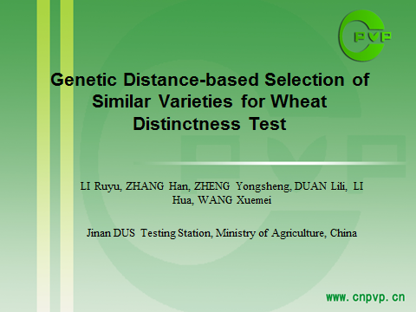

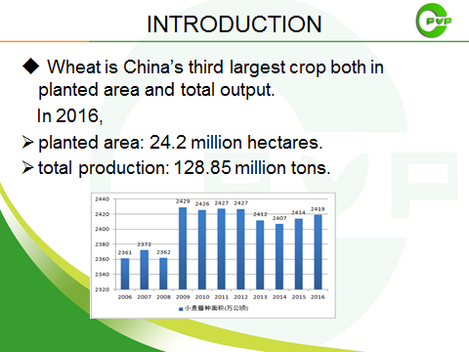

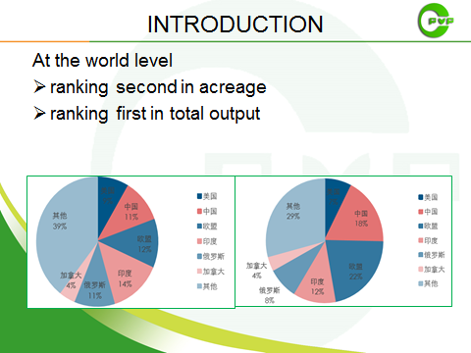

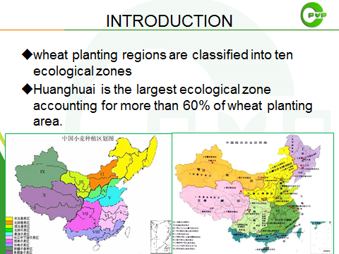

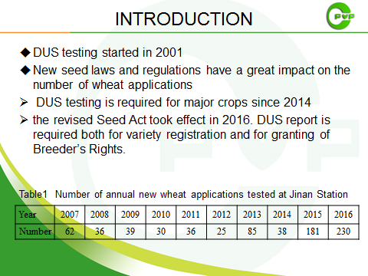

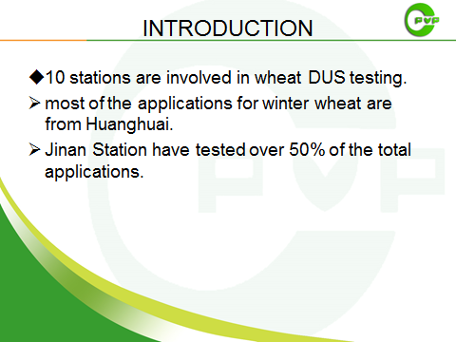

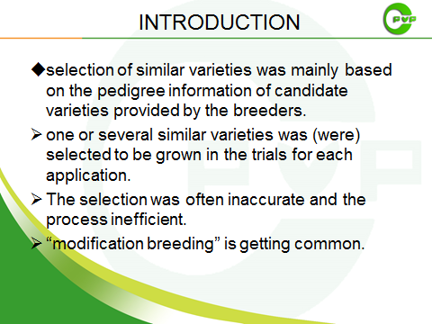

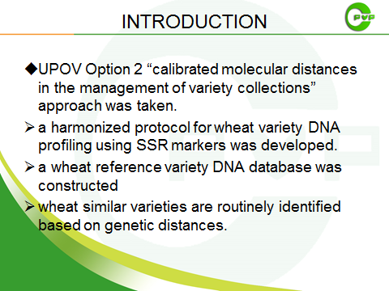

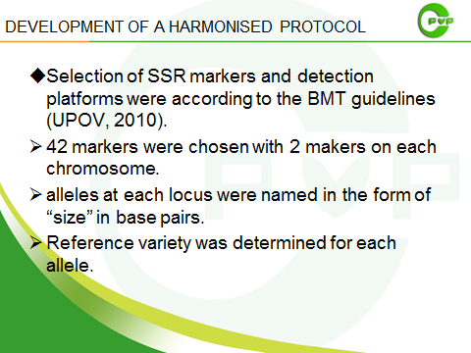

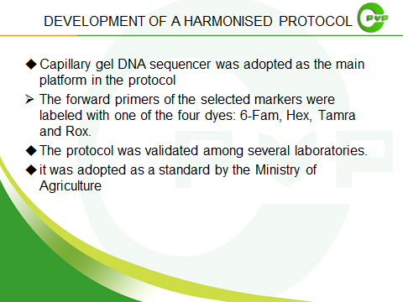

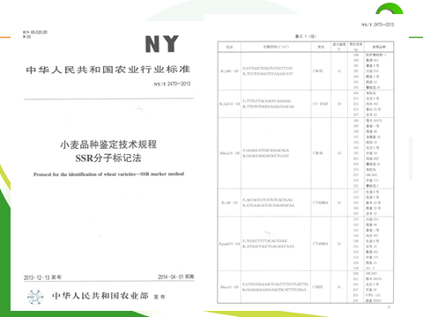

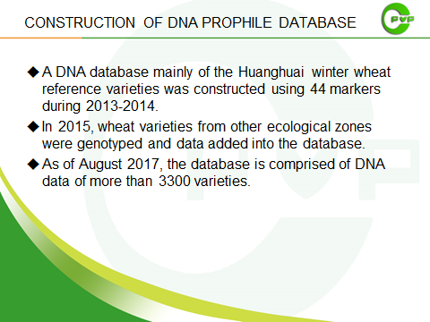

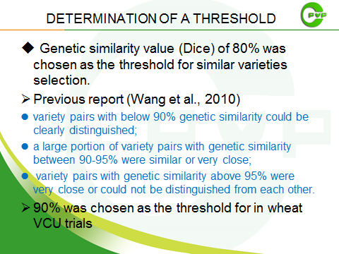

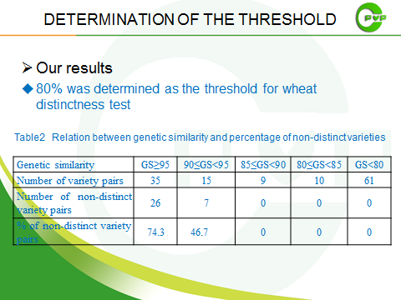

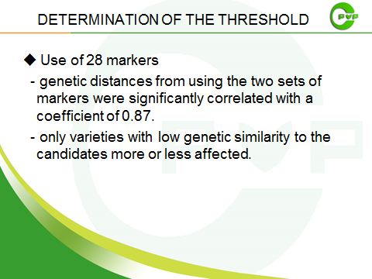

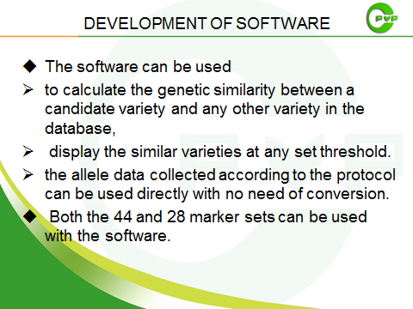

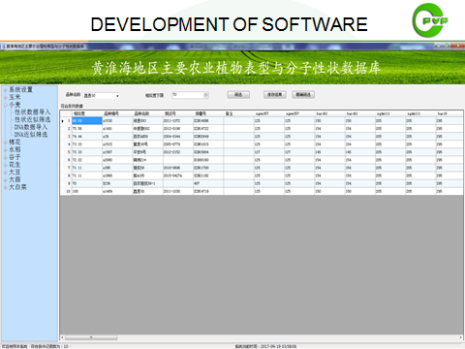

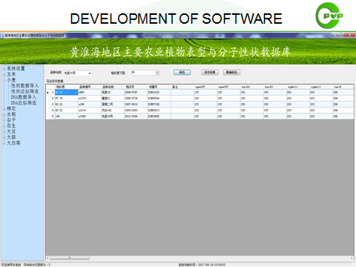

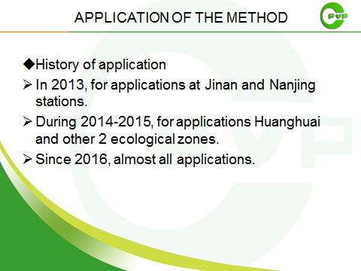

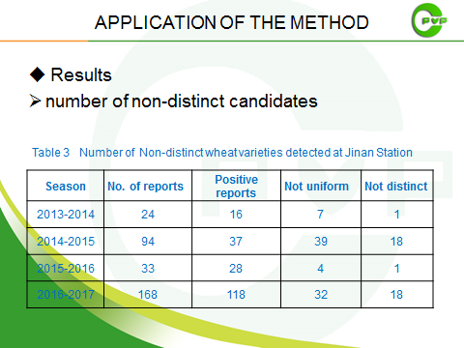

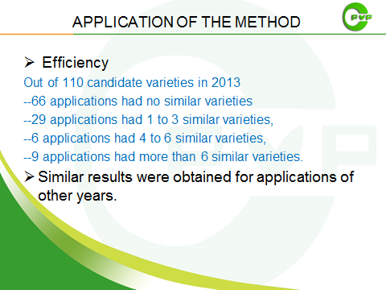

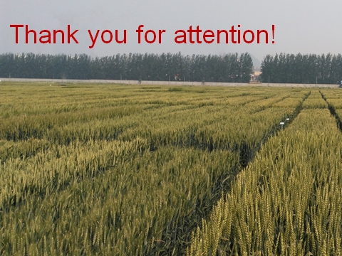

[End of Annex and of document]

