|  |  |
| --- | --- |
|  | E |
| International Union for the Protection of New Varieties of Plants |  |

|  |  |
| --- | --- |
| Working Group on Biochemical and Molecular Techniques  and DNA-Profiling in Particular  Sixteenth Session La Rochelle, France, November 7 to 10, 2017 | BMT/16/3  Original: English  Date: October 25, 2017 |

INTERNATIONAL GUIDELINES ON MOLECULAR METHODOLOGIES INCLUDING COOPERATION BETWEEN OECD, UPOV, ISTA AND ISO

Document prepared by the Office of the Union

Disclaimer: this document does not represent UPOV policies or guidance

# Executive summary

This document reports on developments concerning the Guidelines for DNA-Profiling: Molecular Marker Selection and Database Construction (“BMT Guidelines”) and cooperation between OECD, UPOV, ISTA and ISO.

The BMT is invited to note that:

(a) a Joint OECD/UPOV/ISTA/AOSA Workshop on Biochemical and Molecular Methods was held in Paris on June 8, 2016, and that the recommendations of the Joint OECD/UPOV/ISTA/AOSA Workshop as reproduced in paragraph 9 of this document, were approved by the Annual Meeting of the OECD Seed Schemes, held in Paris on June 9 and 10, 2016;

(b) the TC, at its fifty-third session, agreed that possible future collaboration between UPOV, OECD and ISTA might include the harmonization of terms and methodologies used for different crops and the possible development of standards, after agreement by those organizations;

(c) practical workshops on “DNA Techniques and Variety Identification” were held in Roelofarendsveen, Netherlands, from May 8 to 10, 2017 and from September 20 to 22, 2017;

(d) the TC agreed that UPOV and OECD should consider making progress in the matters reported in this document if ISTA is unable to participate in the near future.

The structure of this document is as follows:

Executive summary 1

BMT guidelines 2

Cooperation between OECD, UPOV, ISTA and ISO 2

OECD/UPOV/ISTA Joint Workshop on Molecular Techniques 2

Developments at the fifty-third session of the TC 3

Practical Workshops on “DNA Techniques and Variety Identification” 3

ANNEX I AGENDA OF PRACTICAL WORKSHOP “DNA TECHNIQUES AND VARIETY IDENTIFICATION”

ANNEX II AGENDA OF INTERNATIONAL WORKSHOP ON DNA TECHNIQUES AND VARIETY IDENTIFICATION

The following abbreviations are used in this document:

BMT: Working Group on Biochemical and Molecular Techniques, and DNA-Profiling in Particular

TC: Technical Committee

TWPs: Technical Working Parties

AOSA: Association of Official Seed Analysts

OECD: Organization for Economic Co-operation and Development

ISO: International Organization for Standardization

ISTA: International Seed Testing Association

# BMT guidelines

At its forty-fourth session, held in Geneva, Switzerland, October 21, 2010, the Council adopted document UPOV/INF/17/1 “Guidelines for DNA-Profiling: Molecular Marker Selection and Database Construction” (“BMT Guidelines”) (see document C/44/17 “Report”, paragraph 34).

It is recalled that the purpose of the BMT Guidelines is to provide guidance for developing harmonized methodologies with the aim of generating high quality molecular data for a range of applications as follows.

“A. INTRODUCTION

The purpose of this document (BMT Guidelines) is to provide guidance for developing harmonized methodologies with the aim of generating high quality molecular data for a range of applications. The BMT Guidelines are also intended to address the construction of databases containing molecular profiles of plant varieties, possibly produced in different laboratories using different technologies. In addition, the aim is to set high demands on the quality of the markers and on the desire for generating reproducible data using these markers in situations where equipment and/or reaction chemicals might change. Specific precautions need to be taken to ensure quality entry into a database.”

The BMT Guidelines will be reviewed at the sixteenth session of the BMT (see agenda item 11, document BMT/16/4 “Review of document UPOV/INF/17 “Guidelines for DNA-Profiling: Molecular Marker Selection and Database Construction (‘BMT Guidelines’)”).

# Cooperation between OECD, UPOV, ISTA and ISO

The background to this matter is provided in document BMT/15/5 “Cooperation between OECD, UPOV, ISO and ISTA”.

## OECD/UPOV/ISTA Joint Workshop on Molecular Techniques

A Joint OECD/UPOV/ISTA/AOSA Workshop on Biochemical and Molecular Methods was held in Paris, France, on June 8, 2016, and the following recommendations of the Joint OECD/UPOV/ISTA/AOSA Workshop were approved by the Annual Meeting of the OECD Seed Schemes, held in Paris, France, on June 9 and 10, 2016:

1. To develop a joint document explaining the principal features (e.g. DUS, variety identification, variety purity, etc.) of the systems of OECD, UPOV, AOSA and ISTA and, for mutual understanding, to repeat the joint workshop at relevant meetings of the OECD and ISTA;
2. To carry out a joint inventory by UPOV, OECD, AOSA and ISTA of the use of molecular marker techniques, by crop, with a view to developing a document containing that information. The OECD will contribute to the document by sharing the ongoing list of molecular techniques used by National Designated Authorities (NDAs) and continuously collected by the Secretariat;
3. To develop a list of terms and their definitions as used by OECD, UPOV, AOSA and ISTA and to make an attempt to harmonize these;
4. To consider organizing another similar workshop in three years’ time; and
5. To consider replacing the term used in the OECD Seed Schemes for the status of DNA based techniques from “internationally validated” to another term such as “internationally harmonized.”

The Annual Meeting of the OECD Seed Schemes endorsed the proposal of the Netherlands to organize a practical workshop in 2017, with support of the OECD, UPOV and ISTA, to explore how molecular techniques might be applied in an efficient way for UPOV, OECD and ISTA purposes.

## Developments at the fifty-third session of the TC

The TC, at its fifty-third session, noted that the development of a joint document explaining the principal features of the systems of the OECD, UPOV and ISTA could only start after agreement by OECD and ISTA (see document TC/53/31, paragraph 199 to 203).

The TC noted that the development of a joint OECD/UPOV/ISTA document containing an inventory of molecular marker techniques used by crop could only start after agreement by OECD and ISTA.

The TC agreed that possible future collaboration between UPOV, OECD and ISTA might include the harmonization of terms and methodologies used for different crops and the possible development of standards, after agreement by those organizations.

The TC considered whether to explore circumstances in which the same techniques and information could be used by OECD, ISTA and UPOV, taking into account the different objectives of the organizations, and agreed that the organization by Naktuinbouw of a practical workshop in 2017, in Roelofarendsveen, Netherlands, from May 8 to 10, 2017, could explore such possibilities on the basis of real situations.

The TC agreed that UPOV and OECD should consider making progress in the matters above if ISTA was unable to participate in the near future.

The TC noted that a Joint OECD/UPOV/ISTA/AOSA Workshop on Biochemical and Molecular Methods had been held in Paris on June 8, 2016, and that the recommendations of the Joint OECD/UPOV/ISTA/AOSA Workshop as reproduced in document TC/53/11, paragraph 25, had been approved by the Annual Meeting of the OECD Seed Schemes, held in Paris on June 9 and 10, 2016 (see document TC/53/31, paragraph 209).

## Practical Workshops on “DNA Techniques and Variety Identification”

In relation to paragraph 14 of this document, a practical workshop “DNA Techniques and Variety Identification” was held in Roelofarendsveen, Netherlands, from May 8 to 10, 2017 and an “International Workshop on DNA Techniques and Variety Identification” was held in Roelofarendsveen, Netherlands, from September 20 to 22, 2017. The agendas of these workshops are reproduced in Annex I and II to this document, respectively.

The BMT is invited to note that:

(a) a Joint OECD/UPOV/ISTA/AOSA Workshop on Biochemical and Molecular Methods was held in Paris on June 8, 2016, and that the recommendations of the Joint OECD/UPOV/ISTA/AOSA Workshop as reproduced in paragraph 9 of this document, were approved by the Annual Meeting of the OECD Seed Schemes, held in Paris on June 9 and 10, 2016;

(b) the TC, at its fifty-third session, agreed that possible future collaboration between UPOV, OECD and ISTA might include the harmonization of terms and methodologies used for different crops and the possible development of standards, after agreement by those organizations;

(c) practical workshops on “DNA Techniques and Variety Identification” were held in Roelofarendsveen, Netherlands, from May 8 to 10, 2017 and from September 20 to 22, 2017; and

(d) the TC agreed that UPOV and OECD should consider making progress in the matters reported in this document if ISTA is unable to participate in the near future.

[Annexes follow]

AGENDA OF PRACTICAL WORKSHOP “DNA TECHNIQUES AND VARIETY IDENTIFICATION”

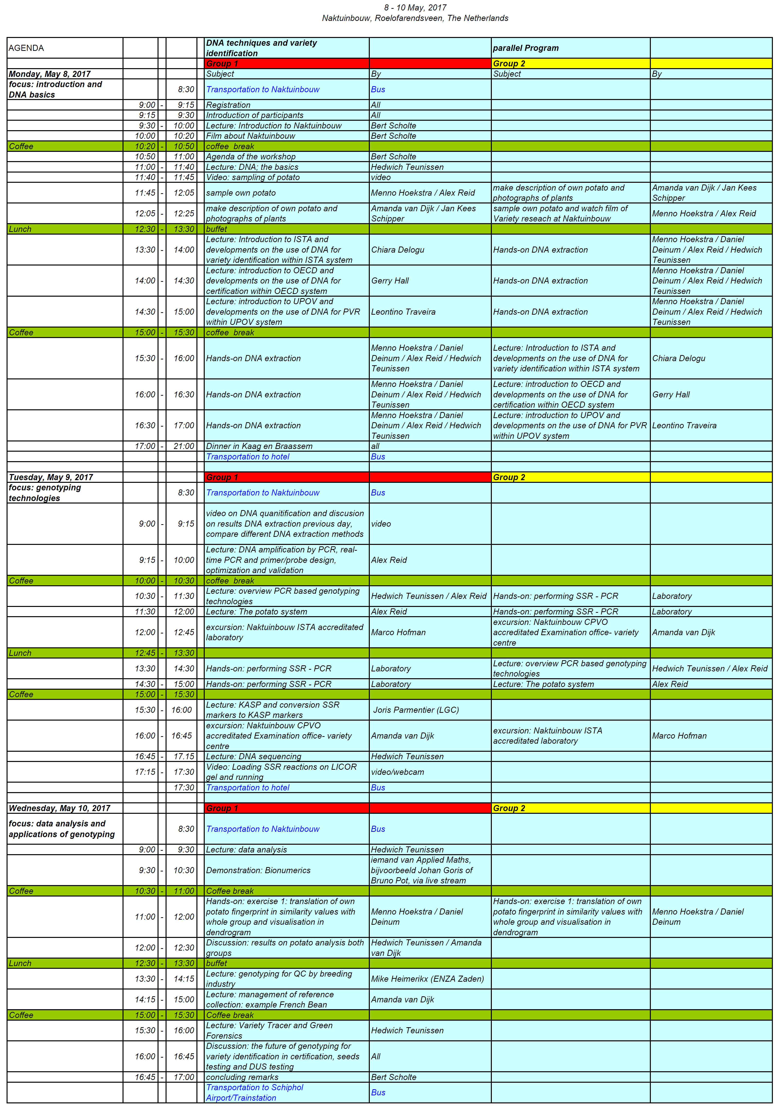

8 – 10 May, 2017, Naktuinbouw, Roelofarendsveen, Netherlands

[Annex II follows]

AGENDA OF INTERNATIONAL WORKSHOP ON DNA TECHNIQUES AND VARIETY IDENTIFICATION



20 – 22 September, 2017, Naktuinbouw, Roelofarendsveen, Netherlands

[End of Annex II and of document]