E
International Union for the Protection of New Varieties of Plants

Working Group on Biochemical and Molecular Techniques  and DNA-Profiling in Particular  Sixteenth Session  La Rochelle, France, November 7 to 10, 2017 | BMT/16/27  Original: English  Date: November 6, 2017
The Tomato project proposal in CPVO IMODDUS program
Document prepared by an expert from the Netherlands
Disclaimer: this document does not represent UPOV policies or guidance
The Annex to this document contains a copy of a presentation “The Tomato project proposal in CPVO IMODDUS program” to be made at its sixteenth session of the Working Group on Biochemical and Molecular Techniques and DNA-Profiling in particular (BMT).

[Annex follows]

THE TOMATO PROJECT PROPOSAL IN CPVO IMODDUS PROGRAM

Presentation prepared by an expert from the Netherlands

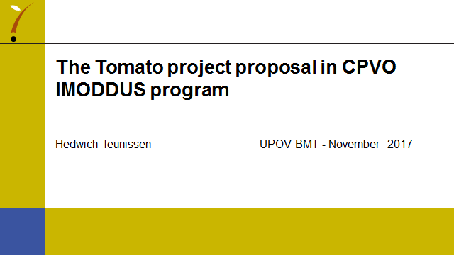

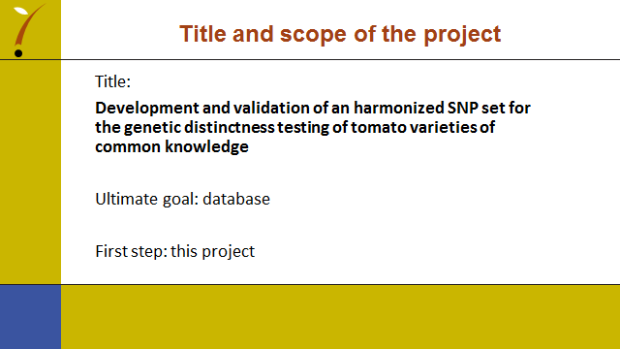

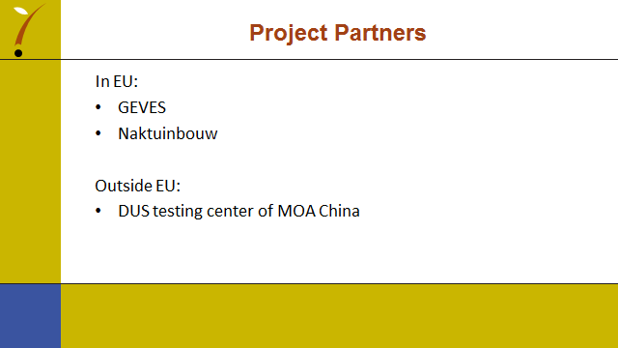

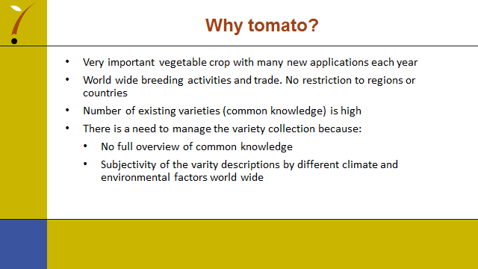

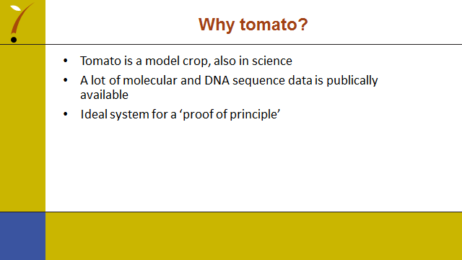

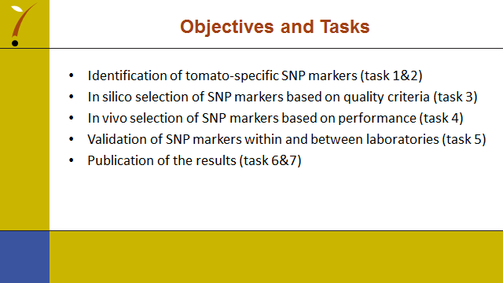

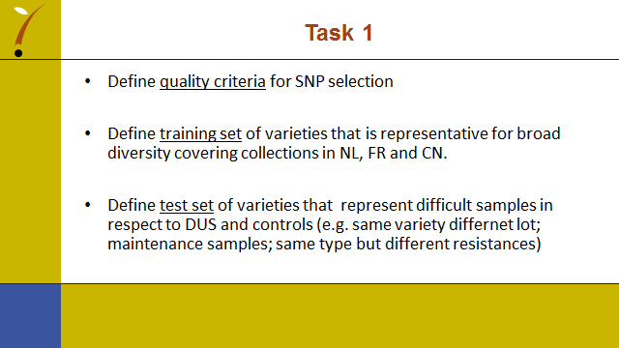

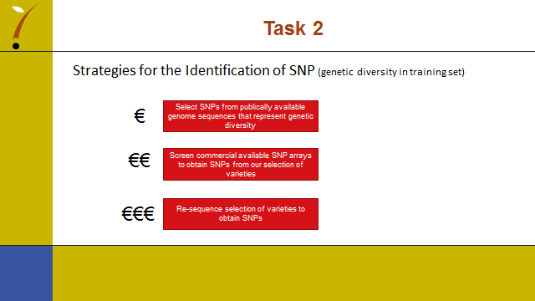

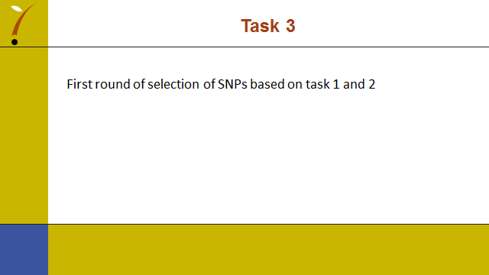

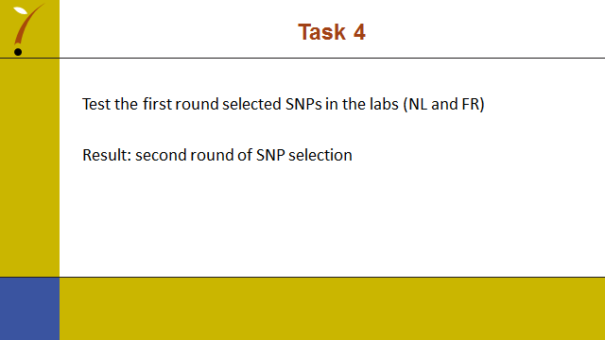

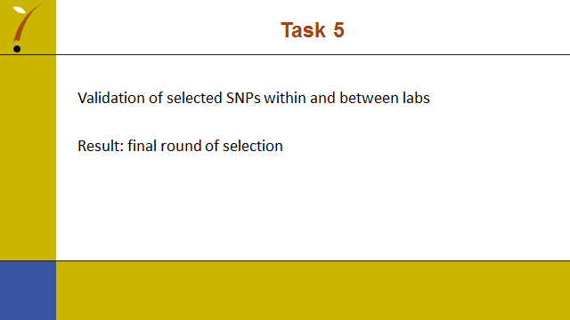

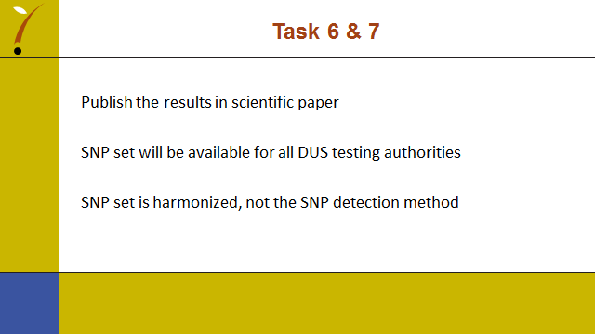

[End of Annex and of document]

