E
International Union for the Protection of New Varieties of Plants

Working Group on Biochemical and Molecular Techniques  and DNA-Profiling in Particular  Sixteenth Session  La Rochelle, France, November 7 to 10, 2017 | BMT/16/24 Add.  Original: English  Date: November 9, 2017
addendum to
Developments and Use of Molecular Techniques for plant variety protection in THE Republic of Korea
Document prepared by an expert from the Republic of Korea
Disclaimer: this document does not represent UPOV policies or guidance
The Annex to this document contains a copy of a presentation on “Developments and Use of Molecular Techniques for plant variety protection in the Republic of Korea”, prepared by an expert from the Republic of Korea, to be made at the sixteenth session of the Working Group on Biochemical and Molecular Techniques and DNA Profiling in Particular (BMT).

[Annex follows]

DEVELOPMENTS AND USE OF MOLECULAR TECHNIQUES FOR PLANT VARIETY PROTECTION IN THE REPUBLIC OF KOREA

Presentation prepared by prepared by an expert from the Republic of Korea

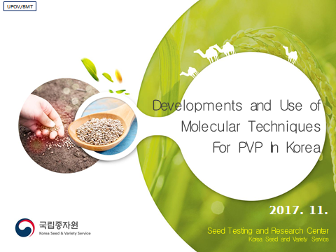

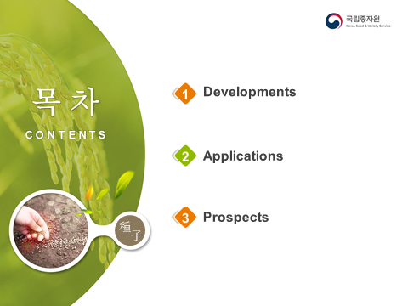

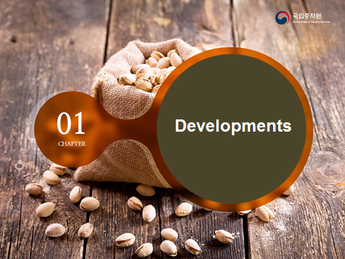

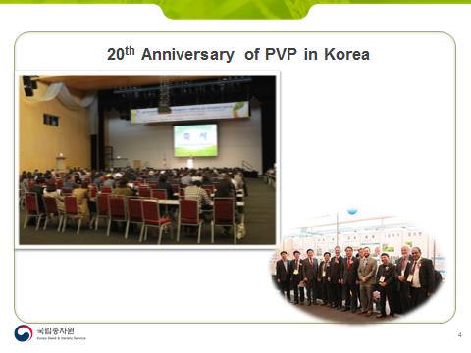

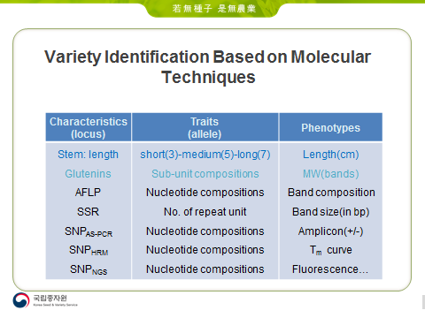

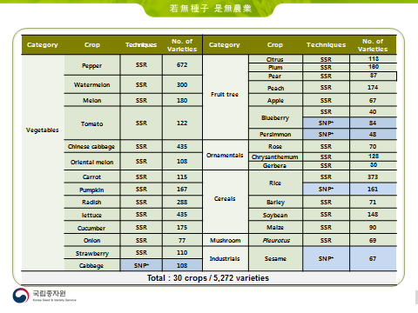

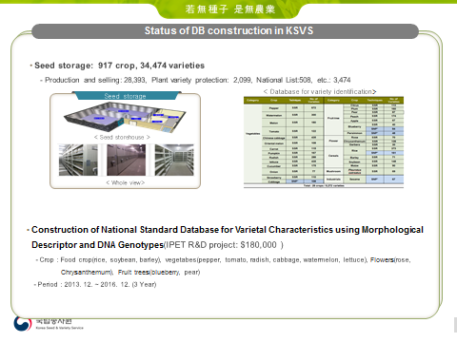

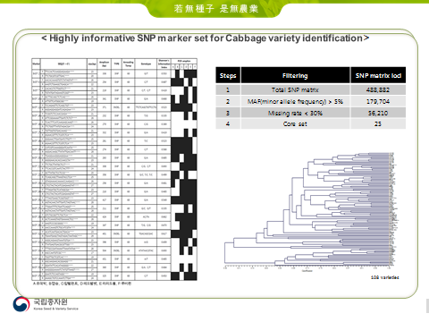

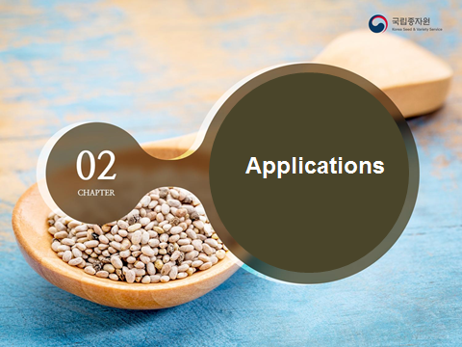

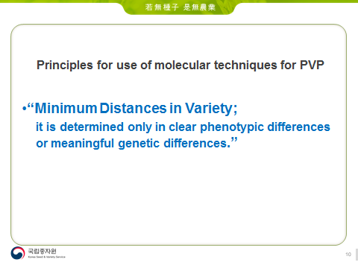

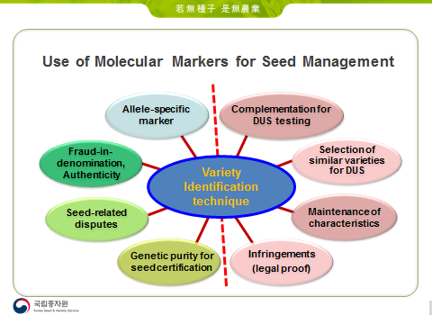

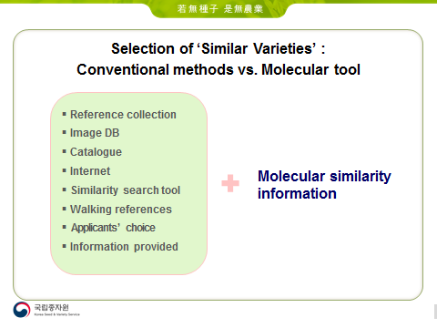

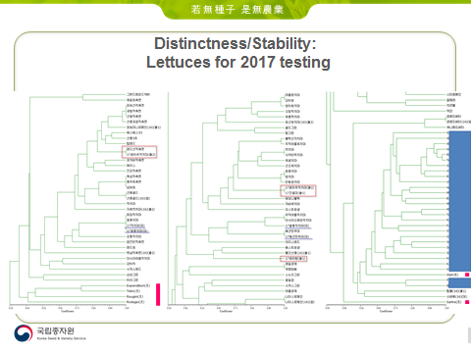

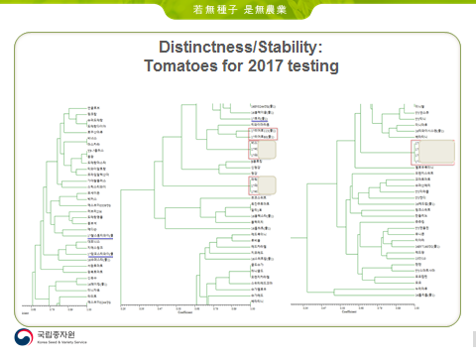

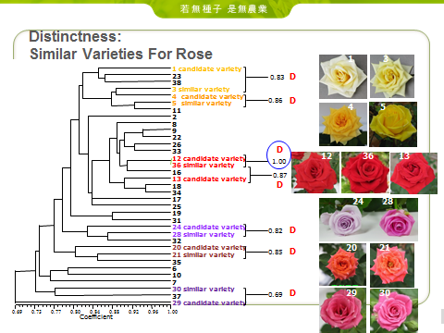

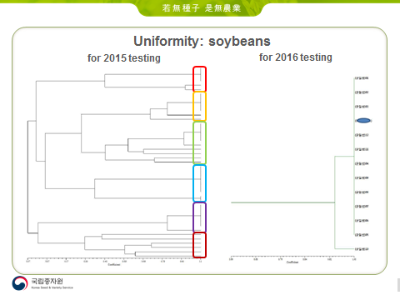

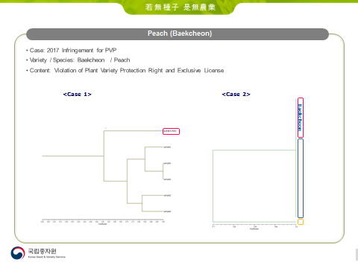

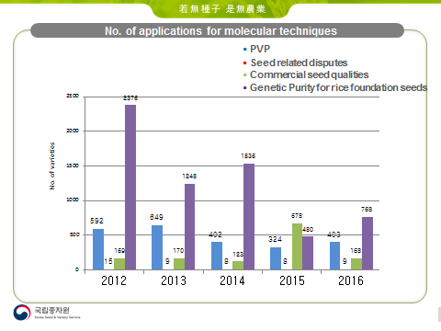

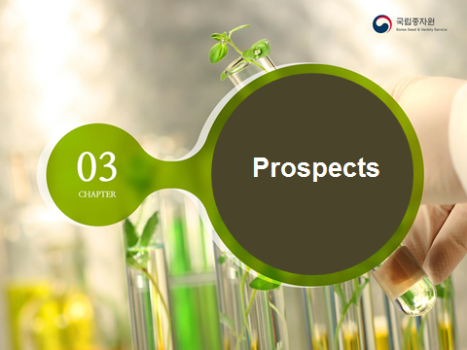

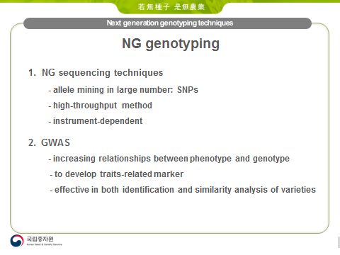

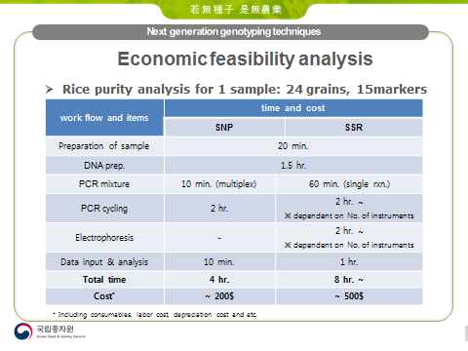

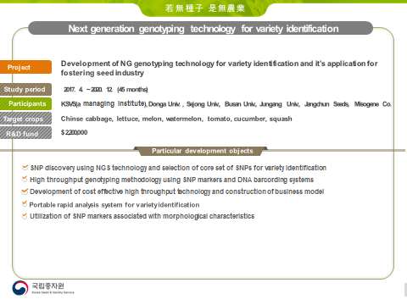

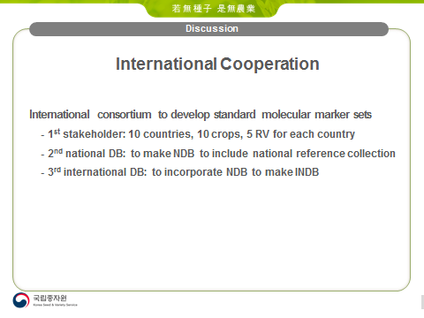

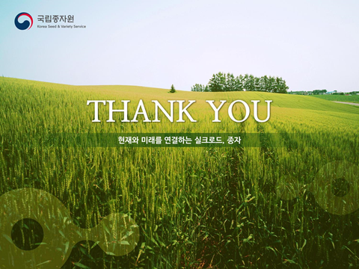

[End of Annex and of document]

