E
International Union for the Protection of New Varieties of Plants

Working Group on Biochemical and Molecular Techniques  and DNA-Profiling in Particular  Sixteenth Session  La Rochelle, France, November 7 to 10, 2017 | BMT/16/22  Original: English  Date: November 3, 2017
report on imoddus activities in 2017
prepared by an expert from the European Union
Disclaimer: this document does not represent UPOV policies or guidance
The Annex to this document contains a copy of a presentation on “Report on IMODDUS activities in 2017”, prepared by an expert from the European Union, to be made at the sixteenth session of the Working Group on Biochemical and Molecular Techniques and DNA-Profiling in Particular (BMT).

[Annex follows]

Report on IMODDUS activities in 2017

Presentation prepared by an expert from the European Union

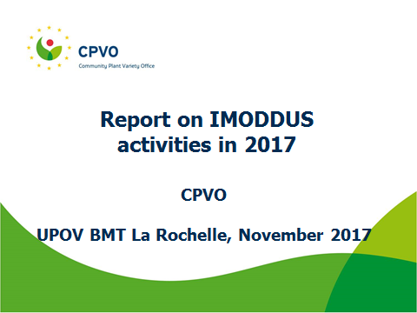

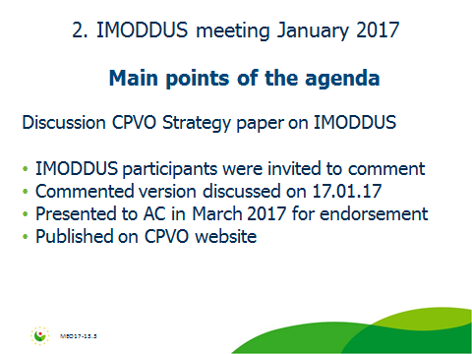

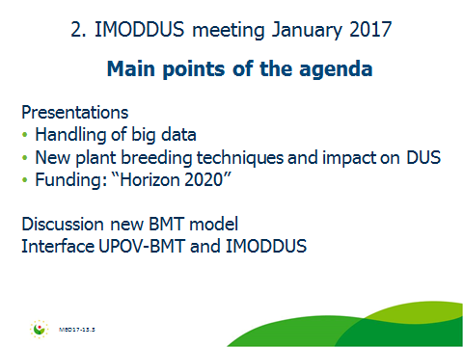

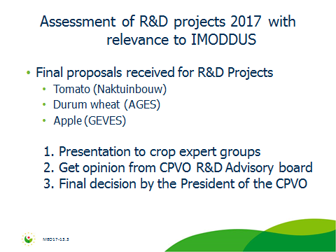

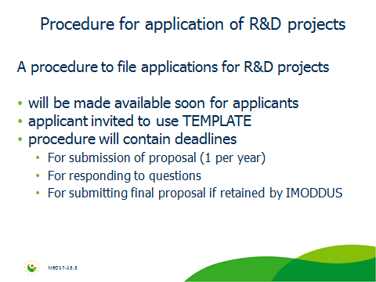

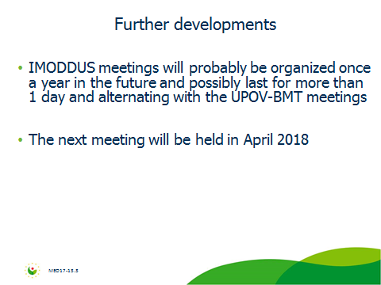

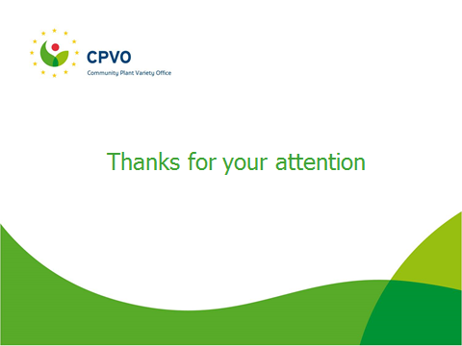

[End of Annex and of document]

