E
International Union for the Protection of New Varieties of Plants

Working Group on Biochemical and Molecular Techniques  and DNA-Profiling in Particular  Sixteenth Session  La Rochelle, France, November 7 to 10, 2017 | BMT/16/19 Add.  Original: English  Date: November 6, 2017
addendum to
Genetic selection of similar varieties for the first growing cycle: example French bean
prepared by an expert from the Netherlands
Disclaimer: this document does not represent UPOV policies or guidance
The Annex to this document contains a copy of a presentation on “Efficient DUS test in French bean (Phaseolus vulgaris L.) by using molecular data: Genetic selection of similar varieties for the first growing cycle”, prepared by an expert from the Netherlands, to be made at the sixteenth session of the Working Group on Biochemical and Molecular Techniques and DNA-Profiling in Particular (BMT).

[Annex follows]

Efficient DUS test in French bean (Phaseolus vulgaris L.) by using molecular data: Genetic selection of similar varieties for the first growing cycle

Presentation prepared by an expert from the Netherlands

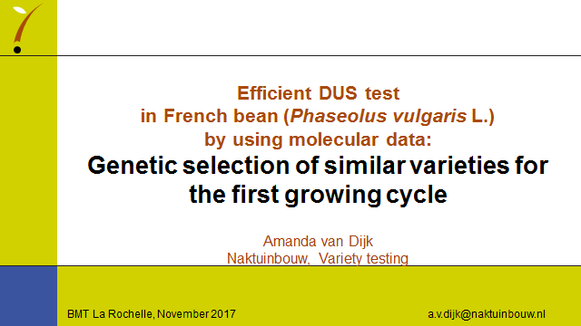

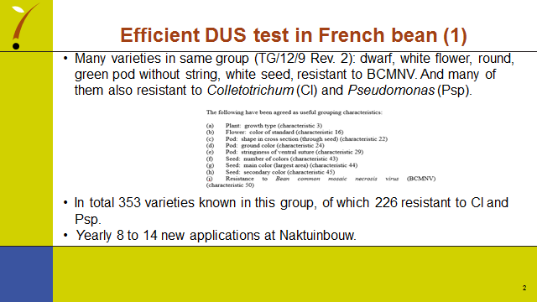

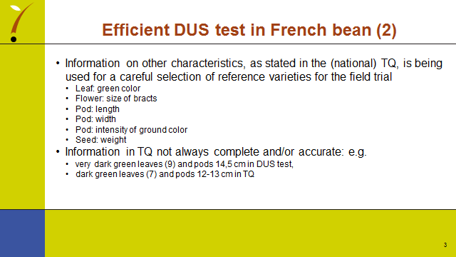

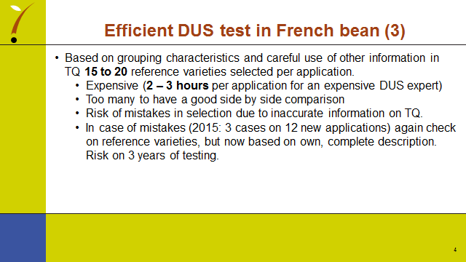

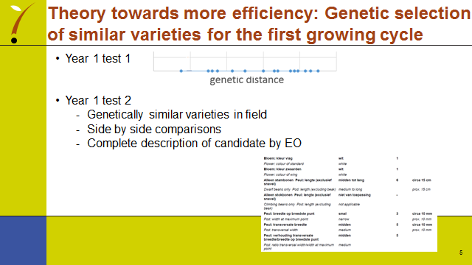

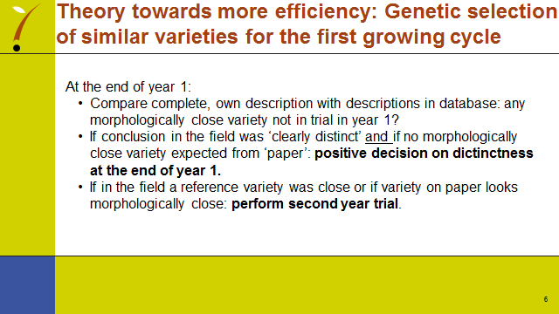

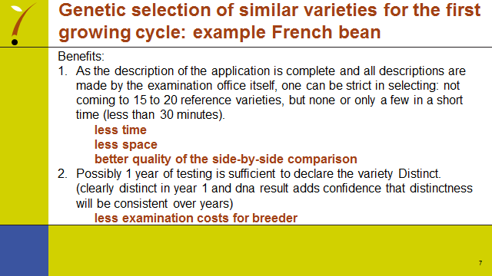

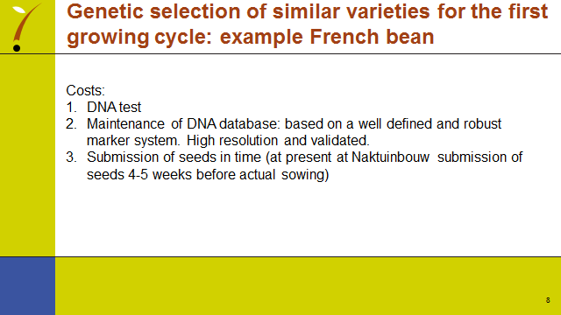

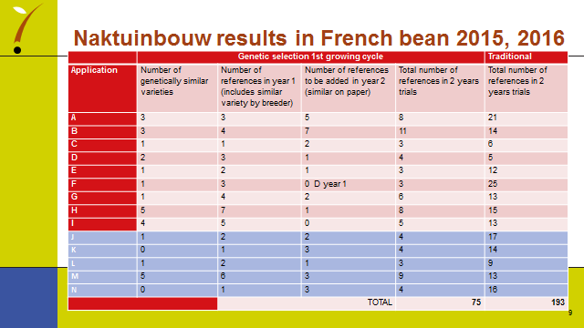

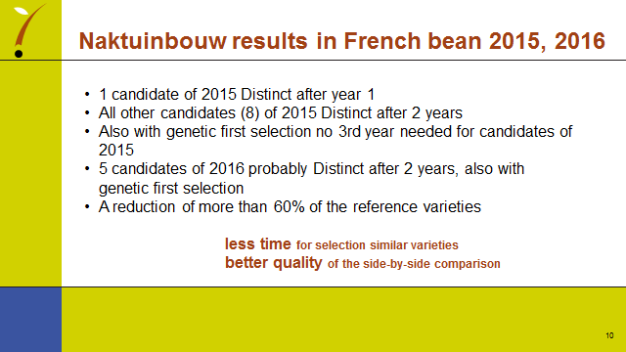

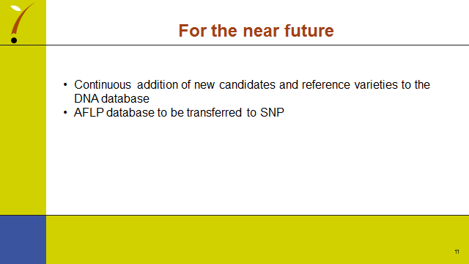

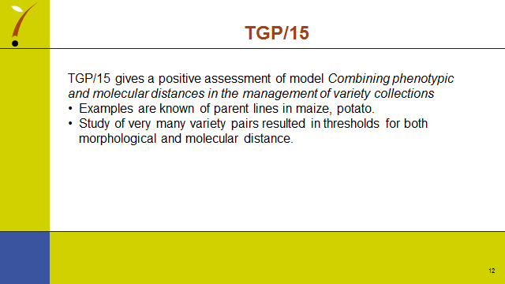

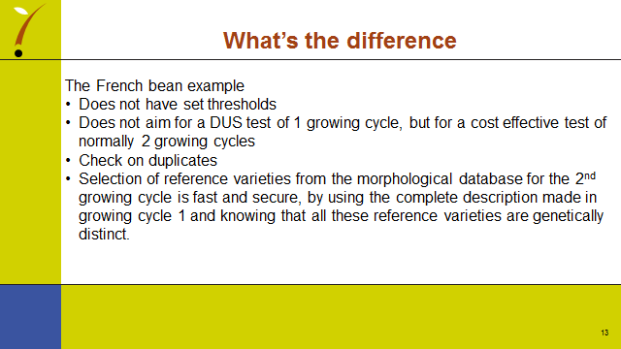

[End of Annex and of document]

