E
BMT/15/7
ORIGINAL: English
DATE: April 18, 2016
INTERNATIONAL UNION FOR THE PROTECTION OF NEW VARIETIES OF PLANTS
Geneva
WORKING GROUP ON BIOCHEMICAL AND MOLECULAR
TECHNIQUES AND DNA PROFILING IN PARTICULAR
Fifteenth Session
Moscow, Russian Federation, May 24 to 27, 2016
UPOV and ISO TC 34/SC 16
From the US Technical Advisory Group and ANSI led host of ISO TC 34/SC 16: Food Products; horizontal methods for molecular biomarker analysis
Document prepared by the International Organization for Standardization (ISO)
Disclaimer: this document does not represent UPOV policies or guidance
The Annex to this document contains a copy of a presentation “UPOV and ISO TC 34/SC 16 From the US Technical Advisory Group and ANSI led host of ISO TC 34/SC 16: Food Products; horizontal methods for molecular biomarker analysis” to be made at its fifteenth session of the Working Group on Biochemical and Molecular Techniques and DNA-Profiling in particular (BMT).

[Annex follows]

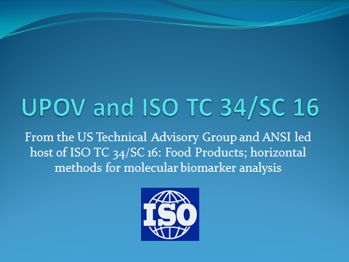

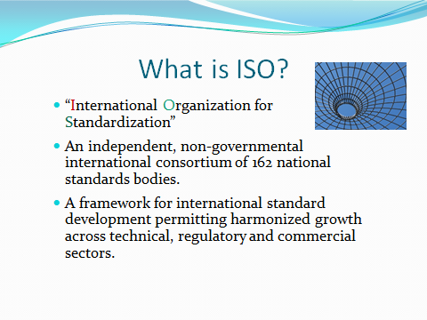

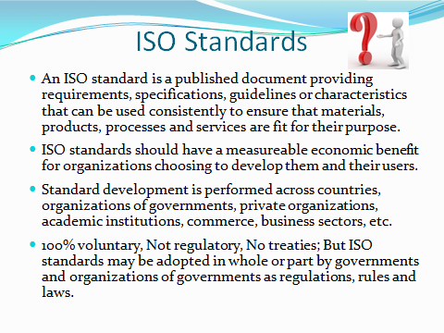

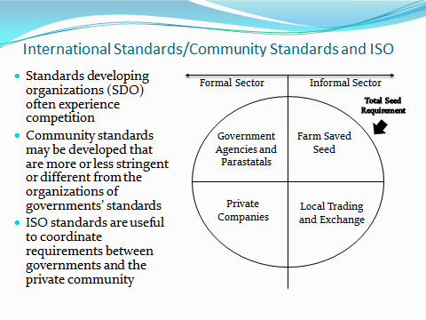

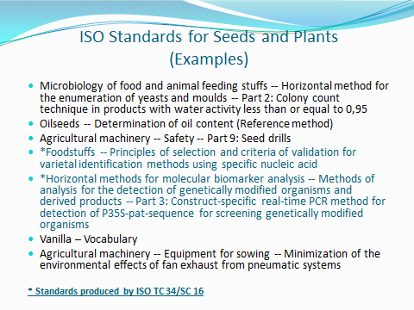

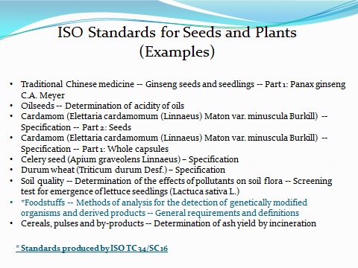

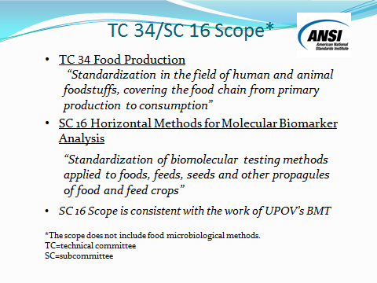

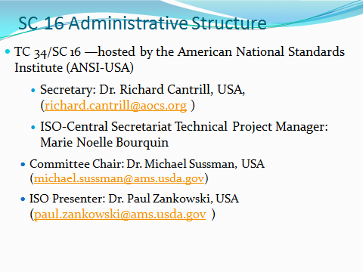

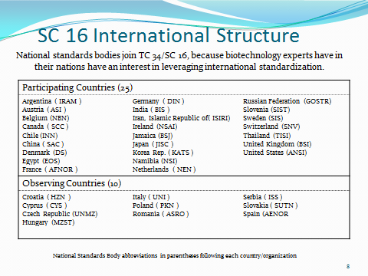

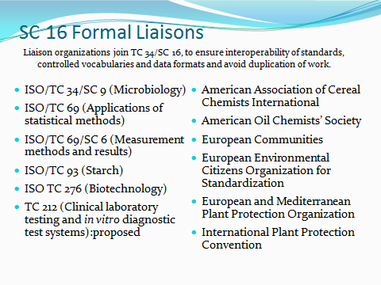

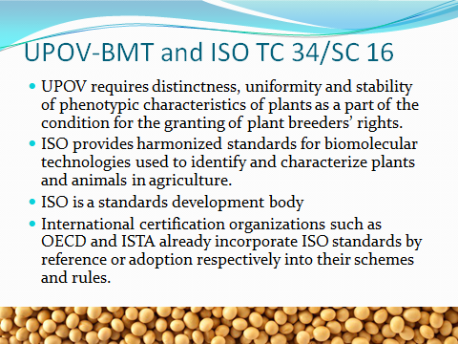

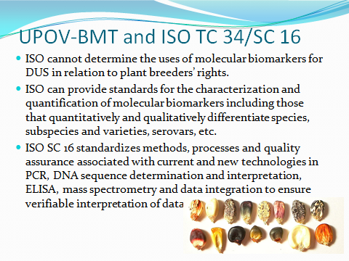

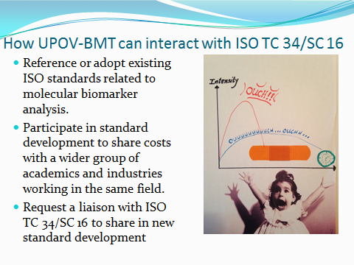

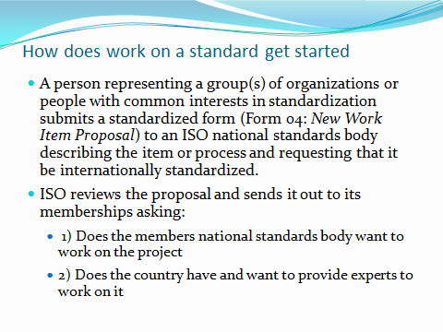

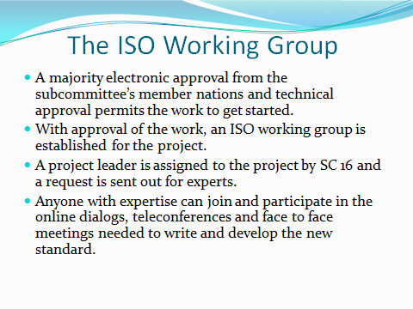

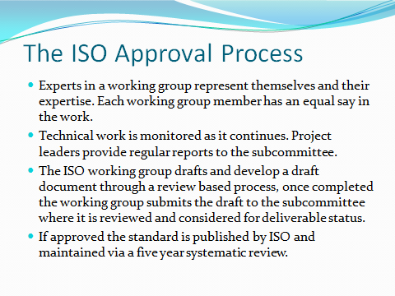

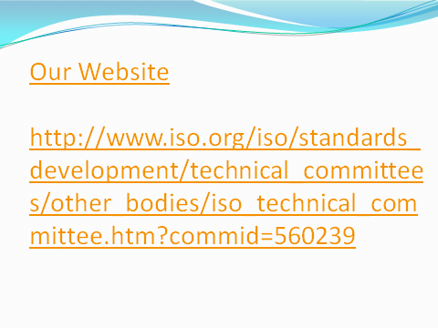
[End of Annex and of document]

