E
BMT/15/27
ORIGINAL: English
DATE: July 5, 2016
INTERNATIONAL UNION FOR THE PROTECTION OF NEW VARIETIES OF PLANTS
Geneva
WORKING GROUP ON BIOCHEMICAL AND MOLECULAR TECHNIQUES
AND DNA-PROFILING IN PARTICULAR
Fifteenth Session
Moscow, Russian Federation, May 24 to 27, 2016
Report by the CPVO to the UPOV BMT meeting in Moscow, 24.-27. May 2016 on CPVO IMODDUS

Document prepared by experts from the Community Plant Variety Office of the European Union
Disclaimer: this document does not represent UPOV policies or guidance

Introduction and background of CPVO IMODDUS

The Community Plant Variety Office of the European Union (CPVO) Administrative Council adopted a R&D Strategy for the period 2015-2020,

The strategy includes the set-up of a CPVO BMT (biochemical and molecular techniques) working group for the promotion of the use of bio-molecular techniques in DUS testing and variety identification. Its name is CPVO IMODDUS which stands for Integration of molecular data into DUS testing.

On the one side, IMODDUS works as a think-tank on how to on a strategic level integrate bio molecular techniques into DUS testing. It assesses and discusses new developments in BMTs and their potential use for DUS, variety identification and enforcement.

On the other side, IMODDUS has a practical approach which aims to identify research and development (R&D) projects for relevant species where these techniques would be promising; to harmonize methodologies and to promote and propose R&D projects for co-funding by the CPVO.

The Composition of IMMODUS is experts from entrusted Examination Offices, experts from the breeding industry appointed by the breeders’ organizations and experts from research institutions, universities or other testing centers participate in the meeting due to their specific knowledge in BMT matters. The composition should ensure expertise in DUS as well as BMT.

In the terms of reference of IMMODUS, its role is essence the following:

i) To propose, for each crop sector, a list of species where the application of biochemical and molecular techniques in DUS testing will be a valuable and useful tool, based on the actual state of the art;

ii) To draft R&D projects focusing on the application or further study of the biochemical and molecular techniques for DUS testing on the species identified under i);

iii) To prepare, if appropriate, guidelines for biochemical and molecular methodologies and their harmonization;

iv) Constitute a forum for discussion on the use of biochemical and molecular techniques in DUS testing; and

v) Clarify any possible questions under their competence raised by the CPVO, the Administrative Council or the Crop Experts Groups.

During 2015, the four existing CPVO crop sector expert groups (DUS experts from each entrusted EO for Agriculture, Vegetables, Fruit & Ornamentals species) have provided input for discussion at the IMODDUS group meeting by suggesting species for R&D projects where these techniques should be considered. Additional proposals came from Examination Offices, a University and a Research Institute.

First IMMODUS Meeting

On 26 April 2016 the first IMMODUS meeting was organized.

In the morning presentations were made on various aspects of using BMT and in the afternoon R&D projects were presented.

Aspects of using BMT

The following three presentations were made:

Use of BMT methods in plant science and future development (University Hohenheim)

Karl SCHMID from the University of Hohenheim gave a presentation about use and actual breeding related research at universities. He gave a general overview of techniques used. He explained that haplotypes are used by breeders rather than markers or phenotypes. This could be also of interest for DUS/VCU related criteria and applications. Further he mentioned a project to analyze rye varieties in cooperation with the Bundessortenamt (BSA; German examination office), COBORU (Polish examination office) and the University of Wrocław. 82 varieties (and 48 individuals of each variety) are screened with 5000 SNP markers to develop “new uses” of markers. Beside the calibration of phenotypic and genetic distances the BSA is interested to see the difference of phenotypic observation of one variety (as a field observation) in comparison to the genetic analysis of 48 individuals of that variety.

Marker technology should be as simple and robust as possible and thereby the technology and concept should be future proofed. The use of BMT should have a strong connection between variety development/breeding and protection. He stated that it may be possible to develop a method using BM data and statistics in DUS testing, a method that may fall all under UPOV Option 3.

Use of BMT methods in plant breeding and future development (ESA)

Stefan van der HEIJDEN on behalf of ESA gave a presentation about the use of BMT in breeding companies and the future challenges. Certain breeding methods will change the development of new varieties and will therefore have also an impact on our current DUS/VCU testing. He stated several species where new BMT methods are already used to develop new varieties. New varieties can therefore be developed faster and more efficiently. The faster establishment/development would also lead to a shorter lifecycle of varieties. Food safety and food security should be of interest for a breeder and assessed criteria of DUS test are often irrelevant for breeders. With new breeding technologies it will become even more difficult to distinguish on the basis of the current DUS criteria.

History and actual state of play of use of BMT methods in DUS testing (NAKTUINBOUW)

NAKTUINBOUW gave two general presentation about the history, actual use of BMT in DUS testing and outlook of the near future and further an overview about the requirements for a DNA database. BMT enables examination offices to develop databases of common knowledge to use for DUS testing, infringement, certification (OECD) and variety identification (ISTA). Further, the implementation and use of the “American Model” was presented and suggested to translate genetic distances in ‘normal’ UPOV characteristics. Meanwhile the selection of standard varieties and the precise definition of the platform used should be solved.
The idea to use DNA data to exclude/include reference varieties in field trials for a first year of testing was also raised, a second year may be used to include further potentially similar varieties. An issue of timing was also raised, taken into account that DNA data would need to be established at a time before the reference varieties for the field trial are identified.

Finally it was discussed if we need a flexible/stable system which is independent from marker systems and if a correlation between the genotype and phenotype is really necessary. Naktuinbouw mentioned to keep classical variety descriptions and add markers as additional characters.

Preliminarily, the resolution and choice of technology should be discussed to develop crop dependent specific solutions. In addition, publicly available information – from breeding companies and scientific researches – should be included in the ongoing discussion of the use of BMT.

Discussion about projects

Presentations on projects that could potentially be co-financed by the CPVO were made

Apple - Developing molecular markers facilitating distinction assessment of apple mutants

Applications of candidate varieties are distinguished between seedlings and mutants. Mutants are more challenging due to tiny differences, the uniformity and the stability depending on the environment. As a crop with multi annual DUS testing the choice of reference varieties at the beginning of the trial is crucial. In a four year project the main focuses will be to (1) phenotype the varieties of ‘GALA’ mutants, (2) identify the phenotypic variety on genetic basis by genetic or epigenetic factors, (3) design genetic and epigenetic molecular markers, (4) validate these markers through ‘GALA’ and other varieties with mutants and finally, to develop a tool box (protocols, prediction models and methodology) to be used in the daily DUS work.

Rose - Development of a SNP marker system for rose

In rose testing no living reference collection exists and due to phytosanitary restrictions it is difficult to import reference material. The photo database is of limited value and the distances become smaller. Beside the existing database with 8 SSR markers it is foreseen to develop new SNP markers. The screening of cut-, pot-, and garden roses is still under discussion. Also the continuation of the ongoing project was discussed.

Phalaenopsis - A joint DNA database for Phalaenopsis

Genetic analysis are based on 8 and 10 different SSR marker, respectively. It is foreseen to exchange the existing DNA and to analyze each sample with the national used SSR markers. The result is a Data base.

Potato - Proposed research to contribute to DUS testing with SNP markers

Beside the current potato project which uses 8 SSR markers the University of Wageningen proposed a new approach. It is foreseen to switch from SSR to SNP marker based technology and to develop a simple and stable system, which could be used by gene banks, breeders and the CPVO. The direct replacement of the actual 8 SSR marker is not intended, therefore the project would concentrate on SNP with a high PIC value and balanced allele frequency. It is foreseen to create a suitable SNP panel which can be used for a broad area and could be also linked to monogenetic traits.

Tomato - Creation of a joint EU database with DNA of tomato

More than 10.000 varieties are registered at the CPVO Variety Finder and around 200 new applications are filed per year. Today, large groups of potentially similar varieties exist and often further growing cycles are required. It is foreseen to reduce the number of growing cycles and the number of reference varieties and to increase the certainty of DUS. In cooperation with Bio-GEVES and University of Amsterdam Naktuinbouw the aim is to choose the right platform and SNP markers to create a DNA database of 8.000 varieties. The data should be available worldwide to increase the accuracy of DUS tests.

Onion/Shallot - Draft idea on the characterization of onion and/or shallot specific DNA markers

Within the species Allium cepa L. different sub-groups exist, which are related to marketing issues. Due to the breeding process and development within this species, clear differentiations are getting more and more difficult. A pilot study done by Naktuinbouw enabled the identification of the subgroups of the Netherlands varieties. To assess the pilot study more marker are needed to ensure the differentiation of the sub-groups and to characterize sub group specific genetic sequences.

Perennial rye grass - Implementation of Genomic prediction in DUS testing of Lolium perenne L

UPOV Model 2 was not working for the pilot study which was conducted in 2014. The genotype x environmental interactions and experimental errors seems to be too high to apply Model 2. The aim will be to create prediction equations to estimate breeding values of target populations. Therefore a high heritability and marker density should be achieved. It was discussed to add additional characters, which mainly play an important role in VCU and are not related to the classical DUS characteristics.

A discussion took place on the most relevant criteria for the assessment of proposals.

Follow-up

Think-tank - strategy

Due to the limited time available for discussions in the meeting it was agreed that the CPVO will start to draft a paper in which it is elaborated on how BMT can be implemented in DUS testing in the short and medium term as well as reflecting on visions for the longer term. Participants can comment on that draft by using an electronic tool. Such a document could serve as a basis for discussions in coming IMMODUS meetings and can be developed as experiences are gained.

It was agreed that the CPVO would present the outcome of the IMMODUS meeting in the UPOV BMT meeting in May 2016.

Assessment of R&D projects

The following criteria will be applied by the CPVO and by the IMODDUS experts as regards the evaluation of the different proposals (list not exhaustive):

Model/Technique

Pilot project which might be valid for a number of species?
New model/technique, to be developed within a project?

Relevance for DUS test

Improvement of management of reference collection?
Quality improvement on decision on D, U, S?
Problems to be solved as regards D?

Costs

Reduction of DUS costs?
Reduction of DUS growing cycles?

The presented proposals will be assessed by the CPVO. Further it is intended to involve all participants to get their opinion to each project in written assessment/evaluation. The list of criteria should be considered to set up priorities.

Once a priority of the proposals have been determined, it will be up to the project partners to draft final proposals to be submitted to the CPVO for co-funding.

The annex to this document contains a copy of a presentation “CPVO Report to UPOV BMT” made at its fifteenth session of the Working Group on Biochemical and Molecular Techniques and DNA-Profiling in particular (BMT).

[Annex follows]

CPVO REPORT TO UPOV BMT

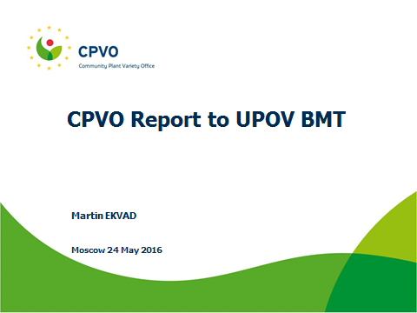

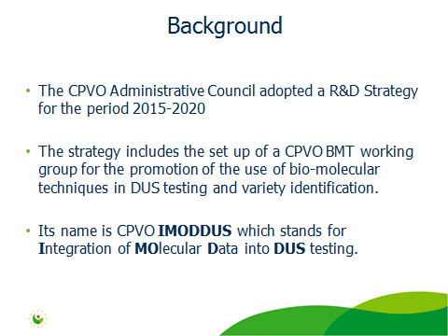

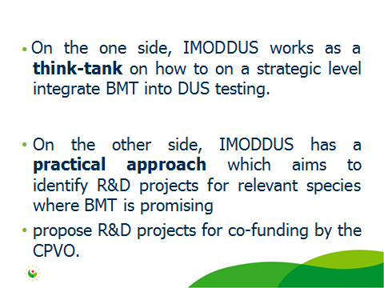

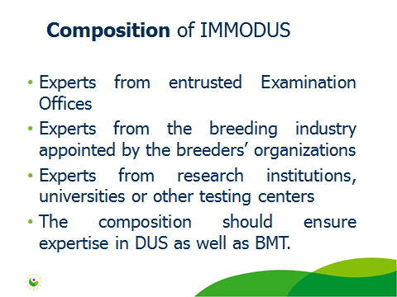

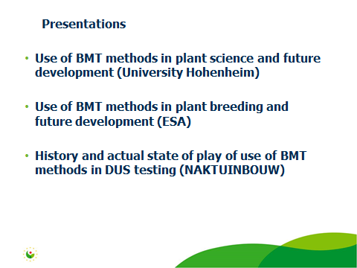

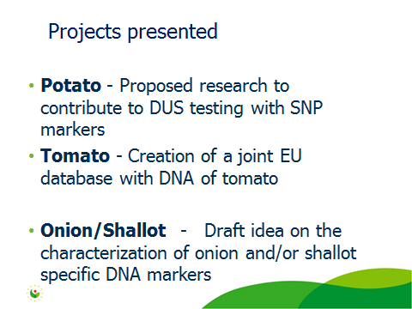

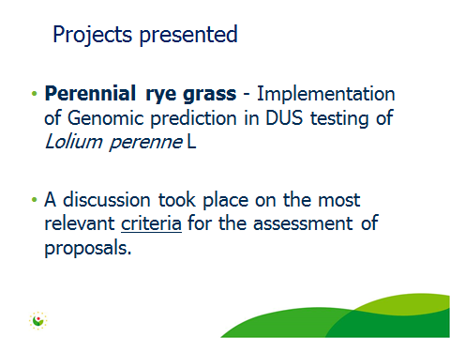

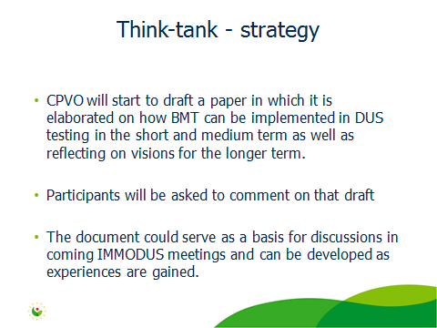

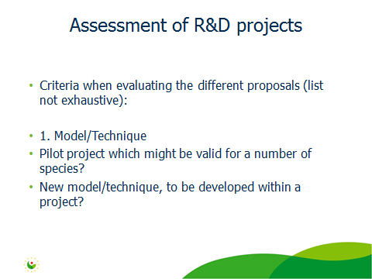

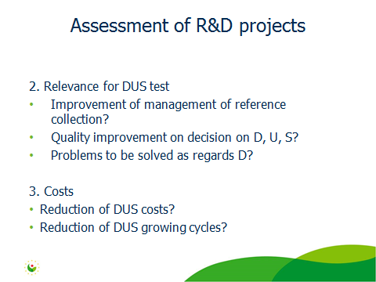

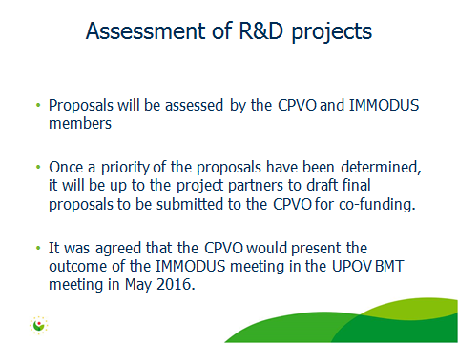

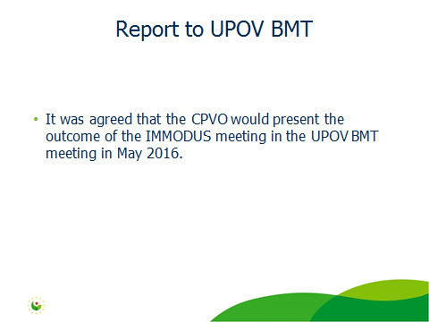

[End of Annex and of document]

