E
BMT/15/26
ORIGINAL: English
DATE: June 27, 2016
INTERNATIONAL UNION FOR THE PROTECTION OF NEW VARIETIES OF PLANTS
Geneva
WORKING GROUP ON BIOCHEMICAL AND MOLECULAR
TECHNIQUES AND DNA PROFILING IN PARTICULAR
Fifteenth Session
Moscow, Russian Federation, May 24 to 27, 2016
Assessment and classification of breeding accessions of vegetable plants with the use of DNA markers
Document prepared by experts from Russian Federation
Disclaimer: this document does not represent UPOV policies or guidance
The Annex to this document contains a copy of a presentation “Assessment and classification of breeding accessions of vegetable plants with the use of DNA markers” made at its fifteenth session of the Working Group on Biochemical and Molecular Techniques and DNA-Profiling in particular (BMT).

Domblides Arthur, Domblides Elena, Bondareva Liudmila, Startsev Victor, Romanov V., Kan L., Timin N.I., Agafonov A.F., Pivovarov V.F., All-Russian Research Institute of Vegetable Breeding & Seed Production

[Annex follows]

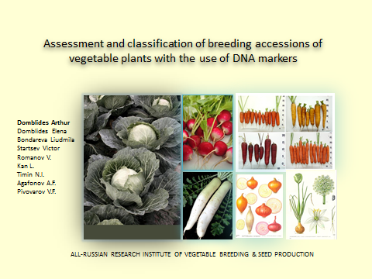

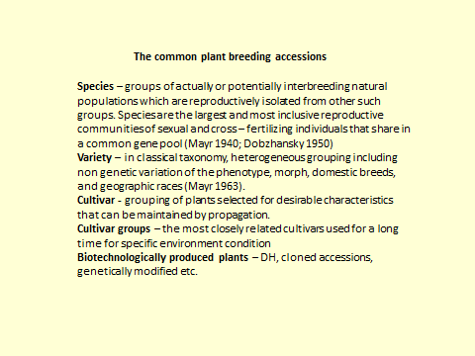

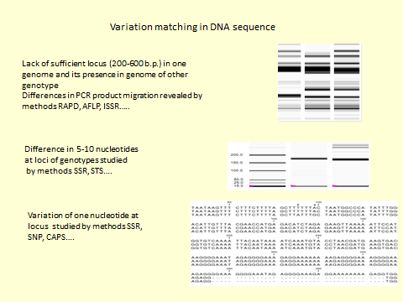

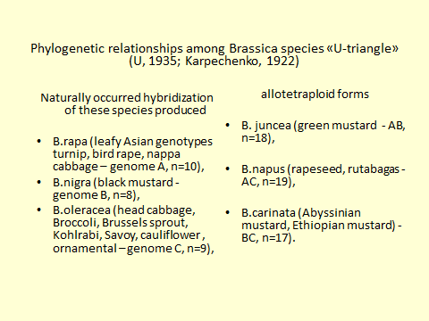

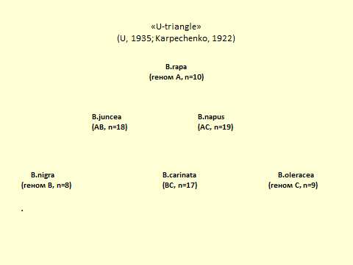

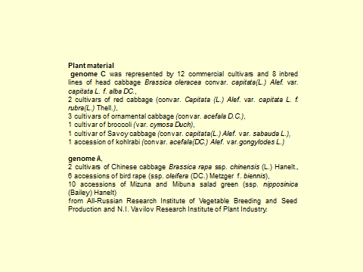

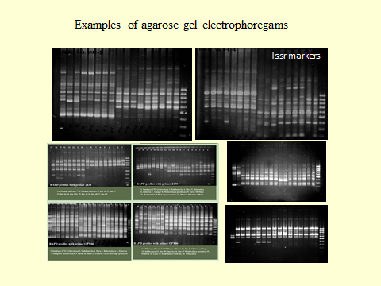

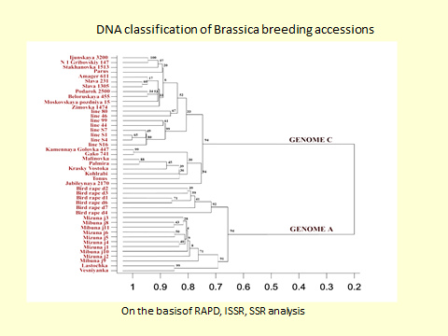

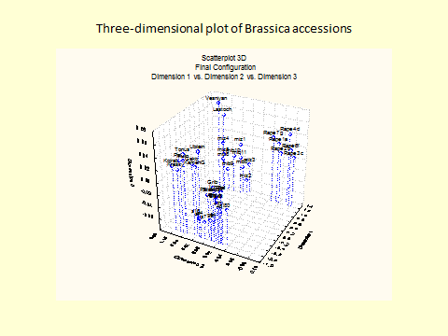

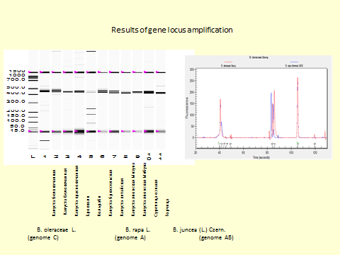

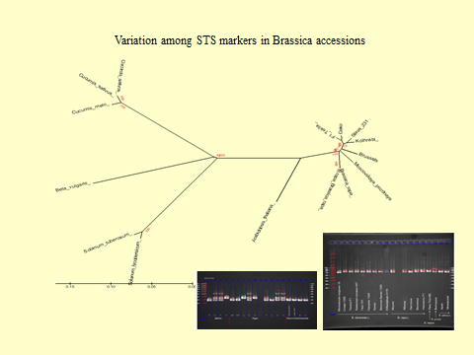

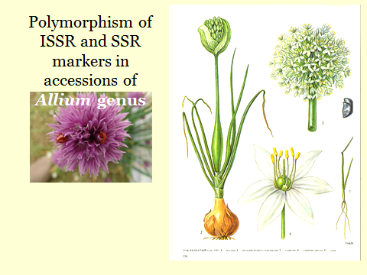

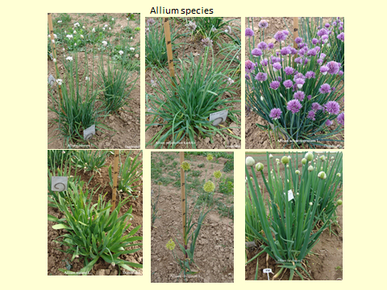

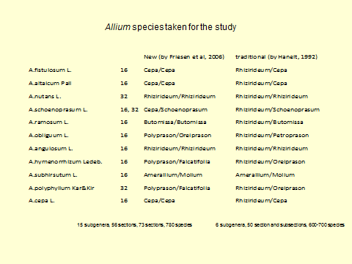

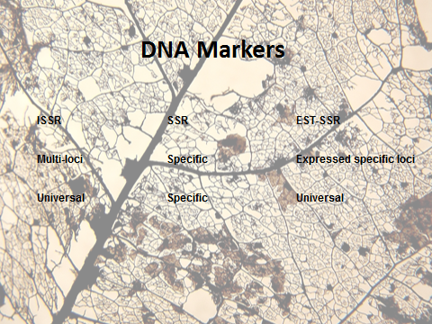

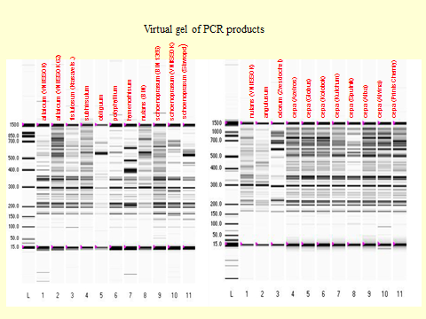

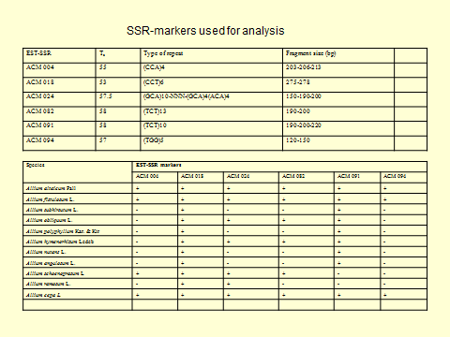

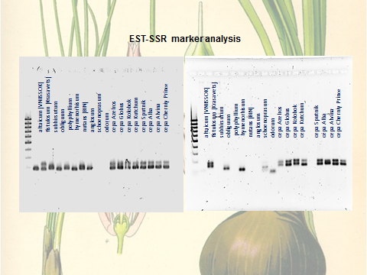

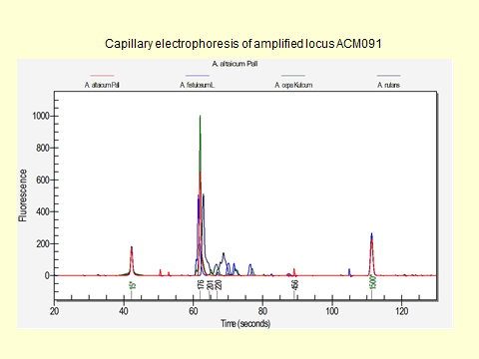

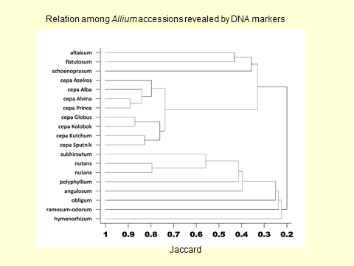

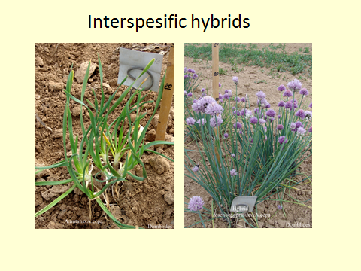

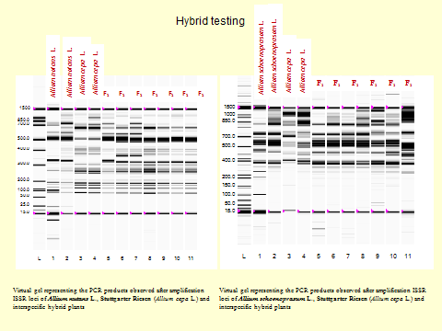

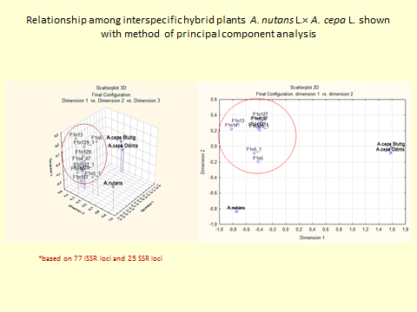

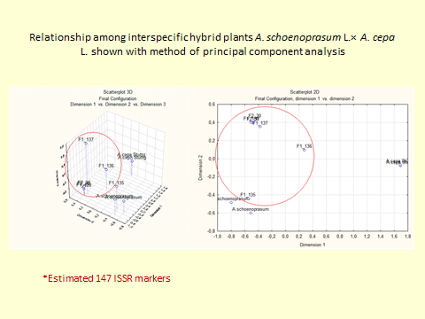

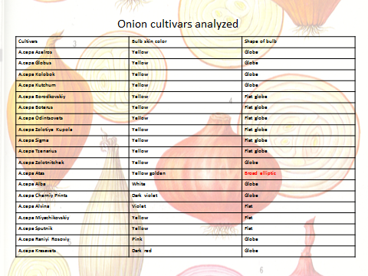

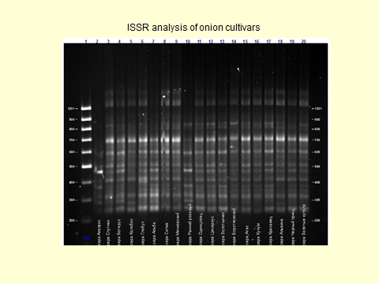

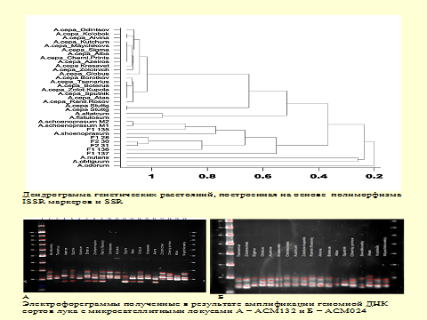

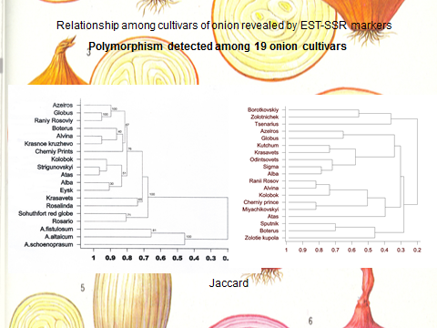

[End of Annex and of document]

