E
BMT/15/25
ORIGINAL: English
DATE: June 27, 2016
INTERNATIONAL UNION FOR THE PROTECTION OF NEW VARIETIES OF PLANTS
Geneva
WORKING GROUP ON BIOCHEMICAL AND MOLECULAR
TECHNIQUES AND DNA PROFILING IN PARTICULAR
Fifteenth Session
Moscow, Russian Federation, May 24 to 27, 2016
Laboratory seed control of barley varieties
Document prepared by an expert from Russian Federation
Disclaimer: this document does not represent UPOV policies or guidance
The Annex to this document contains a copy of a presentation “Laboratory seed control of barley varieties” made at its fifteenth session of the Working Group on Biochemical and Molecular Techniques and DNA-Profiling in particular (BMT).

Pomortsev А., Lyalina E., and Boldyrev S., Federal State Budgetary Scientific Institution “Institurte of General Genetics named after N. I. Vavilov (FSBSA “Vavilov Institute of General Genetics Russian Academy of Science”)

Abbreviations:
VIGG-RAS: Vavilov Institute of Gneral Genetics Russian Academy of Science

[Annex follows]

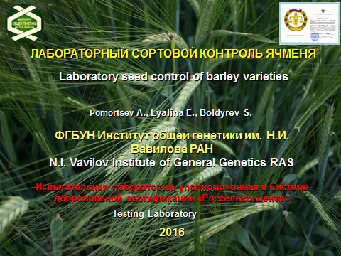

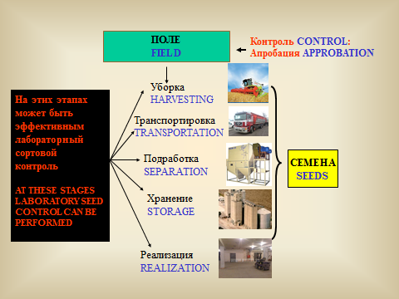

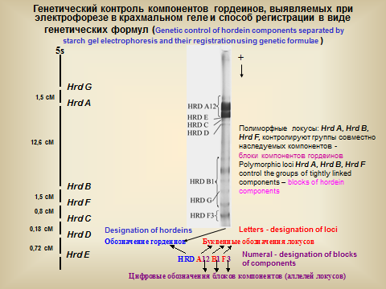

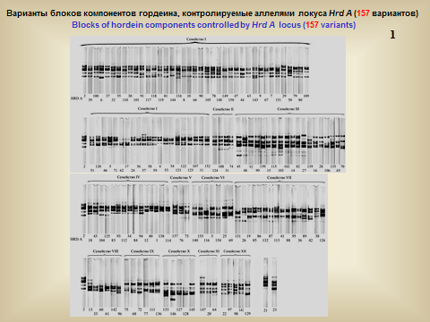

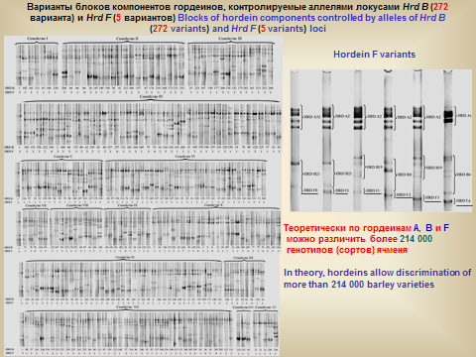

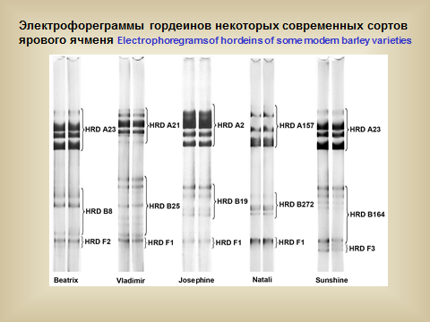

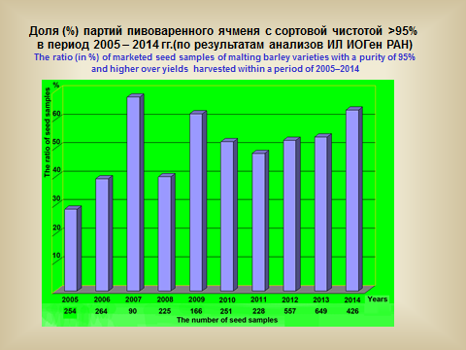

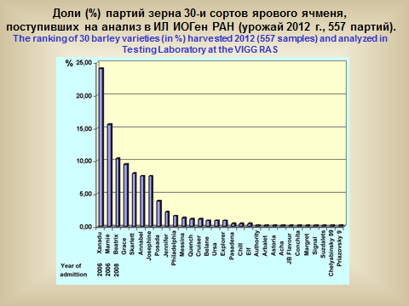

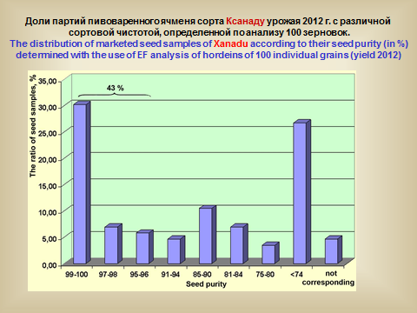

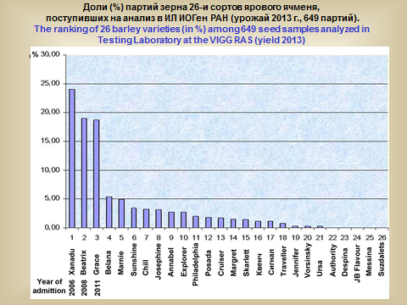

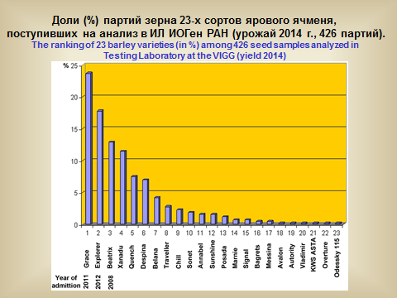

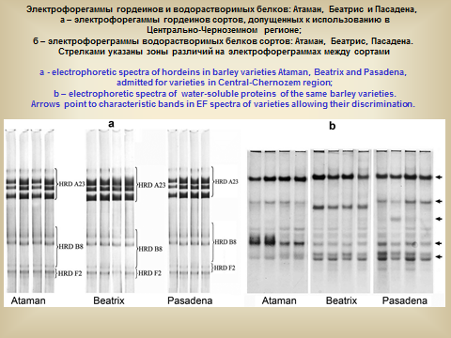

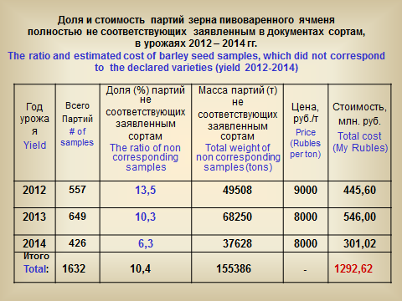

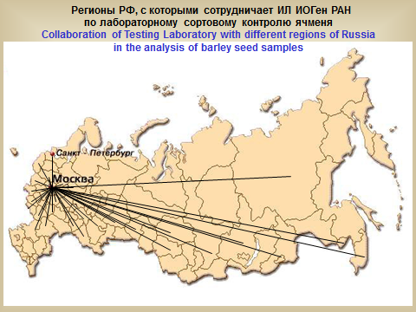

[End of Annex and of document]

