E
BMT/15/22 Rev.
ORIGINAL: English
DATE: June 27, 2016
INTERNATIONAL UNION FOR THE PROTECTION OF NEW VARIETIES OF PLANTS
Geneva
WORKING GROUP ON BIOCHEMICAL AND MOLECULAR
TECHNIQUES AND DNA PROFILING IN PARTICULAR
Fifteenth Session
Moscow, Russian Federation, May 24 to 27, 2016
Can molecular distance be used as a characteristic?
Document prepared by an expert from the Netherlands
Disclaimer: this document does not represent UPOV policies or guidance
The Annex to this document contains a copy of a presentation “Can molecular distance be used as a characteristic?” made at its fifteenth session of the Working Group on Biochemical and Molecular Techniques and DNA-Profiling in particular (BMT).

Kees van Ettekoven, Head Variety testing Department, Naktuinbouw

[Annex follows]

CAN MOLECULAR DISTANCE BE USED AS A CHARACTERISTIC?

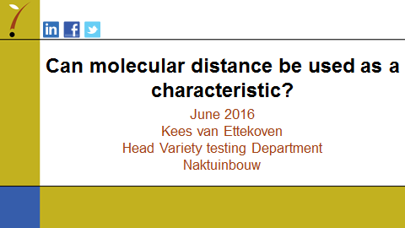

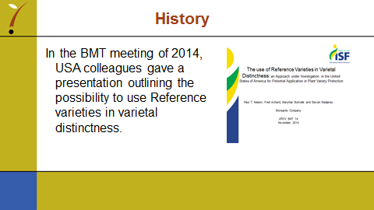

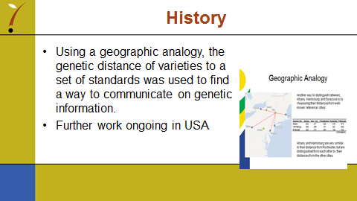

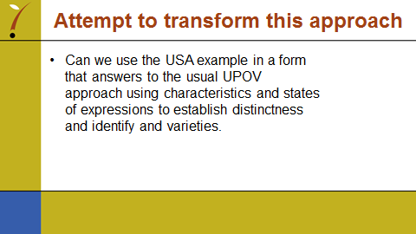

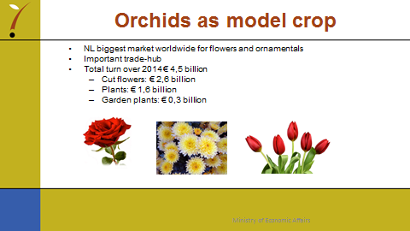

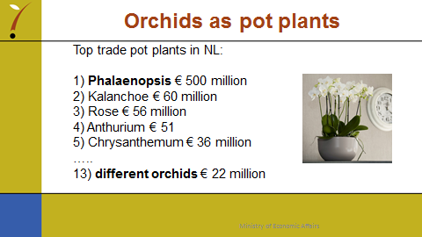

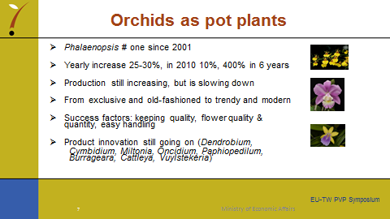

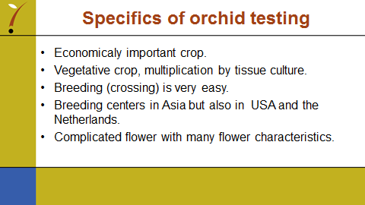

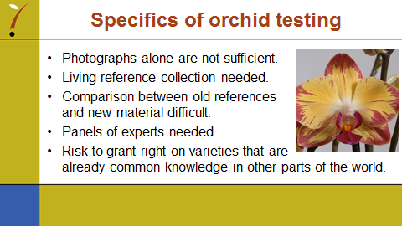

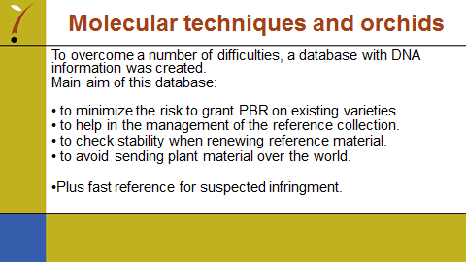

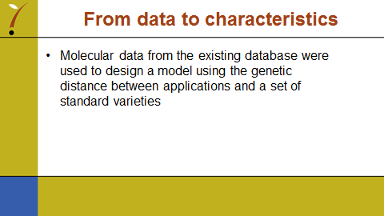

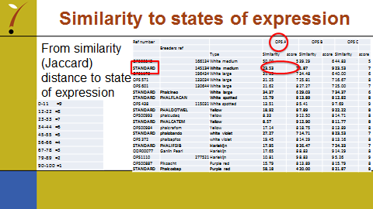

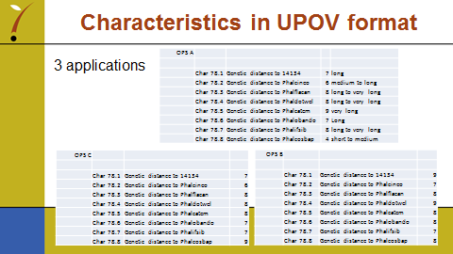

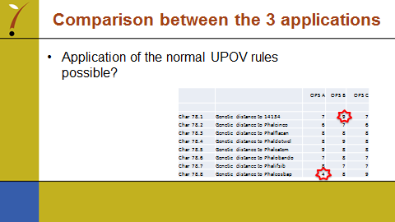

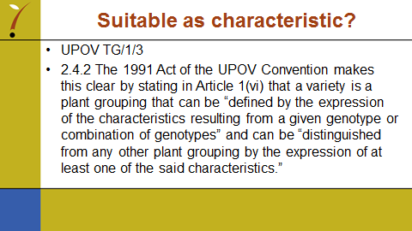

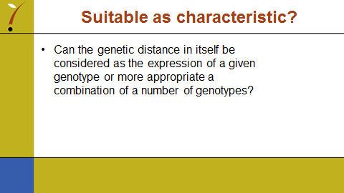

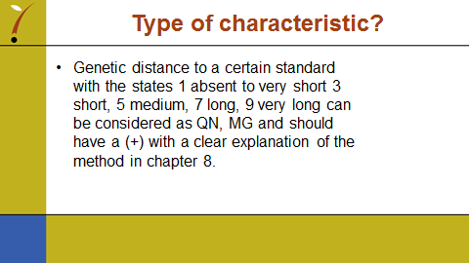

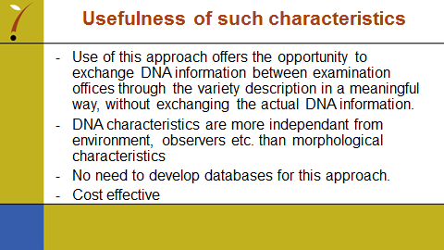

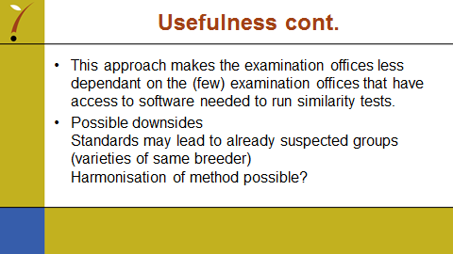

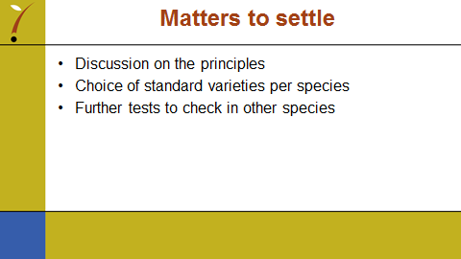

[End of Annex and of document]

