E
BMT/15/2
ORIGINAL: English
DATE: April 26, 2016
INTERNATIONAL UNION FOR THE PROTECTION OF NEW VARIETIES OF PLANTS
Geneva
WORKING GROUP ON BIOCHEMICAL AND MOLECULAR
TECHNIQUES AND DNA PROFILING IN PARTICULAR
Fifteenth Session
Moscow, Russian Federation, May 24 to 27, 2016
Reports on developments in UPOV concerning biochemical and molecular techniques
Document prepared by the Office of the Union
Disclaimer: this document does not represent UPOV policies or guidance

EXECUTIVE SUMMARY

The purpose of this document is to report on developments in UPOV concerning biochemical and molecular techniques.

The BMT is invited to note The BMT is invited to note the developments on molecular techniques in the TC and the TWPs, as set out in this document.

The following abbreviations are used in this document:

BMT: Working Group on Biochemical and Molecular Techniques, and DNA-Profiling
in Particular
CAJ: Administrative and Legal Committee
TC: Technical Committee
TC-EDC: The Enlarged Editorial Committee
TWA: Technical Working Party for Agricultural Crops
TWC: Technical Working Party on Automation and Computer Programs
TWF: Technical Working Party for Fruit Crops
TWO: Technical Working Party for Ornamental Plants and Forest Trees
TWPs: Technical Working Parties
TWV: Technical Working Party for Vegetables

The structure of this document is as follows:

EXECUTIVE SUMMARY 1
developments in 2015 2
Technical Committee 2
Technical Working Parties 2
developments in 2016 3
Frequently asked questions 3

developments in 2015

Technical Committee

The TC, at its fifty-first session, held in Geneva, from March 23 to 25, 2015, received the following presentations on molecular techniques (in order of presentation) (see document TC/51/39 “Report”, paragraph 172):

Reports on developments in UPOV Concerning Biochemical and Molecular Techniques | UPOV Office
Marker-Assisted Selection of “Similar Variety” in DUS Testing | Republic of Korea (Mr. Seung-In Yi)
The Use of Reference Varieties in Varietal Distinctness: An Approach under Investigation in the United States of America for Potential Application in Plant Variety Protection | United States of America  (Mr. Paul Nelson)
A European Potato Database as Centralized Collection of Varieties of Common Knowledge | United Kingdom (Mr. Alex Reid)
Development of EST-SSR Markers of Lettuce and Application for Variety Identification | Republic of Korea (Mr. Seung-In Yi)
Ownership and Use of DUS Samples and of DNA and DNA Data During and After the DUS Tests | Netherlands (Mr. Kees van Ettekoven)
Existing Areas of Cooperation Between OECD, UPOV and ISTA | UPOV Office

The TC, at its fifty-first session, noted that a copy of the presentations would be made available on the UPOV website (see document TC/51/39 “Report”, paragraph 173).

The TC, at its fifty-first session, considered document TC/51/11 Rev. “Molecular techniques” (see document TC/51/39 “Report”, paragraph 174). The TC noted the report on developments in the TC, TWPs and BMT, as set out in paragraphs 4 to 22 of document TC/51/11 Rev. (see document TC/51/39 “Report”, paragraph 175). The TC approved the program for the fifteenth session of the BMT, to be held in 2016, including the dedication of a particular date (“Breeders’ Day”), for the items on the use of molecular techniques in the consideration of essential derivation and in variety identification (see document TC/51/39 “Report”, paragraph 176).

Technical Working Parties

The TWC, at its thirty-third session, held in Natal, Brazil from June 30 to July 2, 2015, noted an oral report by Mr. Kees van Ettekoven, Chairman of the BMT, highlighting the developments on molecular techniques presented at the fourteenth session of the BMT, held in Seoul, Republic of Korea from November 10 to 13, 2014, in particular: a presentation by the Republic of Korea (see document BMT/14/16 Rev.2 “Use of Molecular Marker Techniques for Selection of ‘Similar Variety’ about ‘Candidate Variety”); the United States of America (see documents BMT/14/5 and BMT/14/5 Add. “The Use of Reference Varieties in Varietal Distinctness: An Approach under Investigation in the United States of America for Potential Application in Plant Variety Protection”); the Netherlands (see Document BMT/14/11 “Ownership and Use of DUS Samples and of DNA and DNA Data During and After the DUS Tests”) and on cooperation between UPOV, OECD and ISTA on molecular techniques (see document TC/52/11 “Molecular Techniques”, paragraph 6).

The TWF, at its forty-sixth session, held in Mpumalanga, South Africa, from August 24 to 28, 2015, noted that molecular marker techniques were being used by many UPOV members for variety identification and were an important tool in cases of enforcement of plant breeder’s rights (PBR). The TWF agreed that it would be useful to provide information to a wider audience that molecular marker techniques were widely used in the context of PBR for variety identification and enforcement of the breeder’s rights (see document TC/52/11 “Molecular Techniques”, paragraph 7).

The TWF noted that France had been using molecular distances in combination with phenotypical distance for optimizing the size of trials in fruit crops since 2000. The TWF agreed that molecular markers also provided useful information on species for which the authorities did not hold standard samples of living material (see document TC/52/11 “Molecular Techniques”, paragraph 8).

The TWF noted that in many UPOV members, breeders were requesting authorities to accept molecular marker information with applications for plant breeders’ rights. The TWF noted that authorities did not require molecular marker information with the application for plant breeder’s rights although some authorities accepted it as complementary information. The TWF noted the concern expressed by some members on matters relating to the confidentiality of molecular marker information and whether such information could be made available to the public. (see document TC/52/11 “Molecular Techniques”, paragraph 9).

The TWO, at its forty-eighth session, held in Cambridge, United Kingdom, from September 14 to 18, 2015, noted that some breeders were providing molecular marker information with applications for plant breeders’ rights and agreed that unless the information was validated by the authorities it would not have a proven link to the material used in the examination of DUS (see document TC/52/11 “Molecular Techniques”, paragraph 10).

developments in 2016

The TC, at its fifty-second session, held in Geneva, from March 14 to 16, 2016, noted that the BMT agenda item 5 “Report of work on molecular techniques in relation to DUS examination” would provide an opportunity for UPOV members to report on latest developments concerning the use of molecular techniques in DUS examination, and that this could form the basis to propose new application models for inclusion in document TGP/15 “Guidance on the Use of Biochemical and Molecular Markers in the Examination of Distinctness, Uniformity and Stability (DUS)” (see document TC/52/29 “Report”, paragraph 132).

The TC, at its fifty-second session, noted that the European Union was conducting a project on the use of molecular marker techniques in DUS examination in different crops (see document TC/52/29 “Report”, paragraph 133).

Frequently asked questions

The Consultative Committee, at its eighty-eighth session, held in Geneva, on October 15, 2014, agreed that the draft FAQ concerning information on the situation in UPOV with regard to the use of molecular techniques for a wider audience, including the public in general, should be referred to the TC for consideration (see document C/48/19 “Report by the President on the work of the eighty-sixth session of the Consultative Committee; adoption of recommendations, if any, prepared by that Committee”, paragraph 48).

The TC, at its fifty-second session, agreed a draft question and answer concerning the information on the situation in UPOV with regard to the use of molecular techniques for a wider audience, including the public in general, to read as follows (see document TC/52/29 “Report”, paragraph 131):

“Is it possible to obtain protection of a variety on the basis of its DNA-profile?

“For a variety to be protected, it needs to be clearly distinguishable from all existing varieties on the basis of characteristics that are physically expressed, e.g. plant height, time of flowering, fruit color, disease resistance etc. The DNA-profile is not the basis for obtaining the protection of a variety, although this information may be used as supporting information.

“A more detailed explanation is provided in the FAQ ‘Does UPOV allow molecular techniques (DNA profiles) in the examination of Distinctness, Uniformity and Stability (“DUS”)?’

“See also:
“What are the requirements for protecting a new plant variety?”

Subject to agreement by the CAJ, at its seventy-third session, to be held in Geneva, on October 25, 2016, and the Consultative Committee, at its ninety-second session, to be held in Geneva, on October 27, 2016, the draft question and answer concerning the information on the situation in UPOV with regard to the use of molecular techniques for a wider audience, including the public in general will be presented for adoption by the Council, at its fiftieth ordinary session, to be held in Geneva on October 28, 2016.
The BMT is invited to note the developments on molecular techniques in the TC and the TWPs, as set out in this document.

[Annex follows]

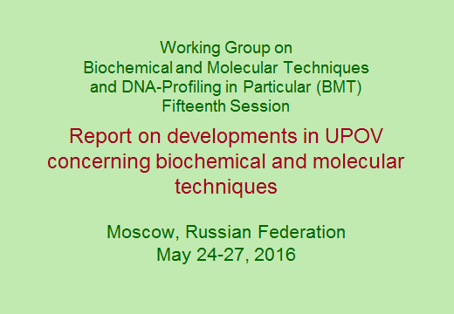

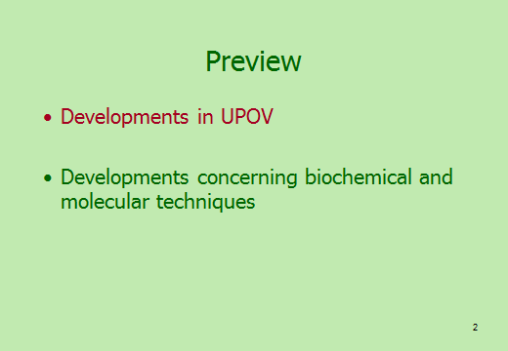

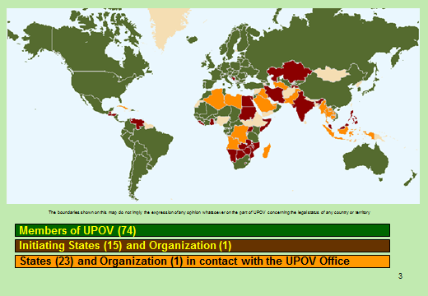

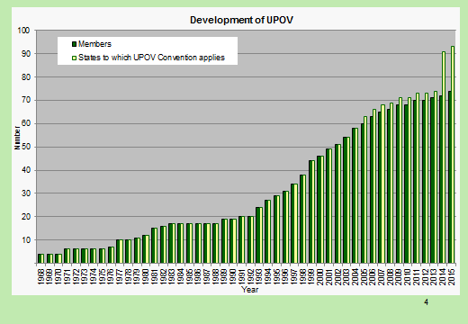

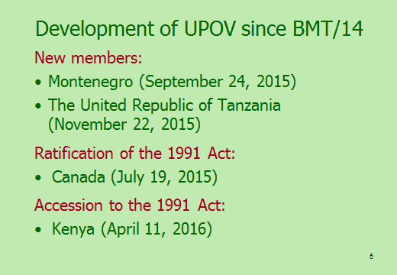

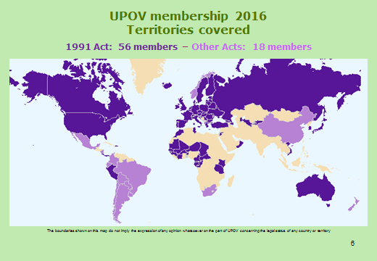

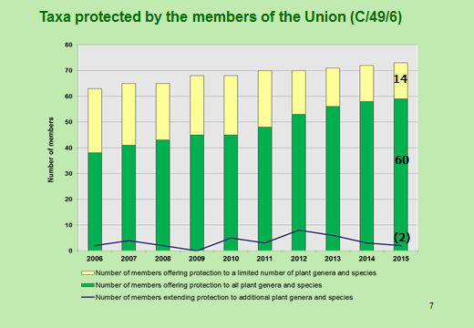

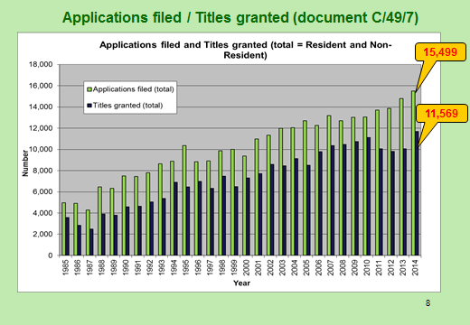

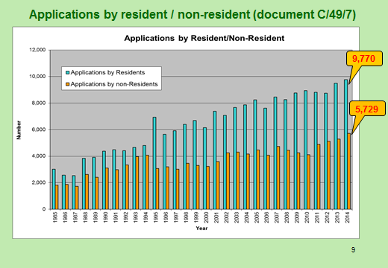

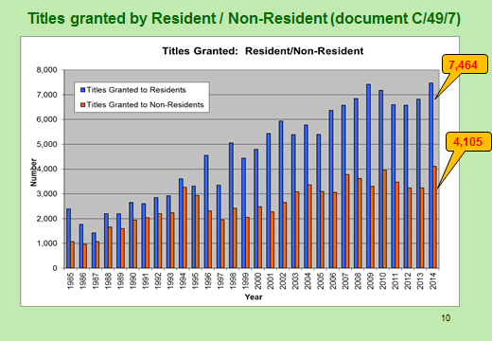

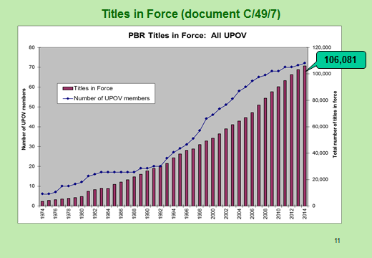

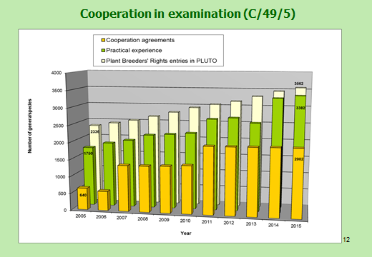

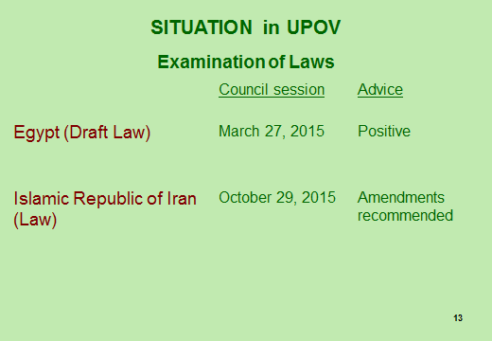

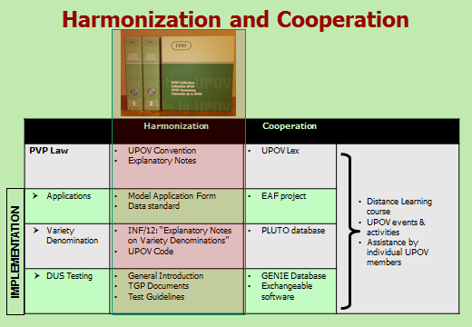

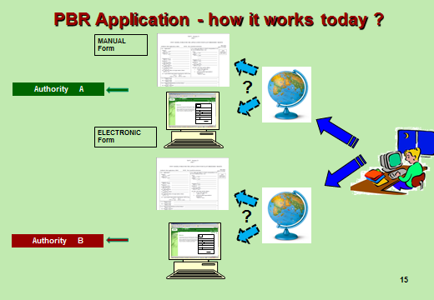

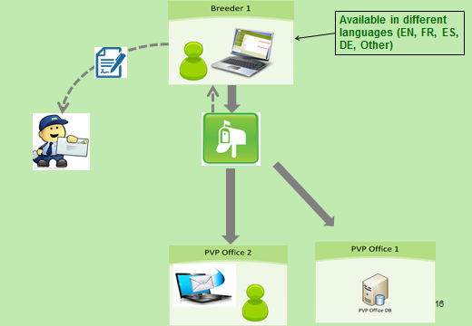

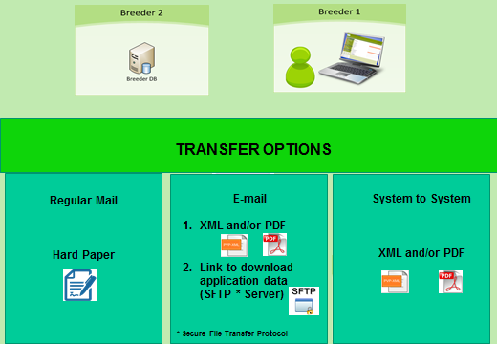

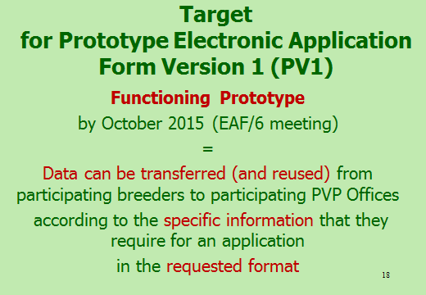

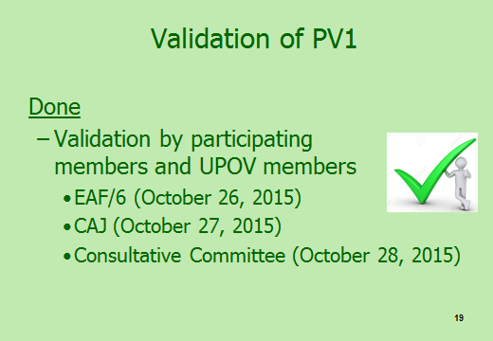

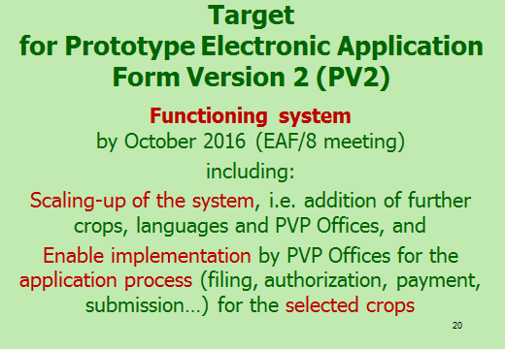

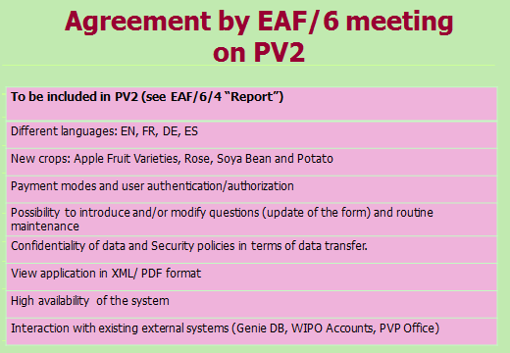

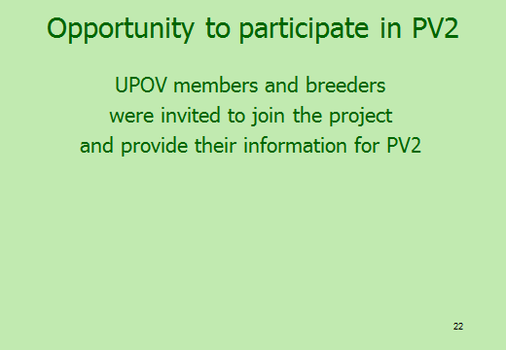

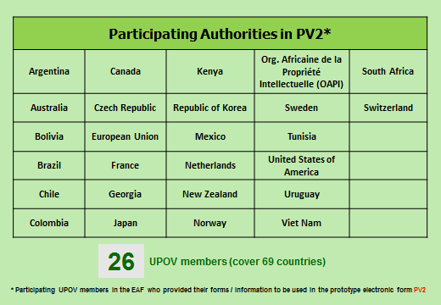

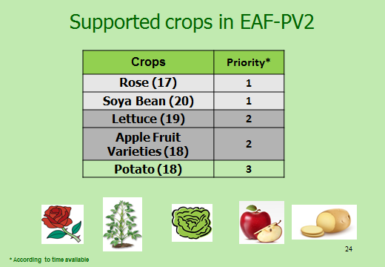

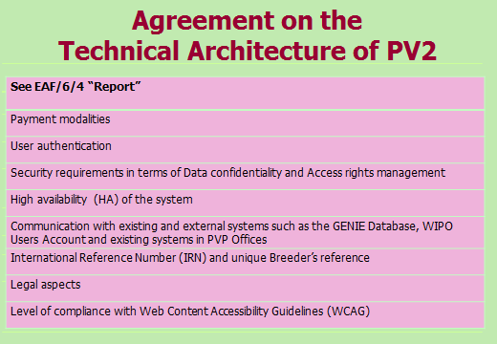

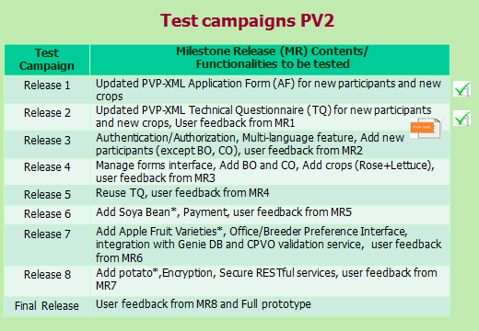

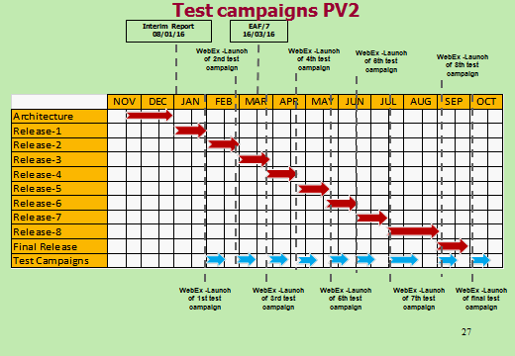

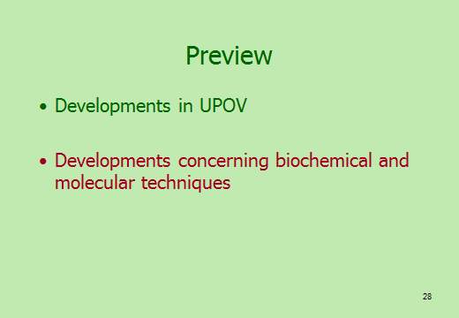

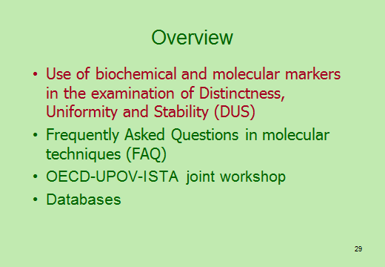

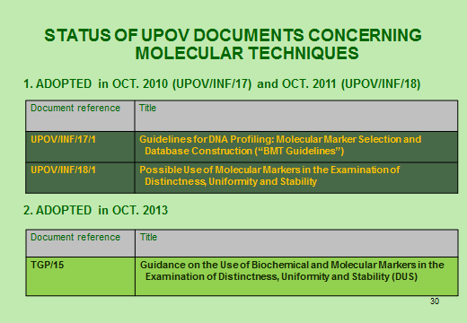

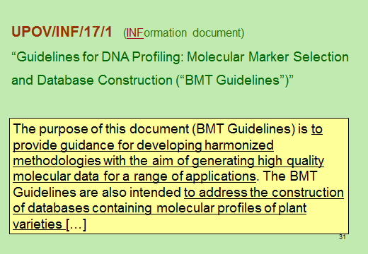

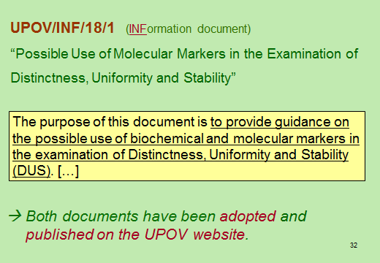

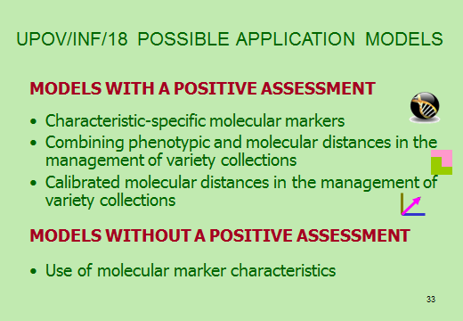

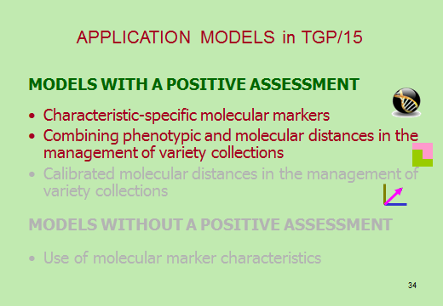

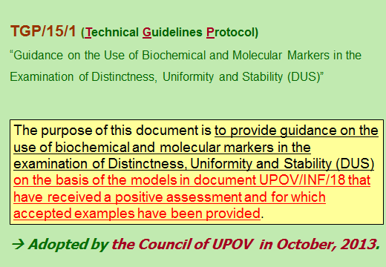

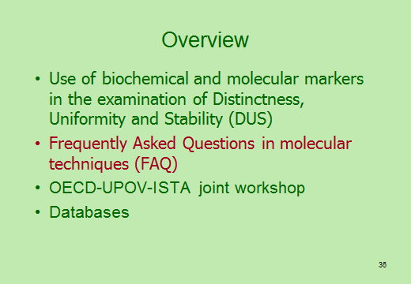

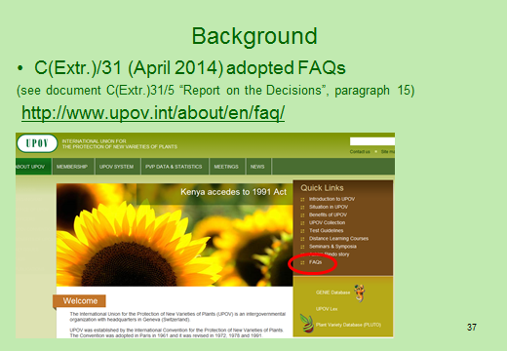

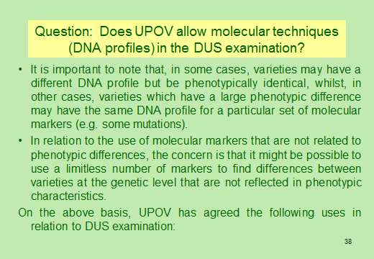

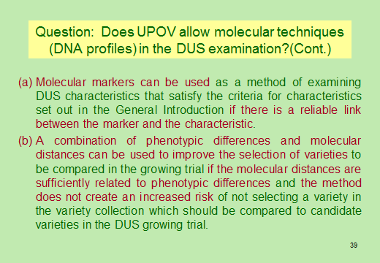

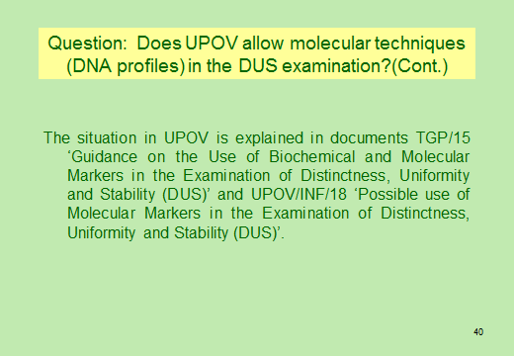

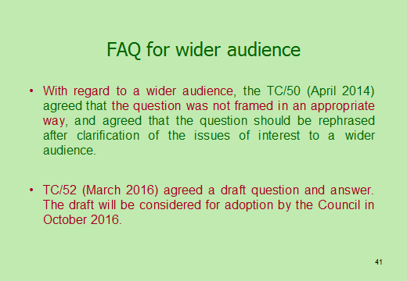

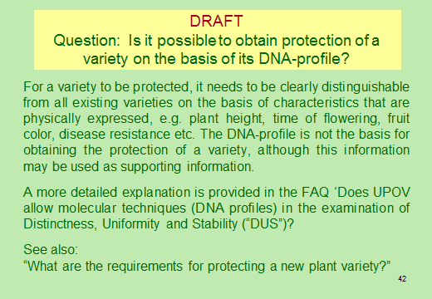

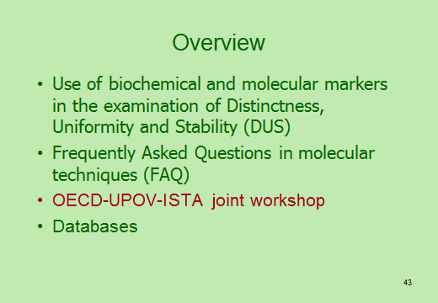

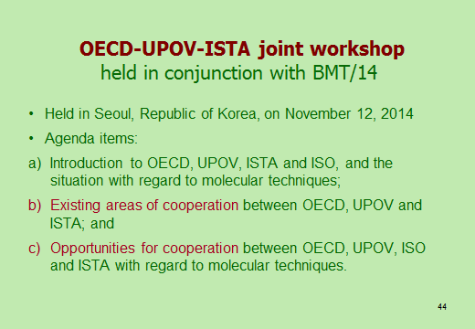

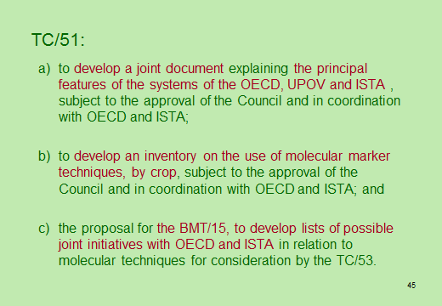

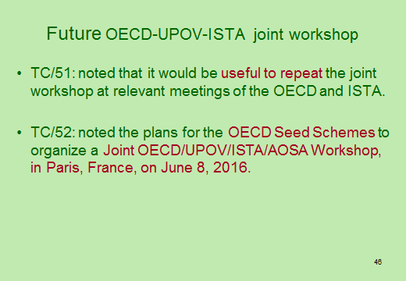

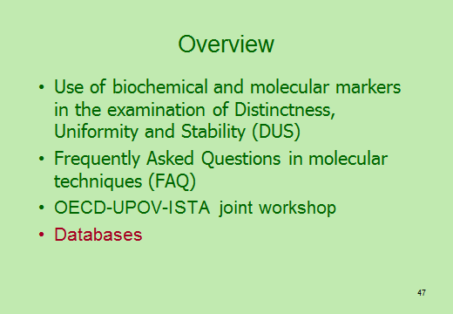

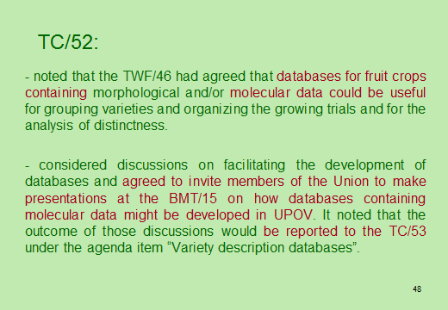

[End of document]

