E
BMT/15/18
ORIGINAL: English
DATE: May 10, 2016
INTERNATIONAL UNION FOR THE PROTECTION OF NEW VARIETIES OF PLANTS
Geneva
WORKING GROUP ON BIOCHEMICAL AND MOLECULAR
TECHNIQUES AND DNA PROFILING IN PARTICULAR
Fifteenth Session
Moscow, Russian Federation, May 24 to 27, 2016
Using of DNA – marker based techniques for varietal identification and fingerprinting of fruit crops and grape genetic resources
Document prepared by experts from Russian Federation
Disclaimer: this document does not represent UPOV policies or guidance
The Annex to this document contains a copy of a presentation “Using of DNA – marker based techniques for varietal identification and fingerprinting of fruit crops and grape genetic resources” to be made at its fifteenth session of the Working Group on Biochemical and Molecular Techniques and DNA-Profiling in particular (BMT).

Ivan Suprun, head of the laboratory of genetics and microbiology, PhD in biology, North Caucasian Regional Research Institute of Horticulture and Viticulture, Krasnodar, Russian Federation

[Annex follows]

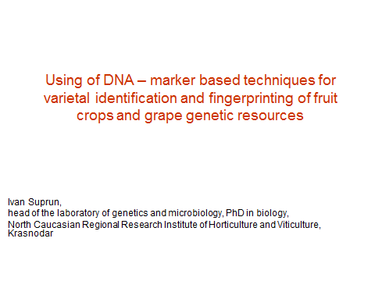

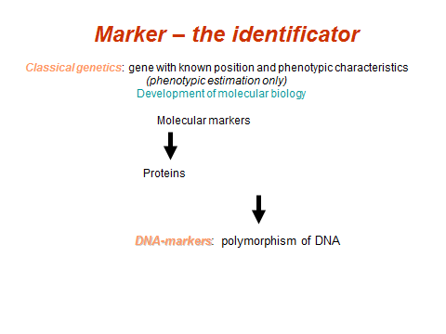

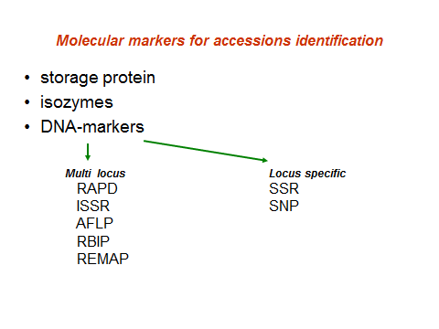

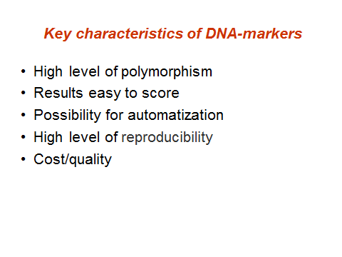

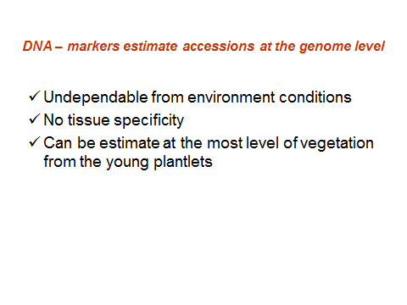

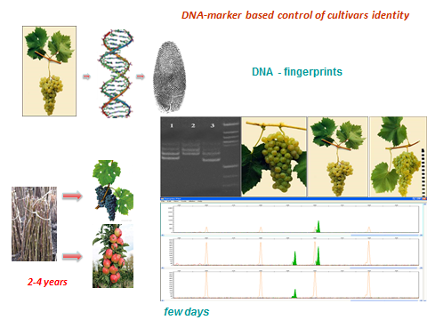

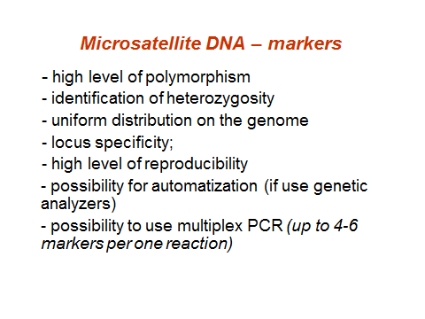

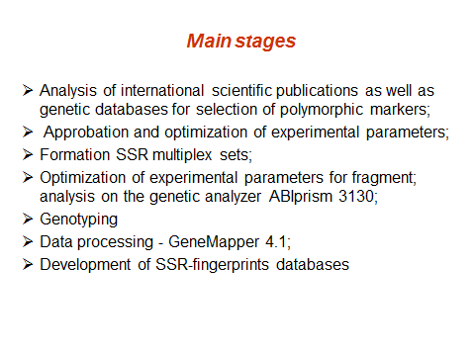

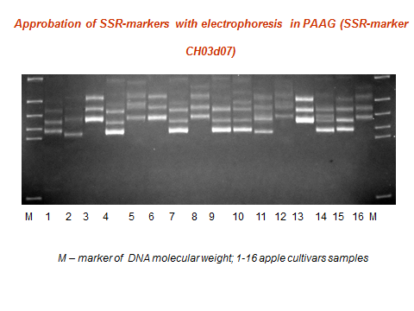

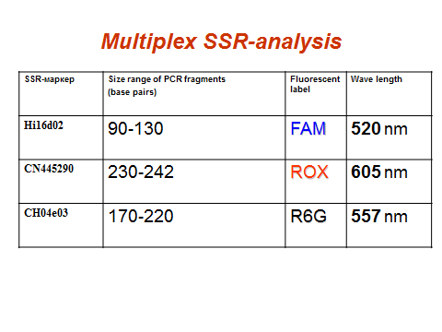

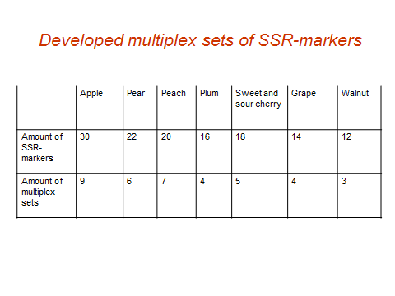

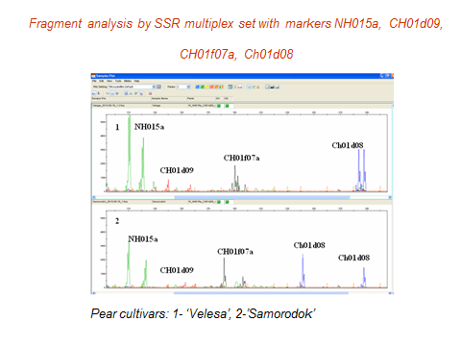

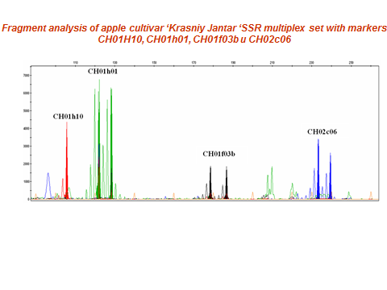

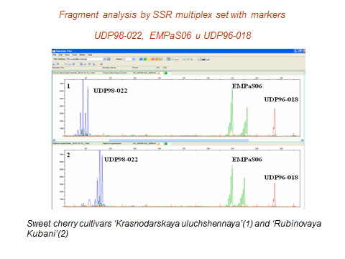

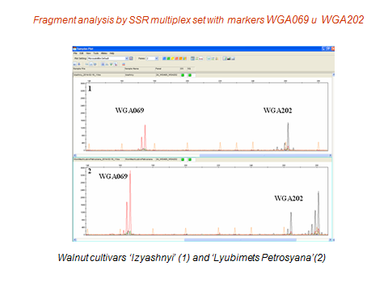

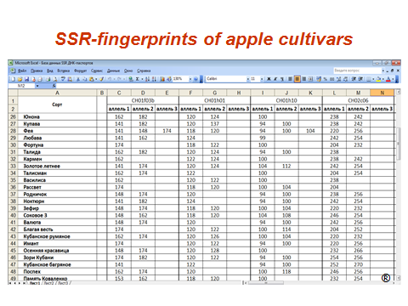

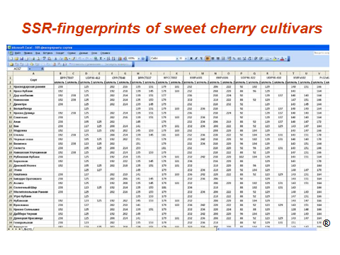

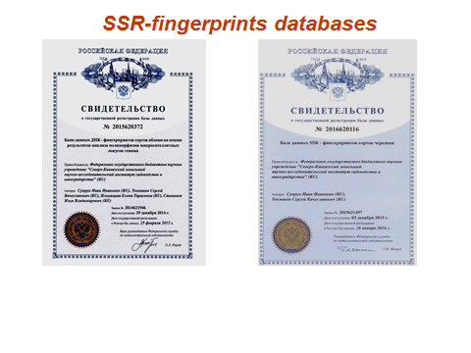

[End of Annex and of document]

