E
BMT/15/13
ORIGINAL: English
DATE: April 26, 2016
INTERNATIONAL UNION FOR THE PROTECTION OF NEW VARIETIES OF PLANTS
Geneva
WORKING GROUP ON BIOCHEMICAL AND MOLECULAR TECHNIQUES
AND DNA-PROFILING IN PARTICULAR
Fifteenth Session
Moscow, Russian Federation, May 24 to 27, 2016
Evaluation of Soybean Molecular Marker Public Resources for Potential Application in Plant Variety Protection
Document prepared by experts from Seed Association of the Americas
Disclaimer: this document does not represent UPOV policies or guidance

Introduction

Specified morphological characteristics are the basis to determine whether a new variety qualifies for Plant Variety Protection (PVP). The United States PVP Board (Board), at its meeting in December 2014, adopted the approach in which the United States Plant Variety Protection Office (US PVP Office) would incorporate the option of using molecular markers as supplementary information for establishing variety distinction.

This report offers an update on the work being conducted thus far, with the objective to that end on soybean (Glycine max) by the Molecular Marker Working Group (MMWG), a subcommittee of technical and legal experts representing both public and private entities, jointly formed in August 2014 by the United States PVP Board and the American Seed Trade Association (ASTA).

Material and methods

The BARCSoy6K chip was selected as the marker platform for the analysis. It is subset of 6,000 markers from the USDA SoySNP50K, which was developed by the Soybean Genomics and Improvement Lab, Beltsville Agricultural Research Center (BARC) as a less expensive alternative to the full SoySNP50K at a public price of $20 USD per sample.

Then a diverse panel of 320 lines was selected from the USDA Soybean Germplasm Collection, which has made their genotypes on theSoySNP50K publicly available, see,. From the full collection of 20,000 entries, we opted for using all the off-PVP varieties (180 entries) as we anticipate those to be genetically closer and often related to commercial material currently being submitted for PVP applications. The remaining varieties were public accessions, selected mostly based on their diversity (160 entries).

Results and discussion

SNP data quality control (QC): the molecular marker data (MM) for the 320 lines was downloaded from the soybase.org web site. QC checks were already applied by the authors by dropping any polymorphic SNP with a rate of missing and heterozygous allele calls greater than 10%. Genotyping was done from seeds developed from a single plant so the heterogeneity is expected to be low. As a result, the average missing and heterozygous allele calls on this data set is less than 1%, and no further QC was necessary.

Pair wise genetic similarities (PWG sim) between the 320 lines in our panels were calculated as the percentage of identical SNP allele calls, see figure 1. The average PWG sim was found to be 63%, with a minimum of 43% and a maximum of 99.8%. Of all the 51040 PWG sim, only 877 (or 1.7%) are showing a PWG sim greater than 80%, which indicates the power of MM to differentiate material.
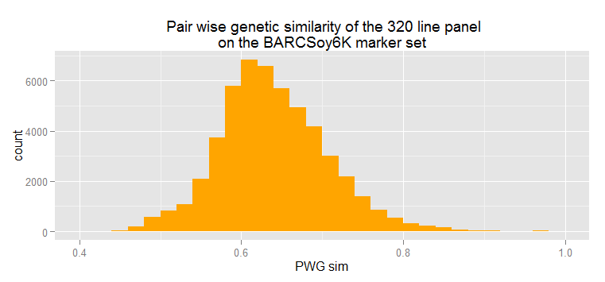
A pedigree analysis of the 10 pairs with the highest PWG sim resulted in identifying 5 cases of Back-crosses, 1 case of Reselection and 4 cases where the high similarity could not be explained by the pedigree. We suspect that sample mix-up might be causing those high similarities. We will further report on the morphology differences between those lines.

We also studied the impact of selecting different marker set sizes selected from the full SoySNP50K set on the PWG sim, and found that even with a much lower number of markers, the correlation remains very high.

Using this publicly available soybean MM resource, we are aiming at making a recommendation of a PWG sim threshold which, in addition to morphology characteristics, could be used by Plant Variety Protection authorities for the purpose of establishing variety distinctness.

Frederic Achard*, Barry Nelson**
* Monsanto Company, 800 North Lindbergh Boulevard, St. Louis, MO 63167, USA
** Pioneer Hi-Bred International Inc., 7300 NW 62nd Ave., Johnston, IA 50131

The U.S. PVP law (Act) provides for a Plant Variety Protection Board ("Board") to be appointed by the United States Secretary of Agriculture. The Board is composed of 14 individuals who are experts in various areas of development and represent the seed industry sector, academia and government. The duties of the Board are to: (1) advise the Secretary concerning the adoption of rules and regulations to facilitate the proper administration of the Act; (2) provide advisory counsel to the Secretary on appeals concerning decisions on applications by the US PVP Office and on requests for emergency public-interest compulsory licenses; and (3) advise the Secretary on any other matters under the Regulations and Rules of Practice and on all questions under Section 44 of the law. The Joint PVP Board – ASTA Molecular Marker Working Group is a subcommittee which advises the Board and effectively advises the Secretary of Agriculture.
http://www.ams.usda.gov/services/plant-variety-protection/pvpo-advisory-board
Song, Q., D. L. Hyten, G. Jia, C. V. Quigley, E. W. Fickus et al., 2013. Development and evaluation of SoySNP50K, a high-density genotyping array for soybean. PLoS One 8: e54985.
Song, Q.; Hyten, D. L.; Jia, G.; et al., 2016. Fingerprinting Soybean Germplasm and Its Utility in Genomic Research. G3-GENES GENOMES GENETICS, 495-495.
http://soybase.org/dlpages/index.php#snp50k [End of document]

