E
BMT/15/11
ORIGINAL: English
DATE: May 12, 2016
INTERNATIONAL UNION FOR THE PROTECTION OF NEW VARIETIES OF PLANTS
Geneva
WORKING GROUP ON BIOCHEMICAL AND MOLECULAR
TECHNIQUES AND DNA PROFILING IN PARTICULAR
Fifteenth Session
Moscow, Russian Federation, May 24 to 27, 2016
Work on molecular techniques in relation to DUS examination of different fruit specieS
Document prepared by experts from France
Disclaimer: this document does not represent UPOV policies or guidance
The Annex to this document contains a copy of a presentation “Work on molecular techniques in relation to DUS examination of different fruit species” to be made at its fifteenth session of the Working Group on Biochemical and Molecular Techniques and DNA-Profiling in particular (BMT).

Bénédicte Jaudeau, Muriel Thomasset, Anne Bernole, Arnaud Remay, Clarisse Maton, René Mathis
GEVES, France

[Annex follows]

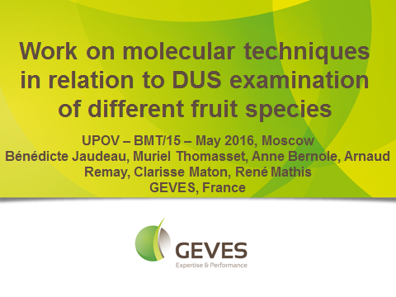

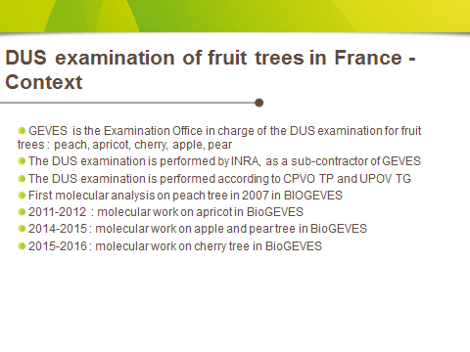

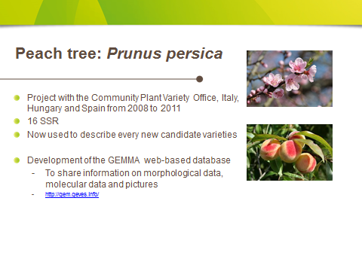

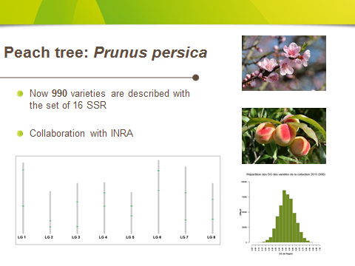

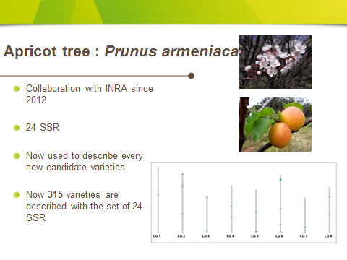

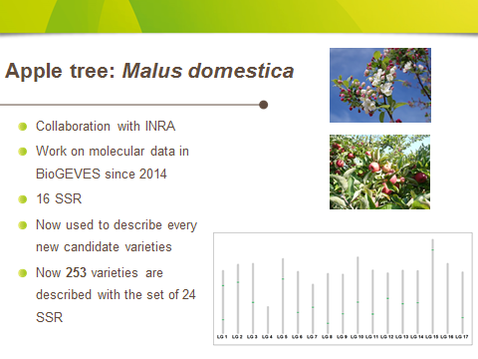

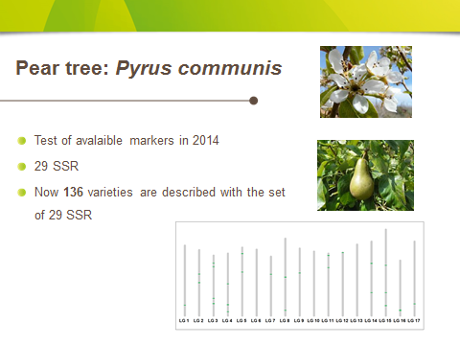

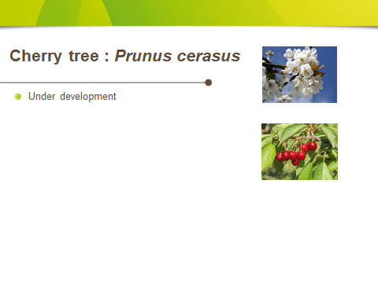

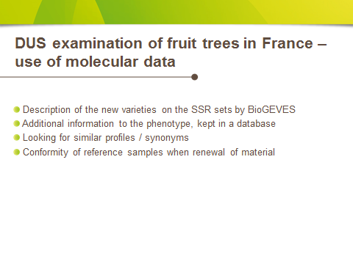

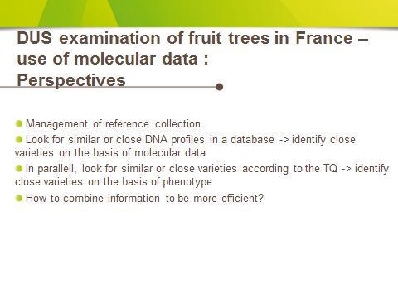

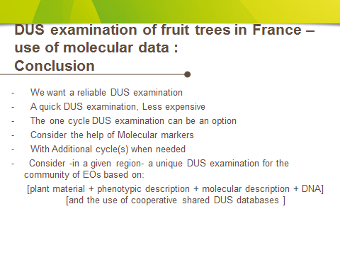

[End of Annex and of document]

