E
BMT/14/Joint/5
ORIGINAL: English
DATE: November 24, 2014
INTERNATIONAL UNION FOR THE PROTECTION OF NEW VARIETIES OF PLANTS
Geneva
OECD/UPOV/ISTA JOINT WORKSHOP ON MOLECULAR TECHNIQUES
Seoul, Republic of Korea, November 12, 2014
Existing areas of cooperation between OECD, UPOV and ISTA
Document prepared by the Office of the Union
Disclaimer: this document does not represent UPOV policies or guidance
The Annex to this document contains a copy of a presentation “Existing Area of Cooperation between OECD, UPOV and ISTA” made at the OECD/UPOV/ISTA Joint Workshop on Molecular Techniques.

[Annex follows]

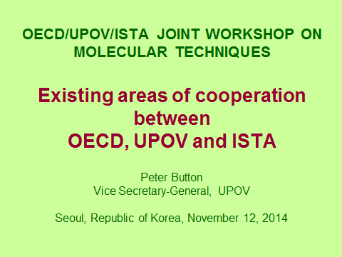  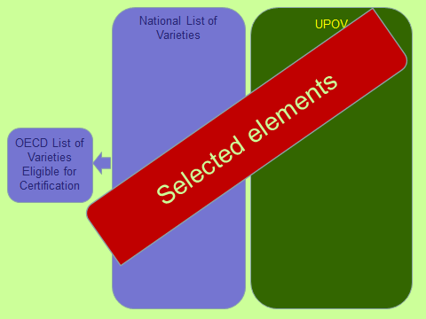  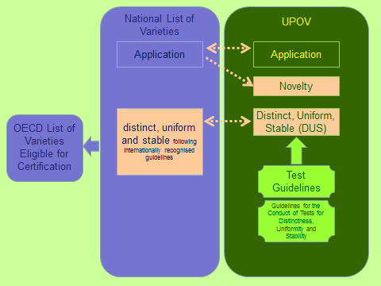  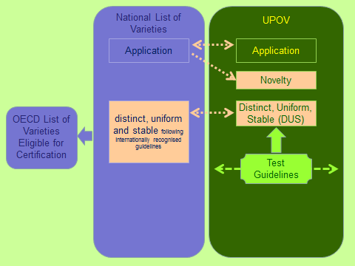  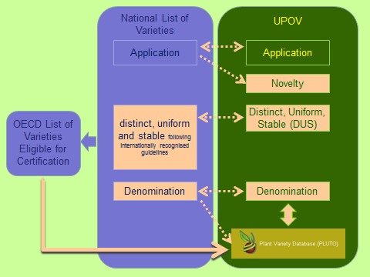  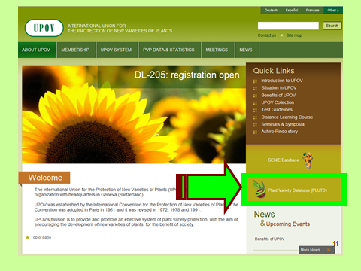  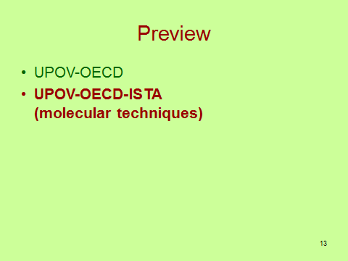  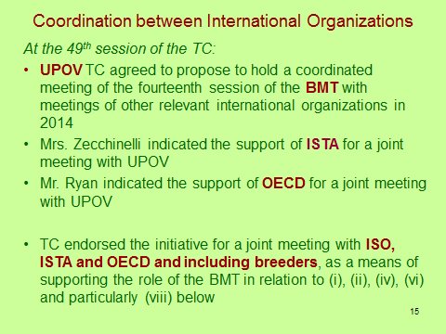  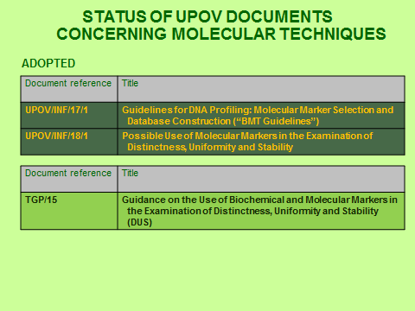  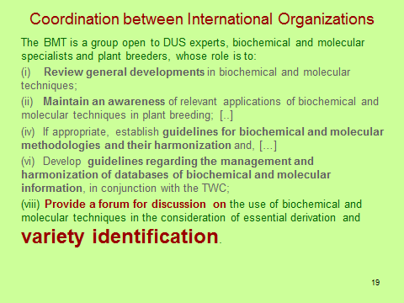 | 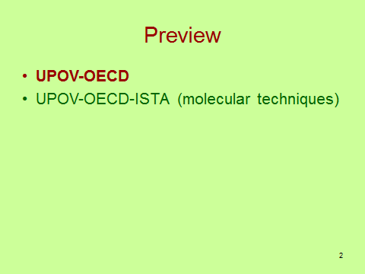  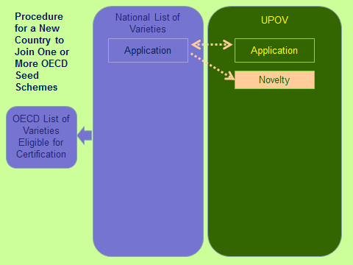  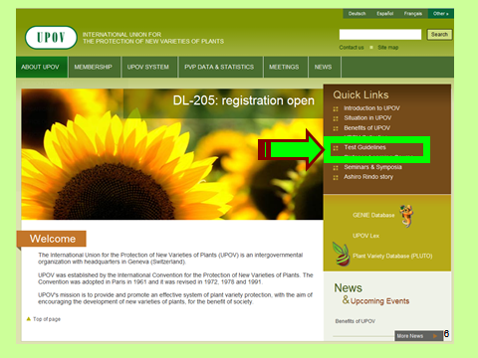  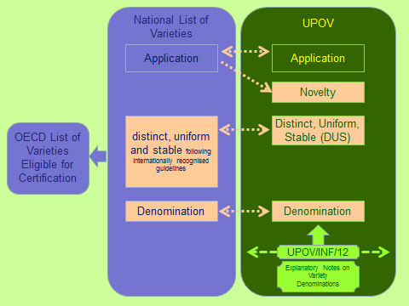  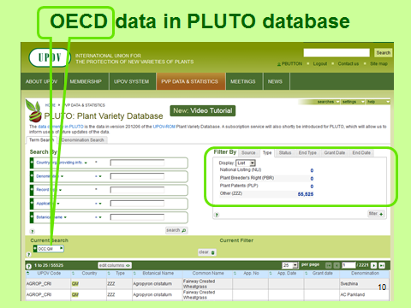  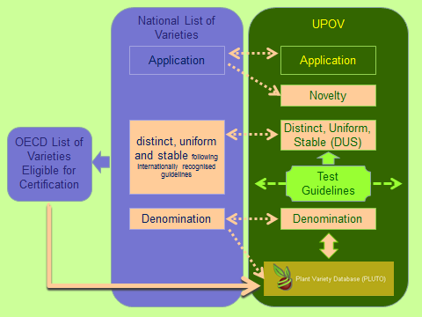  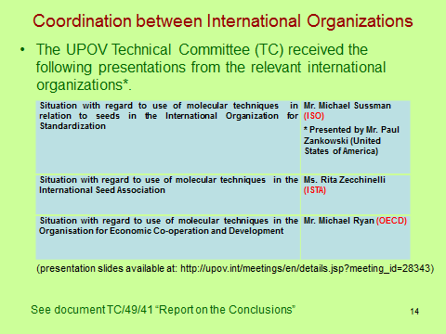  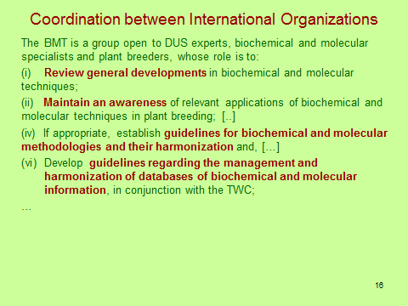  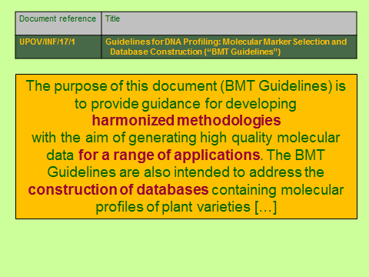  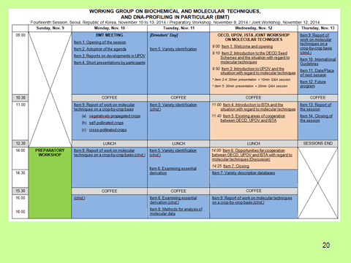
[End of Annex and of document]

