E
BMT/14/8 Add.
ORIGINAL: English
DATE: December 3, 2014
INTERNATIONAL UNION FOR THE PROTECTION OF NEW VARIETIES OF PLANTS
Geneva
WORKING GROUP ON BIOCHEMICAL AND MOLECULAR TECHNIQUES
AND DNA-PROFILING IN PARTICULAR
Fourteenth Session
Seoul, Republic of Korea, November 10 to 13, 2014
addendum to document bmt/14/8

Identification of Rice Varieties using Genic Markers for Three DUS Characteristics
Document prepared by experts from Islamic Republic of Iran
Disclaimer: this document does not represent UPOV policies or guidance
The Annex to this document contains a copy of a presentation “Identification of Rice Varieties using Genic Markers for Three DUS Characteristics” made at the fourteenth session of the Working Group on Biochemical and Molecular Techniques and DNA-Profiling in particular (BMT).

Seyed Hossein Jamali, Leila Sadeghi, Ehsan Pourabed, Mohammad Reza Jazayeri, Samad Mobasser
Plant Variety Identification & Registration Department of Seed & Plant Certification & Registration Institute (SPCRI), Iran (Islamic Republic of)

[Annex follows]

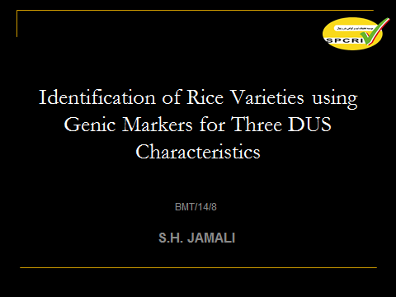

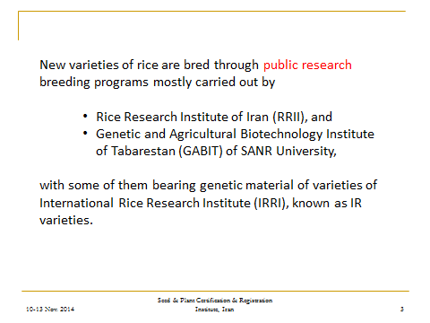

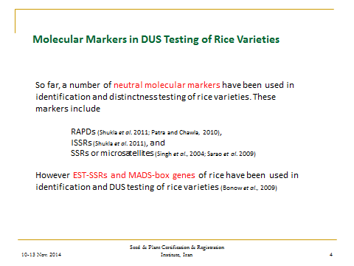

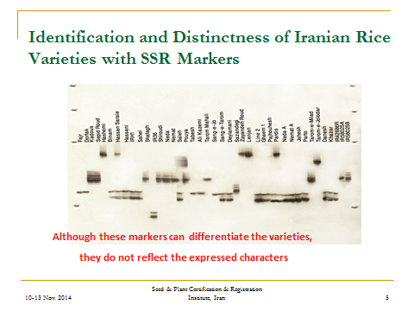

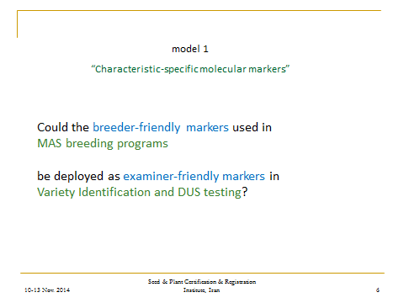

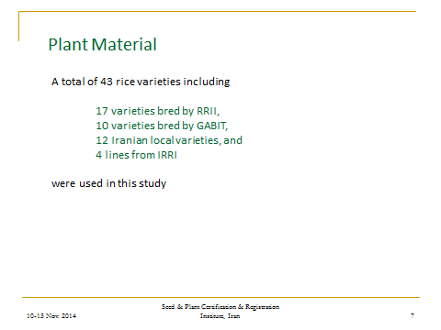

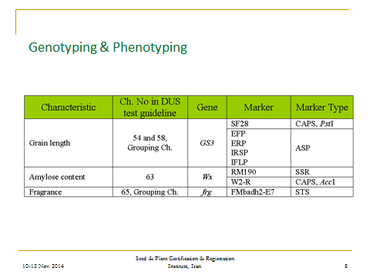

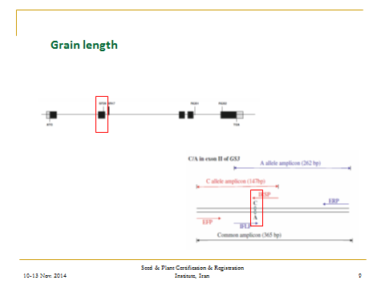

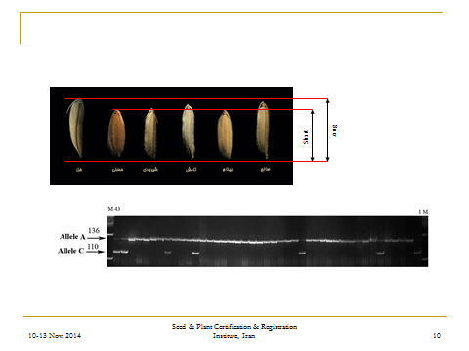

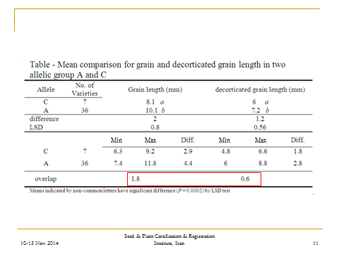

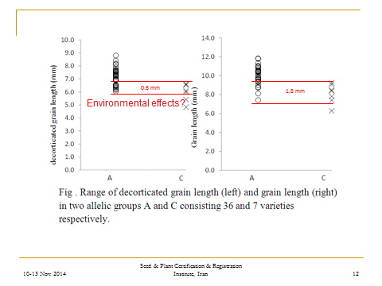

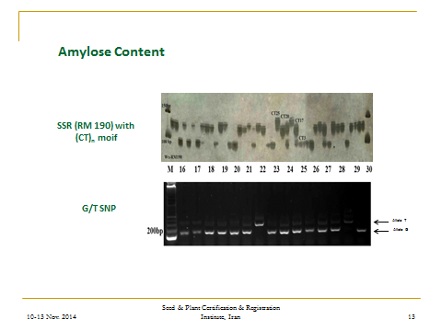

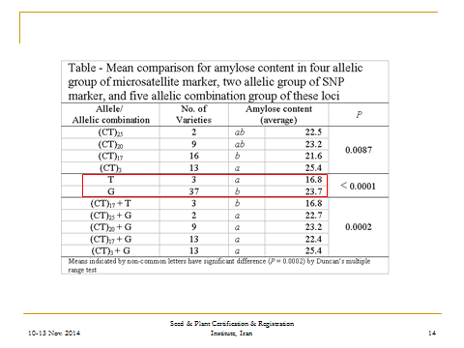

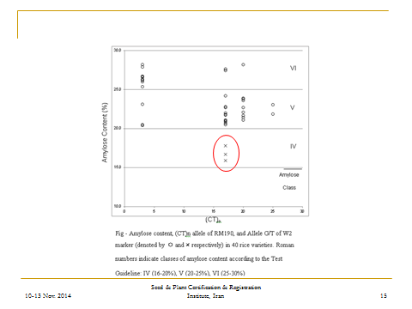

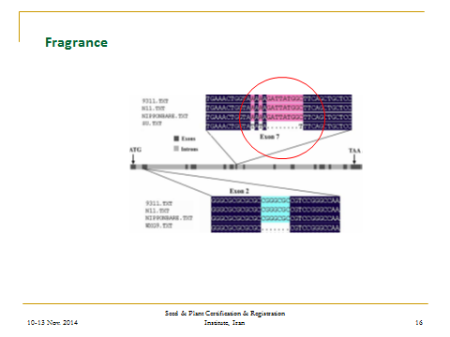

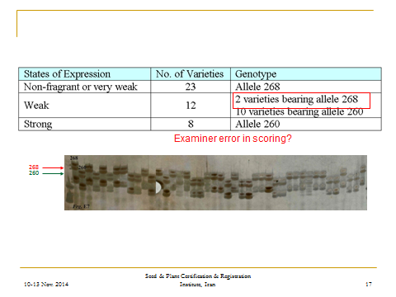

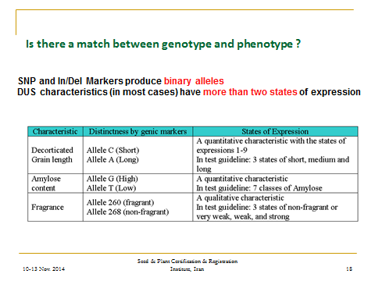

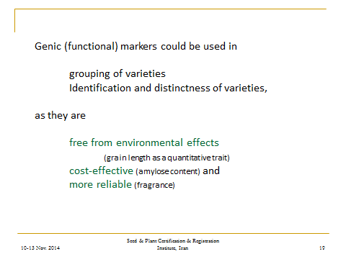

[End of Annex and of document]

