E
BMT/14/6 Add. Rev.
ORIGINAL: English
DATE: November 27, 2014
INTERNATIONAL UNION FOR THE PROTECTION OF NEW VARIETIES OF PLANTS
Geneva
WORKING GROUP ON BIOCHEMICAL AND MOLECULAR TECHNIQUES
AND DNA-PROFILING IN PARTICULAR
Fourteenth Session
Seoul, Republic of Korea, November 10 to 13, 2014
addendum to document bmt/14/6

USE OF DNA VARIETY IDENTIFICATION TECHNIQUE FOR MEASURES AGAINST THE INFRINGEMENT OF PLANT BREEDERS’ RIGHTS IN JAPAN
Document prepared by experts from Japan
Disclaimer: this document does not represent UPOV policies or guidance
The Annex to this document contains a copy of a presentation “Development of EST-SSR Markers of Lettuce and Variety Identification using EST-SSR Markers” made at the fourteenth session of the Working Group on Biochemical and Molecular Techniques and DNA-Profiling in particular (BMT).

Hiroshi GOTO, PVP G-men (Plant Variety Protection Adviser), National Center for Seeds and Seedlings (NCSS), Japan

[Annex follows]

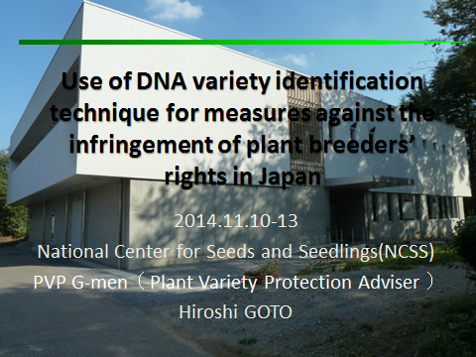

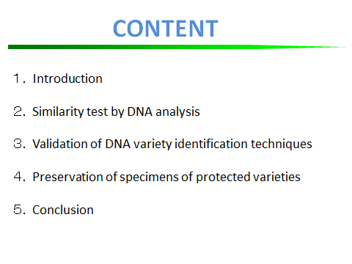

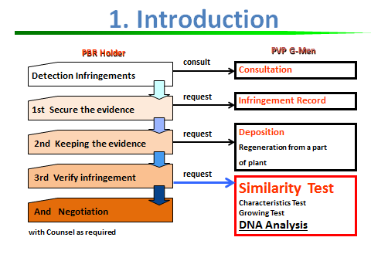

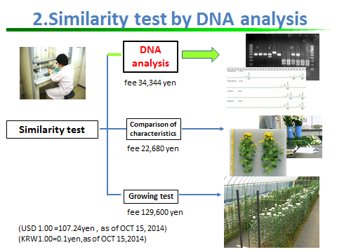

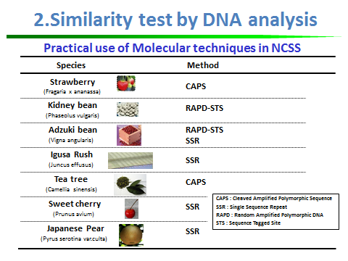

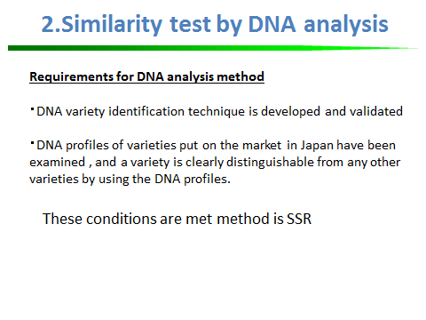

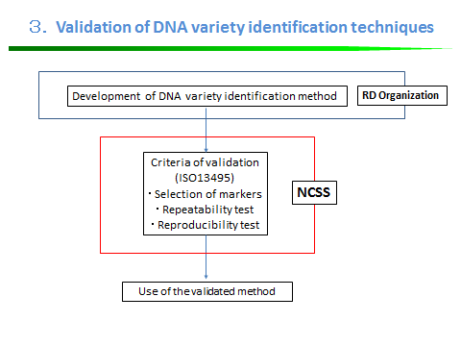

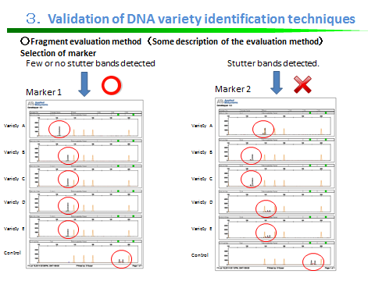

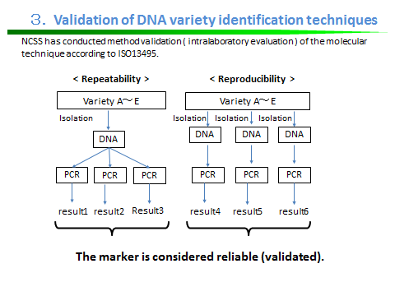

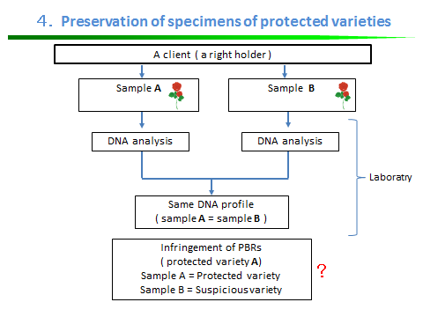

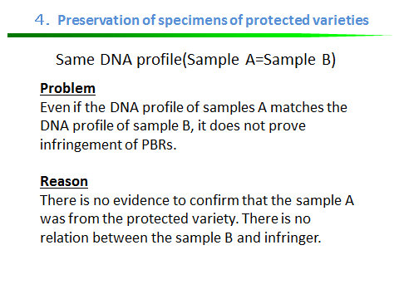

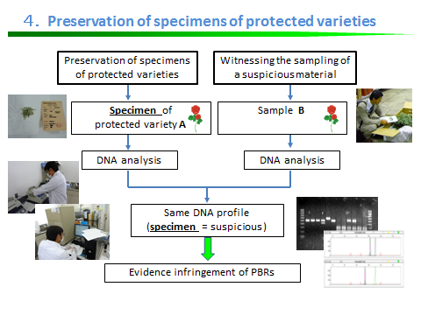

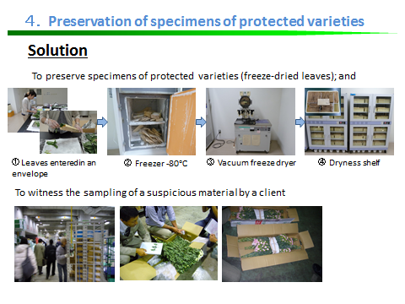

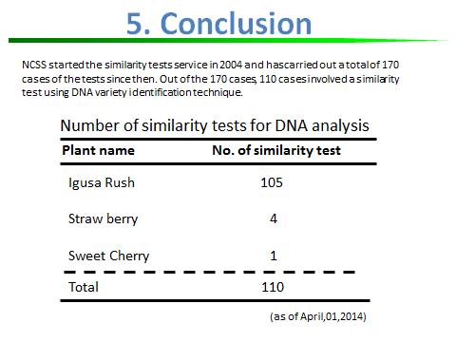

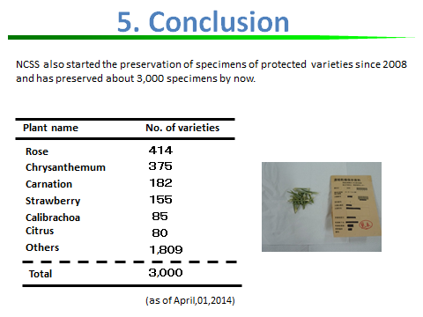

[End of annex and of document]

