E
BMT/14/5 Add. Rev.
ORIGINAL: English
DATE: December 5, 2014
INTERNATIONAL UNION FOR THE PROTECTION OF NEW VARIETIES OF PLANTS
Geneva
WORKING GROUP ON BIOCHEMICAL AND MOLECULAR TECHNIQUES
AND DNA-PROFILING IN PARTICULAR
Fourteenth Session
Seoul, Republic of Korea, November 10 to 13, 2014
addendum to document bmt/14/5

The use of Reference Varieties in Varietal Distinctness: an Approach under Investigation in the United States of america for Potential Application in Plant Variety Protection
Document prepared by experts from Monsanto Company
Disclaimer: this document does not represent UPOV policies or guidance
The Annex to this document contains a copy of a presentation “The Use of Reference Varieties in Varietal Distinctness: an Approach under Investigation in the United States of America for Potential Application in Plant Variety Protection” made at its fourteenth session of the Working Group on Biochemical and Molecular Techniques and DNS-Profiling in particular (BMT).

Paul T. Nelson, Fred Achard, Marymar Butruille, Stevan Madjarac
Monsanto Company, St Louis, MO USA

[Annex follows]

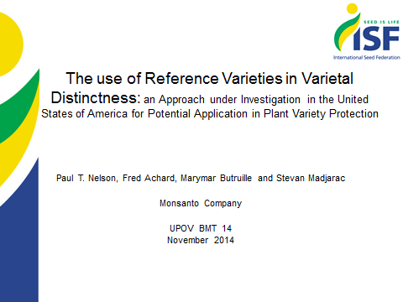

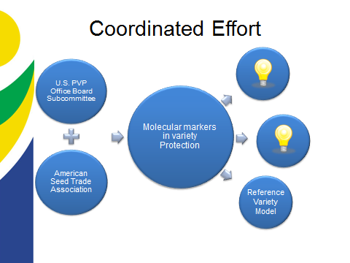

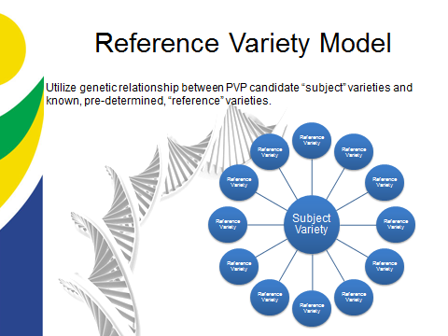

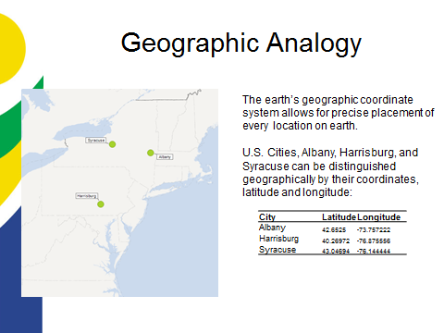

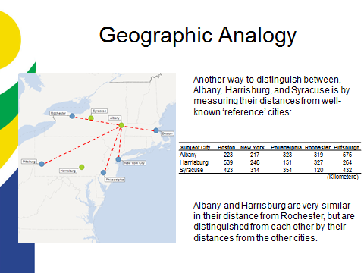

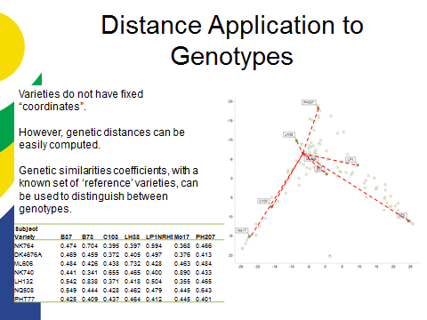

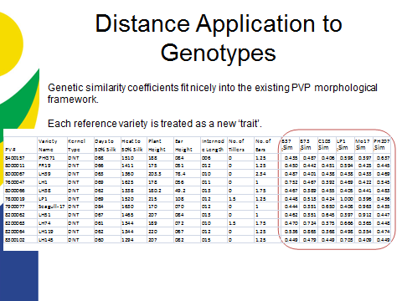

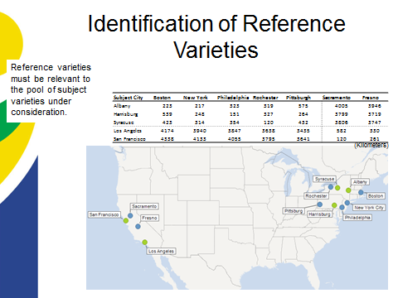

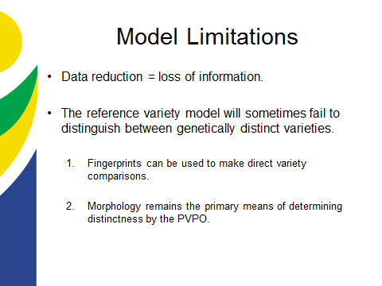

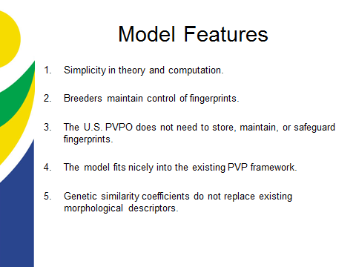

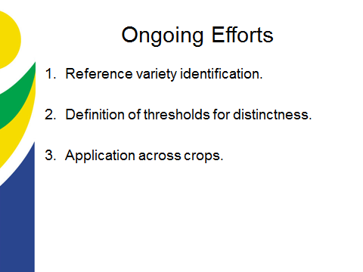
\
[End of annex and of document]

