E
BMT/14/18 Add.
ORIGINAL: English
DATE: November 27, 2014
INTERNATIONAL UNION FOR THE PROTECTION OF NEW VARIETIES OF PLANTS
Geneva
WORKING GROUP ON BIOCHEMICAL AND MOLECULAR TECHNIQUES
AND DNA-PROFILING IN PARTICULAR
Fourteenth Session
Seoul, Republic of Korea, November 10 to 13, 2014
addendum to document bmt/14/18

A EUROPEAN POTATO DATABASE AS CENTRALIZED COLLECTION OF
VARIETIES OF COMMON KNOWLEDGE
(A CPVO FOLLOW UP PROJECT OF THE R&D PROJECT “CONSTRUCTION OF AN INTEGRATED MICROSATELLITE AND KEY MORPHOLOGICAL CHARACTERISTIC DATABASE OF POTATO VARIETIES IN THE EU COMMON CATALOGUE”)

Document prepared by experts from the Community Plant Variety Office of the European Union, the United Kingdom and the Netherlands
Disclaimer: this document does not represent UPOV policies or guidance
The Annex to this document contains a copy of a presentation “A European Potato Database as Centralized Collection of Varieties of Common Knowledge (A CPVO follow up Project of the R&D Project “Construction of an Integrated Microsatellite and key Morphological Characteristic Database of Potato Varieties in the EU Common Catalogue”)” made at the fourteenth session of the Working Group on Biochemical and Molecular Techniques and DNA-Profiling in particular (BMT).

Alex Reid, Science and Advice for Scottish Agriculture (SASA), the United Kingdom (GB)
Hedwich Teunissen, Naktuinbouw, the Netherlands (NL)
Anne Weitz, European Union (EU), Community Plant Variety Office (CPVO)

Abbreviations used in the Annex;
EOs Examination Offices
DB Database
BSA, DE Bundessortenamt, Germany
COBORU, PL The Research Centre of Cultivar Testing, Poland
OEVV, ES Spanish Plant Variety Office, Spain
DAF, IE Department of Agriculture and Food, Ireland
AGES , AT Austrian Agency for Health and Food Safety, Austria
UKZUZ, CZ Central Institute for Supervising and Testing in Agriculture, Czech Republic
UKSUP, SK The Central Controlling and Testing Institute in Agriculture, Slovakia

[Annex follows]

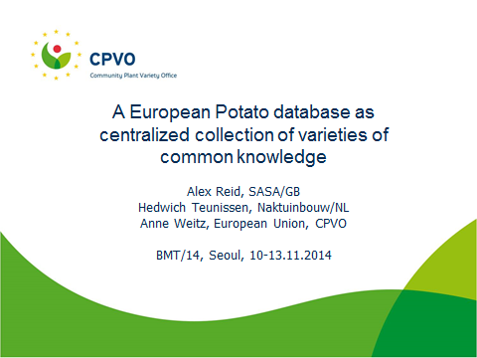

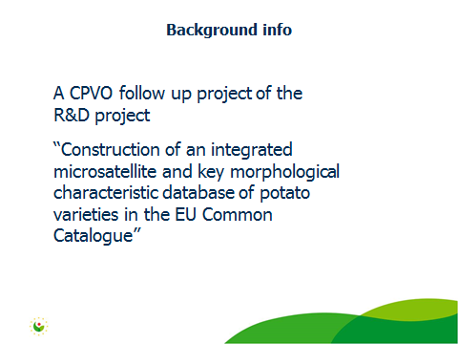

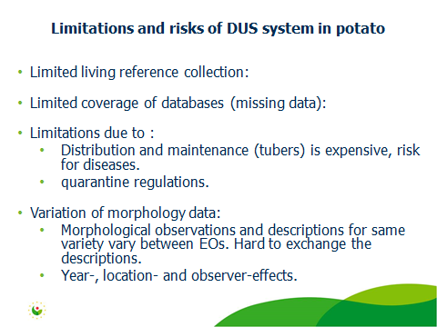

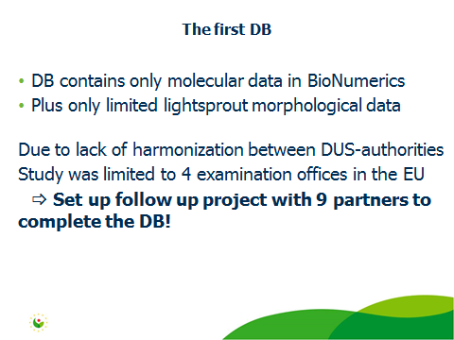

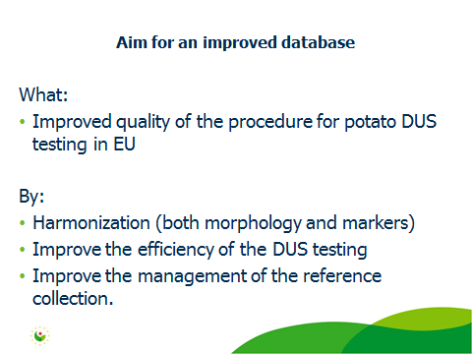

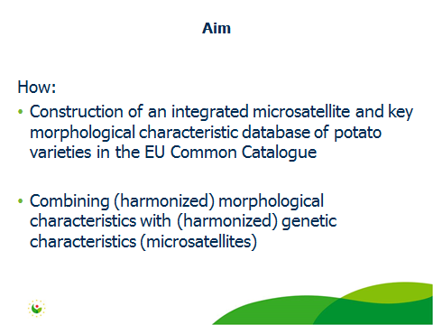

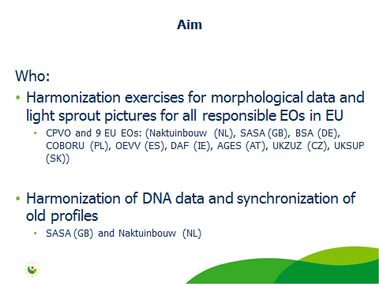

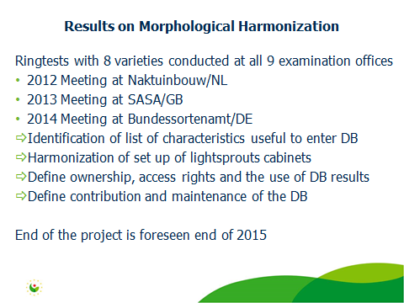

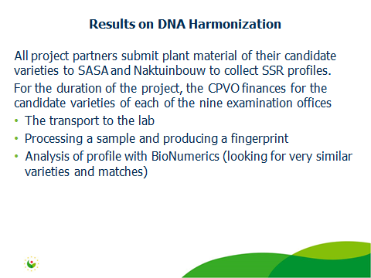

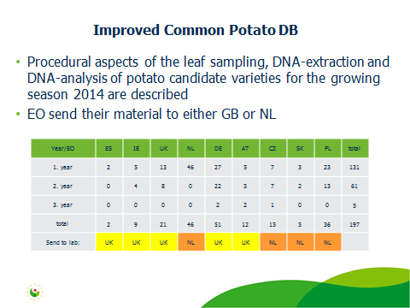

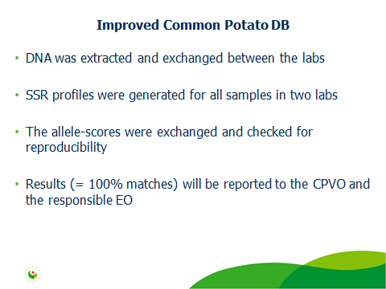

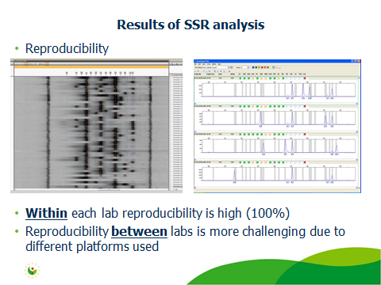

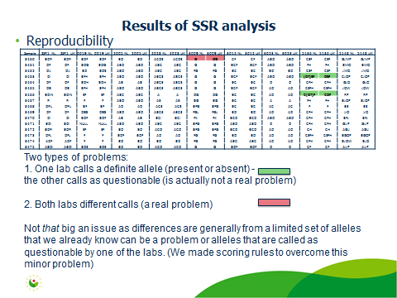

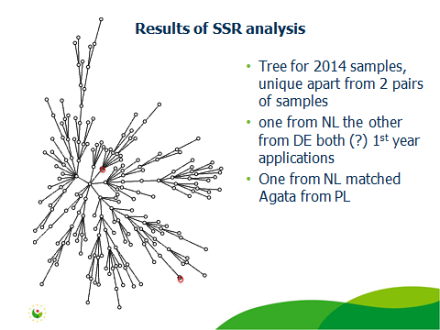

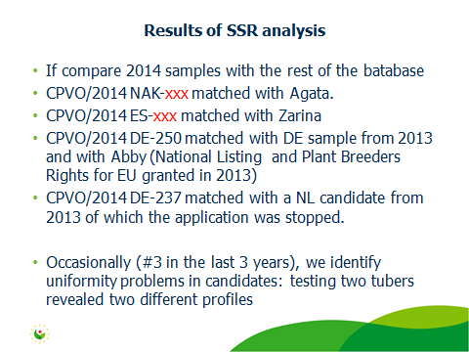

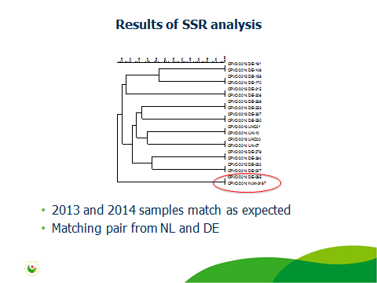

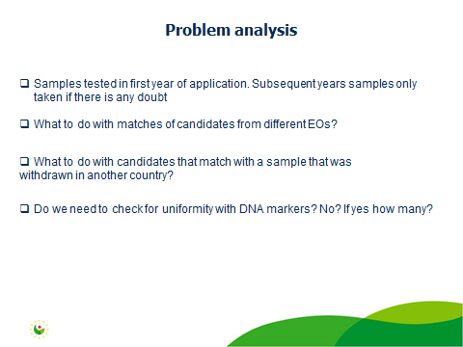

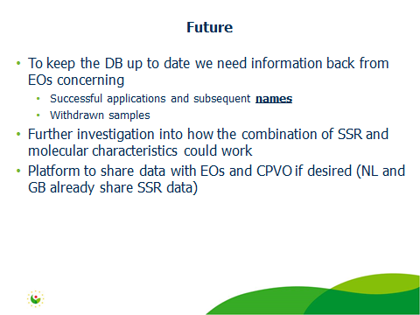

[End of Annex and of document]

