E
BMT/14/15
ORIGINAL: English
DATE: December 5, 2014
INTERNATIONAL UNION FOR THE PROTECTION OF NEW VARIETIES OF PLANTS
Geneva
WORKING GROUP ON BIOCHEMICAL AND MOLECULAR TECHNIQUES
AND DNA-PROFILING IN PARTICULAR
Fourteenth Session
Seoul, Republic of Korea, November 10 to 13, 2014
Reports on development in plant variety protection
from members and observers
Document prepared by the Office of the Union
Disclaimer: this document does not represent UPOV policies or guidance
The Technical Committee (TC), at its forty-seventh session held in Geneva, from April 4 to 6, 2011, agreed to request the Office of the Union to invite experts to submit written reports to the Office of the Union in advance of the Technical Working Party (TWP) sessions in order that a document containing those reports could be prepared by the Office of the Union. The TC noted that TWP experts would be invited to make a brief oral summary of their written report at the session and would also be encouraged to make reports under the agenda item “Experiences with new types and species”, as appropriate. The TC also noted that TWP experts would have an opportunity to raise questions concerning matters of interest (see document TC/47/26 “Report on the Conclusions”, paragraphs 9 and 10).

Written reports were requested by the Office of the Union in Circular E-14/278. The following report was received:

Member of the Union: Annex I: France
Annex II: United States of America

Observer to the Council: Annex III: Iran (Islamic Republic of)

[Annexes follow]

FRANCE

Molecular techniques and DUS testing at Groupe d'Etude et de contrôle des Variétés Et des Semences (GEVES)

- GEVES now uses its expertise in the use of molecular markers for:
• identification and characterization of varieties
• calculation of genetic distances (which can be in combination with phenotypic distances)
• ability to characterize DUS reference collections
• markers relevant to DUS characteristics (such as those linked to disease resistance)
• quality control of seed lots : identity and purity
• detection of specific or non specific GMO event sequences.

- GEVES has recently started using SNP markers in routine analysis (in addition to SSRs and ISSRs).
- As presented at the 14th UPOV BMT meeting, since January 2014 GEVES has officially been using SNP technology on maize as a tool to
• help with the management of the reference collection in DUS studies
• check hybrid formulas
• check conformity of new reference material.
- There are additional benefits to this development of SNP markers on maize, such as its use for confirmation of varietal identity (ongoing work).

- GEVES is currently conducting tests on sorghum: validation of SNP markers for hybrid conformity (in DUS studies). Since 2013 GEVES has been testing an SNP set, and at the end of 2014 a protocol will be submitted for approval to the Comité Technique Permanent de la sélection (CTPS)(national official level).

- GEVES is currently working on an oil seed rape project to test the potential use of SNPs markers, with the overall aim of improving the management of the oil seed rape reference collection by combining phenotypic and molecular data (this project with the support of the Community Plant Variety Office of the European Union (CPVO) will involve other examination offices entrusted on oil seed rape).

- In collaboration with INRA (Institut national de la recherche agronomique), GEVES is currently genotyping fruit trees in the French National Collections using SSR markers in order to complete the characterization of the DUS collections. Additional benefits: this new approach will also help with the management the reference collection; and will be used for true-to-type analysis.

- In conclusion, GEVES is improving its capacity to use adapted markers on a broader range of species with the objective to optimize in field studies in order to 1/reduce the workload and 2/to concentrate on issues requiring in field testing

United States OF AMERICA

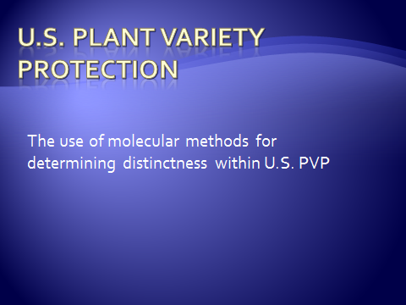

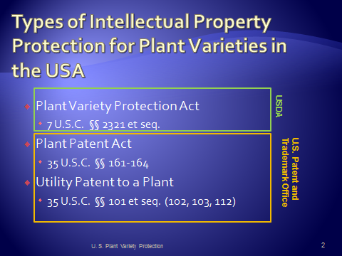

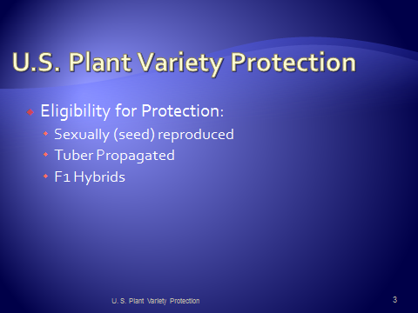

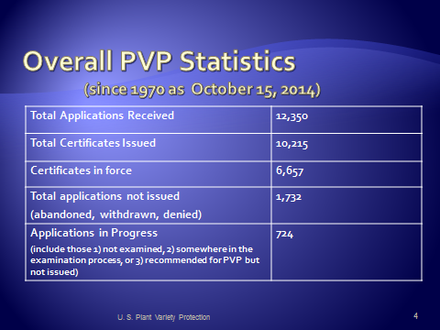

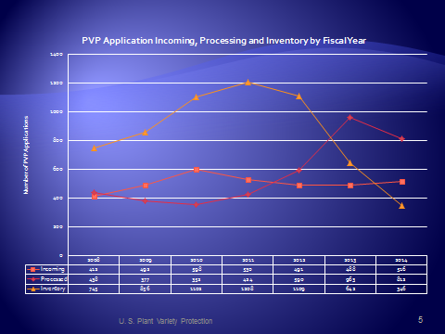

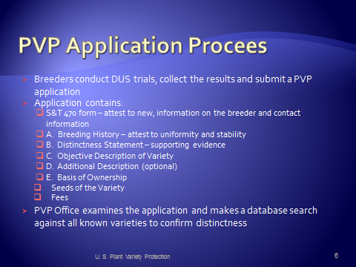

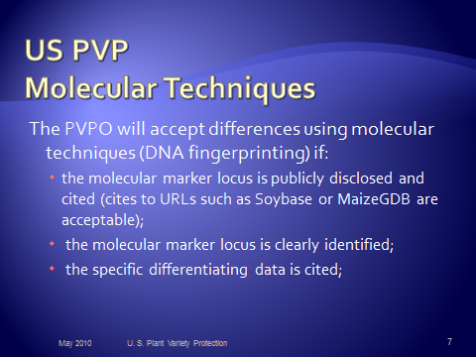

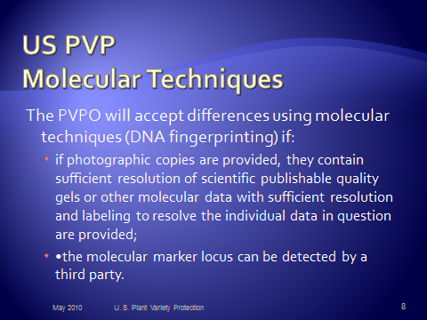

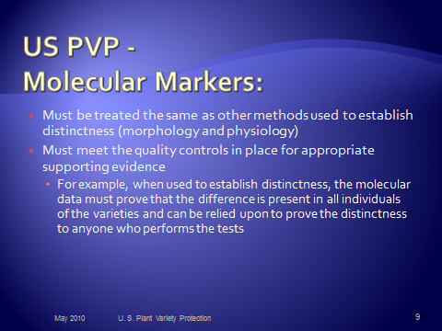

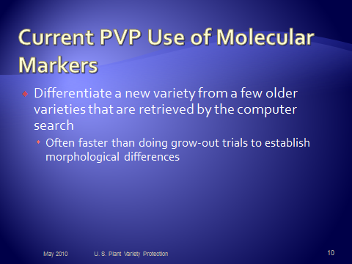

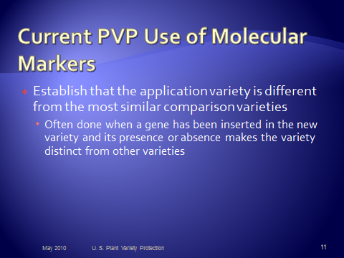

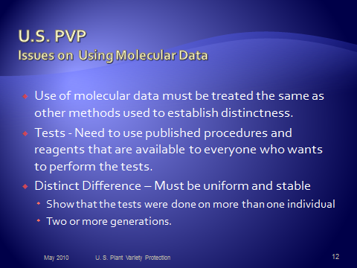

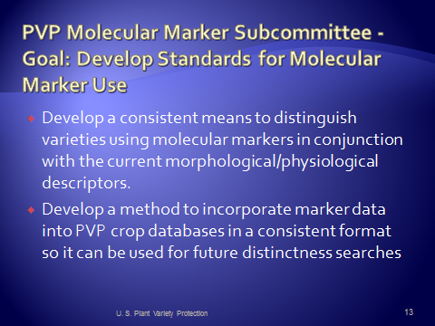

IRAN (Islamic Republic of)

Seed and Plant Certification and Registration Institute (SPCRI) which has been established in 2004 is the national authority for the seed certification and protection of the new varieties of plant. SPCRI is a subsidiary body of Agriculture Research, Education and Extension (AREEO) of the Ministry of Agriculture. The headquarter of the institute is located in Karaj, near the capital, and its 31 provincial branches are located in Provincial Agricultural Research Centers. These provincial branches are only engaged in seed certification. SPCRI is consisted of four departments (based on duties) as 1) Seed Certification, 2) Trees Certification, 3) Seed Technology, and 4) Registration and Protection.

The Registration & Protection department is responsible for granting PBR and also conducting DUS tests. The staff is composed of 13 experts in charge of legal aspect of PVP, examination of application for PBR, conducting DUS tests and molecular tests. By September 2014, 64 national DUS test guidelines have been developed, of which 46 guidelines are available on website and in hard copy.

SPCRI has established with Molecular Markers Laboratory dealing with fingerprinting plant varieties, testing the genetic purity of hybrids and true-to-typeness of propagated plant materials, and detection of GMPs in seed lots. So far, the SSR pattern of a total of 123 local premier varieties of 12 fruit trees like date palm, fig, olive, grapes, walnut, etc. have been developed, as well as DNA profiles of agricultural crops like soybean rice and barley.

SPCRI has enjoyed from a FAO TCP project entitled: Strengthening Capacity on Plant Variety Protection (PVP) which has been implemented during 2007-09 in the Institute. During the project cycle several regional workshops on different aspects of PVP including technical and legal issues and also BMT workshop were elaborated by international and national consultants of the project. One expert was send to The Netherlands to participate in PVP course which annually hold jointly by Naktunibouw and Wageningen UR. For the first time in the country a book entitled Principles of Plant Variety Protection was also complied by a group of authors in Persian language, funded by the project.

Majority of the Registration & Protection department’ staffs have been participated in UPOV’s distance learning course (DL205) on Introduction to the UPOV System of Plant Variety Protection under the UPOV Convention. Another staff of the department was also took part in the above mentioned PVP course in The Netherlands.

Iran is not a member of UPOV and currently its sui generis system is applicable only for Iran`s residents. Nevertheless, according to Economic Cooperation Organization (ECO) commercial agreement law, the residents of ECO (only those countries which have ratified this law by their parliament) can protect their own plant varieties in Iran. Although Iran is not a member of UPOV, the Institute is legally authorized to make its decision to register a variety based on different methods including examination information and documents which are available in UPOV member countries or in countries which have concluded a Plant Variety Protection Agreement with the Iran.

[End of annexes and of document]

