E
BMT/14/14 Rev.
ORIGINAL: English
DATE: November 27, 2014
INTERNATIONAL UNION FOR THE PROTECTION OF NEW VARIETIES OF PLANTS
Geneva
WORKING GROUP ON BIOCHEMICAL AND MOLECULAR TECHNIQUES
AND DNA-PROFILING IN PARTICULAR
Fourteenth Session
Seoul, Republic of Korea, November 10 to 13, 2014

Construction of DNA Profile Database of Strawberry Varieties using SSR Markers
Document prepared by an expert from Republic of Korea
Disclaimer: this document does not represent UPOV policies or guidance
The Annex to this document contains a copy of a presentation “Construction of DNA Profile Database of Strawberry Varieties using SSR Markers” made at the fourteenth session of the Working Group on Biochemical and Molecular Techniques and DNA-Profiling in particular (BMT).

Jee-Hwa Hong, Seed Testing & Research Center, Korea Seed & Variety Service (KSVS), Ministry of Agriculture, Food and Rural Affairs, Republic of Korea

[Annex follows]

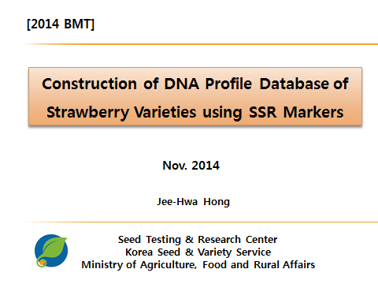

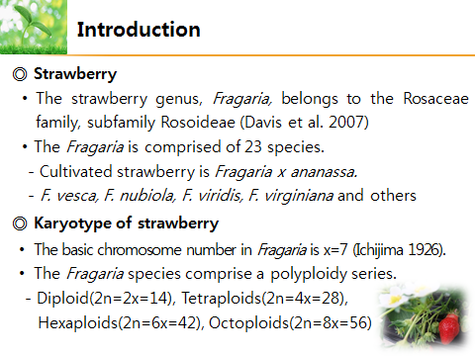

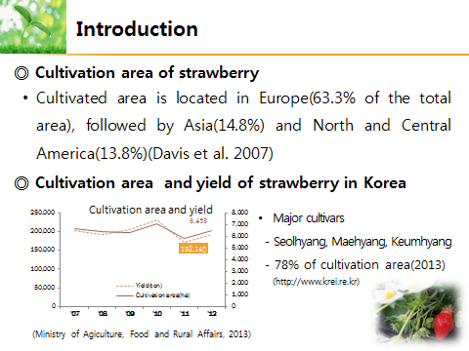

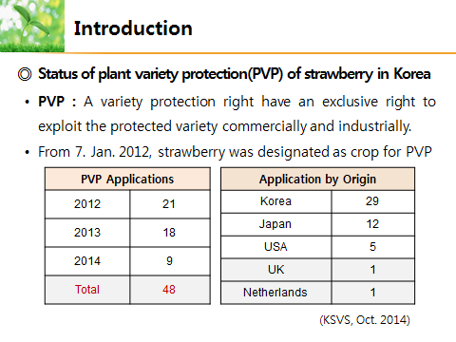

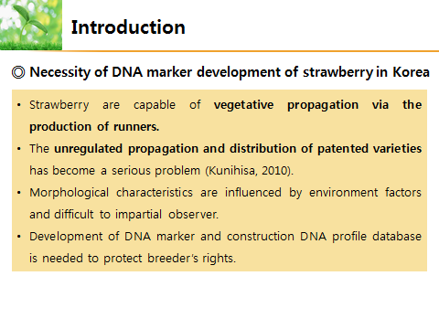

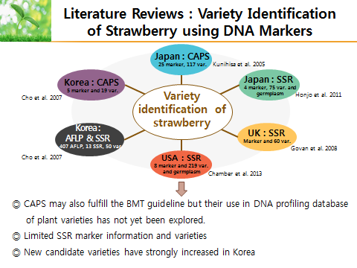

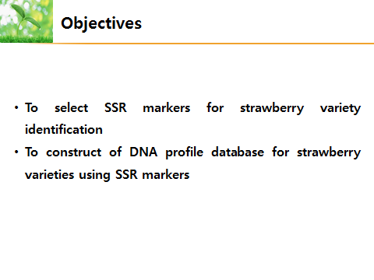

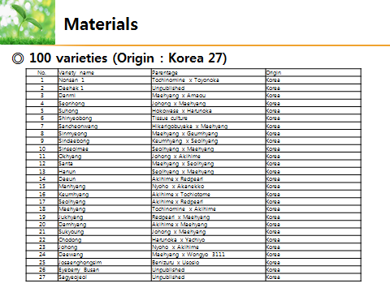

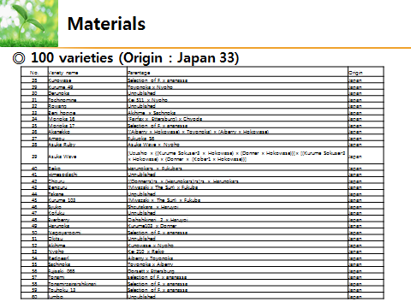

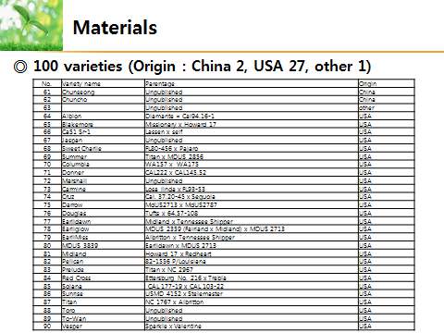

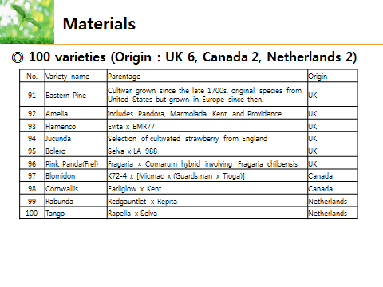

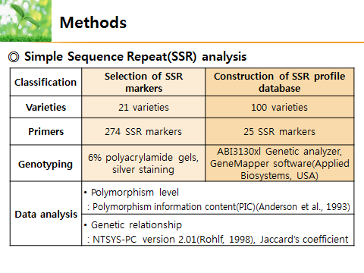

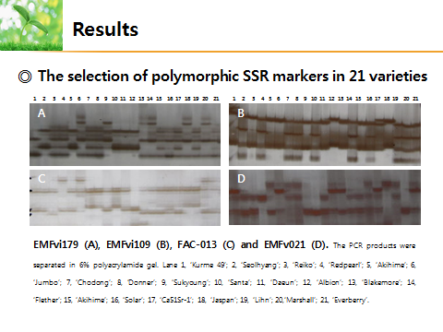

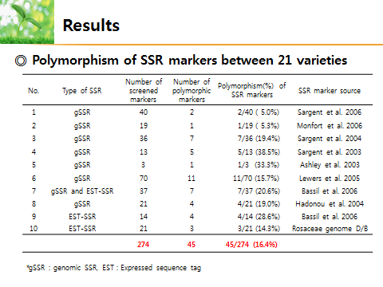

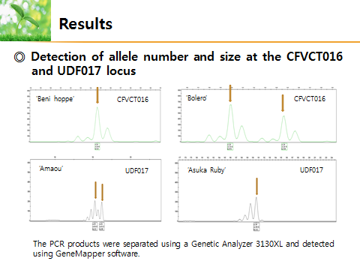

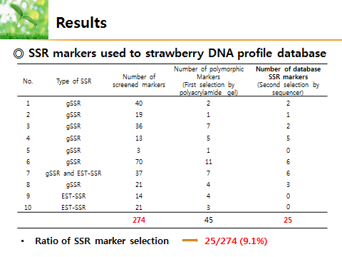

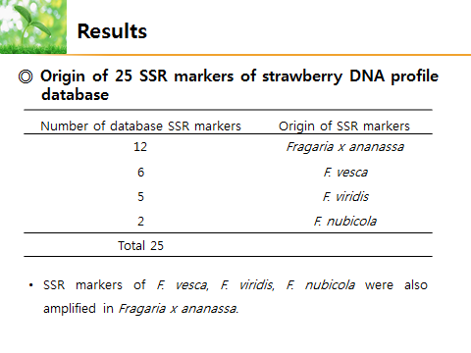

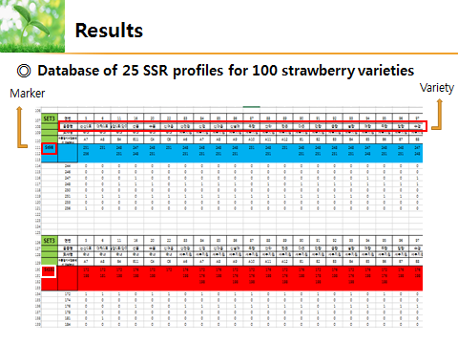

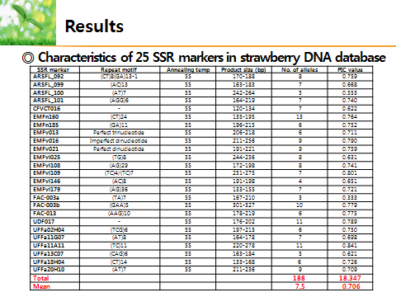

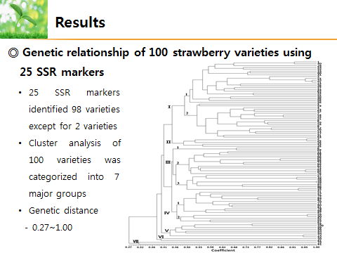

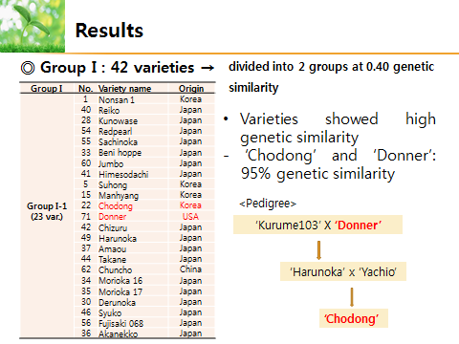

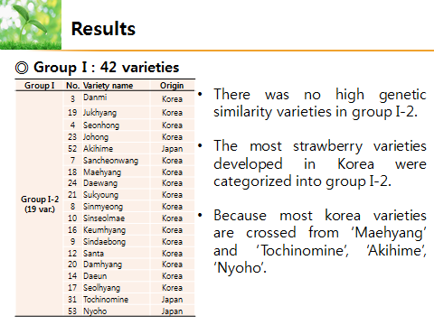

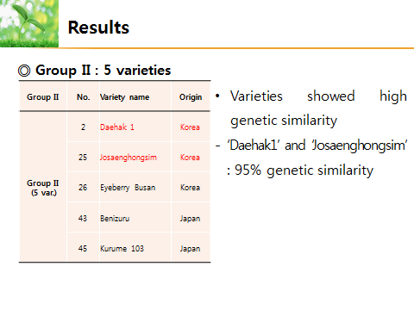

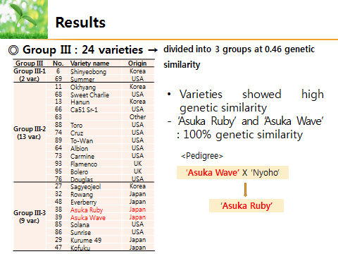

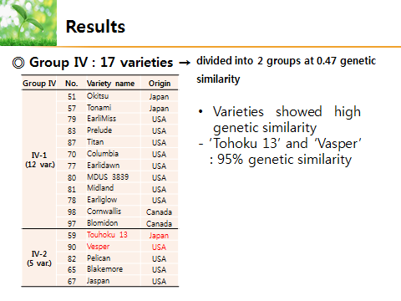

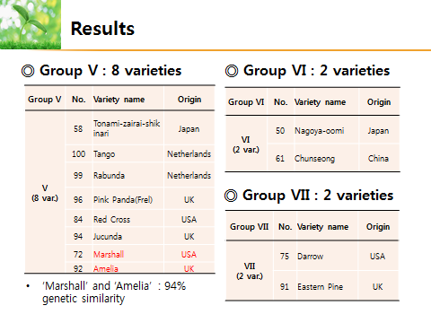

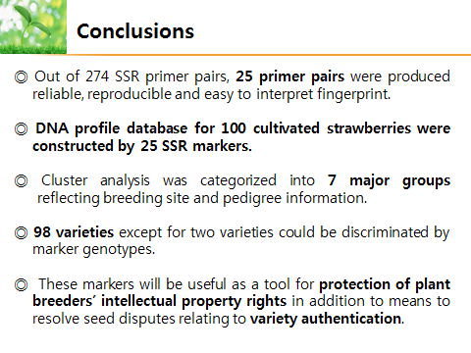

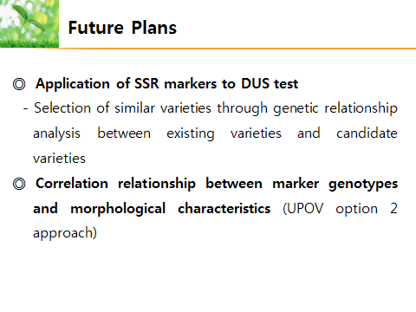

[End of Annex and of document]

