E
BMT/14/12 Add.
ORIGINAL: English
DATE: January 12, 2015
INTERNATIONAL UNION FOR THE PROTECTION OF NEW VARIETIES OF PLANTS
Geneva
WORKING GROUP ON BIOCHEMICAL AND MOLECULAR TECHNIQUES
AND DNA-PROFILING IN PARTICULAR
Fourteenth Session
Seoul, Republic of Korea, November 10 to 13, 2014
addendum to document bmt/14/12

Potential uses of molecular markers in management of Rose varieties for the PVP system
Document prepared by experts from China
Disclaimer: this document does not represent UPOV policies or guidance
The Annex to this document contains a copy of a presentation “Potential uses of Molecular Markers in Management of Rose Varieties for the PVP System” made at its fourteenth session of the Working Group on Biochemical and Molecular Techniques and DNS-Profiling in particular (BMT).

Zheng Yongqi, Yu Xuedan and Huang Ping
Lab for Molecular Identification of Plant Varieties, Office of PVP, State Forestry Administration, Beijing 100091, China

[Annex follows]

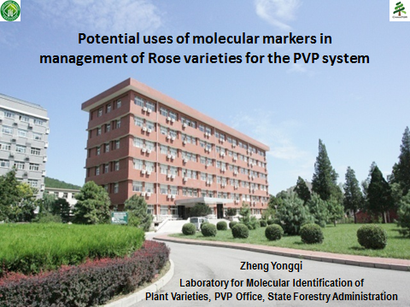

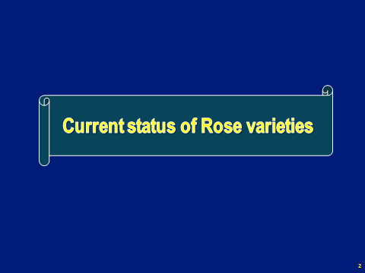

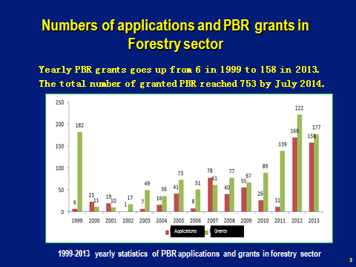

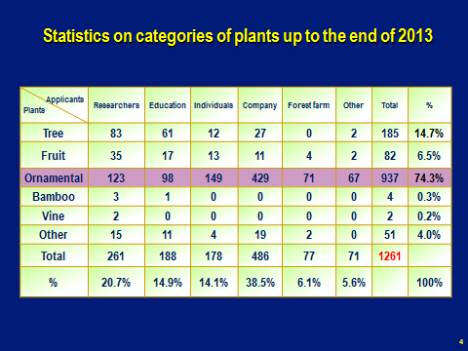

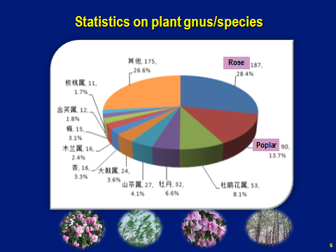

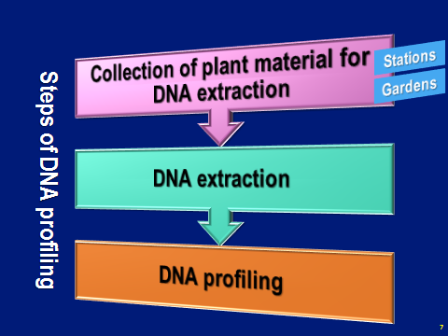

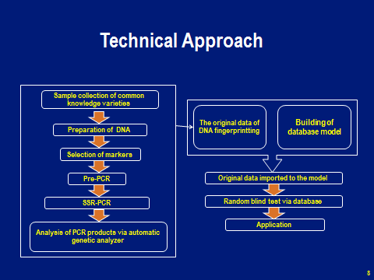

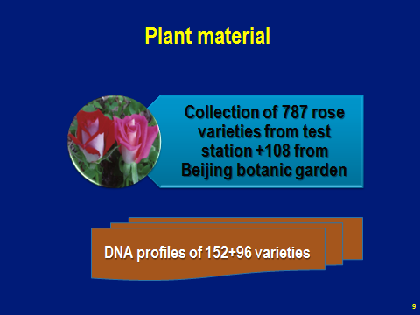

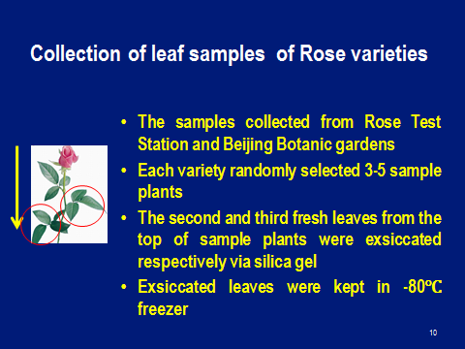

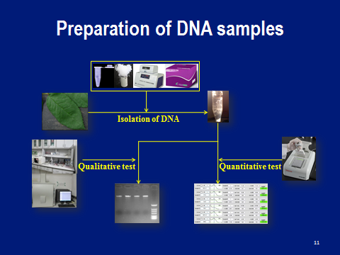

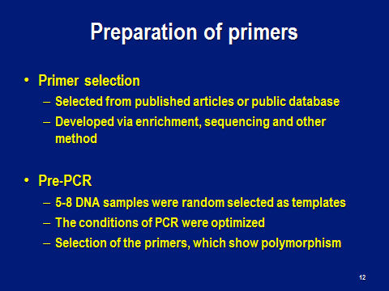

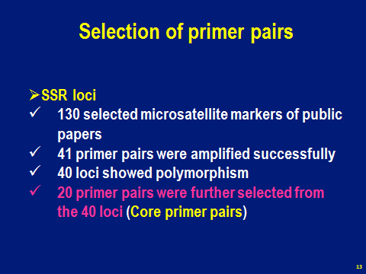

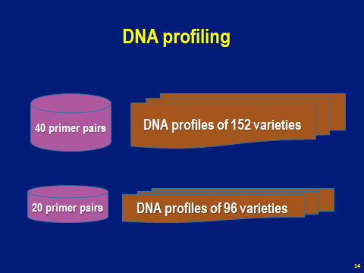

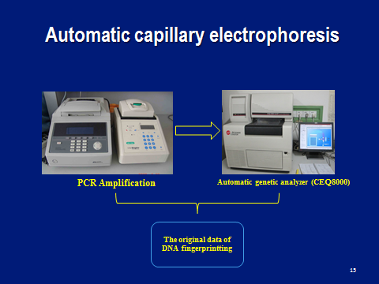

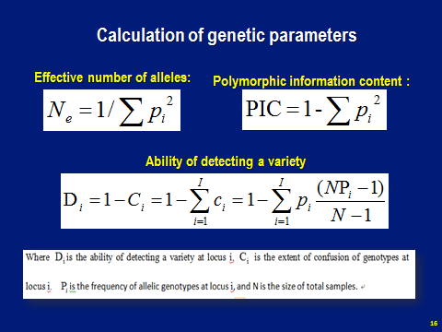

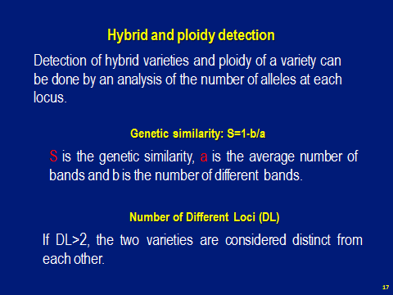

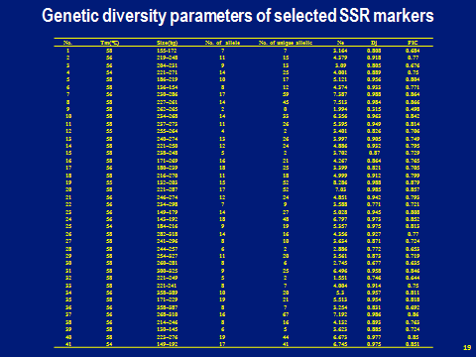

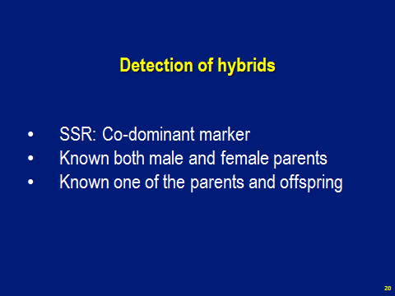

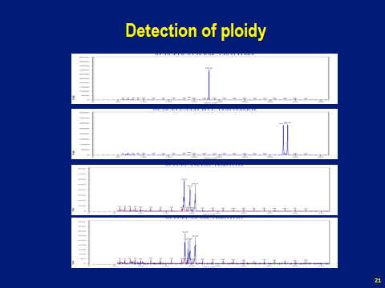

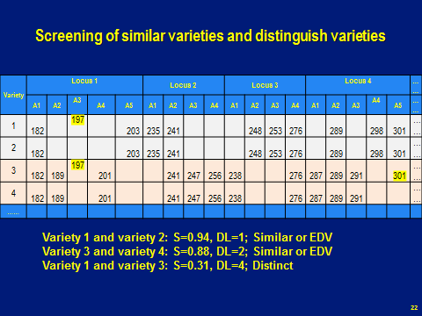

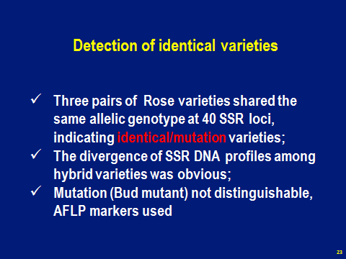

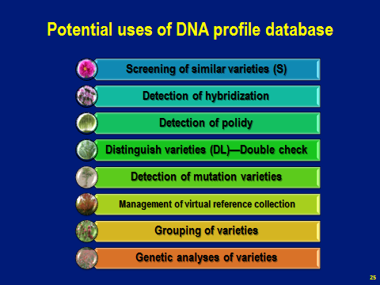

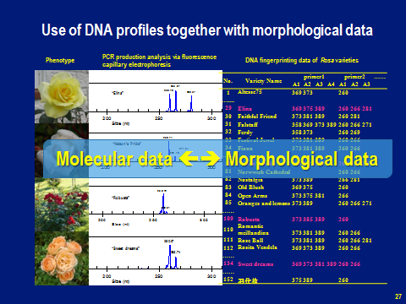

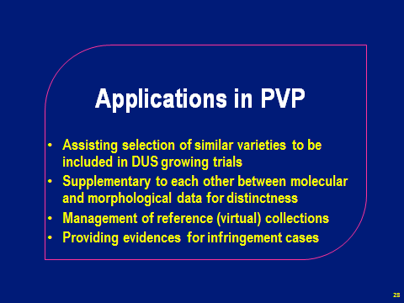

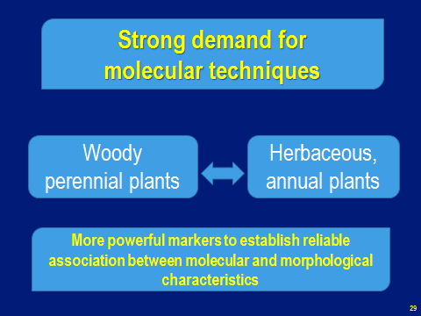

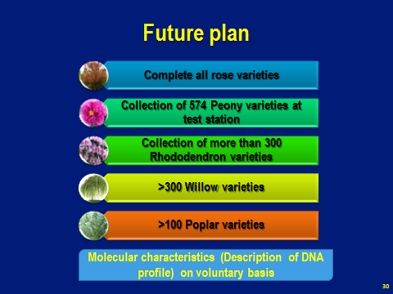

[End of annex and of document]

