E
BMT/14/11
ORIGINAL: English
DATE: October 22, 2014
INTERNATIONAL UNION FOR THE PROTECTION OF NEW VARIETIES OF PLANTS
Geneva
WORKING GROUP ON BIOCHEMICAL AND MOLECULAR TECHNIQUES
AND DNA-PROFILING IN PARTICULAR
Fourteenth Session
Seoul, Republic of Korea, November 10 to 13, 2014
Ownership and use of DUS samples and of DNA and DNA data during and after the DUS tests
Document prepared by an expert from the Netherlands
Disclaimer: this document does not represent UPOV policies or guidance
The Annex to this document contains a copy of a presentation “Ownership and use of DUS Samples and of DNA and DNA data During and After the DUS Tests” to be made at its fourteenth session of the Working Group on Biochemical and Molecular Techniques and DNS-Profiling in particular (BMT).

Kees van Ettekoven, Naktuinbouw Variety Department, the Netherland

[Annex follows]

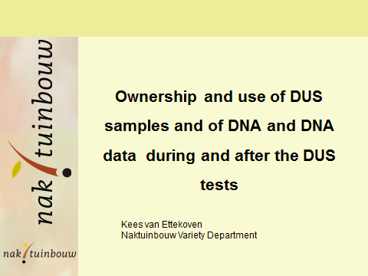

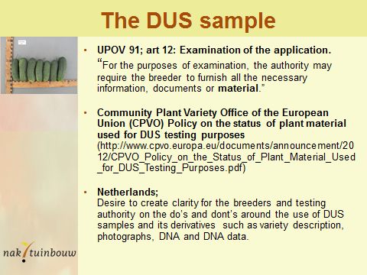

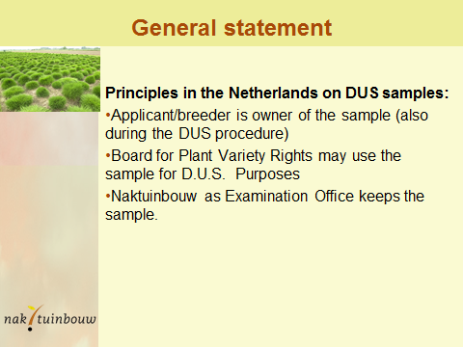

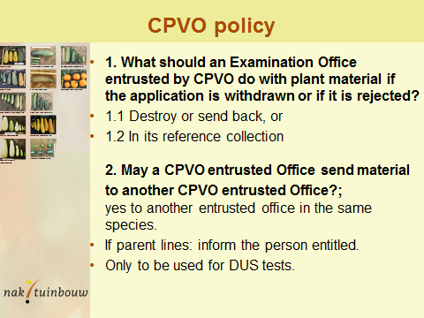

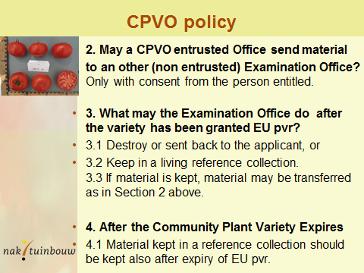

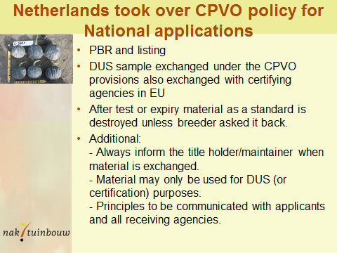

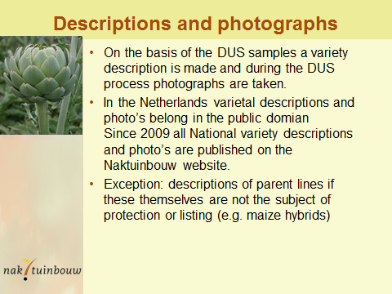

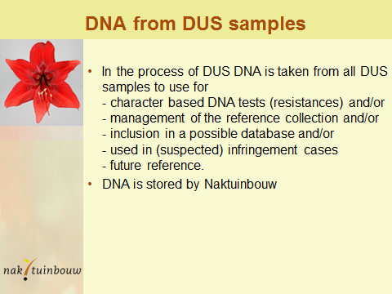

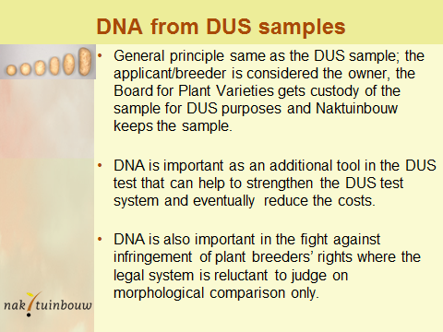

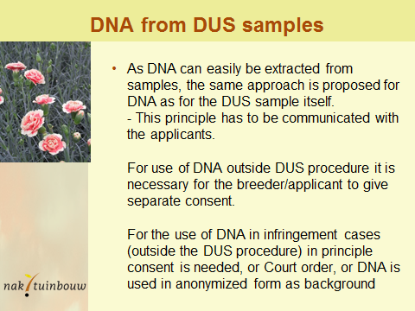

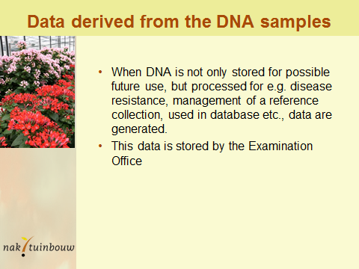

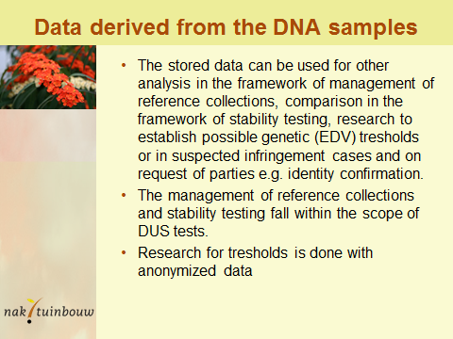

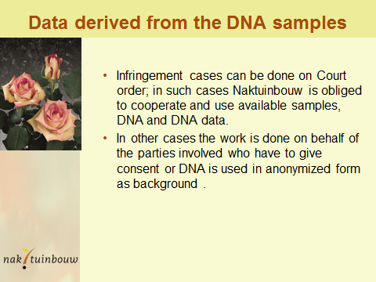

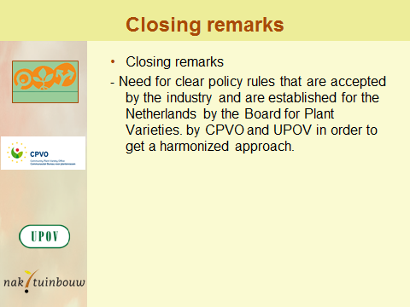

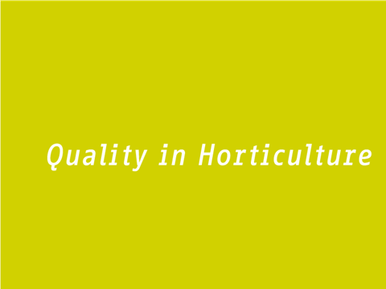
[End of Annex and of document]

