Example from TG/308/1 Pecan Nut

Ad. 22: Nut: shape in lateral view
Ad. 23: Nut: shape in lateral view facing the suture

 |  | ← broadest part →
 |  | below middle | at middle | above middle
width (ratio length/width)
narrow  (high) |  |  | 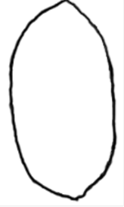  4  oblong
medium  (medium) |  | 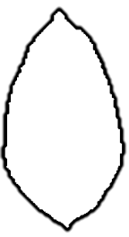  1  ovate | 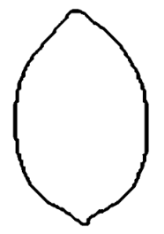  3  elliptic | 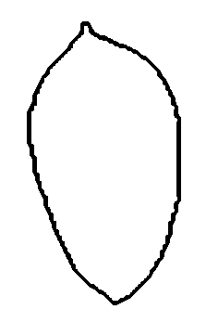  5  obovate
broad  (low) |  |  | 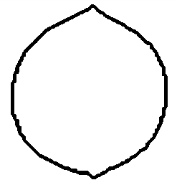  2  circular

BLANK 1

 |  | ← broadest part →
 |  | below middle | at middle
width (ratio length/width)
narrow
(high)
medium
(medium)
broad
(low)

BLANK 2

 |  | ← broadest part →
 |  | below middle | at middle
width (ratio length/width)
narrow
(high)
medium
(medium)
broad
(low)

BLANK 3

 |  | ← broadest part →
 |  | below middle |  | at middle | above middle
width (ratio length/width)
narrow
(high)
medium
(medium)
broad
(low)

BLANK 4

 |  |  | ratio height/diameter
 |  |  | low |  | medium | high
broadest part | above middle
 | at middle
 | below middle

BLANK 5

 |  | ← broadest part →
 |  | at middle | above middle
width (ratio length/width)
narrow
(high)
medium
(medium)
broad
(low)

BLANK 6

 |  | ← broadest part →
 |  | below middle |  | at middle
width (ratio length/width)
narrow
(high)
medium
(medium)
broad
(low)

