
INFORMATION NOTICE NO. 4/2025
Madrid Protocol Concerning the International Registration of Marks
International Registrations Designating Mexico: National Registration Certificates Available for Download
- The Mexican Institute of Industrial Property (IMPI) has informed the International Bureau of the World Intellectual Property Organization (WIPO) that national registration certificates issued for international registrations where protection has been granted in Mexico are available for download in PDF format at no charge from IMPI’s website.
- IMPI has also provided a step-by-step guide on how to download the aforementioned certificates, which is annexed to the present Notice.
- Updated information on this subject and on the procedures to be followed before IMPI is available in the Madrid System Member Profiles database.
- Users of the Madrid System seeking further information may contact IMPI directly.
April 17, 2025

Steps to download a trademark registration certificate

- Go to IMPI’s website.

- In the tab BUSQUEDA AVANZADA (ADVANCED SEARCH), enter the option OTRAS (OTHER).

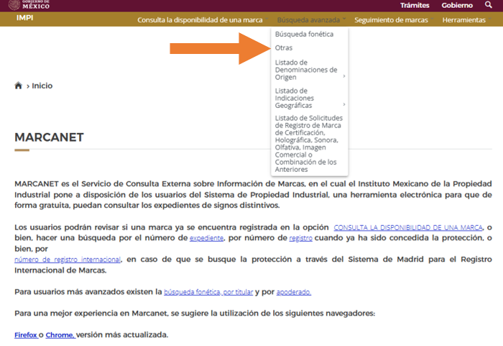

- In the section REGISTRO INTERNACIONAL (INTERNATIONAL REGISTRATION), enter the number of your choice.

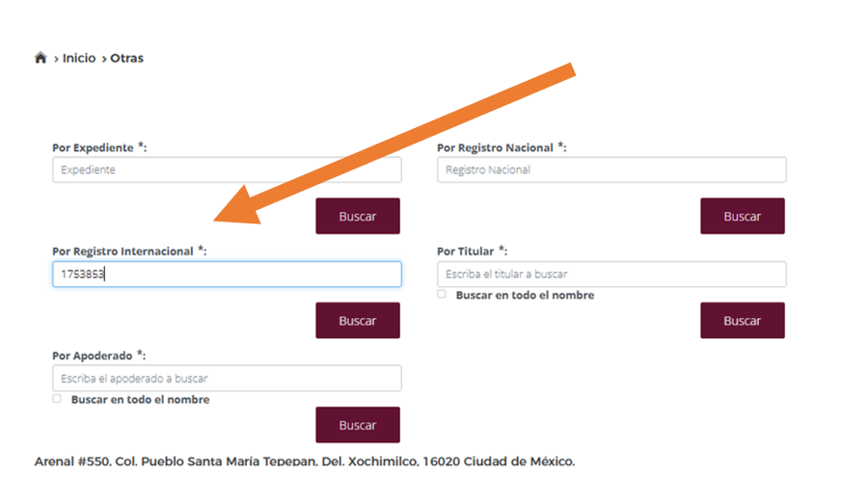

- The system will display the national files associated with the international registration (Mexico has a single class system, so for each class of the international registration a national file number is created).

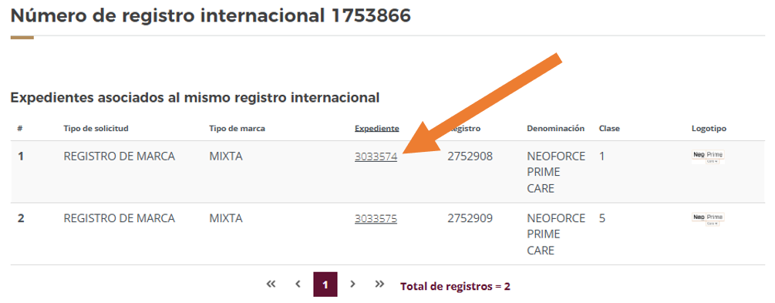

- By selecting the file number, the system will display the data associated with the national file.

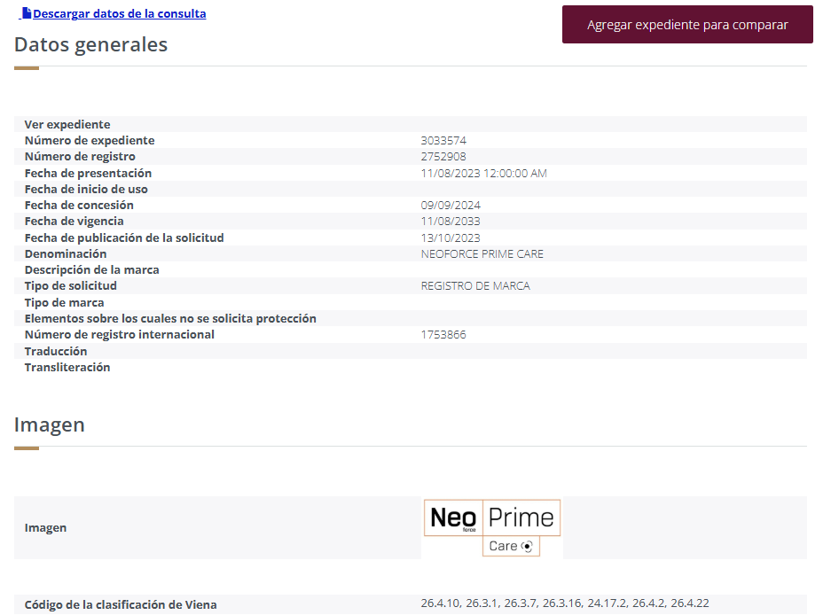

- When navigating to the bottom of the page, the proceedings associated to the file are displayed; in to the item SOLICITUD DE REGISTRO (APPLICATION), you must click on the magnifying glass icon under the column VER DETALLE (VIEW DETAIL).

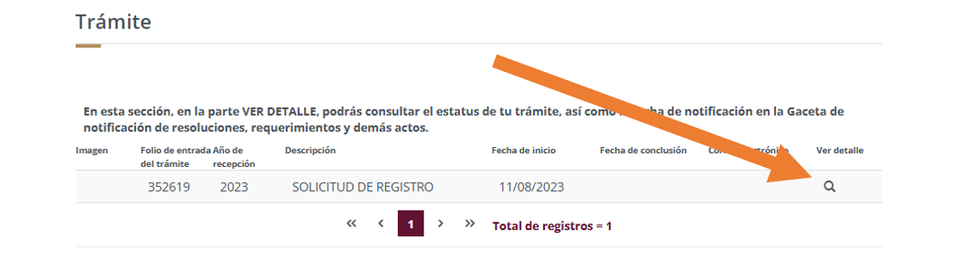

- Then, in to the item CONCESIÓN DE LA PROTECCIÓN (GRANT OF PROTECTION), you must click on the document icon under the column IMAGEN (IMAGE).

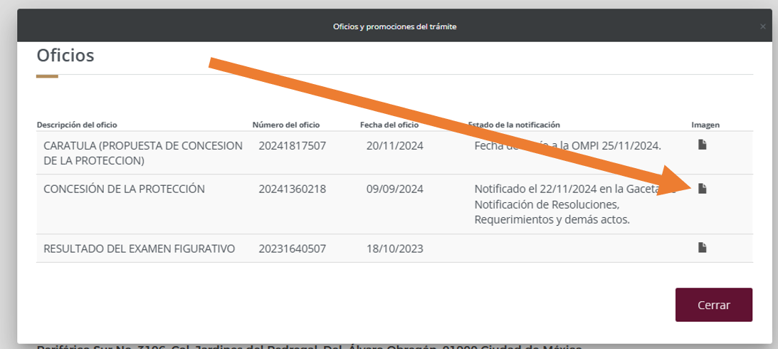

- The registration certificate is displayed and can be downloaded free of charge in electronic format.

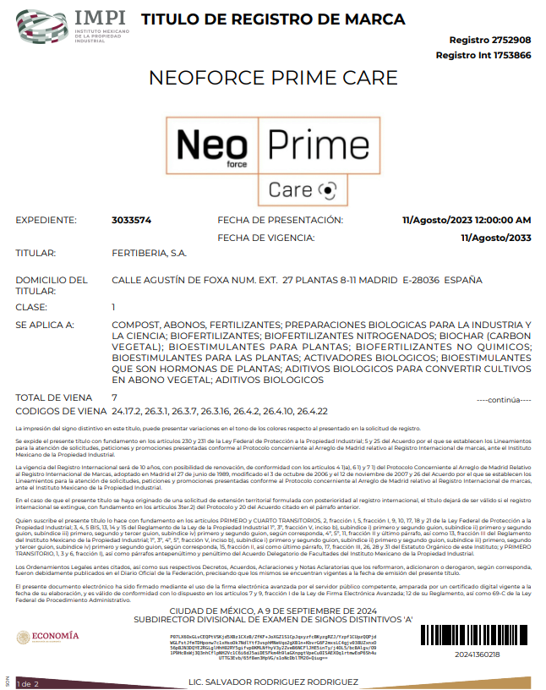

[End of Annex]

