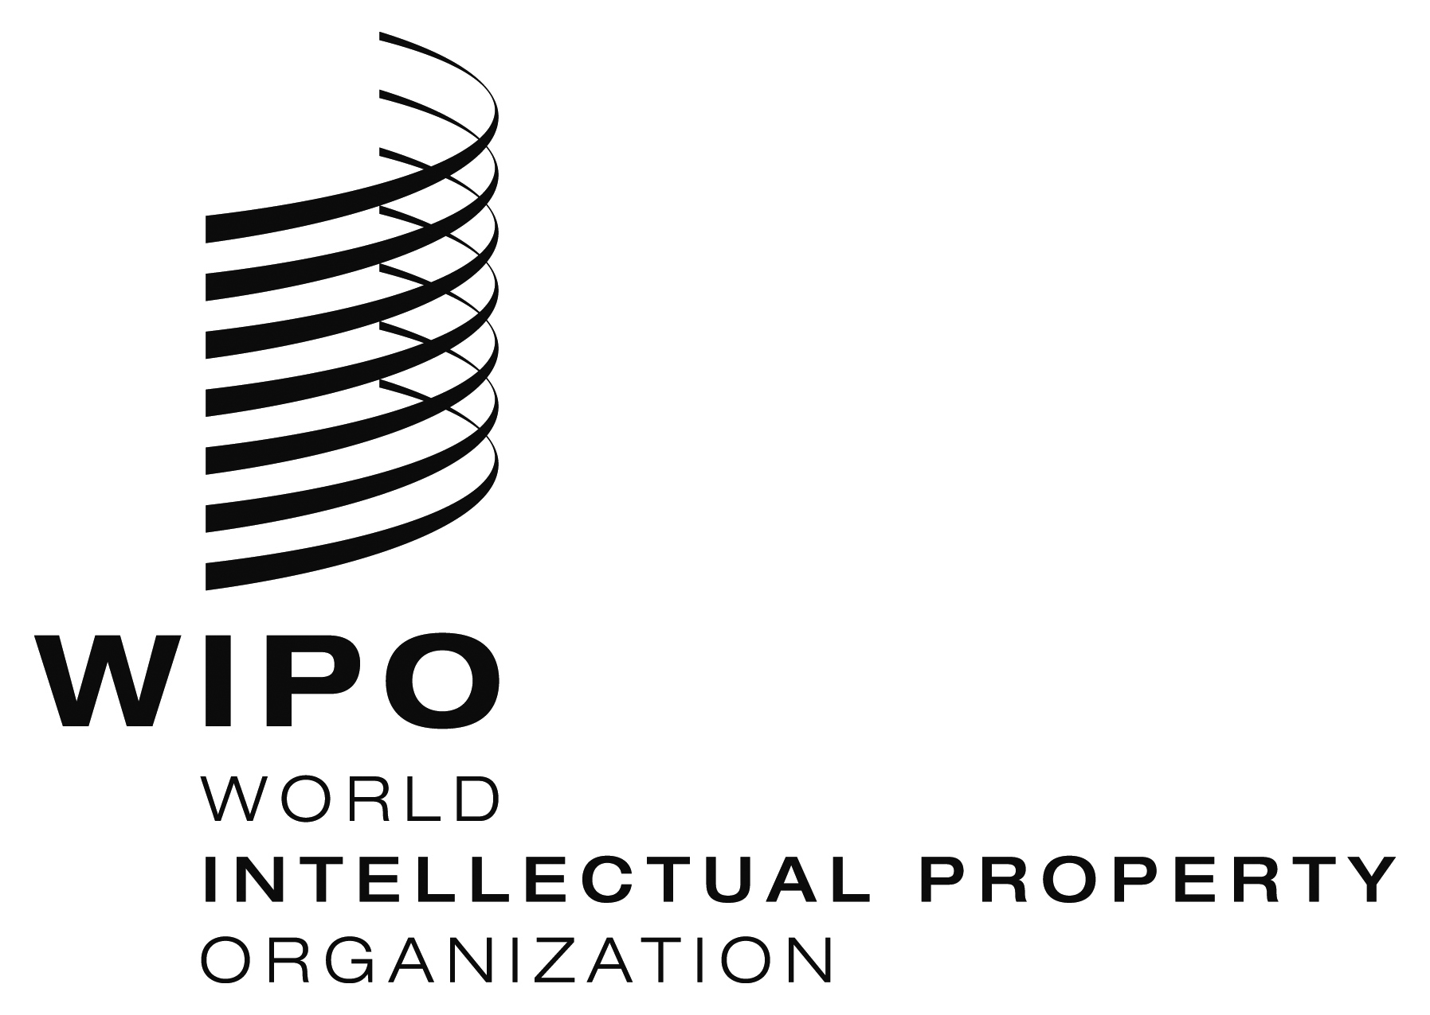
INFORMATION NOTICE NO. 15/2018

Madrid Protocol Concerning the International Registration of Marks

Change in the Amounts of the Individual Fee: Mexico

- The Government of Mexico has notified to the Director General of the World Intellectual Property Organization (WIPO) a declaration modifying the amounts of the individual fee payable with respect to Mexico under Article 8(7) of the Madrid Protocol.
- In accordance with Rule 35(2)(b) of the Common Regulations under the Madrid Agreement and Protocol, the Director General of WIPO has, after consultation with the Office of Mexico, established the following new amounts, in Swiss francs, of the said individual fee:
ITEMS |  | Amounts  (in Swiss francs)
Application or Subsequent Designation | – for each class of goods or services | 167
Renewal | – for each class of goods or services | 161

- This change shall have effect on November 8, 2018. Therefore, these amounts will be payable where Mexico
(a) is designated in an international application which is received by the Office of origin on or after that date; or

(b) is the subject of a subsequent designation which is received by the Office of the Contracting Party of the holder on or after that date, or is filed directly with the International Bureau of WIPO on or after that date; or

(c) has been designated in an international registration which is renewed on or after that date.

September 24, 2018

