 |  | E  TGP/14/1 Draft 4  SECTION 2: Botanical Terms  Subsection 1: Introduction;  Subsection 2: Shapes and Structures  ORIGINAL: English  DATE: December 7, 2007
INTERNATIONAL UNION FOR THE PROTECTION OF NEW VARIETIES OF PLANTS
GENEVA

DRAFT
Associated Document
to the
General Introduction to the Examination
of Distinctness, Uniformity and Stability and the
Development of Harmonized Descriptions of New Varieties of Plants (document TG/1/3)

Document TGP/14
“Glossary of Technical, Botanical and Statistical Terms
Used in UPOV Documents”
Section 2: Botanical Terms
Subsection 1: Introduction;
Subsection 2: Shapes and Structures

Document prepared by the Office of the Union
to be considered by the

Enlarged Editorial Committee at its meeting
to be held in Geneva, Switzerland, on January 8, 2008

Note for Draft version
Footnotes will be retained in published document
Endnotes are background information to assist in the consideration of this draft and will not appear in the final, published document
TABLE OF CONTENTS PAGE
Subsection 1. INTRODUCTION 3
Subsection 2. Shapes and structures 4
I. Shape 4
1. Components of Shape 4
Chart for Simple Symmetric Plane Shapes 7
Chart for Other Plane Shapes 9
2. Developing Shape-Related Characteristics 10
2.1 Introduction 10
2.2 Full plane shape characteristics 11
2.3 Base Shape Characteristics 21
2.4 Apex/Tip Shape Characteristics 24
2.5 Combination of Full Plane-, Base- and Apex Shape Characteristics 27
2.6 Three-dimensional shape characteristics 29
2.7 Symmetry 29
2.8 Types of expression and states / notes 29
2.9 Defining the characteristic 30
2.10 Technical Questionnaire Characteristics 30
3. Shape Illustrations 32
3.1 Full Plane Shapes 32
3.2 Base Shapes 32
3.3 Apex Shapes 33
3.3.1 Apex 33
3.3.2 Differentiated tip 33
3.4 Three-Dimensional Shapes 34
3.5 Symmetry 35
II. STRUCTURE 36
1. Components Of Structure 36
2. Developing Characteristics For Plant Structures 36
2.1 Growth habit 36
2.2 Attitude / direction (Plant parts) 38
2.3 Relative position 39
2.4 Margins 40
2.5 Hairs and Spines 40
3. Illustrations Of Plant Structures 41
3.1 Habit 41
3.2 Attitude / direction (Plant parts) 42
3.3 Relative position 43
[new after 3.3] Types of Inflorescence 43
3.4 Margins 44
3.5 Hairiness (Types of appendage covered by the general term “hair” in the Test Guidelines) 45
3.6 Spines (Types of appendage covered by the general term “spine” in the Test Guidelines) 46
3.7 Other appendages 46
3.8 Texture 47
III. DEFINITIONS for shape and structure terms 48

Subsection 1. INTRODUCTION

The purpose of this document (TGP/14 Section 2: Botanical Terms) is:

(a) to provide guidance on the development of characteristics related to plant shapes, plant structures and color;

(b) to provide standard illustrations of plant shapes, plant structures and color patterns which may be useful for inclusion in Test Guidelines, whilst noting that illustrations for specific characteristics can be found in the relevant Test Guidelines and noting that searches for relevant individual characteristics can be made through TGP/7 “Collection of Approved Characteristics”; and

(c) to provide definitions of botanical terms (e.g. dentate, fastigiate, exserted, elliptic, acute, etc.) which form states of expression for characteristics used in the examination of DUS. Emphasis is placed on the states of expression because those are the basis for the assessment of DUS and, therefore, need to be understood specifically in relation to that function. This document provides illustrations and definitions of some terms which, although not used in the Test Guidelines, may be useful for breeders / applicants for characteristics formulated for use in the Technical Questionnaire. The definitions in this document provide an indication of whether terms are generally used in Test Guidelines, or whether alternative terms might be more appropriate for use in Test Guidelines. In general, the meaning of botanical terms which are used in the Test Guidelines to indicate the relevant part of the plant to be examined, but which are not themselves used as states of expression (e.g. bract, petal, berry, etc.), do not require a UPOV-specific definition and are not included in this document.

Subsection 2. Shapes and structures

I. Shape

1. Components of Shape

1.1 Document TG/1/3 “General Introduction to the Examination of Distinctness, Uniformity and Stability and the Development of Harmonized Descriptions of New Varieties of Plants” (General Introduction) explains that shape can be considered in terms of a pseudo-qualitative characteristic:

“4.4.3 Pseudo-Qualitative Characteristics

“In the case of ‘pseudo-qualitative characteristics’, the range of expression is at least partly continuous, but varies in more than one dimension (e.g. shape: ovate (1), elliptic (2), circular (3), obovate (4)) and cannot be adequately described by just defining two ends of a linear range. In a similar way to qualitative (discontinuous) characteristics – hence the term ‘pseudo-qualitative’ – each individual state of expression needs to be identified to adequately describe the range of the characteristic.”

However, document TGP/9 “Examining Distinctness” explains that the use of pseudo-qualitative characteristics for the assessment of distinctness on the basis of notes has particular limitations (see document TGP/9/1 Draft 6, Section 5.2.3) [cross ref.] :

“Pseudo-qualitative (PQ) characteristics

“[…]

“5.2.3.6 […] However, an important additional factor with pseudo-qualitative characteristics is that, whilst a part of the range is continuous, there is not an even distribution across the scale and the range varies in more than one dimension (e.g. shape: ovate (1), elliptic (2), circular (3), obovate (4): there is a variation in the length/width ratio and in the position of the widest point). This means that it is difficult to define a general rule on the difference in Notes to establish distinctness within a characteristic.”

1.2 Therefore, for the purposes of DUS examination, it can be useful to develop quantitative or qualitative characteristics related to shape, rather than considering shape as a single pseudo-qualitative characteristic. In that respect, it is possible to define a plane shape using the following components:

(a) Ratio length/width (or ratio width/length)
(used as a generic term in this document to cover also ratio: thickness/length; diameter/length; thickness/width, for cross-sections of 3 dimensional shapes)

To ensure that the ratio length/width is clearly understood, it is recommended to use meaningful states such as “very elongated”, rather than states such as “very high”. To avoid confusion concerning the absolute dimensions, it is recommended to avoid the use of terms such as “narrow” and “broad” for ratio length/width, particularly where characteristics for the absolute dimensions are also included for the same plant part;

(b) Position of broadest part
The broadest part may be a point (e.g. for a circle) or, in cases where the sides are parallel (e.g. for an oblong), the broadest part is situated along a length. In cases where the broadest part is not a precise point, the position of the broadest part is considered to be the mid-point along the broadest part. For example:
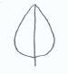
position of broadest part
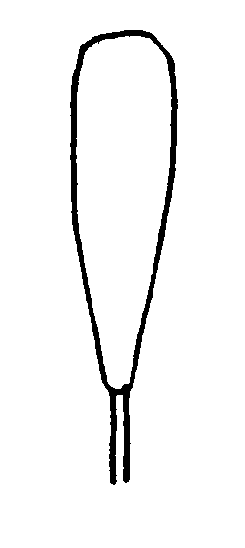
x
x
x
position of broadest part (mid-point of length of broadest part)
(c) Shape of base (see Section 2.3 Base [cross ref.]);
(d) Shape of apex (see Section 2.4 Apex [cross ref.]);
(e) Lateral outline.

1.3 The shape of base and shape of apex are considered in Sections 2.3 and 2.4 [cross ref.] respectively. The chart below (Chart for Simple Symmetric Plane Shapes) illustrates the other three components for simple symmetric plane shapes (those for which the angle at the base and at the apex does not exceed 180°) as follows:

(a) Ratio length/width (or ratio width/length): the ratio length/width varies from left to right within a row [but is approximately the same within a column];
(b) Position of broadest part: the position of the broadest part varies from row to row [but is approximately the same in each row];
(c) Lateral outline: the shape of the lateral sides varies from set to set [but is approximately the same within a set].

1.4 The terms associated with certain length/width ratios in the Chart for Simple Symmetric Plane Shapes are intended to illustrate the use of ratio length/width. Those terms are not necessarily appropriate for use in the Test Guidelines, because terms such as “narrow” and “broad” may be used in relation to the range of expression for the characteristic concerned. For example, if the range for the ratio length/width within a characteristic is from 2:1 to 1:1, then the ratio 2:1 may be indicated as “narrow” (not “medium” as indicated in the Chart for Simple Symmetric Plane Shapes) and the ratio 1:1 as “broad” (not “very broad” as indicated in the Chart for Simple Symmetric Plane Shapes).

Chart for Simple Symmetric Plane Shapes
ratio length/width | >6:1 |  | 6:1 to 3:1 | 2:1 to 1.5:1 | 1.2:1 | 1:1 | 1:1.2 | 1:1.5 to 1:2 | 1:3 to 1:6
 | very narrow |  | narrow | medium | broad | very broad | shallow | very shallow
 |  |  | very elongated | moderately elongated | slightly elongated | medium | slightly compressed | moderately compressed | very compressed
Parallel set
oblong | 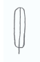 |  | 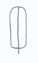 | 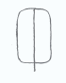 | 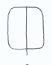 | 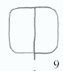 | 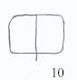 | 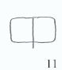 | 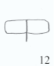
Rounded set
ovate | 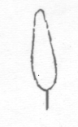 |  | 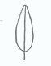 | 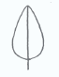 |  | 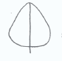 | 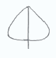 | 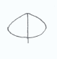 | 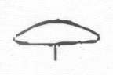
elliptic | 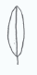 |  | 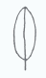 | 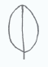 | 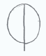 | 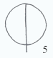 | 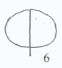 | 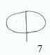 | 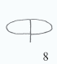
obovate | 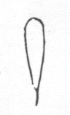 |  | 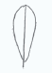 | 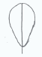 | 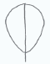 | 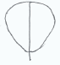 | 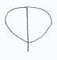 | 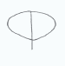 | 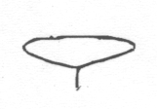
Angular set
triangular | 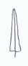 | 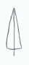 |  | 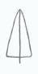 | 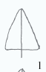 | 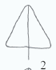 | 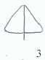 | 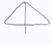 | 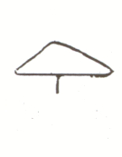
trullate | 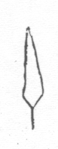 | 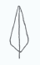 |  | 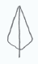 | 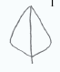 | 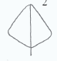 | 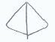 | 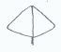 | 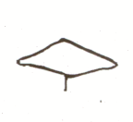
rhombic | 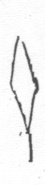 | 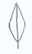 |  | 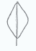 | 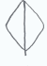 | 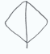 | 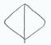  4 | 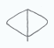 | 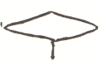
obtrullate | 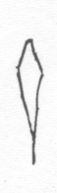 | 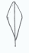 |  | 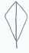 | 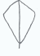 | 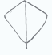 | 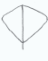 | 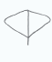 | 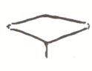
obtriangular | 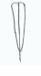 | 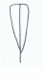 |  | 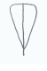 | 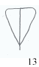 | 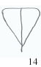 | 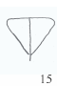 | 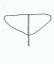 | 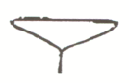

1 (narrow deltate) 9 square
2 (medium deltate) 10 transverse broad oblong
3 (broad deltate) 11 transverse medium oblong
4 (quadrate rhombic) 12 transverse narrow oblong
5 circular 13 (narrow obdeltate)
6 narrow oblate 14 (medium obdeltate)
7 medium oblate 15 (broad obdeltate)
8 broad oblate

Notes

Parallel set: the lateral sides are more or less straight over most of their length and more or less parallel to the main axis (The leaves of most of the monocotyledons belong in this group.)

Rounded set: the lateral sides are rounded in a single, sweeping curve, without sudden changes of direction (The leaves of most of the dicotyledons belong in this group.)

Angular set: the lateral sides are somewhat bent at a certain point, resulting in a change of direction, combined with a somewhat straightening towards the base and apex from that point and more or less forming two triangles joined at the longitudinal axis.

1.5 The following chart (Chart for Other Plane Shapes) illustrates some other common plane shapes:

Chart for Other Plane Shapes

For each of the shapes below, ranges for ratio length/width (or ratio width/length) and position of broadest part can be developed, in a similar way to that shown in the Chart for Simple Symmetric Plane Shapes (Section 1.3 [cross ref.] ).

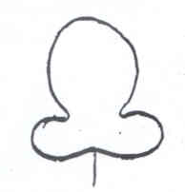 | 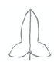 | 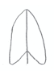 |  | 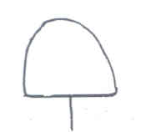
auriculiform | hastiform | sagittate | trapezoidal | semi-elliptic

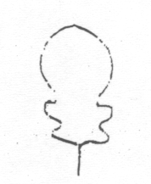 | 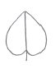 | 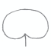 | 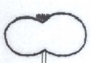 | 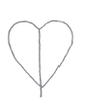
lyrate | cordiform | reniform | transverse 8 shape  (binocular shape?) | obcordiform

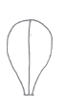 | 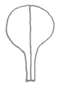 | 2-dimensional illustration to be provided | 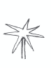
spatulate | clawed | clavate | stellate

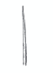 | 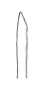 | 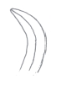 | 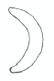
acicular | subulate | falcate | lunate

2. Developing Shape-Related Characteristics

2.1 Introduction

2.1.1 In general, it can be most useful to consider the variation in shape between varieties in the variety collection using the following steps:

Step 1: Ratio length/width (or ratio width/length) (see Section 1 [cross ref.]);
Step 2: Position of broadest part (see Section 1 [cross ref.]);
Step 3: Shape of base (see Section 2.3 Base [cross ref.]);
Step 4: Shape of apex (see Section 2.4 Apex [cross ref.]);
Step 5: Lateral outline (see Section 1 [cross ref.]).

Thus, if all the variation in shape between varieties in the variety collection is accounted for by the ratio length/width (e.g. narrow elliptic, medium elliptic or broad elliptic), it is only necessary to have a characteristic “ratio length/width” (or ratio width/length). Similarly, if all the variation in shape between varieties in the variety collection is accounted for by ratio length/width and position of broadest part (e.g. all varieties fall within the rounded set in the Chart for Simple Symmetric Plane Shapes) it is only necessary to have the characteristics “ratio length/width” (or ratio width/length) and “position of broadest part”. It is only necessary to go to subsequent steps when the variation in shape between varieties in the variety collection has not been accounted for by the preceding steps/components.

2.1.2 In general, where shape characteristics are developed on the basis of the individual components above, it is appropriate to present the characteristics in the order of the steps 1 to 5. However, a particular exception to this approach should be made where a qualitative characteristic is identified. Qualitative characteristics should be presented as the first of the series of shape-related characteristics because of the value of such characteristics for assessing distinctness and because the examination of subsequent shape-related characteristics may not be relevant for varieties with certain states of expression for the qualitative characteristic. For example, “Only varieties with Leaf lateral outline: ovate: Leaf: ratio length/width (or ratio width/length)” might be appropriate if the preceding characteristic for “Leaf: lateral outline” was qualitative, e.g. ovate (1); hastiform (2)) and there was no useful variation in ratio length/width for hastiform varieties.

2.1.3 Notwithstanding the difficulty in using a difference in Notes to establish distinctness for a pseudo-qualitative characteristic (see Section 1 [cross ref.])), it may be appropriate to develop a single pseudo-qualitative characteristic for shape. In such cases, it is important that the difference between the states of expression is indicated in an illustration. The illustration should, as far as possible, place the states with the least difference closest together, regardless of their notes, e.g. the illustrations for notes 1 and 5 might be positioned side-by-side and notes 2 and 4 might be further apart. Where the overall shape is presented as a single pseudo-qualitative characteristic, the order of states should be: primary order, broadest part below middle to broadest part above middle; secondary order, narrow to broad (high to low ratio length/width).

2.2 Full plane shape characteristics

The following illustrations provide examples of variation in full plane shape components (ratio length/width, position of broadest part and lateral outline) for the development of characteristics, either as characteristics for the individual components or as a single overall shape characteristic:
Example 1 (a circle indicates the shape of one or more varieties in the variety collection)

The only variation between varieties is found in the ratio length/width.

Parallel set
oblong
Rounded set
ovate
elliptic
obovate

Possible characteristic(s) (Example 1)

Alternative 1

Plant [part]: ratio length/width (elongated to compressedError: Reference source not found) (QN)

Alternative 2

Plant [part]: shape (narrow obovate (1); medium obovate (2); broad obovate (3)) (QN)
with the following illustration
ratio length/width: elongated | ratio length/width: medium | ratio length/width: compressed
1  (narrow obovate) | 2  (medium obovate) | 3  (broad obovate)
Example 2 (a circle indicates the shape of one or more varieties in the variety collection)

The only variation between varieties is found in the position of the broadest part.

Parallel set
oblong
Rounded set
ovate
elliptic
obovate

Possible characteristic(s) (Example 2)

Alternative 1

Plant [part]: position of broadest part (towards base to towards apex) (QN)

Alternative 2

Plant [part]: shape (ovate (1); elliptic (2); obovate (3)) (QN)
with the following illustration
broadest part towards base | broadest part at middle | broadest part towards apex
1  ovate | 2  elliptic | 3  obovate
Example 3 (a circle indicates the shape of one or more varieties in the variety collection)

There is variation between varieties in the ratio length/width (or ratio width/length), the shape of the base and the lateral outline. The lateral outline varies between ovate and trullate.

Rounded set
ovate
elliptic
obovate
Angular set
triangular
trullate
rhombic |  |  |  |  |  | 4

Possible characteristic(s) (Example 3)

Alternative 1

Plant [part]: ratio length/width (elongated to compressedError: Reference source not found) (QN)
Plant [part]: shape of base (acute, obtuse, rounded) (PQ)
Plant [part]: lateral outline (clearly rounded to clearly triangular) (QN)

Alternative 2

Plant [part]: shape (narrow trullate (1); narrow ovate (2); medium trullate (3); medium ovate (4); broad ovate (5)) (PQ)

with the following illustration

 |  | narrow | ←→ | broad
triangular outline
←→ |  | 1  narrow trullate | 3  medium trullate
rounded outline
 |  | 2  narrow ovate | 4  medium ovate | 5  broad ovate

Example 4

There is variation between varieties in the ratio diameter/height, position of broadest part and the lateral outline in the apical half. The lateral outline varies between ovate and trullate.

 |  | ratio diameter/height
 | lateral outline in apical half  (Notes) | elongatedError: Reference source not found  (3) | medium  (5) | compressed  (7) | position of broadest part  (Notes)
cylindrical waisted | concave (4) | 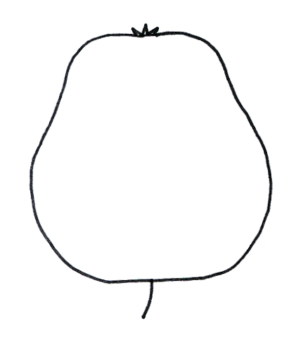 |  |  | at middle (1); moderately towards base (2); or strongly towards base (3)
conic | flat taper (3) | 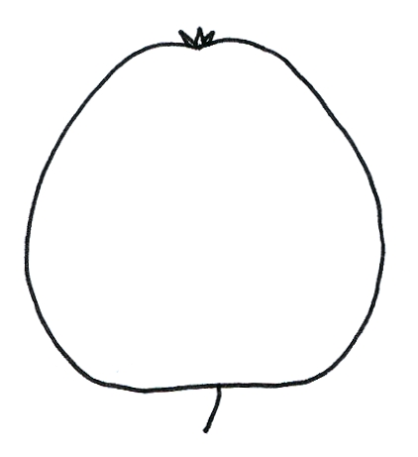 |  |  | at middle (1); moderately towards base (2); or strongly towards base (3)
ovoid | rounded (1) | 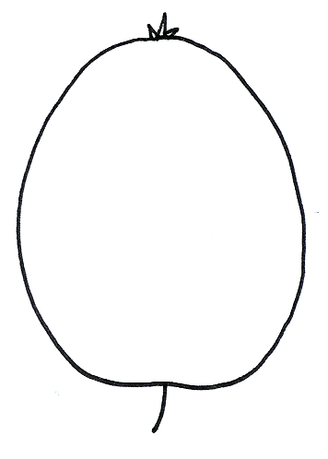 |  |  | moderately towards base (2); or strongly towards base (3)
cylindrical | parallel (2) | 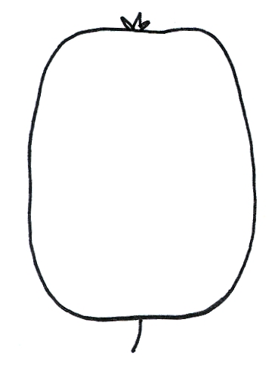 |  |  | at middle (1)
ellipsoid | rounded (1) | 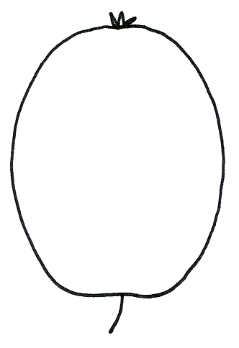  (elliptic) | 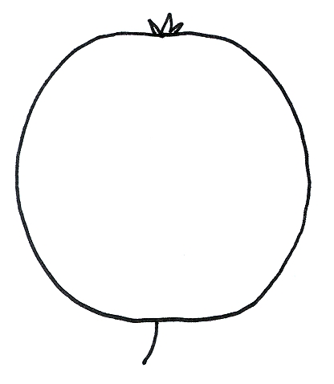  (round) | 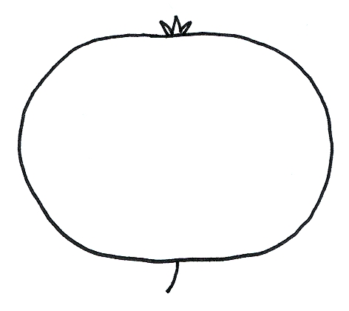  (oblate) | at middle (1)

Possible characteristic(s) (Example 4)

Alternative 1

(a) ratio diameter/height (QN):
e.g. very elongatedError: Reference source not found (1); moderately elongated (3); medium (5); moderately compressed (7); very compressed (9);
(b) position of broadest part (QN):
e.g. at middle (1); moderately towards base (2); strongly towards base (3);
(c) lateral outline in apical half (PQ):
e.g. rounded (1); parallel (2); flat taper (3); concave (4)

Alternative 2

(a) ratio diameter/height (QN):
e.g. very elongated (1); moderately elongated (3); medium (5); moderately compressed (7); very compressed (9)

(b) general shape (PQ):
e.g. cylindrical waisted (1); conic (2); ovate (3); cylindric (4); elliptic (5)

with the following illustration:

 |  | ← lateral outline in apical half →
 |  | concave | flat tapering | rounded | flat parallel sides
at base ← position of broadest part → at middle |  |  |  | 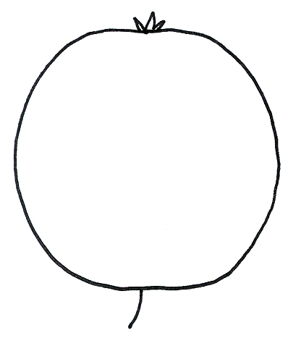  3  ovate
at base ← position of broadest part → at middle |  | 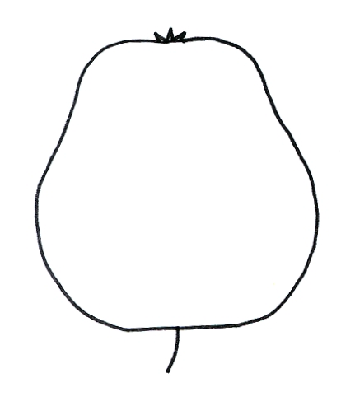 | 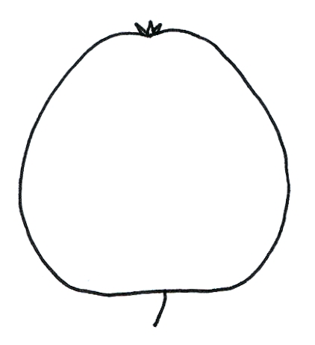
at base ← position of broadest part → at middle |  | 1  cylindrical waisted | 2  conic | 5  elliptic  (includes round and oblate) | 4  cylindric

Example 5

the variation between the range of shapes indicated by the illustrations below:

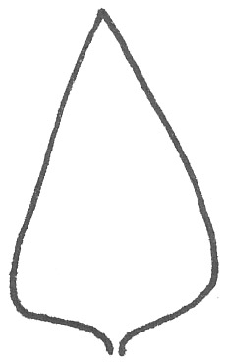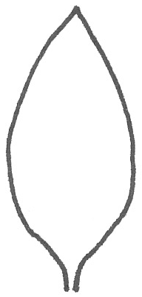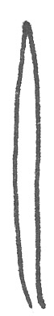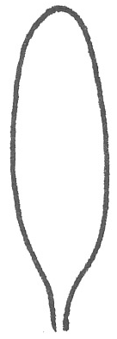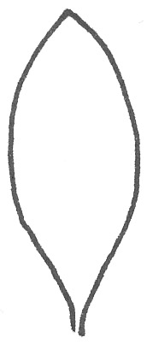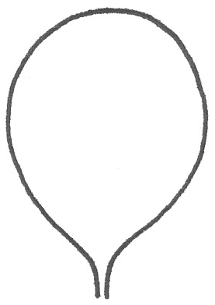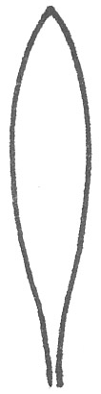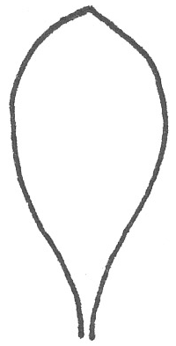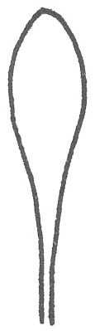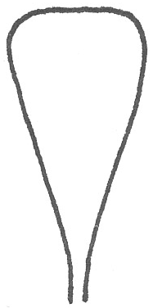

Possible characteristic(s) (Example 5)

Alternative 1

(a) ratio length/width (QN):
e.g. very elongated (1); moderately elongated (3); medium (5); moderately compressed (7); very compressed (9)

(b) position of broadest part (QN):
e.g. strongly towards base (1); moderately towards base (3); at middle (5); moderately towards apex (7); strongly towards apex (9)

Alternative 2

General shape (PQ): triangular (1); ovate (2); linear (3); oblong (4); elliptic (5); circular (6); oblanceolate (7); obovate (8); spatulate (9); obtriangular (10)
(Note: Where the overall shape is presented as a single pseudo-qualitative characteristic, the order of states should be: primary order, broadest part below middle to broadest part above middle; secondary order, narrow to broad (high to low ratio length/width)).

with the following illustration:

 |  | ← broadest part →
 |  | (below middle) | at middle | (above middle)

broad (compressed) ← width (ratio length/width) → narrow (elongated) |  |  |  | 3  linear
 |  |  |  | 4  oblong | 7  oblanceolate | 9  spatulate
 |  | 1  triangular | 2  ovate | 5  elliptic | 8  obovate |  | 10 obtriangular
6
circular

Example 6

the variation between the range of shapes indicated by the illustrations below
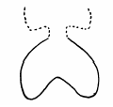 | 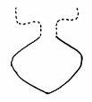 | 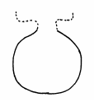 |  | 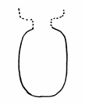

Possible characteristic(s) (Example 6)

Alternative 1

(a) lateral outline (QL)
e.g. reniform (1); rhombic (2); elliptic (3)
(b) ratio length/width (QN):
e.g. elongated (1); medium (2); compressed (3)

Alternative 2

General shape (PQ): reniform (1); rhombic (2); elliptic (3); circular (4); transverse elliptic (5)
with the following illustration:

compressed ← ratio length/width → elongated |  |  |  | 3  elliptic
compressed ← ratio length/width → elongated |  | 1  reniform | 2  rhombic | 4  circular
compressed ← ratio length/width → elongated |  |  |  | 5  transverse elliptic

2.3 Base Shape Characteristics

2.3.1 As explained in Section 2.1 [cross ref.], it is only necessary to develop a characteristic for the shape of base when the variation in shape between varieties in the variety collection has not been accounted for by the ratio length/width or the position of the broadest part concerning the full plant part.

2.3.2 In the same way as for plane shapes, whilst a base shape can be considered in terms of a pseudo-qualitative characteristic, it can be useful to develop quantitative or qualitative characteristics related to base shape, rather than considering shape as a single pseudo-qualitative characteristic. A particular example of this is the consideration of the angle of the base (e.g. as a quantitative characteristic) and the curvature at the base, an example of which is provided below for illustrations purposes.

Example

the variation between the range of base shapes indicated by the illustrations below

Possible characteristic(s)

Alternative 1

(a) angle of base (QN):
e.g. acute (1); obtuse (2); straight (180°) (3); weakly reflex (4); strongly reflex (5)
(b) curvature at base (QN):
e.g. concave (1); flat (2); convex (3)

Alternative 2

Shape of base (PQ): wedge-shaped, convex (1); wedge-shaped, straight (2); wedge-shaped concave (3); broad wedge-shaped, convex (4); broad wedge-shaped, straight (5); broad wedge-shaped, concave (6); rounded (7); flat (8); weakly cordate (9); medium cordate (10); strongly cordate (11).

with the following illustration:

 |  |  | ← angle at base →
 |  |  | acute | obtuse | straight | weakly reflexed | medium reflexed | strongly reflexed
→ | convex
 |  |  | 1  wedge-shaped, convex | 4  broad wedge-shaped, convex | 7  rounded | 9  weakly cordate | 10  medium cordate | 11  strongly cordate
curvature | flat
 |  |  | 2  wedge-shaped, straight | 5  broad wedge-shaped, straight | 8  flat
← | concave
 |  |  | 3  wedge-shaped concave | 6  broad wedge-shaped, concave

2.4 Apex/Tip Shape Characteristics

2.4.1 The APEX (apical or distal part) of an organ or plant part is the end furthest from the point of attachment.

2.4.2 In some cases, the distal extremity of the apex may be differentiated into a “TIP”. In such cases, the shape of the apex is taken as the general shape, excluding any differentiated tip (if present). For example:

Differentiated tip: | acuminate | acuminate | acuminate
Apex: | acute | rounded | truncate

2.4.3 As explained in Section 2.1 [cross ref.], it is only necessary to develop a characteristic for the shape of apex when the variation in shape between varieties in the variety collection has not been accounted for by the ratio length/width or the position of the broadest part concerning the full plant part.

2.4.4 In the same way as for plane shapes, whilst an apex shape can be considered in terms of a pseudo-qualitative characteristic, it can be useful to develop quantitative or qualitative characteristics related to apex shape, rather than considering shape as a single pseudo-qualitative characteristic. A particular example of this is the consideration of the angle of the apex (e.g. as a quantitative characteristic).

2.4.5 In cases where the tip is differentiated within the general shape of the apex, characteristics concerning the shape of the tip may be developed independently from those concerning the general shape of the apex. Different combinations between these two categories are possible, for example: a first characteristic for the general shape of the apex (e.g. acute, obtuse, rounded), together with a second characteristic for emargination at apex (absent, present), or apiculate tip (absent, present).

2.4.6 In the case of tip shapes, it may be more appropriate to have a simple characteristic such as length of tip, rather than using botanical terms. The only difference between mucronate and aristate is the length of the ‘tip’, the only difference between cuspidate and pungent is the length of the ‘tip’, and the only difference between emarginate and retuse is the angle [depth?] of the notch. These pairs can therefore also be quantified where applicable, by stating, for example, ‘length of tip’ or ‘depth of notch’, instead of using the specific botanical terms.

Example

the variation between the range of apex shapes indicated by the illustrations below

Possible characteristic(s)

Alternative 1

(a) angle of apex (excluding tip, if present) (QN):
e.g. strongly acute (1); moderately acute (2); right-angle (3); moderately obtuse (4); strongly obtuse (5)
(b) length of acuminate tip (QN):
e.g. absent or short (1); medium (2); long (3)

Alternative 2

(a) angle of apex (excluding tip, if present) (QN):
e.g. strongly acute (1); moderately acute (2); right-angle (3); moderately obtuse (4); strongly obtuse (5)

(b) tip (PQ): absent or very weak (1); mucronate (2); narrow short acuminate (3); broad short acuminate (4); narrow long acuminate (5); broad long acuminate (6)

with the following illustration:

 |  |  | ← length of tip →
 |  |  | absent or very weak | short | medium | long
← width of tip → | narrow |  | [see below]
← width of tip → |  |  | [see below] | 2  mucronate | 3  narrow short acuminate | 5  narrow long acuminate
← width of tip → | broad |  | [see below]
← width of tip → |  |  | [see below] |  | 4  broad short acuminate | 6  broad long acuminate

examples of tip: absent or very weak (1) with different angles of apex (characteristic (a)):

strongly acute apex | right-angle apex | obtuse apex

2.5 Combination of Full Plane-, Base- and Apex Shape Characteristics

The following example illustrates how the overall shape of an organ or plant part can be observed in relation to the components of shape explained in Sections 2.2 to 2.4 [cross ref.].

Example

the range of shapes covered by the illustrations below

[Note: Calyx to be deleted from illustration?]

can be observed in relation to:

(a) ratio length/width (QN):
e.g. very elongated (1); moderately elongated (3); medium (5); moderately compressed (7); very compressed (9)
(b) position of broadest part (QN):
e.g. at middle (1); moderately towards base (2); strongly towards base (3);
(c) shape of base (QN/PQ):
e.g. pointed (1); rounded (2); depressed (3)
(d) shape of apex (QN/PQ):
e.g. pointed (1); rounded (2); truncate (3); notched (4)

The chart below illustrates how the different components cover the range of overall shapes. Such a chart is not appropriate in the Test Guidelines, although illustrations may be useful for the individual characteristics to clarify the parts to be observed.:

 | shape of base
shape of apex | pointed (1) |  | rounded (2) |  | depressed (3)
pointed (1)
rounded (2) |  |  | (ovate) | position of broadest part
rounded (2) |  | ratio length/width | (round) | position of broadest part
rounded (2) |  | ratio length/width | (oblate)
truncate (3)
notched (4)

2.6 Three-dimensional shape characteristics

Wherever possible, three-dimensional plant parts should be described in cross-section as plane or two-dimensional shapes (see Section 2.1 [cross ref.]: ratio length/width, position of broadest part, base, shape and lateral outline), e.g. using characteristics in cross-section, lateral view, longitudinal section, etc. To describe the three-dimensional shape fully it may also be necessary to use, for example, a characteristic for hollow or solid interior in addition to the characteristics describing the plane shape. The use of characteristics for three-dimensional shapes should only be used where it is not practical to describe the characteristic in a two-dimensional way.

2.7 Symmetry

2.7.1 Lateral symmetry around the main axis may be handled in different ways. For example:

(a) lateral symmetry of plant part shapes may be considered within a particular shape, e.g. falcate and lunate are laterally asymmetric (see Section 1.4 [cross ref.]); or

(b) it may be appropriate to introduce symmetry as a separate characteristic. In such cases, whether the characteristic for symmetry is a qualitative (symmetric / asymmetric), a quantitative (e.g. symmetric or weakly asymmetric (1), moderately asymmetric (2), strongly asymmetric (3)) or a pseudo-qualitative characteristic needs to be considered on a case-by-case basis.

Example:

quantitative characteristic for symmetry

 |  | to be improved?
symmetric or weakly asymmetric (1) | moderately asymmetric  (2) | strongly asymmetric  (3)

2.8 Types of expression and states / notes

The type of expression (i.e. qualitative, quantitative or pseudo-qualitative) of the characteristics describing components of shape needs to be considered separately for each situation. In particular, as explained in document TGP/7 “Development of Test Guidelines”, Annex 4, paragraph 1 “it should be remembered that what may appear to be very similar characteristics in different types of plant, or different organs of the same plant, may in fact be under different types of genetic control.” Thus, for example, in one type of plant, or one organ, the characteristic “position of broadest part” might be a qualitative characteristic but in another type of plant, or organ, it might be a quantitative characteristic. Therefore, the following notes are only intended to indicate the most normal situations:

(a) Ratio length/width: normally a quantitative characteristic
(b) Position of broadest part: within the same lateral outline set (e.g. rounded), this is normally a quantitative characteristic. However, where varieties cover more than one lateral outline set (e.g. angular and hastiform), the position of the broadest part is less likely to be a quantitative characteristic and is more likely to be pseudo-qualitative or qualitative;
(c) Shape of base (see Section 2.3 Base [cross ref.]);
(d) Shape of apex (see Section 2.4 Apex [cross ref.]);
(e) Lateral outline: there is no “normal” situation for the lateral outline, which can be a qualitative, quantitative or pseudo-qualitative characteristic

2.9 Defining the characteristic

In the same way as for any characteristic, each characteristic should be precisely defined. With respect to shape-related characteristics it is particularly important to clarify which part of the plant is to be observed. Some illustrative examples are as follows:

Leaf: ratio length/width

- to specify if any tip (e.g. aristate tip) should be included or excluded from the observation of leaf length
- to specify if the reference point for the “base” should be the point of attachment or the lowest part of the plant part (e.g. for a cordiform leaf);
- to specify how to observe width/length in the case of laterally asymmetric shapes

Leaf: position of broadest part

- to specify if any tip (e.g. aristate tip) should be included or excluded from the observation of the position of the broadest part
- to specify if the reference point for the “base” should be the point of attachment or the lowest part of the plant part (e.g. for a cordiform leaf);
- to specify how to observe position of the broadest part in the case of laterally asymmetric shapes

2.10 Technical Questionnaire Characteristics

Where the normal requirements for a Technical Questionnaire characteristic are met (see document TGP/7 Annex 3 GN 13.3.2), characteristics developed according to the guidance set out in Sections 1.2.1 to 1.2.4 are suitable for inclusion in the Technical Questionnaire. However, document TGP/7: Annex 3 GN 13.3.3 clarifies that “[w]here necessary, characteristics in the Test Guidelines can be simplified (e.g. color groups can be created rather than requesting an RHS Colour Chart reference) for inclusion in the Technical Questionnaire (TQ), if this would be of assistance for the breeder completing the TQ. Furthermore, the characteristics contained in the Test Guidelines can be formulated in a different way, if breeders would then be able to describe them more precisely and the information would be useful for performing the test.”. Thus, in some cases, it may be appropriate to provide breeders with an opportunity to describe shape in a way which is more widely recognized. In such cases, the Technical Questionnaire may invite breeders to indicate shape on the following basis:

(a) Simple Symmetric Plane Shapes: to indicate the shape according to the Chart for Simple Symmetric Plane Shapes (see Section 1.3 [cross ref.]), e.g. narrow oblong

(b) Non-Simple-Symmetric Plane Shapes: to indicate the shape according to the non-simple-symmetric plane shapes identified in Section 1.4 [cross ref.], with an indication of relative width where useful, e.g. narrow cordiform

3. Shape Illustrations

3.1 Full Plane Shapes

See Chart for Simple Symmetric Plane Shapes and Chart for Other Plane Shapes (Section 2.1 [cross ref.])

3.2 Base Shapes

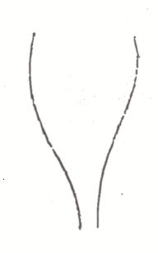 | 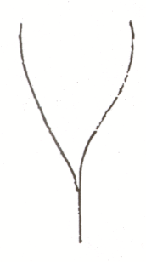 | 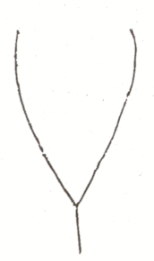 | 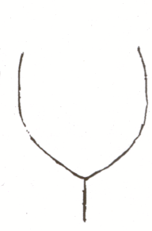 | 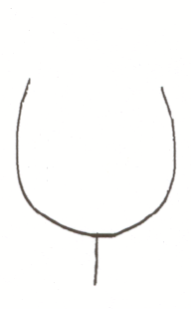
decurrent | attenuate | acute | obtuse | rounded
 |  | cuneate

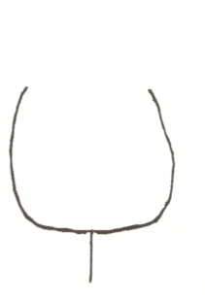 | 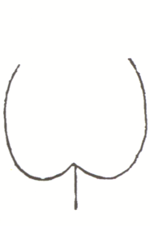
truncate | cordate | sagittate | hastate | auriculate

calcarate  (calcarate: having a “spur”, e.g. toadflax and larkspur) | open calcarate

3.3 Apex Shapes

3.3.1 Apex
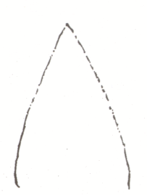 | 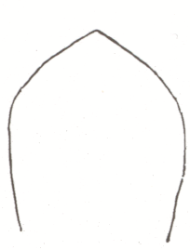 | 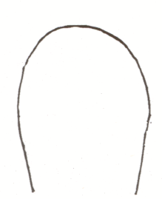 | 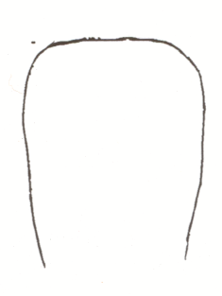 | 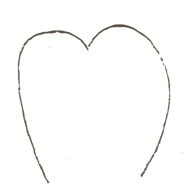
acute | obtuse | rounded | truncate | obcordate

3.3.2 Differentiated tip
length / depth of tip =>
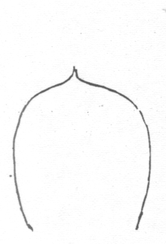 | 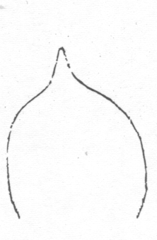 | 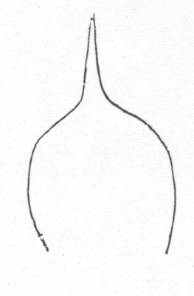
apiculate | acuminate | caudate
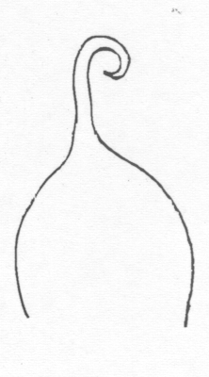
cirrhous
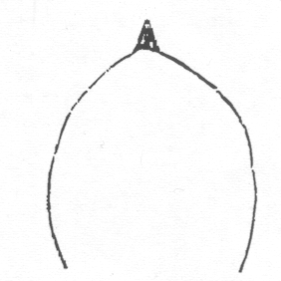 | 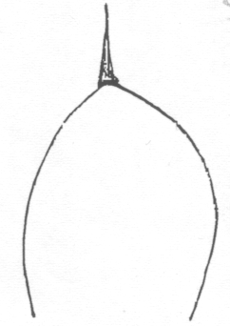
cuspidate | pungent
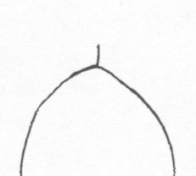 | 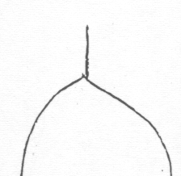
mucronate | aristate
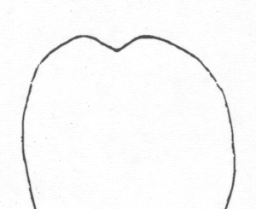 | 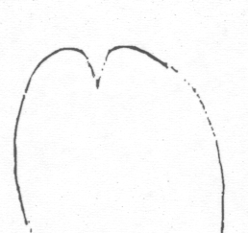
retuse | emarginate
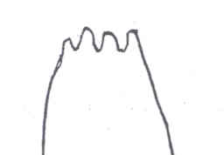

laciniate

3.4 Three-Dimensional Shapes
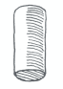
to be improved?
 | acicular | linear | cylindric | oblong

 | 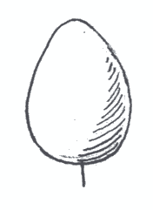
semi-ellipsoid | ovoid | fusiform | ellipsoid | spheric globose | obloid | obovoid

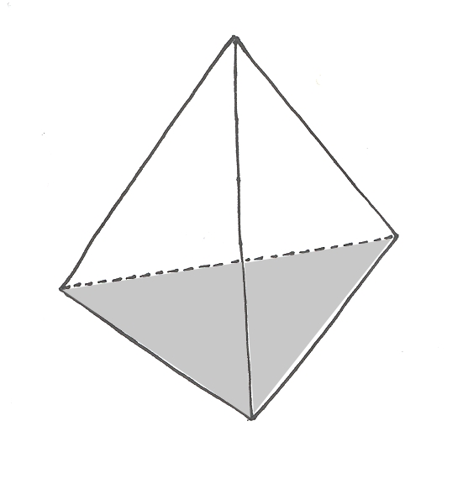 | 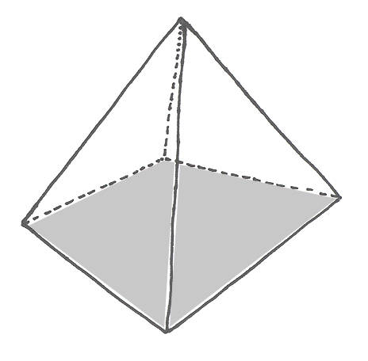 |  | 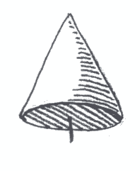 | 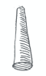 | 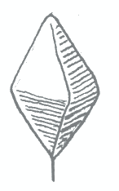
tetrahedronal | pyrimidal | conic | deltoid | terete | rhomboid | obconic

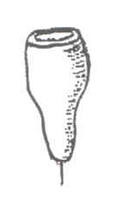 |  | to be improved? | 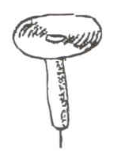 | 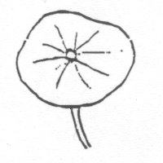 | 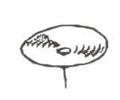 | 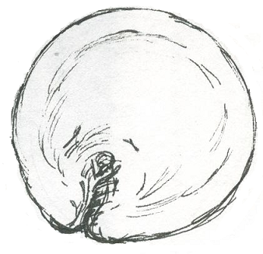
clavate | pyriform | capitate | salverform | peltate | rotate | discoid

 | filiform | spiral | lenticular | sheathing

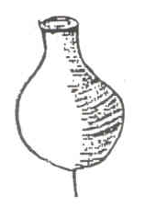 |  |  |  |  | 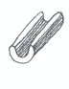
urceolate | tubular | cup-shaped | funnel-shaped | campanulate | canaliculate

3.5 Symmetry

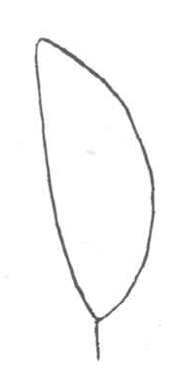 | 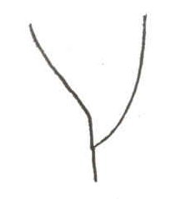 | 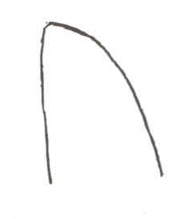 | 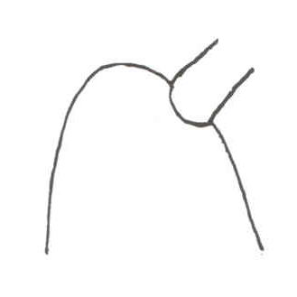
asymmetric full shape | asymmetric base | asymmetric apex | asymmetric position

II. STRUCTURE

1. Components Of Structure

[Editorial Note: New section to be developed explaining the wording of characteristic headings]

2. Developing Characteristics For Plant Structures

2.1 Growth habit

In general, the characteristic “Plant (or Tree): growth habit” is used to describe the overall growth habit of the plant, based on the deportment of the main branches or stems. The characteristic “Plant (or Tree): growth habit” is usually a quantitative characteristic. Whilst growth habit can be considered in terms of a pseudo-qualitative characteristic, it can be useful to develop quantitative or qualitative characteristics related to growth habit, rather than considering growth habit as a single pseudo-qualitative characteristic. In cases where qualitative characteristics exist, those are often presented in the form of “Plant (or Tree): type”, rather than growth habit.

Example 1: “Plant: growth type” determinate (note 1); indeterminate (note 2)
Example 2: “Plant: type” climbing (note 1); non-climbing (note 2)

Examples of “Plant (or Tree): growth habit” are provided below:

Example 1: quantitative characteristic

1 | 2 | 3 | 4 | 5
upright | upright to spreading | spreading | drooping | weeping

Example 2: quantitative characteristic
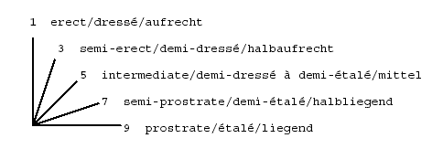

Example 3: pseudo-qualitative characteristic

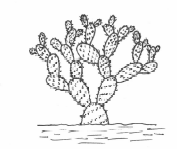 | 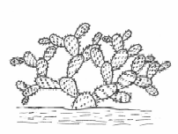 | 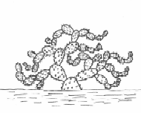 | 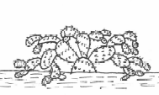
1 | 2 | 3 | 4
upright | spreading | decumbent | drooping

Example 4 – case 1: pseudo-qualitative characteristic

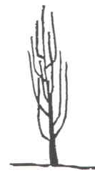
1 | 2 | 3 | 4 | 5 | 6
fastigiate | broad upright | broad upright to spreading | spreading | drooping | weeping

Example 4 – case 2:

(a) qualitative characteristic (Tree: type); and

(b) quantitative characteristic (Only non-fastigiate varieties: Tree: growth habit)

QL | 1 | 2
QL | fastigiate | non-fastigiate

 | QN | 1 | 2 | 3 | 4 | 5
 | QN | upright | upright to spreading | spreading | drooping | weeping

2.2 Attitude / direction (Plant parts)

In cases where individual plant parts are to be observed, the characteristics are, in general, presented as attitude, direction or angle with main axis, rather than habit. In a similar way to growth habit, it can be useful to develop quantitative or qualitative characteristics, rather than considering attitude and direction as a single pseudo-qualitative characteristic.

Examples of attitude as a quantitative characteristic are provided below:

Quantitative Characteristic

Example 1:

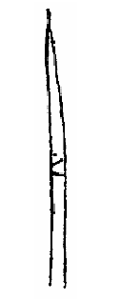 | 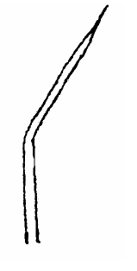 | 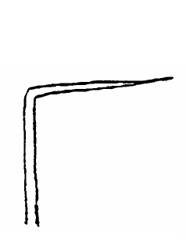 | 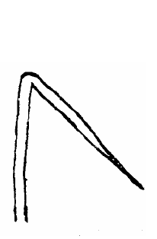
1 | 2 | 3 | 4
erect | semi-erect | horizontal | reflexed

Example 2:

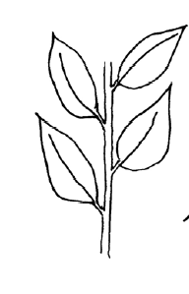 | 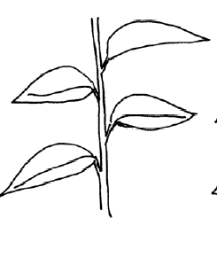 | 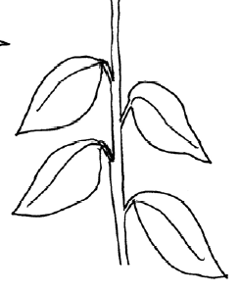
1 | 2 | 3
upwards | outwards | downwards
Example 3: [Note: to provide example for angle where main axis not vertical]

2.3 Relative position

A particular type of characteristic which commonly occurs in Test Guidelines is the relative position of leaves, petals, etc. The following examples can be used as guidance for the presentation of quantitative characteristics:

 | 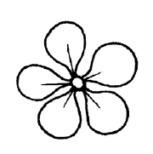 | 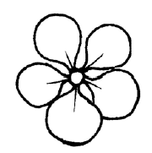 | 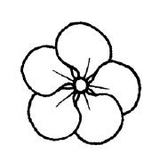
 | 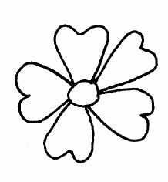 | 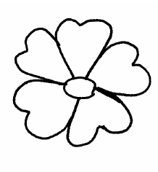 | 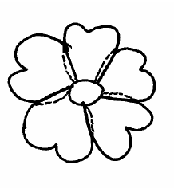
 | 1 | 2 | 3
Version 1 | free | touching | overlapping
Version 2 | free | intermediate | overlapping
Version 3 | no overlapping | some (petals) overlapping | all (petals) overlapping

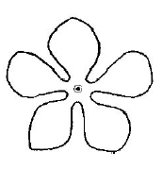 | 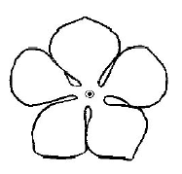 | 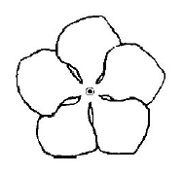 | 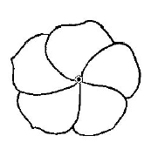
1 | 2 | 3 | 4
free | touching | slightly overlapping | strongly overlapping

2.4 Margins

2.4.1 It may be appropriate to have a quantitative characteristic, such as depth of incisions, rather than using botanical terms. In particular, it is not appropriate to use botanical terms in a way which indicates a qualitative characteristic when the characteristic is not qualitative. Thus, it would not be appropriate to have a characteristic with the states of expression serrate (Note 1) and dentate (Note 2), if there was not a clear discontinuity between those states.

2.4.2 Similarly, it may be appropriate to have a quantitative characteristic, such as depth of lobing, rather than trying to define a lobe. In particular, it is not appropriate to use lobing in a way which indicates a qualitative characteristic when the characteristic is not qualitative. Thus, it would not be appropriate to have a qualitative characteristic such as lobed (Note 1) and not lobed (Note 2) where there was not a clear discontinuity between those states. In the same way, a characteristic for the number of lobes could produce inconsistent results if the determination of lobes was not a qualitative characteristic. Quantitative characteristics such as depth of lobing or degree of lobing may be more appropriate, e.g.

absent or weak | medium | strong

2.5 Hairs and Spines

2.5.1 In general, botanical terms for types of hair and spine (e.g. aculeate, lanate, tomentose, etc.) are not used in the Test Guidelines, since the states of expression are likely to relate to number, density or length of hairs, spines, etc.

2.5.2 In the case of hair, the term “pubescence” is synonymous with “hairiness” for the purposes of Test Guidelines.

3. Illustrations Of Plant Structures

3.1 Habit

upright | spreading | drooping | weeping

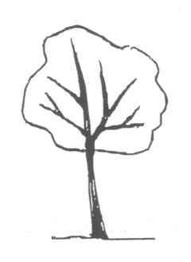 | 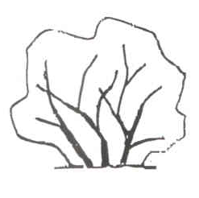 | 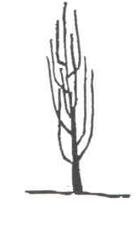
arborescent (tree-like) | shrubby | fastigiate | columnar | divaricate | ramified

 |  | 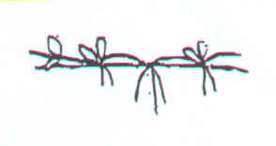
decumbent | procumbent  (not rooting) | stoloniferous (rooting) | reclining
PROSTRATE

clambering | climbing | twining

3.2 Attitude / direction (Plant parts)

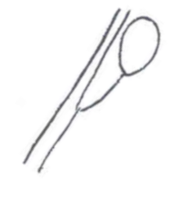 |  |  | 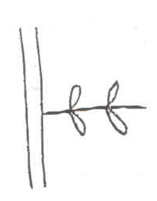 |  | 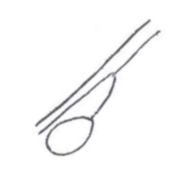
adpressed | erect | semi-erect | horizontal | reflexed | adpressed

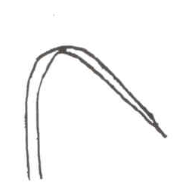
recurved | arched | arcuate | pendulous | pendent | inflexed

incurved | inwards | outwards | convolute | zig-zag

involute | revolute

3.3 Relative position

exserted | included | oblique

free | contiguous (touching – not joined) | coherent  (like parts superficially joined) | connate  (like parts histologically joined)

adherent  (unlike parts superficially joined e.g. anthers to style) | adnate  (unlike parts histologically joined e.g. anthers and style) | adpressed | sessile | stipitate (stalked)

[new after 3.3] Types of Inflorescence

To provide illustrations (and definitions in Section IV) of different types of inflorescence

3.4 Margins

 |  | 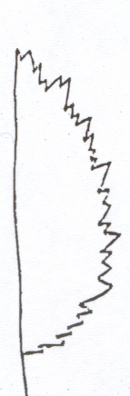 |  |  |  | 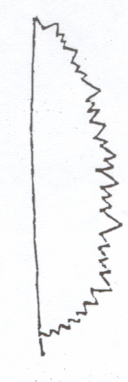
serrate | biserrate (1) | biserrate (2) | serrulate | dentate | bidentate (1) | bidentate (2) | denticulate

 |  | 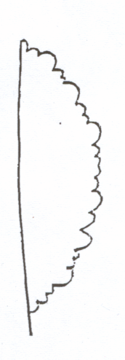
crenate | bicrenate (1) | bicrenate (2) | crenulate | repand | sinuate | erose | entire

fimbriate | ciliate | crispate | undulate | involute | revolute

3.5 Hairiness (Types of appendage covered by the general term “hair” in the Test Guidelines)

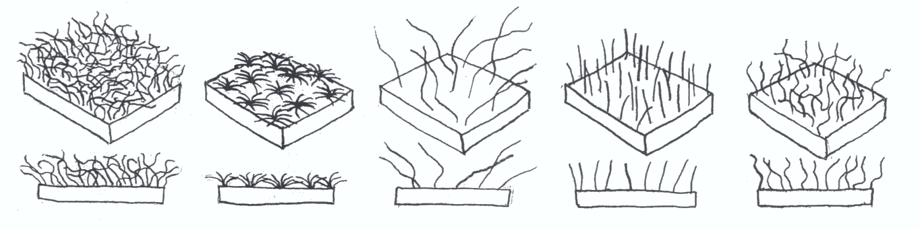
lanate floccose arachnoid pilose villous

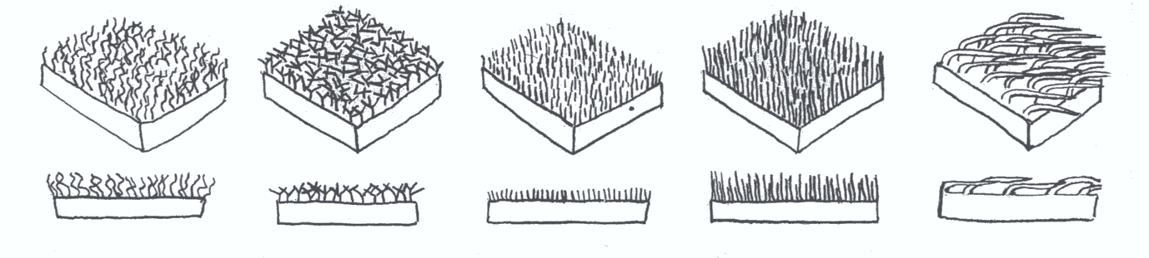
tomentose pannose pubescent velutinous strigose

setose | hispid | hirsute | sericious

3.6 Spines (Types of appendage covered by the general term “spine” in the Test Guidelines)

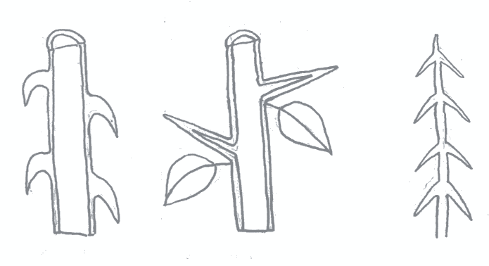
aculeate spinose barbed; barbate

3.7 Other appendages

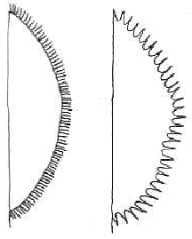
ciliate fimbriate

glandular | lepidote | papillose

3.8 Texture

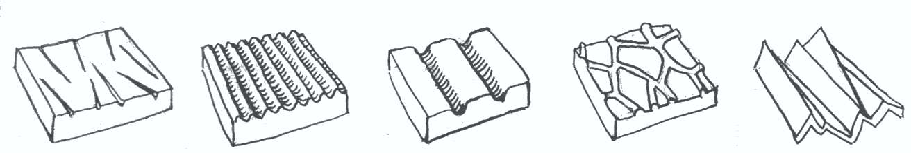

aciculate striate grooved reticulate corrugated

 |  |  | 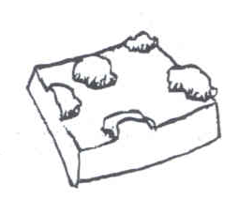
 | rugose | bullate | verrucose

III. DEFINITIONS for shape and structure terms

 |  | Relevant to: | Reference

Term | Definition / comment | Full | Base | Apex | 3-d | Hab/Att/Pos | Margin | Apps. | Surf/Texture | Developing Chars. | IllustrationsError: Reference source not found
Abaxial | The lower, outer or dorsal side; the side facing away from the axis. Compare ‘adaxial’. |  |  |  |  | x
Acicular | Needle-shaped; rigid, long and narrow and tapering to a fine point. Round or grooved in transverse section, e.g. conifers. Applies primarily to three-dimensional shape but may also be used for the outline. | x |  |  | x
Aciculate | With fine, straight stripes, like needle scratches, lying in different directions, and of a different color or texture. Compare ‘striate’ (parallel lines). |  |  |  |  |  |  |  | x
Actinomorphic | Radially symmetric, so that median division in any direction will produce two equal halves, e.g. inflorescence of Asteraceae. Compare ‘zygomorphic’. | x | x | x | x | x
Aculeate | Type of appendage covered by the general term “spine” in the Test Guidelines. Bearing prickles; with stiff, sharp projections from the superficial layers of the plant part.  Compare ‘spinose’ (from the superficial and deeper layers). |  |  |  |  |  |  | x
Acuminate | Tapering gradually, with concave margins, to a sharp or blunt tip. Applies to the apex. Compare ‘apiculate’, tapering more abruptly and ‘caudate’, tapering more gradually, both applying to the tip only. |  |  | x
Acute | With straight to slightly convex margins terminating in a sharp or blunt tip at an angle of less than 90 º. Applies to the base, apex, etc. Compare ‘obtuse’ where the angle is >90 º. In cases where it is useful to distinguish between ‘narrow acute’ and ‘broad acute’, one should remember that they should both still be <90 °. |  | x | x
Adaxial | The upper, inner or ventral side; the side facing the axis. Compare ‘abaxial’. |  |  |  |  | x
Adherent | Dissimilar plant parts in close contact, e.g. anthers adherent to style. Compare ‘adnate’, ‘coalesced’, ‘coherent’, connate’, ‘contiguous’. |  |  |  |  | x
Adnate | Dissimilar plant parts fused histologically, e.g. stamens implanted onto the corolla. Compare ‘adherent’, ‘coalesced’, ‘coherent’, ‘connate’, ‘contiguous’. |  |  |  |  | x
Adpressed | Lying close to or flat against the surface or another organ. |  |  |  |  | x
Apex | The apex (apical or distal part) of an organ or plant part is the end furthest from the point of attachment. The shape of the apex is taken as the general shape, excluding any differentiated tip (if present) |  |  | x |  |  |  |  |  | II, 2.4 | II, 3.3
Apical | Located at the apex and/or furthest from the position of attachment. Compare ‘proximal’, ‘basal’ which is closest to the position of attachment. Synoynms: Apical, Distal, Terminal (most appropriate term to be decided on a case-by-case basis) |  |  | x |  | x
Apiculate | Terminating abruptly in a small sharp but not rigid point which is both vascular and laminar in nature. Applies to the most distal part of the apex (tip). Compare ‘acuminate’ where the tapering is less abrupt and ‘cuspidate’ which is rigid. |  |  | x
Apopetalous | With separate petals; petals not fused into a corolla tube. Compare ‘sympetalous’. |  |  |  |  | x
Arachnoid | Covered by the general term “hair” in the Test Guidelines. Cobwebby; with loosely tangled, long, fine, white hair. |  |  |  |  |  |  | x
Arborescent | Tree-like; large woody plant, usually with a single main stem (trunk). |  |  |  |  | x
Arched, Arching | Strongly curved more or less symmetrically, as an arch. |  |  |  |  | x
Aristate | Awned; bearing a stiff, straight, bristle-like continuation of the primary vein. Applies to the most distal part of the apex (tip) or used for other parts where bristles may occur. Compare ‘mucronate’ where the point is shorter. |  |  | x
Ascending | use “upwards” |  |  |  |  | x
Asymmetric | Not being capable of median division into two equal halves in any direction. | x | x | x | x | x
Attenuate | Tapering gradually, with lateral margins concave. Generally more tapered than ‘acute’. Applies to the base. Compare ‘acuminate’ which applies to the apex. |  | x
Attitude | For UPOV purposes, ‘attitude’ is used for plant parts, while ‘growth habit’ is used for the whole plant. ‘Attitude’ is used in relation to soil level and to other plant parts. Rather to use ‘attitude’ instead of ‘stance’. |  |  |  |  | x
Auriculate | Eared; with two rounded lobes directed outwards to either side and projecting beyond the general outline of the plant part. Applies to the base. Compare ‘hastate’ with triangular lobes directed outwards, and ‘sagittate’ with triangular lobes directed downwards. Compare ‘auriculiform’ which applies to full plane shape. |  | x
Auriculiform | Eared; with two rounded basal lobes directed outwards and projecting beyond the general outline of the plant part. Compare ‘auriculate’ which applies to the base. | x
Axillary | Situated within or arising from the axil, which is the upper angle between the axis and any lateral off-shoot, e.g. an axillary bud arising from the axil of a leaf. |  |  |  |  | x
Barbate | See ‘barbed’ |  |  | x
Barbate | Bearded; with tufts of long hairs. |  |  |  |  |  |  | x
Barbed | Terminating in a reflexed hook. |  |  | x
Barbed | Type of appendage covered by the general term “spine” in the Test Guidelines. With short, rigid, hooked to reflexed bristles or points, like the barb of a fish-hook. |  |  |  |  |  |  | x
Basal | Located at the base, closest to the position of attachment. Compare ‘apical’, ‘distal’, ‘terminal’. Synoynms: Basal, Proximal (most appropriate term to be decided on a case-by-case basis) |  |  |  |  | x
Base | The base (proximal part) of a plant part is the end nearest to the point of attachment. |  |  |  |  | x
Bearded | See ‘barbate’. |  |  |  |  |  |  | x
Bicrenate | Doubly crenate; with the crenations themselves crenate, or with alternating larger and smaller crenations. |  |  |  |  |  | x
Bidentate | Doubly dentate; with the dentations themselves dentate, or with alternating larger and smaller dentations. |  |  |  |  |  | x
Biserrate | Doubly serrate; with the serrations themselves serrate, or with alternating larger and smaller serrations. |  |  |  |  |  | x
Blistered | use ‘bullate’. |  |  |  |  |  |  |  | x
Bristly | With stiff, strong trichomes. A general term including both ‘hispid’ (harsh to the touch) and ‘setose’ (spiny to the touch). |  |  |  |  |  |  | x
Bullate | Blistered; the surface covered with irregular blister-like convexities. Compare ‘papillose’ with more elevated, nipple-like projections and ‘verrucose’ which is warty. |  |  |  |  |  |  |  | x
Bumpy | A general term for a surface with rounded lumps or swellings. |  |  |  |  |  |  |  | x
Campanulate | Bell-shaped; with an inflated tube, gradually widening distally into a limb or lobes. Normally applies to the corolla. Compare ‘funnel-shaped’ which is not inflated basally and ‘cup-shaped’ which does not diverge distally. |  |  |  | x
Canaliculate | Channeled, gutter-shaped; long and narrow, with a longitudinal groove. |  |  |  | x
Capitate | Headed; refers to a plant part which is stalked and terminates in a knob. Also applies to an inflorescence type with crowded flowers (florets) borne in a head-like cluster, e.g. Asteraceae. |  |  |  | x | ?
Cartilaginous | Firm and tough, like cartilage. Compare ‘coriaceous’ which is more flexible. |  |  |  |  |  |  |  | x
Caudate | Tailed; tapering to a long, narrow, pointed appendage which is both vascular and laminar in nature. Applies to the most distal part of the apex (tip). Compare ‘acuminate’ where the point is shorter. |  |  | x
Ciliate | Bearing a marginal fringe of fine trichomes (outgrowths from the epidermis). Compare ‘fimbriate’ which arises not only from the epidermis but from the deeper layers as well. |  |  |  |  |  | x | x
Circular | Round; length/width ratio as well as dimension in all directions 1:1. The term ‘circular‘ is preferable to ‘round’ and ‘orbicular’ for UPOV use. Forms part of the ‘elliptic’ series. Also applies to arrangement. Compare ‘rounded’ which applies to part of an outline, not the full shape. | x |  |  |  | x
Cirrhous | With a tendril; terminating in a narrow spiralled tip which is a continuation of the primary vein. Applies to the most distal part of the apex (tip) or to other parts with tendrils. |  |  | x
Clambering | Climbing without the aid of special structures e.g. tendrils. Compare ‘climbing’. |  |  |  |  | x
Clavate | Club shaped - shaped like a club; thickening towards the apex from a tapered base |  |  |  | x
Clawed | Abruptly contracted to a narrow, petiole-like basal portion. Applies to petals and sepals. Compare ‘spatulate’ which narrows more gradually towards the base. | x
Climbing (Climber) | Climbing by means of special structures e.g. tendrils. Compare ‘clambering’. |  |  |  |  | x
Clustered | Clumped; closely grouped, arising from a common point. |  |  |  |  | x
Coalesced | Unlike plant parts partially and irregularly fused. Compare ‘adherent’, ‘adnate’, ‘coherent’, ‘connate’, ‘contiguous’. |  |  |  |  | x
Coarse | use ‘rough’. |  |  |  |  |  |  |  | x
Coherent | Similar plant parts in close contact, not fused, e.g. anthers clinging together. Compare ‘adherent’, ‘adnate’, ‘coalesced’, ‘connate’, ‘contiguous’. |  |  |  |  | x
Columnar | Upright, with a dominant main stem and suppressed branch development. Compare ‘fastigiate’ where the branch development is not suppressed. |  |  |  |  | x
Compressed | Flattened laterally or lengthwise. Compare ‘depressed’. | x |  |  |  | x
Concave | Hollowed; curved inwards. | x | x | x | x | x
Congested | Densely crowded; with almost no intervening spaces. Compare ‘crowded’ which is less dense. |  |  |  |  | x
Conic | Cone-shaped; tapering evenly from a circular base to an acute apex. Length/diameter ratio of the basic shape: 2:1 to 1,5:1. The conic series also includes ‘deltoid’, with a more specific length/diameter ratio. Compare ‘triangular’ which applies to two-dimensional shape and ‘obconic’ which narrows towards the base. |  |  |  | x
Connate | Like parts fused histologically, e.g. staminal filaments fused into a tube. Compare ‘adherent’, ‘adnate, ‘coalesced’, ‘coherent’, ‘contiguous’. |  |  |  |  | x
Connivent | Converging but not fused, e.g. stamens with anthers touching. |  |  |  |  | x
Contiguous | Touching but not fused. Not ‘adnate’, ‘connate’, ‘adherent’ or ‘coherent’. |  |  |  |  | x
Continuous | In an uninterrupted arrangement. Compare ‘interrupted’. |  |  |  |  | x
Convex | Rounded and curved outwards. | x | x | x | x | x
Convolute | Rolled up longitudinally with the plant parts overlapping, as petals in a bud. |  |  |  |  | x | x
Cordate | Heart-shaped; with two equal, rounded, basal lobes divided by a deep sinus. Compare ‘obcordate’ which has the sinus at the apex and ‘cordiform’ which applies to full plane shape. |  | x
Cordiform | Heart-shaped; with two equal, rounded, basal lobes divided by a deep sinus, and tapering fairly straightly to the apex. Compare ‘cordate’ which applies to the base and ‘obcordate’ which is broadest towards the apex. | x
Coriaceous | Leathery; thick, tough and flexible. Compare ‘cartilaginous’ which is more firm. |  |  |  |  |  |  |  | x
Corrugated | Wrinkled, crumpled or folded into alternating furrows and ridges, e.g. Papaver petals in the bud. Compare ‘rugose’. |  |  |  |  |  |  |  | x
Crenate | Scalloped, with rounded teeth. |  |  |  |  |  | x
Crenulate | having a margin with small rounded teeth (minutely crenate). Compare “crenate”. |  |  |  |  |  | x |  |  |  | II, 3.4
Crispate | With the margin curled or crumpled and irregularly twisted. |  |  |  |  |  | x
Crowded | Grouped together but with some intervening spaces. Compare ‘congested’ which is more densely crowded. |  |  |  |  | x
Crustaceous | Thin, hard and brittle. |  |  |  |  |  |  |  | x
Cuneate | Wedge-shaped; broadest towards the apex, the lateral margins more or less straight and converging towards the base at an acute or obtuse angle. Applies to the base. |  | x
Cuneiform | use ‘obconic’ |  |  |  | x
Cup-Shaped | With a tube which is rounded basally and which does not diverge distally. Compare ‘campanulate’ which diverges distally and ‘funnel-shaped’ which is not rounded basally. |  |  |  | x
Cuspidate | Terminating in a short rigid point, or cusp, which is both vascular and laminar in nature. Applies to the most distal part of the apex (tip). Compare ‘mucronate’ which is only vascular, ‘apiculate’ where the point is not rigid and ‘pungent’ where the point is long and rigid. |  |  | x
Cylindric | Solid, long and narrow with an even diameter, circular in transverse section. Compare ‘tubular’ which is hollow. |  |  |  | x
Decumbent | Growing horizontally on the ground but with the apical parts ascending. Compare ‘prostrate’ where the apical parts do not ascend. |  |  |  |  | x
Decurrent | Running downwards; [with the base of the leaf blade prolonged downwards onto the stem as a wing. Applies to the base of a leaf blade.]  ASL also used for vegetative bud supports in plum – this must be part of the stem I think. |  | x |  |  | ? | ?
Deflexed | use ‘reflexed’. |  |  |  |  | x
Deltate | More or less equilaterally triangular; narrowing towards the apex, that is away from the point of attachment. Length/width ratio of the basic shape: 1:1, same as ‘very broad triangular’. Forms part of the ‘triangular’ series. Compare ‘deltoid’ which applies to three-dimensional shape, also compare obtriangular’ and ‘obdeltate’ which narrow towards the base. | x
Deltoid | More or less equilaterally cone-shaped; tapering evenly from a circular base to an acute apex. Length/diameter ratio of the basic shape: 1:1, same as ‘very broad conic’. Forms part of the ‘conic’ series. Compare ‘deltate’ which applies to two-dimensional shape and ‘obdeltoid’ which narrows towards the base. |  |  |  | x
Dense (Density) | Numerous per unit area, as opposed to sparse. |  |  |  |  | x
Dentate | With sharp teeth pointed outwards. The two sides of a tooth are the same length. Compare ‘denticulate’ which is finer, ‘crenate’ where the teeth are rounded and ‘serrate’ where the teeth point towards the apex. |  |  |  |  |  | x
Denticulate | With fine, sharp teeth pointed outwards (finely dentate). Compare “dentate”. |  |  |  |  |  | x |  |  |  | II, 3.4
Depressed | Sunken, as if pressed into the middle from above or from above and below, causing a concavity. Compare ‘compressed’. |  |  |  |  | x
Descending | Growing or orientated gradually downwards in relation to soil level or to other plant parts. Synonyms: Descending, Downwards (most appropriate term to be decided on a case-by-case basis) |  |  |  |  | x
Diffuse | With plant parts, e.g. petals, spread widely, or with branches spread widely and frequently branching. Compare ‘divergent’, spreading at almost right angles to the main axis. |  |  |  |  | x
Discoid | Having a flat, circular form; disk-shaped. |  |  |  |  | x |  |  |  |  | I, 3.3.4
Distal | Located at the apex and/or furthest from the position of attachment. Compare ‘proximal’, ‘basal’ which is closest to the position of attachment. Synoynms: Apical, Distal, Terminal (most appropriate term to be decided on a case-by-case basis) |  |  |  |  | x
Distinct | to be used only in terms of the meaning within DUS …
Divaricate | With branches spreading widely, at almost right angles to the main axis. ‘Divaricate’ applies more specifically to the growth habit while ‘divergent’ applies to the direction of the branches. ‘A divaricate plant would have divergent branches. |  |  |  |  | x
Divergent | With plant parts, specifically branches, spreading away from each other.  Compare ‘diffuse’ and ‘divaricate’. ‘Divaricate’ applies more specifically to the growth habit while ‘divergent’ applies to the direction of the branches. ‘A divaricate plant would have divergent branches. |  |  |  |  | x
Dorsal | The lower, outer or abaxial side in relation to the axis. Compare ‘ventral’. |  |  |  |  | x
Downwards | Growing or orientated gradually downwards in relation to soil level or to other plant parts. Synonyms: Descending, Downwards (most appropriate term to be decided on a case-by-case basis) |  |  |  |  | x
Drooping | Bending downwards. Compare ‘weeping’ where the downward bending is more pronounced and ‘pendulous’ which is hanging, rather than bending downwards. Also used for growth habit. |  |  |  |  | x
Dwarfed (Dwarf) | A plant or part of a plant of which the growth is suppressed, leading to a much reduced size compared to the average of its kind. |  |  |  |  | x
Ellipsoid | A three-dimensional ellipse; broadest at the middle, with margins tapering convexly and evenly to either end. Length/diameter ratio of the basic shape: 2:1 to 1,5:1. The ‘ellipsoid’ series also includes ‘spheric’ and ‘obloid’, differing only in their length/diameter ratios. Compare ‘elliptic’, ‘circular’ and ‘oblate’ which apply to two-dimensional shapes. |  |  |  | x
Elliptic | Ellipse-shaped; broadest at the middle, the margins tapering convexly and evenly to either end. Length/width ratio of the basic shape: 2:1 to 1,5:1. The elliptic series also includes ‘circular’ and ‘oblate’, differing only in their length/width ratios. | x
Emarginate | Notched; with an acute, deep, central sinus. Applies to the apex. Compare ‘retuse’ and ‘obcordate’. |  |  | x
Entire | With an undivided margin; not toothed or lobed. |  |  |  |  |  | x
Epiphytic (Epiphyte) | A plant growing on another plant, supported by the host, but not depending on it for food or water. Compare ‘parasite’.
Equilateral | With sides or halves of equal shape and/or size. Compare ‘inequilateral’. | x | x | x | x | x
Erect | Vertical in relation to the ground or perpendicular to the surface where the plant part is attached.  For UPOV purposes ‘erect’ is used for plant parts only (attitude) and not for the whole plant (habit). The term to be used for plant habit is ‘upright’. |  |  |  |  | x
Erose | Gnawed; with an irregularly toothed margin, as if chewed. |  |  |  |  |  | x
Even | Smooth; opposite of rough. For internal texture characteristics the term ‘fine’ is used. |  |  |  |  |  |  |  | x
Exserted | Extending beyond the surrounding parts, e.g. stamens protruding beyond the corolla. Compare ‘included’. |  |  |  |  | x
Falcate | Sickle-shaped; strongly curved sideways. | x
Farinaceous (Farinose) | Mealy; with a whitish, powdery covering. Compare ‘granular’. |  |  |  |  |  |  |  | x
Fasciated | With stems fused together and congested lengthwise, malformed and flattened; e.g. stems of pea. |  |  |  |  | x
Fastigiate | Strongly upright, with a narrow crown, the branches virtually erect, parallel and adpressed. Applies to trees. Compare ‘columnar’ of which the branch development is suppressed. |  |  |  |  | x
Felted | use ‘pannose’. |  |  |  |  |  |  | x
Fibrous | With tough strands. |  |  |  |  |  |  |  | x
Filiform | ‘Thread-like’. |  |  |  | x
Fimbriate | Bearing a marginal fringe of hair-like appendages extending not only from the epidermis but from the deeper layers as well. Compare ‘ciliate’ which arises from the epidermis only. |  |  |  |  |  | x | x
Fine | Not textured; smooth, opposite of ‘rough’. For surface characteristics the term ‘smooth’ or ‘even’ is used. |  |  |  |  |  |  |  | x
Fleshy | Pulpy; succulent but firm, easy to cut. |  |  |  |  |  |  |  | x
Flexuous | (a) Resiliently bendable, like a whip / lithe or fluid in movement; or  (b) Having curves, turns or bends |  |  |  |  |  |  |  | x
Floccose | Covered by the general term “hair” in the Test Guidelines. With tufts of long, soft hairs, usually rubbing off easily.’ |  |  |  |  |  |  | x
Form | in the UPOV Test Guidelines, the term “shape” should be used in its broadest sense and the use of terms such as “form” and “profile” should be avoided to minimize discrepancies in translation | x | x | x | x | x | x | x
Free | Separate from one another; not joined. |  |  |  |  | x | x
Funnel-Shaped (Infundibular) | With an obconic tube gradually diverging distally. Compare ‘campanulate’ and ‘cup-shaped’ which are rounded basally. |  |  |  | x
Fusiform | Spindle-shaped; long and narrow, circular in transverse section, thick in the middle and tapering to both ends. |  |  |  | x
Glabrate | Almost hairless. |  |  |  |  |  |  | x | x
Glabrescent | Becoming hairless with age. |  |  |  |  |  |  | x | x
Glabrous | Bald; without trichomes, smooth, hairless. |  |  |  |  |  |  | x | x
Glandular | Bearing glands; with short-stalked or sessile glands or with hairs bearing glands at their tips. |  |  |  |  |  |  | x
Globose | Ball-shaped; round in outline when viewed from any angle. |  |  |  | x
Granular (Grainy) | Covered with small granules or grains. Compare ‘farinaceous’. |  |  |  |  |  |  | x | x
Grooved | With one or more narrow channels |  |  |  |  |  |  |  | x
Hastate | Arrow-shaped; with two equal, more or less triangular lobes directed outwards to either side.  Applies to the base of a leaf blade. Compare ‘auriculate’ with rounded lobes directed outwards, ‘sagittate’ with triangular lobes directed downwards and ‘hastiform’ which applies to full plane shape. |  | x
Hastiform | Arrowhead-shaped; gradually enlarged basally from an acute apex, but with two widely divergent basal lobes, directed outwards. Compare ‘hastate’ which applies to the base and ‘sagittate’ of which the lobes are directed downwards. | x
Herbaceous (Herb) | Plant with soft, non-woody stems, of which the above-ground parts die back after the growing season, or, more generally, any non-woody plant. |  |  |  |  | x
Hirsute | Covered by the general term “hair” in the Test Guidelines. With long, more or less erect, coarse, stiff trichomes. Compare ‘setose’ which is spiny to the touch and ‘hispid’ which is coarser.  EB: I could not find clear differences between ‘hirsute’ and ‘hispid’, except that ‘hirsute’ seems to be somewhat finer.  ASL I think hairs are rough and coarse but do not have to be stiff. |  |  |  |  |  |  | x
Hispid | Covered by the general term “hair” in the Test Guidelines. With stiff, bristly trichomes; harsh to the touch. Compare ‘setose’ which is spiny to the touch, ‘hirsute’ which is somewhat finer and ‘scabrous’ which is also harsh to the touch. |  |  |  |  |  |  | x
Horizontal | Level; parallel to the ground. To be used in relation to soil level, i.e. perpendicular to ‘vertical’. To be used for plant parts and not for growth habit. ‘Prostrate’ is to be used for habit. ‘Adpressed’ is preferable for plant parts lying flat on a surface, therefore not necessarily parallel to the ground. |  |  |  |  | x
Included | Enclosed within; not extending beyond the surrounding parts, e.g. stamens not sticking out beyond the corolla. Compare ‘exserted’. |  |  |  |  | x
Incurved | Curving inwards or upwards (adaxially). Compare ‘inflexed’, which is bent inwards or upwards more abruptly. |  |  |  |  | x
Indistinct | not to be used (see “distinctness”)
Inequilateral | With sides or halves of unequal shape and/or size; oblique. Compare ‘equilateral’. | x | x | x | x | x
Inflated | Blown up; hollow and swollen in appearance. |  |  |  | x | x
Inflexed | Bent inwards or upwards (adaxially) abruptly. Compare ‘incurved’. |  |  |  |  | x
Infundibular | See ‘funnel-shaped’. |  |  |  | x
Interrupted | Not continuous; an arrangement which is disturbed at some point/points. Compare ‘continuous’. |  |  |  |  | x
Intricate | Entangled; irregularly intertwined. |  |  |  |  | x
Involute | With margins rolled towards the adaxial surface. Compare ‘revolute’ with margins rolled downwards. |  |  |  |  | x | x
Inwards | a plant part/plant parts facing inwards in relation to the whole plant or in relation to other relevant plant parts, e.g. stamens facing inwards in relation to the corolla. Compare ‘outwards’. |  |  |  |  | x
Kidney-shaped | Synoynms: Reniform, Kidney-shaped (most appropriate term to be decided on a case-by-case basis) | x
Lanate | Covered by the general term “hair” in the Test Guidelines. Woolly; with long, somewhat matted, tangled trichomes. Compare ‘tomentose’ with shorter, denser hairs and ‘pannose’ which is even denser (felted). |  |  |  |  |  |  | x
Lanceolate | Lance-shaped; narrow ovate, broadest towards the base, that is towards the point of attachment. The apex may have a sharp or blunt tip. Length/width ratio 6:1 to 3:1, same as ‘narrow ovate’. Forms part of the ‘ovate’ series | x
Lateral | Towards or at the side of an axis or plant part. |  |  |  |  | x
Lax | Loose; not compact, in an open arrangement. |  |  |  |  | x
Lenticular | Lens-shaped; doubly convex. |  |  |  | x
Lepidote (Leprous) | Peltate-scaly; with small stalked scales. |  |  |  |  |  |  |  | x
Ligneous | Woody. |  |  |  |  |  |  |  | x
Ligulate (Lorate) | Strap-shaped; long and narrow, with the lateral margins parallel. Length/width ratio 6:1 to 3:1, same as ‘narrow oblong’. Forms part of the ‘oblong’ series. | x
Linear | Long and narrow, with the lateral margins parallel. Length/width ratio more than 6:1, same as ‘very narrow oblong’. Forms part of the ‘oblong’ series. | x |  |  | x | x
Lobe, Lobed | See Part II, Section 2.4.2 [cross ref.]: in general, terms such as ‘lobed’ (cut 1/8 to ¼ of the distance to the middle), ‘cleft’ (cut 1/4 to ½ way to the middle), ‘parted’ (cut ½ to ¾ way to the middle) and ‘divided’ (cut ¾ way to almost all the way to the middle) are not used because they can be misleading if used as states of expression |  |  |  |  |  | x |  |  | II, 2.4
Longitudinal | Parallel to the axis extending through the base and the apex, whether or not this is the longest axis. |  |  |  |  | x
Lorate | See ‘Ligulate’ | x
Lunate | Crescent-shaped with more or less acute ends. Compare ‘reniform’. | x
Lyrate | Lyre-shaped: pinnately lobed, with the terminal lobe much larger than the more basal (lower) lobes. | x
Marginal | Associated with the margin or edge of an organ. |  |  |  |  | x | x
Membranous | Like a membrane; thin and somewhat transparent. Compare ’papyraceous’ which is more opaque. |  |  |  |  |  |  |  | x
Mucronate | Terminating abruptly in a short, hard point which is a continuation of the primary vein and is only vascular in nature. Applies to the most distal part of the apex (tip). Compare ‘aristate’ where the point is longer and ‘cuspidate’ which is both vascular and laminar. |  |  | x
Obconic | Inversely conic; tapering evenly from a circular apex to an acute base. Length/diameter ratio of the basic shape: 2:1 to 1,5:1. The obconic series also includes ‘obdeltoid’, with a more specific length/diameter ratio. Compare ‘obtriangular’ which applies to two-dimensional shape and ‘conic’ which narrows towards the apex. |  |  |  | x
Obcordate | Inversely heart-shaped; with two equal, rounded, apical lobes divided by a deep sinus, and tapering fairly straightly to the base. Applies to full plane shape and the general shape of the apex. Compare ‘cordate’ which has the sinus at the base and ‘obcordiform’ which applies to full plane shape. Also compare ‘emarginate’ and ‘retuse’ where the incisions are too small to affect the general shape.  CB 2005: obcordate is also known as cleft. Cleft and emarginate are often confused. | x |  | x
Obcordiform | Inversely heart-shaped; with two equal, rounded, apical lobes divided by a deep sinus, and tapering fairly straightly to the base. Compare ‘obcordate’ which applies to the apex and ‘cordiform’ which is broadest towards the base. | x
Obdeltate | Inversely deltate; more or less equilaterally obtriangular, narrowing towards the base, that is towards the point of attachment. Length/width ratio of the basic shape: 1:1, same as ‘very broad obtriangular’. Forms part of the ‘triangular’ series. Compare ‘obdeltoid’ which applies to three-dimensional shape and ‘deltate’ which narrows towards the apex. | x
Oblanceolate | Inversely lanceolate; broadest towards the apex, that is furthest from the point of attachment. Length/width ratio 6:1 to 3:1, same as ‘narrow obovate’. Forms part of the ‘obovate’ series. | x
Oblate | Transverse elliptic; ellipse shaped but shorter than broad, broadest at the middle, with margins tapering convexly and evenly to the base and apex, the longest dimension orientated transversely. Length/width ratio of the basic shape:1:1,5 to 1:2. Forms part of the ‘elliptic’ series. | x
Oblique | Oblique to symmetry | x | x | x | x | x
Oblique | Orientated at an angle other than 90 degrees to or parallel to the longitudinal axis. Applies to the base, apex, two-dimensional outline, position and attitude in relation to plant parts. In some cases the term refers to the shape or symmetry of a plant part, while in others it refers to the position. | x | x | x | x | x
Oblique | Orientation of plant part: Orientated at an angle other than 90 degrees to or parallel to the longitudinal axis. Shape of plant part: Inequilateral; bilaterally asymmetric. Applies to the base, apex, two-dimensional outline, position and attitude in relation to plant parts. | x | x | x | x | x
Obloid | Transverse ellipsoid; shorter than broad, broadest at the middle with margins tapering convexly and evenly to the base and apex, the longest dimension orientated transversely. Length/width ratio of the basic shape: 1:1,5 to 1:2. Forms part of the ‘ellipsoid’ series. |  |  |  | x
Oblong | Approximately rectangular, with more or less parallel sides terminating obtusely at both ends; four-sided with opposite sides parallel and all angles approximately 90 degrees. Length/width ratio of the basic shape: 2:1 to 1,5. The ‘oblong’ series also includes ‘square’ and ‘linear’, differing only in their length/width ratios, ‘square’ having the same dimension in both its length and its width. | x
Oblong | With more or less parallel sides terminating obtusely at the base and apex, circular in transverse section. Length/diameter ratio of the basic shape: 2:1 to 1,5:1. Applies to two- and three-dimensional shape. The ‘oblong’ series also includes …… | x |  |  | x
Obovate | Inversely ovate; broadest above the middle, that is towards the apex. Length/width ratio of the basic shape: 2:1 to 1,5:1. Compare the ‘ovate’ series which is broadest towards the base and ‘obovoid’ which applies to three-dimensional shape. | x
Obovoid | Inversely ovoid; broadest above the middle, that is towards the apex. Length/width ratio of the basic shape: 2:1 to 1,5:1. Compare the ‘ovoid’ series which is broadest towards the base and ‘obovate’ which applies to two-dimensional shape. |  |  |  | x
Obtriangular | Inversely triangular; with three more or less straight sides, broadest at the apex and narrowing towards the point of attachment. Length/width ratio of the basic shape: 2:1 to 1,5:1. The ‘obtriangular’ series also includes ‘obdeltate’, with a more specific length/width ratio.  Compare ‘triangular’ which is broadest at the base and ‘obconic’ which applies to three-dimensional shape. | x
Obtrullate | Inversely trullate; broadest above the middle and tapering towards the basal and apical ends, the lateral margins more or less straight but angled at the position of greatest width. Length/width ratio of the basic shape: 2:1 to 1,5:1. Compare the ‘obovate’ series which is less angular, and the ‘rhombic’ series which is broadest at the middle. | x
Obtuse | With straight to convex margins terminating in a blunt tip at an angle of 90 ° or more.  Applies to the apex, base, etc. Compare ‘acute’ where the angle is <90 °. In cases where it is useful to distinguish between ‘narrow obtuse’ and ‘broad obtuse’, one should remember that they should both still be >90 °. |  | x | x |  | x
Open | Term used to describe plants with sparse branches or foliage.
Orbicular | use “Circular” | x
Outwards | a plant part/ plant parts facing outwards in relation to the whole plant or in relation to other relevant plant parts, e.g. the corolla facing outwards in relation to the longitudinal axis of the flower. Compare ‘inwards’. |  |  |  |  | x
Ovate | Chicken-egg-shaped; broadest below the middle, that is towards the point of attachment, the margin entirely convex, although the apex may be either rounded or pointed. Length/width ratio of the basic shape: 2:1 to 1,5:1. Compare the ‘obovate’ series which is broadest towards the apex and ‘ovoid’ which applies to three-dimensional shape. | x
Ovoid | Chicken-egg-shaped; broadest below the middle, that is towards the base, entirely convex, although the apex may be either rounded or pointed. Length/width ratio of the basic shape: 2:1 to 1,5:1. Compare the ‘obovoid’ series which is broadest towards the apex and ‘ovate’ which applies to two-dimensional shape. |  |  |  | x
Pannose | Covered by the general term “hair” in the Test Guidelines. Felted; densely covered with short, matted, intertwined hairs.’ Compare ‘tomentose’ which is less matted. |  |  |  |  |  |  | x
Papillose | Pimpled, with small, rounded, soft to firm, unequal bumps. Compare ‘bullate’ which has flatter, blister-like convexities. |  |  |  |  |  |  | x | x
Papyraceous, Papery | With the consistency of paper; thin and somewhat opaque. Compare ’membranous’ which is more transparent. |  |  |  |  |  |  |  | x
Parasitic (Parasite) | An organism at least partly dependent on another organism (the host) for its food and water. Compare ‘epiphyte’. |  |  |  |  | x
Pear-shaped | See ‘pyriform’. |  |  |  | x
Pedicelled (Pedicellate) | An individual flower or fruit borne on a stalk. |  |  |  |  | x
Peltate | Shield-shaped; applies to a stalked plant part, normally circular in shape and with the stalk attached at or near the center of the lower surface. |  |  |  | x | x
Pendent | Hanging downwards due to its own weight. Compare ‘pendulous’. Compare ‘drooping’ and ‘weeping’, which are ‘bending downwards’, ‘weeping’ being more pronounced than ‘drooping’. |  |  |  |  | x
Pendulous | Hanging downwards, due to the weakness of its support. Compare ‘pendent’. |  |  |  |  | x
Perpendicular | At right angle to another plant part. |  |  |  |  | x
Pilose | Covered by the general term “hair” in the Test Guidelines. With long, soft, sparse, slender trichomes. Compare ‘villous’ which is more shaggy. |  |  |  |  |  |  | x
Pointed | A general term for a base or apex which can be ‘acute’ (<90°) or ‘obtuse’(>90°). For the base, the term cuneate may be used instead of ‘pointed’. |  | x | x
Pointed | A general term for a base or apex, etc. with straight or slightly convex margins terminating in a sharp or blunt tip. Compare ‘acute’ (<90°), obtuse (>90°). |  | x | x
Prickly | See ‘aculeate’. |  |  |  |  |  |  | x
Procumbent | Growing flat on the ground but not rooting at the nodes. Compare ‘stoloniferous’ rooting at the nodes. |  |  |  |  | x
Profile | In the UPOV Test Guidelines, the term “shape” should be used in its broadest sense and the use of terms such as “form” and “profile” should be avoided to minimize discrepancies in translation | x | x | x | x | x | x | x
Prominent | Standing out clearly from the surrounding surface, e.g. veins raised on the abaxial side of a leaf.  Compare ‘conspicuous’, which is ‘clearly visible’. |  |  |  |  |  |  |  | x
Prostrate | Growing flat on the ground. Compare ‘procumbent’ (not rooting at the nodes) and ‘stoloniferous’ (rooting at the nodes or tips), both more specific types of prostrate. Also compare ‘decumbent’ of which the apical parts ascend. |  |  |  |  | x
Proximal | Located at the base, closest to the position of attachment. Compare ‘apical’, ‘distal’, ‘terminal’. Synoynms: Basal, Proximal (most appropriate term to be decided on a case-by-case basis) |  |  |  |  | x
Pubescent | The terms ‘pubescent’/’pubescence’ are synonymous with ‘hairy’/’hairiness’ for the purposes of Test Guidelines. |  |  |  |  |  |  | x |  | II, 2.4 | II, 3.5
Pungent | Terminating in a long, rigid, sharp point which is both vascular and laminar in nature. Applies to the most distal part of the apex (tip). Compare ‘cuspidate’ where the point is shorter. |  |  | x
Pyriform | Pear-shaped; obovoid with a contraction towards the base. |  |  |  | x
Pyrimidal |  |  |  |  | x |  |  |  |  |  | I, 3.3.4
Quadrangular | Rectangular; four-sided with opposite sides parallel and all angles approximately 90 degrees. The term ‘oblong’ is preferred for UPOV use. | x
Ramified | Branched. |  |  |  |  | x
Reclining | With branches gradually curving downwards from an erect position, the distal parts lying on the ground. |  |  |  |  | x
Rectangular | use ‘oblong’ | x
Recurved | Curving downwards (abaxially). Compare ‘reflexed’, which is bent downwards more abruptly. |  |  |  |  | x
Reflexed | (a) An angle which is >180°; or  (b) Bent downwards (abaxially) abruptly. Compare ‘recurved’ of which the downward curving is less abrupt. |  |  |  |  | x
Reniform | Kidney-shaped; thickly lunate with rounded ends. Compare ‘lunate’. Synoynms: Reniform, Kidney-shaped (most appropriate term to be decided on a case-by-case basis) | x
Repand | Shallowly sinuate. Compare ‘undulate’ which is wavy perpendicular to the plane of the plant part. |  |  |  |  |  | x
Resinous | Covered with or exuding resin, which may be sticky. Compare ‘viscid’. |  |  |  |  |  |  |  | x
Reticulate | Netted; with a fine network contrasting in color or texture, e.g. veins on the abaxial side of a leaf. Compare ‘rugose’ which has convex areas in between the netted venation. |  |  |  |  |  |  |  | x
Retuse | Notched; with an obtuse, shallow, central sinus. Applies to the apex. Compare ‘emarginate’ and ‘obcordate’. |  |  | x
Revolute | With margins rolled towards the abaxial surface. Compare ‘involute’ with margins rolled upwards. |  |  |  |  | x | x
Rhombic | Diamond-shaped; broadening towards the middle and tapering with more or less straight margins to the basal and apical end. Length/width ratio of the basic shape: 2:1 to 1,5:1. Compare ‘trullate’ which is broadest below the middle and ‘obtrullate’ which is broadest above the middle. | x
Rhomboid | Diamond-shaped; square in transverse section, broadest and angled at the middle, tapering with more or less straight margins to each end. Length/width ratio of the basic shape: 2:1 to 1,5:1. |  |  |  | x
Rigid | Stiff; not easily bendable. |  |  |  |  |  |  |  | x
Rotate | Disc-shaped; with a short tube and spreading, flattened, circular limb or lobes. Usually applies to the corolla. Compare ‘salverform’ which has a long tube. |  |  |  | x
Rough | Coarse; opposite of ‘even’, ‘fine’ and ‘smooth’. |  |  |  |  |  |  |  | x
Rough | Textured; coarse, opposite of. |  |  |  |  |  |  |  | x
Round | use “circular” | x |  |  |  | x
Rounded | Curved like the outline of a circle. Applies to the base, apex, lateral sides, etc. but not to be used for describing the general outline of a plane figure. |  | x | x
Rugose | Impressed wrinkled; as in a leaf with convex areas in between the netted venation. Compare ‘corrugated’ and ‘reticulate’. |  |  |  |  |  |  |  | x
Sagittate | Arrowhead-shaped; gradually enlarged basally from an acute apex, with two more or less triangular basal lobes directed downward. Applies to the base and overall outline. Compare ‘hastiform’ of which the lobes are directed outwards and ‘hastate’ which applies to the base. | x | x
Sagittate | Arrowhead-shaped; with two equal, more or less triangular lobes directed downwards. Applies to the base and overall outline. Compare ‘hastate’ with triangular lobes directed outwards and ‘auriculate’ with rounded lobes directed outwards. | x | x | x
Salverform | Salver-shaped; with a long, narrow tube abruptly expanding to a flattened limb or lobes. Applies to the corolla. Compare ‘rotate’ which has a short tube. |  |  |  | x
Scabrous | Rough to the touch |  |  |  |  |  |  | x | x
Semi-ellipsoid | Ellipsoid with the basal half cut off; rounded at the apex and flattened at the base. |  |  |  | x
Semi-elliptic | An ellipse with the basal half cut off; rounded at the apex and flattened at the base. | x
Semi-erect | Standing up at more or less 45 degrees in relation to the ground or to the surface where the plant part is attached. For UPOV purposes ‘semi-erect’ is used for plant parts only (attitude) and not for the whole plant (habit). The term to be used for plant habit is ‘semi-upright’. |  |  |  |  | x
Semi-upright | Half-upright; between ‘upright’ and ‘spreading’, not as tall and narrow as ‘upright’ and not as wide as ‘spreading’. For UPOV purposes ‘semi-upright’ is used for the whole plant only (habit) and not for plant parts (attitude). The term to be used for plant parts is ‘semi-erect’. |  |  |  |  | x
Sericeous | Silky; with fine, long, adpressed trichomes. |  |  |  |  |  |  | x
Serrate | With sharp teeth pointed forwards, towards the apex. The front side of a tooth is shorter than the back. Compare ‘crenate’ where the teeth are rounded and ‘dentate’ where the teeth point outwards. |  |  |  |  |  | x
Serrulate | Finely serrated. See “serrate”. |  |  |  |  |  | x |  |  |  | II, 3.4
Sessile | Stalkless; attached directly to the supporting plant part. Compare ‘stalked’ and ‘pedicelled’. |  |  |  |  | x
Setose, Setaceous | Covered by the general term “hair” in the Test Guidelines. Bristly; with long, erect, sharply pointed, rigid trichomes. Spiny to the touch. Compare ‘hispid’ which is harsh to the touch and ‘strigose’ with adpressed trichomes. |  |  |  |  |  |  | x
Shape | In the UPOV Test Guidelines, the term “shape” should be used in its broadest sense and the use of terms such as “form” and “profile” should be avoided to minimize discrepancies in translation | x | x | x | x | x | x | x
Sheathing | Surrounding a plant part and resembling a tube; e.g. the leaf base of a grass surrounding the stem. |  |  |  | x
Shrubby (Shrub) | Woody perennial with multiple stems arising from ground level. |  |  |  |  | x
Sinuate | Alternatively concave and convex in the plane of the organ; wavy. Compare ‘repand’ which is shallowly ‘sinuate’ and ‘undulate’ which is wavy perpendicular to the plane of the plant part.  Comment: When e.g. a leaf is more deeply incised so as not to only affect the margin, it is lobed. This is handled under the section ‘Division’.  EB: To check the above comment.  CB 2005: Page 51 2.18 Yes, comment is useful. We must not confuse margin terms with leaf divisions. It is possible to have a crenate margin on the lobe of a divided leaf. As stated the size of the marginal incision is significant and beyond a certain point it is no longer the margin that is divided but the whole leaf. A guide could be if the incision is more than half the distance between the margin and the midrib, then the leaf is divided, not  just the margin. We need to discuss this.  ASL As I understand – the blade of the leaf is flat but the margin winds strongly inward and outwards  EB: I agree. Is the definition OK?ASL As sinuate but the margin winds up and down |  |  |  |  |  | x
Smooth | Even; opposite of rough. For internal texture characteristics the term ‘fine’ is used. |  |  |  |  |  |  |  | x
Sparse | Few per unit area, as opposed to ‘dense’. The term “open” is used to describe plants with sparse branches or foliage. |  |  |  |  | x
Spathulate | use ‘spatulate’. | x
Spatulate | Spoon-shaped; attenuate at the base and rounded at the apex. Compare ‘clawed’ (‘unguiculate’) which narrows more abruptly towards the base. | x
Spheric | use ‘Globose’ |  |  |  | x
Spine | A rigid, sharply pointed modified organ or part of an organ e.g. a modified stem or reduced branch, leaf, stipule, etc. Contains superficial as well as deeper layers. Compare ‘prickle’ which arises from the superficial layers only and ‘thorn’ which can be used synonymously to ‘spine’ but normally applies to modified stems only.  CB 2005: Page 45 2.5 The use of prickle, spine and thorn are often confused and misunderstood. For the Blackberry guideline revision I have concluded the following. Spine: tough, usually woody structure, exogenous, contains vascular tissue and has a sharp point found on the leaf, stem and root. Prickle: a type of small spine found usually on a leaf. A prickle is not in a leaf axil, subtending a bud, lacks vascular tissue and is exogenous.  Thorn: a type of spine, usually of larger size, sharp pointed, hard outgrowth from stem wood. Could be added to 2.5 as 2.5.4-.6 |  |  |  |  |  |  | x
Spinose (Spiny, Thorny) | Bearing spines; with stiff, sharp projections from the superficial and deeper layers of the plant part. Compare ‘aculeate’ (only from the superficial layers). |  |  |  |  |  |  | x
Spiral | Corkscrew-shaped; the circumference even or diminishing. |  |  |  | x
Spreading | Directed outwards; e.g. branches diverging. Also applies to growth habit. |  |  |  |  | x
Spur Type | Plant habit in which the shoot internodes are very short. Found in some fruit varieties. |  |  |  |  | x
Squamose | Scaly; with minute adpressed scales. |  |  |  |  |  |  |  | x
Square | Equilaterally quadrangular or rectangular; with the length and the width having the same dimensions. Length/width ratio 1:1. Forms part of the ‘oblong’ series. | x
Stalked | Attached to the supporting plant by a stalk. Compare ‘sessile’ and ‘pedicelled’. |  |  |  |  | x
Stance | use ‘attitude’ |  |  |  |  | x
Star-shaped | use ‘stellate’ | x
Stellate | Star-shaped: with several points radiating from the center |  |  |  | x
Stipitate | use ‘stalked’. |  |  |  |  | x
Stoloniferous | Bearing prostrate stems rooting at the nodes or at the tips, producing new plants. Compare ‘procumbent’ not rooting at the nodes. |  |  |  |  | x
Striate | Finely striped; with more or less parallel lines of a different color, or grooves or ridges. Compare ‘aciculate’ (needle scratches in different directions). |  |  |  |  |  |  |  | x
Strigose | Covered by the general term “hair” in the Test Guidelines. With stiff, sharp, coarse, adpressed, bristly trichomes, often swollen at the base. Compare ‘setose’ with erect trichomes. |  |  |  |  |  |  | x
Subulate | Awl-shaped; tapering from a narrow base to a fine, sharp point. | x
Symmetric | Being capable of median division into two equal halves, at least along the longitudinal axis. Compare ‘asymmetric’, ‘actinomorphic’. | x | x | x | x | x
Sympetalous | With petals fused, at least partly, into a corolla tube. Compare ‘apopetalous’. |  |  |  |  | x
Terete | Long and slender, tapering towards the apex, circular in transverse section. |  |  |  | x
Terminal | Located at the apex and/or furthest from the position of attachment. Compare ‘proximal’, ‘basal’ which is closest to the position of attachment. Synoynms: Apical, Distal, Terminal (most appropriate term to be decided on a case-by-case basis) |  |  | x |  | x
Tetrahedronal |  |  |  |  | x |  |  |  |  |  | I, 3.3.4
Thorn | A rigid, sharply pointed modified organ or part of an organ, normally a modified stem. Contains superficial as well as deeper layers. Compare ‘prickle’ which arises from the superficial layers only and ‘spine’ which can be used synonymously to ‘thorn’ but may apply to other modified organs as well, e.g. a leaf or stipule, etc.  CB 2005: Page 45 2.5 The use of prickle, spine and thorn are often confused and misunderstood. For the Blackberry guideline revision I have concluded the following. Spine: tough, usually woody structure, exogenous, contains vascular tissue and has a sharp point found on the leaf, stem and root. Prickle: a type of small spine found usually on a leaf. A prickle is not in a leaf axil, subtending a bud, lacks vascular tissue and is exogenous. Thorn: a type of spine, usually of larger size, sharp pointed, hard outgrowth from stem wood. Could be added to 2.5 as 2.5.4-.6 |  |  |  |  |  |  | x
Thorny | See ‘spinose’. |  |  |  |  |  |  | x
Tip | See Part II, Section 2.4 |  |  |  |  |  |  |  |  | II, 2.4 | II, 3.3.2
Tomentose | Covered by the general term “hair” in the Test Guidelines. Densely woolly; with short, matted, interwoven trichomes. ‘Densely and softly matted-lanate.’ Compare ‘pannose’ which is even denser and more matted (felted) and compare ‘lanate’ with longer, less matted hairs. |  |  |  |  |  |  | x
Top | To be used in relation to soil level. Compare ‘tip’ and ‘apex’. |  |  | x |  | x
Transverse | Perpendicular to the longitudinal axis, i.e. at right angle to the axis extending through the base and the apex, whether or not this is the longest axis. Compare ‘longitudinal’. |  |  |  |  | x
Trapezoidal |  | x
Triangular | With three more or less straight sides, broadening towards the base, that is towards the point of attachment. Length/width ratio of the basic shape: 2:1 to 1,5:1. The triangular series also includes ‘deltate’, with a more specific length/width ratio. Compare ‘obtriangular’ which is broadest towards the apex and ‘conic’ which applies to three-dimensional shape. | x
Trichome | Unbranched hair-like outgrowth from the epidermis.  ASL add with or without glands?  EB: We could add that.  ASL My definitions say trichomes are ‘any hair like growths, glandular or eglandular from the epidermis’ they do not mention branching so one assumes that a branched hair from the epidermis could be called a trichome. |  |  |  |  |  |  | x
Trullate | Broadest below the middle and tapering towards the basal and apical end, the lateral margins more or less straight but angled at the position of greatest width. Length/width ratio of the basic shape: 2:1 to 1,5:1. Compare the ‘ovate’ series which is less angular, and the ‘rhombic’ series which is broadest at the middle. | x
Truncate | With the base (apex) abruptly terminated in a straight, transverse, basal (distal) margin, as if cut off. Applies to the base and apex. |  | x | x
Tubular | Hollow, long and narrow with an even diameter, circular in transverse section. Compare ‘cylindric’, which is solid. |  |  |  | x
Twining | Climbing by coiling around a support. |  |  |  |  | x
Undulate | Wavy perpendicular to the plane of the plant part. Compare ‘repand’ and ‘sinuate’ which are wavy in the plane of the plant part. |  |  |  |  | x | x
Unguiculate | use ‘clawed’. | x
Upright | General term used for tall and narrow plants. More specifically, ‘fastigiate’ may be used if the branches are virtually erect and parallel to the main stem, and ‘columnar’ if the branch development is suppressed. For UPOV purposes ‘upright’ is used for the whole plant only (habit) and not for plant parts (attitude). The term to be used for plant parts is ‘erect’. |  |  |  |  | x
Upwards | Growing or orientated gradually upwards in relation to soil level or to other plant parts. |  |  |  |  | x
Urceolate | Pitcher-shaped; with a tube that is very wide at the base, narrowing towards the apex, and strongly constricted at or below the mouth. Applies to the corolla. |  |  |  | x
Velutinous | Covered by the general term “hair” in the Test Guidelines. Velvety; with long, dense, straight trichomes. Compare ‘tomentose’ with interwoven trichomes. |  |  |  |  |  |  | x
Ventral | The upper, inner or adaxial side in relation to the axis. Compare ‘dorsal’. |  |  |  |  | x
Verrucose | Warty; with more or less irregularly shaped wart-like elevations. Compare ‘bullate’, where the convexities are blister-like. |  |  |  |  |  |  | x
Vertical | Upright in relation to the ground. To be used in relation to soil level, i.e. perpendicular to ‘horizontal’. |  |  |  |  | x
Villous | Covered by the general term “hair” in the Test Guidelines. Shaggy; with long, slender, soft trichomes. Compare ‘pilose’ which is less shaggy. |  |  |  |  |  |  | x
Vine | Climbing or trailing plant with long, slender stems, not self-supporting. |  |  |  |  | x
Viscid | Sticky or gummy. Compare ‘resinous’, in which case the stickiness is due to resin. |  |  |  |  |  |  |  | x
Wart | See ‘verrucose’ |  |  |  |  |  |  | x
Weeping | Bending downwards, the terminal parts hanging. Compare ‘drooping’ where downward bending is less pronounced. |  |  |  |  | x
Wrinkled | With folds or creases; a general term. Compare ‘corrugated’ and ‘rugose’ where the wrinkling has a more specific nature. |  |  |  |  |  |  |  | x
Zig-zag | With regular, angular, alternating changes of direction. |  |  |  |  | x
Zygomorphic | Bilaterally symmetric, only along the longitudinal axis, e.g. flower of Fabaceae. Compare ‘actinomorphic’. | x | x | x | x | x

The term “broadest part” is used in preference to “widest point” in this document, because the broadest part may be a point (e.g. for a circle) or, in cases where the sides are parallel (e.g. for an oblong), the broadest part is situated along a length (see Section 1.2(b)).
To be completed when document finalized.
The TWV concluded that the results of the exercise on shape demonstrated that the observation of the individual components of shape (e.g. position of broadest part, length/width ratio, lateral outline) provided information which was more precise and consistent and which was more powerful for discriminating between varieties. However, the TWV noted that such components of shape might not be easily understood, particularly by applicants for characteristics included in the Technical Questionnaire, and agreed that it would be helpful to develop meaningful states: for example, “very elongated”, rather than “very high” for length/width ratio. The TWO and TWF agreed that the approach of the TWV represented a good balance between the need for precise and consistent observations and the need for shape to be presented in a practical way for the purposes of description. They agreed that that approach for shape should be used for drafting Test Guidelines for their 2008 sessions.
Proposal by the Office of the Union, to reflect wording proposed by TWV. [End of Section 2: Subsection 2]

