E
TG/318/1 Corr.
ORIGINAL: English
DATE: 2016-03-16 + 2017-04-05
INTERNATIONAL UNION FOR THE PROTECTION OF NEW VARIETIES OF PLANTS
Geneva

 | AVOCADO ROOTSTOCKS  UPOV Code: PERSE_AME; PERSE_SCH  Persea americana Mill.;  Persea schiedeana Nees | *

GUIDELINES
FOR THE CONDUCT OF TESTS
FOR DISTINCTNESS, UNIFORMITY AND STABILITY

Alternative Names:*

Botanical name | English | French | German | Spanish
Persea americana Mill. | Avocado | Avocatier | Avocado | Aguacate, Palto
Persea schiedeana Nees | Coyo avocado |  | wilde Avocado | Chinini, Coyó

The purpose of these guidelines (“Test Guidelines”) is to elaborate the principles contained in the General Introduction (document TG/1/3), and its associated TGP documents, into detailed practical guidance for the harmonized examination of distinctness, uniformity and stability (DUS) and, in particular, to identify appropriate characteristics for the examination of DUS and production of harmonized variety descriptions.

ASSOCIATED DOCUMENTS
These Test Guidelines should be read in conjunction with the General Introduction and its associated TGP documents.

Other associated UPOV documents: Test Guidelines for Avocado (TG/97).
TABLE OF CONTENTS PAGE

1. Subject of these Test Guidelines 3
2. Material Required 3
3. Method of Examination 3
3.1 Number of Growing Cycles 3
3.2 Testing Place 3
3.3 Conditions for Conducting the Examination 3
3.4 Test Design 3
3.5 Additional Tests 3
4. Assessment of Distinctness, Uniformity and Stability 3
4.1 Distinctness 3
4.2 Uniformity 4
4.3 Stability 5
5. Grouping of Varieties and Organization of the Growing Trial 5
6. Introduction to the Table of Characteristics 5
6.1 Categories of Characteristics 5
6.2 States of Expression and Corresponding Notes 5
6.3 Types of Expression 6
6.4 Example Varieties 6
6.5 Legend 7
7. Table of Characteristics/Tableau des caractères/Merkmalstabelle/Tabla de caracteres 8
8. Explanations on the Table of Characteristics 14
8.1 Explanations covering several characteristics 14
8.2 Explanations for individual characteristics 14
9. Literature 20
10. Technical Questionnaire 21

Subject of these Test Guidelines

These Test Guidelines apply to all varieties of Persea americana Mill. and Persea schiedeana Nees used as a rootstock.

Material Required

2.1 The competent authorities decide on the quantity and quality of the plant material required for testing the variety and when and where it is to be delivered. Applicants submitting material from a State other than that in which the testing takes place must ensure that all customs formalities and phytosanitary requirements are complied with.

  - The material is to be supplied in the form of vegetatively propagated trees on their own roots.

2.3 The minimum quantity of plant material, to be supplied by the applicant, should be:

5 trees.

2.4 The plant material supplied should be visibly healthy, not lacking in vigor, nor affected by any important pest or disease.

2.5 The plant material should not have undergone any treatment which would affect the expression of the characteristics of the variety, unless the competent authorities allow or request such treatment. If it has been treated, full details of the treatment must be given.

Method of Examination

3.1 Number of Growing Cycles

The minimum duration of tests should normally be a single growing cycle.

3.2 Testing Place

Tests are normally conducted at one place. In the case of tests conducted at more than one place, guidance is provided in TGP/9 “Examining Distinctness”.

3.3 Conditions for Conducting the Examination

The tests should be carried out under conditions ensuring satisfactory growth for the expression of the relevant characteristics of the variety and for the conduct of the examination.

3.4 Test Design

Each test should be designed to result in a total of at least 5 trees.

3.5 Additional Tests

Additional tests, for examining relevant characteristics, may be established.

Assessment of Distinctness, Uniformity and Stability

4.1 Distinctness

4.1.1 General Recommendations

It is of particular importance for users of these Test Guidelines to consult the General Introduction prior to making decisions regarding distinctness. However, the following points are provided for elaboration or emphasis in these Test Guidelines.

4.1.2 Consistent Differences

The differences observed between varieties may be so clear that more than one growing cycle is not necessary. In addition, in some circumstances, the influence of the environment is not such that more than a single growing cycle is required to provide assurance that the differences observed between varieties are sufficiently consistent. One means of ensuring that a difference in a characteristic, observed in a growing trial, is sufficiently consistent is to examine the characteristic in at least two independent growing cycles.

4.1.3 Clear Differences

Determining whether a difference between two varieties is clear depends on many factors, and should consider, in particular, the type of expression of the characteristic being examined, i.e. whether it is expressed in a qualitative, quantitative, or pseudo-qualitative manner. Therefore, it is important that users of these Test Guidelines are familiar with the recommendations contained in the General Introduction prior to making decisions regarding distinctness.

4.1.4 Number of Plants / Parts of Plants to be Examined

Unless otherwise indicated, for the purposes of distinctness, all observations on single plants should be made on 5 plants or parts taken from each of 5 plants and any other observations made on all plants in the test, disregarding any off-type plants. In the case of observations of parts taken from single plants, the number of parts to be taken from each of the plants should be 2.

4.1.5 Method of Observation

The recommended method of observing the characteristic for the purposes of distinctness is indicated by the following key in the second column of the Table of Characteristics (see document TGP/9 “Examining Distinctness”, Section 4 “Observation of characteristics”):

MG: single measurement of a group of plants or parts of plants
MS: measurement of a number of individual plants or parts of plants
VG: visual assessment by a single observation of a group of plants or parts of plants
VS: visual assessment by observation of individual plants or parts of plants

Type of observation: visual (V) or measurement (M)

“Visual” observation (V) is an observation made on the basis of the expert’s judgment. For the purposes of this document, “visual” observation refers to the sensory observations of the experts and, therefore, also includes smell, taste and touch. Visual observation includes observations where the expert uses reference points (e.g. diagrams, example varieties, side-by-side comparison) or non-linear charts (e.g. color charts). Measurement (M) is an objective observation against a calibrated, linear scale e.g. using a ruler, weighing scales, colorimeter, dates, counts, etc.

Type of record: for a group of plants (G) or for single, individual plants (S)

For the purposes of distinctness, observations may be recorded as a single record for a group of plants or parts of plants (G), or may be recorded as records for a number of single, individual plants or parts of plants (S). In most cases, “G” provides a single record per variety and it is not possible or necessary to apply statistical methods in a plant-by-plant analysis for the assessment of distinctness.

In cases where more than one method of observing the characteristic is indicated in the Table of Characteristics (e.g. VG/MG), guidance on selecting an appropriate method is provided in document TGP/9, Section 4.2.

4.2 Uniformity

    - It is of particular importance for users of these Test Guidelines to consult the General Introduction prior to making decisions regarding uniformity. However, the following points are provided for elaboration or emphasis in these Test Guidelines:

4.2.2 For the assessment of uniformity, a population standard of 1% and an acceptance probability of at least 95% should be applied. In the case of a sample size of 5 plants, no off-types are allowed.

4.3 Stability

4.3.1 In practice, it is not usual to perform tests of stability that produce results as certain as those of the testing of distinctness and uniformity. However, experience has demonstrated that, for many types of variety, when a variety has been shown to be uniform, it can also be considered to be stable.

4.3.2 Where appropriate, or in cases of doubt, stability may be further examined by testing a new plant stock to ensure that it exhibits the same characteristics as those shown by the initial material supplied.

Grouping of Varieties and Organization of the Growing Trial

5.1 The selection of varieties of common knowledge to be grown in the trial with the candidate varieties and the way in which these varieties are divided into groups to facilitate the assessment of distinctness are aided by the use of grouping characteristics.

5.2 Grouping characteristics are those in which the documented states of expression, even where produced at different locations, can be used, either individually or in combination with other such characteristics: (a) to select varieties of common knowledge that can be excluded from the growing trial used for examination of distinctness; and (b) to organize the growing trial so that similar varieties are grouped together.

5.3 The following have been agreed as useful grouping characteristics:

(a) Plant: vigor (characteristic 1)
(b) Shoot: length of internodes (characteristic 6)
(c) Shoot: pubescence of terminal bud (characteristic 15)
(d) Young leaf: color (characteristic 17)
(e) Leaf blade: length (characteristic 19)
(f) Leaf blade: density of pubescence of lower side of main vein (characteristic 32)

5.4 Guidance for the use of grouping characteristics, in the process of examining distinctness, is provided through the General Introduction and document TGP/9 “Examining Distinctness”.

Introduction to the Table of Characteristics

6.1 Categories of Characteristics

6.1.1 Standard Test Guidelines Characteristics

Standard Test Guidelines characteristics are those which are approved by UPOV for examination of DUS and from which members of the Union can select those suitable for their particular circumstances.

6.1.2 Asterisked Characteristics

Asterisked characteristics (denoted by *) are those included in the Test Guidelines which are important for the international harmonization of variety descriptions and should always be examined for DUS and included in the variety description by all members of the Union, except when the state of expression of a preceding characteristic or regional environmental conditions render this inappropriate.

6.2 States of Expression and Corresponding Notes

6.2.1 States of expression are given for each characteristic to define the characteristic and to harmonize descriptions. Each state of expression is allocated a corresponding numerical note for ease of recording of data and for the production and exchange of the description.

6.2.2 In the case of qualitative and pseudo-qualitative characteristics (see Chapter 6.3), all relevant states of expression are presented in the characteristic. However, in the case of quantitative characteristics with 5 or more states, an abbreviated scale may be used to minimize the size of the Table of Characteristics. For example, in the case of a quantitative characteristic with 9 states, the presentation of states of expression in the Test Guidelines may be abbreviated as follows:

State | Note
small | 3
medium | 5
large | 7

However, it should be noted that all of the following 9 states of expression exist to describe varieties and should be used as appropriate:

State | Note
very small | 1
very small to small | 2
small | 3
small to medium | 4
medium | 5
medium to large | 6
large | 7
large to very large | 8
very large | 9

6.2.3 Further explanation of the presentation of states of expression and notes is provided in document TGP/7 “Development of Test Guidelines”.

6.3 Types of Expression

An explanation of the types of expression of characteristics (qualitative, quantitative and pseudo-qualitative) is provided in the General Introduction.

6.4 Example Varieties

Where appropriate, example varieties are provided to clarify the states of expression of each characteristic.

6.5 Legend

(*) Asterisked characteristic – see Chapter 6.1.2

QL Qualitative characteristic – see Chapter 6.3
QN Quantitative characteristic – see Chapter 6.3
PQ Pseudo-qualitative characteristic – see Chapter 6.3

MG, MS, VG, VS – see Chapter 4.1.5

(a)-(c) See Explanations on the Table of Characteristics in Chapter 8.1

(+) See Explanations on the Table of Characteristics in Chapter 8.2

Table of Characteristics/Tableau des caractères/Merkmalstabelle/Tabla de caracteres

 |  | English | français | deutsch | español | Example Varieties  Exemples  Beispielssorten  Variedades ejemplo | Note/  Nota
(*)  (+) | VG | Plant: vigor | Plante: vigueur | Pflanze: Wuchsstärke | Planta: vigor
QN |  | weak | faible | gering | débil |  | 1
 |  | medium | moyenne | mittel | medio | Merensky 2 | 3
 |  | strong | forte | stark | fuerte | G 755c | 5
(*)  (+) | VG | Plant: growth habit | Plante: type de croissance | Pflanze: Wuchsform | Planta: habito de crecimiento
QN |  | upright | dressé | aufrecht | erguido | Bounty | 1
 |  | spreading | étalé | breitwüchsig | extendido | Borchard, Merensky 2 | 3
 |  | drooping | retombant | hängend | colgante | Filtro 9 | 5
 | VG | Plant: branching | Plante: ramification | Pflanze: Verzweigung | Planta: ramificación
QN |  | weak | faible | gering | débil | ComCarr 1 | 3
 |  | medium | moyenne | mittel | media | Velvick | 5
 |  | strong | forte | stark | fuerte | Duke 7 | 7
(+) | VG | Young shoot: anthocyanin coloration | Jeune rameau: pigmentation anthocyanique | Junger Trieb: Anthocyanfärbung | Brote joven: pigmentación antociánica
QN | (a) | absent or very weak | nulle ou très faible | fehlend oder sehr gering | ausente o muy débil | Borchard, Thomas | 1
 |  | weak | faible | gering | débil | Uzi | 2
 |  | medium | moyenne | mittel | media | Julian | 3
 |  | strong | forte | stark | fuerte | Merensky 2 | 4
 |  | very strong | très forte | sehr stark | muy fuerte | Zentmyer | 5
 | VG | Shoot: thickness | Rameau: épaisseur | Trieb: Dicke | Brote: grosor
QN | (b) | thin | fin | dünn | delgado |  | 1
 |  | medium | moyen | mittel | medio | Velvick | 3
 |  | thick | épais | dick | grueso | G 755c | 5
(*) | VG/MS | Shoot: length of internodes | Rameau: longueur des entre-nœuds | Trieb: Länge der Internodien | Tallo: longitud de los entrenudos
QN | (b) | short | courte | kurz | corto |  | 1
 |  | medium | moyenne | mittel | medio | Merensky 2 | 3
 |  | long | longue | lang | largo |  | 5
 | VG | Shoot: pubescence of internodes | Rameau: pilosité des entre-nœuds | Trieb: Behaarung der Internodien | Brote: pubescencia de los entrenudos
QN |  | absent or weak | nulle ou faible | fehlend oder gering | ausente o débil | Duke 7 | 1
 |  | medium | moyenne | mittel | media | Uzi | 2
 |  | strong | forte | stark | fuerte | Thomas | 3
 | VG | Shoot: number of lenticels | Rameau: nombre de lenticelles | Trieb: Anzahl Lentizellen | Brote: número de lenticelas
QN | (b) | few | petit | wenige | bajo | Borchard | 1
 |  | medium | moyen | mittel | medio | Steddom | 2
 |  | many | grand | viele | alto | Thomas | 3
 | VG | Shoot: color of lenticels | Rameau: couleur des lenticelles | Trieb: Farbe der Lentizellen | Brote: color de las lenticelas
PQ | (b) | green | vert | grün | verde | G-22 | 1
 |  | yellow | jaune | gelb | amarillo |  | 2
 |  | red | rouge | rot | rojo | Bounty, Duke 6 | 3
 |  | purple | pourpre | purpurn | púrpura | Merensky 2 | 4
(*)  (+) | VG | Shoot: position of vegetative lateral bud in relation to shoot | Rameau: position du bourgeon latéral par rapport au rameau | Trieb: Stellung der vegetativen Seitenknospe im Verhältnis zum Trieb | Brote: posición de la yema vegetativa lateral en relación con el brote
QN | (b) | adpressed | apprimé | anliegend | adpresa |  | 1
 |  | slightly held out | légèrement divergent | leicht abstehend | ligeramente divergente | Thomas | 2
 |  | markedly held out | fortement divergent | deutlich abstehend | fuertemente divergente | Duke 7 | 3
 | VG | Shoot: size of vegetative lateral bud | Rameau: taille du bourgeon latéral | Trieb: Größe der vegetativen Seitenknospe | Brote: tamaño de la yema vegetativa lateral
QN | (b) | small | petit | klein | pequeño | M14 | 1
 |  | medium | moyen | mittel | mediano | Velvick | 3
 |  | large | grand | groß | grande |  | 5
(+) | VG | Shoot: shape of vegetative lateral bud | Rameau: forme du bourgeon latéral | Trieb: Form der vegetativen Seitenknospe | Brote: forma de la yema vegetativa lateral
PQ | (b) | acute | aigu | spitz | aguda | ComCarr 1, Velvick | 1
 |  | obtuse | obtus | stumpf | obtusa | M14, Thomas | 2
 |  | rounded | arrondi | abgerundet | redondeada |  | 3
 | VG | Shoot: size of terminal bud | Rameau: taille du bourgeon terminal | Trieb: Größe der Endknospe | Brote: tamaño de la yema terminal
QN | (c) | small | petit | klein | pequeño |  | 1
 |  | medium | moyen | mittel | mediano |  | 2
 |  | large | grand | groß | grande |  | 3
 | VG | Shoot: shape of terminal bud | Rameau: forme du bourgeon terminal | Trieb: Form der Endknospe | Brote: forma de la yema terminal
PQ | (c) | acute | aigu | spitz | aguda | Velvick | 1
 |  | obtuse | obtus | stumpf | obtusa | Duke 7 | 2
 |  | rounded | arrondi | abgerundet | redondeada |  | 3
(*) | VG | Shoot: pubescence of terminal bud | Rameau: pilosité du bourgeon terminal | Trieb: Behaarung der Endknospe | Brote: pubescencia de la yema terminal
QN | (c) | absent or very weak | nulle ou très faible | fehlend oder sehr gering | ausente o muy débil | M14 | 1
 |  | weak | faible | gering | débil | Duke 7 | 2
 |  | medium | moyenne | mittel | media | Velvick | 3
 |  | strong | forte | stark | fuerte | Thomas | 4
 |  | very strong | très forte | sehr stark | muy fuerte | G 755c | 5
 | VG | Young leaf: color of pubescence of petiole | Jeune feuille: couleur de la pilosité du pétiole | Junges Blatt: Farbe der Behaarung des Blattstiels | Hoja joven: color de la pubescencia del peciolo
PQ | (a) | white | blanc | weiß | blanco | Bounty | 1
 |  | yellow | jaune | gelb | amarillo | Duke 6, Merensky 2 | 2
 |  | brown | marron | braun | marrón | Thomas | 3
 |  | red brown | brun-rouge | rotbraun | marrón rojizo |  | 4
(*) | VG | Young leaf: color | Jeune feuille: couleur | Junges Blatt: Farbe | Hoja joven: color
PQ | (a) | yellow green | vert-jaune | gelbgrün | verde amarillento |  | 1
 |  | green | vert | grün | verde | G-22 | 2
 |  | red | rouge | rot | rojo | Duke 6 | 3
 | VG | Leaf: attitude relative to shoot | Feuille: orientation par rapport à la tige | Blatt: Haltung im Verhältnis zum Trieb | Hoja: porte en relación con el brote
QN | (b) | upwards | vers le haut | aufwärts gerichtet | hacia arriba | Duke 7, G-6 | 1
 |  | outwards | perpendiculaire | abstehend | perpendicular | Bounty, Merensky 2 | 2
 |  | downwards | vers le bas | abwärts gerichtet | hacia abajo |  | 3
(*) | VG/MS | Leaf blade: length | Limbe: longueur | Blattspreite: Länge | Limbo: longitud
QN | (b) | short | court | kurz | corto | Duke 7 | 3
 |  | medium | moyen | mittel | medio | Merensky 2 | 5
 |  | long | long | lang | largo | Filtro 7 | 7
 | VG/MS | Leaf blade: width | Limbe: largeur | Blattspreite: Breite | Limbo: anchura
QN | (b) | very narrow | très étroit | sehr schmal | muy estrecho | Duke 7 | 1
 |  | narrow | étroit | schmal | estrecho | Thomas | 3
 |  | medium | moyen | mittel | medio | Merensky 2 | 5
 |  | broad | large | breit | ancho | Bounty | 7
 |  | very broad | très large | sehr breit | muy ancho | Filtro 9, G 755c | 9
(*)  (+) | VG | Leaf blade: shape | Limbe: forme | Blattspreite: Form | Limbo: forma
PQ | (b) | ovate | ovale | eiförmig | oval | G 755c, Velvick | 1
 |  | lanceolate | lancéolé | lanzettlich | lanceolada | Filtro 7 | 2
 |  | circular | circulaire | kreisförmig | circular |  | 3
 |  | medium elliptic | elliptique moyen | mittel elliptisch | elíptica media | Merensky 2 | 4
 |  | narrow elliptic | elliptique étroit | schmal elliptisch | elíptica estrecha | Thomas | 5
 |  | obovate | obovale | verkehrt eiförmig | oboval |  | 6
(*) | MS/VG | Petiole: length | Pétiole: longueur | Blattstiel: Länge | Peciolo: longitud
QN | (b) | short | court | kurz | corto | Duke 7, Merensky 2 | 3
 |  | medium | moyen | mittel | medio | Bounty, G 755c | 5
 |  | long | long | lang | largo | Filtro 7 | 7
 | VG/MS | Leaf blade: length relative to petiole length | Limbe: longueur par rapport à la longueur du pétiole | Blattspreite: Länge im Verhältnis zur Länge des Blattstiels | Limbo: longitud con relación a la longitud del pecíolo
QN | (b) | short | court | kurz | corto |  | 1
 |  | medium | moyen | mittel | medio | Duke 7 | 3
 |  | long | long | lang | largo | Filtro 9 | 5
(+) | VG | Leaf blade: shape of apex (excluding tip) | Limbe: forme du sommet (pointe exclue) | Blattspreite: Form des Apex (ohne aufgesetzte Spitze) | Limbo: forma del ápice (excluida la punta)
PQ | (b) | acute | aigu | spitz | aguda | Duke 7, Thomas | 1
 |  | obtuse | obtus | stumpf | obtusa | Day, G 755c, Velvick | 2
 |  | rounded | arrondi | abgerundet | redondeada |  | 3
(*)  (+) | VG | Leaf blade: length of tip | Limbe: longueur de la pointe | Blattspreite: Länge der aufgesetzten Spitze | Limbo: longitud de la punta
QN | (b) | very short | très courte | sehr kurz | muy corta | Uzi | 1
 |  | short | courte | kurz | corta | Filtro 9 | 2
 |  | medium | moyenne | mittel | media | Zentmyer | 3
 |  | long | longue | lang | larga | Velvick | 4
(+) | VG | Leaf blade: shape of base | Limbe: forme de la base | Blattspreite: Form der Basis | Limbo: forma de la base
PQ | (b) | acute | pointue | spitz | aguda | Duke 7, Thomas, Velvick | 1
 |  | obtuse | obtuse | stumpf | obtusa | Filtro 7 | 2
 |  | rounded | arrondie | abgerundet | redondeada | G 755c | 3
 |  | truncate | tronquée | gerade | truncada |  | 4
(*)  (+) | VG | Leaf blade: twisting along whole length | Limbe: torsion sur toute la longueur | Blattspreite: Verdrehung auf der ganzen Länge | Limbo: torsión en toda la longitud
QL | (b) | absent | absente | fehlend | ausente | Duke 7, Thomas | 1
 |  | present | présente | vorhanden | presente |  | 9
(+) | VG | Leaf blade: twisting of tip | Limbe: torsion du sommet | Blattspreite: Verdrehung der Spitze | Limbo: torsión de la punta
QL | (b) | absent | absente | fehlend | ausente | Duke 7, Thomas | 1
 |  | present | présente | vorhanden | presente | Bounty | 9
(+) | VG | Leaf blade: undulation of margin | Limbe: ondulation du bord | Blattspreite: Wellung des Randes | Limbo: ondulación del borde
QN | (b) | absent or very weak | nulle ou très faible | fehlend oder sehr gering | ausente o muy débil | Duke 7 | 1
 |  | weak | faible | gering | débil | Thomas | 3
 |  | medium | moyenne | mittel | media | Velvick | 5
 |  | strong | forte | stark | fuerte | Filtro 7 | 7
 |  | very strong | très forte | sehr stark | muy fuerte |  | 9
 | VG | Leaf blade: venation on upper side | Limbe: nervation sur la face supérieure | Blattspreite: Aderung auf Oberseite | Limbo: nervadura del haz
QN | (b) | sunken | légèrement en creux | eingesunken | hundida | ComCarr 1, G 755c | 1
 |  | level | plate | eben | plana | Duke 7 | 2
 |  | raised | en relief | erhaben | protuberante | Merensky 2 | 3
(*) | VG | Leaf blade: number of secondary veins | Limbe: nombre de nervures secondaires | Blattspreite: Anzahl sekundärer Adern | Limbo: número de nervios secundarios
QN | (b) | few | petit | wenige | bajo | Velvick | 1
 |  | medium | moyen | mittel | medio | Duke 7, Thomas | 2
 |  | many | grand | viele | alto | ComCarr 1, G 755c | 3
(*) | VG | Leaf blade: density of pubescence of lower side of main vein | Limbe: densité de la pilosité de la face inférieure de la nervure principale | Blattspreite: Dichte der Behaarung der Unterseite der Hauptader | Limbo: densidad de la pubescencia del envés del nervio principal
QN | (b) | absent or sparse | nulle ou peu dense | fehlend oder locker | ausente o laxa | Day | 1
 |  | medium | moyenne | mittel | media | G 755c, Velvick | 2
 |  | dense | dense | dicht | densa | Thomas | 3
(*)  (+) | VG | Leaf blade: anise aroma | Limbe: arôme anisé | Blattspreite: Anisaroma | Limbo: aroma de anís
QN | (b) | absent or weak | absent ou faible | fehlend oder gering | ausente o débil | Day | 1
 |  | medium | moyen | mittel | medio | Duke 7, Merensky 2 | 2
 |  | strong | fort | stark | fuerte | Thomas | 3
(*) | VG | Petiole: density of pubescence on upper side | Pétiole: pilosité sur la face supérieure | Blattstiel: Behaarung der Oberseite | Pecíolo: pubescencia en la parte superior
QN | (b) | absent or sparse | nulle ou peu dense | fehlend oder locker | ausente o laxa | Day | 1
 |  | medium | moyenne | mittel | media | Duke 7 | 2
 |  | dense | dense | dicht | densa | Thomas | 3
(+) | VG | Petiole: depth of groove | Pétiole: profondeur du sillon | Blattstiel: Tiefe der Rinne | Pecíolo: profundidad de la acanaladura
QN | (b) | absent or shallow | absent ou peu profond | flach | ausente o poco profunda | Duke 7 | 1
 |  | medium | moyen | mittel | media | Day | 2
 |  | deep | profond | tief | profunda | Velvick | 3
(+) | VG | Petiole: cross section | Pétiole: section transversale | Blattstiel: Querschnitt | Pecíolo: sección transversal
QN | (b) | broader than tall | plus large que haute | breiter als hoch | más ancha que alta | G 755c | 1
 |  | as broad as tall | aussi large que haute | so breit wie hoch | tan ancha como alta | Duke 7 | 2
 |  | taller than broad | plus haute que large | höher als breit | más alta que ancha | ComCarr 1 | 3

Explanations on the Table of Characteristics

8.1 Explanations covering several characteristics

Characteristics containing the following key in the second column of the Table of Characteristics should be examined as indicated below:

(a) Observations should be made on the current season’s growth, during a period of active growth (flush).

(b) Observations should be made on branches or stem which are not showing signs of new flush on the outside of the tree. They should be made in the middle third of the last season's growth and close to next bud break.

(c) Observations should be made on branches or stem which are not showing signs of new flush on the outside of the tree. They should be made in the upper third of the last season's growth and close to next bud break.

8.2 Explanations for individual characteristics

Ad. 1: Plant: vigor

The vigor of the plant should be considered as the overall abundance of vegetative growth.

Ad. 2: Plant: growth habit

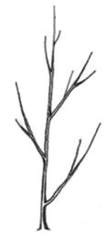 | 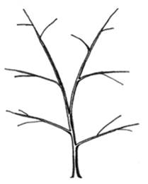 | 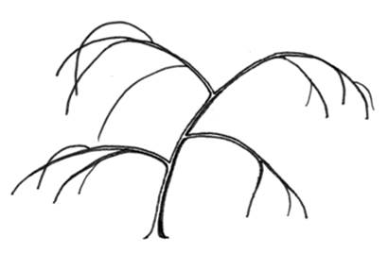
1 | 3 | 5
upright | spreading | drooping

Ad. 4: Young shoot: anthocyanin coloration

Should be assessed on the upper third of the shoot without considering the color of the lenticels.

Ad. 10: Shoot: position of vegetative lateral bud in relation to shoot

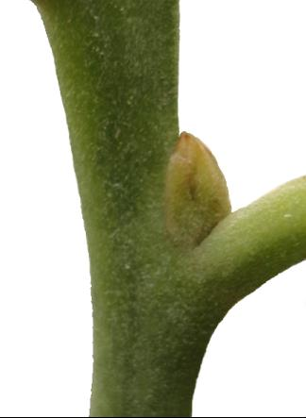 | 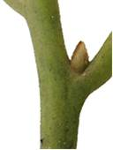 | 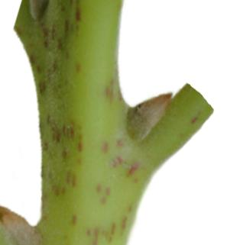
1 | 2 | 3
adpressed | slightly held out | markedly held out

Ad. 12: Shoot: shape of vegetative lateral bud

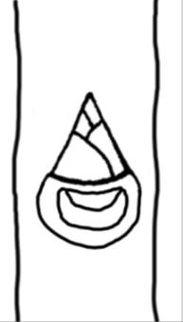 | 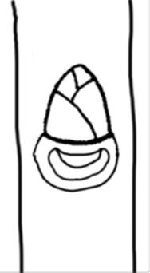 | 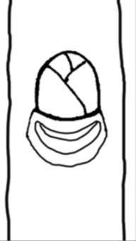
1 | 2 | 3
acute | obtuse | rounded

Ad. 21: Leaf blade: shape

 |  | ← broadest part →
 |  | below middle | at middle | above middle
narrow (high) |  | 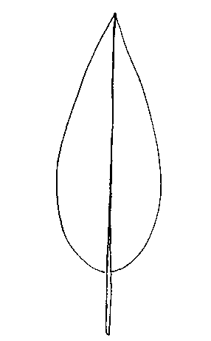  2  lanceolate | 5  narrow elliptic
width (ratio length/width) |  | 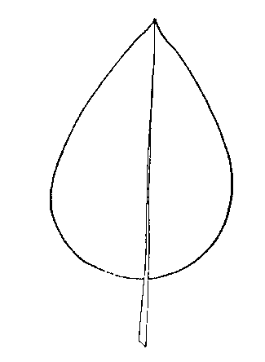  1  ovate | 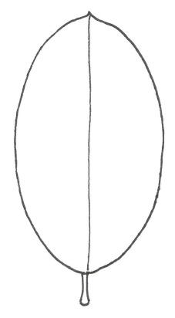  4  medium elliptic | 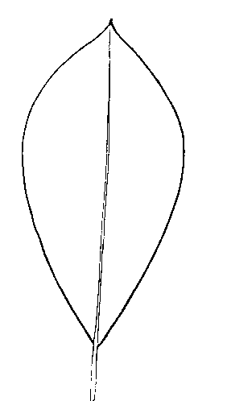  6  obovate
broad (low) |  |  | 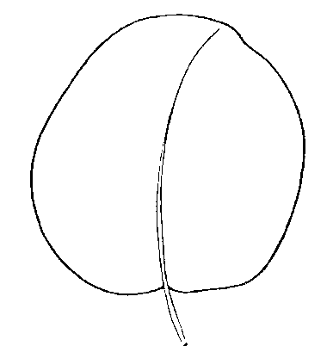  3  circular

Ad. 24: Leaf blade: shape of apex (excluding tip)

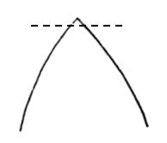 | 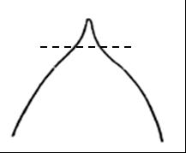 | 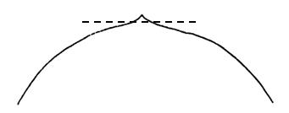
1 | 2 | 3
acute | obtuse | rounded

Ad. 25: Leaf blade: length of tip

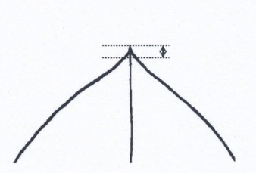 | 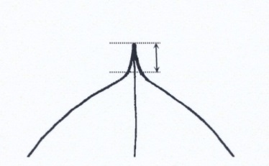 | 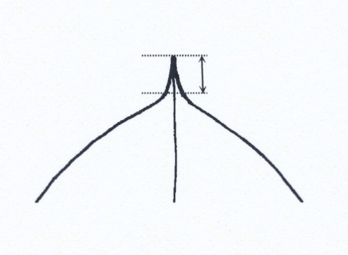 | 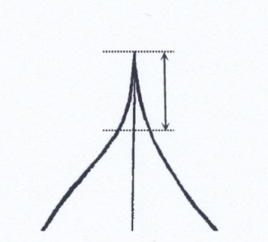
1 | 2 | 3 | 4
very short | short | medium | long

Ad. 26: Leaf blade: shape of base

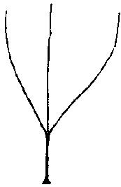 | 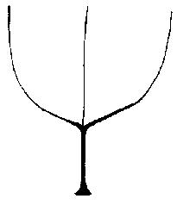 | 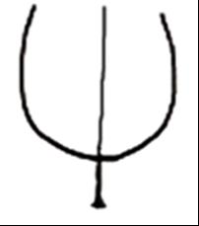 | 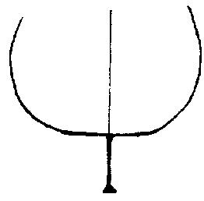
1 | 2 | 3 | 4
acute | obtuse | rounded | truncate

Ad. 27: Leaf blade: twisting along whole length

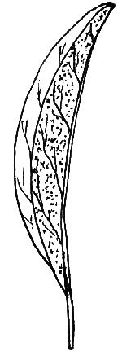 | 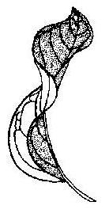
1 | 9
absent | present

Ad. 28: Leaf blade: twisting of tip

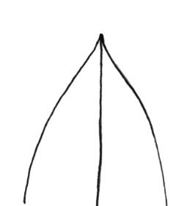 | 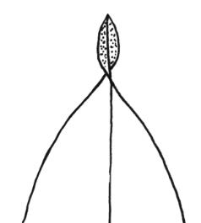
1 | 9
absent | present

Ad. 29: Leaf blade: undulation of margin

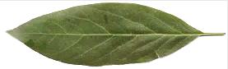 | 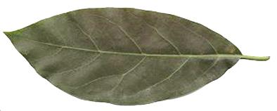 | 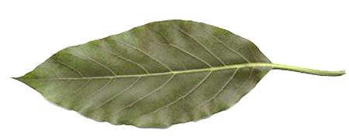 | 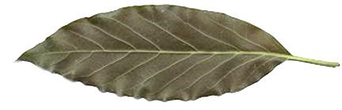 | 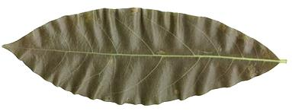
1 | 3 | 5 | 7 | 9
absent or very weak | weak | medium | strong | very strong

Ad. 33: Leaf blade: anise aroma

Should be assessed by crushing the leaf and smelling.

Ad. 35: Petiole: depth of groove

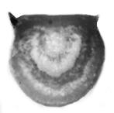 | 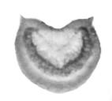 | 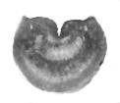
1 | 2 | 3
absent or shallow | medium | deep

Ad. 36: Petiole: cross section

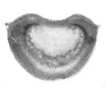 |  | 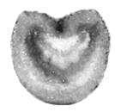
1 | 2 | 3
broader than tall | as broad as tall | taller than broad

Literature

Barrientos-Priego, A. F., Muñoz-Pérez, R., Borys, M. W., Martínez-Damián, Ma. T. 2006: Taxonomía, cultivares y portainjertos. In: El Aguacate y su Manejo Integrado. 2ª edición. D. Téliz, A. Mora (eds.). Mundi-Prensa México, S.A. de C.V. D.F., MX. pp. 30-62.

Crane, J. H., Douhan, G., Faber, B. A., Arpaia, M. L, Bender, G. S., Balerdi, C. F., Barrientos-Priego, A. F. 2013: Cultivars and rootstocks. In: The Avocado Botany, and Uses. B. A. Schaffer, A. W. Whiley, B. N. Wolstenholme. CAB International Publishing. Oxfordshire, UK. pp. 200-233.

Technical Questionnaire

TECHNICAL QUESTIONNAIRE |  |  |  | Page {x} of {y} |  | Reference Number:
 |  |  |  |  |  | Application date:
 |  |  |  |  |  | (not to be filled in by the applicant)
TECHNICAL QUESTIONNAIRE
to be completed in connection with an application for plant breeders’ rights

1. Subject of the Technical Questionnaire
1.1.1 Botanical name |  |  | P. americana Mill. |  |  |  |  |  |  | [ ]
1.1.2 Common name |  |  | Avocado
1.2.1 Botanical name |  |  | P. schiedeana Nees |  |  |  |  |  |  | [ ]
1.2.2 Common name |  |  | Coyo avocado
2. Applicant
Name
Address
Telephone No.
Fax No.
E-mail address
Breeder (if different from
applicant)
3. Proposed denomination and breeder’s reference
Proposed denomination
(if available)
Breeder’s reference
#4. Information on the breeding scheme and propagation of the variety

4.1 Breeding scheme

Variety resulting from:

4.1.1 Crossing

(a) controlled cross [ ]
(please state parent varieties)

(…………………..……………..…) x (……………..…………………..…)
female parent male parent

(b) partially known cross [ ]
(please state known parent variety(ies))

(…………………..……………..…) x (……………..…………………..…)
female parent male parent

(c) unknown cross [ ]

4.1.2 Mutation [ ]
(please state parent variety)

4.1.3 Discovery and development [ ]
(please state where and when discovered and how developed)

4.1.4 Other [ ]
(please provide details)

4.2 Method of propagating the variety

4.2.1 Vegetative propagation

(a) cuttings [ ]

(b) etiolation layering [ ]

(c) other (state method) [ ]

4.2.2 Other [ ]
(please provide details)

5. Characteristics of the variety to be indicated (the number in brackets refers to the corresponding characteristic in Test Guidelines; please mark the note which best corresponds).

 | Characteristics |  |  |  |  |  | Example Varieties |  |  |  | Note
5.1  (1) | Plant: vigor
 | weak |  |  |  |  |  |  |  |  |  | 1[ ]
 | weak to medium |  |  |  |  |  |  |  |  |  | 2[ ]
 | medium |  |  |  |  |  | Merensky 2 |  |  |  | 3[ ]
 | medium to strong |  |  |  |  |  |  |  |  |  | 4[ ]
 | strong |  |  |  |  |  | G 755c |  |  |  | 5[ ]
5.2  (6) | Shoot: length of internodes
 | short |  |  |  |  |  |  |  |  |  | 1[ ]
 | short to medium |  |  |  |  |  |  |  |  |  | 2[ ]
 | medium |  |  |  |  |  | Merensky 2 |  |  |  | 3[ ]
 | medium to long |  |  |  |  |  |  |  |  |  | 4[ ]
 | long |  |  |  |  |  |  |  |  |  | 5[ ]
5.3  (15) | Shoot: pubescence of terminal bud
 | absent or very weak |  |  |  |  |  | M14 |  |  |  | 1[ ]
 | weak |  |  |  |  |  | Duke 7 |  |  |  | 2[ ]
 | medium |  |  |  |  |  | Velvick |  |  |  | 3[ ]
 | strong |  |  |  |  |  | Thomas |  |  |  | 4[ ]
 | very strong |  |  |  |  |  | G 755c |  |  |  | 5[ ]
5.4  (17) | Young leaf: color
 | yellow green |  |  |  |  |  |  |  |  |  | 1[ ]
 | green |  |  |  |  |  | G-22 |  |  |  | 2[ ]
 | red |  |  |  |  |  | Duke 6 |  |  |  | 3[ ]
 | Characteristics |  |  |  |  |  | Example Varieties |  |  |  | Note
5.5  (19) | Leaf blade: length
 | very short |  |  |  |  |  |  |  |  |  | 1[ ]
 | very short to short |  |  |  |  |  |  |  |  |  | 2[ ]
 | short |  |  |  |  |  | Duke 7 |  |  |  | 3[ ]
 | short to medium |  |  |  |  |  |  |  |  |  | 4[ ]
 | medium |  |  |  |  |  | Merensky 2 |  |  |  | 5[ ]
 | medium to long |  |  |  |  |  |  |  |  |  | 6[ ]
 | long |  |  |  |  |  | Filtro 7 |  |  |  | 7[ ]
 | long to very long |  |  |  |  |  |  |  |  |  | 8[ ]
 | very long |  |  |  |  |  |  |  |  |  | 9[ ]
5.6  (32) | Leaf blade: density of pubescence of lower side of main vein
 | absent or sparse |  |  |  |  |  | Day |  |  |  | 1[ ]
 | medium |  |  |  |  |  | G 755c, Velvick |  |  |  | 2[ ]
 | dense |  |  |  |  |  | Thomas |  |  |  | 3[ ]
6. Similar varieties and differences from these varieties

Please use the following table and box for comments to provide information on how your candidate variety differs from the variety (or varieties) which, to the best of your knowledge, is (or are) most similar. This information may help the examination authority to conduct its examination of distinctness in a more efficient way.

Denomination(s) of variety(ies) similar to your candidate variety |  | Characteristic(s) in which your candidate variety differs from the similar variety(ies) |  |  | Describe the expression of the characteristic(s) for the similar variety(ies) |  |  | Describe the expression of the characteristic(s) for your candidate variety
Example |  | Shoot: thickness |  |  | thin |  |  | thick
Comments:

#7. Additional information which may help in the examination of the variety

7.1 In addition to the information provided in sections 5 and 6, are there any additional characteristics which may help to distinguish the variety?

Yes [ ] No [ ]

(If yes, please provide details)

7.2 Are there any special conditions for growing the variety or conducting the examination?

Yes [ ] No [ ]

(If yes, please provide details)

7.3 Other information

8. Authorization for release

(a) Does the variety require prior authorization for release under legislation concerning the protection of the environment, human and animal health?

Yes [ ] No [ ]

(b) Has such authorization been obtained?

Yes [ ] No [ ]

If the answer to (b) is yes, please attach a copy of the authorization.

9. Information on plant material to be examined or submitted for examination

9.1 The expression of a characteristic or several characteristics of a variety may be affected by factors, such as pests and disease, chemical treatment (e.g. growth retardants or pesticides), effects of tissue culture, different rootstocks, scions taken from different growth phases of a tree, etc.

9.2 The plant material should not have undergone any treatment which would affect the expression of the characteristics of the variety, unless the competent authorities allow or request such treatment. If the plant material has undergone such treatment, full details of the treatment must be given. In this respect, please indicate below, to the best of your knowledge, if the plant material to be examined has been subjected to:

(a) Microorganisms (e.g. virus, bacteria, phytoplasma) Yes [ ] No [ ]

(b) Chemical treatment (e.g. growth retardant, pesticide) Yes [ ] No [ ]

(c) Tissue culture Yes [ ] No [ ]

(d) Other factors Yes [ ] No [ ]

Please provide details for where you have indicated “yes”.

9.3 Has the plant material to be examined been tested for the presence of virus or other pathogens?

Yes [ ]

(please provide details as specified by the Authority)

No [ ]

10. I hereby declare that, to the best of my knowledge, the information provided in this form is correct:

Applicant’s name

Signature Date

[End of document]

* These names were correct at the time of the introduction of these Test Guidelines but may be revised or updated. [Readers are advised to consult the UPOV Code, which can be found on the UPOV Website (www.upov.int), for the latest information.]
# Authorities may allow certain of this information to be provided in a confidential section of the Technical Questionnaire.
# Authorities may allow certain of this information to be provided in a confidential section of the Technical Questionnaire.

