 |  | E  TG/284/1  ORIGINAL: English  DATE: 2013-03-20
INTERNATIONAL UNION FOR THE PROTECTION OF NEW VARIETIES OF PLANTS
Geneva

 | POMEGRANATE  UPOV Code: PUNIC_GRA  Punica granatum L. | *

GUIDELINES

FOR THE CONDUCT OF TESTS

FOR DISTINCTNESS, UNIFORMITY AND STABILITY

Alternative Names:*

Botanical name |  | English |  | French |  | German |  | Spanish
Punica granatum L. | Pomegranate |  | Grenadier |  | Granatapfel |  | Granado

The purpose of these guidelines (“Test Guidelines”) is to elaborate the principles contained in the General Introduction (document TG/1/3), and its associated TGP documents, into detailed practical guidance for the harmonized examination of distinctness, uniformity and stability (DUS) and, in particular, to identify appropriate characteristics for the examination of DUS and production of harmonized variety descriptions.

ASSOCIATED DOCUMENTS
These Test Guidelines should be read in conjunction with the General Introduction and its associated TGP documents.
TABLE OF CONTENTS PAGE

1. Subject of these Test Guidelines 3
2. Material Required 3
3. Method of Examination 3
3.1 Number of Growing Cycles 3
3.2 Testing Place 3
3.3 Conditions for Conducting the Examination 3
3.4 Test Design 3
3.5 Additional Tests 4
4. Assessment of Distinctness, Uniformity and Stability 4
4.1 Distinctness 4
4.2 Uniformity 5
4.3 Stability 5
5. Grouping of Varieties and Organization of the Growing Trial 5
6. Introduction to the Table of Characteristics 6
6.1 Categories of Characteristics 6
6.2 States of Expression and Corresponding Notes 6
6.3 Types of Expression 6
6.4 Example Varieties 6
6.5 Legend 7
7. Table of Characteristics/Tableau des caractères/Merkmalstabelle/Tabla de caracteres 8
8. Explanations on the Table of Characteristics 15
8.1 Explanations covering several characteristics 15
8.2 Explanations for individual characteristics 15
9. Literature 21
10. Technical Questionnaire 22

Subject of these Test Guidelines

These Test Guidelines apply to all varieties of Punica granatum L..

Material Required

2.1 The competent authorities decide on the quantity and quality of the plant material required for testing the variety and when and where it is to be delivered. Applicants submitting material from a State other than that in which the testing takes place must ensure that all customs formalities and phytosanitary requirements are complied with.

2.2 The material is to be supplied in the form of one-year-old rooted cuttings.

2.3 The minimum quantity of plant material, to be supplied by the applicant, should be:

5 one-year-old rooted cuttings.

2.4 The plant material supplied should be visibly healthy, not lacking in vigor, nor affected by any important pest or disease.

2.5 The plant material should not have undergone any treatment which would affect the expression of the characteristics of the variety, unless the competent authorities allow or request such treatment. If it has been treated, full details of the treatment must be given.

Method of Examination

3.1 Number of Growing Cycles

    - The minimum duration of tests should normally be two independent growing cycles.

3.1.2 The growing cycle is considered to be the duration of a single growing season, beginning with bud burst (flowering and/or vegetative), flowering and fruit harvest and concluding when the following dormant period ends with the swelling of new season buds.

3.2 Testing Place

Tests are normally conducted at one place. In the case of tests conducted at more than one place, guidance is provided in TGP/9 “Examining Distinctness”.

3.3 Conditions for Conducting the Examination

3.3.1 The tests should be carried out under conditions ensuring satisfactory growth for the expression of the relevant characteristics of the variety and for the conduct of the examination. Trees should only be pruned in the year of planting to ensure good branch formation.

3.3.2 In particular, it is essential that the trees produce a satisfactory crop of fruit in each of the two growing cycles.

3.3.3 The optimum stage of development for the assessment of each characteristic is indicated by a number in the second column of the Table of Characteristics. The stages of development denoted by each number are described in Chapter 8.

3.4 Test Design

3.4.1 Each test should be designed to result in a total of at least 5 plants.

3.4.2 The design of the tests should be such that plants or parts of plants may be removed for measurement or counting without prejudice to the observations which must be made up to the end of the growing cycle.

3.5 Additional Tests

Additional tests, for examining relevant characteristics, may be established.

Assessment of Distinctness, Uniformity and Stability

4.1 Distinctness

4.1.1 General Recommendations

It is of particular importance for users of these Test Guidelines to consult the General Introduction prior to making decisions regarding distinctness. However, the following points are provided for elaboration or emphasis in these Test Guidelines.

4.1.2 Consistent Differences

The differences observed between varieties may be so clear that more than one growing cycle is not necessary. In addition, in some circumstances, the influence of the environment is not such that more than a single growing cycle is required to provide assurance that the differences observed between varieties are sufficiently consistent. One means of ensuring that a difference in a characteristic, observed in a growing trial, is sufficiently consistent is to examine the characteristic in at least two independent growing cycles.

4.1.3 Clear Differences

Determining whether a difference between two varieties is clear depends on many factors, and should consider, in particular, the type of expression of the characteristic being examined, i.e. whether it is expressed in a qualitative, quantitative, or pseudo-qualitative manner. Therefore, it is important that users of these Test Guidelines are familiar with the recommendations contained in the General Introduction prior to making decisions regarding distinctness.

4.1.4 Number of Plants / Parts of Plants to be Examined

Unless otherwise indicated, for the purposes of distinctness, all observations on single plants should be made on 5 plants or parts taken from each of 5 plants and any other observations made on all plants in the test. In the case of observations of parts taken from single plants, the number of parts to be taken from each of the plants should be 2.

4.1.5 Method of Observation

The recommended method of observing the characteristic for the purposes of distinctness is indicated by the following key in the second column of the Table of Characteristics (see document TGP/9 “Examining Distinctness”, Section 4 “Observation of characteristics”):

MG: single measurement of a group of plants or parts of plants
MS: measurement of a number of individual plants or parts of plants
VG: visual assessment by a single observation of a group of plants or parts of plants
VS: visual assessment by observation of individual plants or parts of plants

Type of observation: visual (V) or measurement (M)

“Visual” observation (V) is an observation made on the basis of the expert’s judgment. For the purposes of this document, “visual” observation refers to the sensory observations of the experts and, therefore, also includes smell, taste and touch. Visual observation includes observations where the expert uses reference points (e.g. diagrams, example varieties, side-by-side comparison) or non-linear charts (e.g. color charts). Measurement (M) is an objective observation against a calibrated, linear scale e.g. using a ruler, weighing scales, colorimeter, dates, counts, etc.

Type of record: for a group of plants (G) or for single, individual plants (S)

For the purposes of distinctness, observations may be recorded as a single record for a group of plants or parts of plants (G), or may be recorded as records for a number of single, individual plants or parts of plants (S). In most cases, “G” provides a single record per variety and it is not possible or necessary to apply statistical methods in a plant-by-plant analysis for the assessment of distinctness.

In cases where more than one method of observing the characteristic is indicated in the Table of Characteristics (e.g. VG/MG), guidance on selecting an appropriate method is provided in document TGP/9, Section 4.2.

4.2 Uniformity

4.2.1 It is of particular importance for users of these Test Guidelines to consult the General Introduction prior to making decisions regarding uniformity. However, the following points are provided for elaboration or emphasis in these Test Guidelines:

4.2.2 For the assessment of uniformity, a population standard of 1% and an acceptance probability of at least 95% should be applied. In the case of a sample size of 5 plants, no off-types are allowed.

4.3 Stability

4.3.1 In practice, it is not usual to perform tests of stability that produce results as certain as those of the testing of distinctness and uniformity. However, experience has demonstrated that, for many types of variety, when a variety has been shown to be uniform, it can also be considered to be stable.

4.3.2 Where appropriate, or in cases of doubt, stability may be further examined by testing a new plant stock to ensure that it exhibits the same characteristics as those shown by the initial material supplied.

Grouping of Varieties and Organization of the Growing Trial

5.1 The selection of varieties of common knowledge to be grown in the trial with the candidate varieties and the way in which these varieties are divided into groups to facilitate the assessment of distinctness are aided by the use of grouping characteristics.

5.2 Grouping characteristics are those in which the documented states of expression, even where produced at different locations, can be used, either individually or in combination with other such characteristics: (a) to select varieties of common knowledge that can be excluded from the growing trial used for examination of distinctness; and (b) to organize the growing trial so that similar varieties are grouped together.

5.3 The following have been agreed as useful grouping characteristics:

- Corolla: color (characteristic 17)
(b) Fruit: width (characteristic 23)
(c) Fruit: over color (characteristic 26)
(d) Aril: main color (characteristic 35)
(e) Seed: hardness (characteristic 38)
(f) Time of maturity for consumption (characteristic 40)

5.4 Guidance for the use of grouping characteristics, in the process of examining distinctness, is provided through the General Introduction and document TGP/9 “Examining Distinctness”.

Introduction to the Table of Characteristics

6.1 Categories of Characteristics

6.1.1 Standard Test Guidelines Characteristics

Standard Test Guidelines characteristics are those which are approved by UPOV for examination of DUS and from which members of the Union can select those suitable for their particular circumstances.

6.1.2 Asterisked Characteristics

Asterisked characteristics (denoted by *) are those included in the Test Guidelines which are important for the international harmonization of variety descriptions and should always be examined for DUS and included in the variety description by all members of the Union, except when the state of expression of a preceding characteristic or regional environmental conditions render this inappropriate.

6.2 States of Expression and Corresponding Notes

6.2.1 States of expression are given for each characteristic to define the characteristic and to harmonize descriptions. Each state of expression is allocated a corresponding numerical note for ease of recording of data and for the production and exchange of the description.

6.2.2 In the case of qualitative and pseudo-qualitative characteristics (see Chapter 6.3), all relevant states of expression are presented in the characteristic. However, in the case of quantitative characteristics with 5 or more states, an abbreviated scale may be used to minimize the size of the Table of Characteristics. For example, in the case of a quantitative characteristic with 9 states, the presentation of states of expression in the Test Guidelines may be abbreviated as follows:

State | Note
small | 3
medium | 5
large | 7

However, it should be noted that all of the following 9 states of expression exist to describe varieties and should be used as appropriate:

State | Note
very small | 1
very small to small | 2
small | 3
small to medium | 4
medium | 5
medium to large | 6
large | 7
large to very large | 8
very large | 9

6.2.3 Further explanation of the presentation of states of expression and notes is provided in document TGP/7 “Development of Test Guidelines”.

6.3 Types of Expression

An explanation of the types of expression of characteristics (qualitative, quantitative and pseudo-qualitative) is provided in the General Introduction.

6.4 Example Varieties

Where appropriate, example varieties are provided to clarify the states of expression of each characteristic.

6.5 Legend

(*) Asterisked characteristic – see Chapter 6.1.2

QL Qualitative characteristic – see Chapter 6.3
QN Quantitative characteristic – see Chapter 6.3
PQ Pseudo-qualitative characteristic – see Chapter 6.3

MG, MS, VG, VS – see Chapter 4.1.5

(a)-(e) See Explanations on the Table of Characteristics in Chapter 8.1

(+) See Explanations on the Table of Characteristics in Chapter 8.2.

Table of Characteristics/Tableau des caractères/Merkmalstabelle/Tabla de caracteres

 |  | English | français | deutsch | español | Example Varieties  Exemples  Beispielssorten  Variedades ejemplo | Note/  Nota
1  (*)  (+) | VG | Plant: vigor | Plante : vigueur | Pflanze: Wuchsstärke | Planta: vigor
QN | (a) | weak | faible | gering | débil |  | 3
 |  | medium | moyenne | mittel | medio | Wonderful | 5
 |  | strong | forte | stark | fuerte | Mollar de Elche | 7
2  (+) | VG | Plant: growth habit | Plante : port | Pflanze: Wuchsform | Planta: hábito de crecimiento
PQ | (a) | upright | dressé | aufrecht | erguido |  | 1
 |  | spreading | étalé | breitwüchsig | abierto |  | 3
 |  | weeping | pleureur | lang überhängend | llorón |  | 5
3 | VG | Plant: intensity of grey color of main branches | Plante : intensité de la couleur grise des principales branches | Pflanze: Intensität der Graufärbung der Hauptzweige | Planta: intensidad de color gris de las ramas principales
QN | (a) | light | claire | hell | claro |  | 1
 |  | medium | moyenne | mittel | medio |  | 2
 |  | dark | foncée | dunkel | oscuro |  | 3
4  (+) | VG | Plant: number of one-year-old shoots ending in thorns | Plante : nombre de rameaux d’un an finissant en épines | Pflanze: Anzahl einjähriger Triebe, die mit Dornen abschließen | Planta: número de ramas de un año terminadas en espina
QN | (a) | none or very few | aucun ou très petit | keine oder sehr wenige | ninguna o muy pocas |  | 1
 |  | few | petit | wenige | pocas |  | 2
 |  | medium | moyen | mittel | medias |  | 3
 |  | many | grand | viele | muchas |  | 4
5  (+) | VG | Young shoot: predominant number of leaves per node | Jeune rameau : nombre prédominant de feuilles par nœud | Jungtrieb: vorwiegende Anzahl Blätter pro Knoten | Rama joven: número predominante de hojas por nudo
QN |  | two | deux | zwei | dos | Mollar de Elche | 1
 |  | three | trois | drei | tres |  | 2
 |  | more than three | plus de trois | mehr als drei | más de tres | Porfianca | 3
6 | VG/MS | Leaf blade: length | Limbe : longueur | Blattspreite: Länge | Limbo: longitud
QN | (b) | short | court | kurz | corto | Mollar de Elche, Porfianca | 3
 |  | medium | moyen | mittel | medio | Valenciano | 5
 |  | long | long | lang | largo | Borde, Wonderful | 7
7 | VG/MS | Leaf blade: width | Limbe : largeur | Blattspreite: Breite | Limbo: anchura
QN | (b) | narrow | étroit | schmal | estrecho | Wonderful | 3
 |  | medium | moyen | mittel | medio |  | 5
 |  | broad | large | breit | ancho | Borde, Mollar de Elche | 7
8  (+) | VG/MS | Leaf blade: ratio length/width | Limbe : rapport longueur/largeur | Blattspreite: Verhältnis Länge/Breite | Limbo: relación longitud/anchura
QN | (b) | low | bas | klein | bajo | Mollar de Albatera | 3
 |  | medium | moyen | mittel | medio | Borde | 5
 |  | high | elevé | groß | alto | Tendral | 7
9  (+) | VG | Leaf blade: shape of apex excluding tip | Limbe : forme du sommet, pointe exclue | Blattspreite: Form der Spitze ohne aufgesetzte Spitze | Limbo: forma del ápice excluyendo la punta
QN | (b) | strongly acute | très aigu | sehr spitz | fuertemente agudo |  | 1
 |  | moderately acute | modérément aigu | mäßig spitz | moderadamente agudo | Wonderful | 2
 |  | right angled | à angle droit | rechtwinklig | en ángulo recto | Acco, Tendral | 3
 |  | moderately obtuse | modérément obtus | mäßig stumpf | moderadamente obtuso | Mollar de Elche | 4
 |  | strongly obtuse | très obtus | stark stumpf | fuertemente obtuso |  | 5
10 | VG | Leaf blade: intensity of green color | Limbe : intensité de la couleur verte | Blattspreite: Intensität der Grünfärbung | Limbo: intensidad del color verde
QN | (b) | light | vert clair | hell | claro |  | 3
 |  | medium | vert moyen | mittel | medio |  | 5
 |  | dark | vert foncé | dunkel | oscuro |  | 7
11  (*) | VG/MS | Petiole: length | Pétiole : longueur | Blattstiel: Länge | Peciolo: longitud
QN | (b) | short | court | kurz | corto | Borde | 3
 |  | medium | moyen | mittel | medio | Wonderful | 5
 |  | long | long | lang | largo | Tendral | 7
12  (*) | VG | Petiole: anthocyanin coloration | Pétiole : pigmentation anthocyanique | Blattstiel: Anthocyanfärbung | Peciolo: pigmentación antociánica
QN | (b) | weak | faible | gering | débil | Acco | 3
 |  | medium | moyenne | mittel | media | Mollar de Elche | 5
 |  | strong | forte | stark | fuerte | Borde, Tendral | 7
13  (+) | VG/MS | Calyx: length | Calice : longueur | Kelch: Länge | Cáliz: longitud | .
QN | (c) | short | court | kurz | corto | Malisi | 3
 |  | medium | moyen | mittel | medio | Hicaz Nar | 5
 |  | long | long | lang | largo |  | 7
14  (*)  (+) | VG/MS | Calyx: width | Calice : largeur | Kelch: Breite | Cáliz: anchura
QN | (c) | narrow | étroit | schmal | estrecho | Malisi | 3
 |  | medium | moyen | mittel | medio | Mollar de Elche, Porfianca, Valenciana | 5
 |  | broad | large | breit | ancho | Wonderful | 7
15  (+) | VG/MS | Calyx: ratio length/width | Calice : rapport longueur/largeur | Kelch: Verhältnis Länge/Breite | Cáliz: relación longitud/anchura
QN | (c) | low | bas | klein | bajo | Wonderful | 3
 |  | medium | moyen | mittel | medio | Black | 5
 |  | high | elevé | groß | alto | Bhagwa | 7
16  (+) | VG | Calyx: color | Calice : couleur | Kelch: Farbe | Cáliz: color
PQ | (c) | orange | orange | orange | naranja | Mollar de Elche, Valenciana | 1
 |  | orange red | rouge orangé | orangerot | rojo anaranjado | Wonderful | 2
 |  | medium red | rouge moyen | mittelrot | rojo medio |  | 3
 |  | dark red | rouge foncé | dunkelrot | rojo oscuro |  | 4
17  (*)  (+) | VG | Corolla: color | Corolle : couleur | Krone: Farbe | Corola: color
PQ | (c) | white | blanche | weiß | blanco |  | 1
 |  | pink | rose | rosa | rosa |  | 2
 |  | light orange | orange clair | hellorange | naranja claro | Borde | 3
 |  | medium orange | orange moyen | mittelorange | naranja medio | Mollar de Elche,  Wonderful | 4
 |  | orange red | rouge orangé | orangerot | rojo anaranjado |  | 5
 |  | medium red | rouge moyen | mittelrot | rojo medio |  | 6
18  (*)  (+) | VG/MS | Petal: length | Pétale : longueur | Blütenblatt: Länge | Pétalo: longitud
QN | (c) | short | court | kurz | corto | Mollar de Elche, Valenciana | 3
 |  | medium | moyen | mittel | medio | Hicaz Nar | 5
 |  | long | long | lang | largo |  | 7
19  (+) | VG/MS | Petal: width | Pétale : largeur | Blütenblatt: Breite | Pétalo: anchura
QN | (c) | narrow | étroit | schmal | estrecho | Black, Hicaz Nar | 3
 |  | medium | moyen | mittel | medio | Rosh Hapered, Tendral | 5
 |  | broad | large | breit | ancho |  | 7
20 | VG | Petal: surface | Pétale : surface | Blütenblatt: Oberfläche | Pétalo: superficie
QN | (c) | smooth or slightly wrinkled | lisse ou légèrement ridée | glatt oder leicht gerieft | liso a ligeramente arrugado |  | 1
 |  | moderately wrinkled | modérément ridée | mäßig gerieft | moderadamente arrugado | Bahgwa, Mollar de Elche | 3
 |  | strongly wrinkled | fortement ridée | stark gerieft | fuertemente arrugado | Malisi, Rosh Hapered | 5
21  (+) | VG | One-year-old shoot: predominant number of flowers per node | Rameau d’un an : nombre prédominant de fleurs par nœud | Einjähriger Trieb: vorwiegende Anzahl Blüten pro Knoten | Brotes de un año: número predominante de flores por nudo
QN |  | one | un | eins | uno |  | 1
 |  | two | deux | zwei | dos |  | 2
 |  | three | trois | drei | tres |  | 3
 |  | more than three | plus de trois | mehr als drei | más de tres |  | 4
22  (*)  (+) | VG/MS | Fruit: length | Fruit : longueur | Frucht: Länge | Fruto: longitud
QN | (d) | short | court | kurz | corto |  | 3
 |  | medium | moyen | mittel | medio | Borde | 5
 |  | long | long | lang | largo | Wonderful | 7
23  (*)  (+) | VG/MS | Fruit: width | Fruit : largeur | Frucht: Breite | Fruto: anchura
QN | (d) | narrow | étroit | schmal | estrecho |  | 3
 |  | medium | moyen | mittel | medio | Borde | 5
 |  | broad | large | breit | ancho | Mollar de Elche, Wonderful | 7
24  (+) | VG/MS | Fruit: ratio length/width | Fruit : rapport longueur/largeur | Frucht: Verhältnis Länge/Breite | Fruto: relación longitud/anchura
QN | (d) | low | bas | klein | bajo | Rosh Hapered | 3
 |  | medium | moyen | mittel | medio | Wonderful | 5
 |  | high | elevé | groß | alto | Valenciana | 7
25  (*)  (+) | VG/MS | Fruit: length of crown | Fruit : longueur de la couronne | Frucht: Länge der Krone | Fruto: longitud de la corona
QN | (d) | short | courte | kurz | corto |  | 3
 |  | medium | moyenne | mittel | medio | Mollar de Elche | 5
 |  | long | longue | lang | largo | Wonderful | 7
26  (*) | VG | Fruit: over color | Fruit : couleur du lavis | Frucht: Deckfarbe | Fruto: color superficial
PQ | (d) | orange | orange | orange | naranja | Mollar de Albatera,  Mollar de Elche | 1
 |  | orange red | rouge orangé | orangerot | rojo anaranjado |  | 2
 |  | pink | rose | rosa | rosa |  | 3
 |  | pink red | rose rouge | rosarot | rojo rosáceo | Valenciano | 4
 |  | medium red | rouge moyen | mittelrot | rojo medio | Acco | 5
 |  | red purple | rouge pourpre | rotpurpurn | rojo púrpura |  | 6
 |  | purple | pourpre | purpurn | púrpura | Kamel | 7
 |  | dark purple | pourpre foncé | dunkelpurpurn | púrpura oscuro |  | 8
27 | VG | Fruit: extent of over color | Fruit : ampleur de la couleur du lavis | Frucht: Ausdehnung der Deckfarbe | Fruto: extensión del color superficial
QN | (d) | very small | très petite | sehr gering | muy pequeño |  | 1
 |  | small | petite | gering | pequeño | Wonderful | 3
 |  | medium | moyenne | mittel | medio | Tendral, Valenciano | 5
 |  | large | grande | groß | grande |  | 7
 |  | very large | très grande | sehr groß | muy grande | Acco, Bhagwa, Black | 9
28  (*)  (+) | VG | Fruit: shape in cross section | Fruit : forme en section transversale | Frucht: Form im Querschnitt | Fruto: forma en sección transversal
QN | (d) | circular | circulaire | kreisförmig | circular | Borde, Wonderful | 1
 |  | circular to angular | circulaire à angulaire | kreisförmig bis eckig | circular a angular | Malisi | 2
 |  | angular | angulaire | eckig | angular | Bhagwa, Valenciano | 3
29  (+) | VG/MS | Fruit: thickness of skin | Fruit : épaisseur de l’épiderme | Frucht: Dicke der Schale | Fruto: espesor de la corteza
QN | (d) | thin | mince | dünn | delgada | Acco, Valenciano, Wonderful | 3
 |  | medium | moyen | mittel | media |  | 5
 |  | thick | épais | dick | gruesa | Kamel | 7
30  (*)  (+) | VG/MS | Fruit: sweetness | Fruit : goût sucré | Frucht: Süße | Fruto: dulzura
QN | (d) | low | faible | gering | baja |  | 3
 |  | medium | moyen | mittel | media | Rosh Hapered, Valenciano | 5
 |  | high | fort | hoch | alta |  | 7
31  (+) | VG/MS | Fruit: acidity | Fruit : acidité | Frucht: Säure | Fruto: acidez
QN | (d) | low | faible | gering | baja | Mollar de Elche, Valenciano | 3
 |  | medium | moyenne | mittel | media | Acco, Wonderful | 5
 |  | high | forte | hoch | alta |  | 7
32  (*)  (+) | VG/MS | Fruit: juiciness | Fruit : jutosité | Frucht: Saftigkeit | Fruto: suculencia
QN | (d) | low | faible | gering | baja | Wonderful | 3
 |  | medium | moyenne | mittel | media | Mollar de Elche | 5
 |  | high | forte | hoch | alta | Valenciano | 7
33  (+) | VG/MS | Aril: length | Arille : longueur | Samenmantel: Länge | Arilo: longitud
QN | (e) | short | court | kurz | corto |  | 1
 |  | medium | moyen | mittel | medio | Acco | 2
 |  | long | long | lang | largo | Mollar de Elche | 3
34  (+) | VG/MS | Aril: width | Arille : largeur | Samenmantel: Breite | Arilo: anchura
QN | (e) | narrow | étroit | schmal | estrecho |  | 1
 |  | medium | moyen | mittel | medio | Acco, Wonderful | 2
 |  | broad | large | breit | ancho | Piñón tierno de Ojós | 3
35  (*)  (+) | VG | Aril: main color | Arille : couleur principale | Samenmantel: Hauptfarbe | Arilo: color principal
PQ | (e) | white | blanc | weiß | blanco | Mollar de Elche | 1
 |  | light pink | rose clair | hellrosa | rosa claro | Valenciano | 2
 |  | medium pink | rose moyen | mittelrosa | rosa medio | Tendral | 3
 |  | dark pink | rose foncé | dunkelrosa | rosa oscuro |  | 4
 |  | light red | rouge clair | hellrot | rojo claro |  | 5
 |  | medium red | rouge moyen | mittelrot | rojo medio |  | 6
 |  | dark red | rouge foncé | dunkelrot | rojo oscuro | Wonderful | 7
36  (+) | VG/MS | Seed: length | Graine : longueur | Samen: Länge | Semilla: longitud
QN | (e) | short | courte | kurz | corta | Valenciano | 1
 |  | medium | moyenne | mittel | media | Mollar de Elche | 2
 |  | long | longue | lang | larga |  | 3
37  (+) | VG/MS | Seed: width | Graine : largeur | Samen: Breite | Semilla: anchura
QN | (e) | narrow | étroite | schmal | estrecha |  | 1
 |  | medium | moyenne | mittel | media | Mollar de Elche, Wonderful | 2
 |  | broad | large | breit | ancha |  | 3
38  (*)  (+) | VG | Seed: hardness | Graine : dureté | Samen: Härte | Semilla: dureza
QN | (e) | soft | molle | weich | blanda | Mollar de Elche, Valenciano | 1
 |  | medium | moyenne | mittel | media | Wonderful | 2
 |  | hard | dure | hart | dura | Borde | 3
39  (*)  (+) | VG/MG | Time of beginning of flowering | Époque de début de floraison | Zeitpunkt des Blühbeginns | Época de comienzo de la floración
QN |  | early | précoce | früh | temprana | Valenciano | 3
 |  | medium | moyenne | mittel | media | Mollar de Elche, Wonderful | 5
 |  | late | tardive | spät | tardía |  | 7
40  (*)  (+) | VG/MG | Time of maturity for consumption | Époque de maturité pour la consommation | Zeitpunkt der Genußreife | Época de maduración para el consumo
QN |  | early | précoce | früh | temprana | Valenciano | 3
 |  | medium | moyenne | mittel | media | Mollar de Elche, Wonderful | 5
 |  | late | tardive | spät | tardía |  | 7

Explanations on the Table of Characteristics

8.1 Explanations covering several characteristics

Characteristics containing the following key in the second column of the Table of Characteristics should be examined as indicated below:

- Observations on the plant should be made in the dormant season, when there are no leaves on the tree.

- Observations on the leaf should be made on mature leaves on the middle third of the branch from current season’s shoots and on nodes with a low number of leaves.

- Observations on the flower should be made on the hermaphrodite flowers at the time of full flowering and on fully opened flowers. Time of full flowering is when at least 75 % of flowers are fully open.

- Observations on the fruit should be made on 10 fruits at full maturity for consumption.

- Observations on the seed should be made on fresh seeds on fruits at full maturity for consumption.

8.2 Explanations for individual characteristics

Ad. 1: Plant: vigor

The vigor of the plant should be considered as the overall abundance of vegetative growth at the top of the plants.

Ad. 2: Plant: growth habit

1 | 3 | 5
upright | spreading | weeping

Ad. 4: Plant: number of one-year-old shoots ending in thorns

Observations on the one-year old shoot should be made in the dormant season, unless otherwise indicated.

Ad. 5: Young shoot: predominant number of leaves per node

Observations on young shoots should be made on the middle third of the branch.

Ad. 8: Leaf blade: ratio length/width

 |  | 
3 | 5 | 7
low | medium | high

Ad. 9: Leaf blade: shape of apex excluding tip

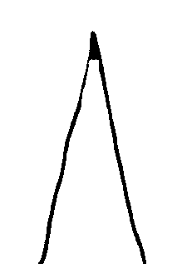 | 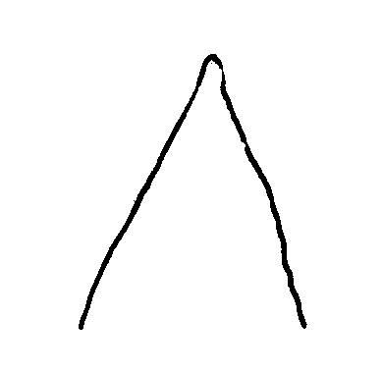 | 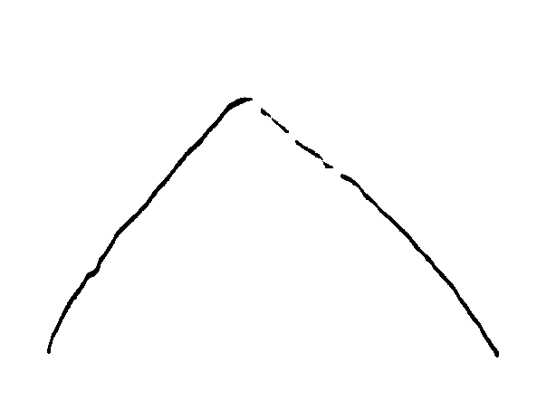 | 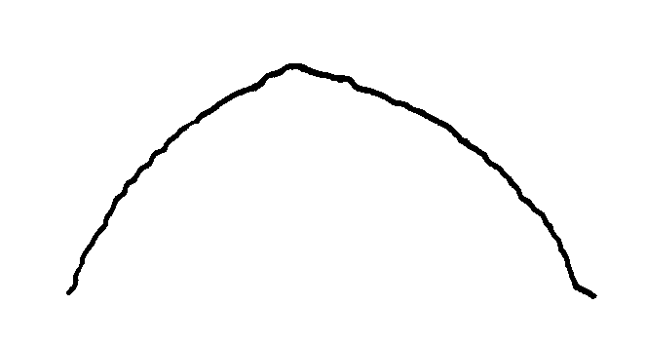 | 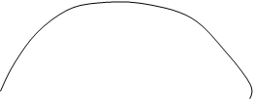
1 | 2 | 3 | 4 | 5
strongly acute | moderately acute | right angled | moderately obtuse | strongly obtuse

Ad. 13: Calyx: length
Ad. 14: Calyx: width

Calyx width should be observed approximately in the middle of calyx length.

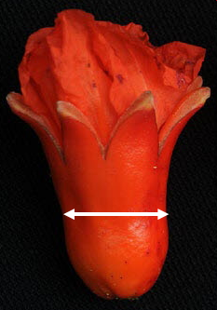
Length
Width

Ad. 15: Calyx: ratio length/width

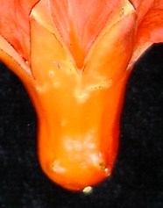 | 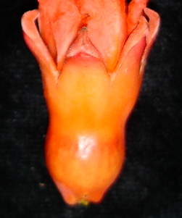 | 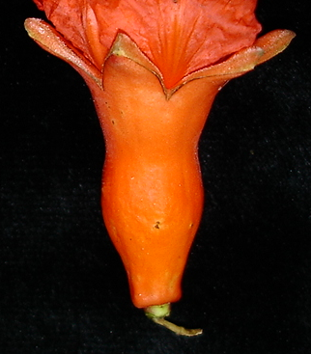
3 | 5 | 7
low | medium | high

Ad. 16: Calyx: color

The color of the calyx should be observed when the sepals are closed.

Ad. 17: Corolla: color

The color of the corolla should be observed when the flower is fully open.

Ad. 18: Petal: length
Ad. 19: Petal: width

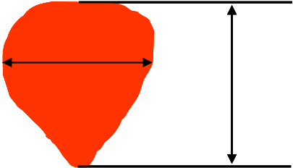
Length
Width

Ad. 21: One-year-old shoot: predominant number of flowers per node

Observations should be made on the hermaphrodite flowers at the time of full flowering.

Ad. 22: Fruit: length
Ad. 23: Fruit: width
Ad. 25: Fruit: length of crown

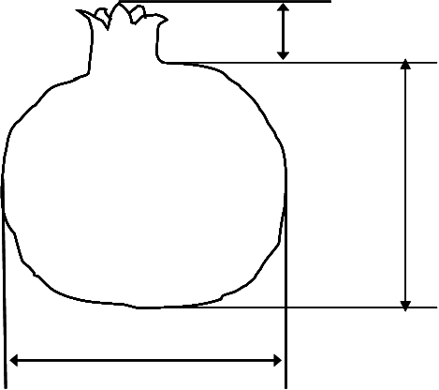
Length
Width

Length of crown

Ad. 24: Fruit: ratio length/width

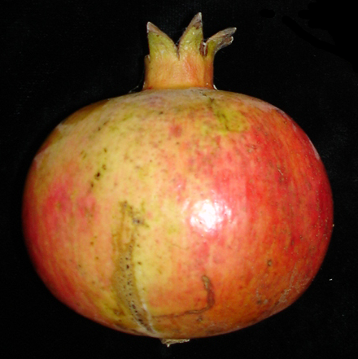 | 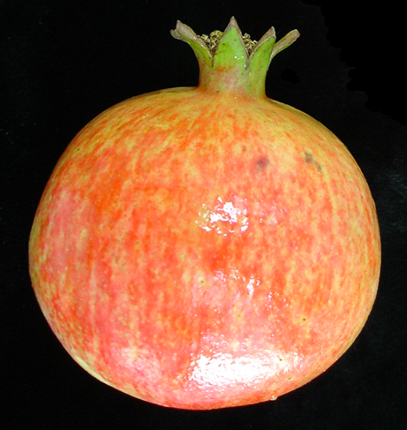 | 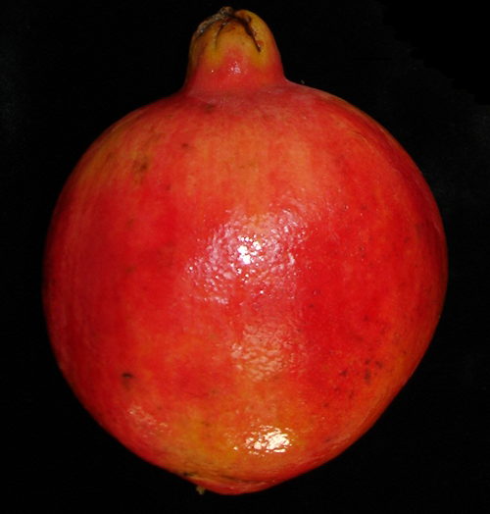
3 | 5 | 7
low | medium | high

Ad. 28: Fruit: shape in cross section

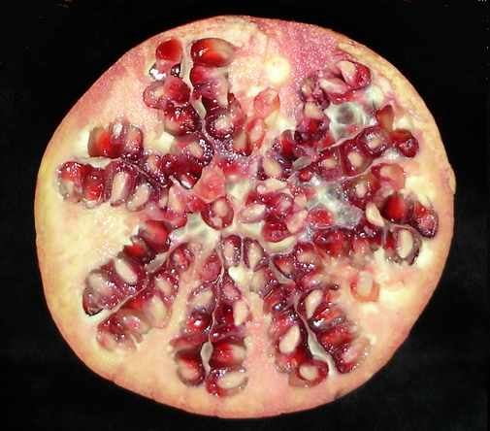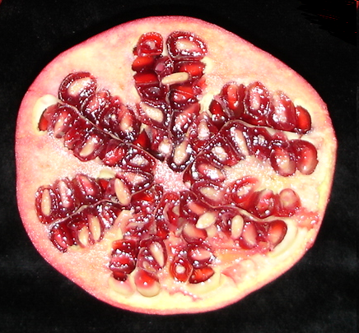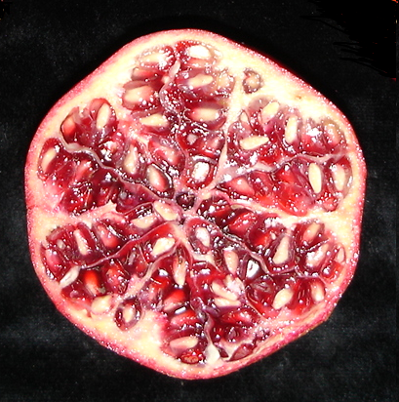
1 | 2 | 3
circular | circular to angular | angular

Ad. 29: Fruit: thickness of skin

Observations should be made at the end of the lobules of arils, see arrows in the picture below.

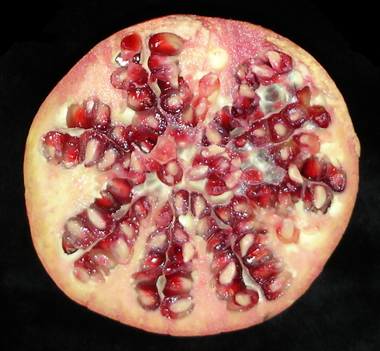

Ad. 30: Fruit: sweetness

The sweetness is determined by using a refractometer. The measured unit is the degree Brix (º Brix).

Ad. 31: Fruit: acidity

The acidity is considered as free acids content, and is determined by titration of a juice sample.

Ad. 32: Fruit: juiciness

Juiciness is considered as the percentage of juice of total fruit weight.

Ad. 33: Aril: length
Ad. 34: Aril: width

Length
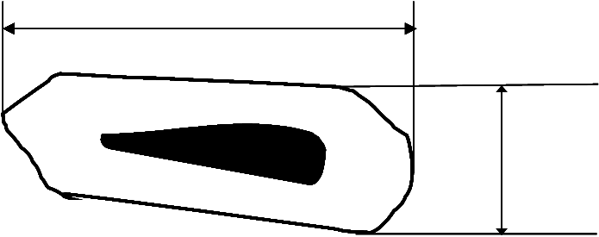
Width

Ad. 35: Aril: main color

The main color is the color with the largest surface area.

Ad. 36: Seed: length
Ad. 37: Seed: width
Length
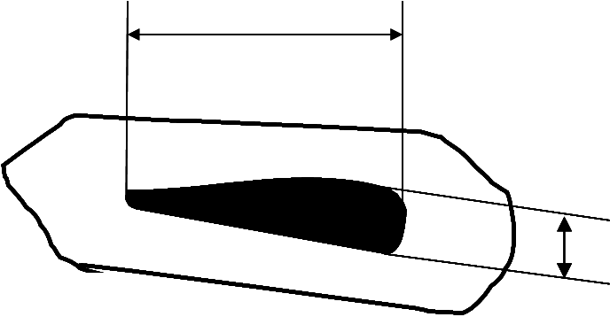
Width

Ad. 38: Seed: hardness

Hardness of tegmen is assessed by chewing the arils. Soft means easy to chew. Hard means difficult to chew.

Ad. 39: Time of beginning of flowering

The beginning of flowering is considered as the time when 25% of the flowers are fully open.

Ad. 40: Time of maturity for consumption

The time of maturity is considered as the time when more than 75% of the fruits are fully colored.

Literature

Holland, D., Hatib, K., Bar-Ya’akov, I., 2009: Pomegranate: Botany, Horticulture, Breeding. In: Horticultural Reviews. Volume 35. Ed. Janick, J. John Wiley and Sons, Inc. Hoboken. New Jersey, US, pp. 127-191.

Melgarejo, P., Salazar, D., 2003: Tratado de fruticultura para zonas áridasy semiáridas. Volumen II. Algarrobo, grandado y jinjolero. AMV. Ediciones Mundiprensa.

Morton, J., 1987: Pomegranate. In: Fruits of warm climates. Ed. Morton, J. Miami FL. pp. 352-355.

Özgüven, A., 2006: Proceedings of the First International Symposium on Pomegranate and Minor Mediterranean Fruits. Acta Horticulturae 818. Adana, TR.

Technical Questionnaire

TECHNICAL QUESTIONNAIRE |  |  |  | Page {x} of {y} |  | Reference Number:
 |  |  |  |  |  | Application date:
 |  |  |  |  |  | (not to be filled in by the applicant)
TECHNICAL QUESTIONNAIRE
to be completed in connection with an application for plant breeders’ rights

1. Subject of the Technical Questionnaire
1.1 Botanical name |  |  | Punica granatum L.
1.2 Common name |  |  | Pomegranate
2. Applicant
Name
Address
Telephone No.
Fax No.
E-mail address
Breeder (if different from applicant)
3. Proposed denomination and breeder’s reference
Proposed denomination
(if available)

Breeder’s reference
#4. Information on the breeding scheme and propagation of the variety

4.1 Breeding scheme

Variety resulting from:

4.1.1 Crossing

(a) controlled cross [ ]
(please state parent varieties)

(…………………..……………..…) x (……………..…………………..…)
female parent male parent

(b) partially known cross [ ]
(please state known parent variety(ies))

(…………………..……………..…) x (……………..…………………..…)
female parent male parent

(c) unknown cross [ ]

4.1.2 Mutation [ ]
(please state parent variety)

4.1.3 Discovery and development [ ]
(please state where and when discovered and how developed)

4.1.4 Other [ ]
(please provide details)

4.2 Method of propagating the variety

4.2.1 Vegetative propagation

(a) cuttings [ ]

(b) in vitro propagation [ ]

(c) other (state method) [ ]

4.2.2 Seed [ ]

4.2.3 Other [ ]
(please provide details)

5. Characteristics of the variety to be indicated (the number in brackets refers to the corresponding characteristic in Test Guidelines; please mark the note which best corresponds).

 | Characteristics |  |  |  |  |  | Example Varieties |  |  | Note
5.1  (17) | Corolla: color
 | white |  |  |  |  |  |  |  |  | 1[ ]
 | pink |  |  |  |  |  |  |  |  | 2[ ]
 | light orange |  |  |  |  |  | Borde |  |  | 3[ ]
 | medium orange |  |  |  |  |  | Mollar de Elche, Wonderful |  |  | 4[ ]
 | orange-red |  |  |  |  |  |  |  |  | 5[ ]
 | medium red |  |  |  |  |  |  |  |  | 6[ ]
5.2  (23) | Fruit: width
 | very narrow |  |  |  |  |  |  |  |  | 1[ ]
 | very narrow to narrow |  |  |  |  |  |  |  |  | 2[ ]
 | narrow |  |  |  |  |  |  |  |  | 3[ ]
 | narrow to medium |  |  |  |  |  |  |  |  | 4[ ]
 | medium |  |  |  |  |  | Borde |  |  | 5[ ]
 | medium to broad |  |  |  |  |  |  |  |  | 6[ ]
 | broad |  |  |  |  |  | Mollar de Elche, Wonderful |  |  | 7[ ]
 | broad to very broad |  |  |  |  |  |  |  |  | 8[ ]
 | very broad |  |  |  |  |  |  |  |  | 9[ ]
5.3  (26) | Fruit: over color
 | orange |  |  |  |  |  | Mollar de Albatera, Mollar de Elche |  |  | 1[ ]
 | orange red |  |  |  |  |  |  |  |  | 2[ ]
 | pink |  |  |  |  |  |  |  |  | 3[ ]
 | pink red |  |  |  |  |  | Valenciano |  |  | 4[ ]
 | medium red |  |  |  |  |  | Acco |  |  | 5[ ]
 | red purple |  |  |  |  |  |  |  |  | 6[ ]
 | purple |  |  |  |  |  | Kamel |  |  | 7[ ]
 | dark purple |  |  |  |  |  |  |  |  | 8[ ]
 | Characteristics |  |  |  |  |  | Example Varieties |  |  | Note
5.4  (35) | Aril: main color
 | white |  |  |  |  |  | Mollar de Elche |  |  | 1[ ]
 | light pink |  |  |  |  |  | Valenciano |  |  | 2[ ]
 | medium pink |  |  |  |  |  | Tendral |  |  | 3[ ]
 | dark pink |  |  |  |  |  |  |  |  | 4[ ]
 | light red |  |  |  |  |  |  |  |  | 5[ ]
 | medium red |  |  |  |  |  |  |  |  | 6[ ]
 | dark red |  |  |  |  |  | Wonderful |  |  | 7[ ]
5.5  (38) | Seed: hardness
 | soft |  |  |  |  |  | Mollar de Elche, Valenciano |  |  | 1[ ]
 | medium |  |  |  |  |  | Wonderful |  |  | 2[ ]
 | hard |  |  |  |  |  | Borde |  |  | 3[ ]
5.6  (40) | Time of maturity for consumption
 | very early |  |  |  |  |  |  |  |  | 1[ ]
 | very early to early |  |  |  |  |  |  |  |  | 2[ ]
 | early |  |  |  |  |  | Valenciano |  |  | 3[ ]
 | early to medium |  |  |  |  |  |  |  |  | 4[ ]
 | medium |  |  |  |  |  | Mollar de Elche, Wonderful |  |  | 5[ ]
 | medium to late |  |  |  |  |  |  |  |  | 6[ ]
 | late |  |  |  |  |  |  |  |  | 7[ ]
 | late to very late |  |  |  |  |  |  |  |  | 8[ ]
 | very late |  |  |  |  |  |  |  |  | 9[ ]
6. Similar varieties and differences from these varieties

Please use the following table and box for comments to provide information on how your candidate variety differs from the variety (or varieties) which, to the best of your knowledge, is (or are) most similar. This information may help the examination authority to conduct its examination of distinctness in a more efficient way.

Denomination(s) of variety(ies) similar to your candidate variety |  | Characteristic(s) in which your candidate variety differs from the similar variety(ies) |  |  | Describe the expression of the characteristic(s) for the similar variety(ies) |  |  | Describe the expression of the characteristic(s) for your candidate variety
Example |  | Fruit: over color |  |  | orange |  |  | orange red
Comments:

#7. Additional information which may help in the examination of the variety

7.1 In addition to the information provided in sections 5 and 6, are there any additional characteristics which may help to distinguish the variety?

Yes [ ] No [ ]

(If yes, please provide details)

7.2 Are there any special conditions for growing the variety or conducting the examination?

Yes [ ] No [ ]

(If yes, please provide details)

  - Other information

What is this variety used for?

Fruit [ ] Ornamental [ ]

A representative color image of the variety should accompany the Technical Questionnaire.

8. Authorization for release

(a) Does the variety require prior authorization for release under legislation concerning the protection of the environment, human and animal health?

Yes [ ] No [ ]

(b) Has such authorization been obtained?

Yes [ ] No [ ]

If the answer to (b) is yes, please attach a copy of the authorization.

9. Information on plant material to be examined or submitted for examination.

9.1 The expression of a characteristic or several characteristics of a variety may be affected by factors, such as pests and disease, chemical treatment (e.g. growth retardants or pesticides), effects of tissue culture, different rootstocks, scions taken from different growth phases of a tree, etc.

9.2 The plant material should not have undergone any treatment which would affect the expression of the characteristics of the variety, unless the competent authorities allow or request such treatment. If the plant material has undergone such treatment, full details of the treatment must be given. In this respect, please indicate below, to the best of your knowledge, if the plant material to be examined has been subjected to:

(a) Microorganisms (e.g. virus, bacteria, phytoplasma) Yes [ ] No [ ]

(b) Chemical treatment (e.g. growth retardant, pesticide) Yes [ ] No [ ]

(c) Tissue culture Yes [ ] No [ ]

(d) Other factors Yes [ ] No [ ]

Please provide details for where you have indicated “yes”.

……………………………………………………………

10. I hereby declare that, to the best of my knowledge, the information provided in this form is correct:

Applicant’s name

Signature Date

[End of document]

* These names were correct at the time of the introduction of these Test Guidelines but may be revised or updated. [Readers are advised to consult the UPOV Code, which can be found on the UPOV Website (www.upov.int), for the latest information.]
# Authorities may allow certain of this information to be provided in a confidential section of the Technical Questionnaire.
# Authorities may allow certain of this information to be provided in a confidential section of the Technical Questionnaire.

