 |  | E  TG/275/1 Corr.  ORIGINAL: English  DATE: 2011-10-20 + 2016-08-17
INTERNATIONAL UNION FOR THE PROTECTION OF NEW VARIETIES OF PLANTS
GENEVA

 | CAMELLIA  UPOV Code: CMLIA  (excluding CMLIA_SIN)  Camellia L.  excluding Camellia sinensis L. O.Kuntze | *

GUIDELINES

FOR THE CONDUCT OF TESTS

FOR DISTINCTNESS, UNIFORMITY AND STABILITY

Alternative Names:*

Botanical name | English | French | German | Spanish
Camellia L. | Camellia | Camélia | Kamelie | Camelia

The purpose of these guidelines (“Test Guidelines”) is to elaborate the principles contained in the General Introduction (document TG/1/3), and its associated TGP documents, into detailed practical guidance for the harmonized examination of distinctness, uniformity and stability (DUS) and, in particular, to identify appropriate characteristics for the examination of DUS and production of harmonized variety descriptions.

ASSOCIATED DOCUMENTS

These Test Guidelines should be read in conjunction with the General Introduction and its associated TGP documents.

Other associated UPOV documents: TG/TEA (Camellia sinensis L. O. Kuntze).

TABLE OF CONTENTS PAGE

1. Subject of these Test Guidelines 3
2. Material Required 3
3. Method of Examination 3
3.1 Number of Growing Cycles 3
3.2 Testing Place 3
3.3 Conditions for Conducting the Examination 3
3.4 Test Design 4
3.5 Additional Tests 4
4. Assessment of Distinctness, Uniformity and Stability 4
4.1 Distinctness 4
4.2 Uniformity 5
4.3 Stability 5
5. Grouping of Varieties and Organization of the Growing Trial 6
6. Introduction to the Table of Characteristics 7
6.1 Categories of Characteristics 7
6.2 States of Expression and Corresponding Notes 7
6.3 Types of Expression 8
6.4 Example Varieties 8
6.5 Legend 9
7. Table of Characteristics/Tableau des caractères/Merkmalstabelle/Tabla de caracteres 10
8. Explanations on the Table of Characteristics 22
8.1 Explanations covering several characteristics 22
8.2 Explanations for individual characteristics 22
9. Literature 32
10. Technical Questionnaire 33

Subject of these Test Guidelines
These Test Guidelines apply to all varieties of Camellia L. excluding Camellia sinensis (L.) O. Kuntze.

Material Required
2.1 The competent authorities decide on the quantity and quality of the plant material required for testing the variety and when and where it is to be delivered. Applicants submitting material from a State other than that in which the testing takes place must ensure that all customs formalities and phytosanitary requirements are complied with.

2.2 The material is to be supplied in the form of plants capable of flowering and expressing all relevant characteristics of the variety during the first or later growing cycle.

2.3 The minimum quantity of plant material, to be supplied by the applicant, should be:

10 plants.

2.4 The plant material supplied should be visibly healthy, not lacking in vigor, nor affected by any important pest or disease.

2.5 The plant material should not have undergone any treatment which would affect the expression of the characteristics of the variety, unless the competent authorities allow or request such treatment. If it has been treated, full details of the treatment must be given.

Method of Examination

3.1 Number of Growing Cycles
The minimum duration of tests should normally be a single growing cycle.

3.2 Testing Place
Tests are normally conducted at one place. In the case of tests conducted at more than one place, guidance is provided in TGP/9 “Examining Distinctness”.

3.3 Conditions for Conducting the Examination
3.3.1 The tests should be carried out under conditions ensuring satisfactory growth for the expression of the relevant characteristics of the variety and for the conduct of the examination.

3.3.2 Observation of color by eye

Because daylight varies, color determinations made against a color chart should be made either in a suitable cabinet providing artificial daylight or in the middle of the day in a room without direct sunlight. The spectral distribution of the illuminant for artificial daylight should conform with the CIE Standard of Preferred Daylight D 6500 and should fall within the tolerances set out in the British Standard 950, Part I. These determinations should be made with the plant part placed against a white background. The color chart and version used should be specified in the variety description.

3.4 Test Design
3.4.1 Each test should be designed to result in a total of at least 10 plants.

3.4.2 The design of the tests should be such that plants or parts of plants may be removed for measurement or counting without prejudice to the observations which must be made up to the end of the growing cycle.

3.5 Additional Tests
Additional tests, for examining relevant characteristics, may be established.

Assessment of Distinctness, Uniformity and Stability

4.1 Distinctness
4.1.1 General Recommendations
It is of particular importance for users of these Test Guidelines to consult the General Introduction prior to making decisions regarding distinctness. However, the following points are provided for elaboration or emphasis in these Test Guidelines.

4.1.2 Consistent Differences
The differences observed between varieties may be so clear that more than one growing cycle is not necessary. In addition, in some circumstances, the influence of the environment is not such that more than a single growing cycle is required to provide assurance that the differences observed between varieties are sufficiently consistent. One means of ensuring that a difference in a characteristic, observed in a growing trial, is sufficiently consistent is to examine the characteristic in at least two independent growing cycles.

4.1.3 Clear Differences
Determining whether a difference between two varieties is clear depends on many factors, and should consider, in particular, the type of expression of the characteristic being examined, i.e. whether it is expressed in a qualitative, quantitative, or pseudo-qualitative manner. Therefore, it is important that users of these Test Guidelines are familiar with the recommendations contained in the General Introduction prior to making decisions regarding distinctness.

4.1.4 Number of Plants / Parts of Plants to be Examined
Unless otherwise indicated, for the purposes of distinctness, all observations on single plants should be made on 9 plants or parts taken from each of 9 plants and any other observations made on all plants in the test, disregarding any off-type plants.

4.1.5 Method of Observation
The recommended method of observing the characteristic for the purposes of distinctness is indicated by the following key in the second column of the Table of Characteristics (see document TGP/9 “Examining Distinctness”, Section 4 “Observation of characteristics”):

MG: single measurement of a group of plants or parts of plants
MS: measurement of a number of individual plants or parts of plants
VG: visual assessment by a single observation of a group of plants or parts of plants
VS: visual assessment by observation of individual plants or parts of plants

Type of observation: visual (V) or measurement (M)

“Visual” observation (V) is an observation made on the basis of the expert’s judgment. For the purposes of this document, “visual” observation refers to the sensory observations of the experts and, therefore, also includes smell, taste and touch. Visual observation includes observations where the expert uses reference points (e.g. diagrams, example varieties, side-by-side comparison) or non-linear charts (e.g. color charts). Measurement (M) is an objective observation against a calibrated, linear scale e.g. using a ruler, weighing scales, colorimeter, dates, counts, etc.

Type of record: for a group of plants (G) or for single, individual plants (S)

For the purposes of distinctness, observations may be recorded as a single record for a group of plants or parts of plants (G), or may be recorded as records for a number of single, individual plants or parts of plants (S). In most cases, “G” provides a single record per variety and it is not possible or necessary to apply statistical methods in a plant-by-plant analysis for the assessment of distinctness.

In cases where more than one method of observing the characteristic is indicated in the Table of Characteristics (e.g. VG/MG), guidance on selecting an appropriate method is provided in document TGP/9, Section 4.2.

4.2 Uniformity
4.2.1 It is of particular importance for users of these Test Guidelines to consult the General Introduction prior to making decisions regarding uniformity. However, the following points are provided for elaboration or emphasis in these Test Guidelines:

4.2.2 For the assessment of uniformity, a population standard of 1% and an acceptance probability of at least 95 % should be applied. In the case of a sample size of 10 plants, 1 off-type is allowed.

4.3 Stability
4.3.1 In practice, it is not usual to perform tests of stability that produce results as certain as those of the testing of distinctness and uniformity. However, experience has demonstrated that, for many types of variety, when a variety has been shown to be uniform, it can also be considered to be stable.

4.3.2 Where appropriate, or in cases of doubt, stability may be further examined by testing a new plant stock to ensure that it exhibits the same characteristics as those shown by the initial material supplied.

Grouping of Varieties and Organization of the Growing Trial
5.1 The selection of varieties of common knowledge to be grown in the trial with the candidate varieties and the way in which these varieties are divided into groups to facilitate the assessment of distinctness are aided by the use of grouping characteristics.

5.2 Grouping characteristics are those in which the documented states of expression, even where produced at different locations, can be used, either individually or in combination with other such characteristics: (a) to select varieties of common knowledge that can be excluded from the growing trial used for examination of distinctness; and (b) to organize the growing trial so that similar varieties are grouped together.

5.3 The following have been agreed as useful grouping characteristics:

(a) Plant: growth habit (characteristic 1)
(b) Leaf blade: length (characteristic 9)
(c) Leaf blade: margin (characteristic 23)
(d) Flower: diameter (characteristic 29)
(e) Flower: form (characteristic 30)
(f) Flower: presence of petaloids (characteristic 31)
(g) Petal: main color (characteristic 41), with the following groups:
Gr.1: white
Gr.2: yellow
Gr.3: orange
Gr.4: pink
Gr.5: red
Gr.6: purple
(h) Petal: secondary color (characteristic 43)
(i) Petal: distribution of secondary color (characteristic 44)
(j) Time of flowering (characteristic 50)

5.4 Guidance for the use of grouping characteristics, in the process of examining distinctness, is provided through the General Introduction and document TGP/9 “Examining Distinctness”.

Introduction to the Table of Characteristics

6.1 Categories of Characteristics
6.1.1 Standard Test Guidelines Characteristics

Standard Test Guidelines characteristics are those which are approved by UPOV for examination of DUS and from which members of the Union can select those suitable for their particular circumstances.

6.1.2 Asterisked Characteristics

Asterisked characteristics (denoted by *) are those included in the Test Guidelines which are important for the international harmonization of variety descriptions and should always be examined for DUS and included in the variety description by all members of the Union, except when the state of expression of a preceding characteristic or regional environmental conditions render this inappropriate.

6.2 States of Expression and Corresponding Notes
6.2.1 States of expression are given for each characteristic to define the characteristic and to harmonize descriptions. Each state of expression is allocated a corresponding numerical note for ease of recording of data and for the production and exchange of the description.

6.2.2 In the case of qualitative and pseudo-qualitative characteristics (see Chapter 6.3), all relevant states of expression are presented in the characteristic. However, in the case of quantitative characteristics with 5 or more states, an abbreviated scale may be used to minimize the size of the Table of Characteristics. For example, in the case of a quantitative characteristic with 9 states, the presentation of states of expression in the Test Guidelines may be abbreviated as follows:

State | Note
small | 3
medium | 5
large | 7

However, it should be noted that all of the following 9 states of expression exist to describe varieties and should be used as appropriate:

State | Note
very small | 1
very small to small | 2
small | 3
small to medium | 4
medium | 5
medium to large | 6
large | 7
large to very large | 8
very large | 9

6.2.3 Further explanation of the presentation of states of expression and notes is provided in document TGP/7 “Development of Test Guidelines”.

6.3 Types of Expression
An explanation of the types of expression of characteristics (qualitative, quantitative and pseudo-qualitative) is provided in the General Introduction.

6.4 Example Varieties
6.4.1 Where appropriate, example varieties are provided to clarify the states of expression of each characteristic.

6.4.2 Example varieties contained in the Table of Characteristics originally belong to following parent species:

Camellia amplexicaulis: Fen Bao Jing Cha

Camellia changii (Camellia azalea): Chun Jiang Zhi Xia

Camellia japonica: Anticipation, Bai Bao Ta, Bai Mu Dan, Betty Foy Sanders, Bian Ye Kuan Cai Dai, Cai Fu Rong, Cai Ye Hong Lu Zhen, Camilla Hebert, Chang E Cai, Chong Qing Hong, Colettii, Da Hong Jin Xin, Da Hong Mu Dan, Da Zhu Sha, Elegans Champagne, Fei Bie Cha, Fen Fu Rong, Fen Xia, Grape Soda, Kujaku-tsubaki, Helen Bower, Holly Bright, Hong Lu Zhen, Hong Shi Ba Xue Shi, Hua Bao Zhu, Hua Mu Dan, Jin Jiang Mu Dan, Jin Pan Li Zhi, Kingyo-tsubaki, Lipstick, L.T. Dees, Margaret Davis, Mary Agnes Patin, Masterpiece, Night Rider, Nokogiriba, Nuccio’s # 4310, Nuccio’s Bella Rossa, Nuccio’s Cameo, Pen Sha, Pu Tao Hong, Raspberry Ice, Ren Mian Tao Hua, Royal Velvet, Sai Luo Yang, Shi Ba Xue Shi, Shi Zi Xiao, Swan Lake, Unryu-tsubaki, Wen Ban Fei Ye Cha, Xiao Tao Hong, Xu Bian, Xue Ta, Yi Lan Jiao, Zao Chun Da Hong Qiu, Zhuang Yuan Hong

Camellia minutiflora: Wei Hua Lian Rui Cha

Camellia reticulata: Bill Goertz, Da Li Cha, Da Tao Hong, Hou Ye De Chi, Massee Lane, Pink Dalhlia, Tong Zi Mian, Zhu Sha Zi Pao

Camellia sasanqua: First Cover, Xia Mei Gui

Hybrids: Dong Hai Guang Yao

6.5 Legend
(*) Asterisked characteristic – see Chapter 6.1.2

QL Qualitative characteristic – see Chapter 6.3
QN Quantitative characteristic – see Chapter 6.3
PQ Pseudo-qualitative characteristic – see Chapter 6.3

MG, MS, VG, VS – see Chapter 4.1.5

(a)-(g) See Explanations on the Table of Characteristics in Chapter 8.1.
(+) See Explanations on the Table of Characteristics in Chapter 8.2.

Table of Characteristics/Tableau des caractères/Merkmalstabelle/Tabla de caracteres
 |  | English | français | deutsch | español | Example Varieties/  Exemples/  Beispielssorten/  Variedades ejemplo | Note/  Nota
1.  (*)  (+) | VG | Plant: growth habit | Plante : port | Pflanze: Wuchsform | Planta: porte
PQ |  | upright | dressé | aufrecht | erecto | Anticipation | 1
 |  | semi-upright | demi-dressé | halbaufrecht | semierecto | Mary Agnes Patin | 2
 |  | spreading | étalé | breitwüchsig | extendido | Masterpiece | 3
 |  | drooping | retombant | überhängend | colgante | Kujaku-tsubaki | 4
 |  | horizontal | horizontal | waagerecht | horizontal | First Cover | 5
2. | VG | Branch: zigzagging | Ramification : zigzagante | Zweig: Zickzackform | Rama: zigzagueo
QL |  | absent | absente | fehlend | ausente | Hong Lu Zhen | 1
 |  | present | présente | vorhanden | presente | Unryu-tsubaki | 9
3.  (*) | VG | Plant: density of foliage | Plante : densité du feuillage | Pflanze: Dichte des Laubs | Planta: densidad del follaje
QN |  | sparse | faible | locker | baja | Da Tao Hong | 3
 |  | medium | moyenne | mittel | media | Chang E Cai | 5
 |  | dense | dense | dicht | alta | Pu Tao Hong | 7
4. | VG | Vegetative bud: color | Bourgeon : couleur | Vegetative Knospe: Farbe | Yema de madera: color
PQ | (a) | yellowish green | vert jaunâtre | gelblichgrün | verde amarillento |  | 1
 |  | green | vert | grün | verde | Elegans Champagne | 2
 |  | purple green | vert pourpre | dunkelgrün | púrpura verde | Ren Mian Tao Hua | 3
 |  | light pink | rose clair | hellrosa | rosa claro | Fen Fu Rong | 4
 |  | purple red | rouge pourpre | purpurrot | rojo púrpura | Nuccio’s Bella Rossa | 5
 |  | dark red | rouge foncé | dunkelrot | rojo oscuro | Night Rider | 6
5.  (*)  (+) | VG | Terminal vegetative bud: number | Bourgeon végétatif : nombre | Terminale vegetative Knospe: Anzahl | Yema de madera terminal: número
QN | (a) | one | un | eine | una |  | 1
 |  | two | deux | zwei | dos |  | 2
 |  | more than two | plus de deux | mehr als zwei | más de dos |  | 3
6.  (*) | VG | Young shoot: color | Jeune pousse : couleur | Jungtrieb: Farbe | Tallo joven: color
PQ | (b) | yellowish green | vert jaunâtre | gelblichgrün | verde amarillento |  | 1
 |  | green | verte | grün | verde |  | 2
 |  | pink | rose | rosa | rosa |  | 3
 |  | yellowish brown | brun jaunâtre | gelblichbraun | amarillento marrón |  | 4
 |  | reddish brown | brun rougeâtre | rötlichbraun | marrón rojizo |  | 5
7.  (*)  (+) | VG | Leaf: attitude | Feuille : port | Blatt: Stellung | Hoja: porte
QN | (c) | upwards | vers le haut | aufwärts gerichtet | hacia arriba | Nuccio’s Cameo | 1
 |  | outwards | vers l’extérieur | abstehend | hacia afuera | Shi Zi Xiao | 2
 |  | downwards | vers le bas | abwärts gerichtet | hacia abajo |  | 3
8.  (*)  (+) | VG | Leaf: arrangement | Feuille : disposition | Blatt: Anordnung | Hoja: disposición
PQ | (c) | alternate | alternées | alternierend | alterna |  | 1
 |  | perpendicular | perpendiculaires | senkrecht | perpendicular |  | 2
 |  | spiral | en spirale | spiralförmig | espiral |  | 3
9.  (*) | VG/MS | Leaf blade: length | Limbe : longueur | Blattspreite: Länge | Limbo: longitud
QN | (c) | short | courte | kurz | corta | Xiao Mei Gui | 3
 |  | medium | moyenne | mittel | media | Hong Lu Zhen | 5
 |  | long | longue | lang | larga | Zhu Sha Zi Pao | 7
10. | VG/MS | Leaf blade: width | Limbe : largeur | Blattspreite: Breite | Limbo: anchura
QN | (c) | very narrow | très étroite | sehr schmal | muy estrecha |  | 1
 |  | narrow | étroite | schmal | estrecha | Xiao Mei Gui | 3
 |  | medium | moyenne | mittel | media | Chun Jiang Zhi Xia | 5
 |  | broad | large | breit | ancha | Hong Lu Zhen | 7
 |  | very broad | très large | sehr breit | muy ancha | Fen Bao Jing Cha | 9
11.  (*)  (+) | VG | Leaf blade: position of broadest part | Limbe : position de la partie la plus large | Blattspreite: Position der breitesten Stelle | Limbo: posición de la parte más ancha
QN | (c) | below middle third | en dessous du tiers moyen | unterhalb des mittleren Drittels | por debajo del tercio medio | Chun Jiang Zhi Xia | 1
 |  | in middle third | au tiers moyen | im mittleren Drittel | en el tercio medio | Fei Bie Cha | 2
 |  | above middle third | au-dessus du tiers moyen | oberhalb des mittleren Drittels | por encima del tercio medio | Hong Lu Zhen | 3
12.  (*)  (+) | VG | Leaf blade: shape of base | Limbe : forme de la base | Blattspreite: Form der Basis | Limbo: forma de la base
PQ | (c) | acute | aiguë | spitz | agudo | Pink Dalhlia | 1
 |  | obtuse | obtuse | stumpf | obtuso | Swan Lake | 2
 |  | rounded | ronde | abgerundet | redondeado | Massee Lane | 3
 |  | cordate | cordiforme | herzförmig | cordado | Fen Bao Jing Cha | 4
13.  (*)  (+) | VG | Leaf blade: shape of apex | Limbe : forme du sommet | Blattspreite: Form der Spitze | Limbo: forma del ápice
PQ | (c) | retuse | échancrée | eingedrückt | retuso | Chun Jiang Zhi Xia | 1
 |  | rounded | ronde | abgerundet | redondeado | Hen Tian Gao | 2
 |  | short acuminate | à pointe courte | kurz zugespitzt | acuminado corto y ancho | Hong Lu Zhen | 3
 |  | medium acuminate | à pointe moyenne | mäßig zugespitzt | acuminado medio |  | 4
 |  | long acuminate | à pointe longue | lang zugespitzt | acuminado largo | Kujaku-tsubaki | 5
 |  | divided | divisée | eingeschnitten | dividido | Kingyo-tsubaki | 6
14.  (*) | VG | Leaf blade: pubescence on upper side | Limbe : pubescence sur la face supérieure | Blattspreite: Behaarung der Oberseite | Limbo: pubescencia en el haz
QL | (c) | absent | absente | fehlend | ausente |  | 1
 |  | present | présente | vorhanden | presente |  | 9
15.  (*) | VG | Leaf blade: thickness | Limbe : épaisseur | Blattspreite: Dicke | Limbo: grosor
QN | (c) | thin | fine | dünn | fino | Xiao Mei Gui | 1
 |  | medium | moyenne | mittel | medio | Hong Lu Zhen | 2
 |  | thick | épaisse | dick | grueso | Hou Ye De Chi | 3
16.  (*) | VG | Leaf blade: venation on upper side | Limbe : nervation sur la face supérieure | Blattspreite: Äderung der Oberseite | Limbo: nervadura del haz
QN | (c) | weak | faible | gering | débil | Shi Zi Xiao | 1
 |  | medium | moyenne | mittel | media | Fen Xia | 2
 |  | strong | forte | stark | fuerte |  | 3
17.  (*) | VG | Leaf blade: glossiness of upper side | Limbe : brillance de la partie supérieure | Blattspreite: Glanz der Oberseite | Limbo: brillo del haz
QN | (c) | weak | faible | gering | débil | Swan Lake | 3
 |  | medium | moyenne | mittel | medio | Da Zhu Sha | 5
 |  | strong | forte | stark | fuerte | Royal Velvet | 7
18.  (*) | VG | Leaf blade: variegation | Limbe : panachure | Blattspreite: Panaschierung | Limbo: variegación
QL | (c) | absent | absente | fehlend | ausente |  | 1
 |  | present | présente | vorhanden | presente |  | 9
19.  (*) | VG | Leaf blade: Color of upper side (excluding variegation) | Limbe : couleur de la face supérieure (panachure exclue) | Blattspreite: Farbe der Oberseite (ohne Panaschierung) | Limbo: Color del haz (excluida la variegación)
PQ | (c) | yellowish green | vert jaunâtre | gelblichgrün | verde amarillento | Nuccio’s # 4310 | 1
 |  | light green | vert clair | hellgrün | verde claro | Xiao Tao Hong | 2
 |  | medium green | vert moyen | mittelgrün | verde medio | Hong Lu Zhen | 3
 |  | dark green | vert foncé | dunkelgrün | verde oscuro | Colettii | 4
 |  | grey green | vert gris | graugrün | verde grisáceo |  | 5
20.  (*) | VG | Leaf blade: color of variegation | Limbe : couleur de la panachure | Blattspreite: Farbe der Panaschierung | Limbo: color de la variegación
PQ | (c) | white | blanche | weiß | blanco | Dong Hai Guang Yao | 1
 |  | light yellow | jaune clair | hellgelb | amarillo claro | Bian Ye Kuan Cai Dai | 2
 |  | medium yellow | jaune moyen | mittelgelb | amarillo medio | Cai Ye Hong Lu Zhen | 3
21.  (*) | VG | Leaf blade: distribution of variegation | Limbe : répartition de la panachure | Blattspreite: Verteilung der Panaschierung | Limbo: distribución de la variegación
PQ | (c) | marginal only | seulement marginale | nur am Rand | sólo en el borde |  | 1
 |  | central zone only | seulement zone centrale | nur im Mittelbereich | sólo en la zona central |  | 2
 |  | irregular | irrégulière | unregelmäßig | irregular |  | 3
22.  (+) | VG | Leaf blade: shape in cross section | Limbe : forme en section transversale | Blattspreite: Form im Querschnitt | Limbo: forma en la sección transversal
QN | (c) | concave | concave | konkav | cóncavo | Tong Zi Mian | 1
 |  | flat | plate | flach | plano | Chang E Cai | 2
 |  | convex | convexe | konvex | convexo | Wen Ban Fei Ye Cha | 3
23.  (*)  (+) | VG | Leaf blade: margin | Limbe : bord | Blattspreite: Rand | Limbo: borde
PQ | (c) | entire | entier | ganzrandig | entero | Chun Jiang Zhi Xia | 1
 |  | serrulate | serrulé | fein gesägt | serrulado | L.T. Dees | 2
 |  | serrate | dentelé | gesägt | serrado | Nokogiriba | 3
 |  | bidentate | bidenté | doppelt gezähnt | bidentado | Bill Goertz | 4
24. | VG/MS | Petiole: length | Pétiole : longueur | Blattstiel: Länge | Peciolo: longitud
QN | (c) | very short | très courte | sehr kurz | muy corto | Fen Bao Jing Cha | 1
 |  | short | courte | kurz | corto | Hong Lu Zhen | 3
 |  | medium | moyenne | mittel | medio |  | 5
 |  | long | longue | lang | largo |  | 7
25.  (*)  (+) | VG | Sepal: position of broadest part | Sépale : position de la partie la plus large | Kelchblatt: Position der breitesten Stelle | Sépalo: posición de la parte más ancha
 | (d) | below middle third | en dessous du tiers moyen | unterhalb des mittleren Drittels | por debajo del tercio medio |  | 1
PQ |  | in middle third | au tiers moyen | im mittleren Drittel | en el tercio medio |  | 2
 |  | above middle third | au-dessus du tiers moyen | oberhalb des mittleren Drittels | por encima del tercio medio |  | 3
26.  (*) | VG | Sepal: color of outer side | Sépale : couleur de la partie extérieure | Kelchblatt: Farbe der Außenseite | Sépalo: color de la cara externa
PQ | (d) | yellow | jaune | gelb | amarillo | Grape Soda | 1
 |  | yellowish green | vert jaunâtre | gelblichgrün | verde amarillento | Xiao Tao Hong | 2
 |  | brown | brun | braun | marrón |  | 3
 |  | purple red | rouge pourpre | purpurrot | rojo púrpura |  | 4
27.  (+) | VG  (d) | Sepal: shape of apex | Sépale : forme de la pointe | Kelchblatt: Form der Spitze | Sépalo: forma del ápice
QN |  | obtuse | obtuse | stumpf | obtuso |  | 1
 |  | rounded | ronde | abgerundet | redondeado |  | 2
 |  | retuse | échancrée | eingedrückt | retuso |  | 3
28.  (*)  (+) | VG | Flower bud: arrangement | Bourgeon floral : disposition | Blütenknospe: Anordnung | Botón floral: disposición
 |  | terminal only | seulement terminale | nur terminal | sólo terminal |  | 1
PQ |  | terminal and axillary | terminale et axillaire | terminal und axillar | terminal y axilar |  | 2
 |  | axillary only | seulement axillaire | nur axillar | sólo axilar |  | 3
29.  (*) | MG/VG | Flower: diameter | Fleur : diamètre | Blüte: Durchmesser | Flor: diámetro
QN | (e) | very small | très petit | sehr klein | muy pequeño | Wei Hua Lian Rui Cha | 1
 |  | small | petit | klein | pequeño | Xiao Mei Gui | 3
 |  | medium | moyen | mittel | medio | Hong Lu Zhen | 5
 |  | large | grand | groß | grande | Da Li Cha | 7
 |  | very large | très grand | sehr groß | muy grande | Fen Bao Jing Cha | 9
30.  (*)  (+) | VG | Flower: form | Fleur : forme | Blüte: Typ | Flor: forma
PQ | (e) | single | simple | einfach | simple | Da Hong Jin Xin | 1
 |  | semi-double | demi-double | halbgefüllt | semidoble | Chun Jiang Zhi Xia | 2
 |  | anemone form | en forme d’anémone | anemonenförmig | en forma de anémona | Jin Pan Li Zhi | 3
 |  | peony form | en forme de pivoine | päonienförmig | en forma de peonía | Hua Mu Dan | 4
 |  | rose form double | double en forme de rose | rosenförmig gefüllt | en forma de rosa doble | Zhuang Yuan Hong | 5
 |  | formal double | double imbriquée | vollständig gefüllt | doble formal | Xue Ta | 6
31.  (*) | VG | Flower: presence of petaloids | Fleur : présence de pétaloïdes | Blüte: Vorhandensein von Petaloiden | Flor: presencia de petaloides
QL | (e) | absent | absents | fehlend | ausentes |  | 1
 |  | present | présents | vorhanden | presentes |  | 9
32.  (*) | MG/VG | Flower:number of petaloids | Fleur : nombre de pétaloïdes | Blüte: Anzahl Petaloiden | Flor:número de petaloides
QN | (e) | few | petit | gering | bajo | Bai Mu Dan | 3
 |  | medium | moyen | mittel | medio | Cai Fu Rong | 5
 |  | many | grand | groß | alto | Jin Pan Li Zhi | 7
33.  (+) | VG | Flower: petaloid organs | Fleur : organes pétaloïdes | Blüte: petaloide Organe | Flor: órganos petaloides
PQ | (e) | some stamens petaloid | quelques étamines pétaloïdes | einige Staubgefäße petaloid | algunos estambres |  | 1
 |  | all stamens petaloid | toutes les étamines pétaloïdes | alle Staubgefäße petaloid | todos los estambres |  | 2
 |  | all stamens and pistil petaloids | toutes les étamines et pistil pétaloïdes | alle Staubgefäße und Griffel petaloid | todos los estambres y el pistilo petaloides |  | 3
34. | VG | Petal: thickness | Pétale : épaisseur | Blütenblatt: Dicke | Pétalo: grosor
QN | (f) | thin | fine | dünn | fino | Xiao Mei Gui | 1
 |  | medium | moyenne | mittel | medio | Xiao Tao Hong | 2
 |  | thick | épaisse | dick | grueso |  | 3
35.  (*)  (+) | VG | Petal: shape of apex | Pétale : forme du sommet | Blütenblatt: Form der Spitze | Pétalo: forma del ápice
PQ | (f) | obtuse | obtus | stumpf | obtuso |  | 1
 |  | rounded | rond | abgerundet | redondeado |  | 2
 |  | retuse | échancré | eingedrückt | retuso |  | 3
36. | VG | Petal: number of incisions of margin | Pétale : nombre d’incisions du bord | Blütenblatt: Anzahl der Randeinschnitte | Pétalo: número de incisiones del borde
QN | (f) | absent or few | nul ou petit | fehlend oder gering | ausente o muy bajo | Chun Jiang Zhi Xia | 1
 |  | medium | moyen | mittel | medio |  | 2
 |  | many | grand | groß | alto | Xu Bian | 3
37.  (*)  (+) | VG | Petal: curvature of longitudinal axis | Pétale : courbure de l’axe longitudinal | Blütenblatt: Biegung der Längsachse | Pétalo: curvatura del eje longitudinal
QN | (f) | incurved | incurvé | aufgebogen | incurvado |  | 1
 |  | flat | plat | flach | plano |  | 2
 |  | recurved | recourbé | zurückgebogen | recurvado |  | 3
38.  (*)  (+) | VG | Flower: shape of petals of first outer row | Fleur : forme des pétales du premier rang externe | Blüte: Form der Blütenblätter der ersten Außenreihe | Flor: forma de los pétalos de la fila exterior
PQ | (f) | ovate | ovale | eiförmig | oval | Helen Bower | 1
 |  | oblong | oblong | rechteckig | oblongo |  | 2
 |  | circular | circulaire | kreisförmig | circular | Swan Lake | 3
 |  | oblate | arrondi aplati | breitrund | oblato |  | 4
 |  | obovate | obovale | verkehrt eiförmig | oboval | Lipstick | 5
 |  | obcordate | obcordé | verkehrt herzförmig | obcordado | Jin Pan Li Zhi | 6
39.  (*)  (+) | VG | Petal: undulation of margin | Pétale : ondulation du bord | Blütenblatt: Randwellung | Pétalo: ondulación del borde
QN | (f) | absent or weak | absente ou faible | fehlend oder gering | ausente o débil | Shi Ba Xue Shi | 1
 |  | medium | moyenne | mittel | media | Raspberry Ice | 2
 |  | strong | forte | stark | fuerte | Holly Bright | 3
40.  (+) | VG | Petal: conspicuousness of veins | Pétale : netteté des nervures | Blütenblatt: Ausprägung der Adern | Pétalo: visibilidad de la nervadura
QN | (f) | weak | faible | gering | débil | Bai Bao Ta | 1
 |  | medium | moyenne | mittel | media | Chun Jiang Zhi Xia | 2
 |  | strong | forte | stark | fuerte | Hong Shi Ba Xue Shi | 3
41. (*)  (+) | VG | Petal: main color | Pétale : couleur principale | Blütenblatt: Hauptfarbe | Pétalo: color principal
PQ | (f) | RHS Colour Chart (indicate reference number) | Code de couleurs RHS (indiquer le numéro de référence) | RHS-Farbkarte (Nummer angeben) | Carta de colores RHS (indíquese el número de referencia)
42.  (*) | VG | Petal: distribution of shading of main color (excluding variegation) | Pétale : répartition du dégradé de la couleur principale (panachure exclue) | Blütenblatt: Verteilung der Schattierung der Hauptfarbe (ohne Panaschierung) | Pétalo: distribución del sombreado del color principal (excluida la variegación)
PQ | (f) | evenly shaded | uniformément dégradé | gleichmäßig schattiert | uniformemente sombreado |  | 1
 |  | darkest in the central zone | plus sombre sur la zone centrale | dunkler im Innenbereich | más oscura en la zona central |  | 2
 |  | darkest in the marginal zone | plus sombre sur la zone marginale | dunkler am Randbereich | más oscura en la zona central |  | 3
 |  | darkest towards the base | plus sombre vers la base | dunkler zur Basis hin | más oscura hacia la base |  | 4
43.  (*)  (+) | VG | Petal: secondary color | Pétale : couleur secondaire | Blütenblatt: Sekundärfarbe | Pétalo: color secundario
PQ | (f) | RHS Colour Chart (indicate reference number) | Code de couleurs RHS (indiquer le numéro de référence) | RHS-Farbkarte (Nummer angeben) | Carta de colores RHS (indíquese el número de referencia)
44.  (*)  (+) | VG | Petal: distribution of secondary color | Pétale : répartition de la couleur secondaire | Blütenblatt: Verteilung der Sekundärfarbe | Pétalo: distribución del color secundario
 | (f) | blotched | en taches | gefleckt | manchada | Pen Sha | 1
 |  | central bar | barre centrale | Mittelstreifen | raya central | Hua Bao Zhu | 2
 |  | striated | striée | gestreift | estriada | Yi Lan Jiao | 3
 |  | marginal | marginale | am Rand | marginal | Margaret Davis | 4
 |  | striped and blotched | en bandes et en taches | gestreift und gefleckt | rayada y manchada |  | 5
 |  | basal zone | zone basale | Basisbereich | zona basal |  | 6
45.  (*)  (+) | VG | Stamens: arrangement | Étamines : disposition | Staubgefäße: Anordnung | Estambres: disposición
PQ | (g) | sasanqua | sasanqua | sasanquaförmig | sasanqua | Xiao Mei Gui | 1
 |  | circular | circulaire | kreisförmig | circular | Sai Luo Yang | 2
 |  | apricot | abricot | aprikosenförmig | albaricoque |  | 3
 |  | tea whisk | fouet à thé | teebesenförmig | batidor de bambú | Da Hong Jin Xin | 4
 |  | pinched | pincée | gestutzt | pinzada |  | 5
 |  | tubular | tubuleuse | röhrenförmig | tubular |  | 6
 |  | split | divisée | gespalten | separada | Jin Jiang Mu Dan | 7
 |  | dispersed | dispersée | verstreut | dispersa | Da Hong Mu Dan | 8
46. | MG | Style: number of splits | Style : nombre de scissions | Griffel: Anzahl der Spalten | Estilo: número de separaciones
QN | (g) | one | une | eine | una |  | 1
 |  | two | deux | zwei | dos |  | 2
 |  | three | trois | drei | tres |  | 3
 |  | four | quatre | vier | cuatro |  | 4
 |  | five | cinq | fünf | cinco |  | 5
47.  (+) | VG | Style: position of splitting | Style : position de la scission | Griffel: Position der Griffelspaltung | Estilo: posición de la división
QN | (g) | low | basse | niedrig | baja |  | 1
 |  | medium | moyenne | mittel | media |  | 2
 |  | high | élevée | hoch | alta |  | 3
48.  (*)  (+) | VG | Stigma: position in relation to stamens | Stigmate : position par rapport aux étamines | Narbe: Stellung im Vergleich zu den Staubgefäßen | Estigma: posición en relación con los estambres
QN | (g) | below | en dessous | unterhalb | por debajo |  | 1
 |  | same level | au même niveau | auf gleicher Höhe | al mismo nivel |  | 2
 |  | above | au-dessus | oberhalb | por encima |  | 3
49. | VG | Ovary: hairs | Ovaire : pilosité | Fruchtknoten: Behaarung | Ovario: pelos
QL | (g) | absent | absente | fehlend | ausentes |  | 1
 |  | present | présente | vorhanden | presentes |  | 9
50.  (*) | MG | Time of flowering | Époque de floraison | Zeitpunkt der Blüte | Época de la floración
QN |  | very early | très précoce | sehr früh | muy temprana | Chun Jiang Zhi Xia | 1
 |  | early | précoce | früh | temprana | Xiao Mei Gui | 3
 |  | medium | moyenne | mittel | media | Zao Chun Da Hong Qiu | 5
 |  | late | tardive | spät | tardía | Chong Qing Hong | 7
 |  | very late | très tardive | sehr spät | muy tardía | Da Hong Jin Xin | 9

Explanations on the Table of Characteristics

8.1 Explanations covering several characteristics
Characteristics containing the following key in the second column of the Table of Characteristics should be examined as indicated below:

(a) Observations should be made on buds just before they sprout in the spring.
(b) Observations should be made on young shoots.
(c) Observations should be made on the mature leaves in the middle third of the shoot in summer or autumn.
(d) Observations should be made on the sepals just before flowering.
(e) Observations should be made on fully open flowers.
(f) Observations should be made on petals in first outer row.
(g) Flower: diagram.

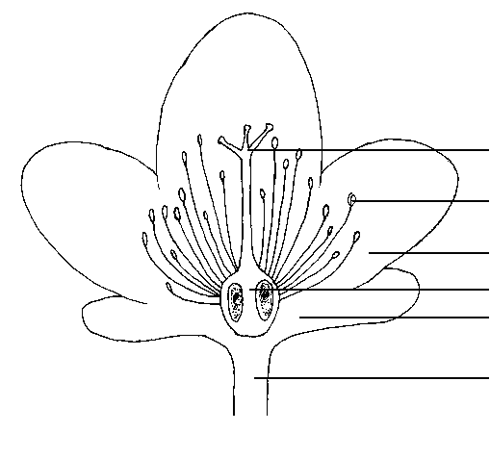
style splitting

stamen

petal
ovary
calyx

pedicel

8.2 Explanations for individual characteristics
Ad. 1: Plant: growth habit

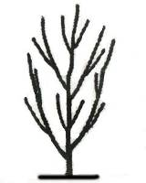 | 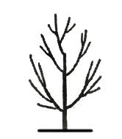 | 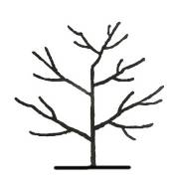 | 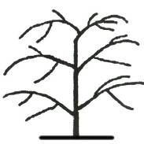 | 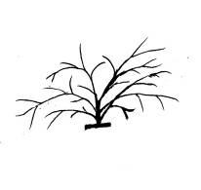
1 | 2 | 3 | 4 | 5
upright | semi-upright | spreading | drooping | horizontal

Ad. 5: Terminal vegetative bud: number

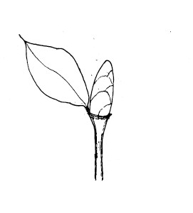 | 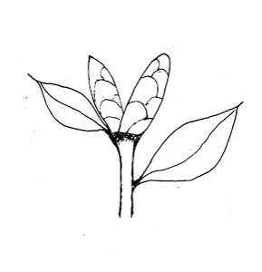 | 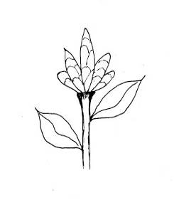
1 | 2 | 3
one | two | more than two

Ad. 7: Leaf: attitude

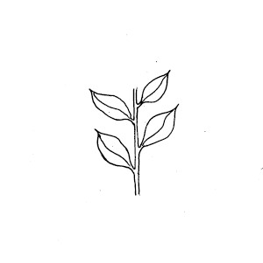 | 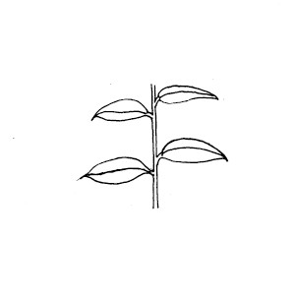 | 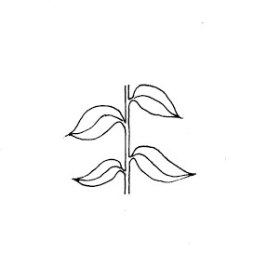
1 | 2 | 3
upwards | outwards | downwards

Ad. 8: Leaf: arrangement

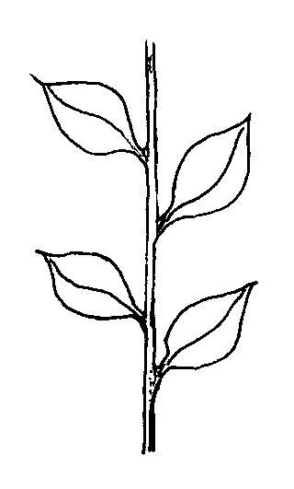 | 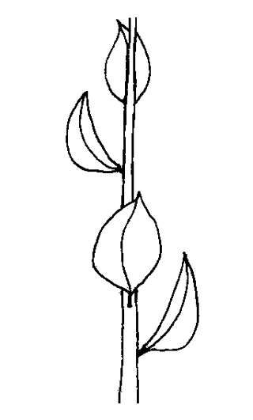 | 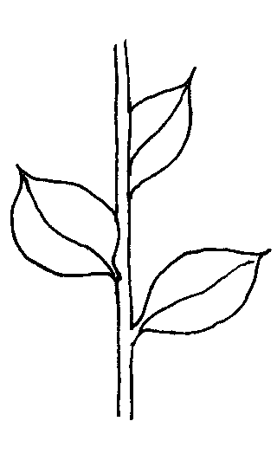
1 | 2 | 3
alternate | perpendicular | spiral

To be observed from above: alternate arrangement means leaves positioned at 180º on stem, perpendicular arrangement means leaves positioned at 90° on stem and spiral arrangement means leaves positioned at less than 90º on stem.

Ad. 11: Leaf blade: position of broadest part

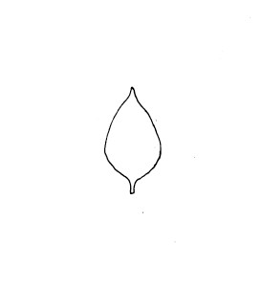 | 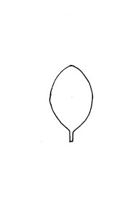 | 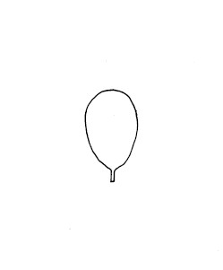
1 | 2 | 3
below middle third | in middle third | above middle third

Ad. 12: Leaf blade: shape of base

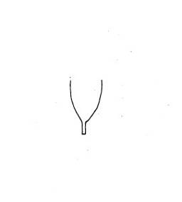 | 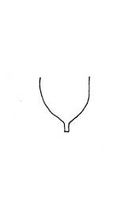 | 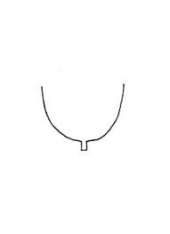 | 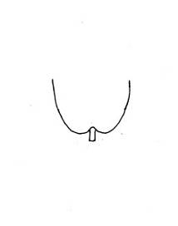
1 | 2 | 3 | 4
acute | obtuse | rounded | cordate

Ad. 13: Leaf blade: shape of apex

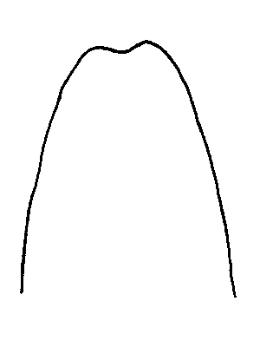 | 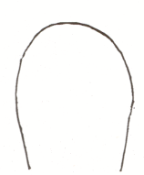 | 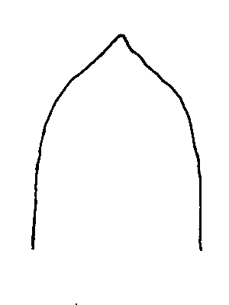 | 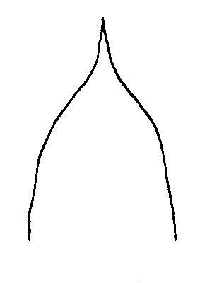 | 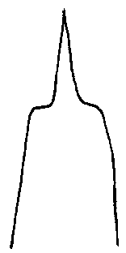 | 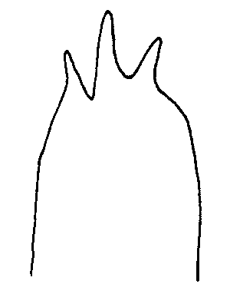
1 | 2 | 3 | 4 | 5 | 6
retuse | rounded | short acuminate | medium acuminate | long acuminate | divided

Ad. 22: Leaf blade: shape in cross section

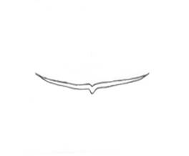 | 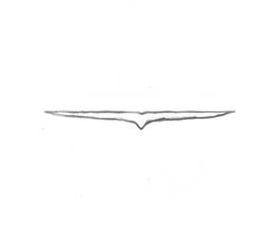 | 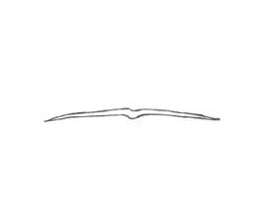
1 | 2 | 3
concave | flat | convex

Ad. 23: Leaf blade: margin

 |  |  | 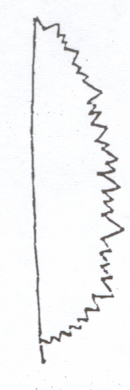
1 | 2 | 3 | 4
entire | serrulate | serrate | bidentate

Ad. 25: Sepal: position of broadest part

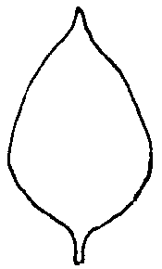 | 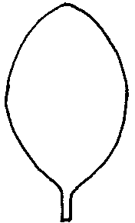 | 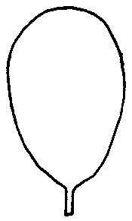
1 | 2 | 3
below middle third | in middle third | above middle third

Ad. 27: Sepal: shape of apex

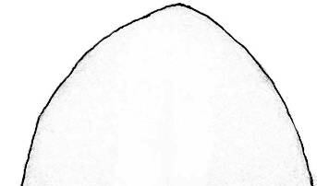 | 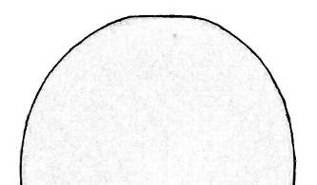 | 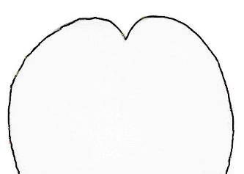
1 | 2 | 3
obtuse | rounded | retuse

Ad. 28: Flower bud: arrangement

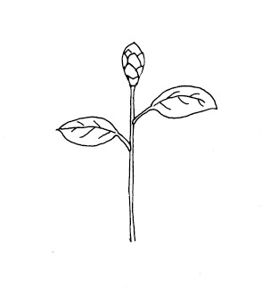 | 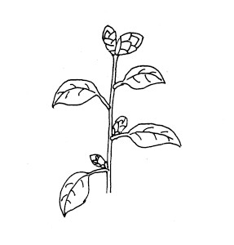 | 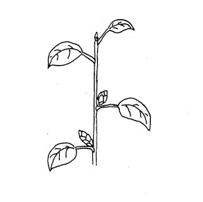
1 | 2 | 3
terminal only | terminal and axillary | axillary only

Ad. 30: Flower: form

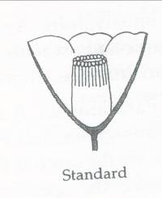 | 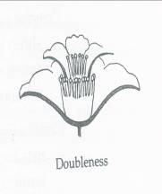 | 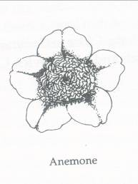 | 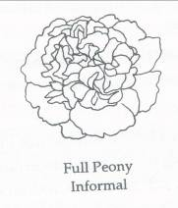 | 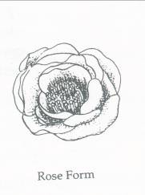 | 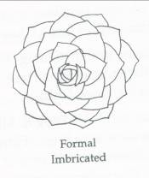
1 | 2 | 3 | 4 | 5 | 6
single | semi-double | anemone form | peony form | rose form double | formal double

1. The single is the typical wild camellia flower form with five to seven irregular, overlapping petals in a single row and a more or less columnar stamen cluster.

2. The semi-double has in excess of eight petals in two or more rows with a conspicuous stamen centre, with no petaloids. The petals may be regular, irregular or loose.

3. The anemone form, has one or more outer rows of large petals while, in the centre, the stamens have become totally petaloid and form a convex mass in the centre of the flower.

4. The peony form has loose petals, usually irregular or wavy, becoming smaller to the centre, where they are divided into by fascicles of stamens; sometimes the centre is a mixture of small petals, petaloids and stamens; or is a convex mass of a mixture of irregular, twisted petals and petaloids, with the stamen, if any, obscured.

5． The rose form double has multiple rows of imbricated petals opening through a
bud-shaped centre to show some stamens in a concave centre when fully open.

6． The formal double has many rows of regular, overlapping petals and has no stamens.

Ad. 33: Flower: petaloid organs

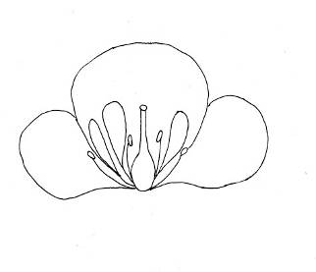 | 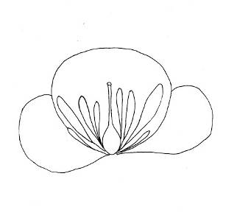 | 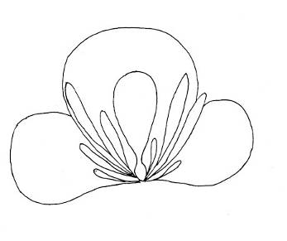
1 | 2 | 3
some stamens petaloid | all stemans petaloid | all stamens and pistil petaloids

Ad. 35: Petal: shape of apex

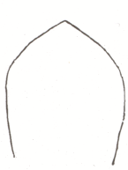 | 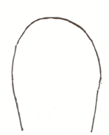 | 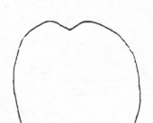
1 | 2 | 3
obtuse | rounded | retuse

Ad. 37: Petal: curvature of longitudinal axis

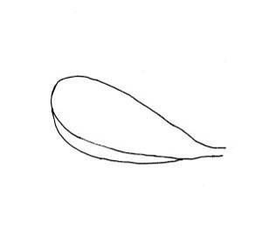 | 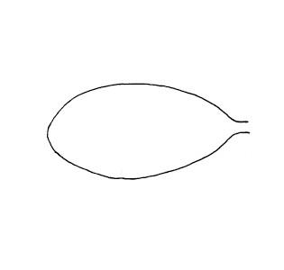 | 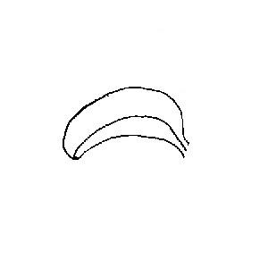
1 | 2 | 3
incurved | flat | recurved

Ad. 38: Flower: shape of petals of first outer row

 | ← broadest part →
 | (below middle) | at middle | (above middle)
broad (compressed) ← width (ratio length/width) → narrow (elongated) |  | 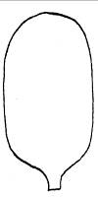  2  oblong | 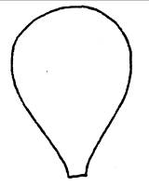  5  obovate
 | 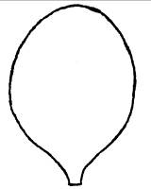  1  ovate |   3  circular
 |  |   4  oblate |   6  obcordate

Ad. 39: Petal: undulation of margin

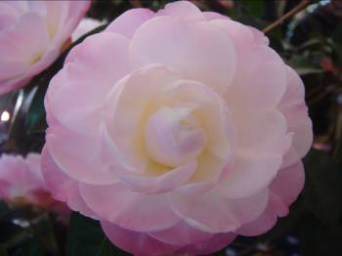 | 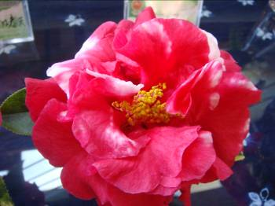 | 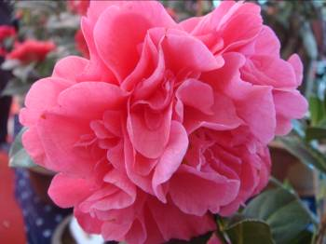
1 | 2 | 3
absent or weak | medium | strong

Ad. 40: Petal: conspicuousness of veins

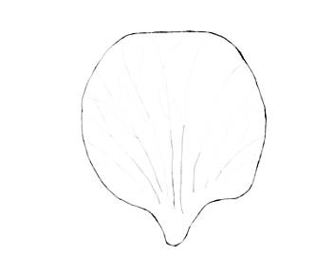 | 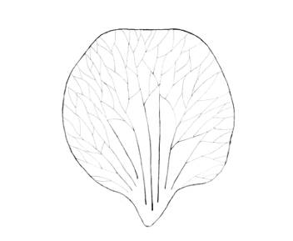 | 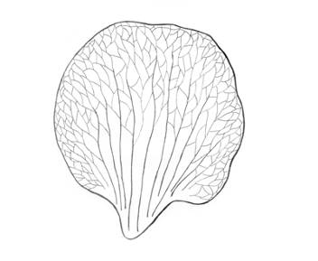
1 | 2 | 3
weak | medium | strong

Ad. 41: Petal: main color

The main color is determined as the color with the largest surface area present on the upper side of a petal.

Ad. 43: Petal: secondary color

The secondary color is determined as the color with the second largest surface area, usually observed as a defined pattern on the upper side of a petal.

Ad. 44: Petal: distribution of secondary color

The main color is determined as the color with the largest surface area present on the upper side of a petal.

The secondary color is determined as the color with the second largest surface area, usually observed as a defined pattern on the upper side of a petal.

In cases where the area of the main and secondary colors are nearly equal, the darker color should be considered to be the main color.

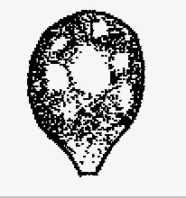 | 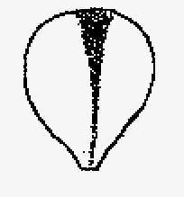 |  | 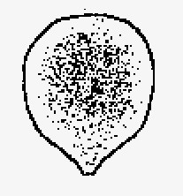
1 | 2 | 3 | 4
blotched | central bar | striated | marginal

Ad. 45: Stamens: arrangements

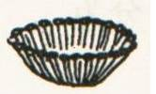 | 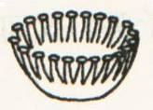 | 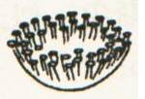 | 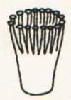
1 | 2 | 3 | 4
sasanqua | circular | apricot | tea whisk

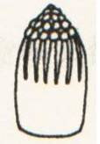 | 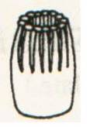 | 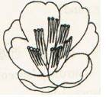 | 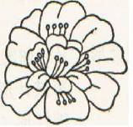
5 | 6 | 7 | 8
pinched | tubular | split | dispersed

Ad. 47: Style: position of splitting

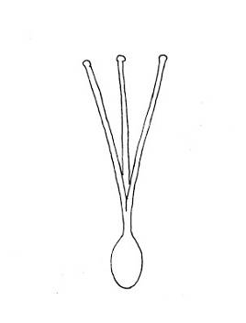 | 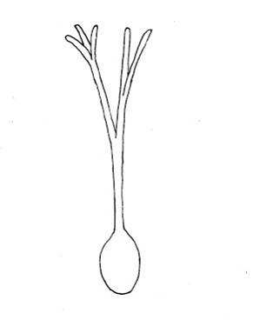 | 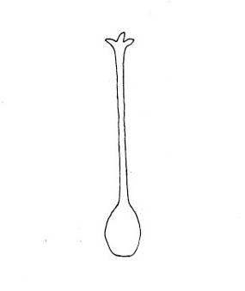
1 | 2 | 3
low | medium | high

Ad. 48: Stigma: position in relation to stamens

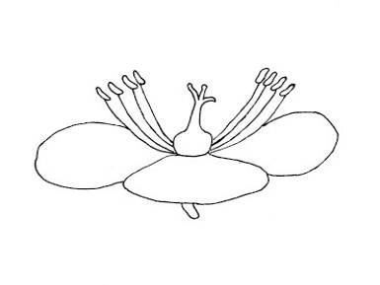 | 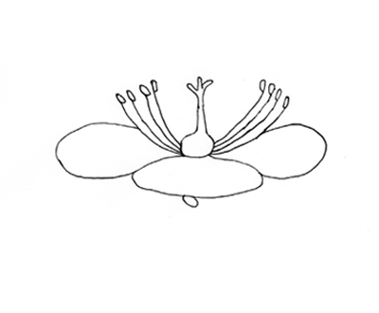 | 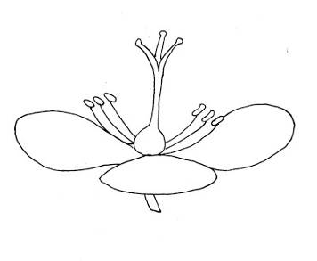
1 | 2 | 3
below | same level | above

Literature
Chang, H., Ren, S., 1988: Flora of China. Vol. 49 (3). Science Press, Beijing, CN, p. 281

Chen, S., 1985: Camellias of Zhejiang Province. Zhejiang Press of Science and Technology, Zhejiang, CN, p. 154

Feng, G., Xia L., Zhu, X., 1981: Yunnan Camellias. Yunnan People’s Press, Yunnan, Kunming, CN, pp. 98-104

Gao, J., Chen, S., 1998: The World’s Best Camellia Cultivars. Zhejiang Press of Science and Technology, Zhejiang, CN, pp. 1-20

Li, J., Zhou J., Ni S., et al, 2012: Guidelines for the conduct of tests for distinctness, uniformity, and stability-Camellia (Camellia L.). GB/T 26911-2011. Standards Press of China, Beijing, CN

Li, J., Ni S., Li X., Zhang X., Gao J. 2008: Developing the International Test Guideline of Distinctness, Uniformity and Stability for Ornamental Camellia Varieties. International Camellia Journal, pp. 112-118

Macoboy, S., 1997: The Illustrated Encyclopedia of Camellias. Timber Press, Portland, US

Savige, T. J., 1993: The International Camellia Register. ICS. Vol.1, pp. 1-28.

Trehance, J. Camellias, 2007: The Gardener’s Encyclopedia. Timber Press, Portland, US

Yu, D., Feng, Y., 1958: Illustrated Camellias of Yunnan. Science Press, Beijing, CN, p. 45

Zhuang, M., 1959: Camellias of Yunnan. Shanghai Press of Science and Technology. Shanghai, CN, p. 35

Technical Questionnaire
TECHNICAL QUESTIONNAIRE |  | Page {x} of {y} | Reference Number:
 |  |  | Application date:
 |  |  | (not to be filled in by the applicant)
TECHNICAL QUESTIONNAIRE
to be completed in connection with an application for plant breeders’ rights

1. Subject of the Technical Questionnaire
1.1 Genus | Camellia L.
1.2. Species |  |  |  | [ ]
1.2.1 Botanical name
1.2.2 Common name
1.3 Hybrid |  |  |  | [ ]
1.3.1 Botanical name
1.3.2 Common name
2. Applicant
Name
Address
Telephone No.
Fax No.
E-mail address
Breeder (if different from applicant)
3. Proposed denomination and breeder’s reference
Proposed denomination
(if available)

Breeder’s reference

TECHNICAL QUESTIONNAIRE | Page {x} of {y} | Reference Number:
#4. Information on the breeding scheme and propagation of the variety

4.1 Breeding scheme

Variety resulting from:

4.1.1 Crossing

(a) controlled cross [ ]
(please state parent varieties)

(…………………..……………..…) x (……………..…………………..…)
female parent male parent

(b) partially known cross [ ]
(please state known parent variety(ies))

(…………………..……………..…) x (……………..…………………..…)
female parent male parent

(c) unknown cross [ ]

4.1.2 Mutation [ ]
(please state parent variety)

4.1.3 Discovery and development [ ]
(please state where and when discovered and how developed)

4.1.4 Other [ ]
(please provide details)

4.2 Method of propagating the variety

4.2.1 Vegetative propagation

(a) cuttings [ ]

(b) in vitro propagation [ ]

(c) other (state method) [ ]

4.2.2 Other [ ]
(please provide details)

TECHNICAL QUESTIONNAIRE |  |  | Page {x} of {y} |  | Reference Number:
5. Characteristics of the variety to be indicated (the number in brackets refers to the corresponding characteristic in Test Guidelines; please mark the note which best corresponds).

 | Characteristics |  |  |  |  | Example Varieties |  | Note
5.1  (1) | Plant: growth habit
 | upright |  |  |  |  | Anticipation |  | 1[ ]
 | semi-upright |  |  |  |  | Mary Agnes Patin |  | 2[ ]
 | spreading |  |  |  |  | Masterpiece |  | 3[ ]
 | drooping |  |  |  |  | Kujaku-tsubaki |  | 4[ ]
 | horizontal |  |  |  |  | First Cover |  | 5[ ]
5.2  (9) | Leaf blade: length
 | very short |  |  |  |  |  |  | 1[ ]
 | very short to short |  |  |  |  |  |  | 2[ ]
 | short |  |  |  |  | Xiao Mei Gui |  | 3[ ]
 | short to medium |  |  |  |  |  |  | 4[ ]
 | medium |  |  |  |  | Hong Lu Zhen |  | 5[ ]
 | medium to long |  |  |  |  |  |  | 6[ ]
 | long |  |  |  |  | Zhu Sha Zi Pao |  | 7[ ]
 | long to very long |  |  |  |  |  |  | 8[ ]
 | very long |  |  |  |  |  |  | 9[ ]
5.3  (23) | Leaf blade: margin
 | entire |  |  |  |  | Chun Jiang Zhi Xia |  | 1[ ]
 | serrulate |  |  |  |  | L.T. Dees |  | 2[ ]
 | serrate |  |  |  |  | Nokogiriba |  | 3[ ]
 | bidentate |  |  |  |  | Bill Goertz |  | 4[ ]
 | Characteristics |  |  |  |  | Example Varieties |  | Note
5.4  (29) | Flower: diameter
 | very small |  |  |  |  | Wei Hua Lian Rui Cha |  | 1[ ]
 | very small to small |  |  |  |  |  |  | 2[ ]
 | small |  |  |  |  | Xiao Mei Gui |  | 3[ ]
 | small to medium |  |  |  |  |  |  | 4[ ]
 | medium |  |  |  |  | Hong Lu Zhen |  | 5[ ]
 | medium to large |  |  |  |  |  |  | 6[ ]
 | large |  |  |  |  | Da Li Cha |  | 7[ ]
 | large to very large |  |  |  |  |  |  | 8[ ]
 | very large |  |  |  |  | Fen Bao Jing Cha |  | 9[ ]
5.5  (30) | Flower: form
 | single |  |  |  |  | Da Hong Jin Xin |  | 1[ ]
 | semi-double |  |  |  |  | Chun Jiang Zhi Xia |  | 2[ ]
 | anemone form |  |  |  |  | Jin Pan Li Zhi |  | 3[ ]
 | peony form |  |  |  |  | Hua Mu Dan |  | 4[ ]
 | rose form double |  |  |  |  | Zhuang Yuan Hong |  | 5[ ]
 | formal double |  |  |  |  | Xue Ta |  | 6[ ]
5.6  (31) | Flower: presence of petaloids
 | absent |  |  |  |  |  |  | 1[ ]
 | present |  |  |  |  |  |  | 9[ ]
 | Characteristics |  |  |  |  | Example Varieties |  | Note
5.7(i)  (41) | Petal: main color
 | RHS Colour Chart (indicate reference number)
5.7(ii)  (41) | Petal: main color
 | white |  |  |  |  |  |  | 1[ ]
 | yellow |  |  |  |  |  |  | 2[ ]
 | orange |  |  |  |  |  |  | 3[ ]
 | pink |  |  |  |  |  |  | 4[ ]
 | red |  |  |  |  |  |  | 5[ ]
 | purple |  |  |  |  |  |  | 6[ ]
5.8  (43) | Petal: secondary color
 | RHS Colour Chart (indicate reference number)
5.9  (50) | Time of flowering
 | very early |  |  |  |  | Chun Jiang Zhi Xia |  | 1[ ]
 | very early to early |  |  |  |  |  |  | 2[ ]
 | early |  |  |  |  | Xiao Mei Gui |  | 3[ ]
 | early to medium |  |  |  |  |  |  | 4[ ]
 | medium |  |  |  |  | Zao Chun Da Hong Qiu |  | 5[ ]
 | medium to late |  |  |  |  |  |  | 6[ ]
 | late |  |  |  |  | Chong Qing Hong |  | 7[ ]
 | late to very late |  |  |  |  |  |  | 8[ ]
 | very late |  |  |  |  | Da Hong Jin Xin |  | 9[ ]
6. Similar varieties and differences from these varieties

Please use the following table and box for comments to provide information on how your candidate variety differs from the variety (or varieties) which, to the best of your knowledge, is (or are) most similar. This information may help the examination authority to conduct its examination of distinctness in a more efficient way.

Denomination(s) of variety(ies) similar to your candidate variety |  | Characteristic(s) in which your candidate variety differs from the similar variety(ies) |  | Describe the expression of the characteristic(s) for the similar variety(ies) |  |  | Describe the expression of the characteristic(s) for your candidate variety
Example |  | Plant: growth habit |  | semi-upright |  |  | upright
Comments:

#7. Additional information which may help in the examination of the variety

7.1 In addition to the information provided in sections 5 and 6, are there any additional characteristics which may help to distinguish the variety?

Yes [ ] No [ ]

(If yes, please provide details)

7.2 Are there any special conditions for growing the variety or conducting the examination?

Yes [ ] No [ ]

(If yes, please provide details)

7.3 Other information

A representative color image of the variety should accompany the Technical Questionnaire.

8. Authorization for release

(a) Does the variety require prior authorization for release under legislation concerning the protection of the environment, human and animal health?

Yes [ ] No [ ]

(b) Has such authorization been obtained?

Yes [ ] No [ ]

If the answer to (b) is yes, please attach a copy of the authorization.

9. Information on plant material to be examined or submitted for examination.

9.1 The expression of a characteristic or several characteristics of a variety may be affected by factors, such as pests and disease, chemical treatment (e.g. growth retardants or pesticides), effects of tissue culture, different rootstocks, scions taken from different growth phases of a tree, etc.

9.2 The plant material should not have undergone any treatment which would affect the expression of the characteristics of the variety, unless the competent authorities allow or request such treatment. If the plant material has undergone such treatment, full details of the treatment must be given. In this respect, please indicate below, to the best of your knowledge, if the plant material to be examined has been subjected to:

(a) Microorganisms (e.g. virus, bacteria, phytoplasma) Yes [ ] No [ ]

(b) Chemical treatment (e.g. growth retardant, pesticide) Yes [ ] No [ ]

(c) Tissue culture Yes [ ] No [ ]

(d) Other factors Yes [ ] No [ ]

Please provide details for where you have indicated “yes”.

………………………………………………………………

10. I hereby declare that, to the best of my knowledge, the information provided in this form is correct:

Applicant’s name

Signature Date

[End of document]

* These names were correct at the time of the introduction of these Test Guidelines but may be revised or updated. [Readers are advised to consult the UPOV Code, which can be found on the UPOV Website (www.upov.int), for the latest information.]
# Authorities may allow certain of this information to be provided in a confidential section of the Technical Questionnaire.
# Authorities may allow certain of this information to be provided in a confidential section of the Technical Questionnaire.

