 |  | E  TG/260/1  ORIGINAL: English  DATE: 2010-03-24
INTERNATIONAL UNION FOR THE PROTECTION OF NEW VARIETIES OF PLANTS
GENEVA

 | PEARL MILLET  UPOV Code: PENNI_GLA  Pennisetum glaucum (L.) R. Br. | *

GUIDELINES

FOR THE CONDUCT OF TESTS

FOR DISTINCTNESS, UNIFORMITY AND STABILITY

Alternative Names:*

Botanical name | English | French | German | Spanish
Pennisetum glaucum (L.) R. Br.,  Pennisetum americanum (L.) Leeke,  Pennisetum typhoides (Burm.f.) Stapf C.E. Hubb. | Pearl Millet | Pénicillaire,  Mil à chandelle,  Mil pénicillaire | Federborstengras | Mijo Perla,  Panizo de Daimiel, Panizo mamozo

The purpose of these guidelines (“Test Guidelines”) is to elaborate the principles contained in the General Introduction (document TG/1/3), and its associated TGP documents, into detailed practical guidance for the harmonized examination of distinctness, uniformity and stability (DUS) and, in particular, to identify appropriate characteristics for the examination of DUS and production of harmonized variety descriptions.

ASSOCIATED DOCUMENTS

These Test Guidelines should be read in conjunction with the General Introduction and its associated TGP documents.
TABLE OF CONTENTS PAGE

1. Subject of these Test Guidelines 3
2. Material Required 3
3. Method of Examination 3
3.1 Number of Growing Cycles 3
3.2 Testing Place 3
3.3 Conditions for Conducting the Examination 3
3.4 Test Design 4
3.5 Number of Plants / Parts of Plants to be Examined 4
3.6 Additional Tests 4
4. Assessment of Distinctness, Uniformity and Stability 4
4.1 Distinctness 4
4.2 Uniformity 5
4.3 Stability 5
5. Grouping of Varieties and Organization of the Growing Trial 5
6. Introduction to the Table of Characteristics 6
6.1 Categories of Characteristics 6
6.2 States of Expression and Corresponding Notes 6
6.3 Types of Expression 6
6.4 Example Varieties 6
6.5 Legend 7
7. Table of Characteristics/Tableau des caractères/Merkmalstabelle/Tabla de caracteres 8
8. Explanations on the Table of Characteristics 14
8.1 Explanations for individual characteristics 14
8.2 Growth stages 18
9. Literature 20
10. Technical Questionnaire 21

Subject of these Test Guidelines
These Test Guidelines apply to all varieties of Pennisetum glaucum (L.) R. Br.

Material Required
2.1 The competent authorities decide on the quantity and quality of the plant material required for testing the variety and when and where it is to be delivered. Applicants submitting material from a State other than that in which the testing takes place must ensure that all customs formalities and phytosanitary requirements are complied with.

2.2 The material is to be supplied in the form of seed.

2.3 The minimum quantity of plant material, to be supplied by the applicant, should be:

500 g.

The seed should meet the minimum requirements for germination, species and analytical purity, health and moisture content, specified by the competent authority. In cases where the seed is to be stored, the germination capacity should be as high as possible and should be stated by the applicant.

2.4 The plant material supplied should be visibly healthy, not lacking in vigor, nor affected by any important pest or disease.

2.5 The plant material should not have undergone any treatment which would affect the expression of the characteristics of the variety, unless the competent authorities allow or request such treatment. If it has been treated, full details of the treatment must be given.

Method of Examination

3.1 Number of Growing Cycles
The minimum duration of tests should normally be two independent growing cycles.

3.2 Testing Place
Tests are normally conducted at one place. In the case of tests conducted at more than one place, guidance is provided in TGP/9 “Examining Distinctness”.

3.3 Conditions for Conducting the Examination
3.3.1 The tests should be carried out under conditions ensuring satisfactory growth for the expression of the relevant characteristics of the variety and for the conduct of the examination.

3.3.2 The optimum stage of development for the assessment of each characteristic is indicated by a number in the second column of the Table of Characteristics. The stages of development denoted by each number are described at the end of Chapter 8.

3.3.3 The recommended method of observing the characteristic is indicated by the following key in the second column of the Table of Characteristics:

MG: single measurement of a group of plants or parts of plants
MS: measurement of a number of individual plants or parts of plants
VG: visual assessment by a single observation of a group of plants or parts of plants
VS: visual assessment by observation of individual plants or parts of plants

3.4 Test Design
3.4.1 Each test should be designed to result in a total of at least 240 plants, which should be divided between two or more replicates.

3.4.2 The design of the tests should be such that plants or parts of plants may be removed for measurement or counting without prejudice to the observations which must be made up to the end of the growing cycle.

3.5 Number of Plants / Parts of Plants to be Examined
3.5.1 In the case of cross-pollinated varieties and three-way-cross hybrids, unless otherwise indicated, all observations on single plants should be made on 60 plants or parts taken from each of 60 plants and any other observations made on all plants in the test.

3.5.2 In the case of inbred lines and single-cross hybrids, unless otherwise indicated, all observations on single plants should be made on 40 plants or parts taken from each of 40 plants and any other observations made on all plants in the test.

3.6 Additional Tests
Additional tests, for examining relevant characteristics, may be established.

Assessment of Distinctness, Uniformity and Stability

4.1 Distinctness

4.1.1 General Recommendations

It is of particular importance for users of these Test Guidelines to consult the General Introduction prior to making decisions regarding distinctness. However, the following points are provided for elaboration or emphasis in these Test Guidelines.

4.1.2 Consistent Differences
The differences observed between varieties may be so clear that more than one growing cycle is not necessary. In addition, in some circumstances, the influence of the environment is not such that more than a single growing cycle is required to provide assurance that the differences observed between varieties are sufficiently consistent. One means of ensuring that a difference in a characteristic, observed in a growing trial, is sufficiently consistent is to examine the characteristic in at least two independent growing cycles.

4.1.3 Clear Differences

Determining whether a difference between two varieties is clear depends on many factors, and should consider, in particular, the type of expression of the characteristic being examined, i.e. whether it is expressed in a qualitative, quantitative, or pseudo-qualitative manner. Therefore, it is important that users of these Test Guidelines are familiar with the recommendations contained in the General Introduction prior to making decisions regarding distinctness.

4.2 Uniformity
4.2.1 It is of particular importance for users of these Test Guidelines to consult the General Introduction prior to making decisions regarding uniformity. However, the following points are provided for elaboration or emphasis in these Test Guidelines:

4.2.2 The assessment of uniformity for cross-pollinated varieties should be according to the recommendations for cross-pollinated varieties in the General Introduction.

4.2.3 For the assessment of uniformity of inbred lines and single-cross hybrids, a population standard of 1% and an acceptance probability of at least 95% should be applied. In the case of a sample size of 240 plants, 5 off-types are allowed.

4.2.4 The assessment of uniformity for hybrid varieties, other than single-cross hybrid varieties, depends on the type of hybrid and should be according to the recommendations for hybrid varieties in the General Introduction.

4.3 Stability
4.3.1 In practice, it is not usual to perform tests of stability that produce results as certain as those of the testing of distinctness and uniformity. However, experience has demonstrated that, for many types of variety, when a variety has been shown to be uniform, it can also be considered to be stable.

4.3.2 Where appropriate, or in cases of doubt, stability may be assessed by testing a new seed stock to ensure that it exhibits the same characteristics as those shown by the previous material supplied.

4.3.3 Where appropriate, or in cases of doubt, the stability of a hybrid variety may, in addition to an examination of the hybrid variety itself, also be assessed by examination of the uniformity and stability of its parent lines.

Grouping of Varieties and Organization of the Growing Trial
5.1 The selection of varieties of common knowledge to be grown in the trial with the candidate varieties and the way in which these varieties are divided into groups to facilitate the assessment of distinctness are aided by the use of grouping characteristics.

5.2 Grouping characteristics are those in which the documented states of expression, even where produced at different locations, can be used, either individually or in combination with other such characteristics: (a) to select varieties of common knowledge that can be excluded from the growing trial used for examination of distinctness; and (b) to organize the growing trial so that similar varieties are grouped together.

5.3 The following have been agreed as useful grouping characteristics:

- Leaf sheath: pubescence (characteristic 6)
- Anther: color (characteristic 7)
- Time of flowering (characteristic 8)
- Glume: number of bristles (characteristic 16)

5.4 Guidance for the use of grouping characteristics, in the process of examining distinctness, is provided through the General Introduction.

Introduction to the Table of Characteristics

6.1 Categories of Characteristics
6.1.1 Standard Test Guidelines Characteristics

Standard Test Guidelines characteristics are those which are approved by UPOV for examination of DUS and from which members of the Union can select those suitable for their particular circumstances.

6.1.2 Asterisked Characteristics

Asterisked characteristics (denoted by *) are those included in the Test Guidelines which are important for the international harmonization of variety descriptions and should always be examined for DUS and included in the variety description by all members of the Union, except when the state of expression of a preceding characteristic or regional environmental conditions render this inappropriate.

6.2 States of Expression and Corresponding Notes
States of expression are given for each characteristic to define the characteristic and to harmonize descriptions. Each state of expression is allocated a corresponding numerical note for ease of recording of data and for the production and exchange of the description.

6.3 Types of Expression
An explanation of the types of expression of characteristics (qualitative, quantitative and pseudo-qualitative) is provided in the General Introduction.

6.4 Example Varieties
Where appropriate, example varieties are provided to clarify the states of expression of each characteristic.

6.5 Legend
(*) Asterisked characteristic – see Chapter 6.1.2

(S) Possible segregation in three-way and double-cross hybrid varieties

QL: Qualitative characteristic – see Chapter 6.3
QN: Quantitative characteristic – see Chapter 6.3
PQ: Pseudo-qualitative characteristic – see Chapter 6.3

MG, MS, VG, VS: see Chapter 3.3.3

(+) See Explanations on the Table of Characteristics in Chapter 8.1
(DS1 - 9) See Explanations on the Table of Characteristics in Chapter 8.2

Table of Characteristics/Tableau des caractères/Merkmalstabelle/Tabla de caracteres
 |  | English | français | deutsch | español | Example Varieties/  Exemples/  Beispielssorten/  Variedades ejemplo | Note/  Nota
1. | DS1  VG | Seedling: anthocyanin coloration of basal leaf sheath | Plantule : pigmentation anthocyanique de la gaine de la feuille basale | Keimpflanze: Anthocyanfärbung der basalen Blattscheide | Plántula: pigmentación antociánica de la vaina de la hoja basal
QN |  | absent or weak | absente ou faible | fehlend oder gering | ausente o débil | ANSB Milheto Okashama | 1
 |  | medium | moyenne | mittel | media |  | 2
 |  | strong | forte | stark | fuerte | Ipa Bulk 1 | 3
2. | DS3  VG | Culm: attitude of tillers | Tige : port des talles | Halm: Haltung der Seitentriebe | Mata: porte de los macollos
QN |  | erect | dressées | aufrecht | erecto | ADR 300 | 1
 |  | semi-erect | demi-dressées | halbaufrecht | semierecto | ANM 23 | 3
 |  | prostrate | étalées | abstehend | postrado |  | 5
3.  (+) | DS3  VG/  MS | Leaf blade: length | Limbe : longueur | Blattscheide: Länge | Limbo: longitud
QN |  | short | court | kurz | corta | ADR 300 | 3
 |  | medium | moyen | mittel | media |  | 5
 |  | long | long | lang | larga | ADR 7010 | 7
4.  (+) | DS3  VG/  MS | Leaf blade: width | Limbe : largeur | Blattscheide: Breite | Limbo: anchura
QN |  | narrow | étroit | schmal | estrecha | ANSB Milheto MC | 3
 |  | medium | moyen | mittel | media | ADR 500 | 5
 |  | broad | large | breit | ancha | ANM 6123 | 7
5. | DS3  VG | Leaf blade: color | Limbe : couleur | Blattscheide: Farbe | Limbo: color
PQ |  | light green | vert clair | hellgrün | verde claro | ANSB Milheto MC | 1
 |  | medium green | vert moyen | mittelgrün | verde medio | ADR 500 | 2
 |  | dark green | vert foncé | dunkelgrün | verde oscuro | ANM 23 | 3
 |  | red | rouge | rot | rojo |  | 4
 |  | purple | pourpre | purpurn | púrpura |  | 5
6.  (*) | DS3  VG | Leaf sheath: pubescence | Gaine de la feuille : pilosité | Blattscheide: Behaarung | Vaina de la hoja: pubescencia
QL |  | absent | absente | fehlend | ausente |  | 1
 |  | present | présente | vorhanden | presente |  | 9
7.  (*)  (+) | DS6⁺  VG | Anther: color | Anthère : couleur | Anthere: Farbe | Antera: color
PQ | (S) | yellow | jaune | gelb | amarillo | ADR 300 | 1
 |  | brown | marron | braun | marrón |  | 2
 |  | purple | pourpre | purpurn | púrpura |  | 3
8.  (*)  (+) | MG | Time of flowering | Époque de floraison | Zeitpunkt der Blüte | Época de floración
QN |  | very early | très précoce | sehr früh | muy temprana |  | 1
 |  | early | précoce | früh | temprana | ANSB Milheto Okashama | 3
 |  | medium | moyenne | mittel | media | BRS 1501 | 5
 |  | late | tardive | spät | tardía | ANM 17 | 7
 |  | very late | très tardive | sehr spät | muy tardía |  | 9
9.  (*) | DS6  VG | Culm: pubescence of node | Tige : pilosité du nœud | Halm: Behaarung des Knotens | Mata: pubescencia del nudo
QL |  | absent | absente | fehlend | ausente | ADR 300 | 1
 |  | present | présente | vorhanden | presente | ENA 1 | 9
10.  (*)  (+) | DS8  MG | Plant: length | Plante : longueur | Pflanze: Länge | Planta: longitud
QN |  | very short | très courte | sehr kurz | muy corta |  | 1
 |  | short | courte | kurz | corta | ANSB Milheto Okashama | 3
 |  | medium | moyenne | mittel | media | ADR 500 | 5
 |  | tall | longue | lang | alta | ADR 7010 | 7
 |  | very tall | très longue | sehr lang | muy alta |  | 9
11.  (*)  (+) | DS8  VG | Panicle: shape | Panicule : forme | Rispe: Form | Panícula: forma
PQ |  | conical | conique | kegelförmig | cónica |  | 1
 |  | subulate | subulée | pfriemförmig | subulada |  | 2
 |  | trullate | trullée | winklig | ahusada |  | 3
 |  | cylindric | cylindrique | zylindrisch | cilíndrica |  | 4
 |  | obtrullate | losangique transverse | verkehrt rautenförmig | rómbica |  | 5
12.  (*)  (+) | DS8  VG/  MS | Panicle: length of main rachis | Panicule : longueur du rachis principal | Rispe: Länge der Hautspindel | Panícula: longitud del raquis principal
QN |  | short | court | kurz | corta | ANSB Milheto Okashama | 3
 |  | medium | moyen | mittel | media | ADR 500 | 5
 |  | long | long | lang | larga | ENA 1 | 7
13.  (+) | DS8  VG/  MS | Panicle: diameter | Panicule : diamètre | Rispe: Durchmesser | Panícula: diámetro
QN |  | small | petit | klein | pequeño | ANSB Milheto MC | 3
 |  | medium | moyen | mittel | medio | ANM 17 | 5
 |  | large | grand | groß | grande | ADR 7010 | 7
14.  (+) | DS8  VG | Panicle: exsertion | Panicule : déploiement | Rispe: Hervorstehen | Panícula: exerción
QN |  | weak | faible | gering | débil |  | 1
 |  | moderate | modéré | mittel | moderado |  | 3
 |  | strong | fort | stark | fuerte |  | 5
15. | DS8  VG | Glume: anthocyanin coloration (excluding tips) | Glume : pigmentation anthocyanique (à l’exclusion des pointes) | Hüllspelze: Anthocyanfärbung (ohne Spitzen) | Gluma: pigmentación antociánica (excluidas las puntas)
QL |  | absent | absente | fehlend | ausente |  | 1
 |  | present | présente | vorhanden | presente |  | 9
16.  (*) | DS8  VG | Glume: number of bristles | Glume : nombre de groupes d’épines | Hüllspelze: Anzahl Stachelborsten | Gluma: número de aristas
QL |  | one | un | eine | una |  | 1
 |  | more than one | plusieurs | mehr als eine | más de una |  | 2
17.  (+) | DS8  VG | Only varieties with glume: one bristle: Bristle: length | Seulement les variétés avec glume : un groupe d’épines : Groupe d’épines : longueur | Nur Sorten mit Hüllspelze: eine Stachelborste: Stachelborste: Länge | Sólo las variedades con gluma: una arista: Arista: longitud
QN |  | short | courtes | kurz | corta | ANSB Milheto Okashama | 3
 |  | medium | moyennes | mittel | media |  | 5
 |  | long | longues | lang | larga | IPA Bulk 1 | 7
18.  (+) | DS8  VG | Only varieties with glume: more than one bristle: Glume: density of bristles | Seulement les variétés avec glume : plusieurs groupes d’épines : Glume : densité des groupes d’épines | Nur Sorten mit Hüllspelze: mehr als eine Stachelborste: Hüllspelze: Dichte der Stachelborsten | Sólo las variedades con gluma: más de una arista: Gluma: densidad de aristas
QN |  | sparse | faible | locker | laxa | ADR 500 | 3
 |  | medium | moyenne | mittel | media |  | 5
 |  | dense | forte | dicht | densa | ADR 7010 | 7
19. | DS8  VG | Bristle: anthocyanin coloration | Groupe d’épines : pigmentation anthocyanique | Stachelborste: Anthocyanfärbung | Arista: pigmentación antociánica
QN |  | absent or very weak | absente ou très faible | fehlend oder sehr gering | ausente o muy débil |  | 1
 |  | weak | faible | gering | débil | BRS 1501 | 3
 |  | moderate | moyenne | mittel | moderada |  | 5
 |  | strong | forte | stark | fuerte | IPA Bulk 1 | 7
20.  (+) | DS8  VG/  MS | Culm: diameter | Tige : diamètre | Halm: Durchmesser | Mata: diámetro
QN |  | small | petit | klein | pequeño | BRS 1501 | 3
 |  | medium | moyen | mittel | medio | ENA 1 | 5
 |  | large | grand | groß | grande | ADR 500 | 7
21. | DS8  MG | Culm: number of panicle-bearing tillers | Tige : nombre de talles portant une panicule | Halm: Anzahl Seitentriebe mit Rispen | Mata: número de macollos con panícula
QN |  | few | petit | gering | pocos | ENA 1 | 1
 |  | medium | moyen | mittel | medios | ADR 500, IPA Bulk 1 | 2
 |  | many | grand | groß | muchos | ADR 300 | 3
22.  (*)  (+) | DS8  VG | Culm: anthocyanin coloration of node | Tige : pigmentation anthocyanique du noeud | Halm: Anthocyanfärbung des Knotens | Mata: pigmentación antociánica del nudo
QN |  | absent or weak | absente ou faible | fehlend oder gering | ausente o débil |  | 1
 |  | medium | moyenne | mittel | media |  | 3
 |  | strong | forte | stark | fuerte | IPA Bulk 1 | 5
23.  (*)  (+) | DS8  VG | Culm: anthocyanin coloration of internode | Tige : pigmentation anthocyanique de l’entre-nœud | Halm: Anthocyanfärbung des Internodiums | Mata: pigmentación antociánica del entrenudo
QN |  | absent or weak | absente ou faible | fehlend oder gering | ausente o débil | ENA 1 | 1
 |  | medium | moyenne | mittel | media | ANM 23 | 2
 |  | strong | forte | stark | fuerte | IPA Bulk 1 | 3
24.  (*)  (+) | DS9  VG | Panicle: density | Panicule : densité | Rispe: Dichte | Panícula: densidad
QN |  | sparse | faible | locker | escasa | ENA 1 | 3
 |  | medium | moyenne | mittle | media | ADR 300 | 5
 |  | dense | forte | dicht | densa | ANM 6123 | 7
25.  (+) | VG | Caryopsis: shape | Caryopse : forme | Karyopse: Form | Cariópside: forma
PQ |  | obtrullate | losangique transverse | verkehrt rautenförmig | rómbica |  | 1
 |  | elliptic | elliptique | elliptisch | elíptica |  | 2
 |  | circular | circulaire | rund | circular |  | 3
 |  | rectangular | rectangulaire | rechteckig | rectangular |  | 4
 |  | obtriangular | obtriangulaire | verkehrt dreieckig | obtriangular |  | 5
26.  (*) | VG | Caryopsis: color | Caryopse : couleur | Karyopse: Farbe | Cariópside: color
PQ | (S) | whitish | blanchâtre | weißlich | blanquecino |  | 1
 |  | cream | crème | cremefarben | crema |  | 2
 |  | yellow | jaune | gelb | amarillo |  | 3
 |  | medium grey | gris moyen | mittelgrau | gris medio |  | 4
 |  | dark grey | gris foncé | dunkelgrau | gris oscuro |  | 5
 |  | grey brown | marron gris | graubraun | marrón grisáceo |  | 6
 |  | brown | marron | braun | marrón |  | 7
 |  | purple | pourpre | purpurn | púrpura |  | 8
 |  | purplish black | noir violacé | purpurschwarz | negro purpúreo |  | 9

Explanations on the Table of Characteristics

Explanations for individual characteristics
Ad. 3: Leaf blade: length
Ad. 4: Leaf blade: width

To be observed on the fourth node from the top on the main culm.

Ad. 7: Anther: color

To be observed on recently opened flowers.

Ad. 8: Time of flowering

The time of flowering is when 50% of plants have emitted the stigma in the main panicle.

Ad. 10: Plant: length

To be observed on the main culm from ground level to the tip of the main panicle.

Ad. 11: Panicle: shape

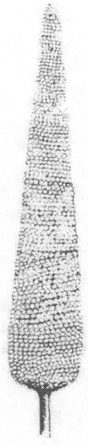 | 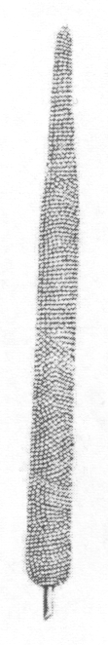 | 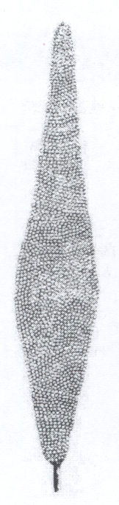 | 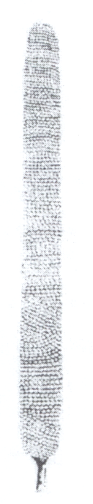 | 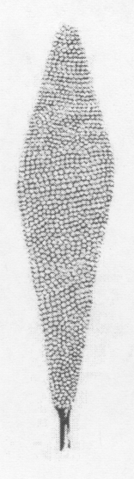
1 | 2 | 3 | 4 | 5
conical | subulate | trullate | cylindric | obtrullate

Ad. 12: Panicle: length of main rachis

To be measured from the base to the tip of the panicle on main rachis.

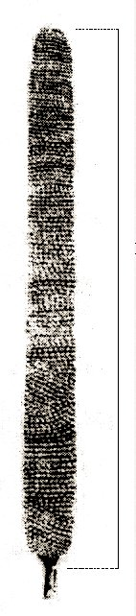 | length of main rachis

Ad. 13: Panicle: diameter

To be observed in the broadest part of the panicle, excluding the bristles.

Ad. 14: Panicle: exsertion
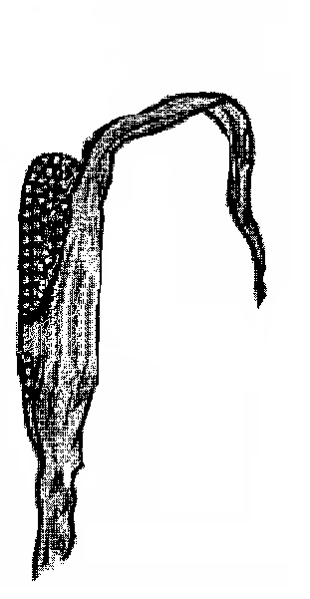 | 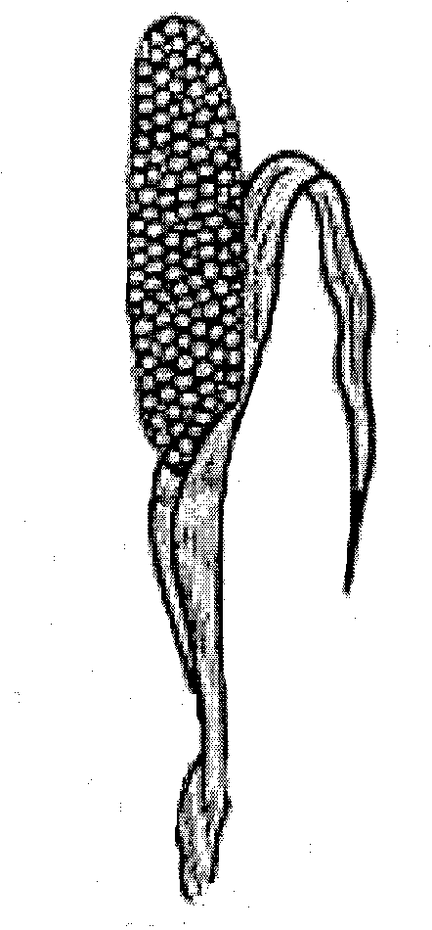 | 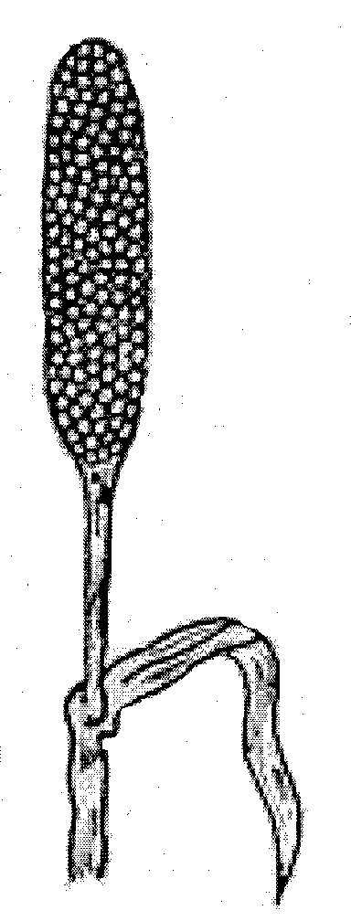
1 | 3 | 5
weak | moderate | strong

Ad. 17: Only varieties with glume: one bristle: Bristle: length

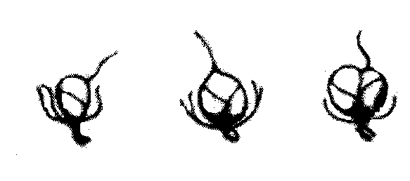 | 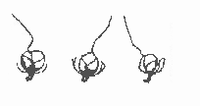 | 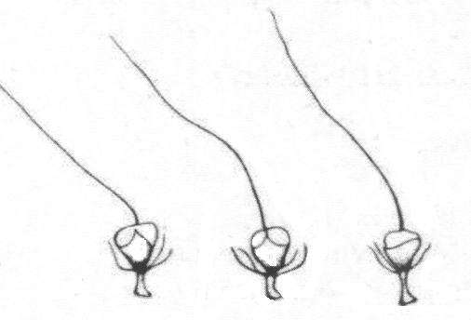
3 | 5 | 7
short | medium | long

Ad. 18: Only varieties with glume: more than one bristle: Glume: density of bristles

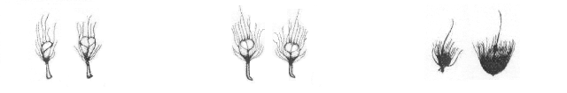
3 | 5 | 7
sparse | medium | dense

Ad. 20: Culm: diameter

To be observed between the third and fourth nodes below the panicle.

Ad. 22: Culm: anthocyanin coloration of node
The anthocyanin coloration of the node should be observed on the fourth node from the ground.

Ad. 23: Culm: anthocyanin coloration of internode
The anthocyanin coloration of the internode should be observed between the third and fourth node above the ground.

Ad. 24: Panicle: density

To be observed on the main panicle.

Ad. 25: Caryopsis: shape

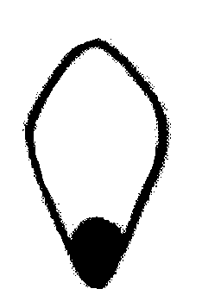 | 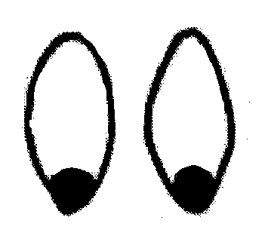 |  | 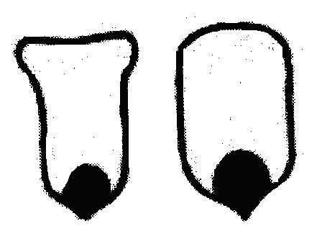 | 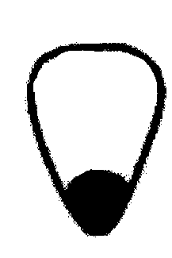
1 | 2 | 3 | 4 | 5
obtrullate | elliptic | circular | rectangular | obtriangular

Ad. 25: Caryopsis: shape
Ad. 26: Caryopsis: color

The caryposis should be observed after thrashing.

8.2 Growth stages
Characteristics containing the following key in the second column of the Table of Characteristics should be examined at the following stages (table and drawing adapted from the book “Pearl Millet, Seed Production & Technology” – see Chapter 9 Literature).

Growth Stage | Identifying Characteristic
GPI | Vegetative Phase
DS0 | Emergence Stage
DS1 | Three Leaf Stage
DS2 | Five Leaf Stage
DS3 | Panicle Initiation Stage
GPII | Panicle Development Phase
DS4 | Flag Leaf Stage
DS5 | Boot Stage
DS6 | Half Bloom Stage
DS6⁺ | Full Flowering (before anther dehiscence)
GPIII | Grain Filling Stage
DS7 | Milk Stage
DS8 | Dough Stage
DS9 | Black Layer Formation

DS-1: emergence | DS-1: three leaf | DS-2: five leaf | DS-3: panicle initiation |  | DS-4: flag leaf | DS-5: boot | DS-6: half bloom |  | DS-7: milk | DS-8: dough | DS-9: black layer
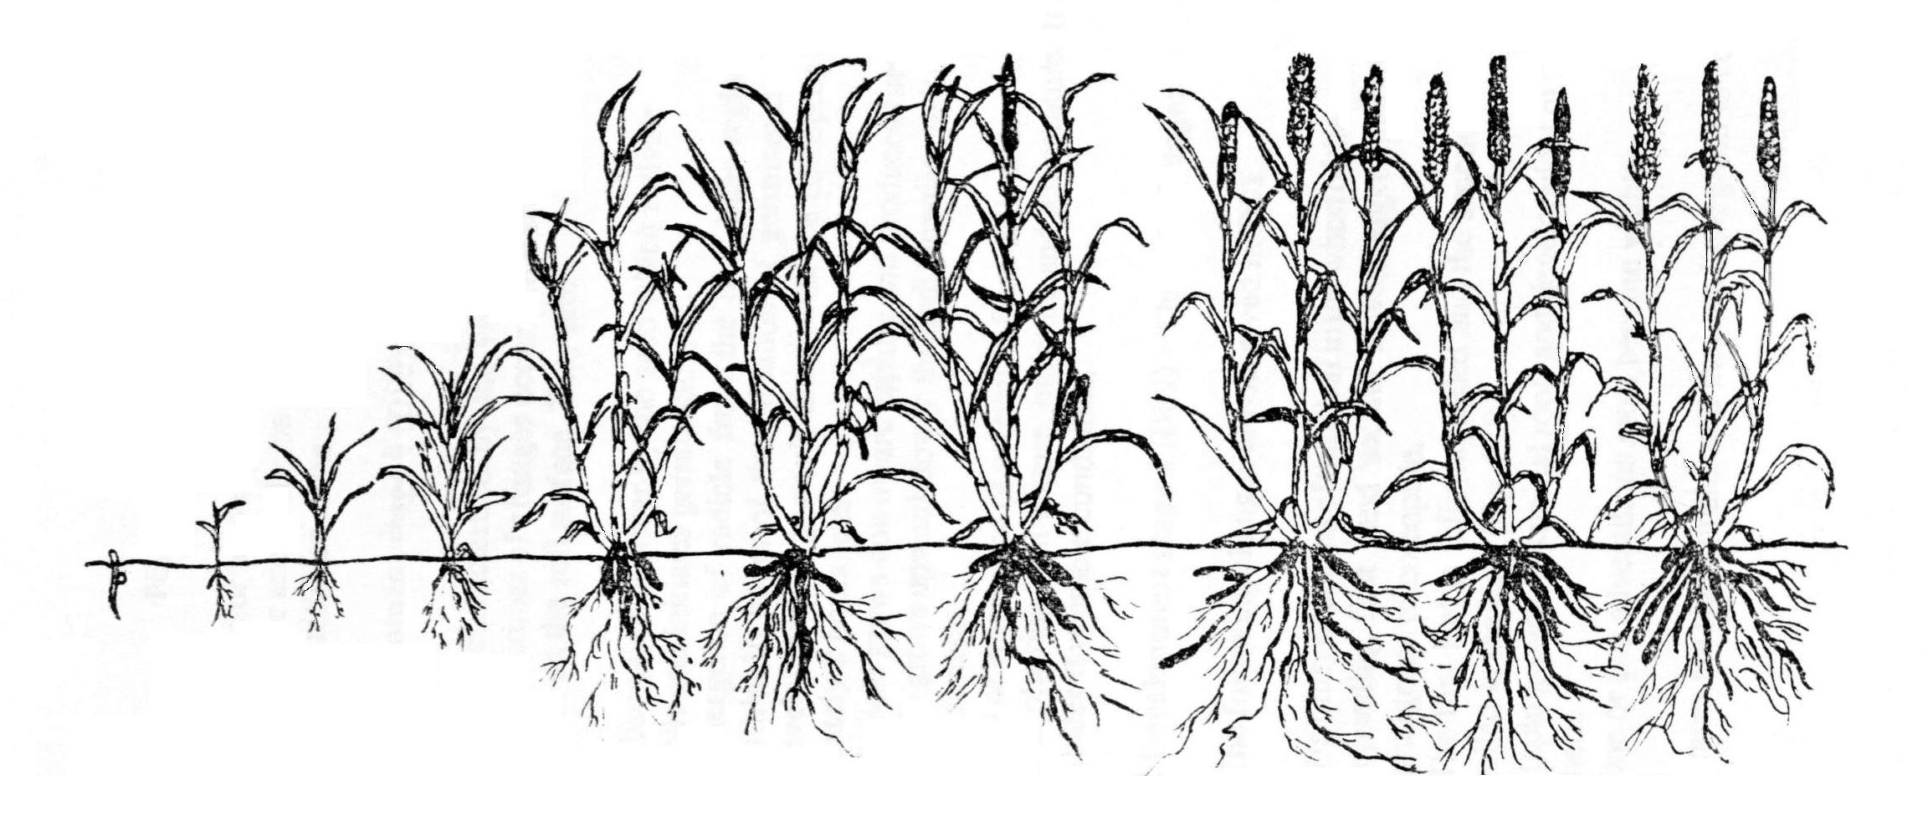
Growth phase I (GP-I)  vegetative |  |  |  | Growth phase II  (GP-II)  panicle development |  |  |  | Growth phase III  (GP-III)  grain filling

Literature
IBPGR/ICRISAT, 1993: Descriptors for Pearl Millet [Pennisetum glaucum (L.) R. Br.]., Rome, IT.

Khairwal, I.S., Ram C. & Chabbra, A.K., 1990: Pearl Millet, Seed Production & Technology. Ed Manohar.

Singh, F., Rai, K.N., Reddy, B.V.S. & Diwakar, B., 1997: Development of Cultivars and Seed Production Techniques in Sorghum and Pearl Millet – Training Manual, ICRISAT.

Drawings:

IBPGR/ICRISAT, 1993: Descriptors for Pearl Millet [Pennisetum glaucum (L.) R. Br.]., Rome, IT.

Khairwal, I.S., Ram C. & Chabbra, A.K., 1990: Pearl Millet, Seed Production & Technology. Ed Manohar.

Technical Questionnaire
TECHNICAL QUESTIONNAIRE |  |  |  | Page {x} of {y} |  | Reference Number:
 |  |  |  |  |  | Application date:
 |  |  |  |  |  | (not to be filled in by the applicant)
TECHNICAL QUESTIONNAIRE
to be completed in connection with an application for plant breeders’ rights

1. Subject of the Technical Questionnaire
1.1 Botanical name |  |  | Pennisetum glaucum (L.) R. Br.
1.2 Common name |  |  | Pearl Millet
2. Applicant
Name
Address
Telephone No.
Fax No.
E-mail address
Breeder (if different from applicant)
3. Proposed denomination and breeder’s reference
Proposed denomination
(if available)

Breeder’s reference
#4. Information on the breeding scheme and propagation of the variety

4.1 Breeding scheme

Variety resulting from:

4.1.1 Crossing

(a) controlled cross [ ]
(please state parent varieties)

(b) partially known cross [ ]
(please state known parent variety(ies))

(c) unknown cross [ ]

4.1.2 Mutation [ ]
(please state parent variety)

4.1.3 Discovery and development [ ]
(please state where and when discovered
and how developed)

4.1.4 Other [ ]
(please provide details)

4.2 Method of propagating the variety

4.2.1 Seed-propagated varieties

(a) Self-pollination [ ]
(b) Cross-pollination
(i) population [ ]
(ii) synthetic variety [ ]
(c) Hybrid (see below) [ ]
(d) Other [ ]
(please provide details)

4.2.2 Other [ ]
(please provide details)

In the case of hybrid varieties the production scheme for the hybrid should be provided on a separate sheet. This should provide details of all the parent lines required for propagating the hybrid e.g.

Single Hybrid

(…………………..……………..…) x (……………..…………………..…)
female parent male parent

Three-Way Hybrid

(…………………..……………..…) x (……………..…………………..…)
female line male line

(……………..…………………..…) x (……………..…………………..…)
single hybrid used as female parent male parent

and should identify in particular:

(a) any male sterile lines
(b) maintenance system of male sterile lines.

5. Characteristics of the variety to be indicated (the number in brackets refers to the corresponding characteristic in Test Guidelines; please mark the note which best corresponds).

 | Characteristics |  |  |  |  |  | Example Varieties |  |  | Note
5.1  (6) | Leaf sheath: pubescence
 | absent |  |  |  |  |  |  |  |  | 1 [ ]
 | present |  |  |  |  |  |  |  |  | 9 [ ]
5.2  (7) | Anther: color
 | yellow |  |  |  |  |  | ADR 300 |  |  | 1 [ ]
 | brown |  |  |  |  |  |  |  |  | 2 [ ]
 | purple |  |  |  |  |  |  |  |  | 3 [ ]
5.1  (8) | Time of flowering
 | very early |  |  |  |  |  |  |  |  | 1 [ ]
 | early |  |  |  |  |  | ANSB Milheto Okashama |  |  | 3 [ ]
 | medium |  |  |  |  |  | BRS 1501 |  |  | 5 [ ]
 | late |  |  |  |  |  | ANM 17 |  |  | 7 [ ]
 | very late |  |  |  |  |  |  |  |  | 9 [ ]
5.4  (16) | Glume: number of bristles
 | one |  |  |  |  |  |  |  |  | 1 [ ]
 | more than one |  |  |  |  |  |  |  |  | 2 [ ]
6. Similar varieties and differences from these varieties

Please use the following table and box for comments to provide information on how your candidate variety differs from the variety (or varieties) which, to the best of your knowledge, is (or are) most similar. This information may help the examination authority to conduct its examination of distinctness in a more efficient way.

Denomination(s) of variety(ies) similar to your candidate variety |  | Characteristic(s) in which your candidate variety differs from the similar variety(ies) |  |  | Describe the expression of the characteristic(s) for the similar variety(ies) |  |  | Describe the expression of the characteristic(s) for your candidate variety
Example |  | Time of flowering |  |  | very early |  |  | early
Comments:

#7. Additional information which may help in the examination of the variety

7.1 In addition to the information provided in sections 5 and 6, are there any additional characteristics which may help to distinguish the variety?

Yes [ ] No [ ]

(If yes, please provide details)

7.2 Are there any special conditions for growing the variety or conducting the examination?

Yes [ ] No [ ]

(If yes, please provide details)

7.3 Other information

8. Authorization for release

(a) Does the variety require prior authorization for release under legislation concerning the protection of the environment, human and animal health?

Yes [ ] No [ ]

(b) Has such authorization been obtained?

Yes [ ] No [ ]

If the answer to (b) is yes, please attach a copy of the authorization.

9. Information on plant material to be examined or submitted for examination.

9.1 The expression of a characteristic or several characteristics of a variety may be affected by factors, such as pests and disease, chemical treatment (e.g. growth retardants or pesticides), effects of tissue culture, different rootstocks, scions taken from different growth phases of a tree, etc.

9.2 The plant material should not have undergone any treatment which would affect the expression of the characteristics of the variety, unless the competent authorities allow or request such treatment. If the plant material has undergone such treatment, full details of the treatment must be given. In this respect, please indicate below, to the best of your knowledge, if the plant material to be examined has been subjected to:

(a) Microorganisms (e.g. virus, bacteria, phytoplasma) Yes [ ] No [ ]

(b) Chemical treatment (e.g. growth retardant, pesticide) Yes [ ] No [ ]

(c) Tissue culture Yes [ ] No [ ]

(d) Other factors Yes [ ] No [ ]

Please provide details for where you have indicated “yes”.

……………………………………………………………

10. I hereby declare that, to the best of my knowledge, the information provided in this form is correct:

Applicant’s name

Signature Date

[End of document]

* These names were correct at the time of the introduction of these Test Guidelines but may be revised or updated. [Readers are advised to consult the UPOV Code, which can be found on the UPOV Website (www.upov.int), for the latest information.]
# Authorities may allow certain of this information to be provided in a confidential section of the Technical Questionnaire.
# Authorities may allow certain of this information to be provided in a confidential section of the Technical Questionnaire.

