 |  | E  TG/255/1  ORIGINAL: English  DATE: 2009-04-01
INTERNATIONAL UNION FOR THE PROTECTION OF NEW VARIETIES OF PLANTS
GENEVA

 | COLOCASIA  UPOV Code: COLOC_ESC,  COLOC_GIG  Colocasia esculenta (L.) Schott,  Colocasia gigantea (Blume) Hook. f. | *

GUIDELINES

FOR THE CONDUCT OF TESTS

FOR DISTINCTNESS, UNIFORMITY AND STABILITY

Alternative Names:*

Botanical name | English | French | German | Spanish
Colocasia esculenta (L.) Schott | Cocoyam, Dasheen, Eddo, Elephant’s-ear, Kalo, Madumbe, Taro | Colocasie, Taro | Taro, Zehrwurz | Alcocaz, Colocasia, Malanga, Taro, Tayoba
Colocasia gigantea (Blume) Hook. f.

The purpose of these guidelines (“Test Guidelines”) is to elaborate the principles contained in the General Introduction (document TG/1/3), and its associated TGP documents, into detailed practical guidance for the harmonized examination of distinctness, uniformity and stability (DUS) and, in particular, to identify appropriate characteristics for the examination of DUS and production of harmonized variety descriptions.

ASSOCIATED DOCUMENTS

These Test Guidelines should be read in conjunction with the General Introduction and its associated TGP documents.

TABLE OF CONTENTS PAGE

1. Subject of these Test Guidelines 3
2. Material Required 3
3. Method of Examination 3
3.1 Number of Growing Cycles 3
3.2 Testing Place 3
3.3 Conditions for Conducting the Examination 3
3.4 Test Design 4
3.5 Number of Plants / Parts of Plants to be Examined 4
3.6 Additional Tests 4
4. Assessment of Distinctness, Uniformity and Stability 4
4.1 Distinctness 4
4.2 Uniformity 4
4.3 Stability 5
5. Grouping of Varieties and Organization of the Growing Trial 5
6. Introduction to the Table of Characteristics 5
6.1 Categories of Characteristics 5
6.2 States of Expression and Corresponding Notes 6
6.3 Types of Expression 6
6.4 Example Varieties 6
6.5 Legend 6
7. Table of Characteristics/Tableau des caractères/Merkmalstabelle/Tabla de caracteres 7
8. Explanations on the Table of Characteristics 13
8.1 Explanations covering several characteristics 13
8.2 Explanations for individual characteristics 13
9. Literature 17
10. Technical Questionnaire 18

Subject of these Test Guidelines
These Test Guidelines apply to all varieties of Colocasia esculenta (L.) Schott and Colocasia gigantea (Blume) Hook. f..

Material Required
2.1 The competent authorities decide on the quantity and quality of the plant material required for testing the variety and when and where it is to be delivered. Applicants submitting material from a State other than that in which the testing takes place must ensure that all customs formalities and phytosanitary requirements are complied with.

2.2 The material is to be supplied in the form of cormels, within the weight range 35 to 40 g.

2.3 The minimum quantity of plant material, to be supplied by the applicant, should be:

20 cormels.

2.4 The plant material supplied should be visibly healthy, not lacking in vigor, nor affected by any important pest or disease.

2.5 The plant material should not have undergone any treatment which would affect the expression of the characteristics of the variety, unless the competent authorities allow or request such treatment. If it has been treated, full details of the treatment must be given.

Method of Examination

3.1 Number of Growing Cycles
The minimum duration of tests should normally be two independent growing cycles.

3.2 Testing Place
Tests are normally conducted at one place. In the case of tests conducted at more than one place, guidance is provided in TGP/9 “Examining Distinctness”.

3.3 Conditions for Conducting the Examination
3.3.1 The tests should be carried out under conditions ensuring satisfactory growth for the expression of the relevant characteristics of the variety and for the conduct of the examination.

3.3.2 The recommended method of observing the characteristic is indicated by the following key in the second column of the Table of Characteristics:

MG: single measurement of a group of plants or parts of plants
MS: measurement of a number of individual plants or parts of plants
VG: visual assessment by a single observation of a group of plants or parts of plants
VS: visual assessment by observation of individual plants or parts of plants.

3.4 Test Design
3.4.1 Each test should be designed to result in a total of at least 20 plants, which should be divided between 2 or more replicates.

3.4.2 The design of the tests should be such that plants or parts of plants may be removed for measurement or counting without prejudice to the observations which must be made up to the end of the growing cycle.

3.5 Number of Plants / Parts of Plants to be Examined
Unless otherwise indicated, all observations should be made on 20 plants or parts taken from each of 20 plants.

3.6 Additional Tests
Additional tests, for examining relevant characteristics, may be established.

Assessment of Distinctness, Uniformity and Stability

4.1 Distinctness

4.1.1 General Recommendations

It is of particular importance for users of these Test Guidelines to consult the General Introduction prior to making decisions regarding distinctness. However, the following points are provided for elaboration or emphasis in these Test Guidelines.

4.1.2 Consistent Differences

The differences observed between varieties may be so clear that more than one growing cycle is not necessary. In addition, in some circumstances, the influence of the environment is not such that more than a single growing cycle is required to provide assurance that the differences observed between varieties are sufficiently consistent. One means of ensuring that a difference in a characteristic, observed in a growing trial, is sufficiently consistent is to examine the characteristic in at least two independent growing cycles.

4.1.3 Clear Differences

Determining whether a difference between two varieties is clear depends on many factors, and should consider, in particular, the type of expression of the characteristic being examined, i.e. whether it is expressed in a qualitative, quantitative, or pseudo-qualitative manner. Therefore, it is important that users of these Test Guidelines are familiar with the recommendations contained in the General Introduction prior to making decisions regarding distinctness.

4.2 Uniformity
4.2.1 It is of particular importance for users of these Test Guidelines to consult the General Introduction prior to making decisions regarding uniformity. However, the following points are provided for elaboration or emphasis in these Test Guidelines:
4.2.2 For the assessment of uniformity, a population standard of 1% and an acceptance probability of at least 95% should be applied. In the case of a sample size of 20 plants, 1 off-type is allowed.

4.3 Stability
4.3.1 In practice, it is not usual to perform tests of stability that produce results as certain as those of the testing of distinctness and uniformity. However, experience has demonstrated that, for many types of variety, when a variety has been shown to be uniform, it can also be considered to be stable.

4.3.2 Where appropriate, or in cases of doubt, stability may be tested, either by growing a further generation, or by testing a new plant stock to ensure that it exhibits the same characteristics as those shown by the previous material supplied.

Grouping of Varieties and Organization of the Growing Trial
5.1 The selection of varieties of common knowledge to be grown in the trial with the candidate varieties and the way in which these varieties are divided into groups to facilitate the assessment of distinctness are aided by the use of grouping characteristics.

5.2 Grouping characteristics are those in which the documented states of expression, even where produced at different locations, can be used, either individually or in combination with other such characteristics: (a) to select varieties of common knowledge that can be excluded from the growing trial used for examination of distinctness; and (b) to organize the growing trial so that similar varieties are grouped together.

5.3 The following have been agreed as useful grouping characteristics:

(a) Plant: growth habit (characteristic 2)
(b) Corm: shape (characteristic 19)
(c) Corm: adherence of primary cormels (characteristic 20)
(d) Only varieties with corm: adherence of primary cormels: detachable from corm: Corm: arrangement of primary cormels (characteristic 21)
(e) Primary cormel: shape (characteristic 24)

5.4 Guidance for the use of grouping characteristics, in the process of examining distinctness, is provided through the General Introduction.

Introduction to the Table of Characteristics

6.1 Categories of Characteristics
6.1.1 Standard Test Guidelines Characteristics

Standard Test Guidelines characteristics are those which are approved by UPOV for examination of DUS and from which members of the Union can select those suitable for their particular circumstances.

6.1.2 Asterisked Characteristics

Asterisked characteristics (denoted by *) are those included in the Test Guidelines which are important for the international harmonization of variety descriptions and should always be examined for DUS and included in the variety description by all members of the Union, except when the state of expression of a preceding characteristic or regional environmental conditions render this inappropriate.

6.2 States of Expression and Corresponding Notes
States of expression are given for each characteristic to define the characteristic and to harmonize descriptions. Each state of expression is allocated a corresponding numerical note for ease of recording of data and for the production and exchange of the description.

6.3 Types of Expression
An explanation of the types of expression of characteristics (qualitative, quantitative and pseudo-qualitative) is provided in the General Introduction.

6.4 Example Varieties
Where appropriate, example varieties are provided to clarify the states of expression of each characteristic.

6.5 Legend
(*) Asterisked characteristic – see Chapter 6.1.2

QL: Qualitative characteristic – see Chapter 6.3
QN: Quantitative characteristic – see Chapter 6.3
PQ: Pseudo-qualitative characteristic – see Chapter 6.3

MG, MS, VG, VS: See Chapter 3.3.2

(a)-(b) See Explanations on the Table of Characteristics in Chapter 8.1
(+) See Explanations on the Table of Characteristics in Chapter 8.2

Table of Characteristics/Tableau des caractères/Merkmalstabelle/Tabla de caracteres
 |  |  | English | français | deutsch | español | Example Varieties/  Exemples/  Beispielssorten/  Variedades ejemplo | Note/  Nota
1. |  | VG | Sprout: anthocyanin coloration | Bourgeon : pigmentation anthocyanique | Keim: Anthocyan-  färbung | Brote: pigmentación antociánica
QL |  |  | absent | absente | fehlend | ausente | Egu-imo | 1
 |  |  | present | présente | vorhanden | presente | Serebesu | 9
2.  (*)  (+) |  | VG | Plant: growth habit | Plante : port | Pflanze: Wuchsform | Planta: porte
QN |  | (a) | upright | dressé | aufrecht | erguido | Egu-imo | 1
 |  |  | semi-upright | demi-dressé | halbaufrecht | semierguido | Ishikawa-wase | 3
 |  |  | spreading | étalé | breitwüchsig | desplegada | Tono-imo | 5
3. |  | VG | Plant: height | Plante : hauteur | Pflanze: Höhe | Planta: altura
QN |  | (a) | short | courte | niedrig | baja | Yamato | 1
 |  |  | medium | moyenne | mittel | media | Ishikawa-wase | 2
 |  |  | tall | haute | hoch | alta | Tono-imo | 3
4.  (*)  (+) | VG |  | Leaf blade: attitude | Limbe : port | Blattspreite: Haltung | Limbo: porte
QN | (a) |  | horizontal | horizontal | waagerecht | horizontal | Wase-hasuba-imo | 1
 |  |  | oblique | oblique | schräg abstehend | oblicuo | Ishikawa-wase | 2
 |  |  | vertical | vertical | senkrecht | vertical | Takenoko-imo | 3
5.  (+) |  | VG/  MS | Leaf blade: length | Limbe : longueur | Blattspreite: Länge | Limbo: longitud
QN |  | (a) | short | court | kurz | corto | Wase-hasuba-imo | 3
 |  |  | medium | moyen | mittel | medio | Ishikawa-wase | 5
 |  |  | long | long | lang | largo | Egu-imo | 7
6.  (+) |  | VG/  MS | Leaf blade: width | Limbe : largeur | Blattspreite: Breite | Limbo: anchura
QN |  | (a) | narrow | étroit | schmal | estrecho | Takenoko-imo | 3
 |  |  | medium | moyen | mittel | medio | Ishikawa-wase | 5
 |  |  | broad | large | breit | ancho | Egu-imo | 7
7.  (*)  (+) |  | VG | Leaf blade: ratio length/width | Limbe : rapport longueur/largeur | Blattspreite: Verhältnis Länge/Breite | Limbo: relación longitud/anchura
QN |  | (a) | moderately elongated | modérément allongé | mittel verlängert | moderadamente allargada | Dotare | 3
 |  |  | medium | moyen | mittel | media | Yamato | 5
 |  |  | moderately compressed | modérément comprimé | mittel komprimiert | moderadamente comprimida | Onna-wase | 7
8.  (+) |  | VG | Leaf blade: depth of sinus | Limbe : profondeur du sinus | Blattspreite: Tiefe der Ausbuchtung | Limbo: profundidad del seno
QN |  | (a) | shallow | peu profond | flach | poco profundo | Egu-imo | 3
 |  |  | medium | moyen | mittel | medio | Ishikawa-wase | 5
 |  |  | deep | profond | tief | profundo | Wase-hasuba-imo | 7
9.  (+) |  | VG | Leaf blade: shape of apex | Limbe : forme du sommet | Blattspreite: Form der Spitze | Limbo: forma del ápice
PQ |  | (a) | acute | aigu | spitz | agudo | Takenoko-imo | 1
 |  |  | obtuse | obtus | stumpf | obtuso | Ishikawa-wase | 2
 |  |  | rounded | arrondi | abgerundet | redondeado | Wase-hasuba-imo | 3
10. |  | VG | Leaf blade: intensity of green color | Limbe : intensité de la couleur verte | Blattspreite: Intensität der Grünfärbung | Limbo: intensidad del color verde
QN |  | (a) | light | claire | hell | claro | Ishikawa-wase | 3
 |  |  | medium | moyenne | mittel | medio | Dotare | 5
 |  |  | dark | foncée | dunkel | oscuro | Serebesu | 7
11.  (+) |  | VG/  MS | Petiole: length | Pétiole : longueur | Blattstiel: Länge | Pecíolo: longitud
QN |  | (a) | short | court | kurz | corto | Wase-hasuba-imo | 3
 |  |  | medium | moyen | mittel | medio | Ishikawa-wase | 5
 |  |  | long | long | lang | largo | Daikichi | 7
12.  (+) |  | VG/  MS | Petiole: thickness at top of sheath | Pétiole : épaisseur au sommet de la gaine | Blattstiel: Dicke auf der Spitze der Scheide | Pecíolo: grosor de la parte superior de la vaina
QN |  | (a) | thin | mince | dünn | delgado |  | 3
 |  |  | medium | moyen | mittel | medio | Ishikawa-wase | 5
 |  |  | thick | épais | dick | grueso | Tono-imo | 7
13.  (+) |  | VG | Petiole: anthocyanin coloration of upper part | Pétiole : pigmentation anthocyanique de la partie supérieure | Blattstiel: Anthocyan-  färbung des oberen Teils | Pecíolo: pigmentación antociánica de la parte superior
QN |  | (a) | absent or very weak | nulle ou très faible | fehlend oder sehr gering | ausente o muy débil | Hasu-imo | 1
 |  |  | weak | faible | gering | débil | Egu-imo | 3
 |  |  | medium | moyenne | mittel | media | Tono-imo | 5
 |  |  | strong | forte | stark | fuerte | Serebesu | 7
14.  (+) |  | VG | Petiole: anthocyanin coloration of lower part | Pétiole : pigmentation anthocyanique de la partie inférieure | Blattstiel: Anthocyan-  färbung des unteren Teils | Pecíolo: pigmentación antociánica de la parte inferior
QN |  | (a) | absent or very weak | nulle ou très faible | fehlend oder sehr gering | ausente o muy débil | Egu-imo | 1
 |  |  | weak | faible | gering | débil | Ishikawa-wase | 3
 |  |  | medium | moyenne | mittel | media | Yamato | 5
 |  |  | strong | forte | stark | fuerte |  | 7
15.  (+) |  | VG/  MS | Sheath: length | Gaine : longueur | Scheide: Länge | Vaina: longitud
QN |  | (a) | short | courte | kurz | corta | Onna-wase | 3
 |  |  | medium | moyenne | mittel | media | Egu-imo | 5
 |  |  | long | longue | lang | larga | Takenoko-imo | 7
16. |  | VG | Sheath: anthocyanin coloration | Gaine : pigmentation anthocyanique | Scheide: Anthocyan-  färbung | Vaina : pigmentación antociánica
QL |  | (a) | absent | absente | fehlend | ausente | Tono-imo | 1
 |  |  | present | présente | vorhanden | presente | Ishikawa-wase | 9
17. |  | VG/  MS | Corm: number of leaves | Corme : nombre de feuilles | Knolle: Anzahl Blätter | Cormo: número de hojas
QN |  | (a) | few | peu nombreuses | gering | pocas | Dotare | 3
 |  |  | medium | moyennement nombreuses | mittel | medio | Ishikawa-wase | 5
 |  |  | many | nombreuses | groß | muchas |  | 7
18. |  | VG | Corm: size | Corme : taille | Knolle: Größe | Cormo: tamaño
QN |  | (b) | small | petit | klein | pequeño | Ishikawa-wase | 3
 |  |  | medium | moyen | mittel | medio | Egu-imo | 5
 |  |  | large | grand | groß | grande | Serebesu | 7
19.  (*)  (+) |  | VG | Corm: shape | Corme : forme | Knolle: Form | Cormo: forma
PQ |  | (b) | fusiform | fusiforme | spindelförmig | fusiforme | Takenoko-imo | 1
 |  |  | circular | circulaire | kreisförmig | circular | Serebesu | 2
 |  |  | cylindric | cylindrique | zylindrisch | cilíndrico | Okinawa-aokuki | 3
 |  |  | oblate | oblong | breitrund | achatado |  | 4
20.  (*)  (+) |  | VG | Corm: adherence of primary cormels | Corme : adhérence des cormels primaires | Knolle: Anhaften der primären Brutknollen | Cormo: adherencia de los cormelos primarios
QL |  | (b) | detachable from corm | détachables du corme | von der Knolle abtrennbar | desprendibles del cormo | Ishikawa-wase | 1
 |  |  | non-detachable from corm | non détachables du corme | von der Knolle nicht abtrennbar | no desprendibles del cormo | Yatugashira | 2
21.  (*)  (+) |  | VG | Only varieties with corm: adherence of primary cormels: detachable from corm: Corm: arrangement of primary cormels | Seulement pour les variétés avec corme : adhérence des cormels primaires : détachables du corme : Corme : disposition des cormels primaires | Nur Sorten mit Knolle: Anhaften der primären Brutknollen: von der Knolle abtrennbar: Knolle: Anordnung der Brutknollen | Sólo variedades con cormo: adherencia de cormelos primarios: desprendibles del cormo: Cormo: disposición de los cormelos primarios
PQ | (b) |  | sparsely budding | faiblement bouturé | locker keimend | brotes escasos | Ni-imo | 1
 |  |  | densely budding | fortement bouturé | dicht keimend | brotes apiñados | Dotare | 2
 |  |  | clustered | groupé | in Büscheln | arracimados | Ishikawa-wase | 3
22. |  | VG/  MS | Corm: number of primary cormels | Corme : nombre de cormels primaires | Knolle: Anzahl primäre Brutknollen | Cormo: número de cormelos primarios
QN |  | (b) | few | rares | gering | pocos | Fukugasira | 3
 |  |  | medium | peu nombreux | mittel | medio | Ishikawa-wase | 5
 |  |  | many | nombreux | groß | muchos | Dotare | 7
23. |  | VG | Primary cormel: size | Cormel primaire : taille | Primäre Brutknolle: Größe | Cormelo primario: tamaño
QN |  | (b) | small | petit | klein | pequeño | Tono-imo | 3
 |  |  | medium | moyen | mittel | medio | Ishikawa-wase | 5
 |  |  | large | grand | groß | grande | Serebesu | 7
24.  (*)  (+) |  | VG | Primary cormel: shape | Cormel primaire : forme | Primäre Brutknolle: Form | Cormelo primario: forma
PQ |  | (b) | circular | circulaire | kreisförmig | circular | Ishikawa-wase | 1
 |  |  | obovate | obovale | verkehrt eiförmig | oboval | Okinawa-aokuki | 2
 |  |  | shrimp-shape | en forme de crevette | garnelenförmig | de base oblicua | Tono-imo | 3
25.  (+) |  | VG | Primary cormel: density of fibers on surface | Cormel primaire : densité des fibres à la surface | Primäre Brutknolle: Dichte der Fasern an der Oberfläche | Cormelo primario: densidad de fibras en la superficie
QN |  | (b) | sparse | faible | locker | débil | Takenoko-imo | 1
 |  |  | medium | moyenne | mittel | media | Egu-imo | 2
 |  |  | dense | forte | dicht | densa | Dotare | 3
26. | VG |  | Primary cormel: number of secondary cormels | Cormel primaire : nombre de cormels secondaires | Primäre Brutknolle: Anzahl sekundäre Brutknollen | Cormelo primario: número de cormelos secundarios
QN | (b) |  | few | rares | gering | pocos | Yamato | 3
 |  |  | medium | peu nombreux | mittel | medio | Ishikawa-wase | 5
 |  |  | many | nombreux | groß | muchos | Egu-imo | 7
27. |  | VG | Secondary cormel: size | Cormel secondaire : taille | Sekundäre Brutknolle: Größe | Cormelo secundario: tamaño
QN |  | (b) | small | petit | klein | pequeño | Daikichi | 3
 |  |  | medium | moyen | mittel | medio | Ishikawa-wase | 5
 |  |  | large | grand | groß | grande | Onna-wase | 7
28.  (+) | MG |  | Time of harvest | Époque de la récolte | Zeitpunkt der Ernte | Época de la cosecha
QN |  |  | early | précoce | früh | temprana | Ishikawa-wase | 3
 |  |  | medium | moyenne | mittel | media | Yamato | 5
 |  |  | late | tardive | spät | tardía | Takenoko-imo | 7

Explanations on the Table of Characteristics

8.1 Explanations covering several characteristics
Characteristics containing the following key in the second column of the Table of Characteristics should be examined as indicated below:

(a) Plant, stem, leaf blade, petiole: all observations should be made when the plant is fully developed in late summer.
(b) Corm, cormel: should be observed when the corm and cormels are fully developed.

Corm, primary cormel, second cormel

petiole
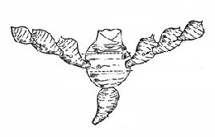
primary cormel
corm
Seed: mother plant
(submitted cormel)

secondary cormel
tertiary cormel

8.2 Explanations for individual characteristics
Ad. 2: Plant: growth habit

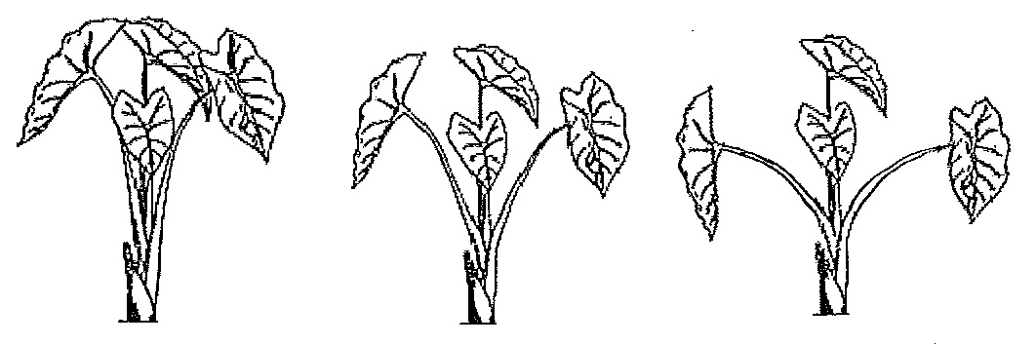
1 | 3 | 5
upright | semi-upright | spreading

Ad. 4: Leaf blade: attitude

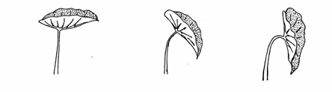
1 | 2 | 3
horizontal | oblique | vertical

Ad. 5: Leaf blade: length
Ad. 6: Leaf blade: width
Ad. 7: Leaf blade: ratio length/width
Ad. 8: Leaf blade: depth of sinus

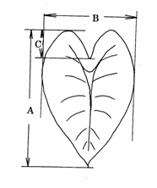 | A: length  B: width  C: depth of sinus

Ad. 9: Leaf blade: shape of apex

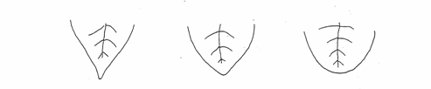
1 | 2 | 3
acute | obtuse | rounded

Ad. 11: Petiole: length
Ad. 12: Petiole: thickness at top of sheath
Ad. 13: Petiole: anthocyanin coloration of upper part
Ad. 14: Petiole: anthocyanin coloration of lower part
Ad. 15: Sheath: length

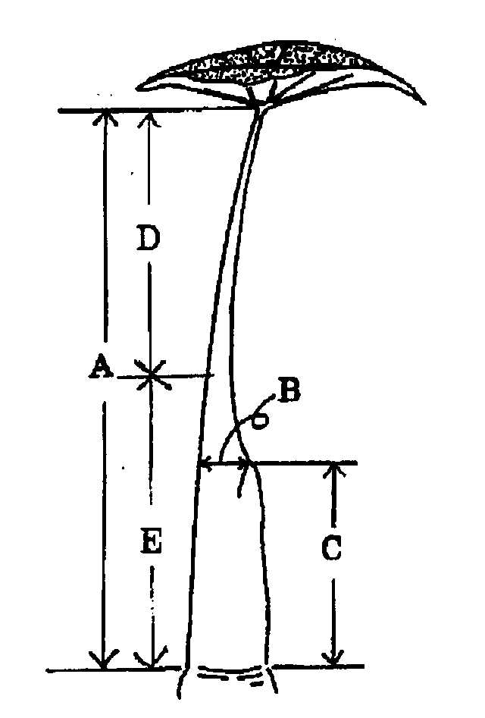 | A: Char. 11: Petiole: length  B: Char. 12: Petiole: thickness at top of sheath  C: Char. 15: Sheath: length  D: Char. 13: Petiole: anthocyanin coloration of upper part  E: Char. 14: Petiole: anthocyanin coloration of lower part

Ad. 19: Corm: shape

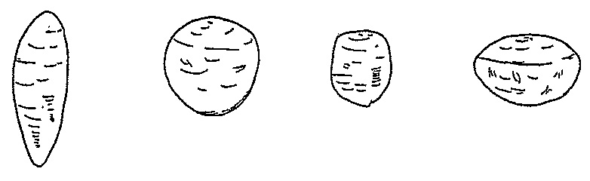
1 | 2 | 3 | 4
fusiform | circular | cylindric | oblate

Ad. 20: Corm: adherence of primary cormels

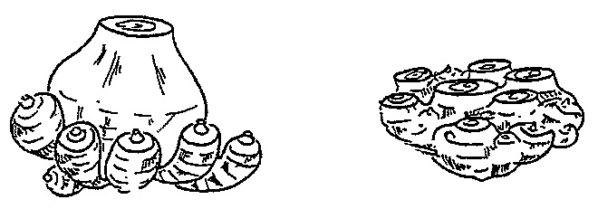
1 | 2
detachable from corm | non-detachable from corm

Adherence of primary cormels refers to whether the primary cormels are readily detachable by hand.
Ad. 21: Only varieties with corm: adherence of primary cormels: detachable from corm:
Corm: arrangement of primary cormels

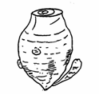 | 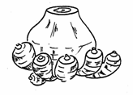 | 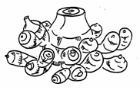
1 | 2 | 3
sparsely budding | densely budding | clustered  (multiple rings  of primary cormels)

Ad. 24: Primary cormel: shape

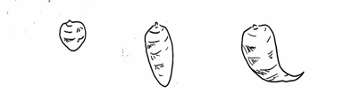
1 | 2 | 3
circular | obovate | shrimp-shape

Ad. 25: Primary cormel: density of fibers on surface

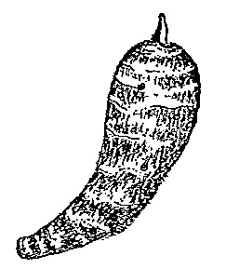

Fibers adhere on surface.

Ad. 28: Time of harvest

The time of harvest is observed as the time when the corm and cormels are fully developed.

Literature
Hotta, M., 1991: Colocasia L., The Grand Dictionary of Horticulture, Vol. 2. 360, Shougakkan, JP.

Larkom, J., 1991: Taro, Oriental Vegetables 122-123, Jon Murry, GB.

Ministry of Agriculture, Forestry & Fisheries, 1981: National Test Guideline for Satoimo.

Phillips, R., Rix, M.: 1993, Taro, Vegetables 237, Pan Books, GB.

Hidaka, Y., 1988: Nigauri, Nogyo-Gijutu-Taikei-Vegatable Vol.10, 1-46, Nosangyoson-Bunka-Kyokai, JP.

Technical Questionnaire
TECHNICAL QUESTIONNAIRE |  |  |  | Page {x} of {y} |  | Reference Number:
 |  |  |  |  |  | Application date:
 |  |  |  |  |  | (not to be filled in by the applicant)
TECHNICAL QUESTIONNAIRE
to be completed in connection with an application for plant breeders’ rights

1. Subject of the Technical Questionnaire
1.1.1 Botanical name |  |  | Colocasia esculenta (L.) Schott |  |  |  |  |  | [ ]
1.1.2 Common name |  |  | Taro
1.2.1 Botanical name |  |  | Colocasia gigantea (Blume) Hook. f. |  |  |  |  |  | [ ]
1.2.2 Common name
2. Applicant
Name
Address
Telephone No.
Fax No.
E-mail address
Breeder (if different from applicant)
3. Proposed denomination and breeder’s reference
Proposed denomination
(if available)
Breeder’s reference
#4. Information on the breeding scheme and propagation of the variety

4.1 Breeding scheme

Variety resulting from:

4.1.1 Crossing

(a) controlled cross [ ]
(please state parent varieties)
(b) partially known cross [ ]
(please state known parent variety(ies))
(c) unknown cross [ ]

4.1.2 Mutation [ ]
(please state parent variety)

4.1.3 Discovery and development [ ]
(please state where and when discovered
and how developed)

4.1.4 Other [ ]
(please provide details)

4.2 Method of propagating the variety

4.2.1 Vegetative propagation

(a) separation [ ]

(b) in vitro propagation [ ]

(c) other (state method) [ ]

4.2.2 Other [ ]
(please provide details)

5. Characteristics of the variety to be indicated (the number in brackets refers to the corresponding characteristic in Test Guidelines; please mark the note which best corresponds).

 | Characteristics |  |  |  |  |  | Example Varieties |  |  | Note
5.1  (2) | Plant: growth habit
 | upright |  |  |  |  |  | Egu-imo |  |  | 1[ ]
 | semi-upright |  |  |  |  |  | Ishikawa-wase |  |  | 3[ ]
 | spreading |  |  |  |  |  | Tono-imo |  |  | 5[ ]
5.4  (19) | Corm: shape
 | fusiform |  |  |  |  |  | Takenoko-imo |  |  | 1[ ]
 | circular |  |  |  |  |  | Serebesu |  |  | 2[ ]
 | cylindric |  |  |  |  |  | Okinawa-aokuki |  |  | 3[ ]
 | oblate |  |  |  |  |  |  |  |  | 4[ ]
5.2  (20) | Corm: adherence of primary cormels
 | detachable from corm |  |  |  |  |  | Ishikawa-wase |  |  | 1[ ]
 | non-detachable from corm |  |  |  |  |  | Yatugashira |  |  | 2[ ]
5.3  (21) | Only varieties with corm: adherence of primary cormels: detachable from corm: Corm: arrangement of primary cormels
 | sparsely budding |  |  |  |  |  | Ni-imo |  |  | 1[ ]
 | densely budding |  |  |  |  |  | Dotare |  |  | 2[ ]
 | clustered |  |  |  |  |  | Ishikawa-wase |  |  | 3[ ]
5.5  (24) | Primary cormel: shape
 | circular |  |  |  |  |  | Ishikawa-wase |  |  | 1[ ]
 | obovate |  |  |  |  |  | Okinawa-aokuki |  |  | 2[ ]
 | shrimp-shape |  |  |  |  |  | Tono-imo |  |  | 3[ ]
6. Similar varieties and differences from these varieties

Please use the following table and box for comments to provide information on how your candidate variety differs from the variety (or varieties) which, to the best of your knowledge, is (or are) most similar. This information may help the examination authority to conduct its examination of distinctness in a more efficient way.

Denomination(s) of variety(ies) similar to your candidate variety |  | Characteristic(s) in which your candidate variety differs from the similar variety(ies) |  |  | Describe the expression of the characteristic(s) for the similar variety(ies) |  |  | Describe the expression of the characteristic(s) for your candidate variety
Example |  | Primary cormel: shape |  |  | obovate |  |  | shrimp-shape
Comments:

#7. Additional information which may help in the examination of the variety

7.1 In addition to the information provided in sections 5 and 6, are there any additional characteristics which may help to distinguish the variety?

Yes [ ] No [ ]

(If yes, please provide details)

7.2 Are there any special conditions for growing the variety or conducting the examination?

Yes [ ] No [ ]

(If yes, please provide details)

7.3 Other information

8. Authorization for release

(a) Does the variety require prior authorization for release under legislation concerning the protection of the environment, human and animal health?

Yes [ ] No [ ]

(b) Has such authorization been obtained?

Yes [ ] No [ ]

If the answer to (b) is yes, please attach a copy of the authorization.

9. Information on plant material to be examined or submitted for examination.

9.1 The expression of a characteristic or several characteristics of a variety may be affected by factors, such as pests and disease, chemical treatment (e.g. growth retardants or pesticides), effects of tissue culture, different rootstocks, scions taken from different growth phases of a tree, etc.

9.2 The plant material should not have undergone any treatment which would affect the expression of the characteristics of the variety, unless the competent authorities allow or request such treatment. If the plant material has undergone such treatment, full details of the treatment must be given. In this respect, please indicate below, to the best of your knowledge, if the plant material to be examined has been subjected to:

(a) Microorganisms (e.g. virus, bacteria, phytoplasma) Yes [ ] No [ ]

(b) Chemical treatment (e.g. growth retardant, pesticide) Yes [ ] No [ ]

(c) Tissue culture Yes [ ] No [ ]

(d) Other factors Yes [ ] No [ ]

Please provide details for where you have indicated “yes”.

……………………………………………………………

10. I hereby declare that, to the best of my knowledge, the information provided in this form is correct:

Applicant’s name

Signature Date

[End of document]

* These names were correct at the time of the introduction of these Test Guidelines but may be revised or updated. [Readers are advised to consult the UPOV Code, which can be found on the UPOV Website (www.upov.int), for the latest information.]
# Authorities may allow certain of this information to be provided in a confidential section of the Technical Questionnaire.
# Authorities may allow certain of this information to be provided in a confidential section of the Technical Questionnaire.

