 |  | E  TG/253/1  ORIGINAL: English  DATE: 2009-04-01
INTERNATIONAL UNION FOR THE PROTECTION OF NEW VARIETIES OF PLANTS
GENEVA

 | BIRD CHERRY  UPOV Code: PRUNU_PAD  Prunus padus L. | *

GUIDELINES

FOR THE CONDUCT OF TESTS

FOR DISTINCTNESS, UNIFORMITY AND STABILITY

Alternative Names:*

Botanical name | English | French | German | Spanish
Prunus padus L., Padus racemosa (Lam.) C. K. Schneid., Prunus racemosa Lam. | Bird cherry | Merisier à grappes | Traubenkirsche | Cerezo de racimo

The purpose of these guidelines (“Test Guidelines”) is to elaborate the principles contained in the General Introduction (document TG/1/3), and its associated TGP documents, into detailed practical guidance for the harmonized examination of distinctness, uniformity and stability (DUS) and, in particular, to identify appropriate characteristics for the examination of DUS and production of harmonized variety descriptions.

ASSOCIATED DOCUMENTS

These Test Guidelines should be read in conjunction with the General Introduction and its associated TGP documents.

TABLE OF CONTENTS PAGE

1. Subject of these Test Guidelines 3
2. Material Required 3
3. Method of Examination 3
3.1 Number of Growing Cycles 3
3.2 Testing Place 3
3.3 Conditions for Conducting the Examination 3
3.4 Test Design 4
3.5 Number of Plants / Parts of Plants to be Examined 4
3.6 Additional Tests 4
4. Assessment of Distinctness, Uniformity and Stability 4
4.1 Distinctness 4
4.2 Uniformity 5
4.3 Stability 5
5. Grouping of Varieties and Organization of the Growing Trial 5
6. Introduction to the Table of Characteristics 6
6.1 Categories of Characteristics 6
6.2 States of Expression and Corresponding Notes 6
6.3 Types of Expression 6
6.4 Example Varieties 6
6.5 Legend 6
7. Table of Characteristics/Tableau des caractères/Merkmalstabelle/Tabla de caracteres 7
8. Explanations on the Table of Characteristics 12
8.1 Explanations covering several characteristics 12
8.2 Explanations for individual characteristics 12
9. Literature 16
10. Technical Questionnaire 17

Subject of these Test Guidelines
These Test Guidelines apply to all varieties of Prunus padus L. of the family Rosaceae. These Test Guidelines may also be useful for the examination of hybrids between Prunus padus L. and other species of Prunus L.

Material Required
2.1 The competent authorities decide on the quantity and quality of the plant material required for testing the variety and when and where it is to be delivered. Applicants submitting material from a State other than that in which the testing takes place must ensure that all customs formalities and phytosanitary requirements are complied with.

2.2 The material is to be supplied in the form of three-year-old trees grafted on a rootstock. The rootstock to be used is specified by the competent authority.

2.3 The minimum quantity of plant material, to be supplied by the applicant, should be:

8 trees.

2.4 The plant material supplied should be visibly healthy, not lacking in vigor, nor affected by any important pest or disease.

2.5 The plant material should not have undergone any treatment which would affect the expression of the characteristics of the variety, unless the competent authorities allow or request such treatment. If it has been treated, full details of the treatment must be given.

Method of Examination

3.1 Number of Growing Cycles
The minimum duration of tests should normally be two independent growing cycles.

3.2 Testing Place
Tests are normally conducted at one place. In the case of tests conducted at more than one place, guidance is provided in TGP/9 “Examining Distinctness”.

3.3 Conditions for Conducting the Examination
3.3.1 The tests should be carried out under conditions ensuring satisfactory growth for the expression of the relevant characteristics of the variety and for the conduct of the examination.

3.3.2 The recommended method of observing the characteristic is indicated by the following key in the second column of the Table of Characteristics:

VG: visual assessment by a single observation of a group of plants or parts of plants
MG: single measurement of a group of plants or parts of plants

3.4 Test Design
3.4.1 Each test should be designed to result in a total of at least 6 trees.

3.4.2 The design of the tests should be such that plants or parts of plants may be removed for measurement or counting without prejudice to the observations which must be made up to the end of the growing cycle.

3.5 Number of Plants / Parts of Plants to be Examined
Unless otherwise indicated, all observations should be made on 6 plants or parts taken from each of 6 plants.

3.6 Additional Tests
Additional tests, for examining relevant characteristics, may be established.

Assessment of Distinctness, Uniformity and Stability

4.1 Distinctness

4.1.1 General Recommendations
It is of particular importance for users of these Test Guidelines to consult the General Introduction prior to making decisions regarding distinctness. However, the following points are provided for elaboration or emphasis in these Test Guidelines.

4.1.2 Consistent Differences
The differences observed between varieties may be so clear that more than one growing cycle is not necessary. In addition, in some circumstances, the influence of the environment is not such that more than a single growing cycle is required to provide assurance that the differences observed between varieties are sufficiently consistent. One means of ensuring that a difference in a characteristic, observed in a growing trial, is sufficiently consistent is to examine the characteristic in at least two independent growing cycles.

4.1.3 Clear Differences

Determining whether a difference between two varieties is clear depends on many factors, and should consider, in particular, the type of expression of the characteristic being examined, i.e. whether it is expressed in a qualitative, quantitative, or pseudo-qualitative manner. Therefore, it is important that users of these Test Guidelines are familiar with the recommendations contained in the General Introduction prior to making decisions regarding distinctness.

4.2 Uniformity
4.2.1 It is of particular importance for users of these Test Guidelines to consult the General Introduction prior to making decisions regarding uniformity. However, the following points are provided for elaboration or emphasis in these Test Guidelines:

4.2.2 For the assessment of uniformity, a population standard of 1% and an acceptance probability of at least 95% should be applied. In the case of a sample size of 6 plants, 1 off-type is allowed.

4.3 Stability
4.3.1 In practice, it is not usual to perform tests of stability that produce results as certain as those of the testing of distinctness and uniformity. However, experience has demonstrated that, for many types of variety, when a variety has been shown to be uniform, it can also be considered to be stable.

4.3.2 Where appropriate, or in cases of doubt, stability may be tested, either by growing a further generation, or by testing a new plant stock to ensure that it exhibits the same characteristics as those shown by the previous material supplied.

Grouping of Varieties and Organization of the Growing Trial
5.1 The selection of varieties of common knowledge to be grown in the trial with the candidate varieties and the way in which these varieties are divided into groups to facilitate the assessment of distinctness are aided by the use of grouping characteristics.

5.2 Grouping characteristics are those in which the documented states of expression, even where produced at different locations, can be used, either individually or in combination with other such characteristics: (a) to select varieties of common knowledge that can be excluded from the growing trial used for examination of distinctness; and (b) to organize the growing trial so that similar varieties are grouped together.

5.3 The following have been agreed as useful grouping characteristics:

(a) Tree: growth habit (characteristic 2)
(b) Tree: shape of crown (characteristic 3)
(c) Young leaf: color of blade (characteristic 8)
(d) Leaf blade: variegation on upper side (characteristic 10)
(e) Leaf blade: color of upper side (excluding variegation) (characteristic 11)
(f) Petal: color (characteristic 24)

5.4 Guidance for the use of grouping characteristics, in the process of examining distinctness, is provided through the General Introduction.

Introduction to the Table of Characteristics

6.1 Categories of Characteristics
6.1.1 Standard Test Guidelines Characteristics

Standard Test Guidelines characteristics are those which are approved by UPOV for examination of DUS and from which members of the Union can select those suitable for their particular circumstances.

6.1.2 Asterisked Characteristics

Asterisked characteristics (denoted by *) are those included in the Test Guidelines which are important for the international harmonization of variety descriptions and should always be examined for DUS and included in the variety description by all members of the Union, except when the state of expression of a preceding characteristic or regional environmental conditions render this inappropriate.

6.2 States of Expression and Corresponding Notes
States of expression are given for each characteristic to define the characteristic and to harmonize descriptions. Each state of expression is allocated a corresponding numerical note for ease of recording of data and for the production and exchange of the description.

6.3 Types of Expression
An explanation of the types of expression of characteristics (qualitative, quantitative and pseudo-qualitative) is provided in the General Introduction.

6.4 Example Varieties
Where appropriate, example varieties are provided to clarify the states of expression of each characteristic.

6.5 Legend
(*) Asterisked characteristic – see Chapter 6.1.2

QL: Qualitative characteristic – see Chapter 6.3
QN: Quantitative characteristic – see Chapter 6.3
PQ: Pseudo-qualitative characteristic – see Chapter 6.3

VG, MG: See Chapter 3.3.2

(a)-(d) See Explanations on the Table of Characteristics in Chapter 8.1
(+) See Explanations on the Table of Characteristics in Chapter 8.2

Table of Characteristics/Tableau des caractères/Merkmalstabelle/Tabla de caracteres
 |  |  |  | English | français | Deutsch | español | Example Varieties  Exemples  Beispielssorten  Variedades ejemplo | Note/  Nota
1  (+) | VG |  | Tree: vigor |  | Arbre : vigueur | Baum: Wuchsstärke | Árbol: vigor
QN | (a) |  | weak |  | faible | schwach | débil | Nana | 3
 |  |  | medium |  | moyenne | mittel | medio | Colorata | 5
 |  |  | strong |  | forte | stark | fuerte | Albertii, Watereri | 7
2  (*)  (+) | VG |  | Tree: growth habit |  | Arbre : port | Baum: Wuchsform | Árbol: porte
QN | (a) |  | upright |  | dressé | aufrecht | erguido | Albertii | 1
 |  |  | semi-upright |  | demi-dressé | halbaufrecht | semierguido |  | 2
 |  |  | spreading |  | divergent | breitwüchsig | extendido | Colorata | 3
 |  |  | drooping |  | retombant | überhängend | colgante | Pendula | 4
3  (*)  (+) | VG |  | Tree: shape of crown |  | Arbre : forme de la couronne | Baum: Form der Krone | Árbol: forma de la copa
PQ | (a) |  | acute |  | pointue | spitz | aguda | Albertii | 1
 |  |  | obtuse |  | obtuse | stumpf | obtusa |  | 2
 |  |  | rounded |  | arrondie | abgerundet | redondeada | Nana | 3
4 | VG |  | Vegetative bud: color |  | Bourgeon végétatif : couleur | Blattknospe: Farbe | Yema de madera: color
QL | (a) |  | purple brown |  | brun pourpre | purpurbraun | marrón púrpura | Colorata | 1
 |  |  | greenish brown |  | brun verdâtre | grünlichbraun | marrón verdoso | Watereri | 2
5  (*) | VG |  | Young shoot: color |  | Jeune rameau : couleur | Jungtrieb: Farbe | Vástago joven: color
PQ | (b) |  | green |  | vert | grün | verde | Nana | 1
 |  |  | purple brown |  | brun pourpre | purpurbraun | marrón púrpura | Colorata, Rózsaszín Május | 2
 |  |  | brown |  | brun | braun | marrón |  | 3
6 | VG |  | One-year-old shoot: thickness |  | Rameau d’un an : épaisseur | Einjähriger Trieb: Dicke | Vástago de un año: grosor
QN | (a) |  | thin |  | fin | dünn | delgado |  | 3
 |  |  | medium |  | moyen | mittel | medio | Colorata | 5
 |  |  | thick |  | épais | dick | grueso | Nana | 7
7 | VG |  | One-year-old shoot: length |  | Rameau d’un an : longueur | Einjähriger Trieb: Länge | Vástago de un año: longitud
QN | (a) |  | short |  | court | kurz | corto |  | 3
 |  |  | medium |  | moyen | mittel | medio |  | 5
 |  |  | long |  | long | lang | largo |  | 7
8  (*) | VG |  | Young leaf: color of blade |  | Feuille jeune : couleur du limbe | Junges Blatt: Farbe der Spreite | Hoja joven: color del limbo
PQ | (b) |  | yellow |  | jaune | gelb | amarillo | Aurea | 1
 |  |  | green |  | verte | grün | verde | Albertii | 2
 |  |  | bronze green |  | vert bronze | bronzegrün | verde marrón | Watereri | 3
 |  |  | brown red |  | rouge-brun | braunrot | marrón rojizo | Colorata | 4
9  (+) | VG |  | Leaf blade: shape |  | Limbe : forme | Blattspreite: Form | Limbo: forma
PQ | (c) |  | ovate |  | ovale | eiförmig | ovado | Albertii | 1
 |  |  | elliptic |  | elliptique | elliptisch | elíptico | Colorata | 2
 |  |  | obovate |  | obovale | verkehrt eiförmig | obovado |  | 3
10  (*) | VG |  | Leaf blade: variegation on upper side |  | Limbe : panachure sur la face supérieure | Blattspreite: Panaschierung an der Oberseite | Limbo: variegación del haz
QL | (c) |  | absent |  | absente | fehlend | ausente | Watereri | 1
 |  |  | present |  | présente | vorhanden | presente | Aucubifolia | 9
11  (*)  (+) | VG |  | Leaf blade: color of upper side (exclu-ding variegation) |  | Limbe : couleur de la face supérieure (à l’exclusion de la panachure) | Blattspreite: Farbe der Oberseite (ohne Panaschierung) | Limbo: color del haz (excluida la variegación)
PQ | (c) |  | green |  | vert | grün | verde | Albertii | 1
 |  |  | red purple |  | violacé | rotpurpurn | púrpura rojo |  | 2
 |  |  | purple |  | pourpre | purpurn | púrpura |  | 3
 |  |  | brownish |  | brunâtre | bräunlich | amarronado | Rózsaszín Május | 4
12 | VG |  | Leaf blade: color of variegation on upper side |  | Limbe : couleur de la panachure de la face supérieure | Blattspreite: Farbe der Panaschierung der Oberseite | Limbo: color de la variegación del haz
PQ | (c) |  | white |  | blanche | weiß | blanco |  | 1
 |  |  | yellow |  | jaune | gelb | amarillo | Aucubifolia | 2
 |  |  | purple |  | pourpre | purpurn | púrpura |  | 3
13  (+) | VG |  | Leaf blade: distribution of variegation on upper side |  | Limbe : répartition de la panachure de la face supérieure | Blattspreite: Verteilung der Panaschierung der Oberseite | Limbo: distribución de la variegación del haz
PQ | (c) |  | marginal |  | marginale | am Rand | borde |  | 1
 |  |  | speckled |  | tachetée | gefleckt | moteado | Aucubifolia | 2
 |  |  | central zone |  | zone centrale | Mittelzone | parte central |  | 3
14 | VG |  | Leaf blade: glossiness of upper side |  | Limbe : brillance de la face supérieure | Blattspreite: Glanz der Oberseite | Limbo: brillo del haz
QN | (c) |  | absent or weak |  | nulle ou faible | fehlend oder gering | ausente o débil |  | 1
 |  |  | medium |  | moyenne | mittel | medio |  | 2
 |  |  | strong |  | forte | stark | fuerte |  | 3
15  (*) | VG |  | Leaf blade: color of lower side |  | Limbe : couleur de la face inférieure | Blattspreite: Farbe der Unterseite | Limbo: color del envés
PQ | (c) |  | green |  | verte | grün | verde | Albertii | 1
 |  |  | purple red |  | rouge-pourpre | purpurrot | rojo púrpura | Rózsaszín Május | 2
 |  |  | silvery red |  | rouge argenté | silbrigrot | rojo plateado | Colorata | 3
16 | VG |  | Petiole: stipules |  | Pétiole : stipules | Blattstiel: Nebenblätter | Pecíolo: estípulas
QL | (c) |  | absent |  | absentes | fehlend | ausentes |  | 1
 |  |  | present |  | présentes | vorhanden | presentes | Albertii | 9
17  (+) | VG |  | Inflorescence: attitude |  | Inflorescence : port | Blütenstand: Haltung | Inflorescencia: porte
QN | (d) |  | upwards |  | dressé | aufwärts gerichtet | hacia arriba | Stricta | 1
 |  |  | outwards |  | perpendiculaire | abstehend | hacia fuera |  | 2
 |  |  | downwards |  | retombant | abwärts gerichtet | hacia abajo | Watereri | 3
18  (+) | VG |  | Inflorescence: length (excluding peduncle) |  | Inflorescence : longueur (à l’exclusion du pédoncule) | Blütenstand: Länge (ohne Blüten-standsstiel) | Inflorescencia: longitud (excluido el pedúnculo)
QN | (d) |  | short |  | courte | kurz | corta |  | 3
 |  |  | medium |  | moyenne | mittel | media | Colorata | 5
 |  |  | long |  | longue | lang | larga | Watereri | 7
19 | VG |  | Inflorescence: density of florets |  | Inflorescence : densité des fleurs | Blütenstand: Dichte der Blüten | Inflorescencia: densidad de las flores
QN | (d) |  | sparse |  | faible | locker | escasa |  | 3
 |  |  | medium |  | moyenne | mittel | media |  | 5
 |  |  | dense |  | dense | dicht | densa | Nana | 7
20  (+) | VG |  | Flower bud: color |  | Bouton : couleur | Blütenknospe: Farbe | Botón floral: color
PQ |  |  | white |  | blanc | weiß | blanco |  | 1
 |  |  | green yellow |  | jaune vert | grüngelb | amarillo verde | Albertii | 2
 |  |  | pink |  | rose | rosa | rosa | Colorata | 3
21  (*)  (+) | VG |  | Flower: type |  | Fleur : type | Blüte: Typ | Flor: tipo
QN | (d) |  | single |  | simple | einfach | sencilla | Albertii | 1
 |  |  | semi double |  | semi-double | halbgefüllt | semidoble | Plena | 2
 |  |  | double |  | double | gefüllt | doble |  | 3
22 | VG |  | Flower: diameter |  | Fleur : diamètre | Blüte: Durchmesser | Flor: diámetro
QN | (d) |  | small |  | petit | klein | pequeño |  | 3
 |  |  | medium |  | moyen | mittel | medio |  | 5
 |  |  | large |  | grand | groß | grande | Watereri | 7
23 | VG |  | Flower: fragrance |  | Fleur : parfum | Blüte: Duft | Flor: fragancia
QN | (d) |  | absent or very weak |  | absent ou très faible | fehlend oder sehr schwach | ausente o muy débil |  | 1
 |  |  | weak |  | faible | schwach | débil |  | 2
 |  |  | strong |  | fort | stark | fuerte | Rózsaszín Május | 3
24  (*) | VG |  | Petal: color |  | Pétale : couleur | Blütenblatt: Farbe | Pétalo: color
PQ | (d) |  | white |  | blanc | weiß | blanco | Albertii, Watereri | 1
 |  |  | light pink |  | rose pâle | hellrosa | rosa claro |  | 2
 |  |  | medium pink |  | rose moyen | mittelrosa | rosa medio | Rózsaszín Május | 3
 |  |  | dark pink |  | rose foncé | dunkelrosa | rosa oscuro | Colorata | 4
25  (*)  (+) | MG |  | Time of flowering |  | Époque de floraison | Zeitpunkt der Blüte | Época de floración
QN |  |  | early |  | précoce | früh | temprana | Rózsaszín Május | 3
 |  |  | medium |  | moyenne | mittel | media |  | 5
 |  |  | late |  | tardive | spät | tardía | Nana | 7

Explanations on the Table of Characteristics

8.1 Explanations covering several characteristics
Characteristics containing the following key in the second column of the Table of Characteristics should be examined as indicated below:

- Tree/One-year-old shoot: Observations on the tree and the one year-old shoot should be made during the dormant season. Observations on the one year-old shoot should be made on the middle third of the shoot.
- Shoot and young leaf: Observations should be made on the young shoot and leaves.
- Leaf: Observations on the leaf should be made in summer on fully developed leaves from the middle third of a current season’s shoot.
- Inflorescence and flower: Observations should be made on fully developed flowers at full flowering.

8.2 Explanations for individual characteristics
Ad. 1: Tree: vigor

The vigor is observed as the overall abundance of vegetative growth.

Ad. 2: Tree: growth habit

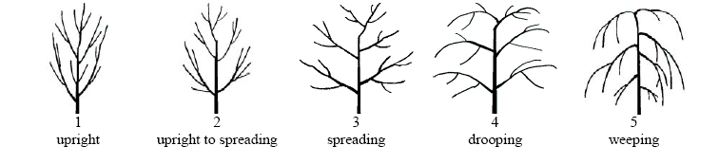
1 | 2 | 3 | 4
upright | semi-upright | spreading | drooping

Ad. 3: Tree: shape of crown

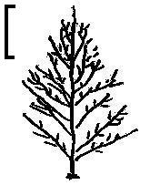 | 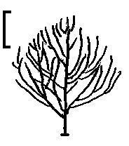 | 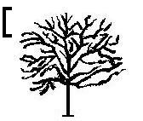
1 | 2 | 3
acute | obtuse | rounded

Ad. 9: Leaf blade: shape

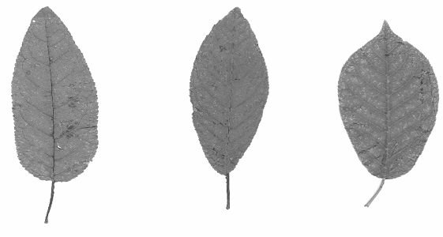
1 | 2 | 3
ovate | elliptic | obovate

Ad. 11: Leaf blade: color of upper side (excluding variegation)

Variegation is well-defined areas of different color, with less or no chlorophyll, especially as irregular patches or stripes.

Ad. 13: Leaf blade: distribution of variegation on upper side

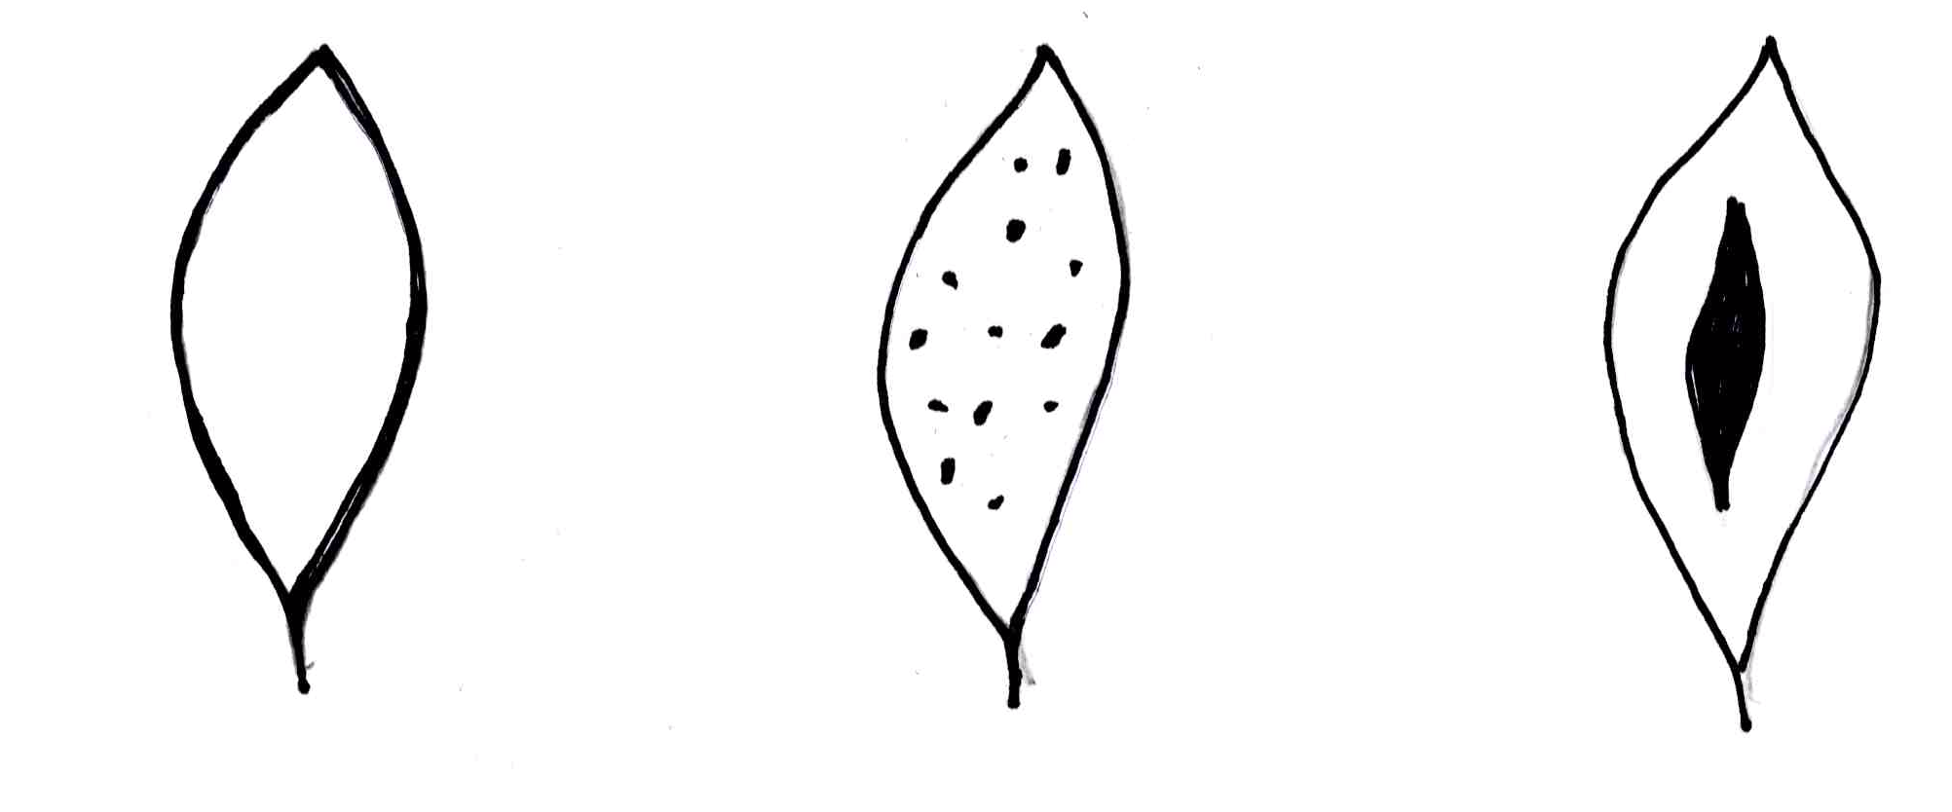
1 | 2 | 3
marginal | speckled | central zone

Ad. 17: Inflorescence: attitude

The general attitude of the lateral inflorescences should be observed.

Ad. 18: Inflorescence: length (excluding peduncle)

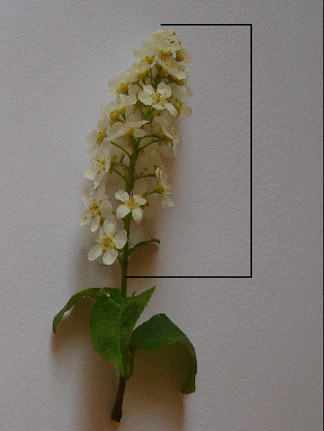

The length of the lateral inflorescence should be observed.

Ad. 20: Flower bud: color

Observations should be made on flower buds just before opening.
Ad. 21: Flower: type
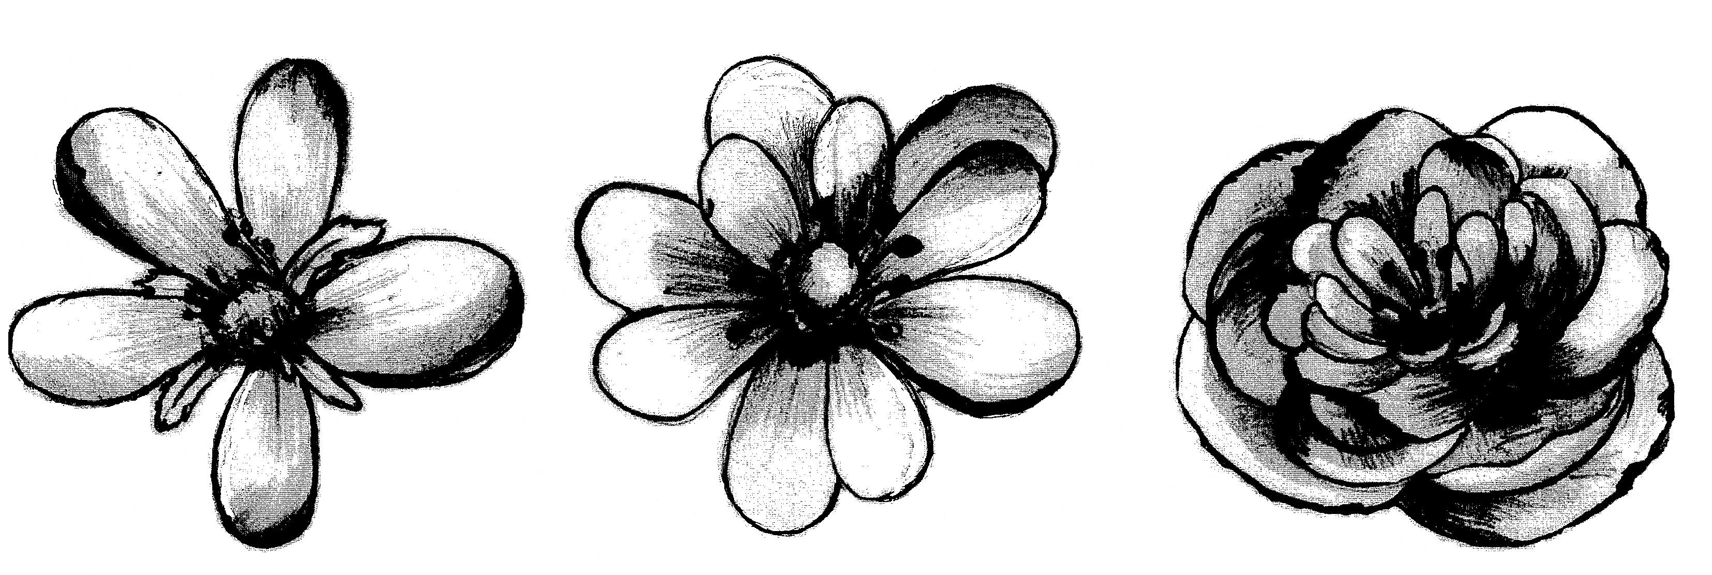
1 | 2 | 3
single | semi double | double
(5 petals) | (2 or 3 circles of petals: maximum of 15 petals) | (more than 3 circles of petals)

Ad. 25: Time of flowering

The time of flowering is when 50% of the flowers are fully open.

Literature
Krüssmann, G., 1978: Handbuch der Laubgehölze. Berlin, DE, Bd. III, pp. 38.

Uusitalo, M., 2004: European bird cherry (Prunus padus L.) a biodiverse wild plant for horticulture. MTT Agrifood Research Finland, Jokioinen, FI.
(www.mtt.fi/met/pdf/met 61.pdf)

Technical Questionnaire
TECHNICAL QUESTIONNAIRE |  |  |  | Page {x} of {y} |  | Reference Number:
 |  |  |  |  |  | Application date:
 |  |  |  |  |  | (not to be filled in by the applicant)
TECHNICAL QUESTIONNAIRE
to be completed in connection with an application for plant breeders’ rights

1. Subject of the Technical Questionnaire
1.1 Botanical name |  |  | Prunus padus L.
1.2 Common name |  |  | Bird Cherry
2. Applicant
Name
Address
Telephone No.
Fax No.
E-mail address
Breeder (if different from applicant)
3. Proposed denomination and breeder’s reference
Proposed denomination
(if available)

Breeder’s reference
#4. Information on the breeding scheme and propagation of the variety

4.1 Breeding scheme

Variety resulting from:

4.1.1 Crossing

(a) controlled cross [ ]
(please state parent varieties)
(b) partially known cross [ ]
(please state known parent variety(ies))
(c) unknown cross [ ]

4.1.2 Mutation [ ]
(please state parent variety)

4.1.3 Discovery and development [ ]
(please state where and when discovered and how developed)

4.1.4 Other [ ]
(please provide details)

4.2 Method of propagating the variety

4.2.1 Vegetative propagation

(a) cuttings [ ]
(b) in vitro propagation [ ]
(c) other (state method) [ ]

4.2.2 Other [ ]
(please provide details)

5. Characteristics of the variety to be indicated (the number in brackets refers to the corresponding characteristic in Test Guidelines; please mark the note which best corresponds).

 | Characteristics |  |  |  |  |  | Example Varieties |  |  |  | Note
5.1  (2) | Tree: growth habit
 | upright |  |  |  |  |  | Albertii |  |  |  | 1[ ]
 | semi-upright |  |  |  |  |  |  |  |  |  | 2[ ]
 | spreading |  |  |  |  |  | Colorata |  |  |  | 3[ ]
 | drooping |  |  |  |  |  | Pendula |  |  |  | 4[ ]
5.2  (3) | Tree: shape of crown
 | acute |  |  |  |  |  | Albertii |  |  |  | 1[ ]
 | obtuse |  |  |  |  |  |  |  |  |  | 2[ ]
 | rounded |  |  |  |  |  | Nana |  |  |  | 3[ ]
5.3  (8) | Young leaf: color of blade
 | yellow |  |  |  |  |  | Aurea |  |  |  | 1[ ]
 | green |  |  |  |  |  | Albertii |  |  |  | 2[ ]
 | bronze green |  |  |  |  |  | Watereri |  |  |  | 3[ ]
 | brown red |  |  |  |  |  | Colorata |  |  |  | 4[ ]
5.4  (10) | Leaf blade: variegation on upper side
 | absent |  |  |  |  |  | Watereri |  |  |  | 1[ ]
 | present |  |  |  |  |  | Aucubifolia |  |  |  | 9[ ]
 | Characteristics |  |  |  |  |  | Example Varieties |  |  |  | Note
5.5  (11) | Leaf blade: color of upper side (excluding variegation)
 | green |  |  |  |  |  | Albertii |  |  |  | 1[ ]
 | red purple |  |  |  |  |  |  |  |  |  | 2[ ]
 | purple |  |  |  |  |  |  |  |  |  | 3[ ]
 | brownish |  |  |  |  |  | Rózsaszín Május |  |  |  | 4[ ]
5.6  (21) | Flower: type
 | single |  |  |  |  |  | Albertii |  |  |  | 1[ ]
 | semi double |  |  |  |  |  | Plena |  |  |  | 2[ ]
 | double |  |  |  |  |  |  |  |  |  | 3[ ]
5.7  (24) | Petal: color
 | white |  |  |  |  |  | Albertii, Watereri |  |  |  | 1[ ]
 | light pink |  |  |  |  |  |  |  |  |  | 2[ ]
 | medium pink |  |  |  |  |  | Rózsaszín Május |  |  |  | 3[ ]
 | dark pink |  |  |  |  |  | Colorata |  |  |  | 4[ ]
6. Similar varieties and differences from these varieties

Please use the following table and box for comments to provide information on how your candidate variety differs from the variety (or varieties) which, to the best of your knowledge, is (or are) most similar. This information may help the examination authority to conduct its examination of distinctness in a more efficient way.

Denomination(s) of variety(ies) similar to your candidate variety |  | Characteristic(s) in which your candidate variety differs from the similar variety(ies) |  |  | Describe the expression of the characteristic(s) for the similar variety(ies) |  |  | Describe the expression of the characteristic(s) for your candidate variety
Example |  | Petal: color |  |  | white |  |  | light pink
Comments:

#7. Additional information which may help in the examination of the variety

7.1 In addition to the information provided in sections 5 and 6, are there any additional characteristics which may help to distinguish the variety?

Yes [ ] No [ ]

(If yes, please provide details)

7.2 Are there any special conditions for growing the variety or conducting the examination?

Yes [ ] No [ ]

(If yes, please provide details)

7.3 Other information

A representative color photograph of the variety should accompany the Technical Questionnaire.

8. Authorization for release

(a) Does the variety require prior authorization for release under legislation concerning the protection of the environment, human and animal health?

Yes [ ] No [ ]

(b) Has such authorization been obtained?

Yes [ ] No [ ]

If the answer to (b) is yes, please attach a copy of the authorization.

9. Information on plant material to be examined or submitted for examination.

9.1 The expression of a characteristic or several characteristics of a variety may be affected by factors, such as pests and disease, chemical treatment (e.g. growth retardants or pesticides), effects of tissue culture, different rootstocks, scions taken from different growth phases of a tree, etc.

9.2 The plant material should not have undergone any treatment which would affect the expression of the characteristics of the variety, unless the competent authorities allow or request such treatment. If the plant material has undergone such treatment, full details of the treatment must be given. In this respect, please indicate below, to the best of your knowledge, if the plant material to be examined has been subjected to:

(a) Microorganisms (e.g. virus, bacteria, phytoplasma) Yes [ ] No [ ]

(b) Chemical treatment (e.g. growth retardant, pesticide) Yes [ ] No [ ]

(c) Tissue culture Yes [ ] No [ ]

(d) Other factors Yes [ ] No [ ]

Please provide details for where you have indicated “yes”.

……………………………………………………………

10. I hereby declare that, to the best of my knowledge, the information provided in this form is correct:

Applicant’s name

Signature Date

[End of document]

* These names were correct at the time of the introduction of these Test Guidelines but may be revised or updated. [Readers are advised to consult the UPOV Code, which can be found on the UPOV Website (www.upov.int), for the latest information.]
# Authorities may allow certain of this information to be provided in a confidential section of the Technical Questionnaire.
# Authorities may allow certain of this information to be provided in a confidential section of the Technical Questionnaire.

