 |  | E  TG/235/1  ORIGINAL: English  DATE: 2007-03-28
INTERNATIONAL UNION FOR THE PROTECTION OF NEW VARIETIES OF PLANTS
GENEVA

 | BITTER GOURD  UPOV Code: MOMOR_CHA  Momordica charantia L. | *

GUIDELINES

FOR THE CONDUCT OF TESTS

FOR DISTINCTNESS, UNIFORMITY AND STABILITY

Alternative Names:*

Botanical name | English | French | German | Spanish
Momordica charantia L. | Balsam apple,  Balsam pear,  Bitter cucumber, Bitter gourd,  Bitter melon,  Cassila gourd | Concombre africain,  Margose, Momordique | Bittergurke,  Balsambirne | Balsamito, Cundeamor, Momordica

The purpose of these guidelines (“Test Guidelines”) is to elaborate the principles contained in the General Introduction (document TG/1/3), and its associated TGP documents, into detailed practical guidance for the harmonized examination of distinctness, uniformity and stability (DUS) and, in particular, to identify appropriate characteristics for the examination of DUS and production of harmonized variety descriptions.

ASSOCIATED DOCUMENTS

These Test Guidelines should be read in conjunction with the General Introduction and its associated TGP documents.
TABLE OF CONTENTS PAGE

1. Subject of these Test Guidelines 3
2. Material Required 3
3. Method of Examination 3
3.1 Number of Growing Cycles 3
3.2 Testing Place 3
3.3 Conditions for Conducting the Examination 3
3.4 Test Design 4
3.5 Number of Plants / Parts of Plants to be Examined 4
3.6 Additional Tests 4
4. Assessment of Distinctness, Uniformity and Stability 4
4.1 Distinctness 4
4.2 Uniformity 5
4.3 Stability 5
5. Grouping of Varieties and Organization of the Growing Trial 5
6. Introduction to the Table of Characteristics 6
6.1 Categories of Characteristics 6
6.2 States of Expression and Corresponding Notes 6
6.3 Types of Expression 6
6.4 Example Varieties 6
6.5 Legend 6
7. Table of Characteristics/Tableau des caractères/Merkmalstabelle/Tabla de caracteres 7
8. Explanations on the Table of Characteristics 14
8.1 Explanations covering several characteristics 14
8.2 Explanations for individual characteristics 14
9. Literature 18
10. Technical Questionnaire 19

Subject of these Test Guidelines
These Test Guidelines apply to all varieties of Momordica charantia L.

Material Required
2.1 The competent authorities decide on the quantity and quality of the plant material required for testing the variety and when and where it is to be delivered. Applicants submitting material from a State other than that in which the testing takes place must ensure that all customs formalities and phytosanitary requirements are complied with.

2.2 The material is to be supplied in the form of seed.

2.3 The minimum quantity of plant material, to be supplied by the applicant, should be:

1,500 seeds.

The seed should meet the minimum requirements for germination, species and analytical purity, health and moisture content, specified by the competent authority. In cases where the seed is to be stored, the germination capacity should be as high as possible and should, be stated by the applicant.

2.4 The plant material supplied should be visibly healthy, not lacking in vigor, nor affected by any important pest or disease.

2.5 The plant material should not have undergone any treatment which would affect the expression of the characteristics of the variety, unless the competent authorities allow or request such treatment. If it has been treated, full details of the treatment must be given.

Method of Examination

3.1 Number of Growing Cycles
The minimum duration of tests should normally be two independent growing cycles.

3.2 Testing Place
Tests are normally conducted at one place. In the case of tests conducted at more than one place, guidance is provided in TGP/9 “Examining Distinctness”.

3.3 Conditions for Conducting the Examination
3.3.1 The tests should be carried out under conditions ensuring satisfactory growth for the expression of the relevant characteristics of the variety and for the conduct of the examination.

3.3.2 The recommended method of observing the characteristic is indicated by the following key in the second column of the Table of Characteristics:

MG: single measurement of a group of plants or parts of plants
MS: measurement of a number of individual plants or parts of plants
VG: visual assessment by a single observation of a group of plants or parts of plants
VS: visual assessment by observation of individual plants or parts of plants

3.4 Test Design
3.4.1 Each test should be designed to result in a total of at least 40 plants, which should be divided between two or more replicates.

3.4.2 The design of the tests should be such that plants or parts of plants may be removed for measurement or counting without prejudice to the observations which must be made up to the end of the growing cycle.

3.5 Number of Plants / Parts of Plants to be Examined
Unless otherwise indicated, all observations on single plants should be made on 20 plants or parts taken from each of 20 plants and any other observations should be made on all plants in the test.

3.6 Additional Tests
Additional tests, for examining relevant characteristics, may be established.

Assessment of Distinctness, Uniformity and Stability

4.1 Distinctness

4.1.1 General Recommendations

It is of particular importance for users of these Test Guidelines to consult the General Introduction prior to making decisions regarding distinctness. However, the following points are provided for elaboration or emphasis in these Test Guidelines.

4.1.2 Consistent Differences

The differences observed between varieties may be so clear that more than one growing cycle is not necessary. In addition, in some circumstances, the influence of the environment is not such that more than a single growing cycle is required to provide assurance that the differences observed between varieties are sufficiently consistent. One means of ensuring that a difference in a characteristic, observed in a growing trial, is sufficiently consistent is to examine the characteristic in at least two independent growing cycles.

4.1.3 Clear Differences

Determining whether a difference between two varieties is clear depends on many factors, and should consider, in particular, the type of expression of the characteristic being examined, i.e. whether it is expressed in a qualitative, quantitative, or pseudo-qualitative manner. Therefore, it is important that users of these Test Guidelines are familiar with the recommendations contained in the General Introduction prior to making decisions regarding distinctness.

4.2 Uniformity
4.2.1 It is of particular importance for users of these Test Guidelines to consult the General Introduction prior to making decisions regarding uniformity. However, the following points are provided for elaboration or emphasis in these Test Guidelines:

4.2.2 The assessment of uniformity for cross-pollinated varieties should be according to the recommendations for cross-pollinated varieties in the General Introduction.

4.2.3 The assessment of uniformity for hybrid varieties, a population standard of 1% and an acceptance probability of at least 95 % should be applied. In the case of a sample size of 40 plants, 2 off-types are allowed.

4.3 Stability
4.3.1 In practice, it is not usual to perform tests of stability that produce results as certain as those of the testing of distinctness and uniformity. However, experience has demonstrated that, for many types of variety, when a variety has been shown to be uniform, it can also be considered to be stable.

4.3.2 Where appropriate, or in cases of doubt, stability may be tested, either by growing a further generation, or by testing a new seed stock to ensure that it exhibits the same characteristics as those shown by the previous material supplied.

Grouping of Varieties and Organization of the Growing Trial
5.1 The selection of varieties of common knowledge to be grown in the trial with the candidate varieties and the way in which these varieties are divided into groups to facilitate the assessment of distinctness are aided by the use of grouping characteristics.

5.2 Grouping characteristics are those in which the documented states of expression, even where produced at different locations, can be used, either individually or in combination with other such characteristics: (a) to select varieties of common knowledge that can be excluded from the growing trial used for examination of distinctness; and (b) to organize the growing trial so that similar varieties are grouped together.

5.3 The following have been agreed as useful grouping characteristics:

(a) Leaf blade: number of lobes (characteristic 8)
(b) Fruit: length (characteristic 14)
(c) Fruit: diameter (characteristic 15)
(d) Fruit: shape in longitudinal section (characteristic 16)
(e) Fruit: color of skin (characteristic 17)
(f) Fruit: wart: size (characteristic 21)

5.4 Guidance for the use of grouping characteristics, in the process of examining distinctness, is provided through the General Introduction.

Introduction to the Table of Characteristics

6.1 Categories of Characteristics
6.1.1 Standard Test Guidelines Characteristics

Standard Test Guidelines characteristics are those which are approved by UPOV for examination of DUS and from which members of the Union can select those suitable for their particular circumstances.

6.1.2 Asterisked Characteristics

Asterisked characteristics (denoted by *) are those included in the Test Guidelines which are important for the international harmonization of variety descriptions and should always be examined for DUS and included in the variety description by all members of the Union, except when the state of expression of a preceding characteristic or regional environmental conditions render this inappropriate.

6.2 States of Expression and Corresponding Notes
States of expression are given for each characteristic to define the characteristic and to harmonize descriptions. Each state of expression is allocated a corresponding numerical note for ease of recording of data and for the production and exchange of the description.

6.3 Types of Expression
An explanation of the types of expression of characteristics (qualitative, quantitative and pseudo-qualitative) is provided in the General Introduction.

6.4 Example Varieties
Where appropriate, example varieties are provided to clarify the states of expression of each characteristic.

6.5 Legend
(*) Asterisked characteristic – see Chapter 6.1.2

QL: Qualitative characteristic – see Chapter 6.3
QN: Quantitative characteristic – see Chapter 6.3
PQ: Pseudo-qualitative characteristic – see Chapter 6.3

MG, MS, VG, VS: See Chapter 3.3.2

(a)-(e) See Explanations on the Table of Characteristics in Chapter 8.1

(+) See Explanations on the Table of Characteristics in Chapter 8.2

Table of Characteristics/Tableau des caractères/Merkmalstabelle/Tabla de caracteres
 |  | English | français | Deutsch | español | Example Varieties/  Exemples/  Beispielssorten/  Variedades ejemplo | Note/  Nota
1. | VG | Cotyledon: intensity of green color | Cotylédon : intensité de la couleur verte | Keimblatt: Intensität der Grünfärbung | Cotiledón: intensidad del color verde
QN |  | light | claire | hell | clara | Miazaki-shiro-naga | 3
 |  | medium | moyenne | mittel | media |  | 5
 |  | dark | foncée | dunkel | oscura | Okinawa-ao-naga | 7
2. | VG/MS | Stem: length of internode of main stem (between 15th and 20th node) | Tige : longueur de l’entre-nœud de la tige principale (entre le 15e et le 20e nœud) | Stängel: Internodienlänge des Hauptstiels (zwischen dem 15. und dem 20. Knoten) | Tallo: longitud del internudo del tallo principal (entre el 15º y el 20º nudo)
QN | (a) | short | court | kurz | corta | Okinawa-ao-chunaga | 3
 |  | medium | moyen | mittel | media | Sadowara-shiro-naga | 5
 |  | long | long | lang | larga | Miazaki-shiro-naga | 7
3. | VG/MS | Stem: thickness of main stem  (as for 2) | Tige : grosseur de la tige principale (comme pour 2) | Stängel: Dicke des Hauptstiels  (wie unter 2) | Tallo: espesor del tallo principal  (como en el 2)
QN | (a) | thin | fine | dünn | delgado |  | 3
 |  | medium | moyenne | mittel | medio | Miazaki-shiro-naga | 5
 |  | thick | épaisse | dick | grueso | Okinawa-tan-dai | 7
4. | VG | Stem: number of side shoots | Tige : nombre de pousses latérales | Stängel: Anzahl Seitentriebe | Tallo: número de brotes laterales
QN | (a) | few | petit | gering | bajo | Sadowara-shiro-naga | 3
 |  | medium | moyen | mittel | medio | Miazaki-shiro-naga | 5
 |  | many | grand | groß | alto | Okinawa-ao-chunaga | 7
5. | VG | Leaf blade: size | Limbe : taille | Blattspreite: Größe | Limbo: tamaño
QN | (b) | small | petit | klein | pequeño | Kagoshima-shiro-naga | 3
 |  | medium | moyen | mittel | medio | Okinawa-ao-naga | 5
 |  | large | grand | groß | grande | Miazaki-shiro-naga | 7
6. | VG | Leaf blade: intensity of green color | Limbe : intensité de la couleur verte | Blattspreite: Intensität der Grünfärbung | Limbo: intensidad del color verde
QN | (b) | light | claire | hell | clara | Sadowara-shiro-naga | 3
 |  | medium | moyenne | mittel | media | Miazaki-shiro-naga | 5
 |  | dark | foncée | dunkel | oscura | Okinawa-ao-chunaga | 7
7.  (*)  (+) | VG | Leaf blade: ratio length/width lobe | Limbe : rapport longueur/largeur lobe | Blattspreite: Verhältnis Länge/Breite Lappen | Limbo: relación longitud/anchura lóbulo
QN | (b) | small | petit | klein | pequeña | Okinawa-ao-chuunaga | 1
 |  | medium | moyen | mittel | media | Miazaki-shiro-naga | 2
 |  | large | grand | groß | grande |  | 3
8.  (*) | MS | Leaf blade: number of lobes | Limbe : nombre de lobes | Blattspreite: Anzahl Lappen | Limbo: número de lóbulos
QL | (b) | five lobes | cinq lobes | fünf Lappen | cinco |  | 1
 |  | seven lobes | sept lobes | sieben Lappen | siete | Sadowara-shiro-naga | 2
 |  | nine lobes | neuf lobes | neun Lappen | nueve |  | 3
9. | VG | Leaf blade: depth of lobing | Limbe : profondeur de la découpure des bords | Blattspreite: Tiefe der Einschnitte | Limbo: profundidad del lobulado
QN | (b) | shallow | peu profonde | flach | poco profunda | Sadowara-shiro-naga | 3
 |  | medium | moyenne | mittel | media | Kagoshima-shiro-naga | 5
 |  | deep | profonde | tief | profunda | Okinawa-ao-chunaga | 7
10. | VG/ MS | Petiole: length | Pétiole : longueur | Blattstiel: Länge | Peciolo: longitud
QN | (b) | short | court | kurz | corta | Kagoshima-shiro-naga | 3
 |  | medium | moyen | mittel | media | Sadowara-shiro-naga | 5
 |  | long | long | lang | larga |  | 7
11. | MS | Plant: number of nodes up to node with 1st female flower | Plante : nombre de nœuds jusqu’au nœud portant la première fleur femelle | Pflanze: Anzahl Knoten bis zum Knoten mit der 1. weiblichen Blüte | Planta: número de nudos hasta el nudo con la primera flor femenina
QN | (c) | few | petit | gering | bajo | Sadowara-shiro-naga | 3
 |  | medium | moyen | mittel | medio | Miazaki-shiro-naga | 5
 |  | many | grand | groß | alto | Okinawa-ao-chunaga | 7
12. | VG/MS | Ovary: length | Ovaire : longueur | Fruchtknoten: Länge | Ovario: longitud
QN | (c) | short | court | kurz | corta |  | 3
 |  | medium | moyen | mittel | media | Okinawa-ao-chunaga | 5
 |  | long | long | lang | larga | Miazaki-shiro-naga | 7
13. | VG | Stigma : intensity of green color | Stigmate : intensité de la couleur verte | Narbe: Intensität der Grünfärbung | Estigma: intensidad del color verde
QN | (c) | light | claire | hell | clara | Okinawa-shiro-naga | 3
 |  | medium | moyenne | mittel | media | Onaga-nishaku | 5
 |  | dark | foncée | dunkel | oscura | Okinawa-ao-chunaga | 7
14.  (*) | VG/ MS | Fruit : length | Fruit : longueur | Frucht: Länge | Fruto: longitud
QN | (d) | short | court | kurz | corta | Okinawa-tandai | 3
 |  | medium | moyen | mittel | media | Okinawa-ao-chunaga | 5
 |  | long | long | lang | larga | Sadowara-shiro-naga | 7
15.  (*) | VG/ MS | Fruit: diameter | Fruit : diamètre | Frucht: Durchmesser | Fruto: diámetro
QN | (d) | small | petit | klein | pequeño | Miyazaki-shiro-naga | 3
 |  | medium | moyen | mittel | medio | Onaga-nishaku | 5
 |  | large | grand | groß | grande | Okinawa-ao-naga | 7
16.  (*)  (+) | VG | Fruit: shape in longitudinal section | Fruit : forme en section longitudinale | Frucht: Form im Längsschnitt | Fruto: forma en sección longitudinal
PQ | (d) | triangular | triangulaire | dreieckig | triangular |  | 1
 |  | ovate | ovale | eiförmig | oval |  | 2
 |  | spindle-shaped | fuselée | spindelförmig | fusiforme | Okinawa-ao-naga | 3
 |  | oblong | oblongue | rechteckig | oblonga | Sadowara-shiro-naga | 4
17.  (*) | VG | Fruit: color of skin | Fruit : couleur de l’épiderme | Frucht: Farbe der Schale: | Fruto: color de la epidermis
PQ | (d) | white | blanc | weiß | blanco | Shiro-reishi | 1
 |  | light green | vert clair | hellgrün | verde claro | Sadowara-shiro-naga | 2
 |  | medium green | vert moyen | mittelgrün | verde medio | Onaga-nishaku | 3
 |  | dark green | vert foncé | dunkelgrün | verde oscuro | Okinawa-ao-naga | 4
18.  (*)  (+) | VG | Fruit: shape of base | Fruit : forme de la base | Frucht: Form der Basis | Fruto: forma de la base
PQ | (d) | acute | aiguë | spitz | aguda | Miazaki-shiro-naga | 1
 |  | obtuse | obtuse | stumpf | obtusa | Onaga-nishaku | 2
 |  | rounded | arrondie | abgerundet | redondeada | Okinawa-ao-chunaga | 3
 |  | flattened | aplatie | abgeflacht | aplanada |  | 4
19.  (*)  (+) | VG | Fruit: shape of apex | Fruit : forme du sommet | Frucht: Form der Spitze | Fruto: forma del ápice
PQ | (d) | acute | aiguë | spitz | aguda | Miazaki-shiro-naga | 1
 |  | obtuse | obtuse | stumpf | obtusa | Onaga-nishaku | 2
 |  | rounded | arrondie | abgerundet | redondeada | Okinawa-ao-chunaga | 3
 |  | flattened | aplatie | abgeflacht | aplanada | Torapi, Verdure | 4
20.  (+) | VG/ MS | Fruit: number of warts | Fruit : nombre de verrues | Frucht: Anzahl Warzen | Fruto: número de verrugas
QN | (d) | few | petit | gering | bajo |  | 3
 |  | medium | moyen | mittel | medio | Onaga-nishaku | 5
 |  | many | grand | groß | alto | Okinawa-ao-chunaga | 7
21.  (*)  (+) | VG | Wart: size | Verrue : taille | Warze: Größe | Verruga: tamaño
QN | (d) | small | petites | klein | pequeño | Okinawa-ao-chunaga | 3
 |  | medium | moyennes | mittel | medio | Miazaki-shiro-naga | 5
 |  | large | grandes | groß | grande | Sadowara-shiro-naga | 7
22.  (*)  (+) | VG | Wart: shape of top | Verrue : forme du sommet | Warze: Form der Spitze | Verruga: forma del extremo superior
PQ | (d) | acute | aiguë | spitz | aguda | Okinawa-ao-chunaga | 1
 |  | obtuse | obtuse | stumpf | obtusa | Sadowara-shiro-naga | 2
 |  | rounded | arrondie | abgerundet | redondeada | Shiro-reishi | 3
23. | VG | Wart: presence of spines | Verrue : présence d’épines | Warze: Vorhandensein von der Warze | Verruga: presencia de espinas
QL | (d) | absent | absentes | fehlend | ausentes | Ravana | 1
 |  | present | présentes | vorhanden | presentes | Indra | 9
24.  (*)  (+) | VG/ MS | Fruit: length of ridge | Fruit : longueur de l’arête | Frucht: Länge der Furche | Fruto: longitud de la cresta
QN | (d) | short | courte | kurz | corta | Okinawa-ao-chunaga | 3
 |  | medium | moyenne | mittel | media | Sadowara-shiro-naga | 5
 |  | long | longue | lang | larga |  | 7
25.  (*)  (+) | VG | Fruit: color of skin at ripe stage | Fruit : couleur de l’épiderme à maturité | Frucht: Farbe der Schale im Reifestadium | Fruto: color de la epidermis en la etapa de madurez
PQ |  | yellow | jaune | gelb | amarillo | Shiro-reishi | 1
 |  | orange | orange | orange | anaranjado | Onaga-nishaku | 2
 |  | reddish orange | orange rougeâtre | rötlich orange | anaranjado rojizo |  | 3
26.  (+) | MG | Fruit: bitterness | Fruit : amertume | Frucht: Bitterkeit | Fruto: amargor
QL | (d) | absent | absente | fehlend | ausente |  | 1
 |  | present | présente | vorhanden | presente |  | 9
27.  (+) | MG | Fruit: intensity of bitterness | Fruit : intensité de l’amertume | Frucht: Intensität der Bitterkeit | Fruto: intensidad del amargor
QN | (d) | weak | faible | gering | débil |  | 3
 |  | medium | moyenne | mittel | media |  | 5
 |  | strong | forte | stark | fuerte |  | 7
28. | VG | Seed: size | Graine : taille | Samen: Größe | Semilla: tamaño
QN | (e) | small | petite | klein | pequeño |  | 3
 |  | medium | moyenne | mittel | medio | Onaga-nishaku | 5
 |  | large | grande | groß | grande | Sadowara-shiro-naga | 7
29. | VG | Seed: intensity of brown color of testa | Graine : intensité de la couleur brune des téguments | Samen: Intensität der Braunfärbung der Samenschale | Semilla: intensidad del color marrón de la testa
QN | (e) | light | claire | hell | clara | Sadowara-shiro-naga | 3
 |  | medium | moyenne | mittel | media | Onaga-nishaku | 5
 |  | dark | foncée | dunkel | oscura | Okinawa-shiro-naga | 7
30.  (+) | VG | Seed: indentation of edge | Graine : découpure du bord | Samen: Buchtung des Randes | Semilla: indentación del borde
QN | (e) | small | faible | gering | pequeña | Onaga-nishaku | 3
 |  | medium | moyenne | mittel | media | Sadowara-shiro-naga | 5
 |  | large | profonde | groß | grande | Okinawa-ao-naga | 7
31.  (+) | VG | Time of physiological maturity | Époque de maturité physiologique | Zeitpunkt der physiologischen Reife | Época de madurez fisiológica
QN |  | early | précoce | früh | temprana | China girl | 3
 |  | medium | moyenne | mittel | media | Onaga-nishaku | 5
 |  | late | tardive | spät | tardía | Okinawa-ao-chunaga | 7

Explanations on the Table of Characteristics

8.1 Explanations covering several characteristics
Characteristics containing the following key in the second column of the Table of Characteristics should be examined as indicated below:

(a) Stem: should be observed when plant is fully developed.
(b) Leaf (blade, petiole): All observations on the leaf should be made on fully developed leaves, from the 15th to 20th nodes.
(c) Flower (flower, ovary, stigma): All observations on the flower should be made when the plant is fully developed.
(d) Fruit: All observations on the fruit should be made approximately 20 days after flowering (harvest maturity stage).
(e) Seed: All observations on the seed should be made on fully developed and dry seed, after washing and drying in the shade.

8.2 Explanations for individual characteristics

Ad. 1: Cotyledon: intensity of green color

Should be observed just before the development of the first true leaf.

Ad. 7: Leaf blade: ratio length/width lobe

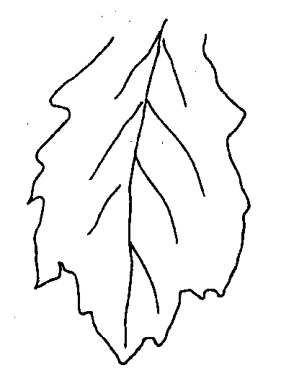 | 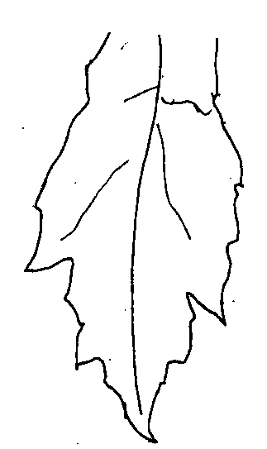 | 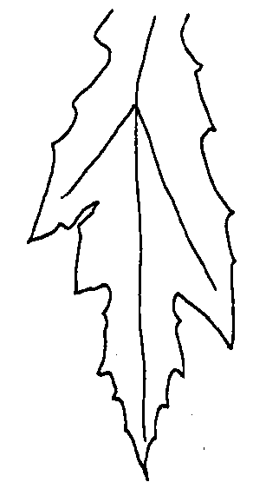
1 | 2 | 3
small | medium | large

Ad. 16: Fruit: shape in longitudinal section

1 | 2 | 3 | 4
triangular | ovate | spindle-shaped | oblong

Ad. 18: Fruit: shape of base

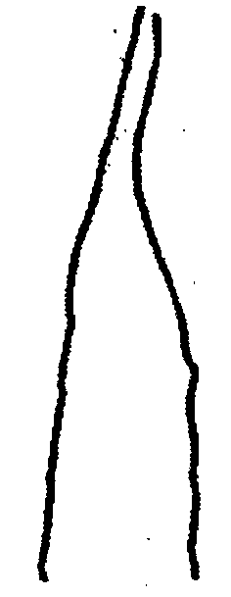 | 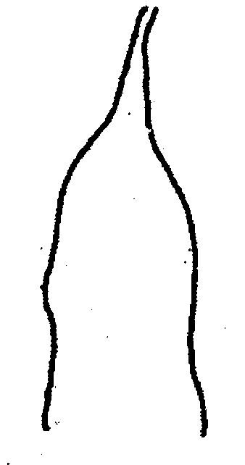 | 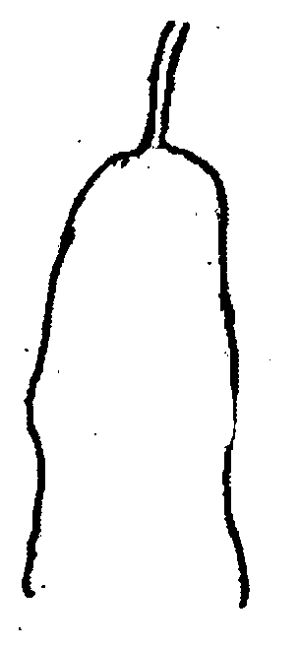 | 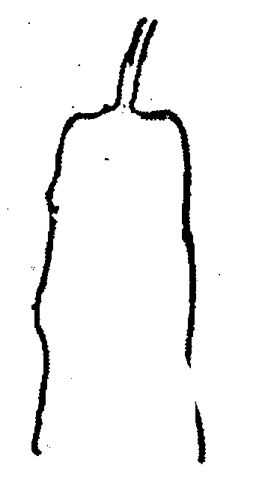
1 | 2 | 3 | 4
acute | obtuse | rounded | flattened

Ad. 19: Fruit: shape of apex

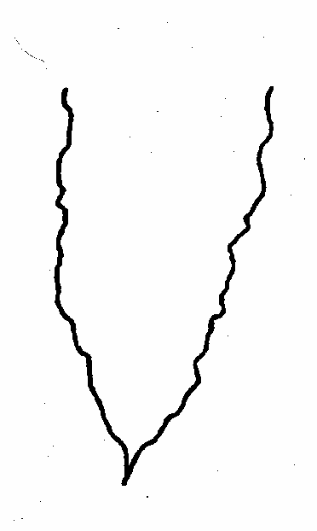 |  |  | 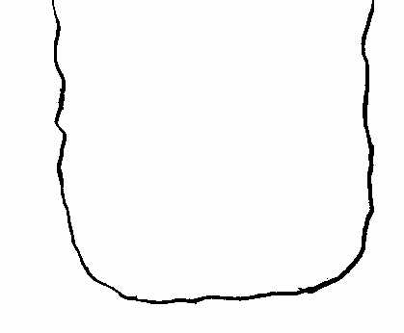
1 | 2 | 3 | 4
acute | obtuse | rounded | flattened

Ad. 20: Fruit: number of warts
Ad. 21: Wart: size
Ad. 22: Wart: shape of top
Ad. 24: Fruit: length of ridge

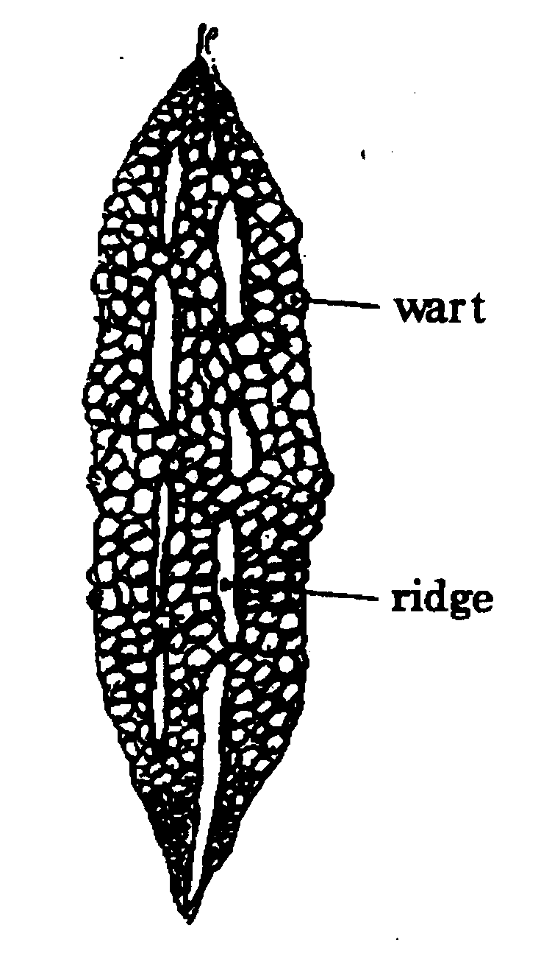

Ad. 25: Fruit: color of skin at ripe stage

Observations should be made when the fruit left on the plant has turned completely yellow, orange or reddish orange.

Ad. 26: Fruit: bitterness
Ad. 27: Fruit: intensity of bitterness

The bitterness of the fruit should be observed by tasting the flesh of the middle part of the fruit at harvest maturity (see Chapter 8.1 (d)).

Ad. 30: Seed: indentation of edge

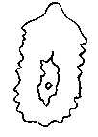
indentation of edge

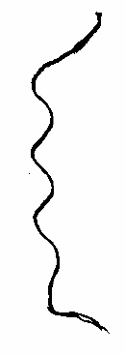
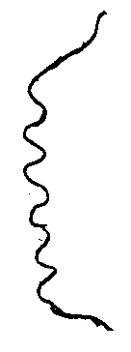
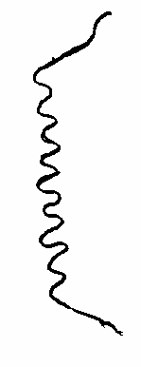

3 | 5 | 7
small | medium | large

Ad. 31: Time of physiological maturity

The time of physiological maturity is when the fruit is fully developed.

Literature
Higa, T., Momordica L., 1991: The Grand Dictionary of Horticulture, Vol. 3. 303, Shougakkan, JP.

Inoue, Y., 1983: Turureishi, Encyclopedia of Horticulture, Vol. 11, 293-240, Seibundo-Shinkousha, JP.

Larkom, J., 1991: Bitter gourd, Oriental Vegetables 87-89, Jon Murry, UK.

Ministry of Agriculture, Forestry & Fisheries, 1981: National Test Guideline for Bitter Gourd.

Phillips, R., Rix, M., 1993: Bitter Cucumber, Vegetables 198-199, Pan Books, UK.

Sakamoto, M., 1988: Nigauri, Nogyo-Gijutu-Taikei-Vegetable Vol.11, 473-480, Nosangyoson-Bunka-Kyokai, JP.

Technical Questionnaire
TECHNICAL QUESTIONNAIRE |  |  |  | Page {x} of {y} |  | Reference Number:
 |  |  |  |  |  | Application date:
 |  |  |  |  |  | (not to be filled in by the applicant)
TECHNICAL QUESTIONNAIRE
to be completed in connection with an application for plant breeders’ rights

1. Subject of the Technical Questionnaire
1.1 Botanical name |  |  | Momordica charantia L.
1.2 Common name |  |  | Bitter Gourd
2. Applicant
Name
Address
Telephone No.
Fax No.
E-mail address
Breeder (if different from applicant)
3. Proposed denomination and breeder’s reference
Proposed denomination
(if available)

Breeder’s reference
#4. Information on the breeding scheme and propagation of the variety

4.1 Breeding scheme

Variety resulting from:

4.1.1 Crossing

(a) controlled cross [ ]
(please state parent varieties)

(b) partially known cross [ ]
(please state known parent variety(ies))

(c) unknown cross [ ]

4.1.2 Mutation [ ]
(please state parent variety)

4.1.3 Discovery and development [ ]
(please state where and when discovered
and how developed)

4.1.4 Other [ ]
(please provide details)

4.2 Method of propagating the variety

4.2.1 Seed-propagated varieties

(a) Self-pollination [ ]

(b) Cross-pollination
(i) population [ ]
(ii) synthetic variety [ ]

(c) Hybrid [ ]

(d) Other [ ]
(please provide details)

4.2.2 Vegetatively propagated varieties [ ]

4.2.3 Other [ ]
(please provide details)

5. Characteristics of the variety to be indicated (the number in brackets refers to the corresponding characteristic in Test Guidelines; please mark the note which best corresponds).

 | Characteristics |  |  |  |  |  | Example Varieties |  |  | Note
5.1  (8) | Leaf blade: number of lobes
 | five lobes |  |  |  |  |  |  |  |  | 1[ ]
 | seven lobes |  |  |  |  |  | Sadowara-shiro-naga |  |  | 2[ ]
 | nine lobes |  |  |  |  |  |  |  |  | 3[ ]
5.2  (14) | Fruit: length
 | short |  |  |  |  |  | Okinawa-tandai |  |  | 3[ ]
 | medium |  |  |  |  |  | Okinawa-ao-chunaga |  |  | 5[ ]
 | long |  |  |  |  |  | Sadowara-shiro-naga |  |  | 7[ ]
5.3  (15) | Fruit: diameter
 | small |  |  |  |  |  | Miyazaki-shiro-naga |  |  | 3[ ]
 | medium |  |  |  |  |  | Onaga-nishaku |  |  | 5[ ]
 | large |  |  |  |  |  | Okinawa-ao-naga |  |  | 7[ ]
5.4  (16) | Fruit: shape in longitudinal section
 | triangular |  |  |  |  |  |  |  |  | 1[ ]
 | ovate |  |  |  |  |  |  |  |  | 2[ ]
 | spindle-shaped |  |  |  |  |  | Okinawa-ao-naga |  |  | 3[ ]
 | oblong |  |  |  |  |  | Sadowara-shiro-naga |  |  | 4[ ]
5.5  (17) | Fruit: color of skin
 | white |  |  |  |  |  | Shiro-reishi |  |  | 1[ ]
 | light green |  |  |  |  |  | Sadowara-shiro-naga |  |  | 2[ ]
 | medium green |  |  |  |  |  | Onaga-nishaku |  |  | 3[ ]
 | dark green |  |  |  |  |  | Okinawa-ao-naga |  |  | 4[ ]
 | Characteristics |  |  |  |  |  | Example Varieties |  |  | Note
5.6  (21) | Wart: size
 | small |  |  |  |  |  | Okinawa-ao-chunaga |  |  | 3[ ]
 | medium |  |  |  |  |  | Miazaki-shiro-naga |  |  | 5[ ]
 | large |  |  |  |  |  | Sadowara-shiro-naga |  |  | 7[ ]
6. Similar varieties and differences from these varieties

Please use the following table and box for comments to provide information on how your candidate variety differs from the variety (or varieties) which, to the best of your knowledge, is (or are) most similar. This information may help the examination authority to conduct its examination of distinctness in a more efficient way.

Denomination(s) of variety(ies) similar to your candidate variety |  | Characteristic(s) in which your candidate variety differs from the similar variety(ies) |  |  | Describe the expression of the characteristic(s) for the similar variety(ies) |  |  | Describe the expression of the characteristic(s) for your candidate variety
Example: |  | Fruit: shape in longitudinal section |  |  | spindle-shaped |  |  | oblong
Comments:

#7. Additional information which may help in the examination of the variety

7.1 In addition to the information provided in sections 5 and 6, are there any additional characteristics which may help to distinguish the variety?

Yes [ ] No [ ]

(If yes, please provide details)

7.2 Are there any special conditions for growing the variety or conducting the examination?

Yes [ ] No [ ]

(If yes, please provide details)

7.3 Other information

7.3.1 Main use

(a) fruit [ ]
(b) young shoot/leaves [ ]
(c) medicinal [ ]
(please provide details)

7.3.2 A representative color photograph of the fruit of the variety should accompany the Technical Questionnaire.

8. Authorization for release

(a) Does the variety require prior authorization for release under legislation concerning the protection of the environment, human and animal health?

Yes [ ] No [ ]

(b) Has such authorization been obtained?

Yes [ ] No [ ]

If the answer to (b) is yes, please attach a copy of the authorization.

9. Information on plant material to be examined or submitted for examination.

9.1 The expression of a characteristic or several characteristics of a variety may be affected by factors, such as pests and disease, chemical treatment (e.g. growth retardants or pesticides), effects of tissue culture, different rootstocks, scions taken from different growth phases of a tree, etc.

9.2 The plant material should not have undergone any treatment which would affect the expression of the characteristics of the variety, unless the competent authorities allow or request such treatment. If the plant material has undergone such treatment, full details of the treatment must be given. In this respect, please indicate below, to the best of your knowledge, if the plant material to be examined has been subjected to:

(a) Microorganisms (e.g. virus, bacteria, phytoplasma) Yes [ ] No [ ]

(b) Chemical treatment (e.g. growth retardant, pesticide) Yes [ ] No [ ]

(c) Tissue culture Yes [ ] No [ ]

(d) Other factors Yes [ ] No [ ]

Please provide details for where you have indicated “yes”.

……………………………………………………………

10. I hereby declare that, to the best of my knowledge, the information provided in this form is correct:

Applicant’s name

Signature Date

[End of document]

* These names were correct at the time of the introduction of these Test Guidelines but may be revised or updated. [Readers are advised to consult the UPOV Code, which can be found on the UPOV Website (www.upov.int), for the latest information.]
# Authorities may allow certain of this information to be provided in a confidential section of the Technical Questionnaire.
# Authorities may allow certain of this information to be provided in a confidential section of the Technical Questionnaire.

