 |  | E  TG/233/1  ORIGINAL: English  DATE: 2007-03-28
INTERNATIONAL UNION FOR THE PROTECTION OF NEW VARIETIES OF PLANTS
GENEVA

 | DIASCIA  UPOV Code: DIASC  Diascia Link & Otto | *

GUIDELINES

FOR THE CONDUCT OF TESTS

FOR DISTINCTNESS, UNIFORMITY AND STABILITY

Alternative Names: *
Botanical name | English | French | German | Spanish
Diascia Link & Otto | Diascia, Twinspur | Diascia, Diascie | Diascie, Doppelhörnchen | Diascia

The purpose of these guidelines (“Test Guidelines”) is to elaborate the principles contained in the General Introduction (document TG/1/3), and its associated TGP documents, into detailed practical guidance for the harmonized examination of distinctness, uniformity and stability (DUS) and, in particular, to identify appropriate characteristics for the examination of DUS and production of harmonized variety descriptions.

ASSOCIATED DOCUMENTS
These Test Guidelines should be read in conjunction with the General Introduction and its associated TGP documents.
TABLE OF CONTENTS PAGE

1. Subject of these Test Guidelines 3
2. Material Required 3
3. Method of Examination 3
3.1 Number of Growing Cycles 3
3.2 Testing Place 3
3.3 Conditions for Conducting the Examination 3
3.4 Test Design 4
3.5 Number of Plants / Parts of Plants to be Examined 4
3.6 Additional Tests 4
4. Assessment of Distinctness, Uniformity and Stability 4
4.1 Distinctness 4
4.2 Uniformity 5
4.3 Stability 5
5. Grouping of Varieties and Organization of the Growing Trial 6
6. Introduction to the Table of Characteristics 6
6.1 Categories of Characteristics 6
6.2 States of Expression and Corresponding Notes 7
6.3 Types of Expression 7
6.4 Example Varieties 7
6.5 Legend 7
7. Table of Characteristics/Tableau des caractères/Merkmalstabelle/Tabla de caracteres 8
8. Explanations on the Table of Characteristics 15
8.1 Explanations covering several characteristics 15
8.2 Explanations for individual characteristics 15
9. Literature 20
10. Technical Questionnaire 21

Subject of these Test Guidelines
These Test Guidelines apply to all varieties of Diascia Link & Otto of the family Scrophulariaceae.

Material Required
2.1 The competent authorities decide on the quantity and quality of the plant material required for testing the variety and when and where it is to be delivered. Applicants submitting material from a State other than that in which the testing takes place must ensure that all customs formalities and phytosanitary requirements are complied with.

2.2 The material is to be supplied in the form of seed or rooted cuttings.

2.3 The minimum quantity of plant material, to be supplied by the applicant, should be:

10 rooted cuttings, for vegetatively propagated varieties; or
a sufficient quantity of seed to produce 20 plants, for seed-propagated varieties.

In the case of seed, the seed should meet the minimum requirements for germination, species and analytical purity, health and moisture content, specified by the competent authority. In cases where the seed is to be stored, the germination capacity should be as high as possible and should be stated by the applicant.

2.4 The plant material supplied should be visibly healthy, not lacking in vigor, nor affected by any important pest or disease.

2.5 The plant material should not have undergone any treatment, which would affect the expression of the characteristics of the variety, unless the competent authorities allow or request such treatment. If it has been treated, full details of the treatment must be given.

Method of Examination

3.1 Number of Growing Cycles
The minimum duration of tests should normally be a single growing cycle.

3.2 Testing Place
Tests are normally conducted at one place. In the case of tests conducted at more than one place, guidance is provided in TGP/9 “Examining Distinctness”.

3.3 Conditions for Conducting the Examination
3.3.1 The tests should be carried out under conditions ensuring satisfactory growth for the expression of the relevant characteristics of the variety and for the conduct of the examination. The plants should be grown in containers to observe the plant growth habit (characteristic 1).
3.3.2 The optimum stage of development for the assessment of each characteristic is indicated by a number in the second column of the Table of Characteristics. The stages of development denoted by each number are described at the end of Chapter 8.

3.3.3 Because daylight varies, color determinations made against a color chart should be made either in a suitable cabinet providing artificial daylight or in the middle of the day in a room without direct sunlight. The spectral distribution of the illuminant for artificial daylight should conform with the CIE Standard of Preferred Daylight D 6500 and should fall within the tolerances set out in the British Standard 950, Part I. These determinations should be made with the plant part placed against a white background.

3.4 Test Design
3.4.1 Vegetatively propagated varieties: each test should be designed to result in a total of at least 10 plants.

3.4.2 Seed-propagated varieties: each test should be designed to result in a total of at least 20 plants.

3.4.3 The design of the tests should be such that plants or parts of plants may be removed for measurement or counting without prejudice to the observations which must be made up to the end of the growing cycle.

3.5 Number of Plants / Parts of Plants to be Examined
3.5.1 Vegetatively propagated varieties: unless otherwise indicated, all observations on single plants should be made on 10 plants or parts taken from each of 10 plants and any other observations made on all plants in the test.

3.5.2 Seed-propagated varieties: unless otherwise indicated, all observations on single plants should be made on 20 plants or parts taken from each of 20 plants and any other observations made on all plants in the test.

3.6 Additional Tests
Additional tests, for examining relevant characteristics, may be established.

Assessment of Distinctness, Uniformity and Stability

4.1 Distinctness
4.1.1 General Recommendations

It is of particular importance for users of these Test Guidelines to consult the General Introduction prior to making decisions regarding distinctness. However, the following points are provided for elaboration or emphasis in these Test Guidelines.

4.1.2 Consistent Differences

The differences observed between varieties may be so clear that more than one growing cycle is not necessary. In addition, in some circumstances, the influence of the environment is not such that more than a single growing cycle is required to provide assurance that the differences observed between varieties are sufficiently consistent. One means of ensuring that a difference in a characteristic, observed in a growing trial, is sufficiently consistent is to examine the characteristic in at least two independent growing cycles.
4.1.3 Clear Differences

Determining whether a difference between two varieties is clear depends on many factors, and should consider, in particular, the type of expression of the characteristic being examined, i.e. whether it is expressed in a qualitative, quantitative, or pseudo-qualitative manner. Therefore, it is important that users of these Test Guidelines are familiar with the recommendations contained in the General Introduction prior to making decisions regarding distinctness.

4.2 Uniformity
4.2.1 It is of particular importance for users of these Test Guidelines to consult the General Introduction prior to making decisions regarding uniformity. However, the following points are provided for elaboration or emphasis in these Test Guidelines:

4.2.2 For the assessment of uniformity of vegetatively propagated varieties, a population standard of 1% and an acceptance probability of at least 95% should be applied. In the case of a sample size of 10 plants, one off-type is allowed.

4.2.3 For the assessment of uniformity of seed-propagated varieties which are
self-pollinated, a population standard of 1% and an acceptance probability of at least 95% should be applied. In the case of a sample size of 20 plants, one off-type is allowed.

4.2.4 For the assessment of uniformity of seed-propagated varieties which are cross-pollinated or hybrids, the recommendations in the General Introduction for cross-pollinated or hybrid varieties should be followed, as appropriate.

4.3 Stability
4.3.1 In practice, it is not usual to perform tests of stability that produce results as certain as those of the testing of distinctness and uniformity. However, experience has demonstrated that, for many types of variety, when a variety has been shown to be uniform, it can also be considered to be stable.

4.3.2 Where appropriate, or in cases of doubt, stability may be tested, either by growing a further generation, or by testing a new seed or plant stock to ensure that it exhibits the same characteristics as those shown by the previous material supplied.

4.3.3 Where appropriate, or in cases of doubt, the stability of a hybrid variety may, in addition to an examination of the hybrid variety itself, also be assessed by examination of the uniformity and stability of its parent lines.

Grouping of Varieties and Organization of the Growing Trial
5.1 The selection of varieties of common knowledge to be grown in the trial with the candidate varieties and the way in which these varieties are divided into groups to facilitate the assessment of distinctness are aided by the use of grouping characteristics.

5.2 Grouping characteristics are those in which the documented states of expression, even where produced at different locations, can be used, either individually or in combination with other such characteristics: (a) to select varieties of common knowledge that can be excluded from the growing trial used for examination of distinctness; and (b) to organize the growing trial so that similar varieties are grouped together.

5.3 The following have been agreed as useful grouping characteristics:

(a) Plant: growth habit (characteristic 1)
(b) Corolla: main color (characteristic 20) with the following groups:
Gr. 1: white
Gr. 2: light pink
Gr. 3: medium pink
Gr. 4: dark pink
Gr. 5: orange pink
Gr. 6: orange
Gr. 7: orange red
Gr. 8: red
Gr. 9: red purple
Gr. 10: light violet

5.4 Guidance for the use of grouping characteristics, in the process of examining distinctness, is provided through the General Introduction.

Introduction to the Table of Characteristics

6.1 Categories of Characteristics
6.1.1 Standard Test Guidelines Characteristics

Standard Test Guidelines characteristics are those which are approved by UPOV for examination of DUS and from which members of the Union can select those suitable for their particular circumstances.

6.1.2 Asterisked Characteristics

Asterisked characteristics (denoted by *) are those included in the Test Guidelines which are important for the international harmonization of variety descriptions and should always be examined for DUS and included in the variety description by all members of the Union, except when the state of expression of a preceding characteristic or regional environmental conditions render this inappropriate.

6.2 States of Expression and Corresponding Notes
States of expression are given for each characteristic to define the characteristic and to harmonize descriptions. Each state of expression is allocated a corresponding numerical note for ease of recording of data and for the production and exchange of the description.

6.3 Types of Expression
An explanation of the types of expression of characteristics (qualitative, quantitative and pseudo-qualitative) is provided in the General Introduction.

6.4 Example Varieties
Where appropriate, example varieties are provided to clarify the states of expression of each characteristic.

6.5 Legend
(*) Asterisked characteristic – see Chapter 6.1.2

QL Qualitative characteristic – see Chapter 6.3
QN Quantitative characteristic – see Chapter 6.3
PQ Pseudo-qualitative characteristic – see Chapter 6.3

(a)–(e) See Explanations on the Table of Characteristics in Chapter 8.1

(+) See Explanations on the Table of Characteristics in Chapter 8.2

Table of Characteristics/Tableau des caractères/Merkmalstabelle/Tabla de caracteres
 |  | English | français | Deutsch | español | Example Varieties/  Exemples/  Beispielssorten/  Variedades ejemplo | Note/Nota
1.  (*)  (+) |  | Plant: growth habit | Plante: port | Pflanze: Wuchsform | Planta: Porte
PQ |  | upright | dressé | aufrecht | erecto | Codiap, Heccharm, Prince of Orange | 1
 |  | semi-upright | demi-dressé | halbaufrecht | semierecto | Coditer, Ice Cream | 2
 |  | spreading | étalé | breitwüchsig | abierto | Diastara | 3
 |  | semi-trailing | demi-courbé | halbhängend | semirastrero | Hecrace | 4
2.  (+) |  | Plant: height | Plante: hauteur | Pflanze: Höhe | Planta: altura
QN |  | short | basse | niedrig | baja | Codiap, Codilav, Pendan | 3
 |  | medium | moyenne | mittel | media | Diastonia, Diastu | 5
 |  | tall | haute | hoch | alta | Balwhiswhit, Ice Cream | 7
3. |  | Plant: width at broadest part | Plante: largeur sur la partie la plus large | Pflanze: Breite am breitesten Teil | Planta: anchura en la parte más ancha
QN |  | narrow | étroite | schmal | estrecha | Codilav, Ice Cream | 3
 |  | medium | moyenne | mittel | media | Codiusre | 5
 |  | broad | large | breit | ancha | Balwhiswhit | 7
4. |  | Plant: density | Plante: densité | Pflanze: Dichte | Planta: densidad
QN |  | sparse | lâche | locker | laxa | Hecrace, Ice Cracker | 3
 |  | medium | moyenne | mittel | media | Codiap | 5
 |  | dense | forte | dicht | densa | Diastrosis, Diastu, Heccharm | 7
5. |  | Stem: anthocyanin coloration below inflorescence | Tige: pigmentation anthocyanique sous inflorescence | Trieb: Anthocyanfärbung unter dem Blütenstand | Tallo: pigmentación antociánica por debajo de la inflorescencia
QN |  | absent or weak | absente ou faible | fehlend oder gering | ausente o débil | Heccharm | 1
 |  | medium | moyenne | mittel | media | Hecrace | 2
 |  | strong | forte | stark | fuerte |  | 3
6.  (*) | (a) | Leaf blade: length | Limbe: longueur | Blattspreite: Länge | Limbo: longitud
QN |  | short | courte | kurz | corto | Coditer,  Strawberry Sundae | 3
 |  | medium | moyenne | mittel | medio | Codiusre | 5
 |  | long | longue | lang | largo | Balwhislapi, Balwhiswhit | 7
7.  (*) | (a) | Leaf blade: width | Limbe: largeur | Blattspreite: Breite | Limbo: anchura
QN |  | narrow | étroite | schmal | estrecho | Balwhiswhit, Coditer, Strawberry Sundae | 3
 |  | medium | moyenne | mittel | medio | Codipeim, Diastonia | 5
 |  | broad | large | breit | ancho | Balwhislapi | 7
8.  (+) | (a) | Leaf blade: shape of apex | Limbe: forme du sommet | Blattspreite: Form der Spitze | Limbo: forma del ápice
PQ |  | acute | aigu | spitz | agudo | Balwhiswhit, Diastu, Diastured, Heccharm | 1
 |  | obtuse | obtus | stumpf | obtuso | Balwinimstr | 2
 |  | rounded | arrondi | abgerundet | redondeado | Diasroroc | 3
9.  (+) | (a) | Leaf blade: shape of base | Limbe: forme de la base | Blattspreite: Form der Basis | Limbo: forma de la base
PQ |  | rounded | arrondie | abgerundet | redondeada | Balwhiswhit | 1
 |  | truncate | tronquée | gerade | truncada | Diastara, Icepole | 2
 |  | cordate | cordiforme | herzförmig | cordiforme | Codiap, Diastina, Heccharm | 3
10. | (a) (b) | Leaf blade: glossiness | Limbe: brillance | Blattspreite: Glanz | Limbo: brillo
QN |  | absent or weak | nulle ou faible | fehlend oder gering | ausente o débil | Diasroroc | 1
 |  | medium | moyenne | mittel | medio | Diastonia | 2
 |  | strong | forte | stark | fuerte | Diastusca | 3
11.  (*) | (a) (b) | Leaf blade: variegation | Limbe: panachure | Blattspreite: Panaschierung | Limbo: variegación
QL |  | absent | absente | fehlend | ausente | Diastu | 1
 |  | present | présente | vorhanden | presente | Belmore Beauty, Golden Dancer, Katherine Sharman | 9
12.  (*) | (a) (b) | Leaf blade: green color | Limbe: couleur verte | Blattspreite: grüne Blattfarbe | Limbo: color verde
QN |  | light | clair | hell | claro | Balwhislapi, Iceberg | 1
 |  | medium | moyen | mittel | medio | Codiap, Coditer, Hecrace | 2
 |  | dark | foncé | dunkel | oscuro | Balwhiscran, Codiusre,  Strawberry Sundae | 3
13.  (*) | (a) (b) | Leaf blade: color of variegation | Limbe: couleur de la panachure | Blattspreite: Farbe der Panaschierung | Limbo: color de la variegación
PQ |  | light yellow | jaune clair | hellgelb | amarillo claro | Katherine Sharman | 1
 |  | medium yellow | jaune moyen | mittelgelb | amarillo medio | Belmore Beauty | 2
 |  | yellow green | vert jaune | gelbgrün | verde amarillento | Golden Dancer | 3
14. | (c) | Inflorescence: density | Inflorescence: densité | Blütenstand: Dichte | Inflorescencia: densidad
QN |  | sparse | lâche | locker | laxa | Balwhislapi,  Ice Cream | 3
 |  | medium | moyenne | mittel | media | Codilav, Diastu | 5
 |  | dense | dense | dicht | densa | Balwinlapi, Coditer, Strawberry Sundae | 7
15. | (c) | Pedicel: length | Pédicelle: longueur | Blütenstiel: Länge | Pedicelo: longitud
QN |  | short | court | kurz | corto | Diastis, Lilac Belle | 1
 |  | medium | moyen | mittel | medio | Diasttralav, Diastu | 2
 |  | long | long | lang | largo | Balwinwite, Hecrace | 3
16. | (c) | Pedicel: angle relative to peduncle | Pédicelle: angle par rapport au pédoncule | Blütenstiel: Winkel im Verhältnis zum Blütenstandsstiel | Pedicelo: ángulo en relación con el pedúnculo
QN |  | small | petit | klein | pequeño | Diasroroc, Diastu | 3
 |  | medium | moyen | mittel | medio | Diastusca, Kledi04015 | 5
 |  | large | grand | groß | grande | Pendan,  Wink Pink Improved | 7
17. | (c) | Pedicel: anthocyanin coloration | Pédicelle: pigmentation anthocyanique | Blütenstiel: Anthocyanfärbung | Pedicelo: pigmentación antociánica
QN |  | absent or weak | absente ou faible | fehlend oder gering | ausente o débil | Diastis | 1
 |  | medium | moyenne | mittel | media | Diastonia, Diastu | 2
 |  | strong | forte | stark | fuerte | Diastara, Hecrace | 3
18.  (*)  (+) | (d) | Corolla: length | Corolle: longueur | Krone: Länge | Corola: longitud
QN |  | short | courte | kurz | corta | Codiusre, Diastonia, Lilac Belle | 3
 |  | medium | moyenne | mittel | media | Diastu | 5
 |  | long | longue | lang | larga | Balwhistang, Balwhiswhit, Hecrace | 7
19.  (*)  (+) | (d) | Corolla: width | Corolle: largeur | Krone: Breite | Corola: anchura
QN |  | narrow | étroite | schmal | estrecha | Diastonia, Lilac Belle | 3
 |  | medium | moyenne | mittel | media | Codilav, Diastu | 5
 |  | broad | large | breit | ancha | Balwhiswhit, Codipeim, Diatrosis | 7
20.  (*) | (d)  (e) | Corolla: main color | Corolle: couleur principale | Krone: Hauptfarbe | Corola: color principal
PQ |  | RHS Colour Chart (indicate reference number) | Code RHS des couleurs (indiquer le numéro de référence) | RHS-Farbkarte (Nummer angeben) | Carta de colores RHS (indíquese el número de referencia)
21.  (+) | (d) | Corolla: reflexing of lateral lobes | Corolle: courbure des lobes latéraux | Krone: Zurück-biegung der Seitenlappen | Corola: curvatura de los lóbulos laterales
QN |  | absent or weak | nulle ou faible | fehlend oder gering | ausente o débil | Balwhiswhit, Diastara, Pendan | 1
 |  | medium | moyenne | mittel | media | Codipeim, Diastis, Penther | 2
 |  | strong | forte | stark | fuerte | Diaspetis, Ice Cream | 3
22.  (*)  (+) | (d) | Corolla: lower lobe: length in relation to width | Corolle : lobe inférieur : rapport longueur/largeur | Krone: unterer Lappen: Länge im Verhältnis zur Breite | Corola: lóbulo inferior: longitud en relación con la anchura
QN |  | longer than broad | plus long que large | länger als breit | más larga que ancha | Coditer, Rupert Lambert | 1
 |  | as long as broad | aussi long que large | so lang wie breit | tan larga como ancha | Balwinlapi, Diastu | 2
 |  | broader than long | plus large que long | breiter als lang | más ancha que larga | Balwhiswhit, Hecrace, Ice Cream | 3
23.  (+) | (d) | Corolla: lower lobe: incurving | Corolle : lobe inférieur : courbure | Krone: unterer Lappen: Aufbiegung | Corola: lóbulo inferior: curvado hacia arriba
QN |  | absent or weak | nulle ou faible | fehlend oder gering | ausente o débil | Balwhisdarco | 1
 |  | medium | moyenne | mittel | medio | Diastara | 2
 |  | strong | forte | stark | fuerte | Diastusca | 3
24. | (d) | Corolla: lower lobe: undulation of margin | Corolle : lobe inférieur : ondulation du bord | Krone: unterer Lappen: Randwellung | Corola: lóbulo inferior: ondulación del margen
QN |  | weak | faible | gering | débil | Balwhiswhit, Heccharm, Penther | 3
 |  | medium | moyenne | mittel | media | Diastu, Sumdia 02 | 5
 |  | strong | forte | stark | fuerte | Diaspetis,  Rupert Lambert | 7
25.  (*)  (+) | (d)  (e) | Corolla: lower lobe: presence of trichomal elaiophores | Corolle : lobe inférieur : présence d’élaïophores trichomaux | Krone: unterer Lappen: Vorhandensein von Trichom-Elaiophoren | Corola: lóbulo inferior: presencia de tricomas glandulares
QL |  | absent | absents | fehlend | ausente | Balwinlapi, Codipeim, Diastina, Diaspetis | 1
 |  | present | présents | vorhanden | presente | Diastis, Diastu, Hecrace, Ice Cream | 9
26.  (*) | (d)  (e) | Trichomal elaiophores: density | Élaïophores trichomaux: densité | Trichom-Elaiophoren: Dichte | Tricomas glandulares: densidad
QN |  | sparse | lâche | locker | laxa | Balwhiscran, Codilav, Diastonia, Hecrace | 1
 |  | medium | moyenne | mittel | media | Balwhiswhit, Diastu | 2
 |  | dense | forte | dicht | tensa | Codiusre, Diastis,  Ice Cream | 3
27.  (+) | (d)  (e) | Corolla window: color | Fenêtre corollaire: couleur | Kronenfenster: Farbe | Ventana de la corola: color
PQ |  | green yellow | jaune vert | grüngelb | amarillo verduzco | Diastu | 1
 |  | light yellow | jaune clair | hellgelb | amarillo claro | Diastuca | 2
 |  | medium yellow | jaune moyen | mittelgelb | amarillo medio | Balwhisdarco, Codipeim, Diaspetis | 3
 |  | dark yellow | jaune foncé | dunkelgelb | amarillo oscuro | Coditer, Diastina, Diastis, Diastured | 4
28.  (*)  (+) | (d) | Spur: length | Éperon: longueur | Sporn: Länge | Espolón: longitud
QN |  | short | courts | kurz | cortos | Codilav, Codiusre, Sumdia 03 | 3
 |  | medium | moyens | mittel | medios | Balwinlapi, Codipeim | 5
 |  | long | longs | lang | largos | Balwincor, Diastara, Strawberry Sundae | 7
29.  (+) | (d) | Spur: color | Éperon: couleur | Sporn: Farbe | Espolón: color
PQ |  | RHS Colour Chart (indicate reference number) | Code RHS des couleurs (indiquer le numéro de référence) | RHS-Farbkarte (Nummer angeben) | Carta de colores RHS (indíquese el número de referencia)
30.  (+) | (d) | Spur: curvature | Éperon: courbure | Sporn: Biegung | Espolón: curvatura
QN |  | absent or weak | nulle ou faible | fehlend oder gering | ausente o débil | Penther | 1
 |  | medium | moyenne | mittel | media | Balwinlapi, Codipeim, Diastara | 2
 |  | strong | forte | stark | fuerte | Balwinimstr, Diastis, Diastonia | 3
31.  (+) | (d) | Spur: attitude of tip | Éperon: port du sommet | Sporn: Haltung der Spitzen | Espolón: porte del ápice
PQ |  | pointing inwards | orienté vers l’intérieur | nach innen gebogen | curvado hacia dentro |  | 1
 |  | pointing downwards | retombant | nach unten gebogen | Vertical |  | 2
 |  | pointing outwards | orienté vers l’extérieur | nach außen gebogen | extendido hacia fuera |  | 3

Explanations on the Table of Characteristics

8.1 Explanations covering several characteristics
Unless otherwise indicated, all characteristics should be observed at the time of full flowering.

Characteristics containing the following key in the second column of the Table of Characteristics should be examined as indicated below:

(a) Observations on the leaf blade should be made on fully expanded leaves from the middle third of a flowering stem;

(b) Observations on the leaf blade should be made on the upper side;

(c) Observations should be made on the middle third of an inflorescence;

(d) Observations on the corolla should be made on fresh fully open flowers;

(e) Observations on the corolla should be made on the inner side.

8.2 Explanations for individual characteristics
Ad. 1: Plant: growth habit

The plants should be grown in containers to observe the plant growth habit.

Ad. 2: Plant: height

Plant height should be measured from the surface of the growing medium.

Ad. 8: Leaf blade: shape of apex
1 | 2 | 3
acute | obtuse | rounded

Ad. 9: Leaf blade: shape of base

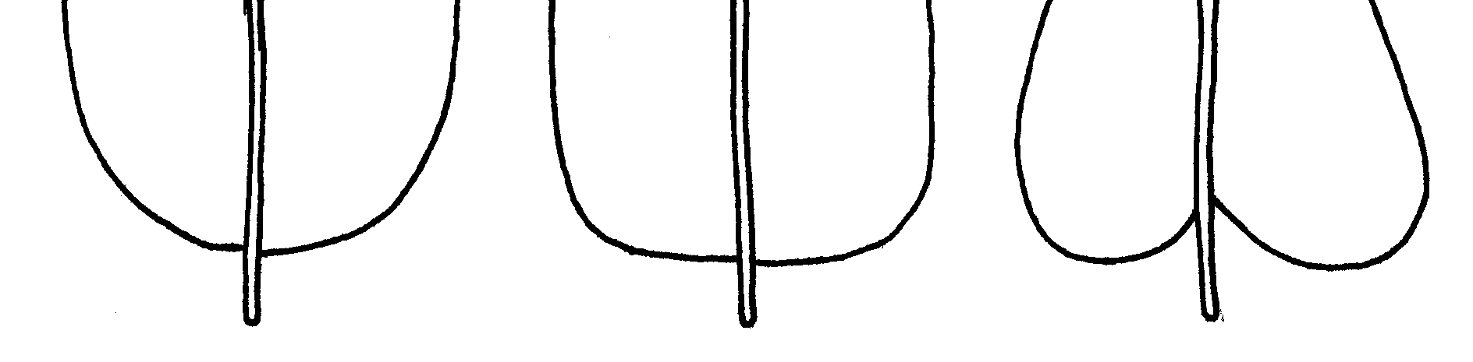
1 | 2 | 3
rounded | truncate | cordate

Ad. 18: Corolla: length
Ad. 19: Corolla: width

width  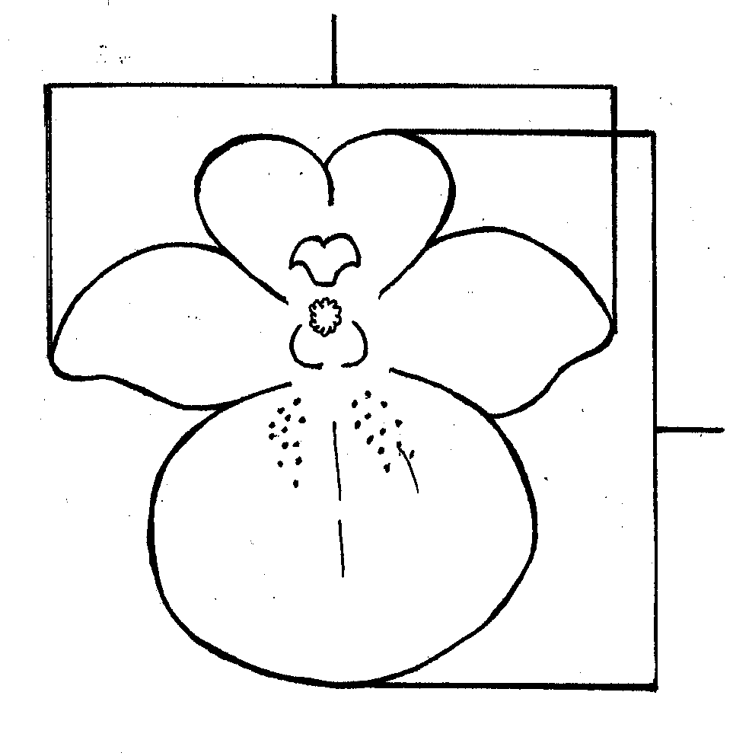 | length

Ad. 21: Corolla: reflexing of lateral lobes
Ad. 22: Corolla: length in relation to width

lateral lobes of corolla

upper lip of corolla

lower lip of corolla

lower lobe of corolla

Ad. 23: Corolla: lower lobe: incurving

Observations should be made on the corolla in side view.
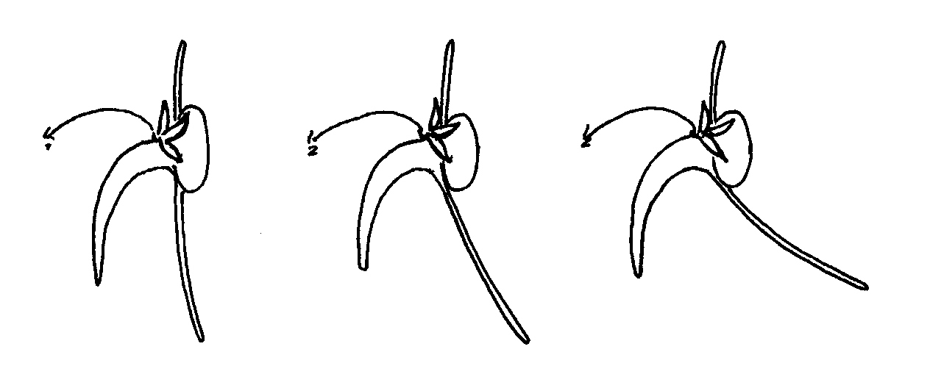
1 | 2 | 3
absent or weak | medium | strong

Ad. 25: Corolla: lower lobe: presence of trichomal elaiophores

Trichomal elaiophores are floral glands that actively secrete oil to attract pollinating bees. They consist of many glandular trichomes, or outgrowths from the epidermis of the flower (Rasmussen 1999). In Diascia, trichomal elaiophores are positioned within the double spurs and may or may not be present on the inner side of the lower lip of the corolla.

The observation of this characteristic should be made exclusively on the lower lip and not on any other part of the corolla.
Ad. 27: Corolla window: color

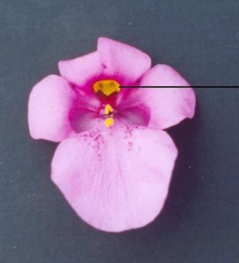 | corolla window

Ad. 28: Spur: length

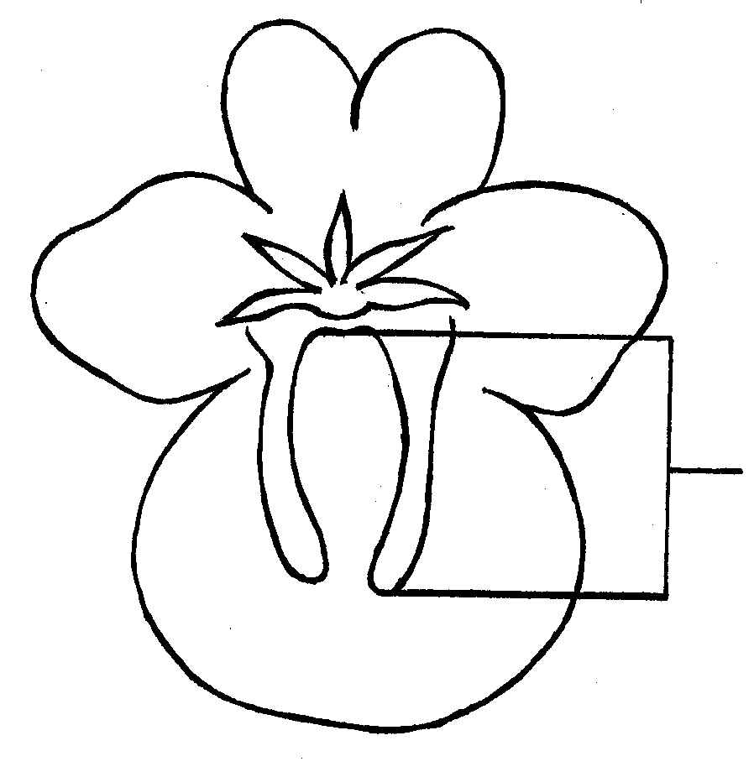 | length

Ad. 29: Spur: color

Observations should be made on the middle third of a spur.

Ad. 30: Spur: curvature

Observations should be made on the corolla in side view.
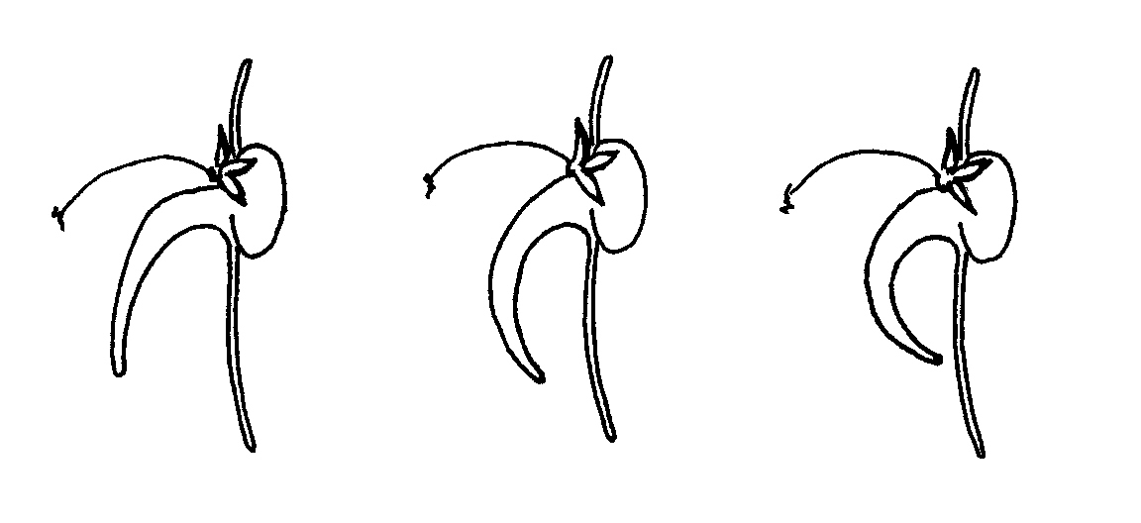
1 | 2 | 3
absent or weak | medium | strong

Ad. 31: Spur: attitude of tip

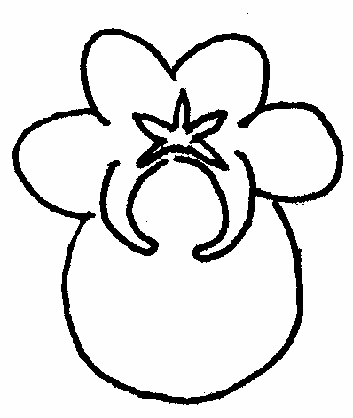 | 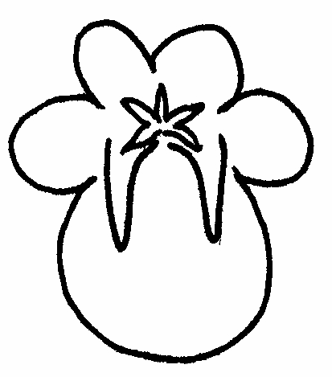 | 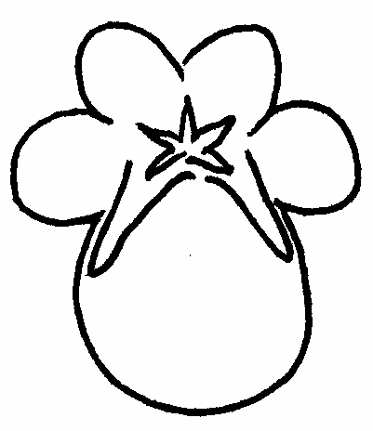
1 | 2 | 3
pointing inwards | pointing downwards | pointing outwards

Literature
Beckett, K.A., 1995: The R.H.S. Encyclopedia of House Plants. Colour Library Books Ltd., Godalming, Surrey, US, pp. 206-207.

Hay, R., Beckett K. A. et al., 1978: Reader’s Digest Encyclopedia of Garden Plants and Flowers. The Reader’s Digest Association Limited, London, GB, p. 228.

Huxley, A. (ed.), Griffiths, M. (ed.), Levy, M. (ed.), 1999: The Royal Horticultural Society Dictionary of Gardening. Volume 2. McMillan Reference Ltd. London, GB, p. 57.

Rasmussen, C., 1999: Coevolution of the oil bee-Calceolaria system in the Andes of Peru. Master of Science Thesis, University of Århus, DK, pp. iv + 87.

Staff of the Liberty Hyde Bailey Hortorium, Cornell University, 1976: Hortus Third:
A Concise Dictionary of Plants Cultivated in the United States and Canada. MacMillan Publishing Company. New York, New York, US, p. 380.

Technical Questionnaire
TECHNICAL QUESTIONNAIRE |  |  |  | Page {x} of {y} |  |  | Reference Number:
 |  |  |  |  |  |  | Application date:
 |  |  |  |  |  |  | (not to be filled in by the applicant)
TECHNICAL QUESTIONNAIRE
to be completed in connection with an application for plant breeders’ rights

1. Subject of the Technical Questionnaire
1.1 Genus
1.1.1 Botanical name |  |  | Diascia Link & Otto
1.1.2 Common name |  |  | Diascia, Twinspur
1.2 Species / Group
(please complete)
2. Applicant
Name
Address
Telephone No.
Fax No.
E-mail address
Breeder (if different from applicant)
3. Proposed denomination and breeder’s reference
Proposed denomination
(if available)

Breeder’s reference
#4. Information on the breeding scheme and propagation of the variety

4.1 Breeding scheme

Variety resulting from:

4.1.1 Crossing

(a) controlled cross [ ]
(please state parent varieties)

(b) partially known cross [ ]
(please state known parent variety(ies))

(c) unknown cross [ ]

4.1.2 Mutation [ ]
(please state parent variety)

4.1.3 Discovery and development [ ]
(please state where and when discovered
and how developed)

4.1.4 Other [ ]
(please provide details)

4.2 Method of propagating the variety

4.2.1 Seed-propagated varieties

(a) Self-pollination [ ]

(b) Cross-pollination
(i) population [ ]
(ii) synthetic variety [ ]

(c) Hybrid [ ]

(d) Other [ ]
(please provide details)

4.2.2 Vegetatively propagated varieties

(a) cuttings [ ]

(b) in vitro propagation [ ]

(c) other (state method) [ ]

4.2.3 Other [ ]
(please provide details)

5. Characteristics of the variety to be indicated (the number in brackets refers to the corresponding characteristic in Test Guidelines; please mark the note which best corresponds).

 | Characteristics |  |  |  |  | Example Varieties |  |  |  | Note
5.1  (1) | Plant: growth habit
 | upright |  |  |  |  | Codiap, Heccharm, Prince of Orange |  |  |  | 1[ ]
 | semi-upright |  |  |  |  | Coditer, Ice Cream |  |  |  | 2[ ]
 | spreading |  |  |  |  | Diastara |  |  |  | 3[ ]
 | semi-trailing |  |  |  |  | Hecrace |  |  |  | 4[ ]
5.2  (11) | Leaf blade: variegation
 | absent |  |  |  |  | Diastu |  |  |  | 1[ ]
 | present |  |  |  |  | Belmore Beauty, Golden Dancer,  Katherine Sharman |  |  |  | 9[ ]
5.3  (12) | Leaf blade: green color
 | light |  |  |  |  | Balwhislapi, Iceberg |  |  |  | 1[ ]
 | medium |  |  |  |  | Codiap, Coditer, Hecrace |  |  |  | 2[ ]
 | dark |  |  |  |  | Balwhiscran, Codiusre, Strawberry Sundae |  |  |  | 3[ ]
5.4  (18) | Corolla: length
 | short |  |  |  |  | Codiusre, Diastonia, Lilac Belle |  |  |  | 3[ ]
 | medium |  |  |  |  | Diastu |  |  |  | 5[ ]
 | long |  |  |  |  | Balwhistang, Balwhiswhit, Hecrace |  |  |  | 7[ ]
5.5  (19) | Corolla: width
 | narrow |  |  |  |  | Diastonia, Lilac Belle |  |  |  | 3[ ]
 | medium |  |  |  |  | Codilav, Diastu |  |  |  | 5[ ]
 | broad |  |  |  |  | Balwhiswhit, Codipeim, Diatrosis |  |  |  | 7[ ]
 | Characteristics |  |  |  |  | Example Varieties |  |  |  | Note
5.6 (i)  (20) | Corolla: main color |  |  |  |  | RHS Colour Chart  (indicate reference number)
5.6 (ii)  (20) | Corolla: main color
 | white |  |  |  |  | Balwhiswhit, Ice Cream |  |  |  | 1[ ]
 | light pink |  |  |  |  | Balwinlapi, Diastara |  |  |  | 2[ ]
 | medium pink |  |  |  |  | Wink Pink Improved |  |  |  | 3[ ]
 | dark pink |  |  |  |  | Divoro |  |  |  | 4[ ]
 | orange pink |  |  |  |  | Balwhisaptim |  |  |  | 5[ ]
 | orange |  |  |  |  | Prince of Orange |  |  |  | 6[ ]
 | orange red |  |  |  |  | Diasscal, Diastina |  |  |  | 7[ ]
 | red |  |  |  |  | Codiusre, Diastonia, Hecrace |  |  |  | 8[ ]
 | red purple |  |  |  |  | Balwingarn |  |  |  | 9[ ]
 | light violet |  |  |  |  | Lilac Belle |  |  |  | 10[ ]
 | other color (indicate)  …………………………. |  |  |  |  |  |  |  |  | 11[ ]
6. Similar varieties and differences from these varieties

Please use the following table and box for comments to provide information on how your candidate variety differs from the variety (or varieties) which, to the best of your knowledge, is (or are) most similar. This information may help the examination authority to conduct its examination of distinctness in a more efficient way..

Denomination(s) of variety(ies) similar to your candidate variety |  | Characteristic(s) in which your candidate variety differs from the similar variety(ies) |  |  | Describe the expression of the characteristic(s) for the similar variety(ies) |  |  | Describe the expression of the characteristic(s) for your candidate variety
Example |  | Corolla: width |  |  | narrow |  |  | medium
Comments:

#7. Additional information which may help in the examination of the variety

7.1 In addition to the information provided in sections 5 and 6, are there any additional characteristics which may help to distinguish the variety?

Yes [ ] No [ ]

(If yes, please provide details)

7.2 Are there any special conditions for growing the variety or conducting the examination?

Yes [ ] No [ ]

(If yes, please provide details)

7.3 Other information

A representative color photograph of the variety should accompany the Technical Questionnaire.

8. Authorization for release

(a) Does the variety require prior authorization for release under legislation concerning the protection of the environment, human and animal health?

Yes [ ] No [ ]

(b) Has such authorization been obtained?

Yes [ ] No [ ]

If the answer to (b) is yes, please attach a copy of the authorization.

9. Information on plant material to be examined or submitted for examination.

9.1 The expression of a characteristic or several characteristics of a variety may be affected by factors, such as pests and disease, chemical treatment (e.g. growth retardants or pesticides), effects of tissue culture, different rootstocks, scions taken from different growth phases of a tree, etc.

9.2 The plant material should not have undergone any treatment which would affect the expression of the characteristics of the variety, unless the competent authorities allow or request such treatment. If the plant material has undergone such treatment, full details of the treatment must be given. In this respect, please indicate below, to the best of your knowledge, if the plant material to be examined has been subjected to:

(a) Microorganisms (e.g. virus, bacteria, phytoplasma) Yes [ ] No [ ]

(b) Chemical treatment (e.g. growth retardant, pesticide) Yes [ ] No [ ]

(c) Tissue culture Yes [ ] No [ ]

(d) Other factors Yes [ ] No [ ]

Please provide details for where you have indicated “yes”.

……………………………………………………………

10. I hereby declare that, to the best of my knowledge, the information provided in this form is correct:

Applicant’s name

Signature Date

[End of document]

* These names were correct at the time of the introduction of these Test Guidelines but may be revised or updated. [Readers are advised to consult the UPOV Code, which can be found on the UPOV Website (www.upov.int), for the latest information.]
# Authorities may allow certain of this information to be provided in a confidential section of the Technical Questionnaire.
# Authorities may allow certain of this information to be provided in a confidential section of the Technical Questionnaire.

