 |  | E  TG/228/1  ORIGINAL: English  DATE: 2006-04-05
INTERNATIONAL UNION FOR THE PROTECTION OF NEW VARIETIES OF PLANTS
GENEVA

 | MEDICS  UPOV Code: MEDIC  (excluding: MEDIC_SAT)  Medicago L. (excluding Medicago sativa L.) | *

GUIDELINES

FOR THE CONDUCT OF TESTS

FOR DISTINCTNESS, UNIFORMITY AND STABILITY

Alternative Names:*

Botanical name | English | French | German | Spanish
Medicago L. (excluding  Medicago sativa L.) | Medics | Luzernes annuelles

The purpose of these guidelines (“Test Guidelines”) is to elaborate the principles contained in the General Introduction (document TG/1/3), and its associated TGP documents, into detailed practical guidance for the harmonized examination of distinctness, uniformity and stability (DUS) and, in particular, to identify appropriate characteristics for the examination of DUS and production of harmonized variety descriptions.

ASSOCIATED DOCUMENTS

These Test Guidelines should be read in conjunction with the General Introduction and its associated TGP documents.

Other associated UPOV documents: TG/6/5 Lucerne (Medicago sativa L. and Medicago×varia Martyn)
TABLE OF CONTENTS PAGE

1. Subject of these Test Guidelines 3
2. Material Required 3
3. Method of Examination 3
3.1 Number of Growing Cycles 3
3.2 Testing Place 3
3.3 Conditions for Conducting the Examination 3
3.4 Test Design 4
3.5 Number of Plants / Parts of Plants to be Examined 4
3.6 Additional Tests 4
4. Assessment of Distinctness, Uniformity and Stability 4
4.1 Distinctness 4
4.2 Uniformity 5
4.3 Stability 5
5. Grouping of Varieties and Organization of the Growing Trial 5
6. Introduction to the Table of Characteristics 6
6.1 Categories of Characteristics 6
6.2 States of Expression and Corresponding Notes 6
6.3 Types of Expression 6
6.4 Example Varieties 6
6.5 Legend 7
7. Table of Characteristics/Tableau des caractères/Merkmalstabelle/
Tabla de caracteres 8
8. Explanations on the Table of Characteristics 20
8.1 Explanations covering several characteristics 20
8.2 Explanations for individual characteristics 20
9. Literature 26
10. Technical Questionnaire 27

Subject of these Test Guidelines
These Test Guidelines apply to all varieties of Medicago L. excluding Medicago sativa L.

Material Required
2.1 The competent authorities decide on the quantity and quality of the plant material required for testing the variety and when and where it is to be delivered. Applicants submitting material from a State other than that in which the testing takes place must ensure that all customs formalities and phytosanitary requirements are complied with.

2.2 The material is to be supplied in the form of seed.

2.3 The minimum quantity of plant material, to be supplied by the applicant, should be:

500 g.

2.4 The plant material supplied should be visibly healthy, not lacking in vigor, nor affected by any important pest or disease.

2.5 The seed should meet the minimum requirements for germination, species and analytical purity, health and moisture content, specified by the competent authority.

2.6 The plant material should not have undergone any treatment which would affect the expression of the characteristics of the variety, unless the competent authorities allow or request such treatment. If it has been treated, full details of the treatment must be given.

Method of Examination

3.1 Number of Growing Cycles
The minimum duration of tests should normally be two independent growing cycles.

3.2 Testing Place
Tests are normally conducted at one place. In the case of tests conducted at more than one place, guidance is provided in TGP/9 “Examining Distinctness”.

3.3 Conditions for Conducting the Examination
3.3.1 The tests should be carried out under conditions ensuring satisfactory growth for the expression of the relevant characteristics of the variety and for the conduct of the examination.

3.3.2 The recommended method of observing the characteristic is indicated by the following key in the second column of the Table of Characteristics:

MG: single measurement of a group of plants or parts of plants
MS: measurement of a number of individual plants or parts of plants
VG: visual assessment by a single observation of a group of plants or parts of plants
VS: visual assessment by observation of individual plants or parts of plants

3.3.3 The recommended type of plot in which to observe the characteristic is indicated by the following key in the second column of the Table of Characteristics:

A: spaced plants
B: row plot

3.4 Test Design
3.4.1 Each test should be designed to result in a total of at least 60 spaced and 10 meters of row plot. The spaced plants should be arranged in at least 3 replicates. The row plots should be arranged with at least 3 replicates and the density of sowing should be such that approximately 200 plants per meter can be expected.

3.4.2 The design of the tests should be such that plants or parts of plants may be removed for measurement or counting without prejudice to the observations which must be made up to the end of the growing cycle.

3.5 Number of Plants / Parts of Plants to be Examined
Unless otherwise indicated, all observations should be made on 60 plants or parts taken from each of 60 plants.

3.6 Additional Tests
Additional tests, for examining relevant characteristics, may be established.

Assessment of Distinctness, Uniformity and Stability

4.1 Distinctness
4.1.1 General Recommendations

It is of particular importance for users of these Test Guidelines to consult the General Introduction prior to making decisions regarding distinctness. However, the following points are provided for elaboration or emphasis in these Test Guidelines.

4.1.2 Consistent Differences

The differences observed between varieties may be so clear that more than one growing cycle is not necessary. In addition, in some circumstances, the influence of the environment is not such that more than a single growing cycle is required to provide assurance that the differences observed between varieties are sufficiently consistent. One means of ensuring that a difference in a characteristic, observed in a growing trial, is sufficiently consistent is to examine the characteristic in at least two independent growing cycles.
4.1.3 Clear Differences

Determining whether a difference between two varieties is clear depends on many factors, and should consider, in particular, the type of expression of the characteristic being examined, i.e. whether it is expressed in a qualitative, quantitative, or pseudo-qualitative manner. Therefore, it is important that users of these Test Guidelines are familiar with the recommendations contained in the General Introduction prior to making decisions regarding distinctness.

4.2 Uniformity
4.2.1 It is of particular importance for users of these Test Guidelines to consult the General Introduction prior to making decisions regarding uniformity. However, the following points are provided for elaboration or emphasis in these Test Guidelines.

4.2.2 The assessment of uniformity should be according to the recommendations for cross-pollinated varieties in the General Introduction.

4.3 Stability
4.3.1 In practice, it is not usual to perform tests of stability that produce results as certain as those of the testing of distinctness and uniformity. However, experience has demonstrated that, for many types of variety, when a variety has been shown to be uniform, it can also be considered to be stable.

4.3.2 Where appropriate, or in cases of doubt, stability may be tested, either by growing a further generation, or by testing a new seed stock to ensure that it exhibits the same characteristics as those shown by the previous material supplied.

Grouping of Varieties and Organization of the Growing Trial
5.1 The selection of varieties of common knowledge to be grown in the trial with the candidate varieties and the way in which these varieties are divided into groups to facilitate the assessment of distinctness are aided by the use of grouping characteristics.

5.2 Grouping characteristics are those in which the documented states of expression, even where produced at different locations, can be used, either individually or in combination with other such characteristics: (a) to select varieties of common knowledge that can be excluded from the growing trial used for examination of distinctness; and (b) to organize the growing trial so that similar varieties are grouped together.

5.3 The following have been agreed as useful grouping characteristics:

(a) Leaflet: presence of marks (characteristic 1)
(b) Leaflet: type of marks on upper side (characteristic 2)
(c) Time of flowering (characteristic 6)
(d) Leaflet: pubescence on upper side (characteristic 16)
(e) Leaflet: pubescence on lower side (characteristic 18)
(f) Pod: shape (characteristic 29)
(g) Excluding varieties with sickle-shaped pods: Pod: texture of whorl edges (characteristic 33)

5.4 Guidance for the use of grouping characteristics, in the process of examining distinctness, is provided through the General Introduction.

Introduction to the Table of Characteristics

6.1 Categories of Characteristics
6.1.1 Standard Test Guidelines Characteristics

Standard Test Guidelines characteristics are those which are approved by UPOV for examination of DUS and from which members of the Union can select those suitable for their particular circumstances.

6.1.2 Asterisked Characteristics

Asterisked characteristics (denoted by *) are those included in the Test Guidelines which are important for the international harmonization of variety descriptions and should always be examined for DUS and included in the variety description by all members of the Union, except when the state of expression of a preceding characteristic or regional environmental conditions render this inappropriate.

6.2 States of Expression and Corresponding Notes
States of expression are given for each characteristic to define the characteristic and to harmonize descriptions. Each state of expression is allocated a corresponding numerical note for ease of recording of data and for the production and exchange of the description.

6.3 Types of Expression
An explanation of the types of expression of characteristics (qualitative, quantitative and pseudo-qualitative) is provided in the General Introduction.

6.4 Example Varieties
6.4.1 Where appropriate, example varieties are provided to clarify the states of expression of each characteristic.

6.4.2 The species of the example varieties are indicated as follows:

(M.f.): Medicago falcata
(M.l.): Medicago littoralis
(M.p.): Medicago polymorpha
(M.s.): Medicago scutellata
(M.to.): Medicago tornata
(M.tr.): Medicago truncatula

6.5 Legend
(*) Asterisked characteristic – see Chapter 6.1.2

QL Qualitative characteristic – see Chapter 6.3
QN Quantitative characteristic – see Chapter 6.3
PQ Pseudo-qualitative characteristic – see Chapter 6.3

MG, MS, VG, VS See Chapter 3.3.2

A, B See Chapter 3.3.3

(a) – (e) See Explanations on the Table of Characteristics in Chapter 8.1

(+) See Explanations on the Table of Characteristics in Chapter 8.2

(M.f.): Medicago falcata See Chapter 6.4
(M.l.): Medicago littoralis See Chapter 6.4
(M.p.): Medicago polymorpha See Chapter 6.4
(M.s.): Medicago scutellata See Chapter 6.4
(M.to.): Medicago tornata See Chapter 6.4
(M.tr.): Medicago truncatula See Chapter 6.4

Table of Characteristics/Tableau des caractères/Merkmalstabelle/Tabla de caracteres
 |  | English | français |  | deutsch |  |  | español | Example Varieties/  Exemples/  Beispielssorten/  Variedades ejemplo |  |  | Note/  Nota
1.  (*) | VG  A | Leaflet: presence of marks | Foliole: présence de marques |  | Blattfieder: Vorhandensein von Zeichnungen |  |  | Foliolo: presencia de marcas
QL | (a) | absent on both sides | absentes sur les deux faces |  | an beiden Seiten fehlend |  |  | ausente en ambas caras | Serena (M.p.),  Toreador (M.l.),  Tornafield (M.to.) |  |  | 1
 |  | present on upper side only | présentes sur la face supérieure seulement |  | nur an der Oberseite vorhanden |  |  | presente en el haz únicamente | Jester (M.tr.),  Kelson (M.s.),  Santiago (M.p.) |  |  | 2
 |  | present on lower side only | présentes sur la face inférieure seulement |  | nur an der Unterseite vorhanden |  |  | presente en el envés únicamente | Cyprus (M.tr.) |  |  | 3
 |  | present on both sides | présentes sur les deux faces |  | an beiden Seiten vorhanden |  |  | presente en ambas caras | Bokveld (M.p.),  Herald (M.l.),  Mogul (M.tr.),  Rivoli (M.to.) |  |  | 4
2.  (*)  (+) | VG  A | Leaflet: type of marks on upper side | Foliole: type de marques sur la face supérieure |  | Blattfieder: Typ der Zeichnungen an der Oberseite |  |  | Foliolo: tipo de marcas en el haz
PQ | (a) | faded blotch | une tache délavée |  | verwaschener Fleck |  |  | mancha difuminada | Parabinga (M.tr.) |  |  | 1
 |  | clear blotch | une tache nette |  | deutlicher Fleck |  |  | mancha clara | Herald (M.to.),  Jester (M.tr.),  Polyanna (M.p.) |  |  | 2
 |  | spotted | tachetée |  | gepunktet |  |  | puntada |  |  |  | 3
 |  | flecked | mouchetée |  | gefleckt |  |  | motada | Bokveld (M.p.),  Borung (M.tr.) |  |  | 4
 |  | crescent | en croissant |  | Halbmond |  |  | luna creciente | Santiago (M.p.) |  |  | 5
3.  (*)  (+) | VG  A | Leaflet: position of marks on upper side | Foliole: position des marques sur la face supérieure |  | Blattfieder: Position der Zeichnungen an der Oberseite |  |  | Foliolo: ubicación de las marcas en el haz
PQ | (a) | at base | à la base |  | an der Basis |  |  | en la base | Polyanna (M.p.) |  |  | 1
 |  | towards base | vers la base |  | zur Basis hin |  |  | hacia la base | Santiago (M.p.) |  |  | 2
 |  | central | centrale |  | in der Mitte |  |  | en el centro | Herald (M.l.),  Sephi (M.tr.) |  |  | 3
 |  | towards apex | vers le sommet |  | zur Spitze hin |  |  | hacia el ápice | Parabinga (M.tr.) |  |  | 4
 |  | at apex | au sommet |  | an der Spitze |  |  | en el ápice |  |  |  | 5
 |  | over whole surface | sur toute la surface |  | an der ganzen Oberfläche |  |  | en toda la superficie | Bokveld (M.p.),  Borung (M.tr.) |  |  | 6
4. | VG  A | Only varieties with spot or fleck type of marks on upper side (see char. 2): Leaflet: number of marks on upper side | Seulement les variétés à macule ou panachure sur la face supérieure (voir car. 2): Foliole: nombre de marques sur la face supérieure |  | Nur Sorten mit Punkt- oder Flecktyp der Zeichnungen an der Oberseite (vergleiche Merkmal 2): Blattfieder: Anzahl Zeichnungen an der Oberseite |  |  | Sólo las variedades con el tipo de marcas de puntos o motas en el haz (véase el carácter 2): Foliolo: número de marcas en el haz
QN | (a) | few | petit |  | gering |  |  | pocas | Bokveld (M.p.),  Paraggio (M.tr.) |  |  | 3
 |  | medium | moyen |  | mittel |  |  | media | Borung (M.tr.) |  |  | 5
 |  | many | grand |  | groß |  |  | muchas |  |  |  | 7
5. | VG  A | Only varieties with marks on lower side (see char. 1): Leaflet: number of marks on lower side | Seulement les variétés à marques sur la face inférieure (voir car. 1): Foliole: nombre de marques sur la face inférieure |  | Nur Sorten mit Zeichnungen an der Unterseite (vergleiche Merkmal 1): Blattfieder: Anzahl Zeichnungen der der Unterseite |  |  | Sólo las variedades con marcas en el envés (véase el carácter 1): Foliolo: número de marcas en el envés
QN | (a) | few | petit |  | gering |  |  | pocas | Rivoli (M.to.),  Sephi (M.tr.) |  |  | 3
 |  | medium | moyen |  | mittel |  |  | media | Parabinga (M.tr.) |  |  | 5
 |  | many | grand |  | groß |  |  | muchas | Bokveld (M.p.),  Borung (M.tr.) |  |  | 7
6.  (*)  (+) | MG  B/  MS  A | Time of flowering | Époque de floraison |  | Zeitpunkt der Blüte |  |  | Época de floración
QN |  | very early | très précoce |  | sehr früh |  |  | muy temprana | Caliph (M.tr.),  Serena (M.p.) |  |  | 1
 |  | early | précoce |  | früh |  |  | temprana | Borung (M.tr.),  Santiago (M.p.), Toreador (M.l.) |  |  | 3
 |  | medium | moyenne |  | mittel |  |  | media | Cavalier (M.p.),  Rivoli (M.to.) |  |  | 5
 |  | late | tardive |  | spät |  |  | tardía | Circle Valley (M.p.),  Jemalong (M.tr.) |  |  | 7
 |  | very late | très tardive |  | sehr spät |  |  | muy tardía |  |  |  | 9
7. | MS  A | Plant: length of longest stem | Plante: longueur de la plus longue tige |  | Pflanze: Länge des längsten Stiels |  |  | Planta: longitud del tallo más largo
QN | (b) | short | courte |  | kurz |  |  | corta | Harbinger (M.l.),  Jester (M.tr.),  Scimitar (M.p.) |  |  | 3
 |  | medium | moyenne |  | mittel |  |  | media | Borung (M.tr.),  Circle Valley (M.p.) |  |  | 5
 |  | long | longue |  | lang |  |  | larga | Cavalier (M.p.),  Paraggio (M.tr.),  Tornafield (M.to.) |  |  | 7
8. | MS  A | Plant: length of internode | Plante: longueur de l’entre-nœud |  | Pflanze: Länge des Internodiums |  |  | Planta: longitud del entrenudo
QN | (b) | short | court |  | kurz |  |  | corta | Harbinger (M.l.),  Santiago (M.p.),  Sephi (M.tr.) |  |  | 3
 |  | medium | moyen |  | mittel |  |  | media | Parabinga (M.tr.),  Rivoli (M.to.) |  |  | 5
 |  | long | long |  | lang |  |  | larga | Paraggio (M.tr.),  Tornafield (M.to.) |  |  | 7
9. | VG  A | Runner: pubescence | Stolon: pilosité |  | Ausläufer: Behaarung |  |  | Estolón: pubescencia
QN | (b) | absent or very sparse | absente ou très faible |  | fehlend oder sehr locker |  |  | ausente o muy laxa | Paraggio (M.tr.),  Santiago (M.p.) |  |  | 1
 |  | sparse | faible |  | locker |  |  | laxa | Jester (M.tr.) |  |  | 3
 |  | medium | moyenne |  | mittel |  |  | media | Parabinga (M.tr.) |  |  | 5
 |  | dense | dense |  | dicht |  |  | densa | Sephi (M.tr.) |  |  | 7
10. | MS  A | Leaflet: length | Foliole: longueur |  | Blattfieder: Länge |  |  | Foliolo: longitud
QN | (c) | very short | très courte |  | sehr kurz |  |  | muy corta | Herald (M.l.),  Sephi (M.tr.) |  |  | 1
 |  | short | courte |  | kurz |  |  | corta | Jemalong (M.tr.),  Santiago (M.p.),  Toreador (M.l.) |  |  | 3
 |  | medium | moyenne |  | mittel |  |  | media | Cavalier (M.p.),  Cyprus (M.tr.),  Kelson (M.s.) |  |  | 5
 |  | long | longue |  | lang |  |  | larga | Paraggio (M.tr.) |  |  | 7
 |  | very long | très longue |  | sehr lang |  |  | muy larga | Jester (M.tr.),  Tornafield (M.to.) |  |  | 9
11. | MS  A | Leaflet: width | Foliole: largeur |  | Blattfieder: Breite |  |  | Foliolo: anchura
QN | (c) | very narrow | très étroite |  | sehr schmal |  |  | muy estrecha | Sephi (M.tr.),  Toreador (M.l.) |  |  | 1
 |  | narrow | étroite |  | schmal |  |  | estrecha | Jemalong (M.tr.),  Rivoli (M.to.),  Santiago (M.p.) |  |  | 3
 |  | medium | moyenne |  | mittel |  |  | media | Cavalier (M.p.),  Cyprus (M.tr.),  Kelson (M.s.) |  |  | 5
 |  | broad | large |  | breit |  |  | ancha | Jester (M.tr.) |  |  | 7
 |  | very broad | très large |  | sehr breit |  |  | muy ancha | Mogul (M.tr.),  Tornafield (M.to.) |  |  | 9
12. | MS  A | Leaflet: ratio length/width | Foliole: rapport longueur/largeur |  | Blattfieder: Verhältnis Länge/Breite |  |  | Foliolo: relación longitud/anchura
QN | (c) | small | petit |  | gering |  | pequeña |  | Mogul (M.tr.),  Tornafield (M.to.) |  | 3
 |  | medium | moyen |  | mittel |  |  | media |  | Cyprus (M.tr.),  Cavalier (M.p.) |  | 5
 |  | large | grand |  | groß |  |  | grande |  | Jester (M.tr.),  Rivoli (M.to.),  Toreador (M.l.) |  | 7
13.  (+) | VG  A | Leaflet: shape of base | Foliole: forme de la base |  | Blattfieder: Form der Basis |  |  | Foliolo: forma de la base
PQ | (c) | narrow acute | aiguë étroite |  | schmalspitz |  |  | aguda estrecha |  | Harbinger (M.l.),  Paraggio (M.tr.) |  | 1
 |  | broad acute | aiguë large |  | breitspitz |  |  | aguda ancha |  | Cavalier (M.p.),  Mogul (M.tr.) |  | 2
 |  | obtuse | obtuse |  | stumpf |  |  | obtusa |  | Pavlovskaya 7 (M.f.) |  | 3
14.  (+) | VG  A | Leaflet: shape of apex | Foliole: forme du sommet |  | Blattfieder: Form der Spitze |  |  | Foliolo: forma del ápice
PQ | (c) | acute | aigu |  | spitz |  |  | aguda |  | Tornafield (M.to.) |  | 1
 |  | obtuse | obtus |  | stumpf |  |  | obtusa |  | Herald (M.l.) |  | 2
 |  | rounded | arrondi |  | abgerundet |  |  | redondeada |  | Borung (M.tr.),  Pavlovskaya 7 (M.f.),  Polyanna (M.p.) |  | 3
 |  | truncate | tronqué |  | gerade |  |  | truncada |  |  |  | 4
 |  | obcordate | obcordé |  | verkehrt herzförmig |  |  | obcordiforme |  | Scimitar (M.p.) |  | 5
15. | VG  A | Leaflet: serration of margin | Foliole: incisions du bord |  | Blattfieder: Einsägung des Randes |  |  | Foliolo: serrado del margen
QN | (c) | absent or very fine | absentes ou très fines |  | fehlend oder sehr fein |  |  | ausente o muy fino |  | Pavlovskaya 7 (M.f.),  Scimitar (M.p.) |  | 1
 |  | fine | fines |  | fein |  |  | fino |  | Cavalier (M.p.) |  | 3
 |  | medium | moyennes |  | mittel |  |  | medio |  | Sephi (M.tr.) |  | 5
 |  | coarse | grossières |  | grob |  |  | profundo |  | Herald (M.l.),  Kelson (M.s.),  Parabinga (M.tr.),  Rivoli (M.to.) |  | 7
16.  (*) | VG  A | Leaflet: pubescence on upper side | Foliole: pilosité de la face supérieure |  | Blattfieder: Behaarung an der Oberseite |  |  | Foliolo: pubescencia en el haz
QL | (c) | absent | absente |  | fehlend |  |  | ausente |  | Circle Valley (M.p.),  Pavlovskaya 7 (M.f.),  Rivoli (M.to.) |  | 1
 |  | present | présente |  | vorhanden |  |  | presente |  | Harbinger (M.l.),  Kelson (M.s.),  Mogul (M.tr.) |  | 9
17. | VG  A | Leaflet: density of pubescence on upper side | Foliole: densité de la pilosité sur la face supérieure |  | Blattfieder: Dichte der Behaarung an der Oberseite |  |  | Foliolo: densidad de la pubescencia en el haz
QN | (c) | sparse | faible |  | locker |  |  | laxa |  | Kelson (M.s.) |  | 3
 |  | medium | moyenne |  | mittel |  |  | media |  | Paraggio (M.tr.) |  | 5
 |  | dense | dense |  | dicht |  |  | densa |  | Caliph (M.tr.) |  | 7
18.  (*) | VG  A | Leaflet: pubescence on lower side | Foliole: pilosité de la face inférieure |  | Blattfieder: Behaarung an der Unterseite |  |  | Foliolo: pubescencia en el envés
QL | (c) | absent | absente |  | fehlend |  |  | ausente |  | Circle Valley (M.p.),  Pavlovskaya 7 (M.f.) |  | 1
 |  | present | présente |  | vorhanden |  |  | presente |  | Harbinger (M.l.),  Kelson (M.s.),  Mogul (M.tr.),  Rivoli (M.to.) |  | 9
19. | VG  A | Leaflet: density of pubescence on lower side | Foliole: densité de la pilosité sur la face inférieure |  | Blattfieder: Dichte der Behaarng an der Unterseite |  |  | Foliolo: densidad de la pubescencia en el envés
QN | (c) | sparse | faible |  | locker |  |  | laxa |  | Kelson (M.s.),  Rivoli (M.to.) |  | 3
 |  | medium | moyenne |  | mittel |  |  | media |  | Paraggio (M.tr.) |  | 5
 |  | dense | dense |  | dicht |  |  | densa |  | Caliph (M.tr.) |  | 7
20. | MS  A | Petiole: length | Pétiole: longueur |  | Blattstiel: Länge |  |  | Pecíolo: longitud
QN | (c) | short | court |  | kurz |  |  | corto |  | Borung (M.tr.),  Circle Valley (M.p.),  Herald (M.l.),  Kelson (M.s.),  Rivoli (M.to.) |  | 3
 |  | medium | moyen |  | mittel |  |  | medio |  | Paraggio (M.tr.) |  | 5
 |  | long | long |  | lang |  |  | largo |  | Tornafield (M.to.) |  | 7
21. | VG  A | Petiole: thickness | Pétiole: épaisseur |  | Blattstiel: Dicke |  |  | Pecíolo: grosor
QN | (c) | thin | mince |  | dünn |  |  | delgado |  | Herald (M.l.),  Pavlovskaya 7 (M.f.) |  | 3
 |  | medium | moyen |  | mittel |  |  | medio |  | Paraggio (M.tr.),  Kelson (M.s.),  Santiago (M.p.) |  | 5
 |  | thick | épais |  | dick |  |  | grueso |  | Cavalier (M.p.),  Mogul (M.tr.) |  | 7
22. | VG  A | Stipule: size | Stipule: taille |  | Nebenblatt: Größe |  |  | Estípula: tamaño
QN | (b) | small | petite |  | klein |  |  | pequeña |  | Harbinger (M.l.),  Serena (M.p.) |  | 3
 |  | medium | moyenne |  | mittel |  |  | media |  | Paraggio (M.tr.), Polyanna (M.p.) |  | 5
 |  | large | grande |  | groß |  |  | grande |  | Bokveld (M.p.),  Kelson (M.s.) |  | 7
23. | VG  A | Stipule: length of teeth | Stipule: longueur des dents |  | Nebenblatt: Länge der Zähne |  |  | Estípula: longitud de los dientes
QN | (b) | short | courtes |  | kurz |  |  | cortos |  | Kelson (M.s.) |  | 3
 |  | medium | moyennes |  | mittel |  |  | medio |  | Paraggio (M.tr.),  Serena (M.p.) |  | 5
 |  | long | longues |  | lang |  |  | largos |  | Jester (M.tr.),  Santiago (M.p.) |  | 7
24. | VG  A | Inflorescence: predominant number of florets | Inflorescence: nombre prédominant de fleurons |  | Blütenstand: vorwiegende Anzahl Blüten |  |  | Inflorescencia: número predominante de flósculos
QN | (d) | two | deux |  | zwei |  |  | dos |  | Sephi (M.tr.) |  | 1
 |  | three | trois |  | drei |  |  | tres |  | Parabinga (M.tr.),  Santiago (M.p.) |  | 2
 |  | four | quatre |  | vier |  |  | cuatro |  | Harbinger (M.l.), Scimitar (M.p.) |  | 3
 |  | five | cinq |  | fünf |  |  | cinco |  | Toreador (M.l.) |  | 4
 |  | six or more | six ou plus |  | sechs oder mehr |  |  | seis o más |  | Pavlovskaya 7 (M.f),  Rivoli (M.to.) |  | 5
25. | VG  A | Flower: intensity of yellow color of petal | Fleur: intensité de la couleur jaune du pétale |  | Blüte: Intensität der Gelbfärbung des Blütenblattes |  |  | Flor: intensidad del color amarillo del pétalo
QN | (d) | light | clair |  | hell |  |  | claro |  |  |  | 3
 |  | medium | moyen |  | mittel |  |  | medio |  | Mogul (M.tr.),  Santiago (M.p.) |  | 5
 |  | dark | foncé |  | dunkel |  |  | oscuro |  | Rivoli (M.to.) |  | 7
26.  (+) | VG  A | Flower: marks on calyx | Fleur: marques sur le calice |  | Blüte: Zeichnungen am Kelch |  |  | Flor: marcas en el cáliz
QL | (d) | absent | absentes |  | fehlend |  |  | ausente |  | Borung (M.tr.),  Kelson (M.s.),  Santiago (M.p.) |  | 1
 |  | present | présentes |  | vorhanden |  |  | presente |  | Bokveld (M.p.),  Rivoli (M.to.) |  | 9
27.  (+) | MG  B | Time of physiological ripening of pods | Époque de maturation physiologique des gousses |  | Zeitpunkt des physiologischen Reifens der Hülsen |  |  | Época de maduración fisiológica de las vainas
QN | MS  A | early | précoce |  | früh |  |  | temprana |  | Caliph (M.tr.),  Santiago (M.p.) |  | 3
 |  | medium | moyenne |  | mittel |  |  | media |  | Cavalier (M.p.),  Paraggio (M.tr.),  Toreador (M.l.) |  | 5
 |  | late | tardive |  | spät |  |  | tardía |  | Herald (M.l.),  Jester (M.tr.) |  | 7
28. | MS  A | Pod: length | Gousse: longueur |  | Hülse: Länge |  |  | Vaina: longitud
QN | (e) | short | courte |  | kurz |  |  | corta |  | Borung (M.tr.),  Circle Valley (M.p.),  Harbinger (M.l.),  Tornafield (M.to.) |  | 3
 |  | medium | moyenne |  | mittel |  |  | media |  | Caliph (M.tr.),  Scimitar (M.p.),  Toreador (M.l.) |  | 5
 |  | long | longue |  | lang |  |  | larga |  | Cavalier (M.p.),  Herald (M.l.),  Jemalong (M.tr.),  Rivoli (M.to.) |  | 7
29.  (*)  (+) | VG  A | Pod: shape | Gousse: forme |  | Hülse: Form |  |  | Vaina: forma
PQ | (e) | disk-shaped | discoïdale |  | scheibenförmig |  |  | forma de disco |  | Toreador (M.l.),  Tornafield (M.to.) |  | 1
 |  | globular | sphérique |  | kugelförmig |  |  | globulosa |  | Herald (M.l.),  Kelson (M.s.),  Rivoli (M.to.),  Sephi (M.tr.) |  | 2
 |  | ovoid | ovoïde |  | eiförmig |  |  | ovoide |  | Cyprus (M.tr.),  Harbinger (M.l.) |  | 3
 |  | cylindrical | cylindrique |  | zylindrisch |  |  | cilíndrica |  | Paraggio (M.tr.) |  | 4
 |  | sickle-shaped | en forme de faucille | sichelförmig |  | falciforme |  |  | Pavlovskaya 7 (M.f.) |  | 5
30. | VG  A | Excluding varieties with sickle-shaped pods: Pod: compactness of whorls | À l'exclusion des variétés avec des gousses en forme de faucille: Gousse: densité des verticilles |  | Ohne Sorten mit sichelförmigen Hülsen: Hülse: Dichte der Quirle |  |  | Excluidas las variedades con vainas falcada: Vaina: compactibilidad de los verticilos
QN | (e) | loose | lâche |  | locker |  |  | ligera |  | Circle Valley (M.p.),  Jester (M.tr.),  Toreador (M.l.) |  | 3
 |  | medium | moyenne |  | mittel |  |  | media |  | Herald (M.l.),  Santiago (M.p.),  Tornafield (M.to.) |  | 5
 |  | compact | compacte |  | dicht |  |  | compacta |  | Harbinger (M.l.),  Paraggio (M.tr.),  Rivoli (M.to.),  Scimitar (M.p.) |  | 7
31.  (+) | VG  A | Excluding varieties with sickle-shaped pods: Pod: direction of whorls | À l'exclusion des variétés avec des gousses en forme de faucille: Gousse: orientation des verticilles |  | Ohne Sorten mit sichelförmigen Hülsen: Hülse: Richtung der Quirle |  |  | Excluidas las variedades con vainas falcada: Vaina: dirección de los verticilos
QL | (e) | anti-clockwise | dans le sens inverse des aiguilles d’une montre |  | entgegen Uhrzeigersinn |  |  | en sentido contrario a las agujas del reloj |  | Cavalier (M.p.),  Jemalong (M.tr.),  Kelson (M.s.),  Tornafield (M.to.) |  | 1
 |  | clockwise | dans le sens des aiguilles d’une montre |  | Uhrzeigersinn |  |  | en el sentido de las agujas del reloj |  | Cyprus (M.tr.),  Herald (M.l.),  Rivoli (M.to.) |  | 2
32.  (+) | VG  A | Excluding varieties with sickle-shaped pods: Pod: number of whorls | À l'exclusion des variétés avec des gousses en forme de faucille: Gousse: nombre de verticilles |  | Ohne Sorten mit sichelförmigen Hülsen: Hülse: Anzahl Quirle |  |  | Excluidas las variedades con vainas falcada: Vaina: número de verticilos
PQ | (e) | less than three | moins de trois |  | weniger als drei |  |  | menos de tres |  | Tornafield (M.to.) |  | 1
 |  | three to five | trois à cinq |  | drei bis fünf |  |  | de tres a cinco |  | Cavalier (M.p.),  Harbinger (M.l.),  Paraggio (M.tr.) |  | 2
 |  | more than five | plus de cinq |  | mehr als fünf |  |  | más de cinco |  | Jemalong (M.tr.),  Kelson (M.s.),  Rivoli (M.to.) |  | 3
33.  (*)  (+) | VG  A | Excluding varieties with sickle-shaped pods: Pod: texture of whorl edges | À l'exclusion des variétés avec des gousses en forme de faucille: Gousse: texture des bords du verticille |  | Ohne Sorten mit sichelförmigen Hülsen: Hülse: Textur der Quirlränder |  |  | Excluidas las variedades con vainas falcada: Vaina: textura de los bordes del verticilo
QL | (e) | smooth | lisses |  | glatt |  |  | lisa |  | Kelson (M.s.),  Toreador (M.l.),  Tornafield (M.to.) |  | 1
 |  | tubercled | tuberculés |  | knotig |  |  | tuberculada |  | Herald (M.l.) |  | 2
 |  | spined | épineux |  | stachelig |  |  | espinosa |  | Harbinger (M.l.),  Paraggio (M.tr.) |  | 3
34. | VG  A | Only varieties with spined texture of whorl edges: Pod: length of spines | Seulement les variétés à bords du verticille épineux: Gousse: longueur des épines |  | Nur Sorten mit stacheliger Textur der Quirlränder: Hülse: Länge der Stacheln |  |  | Sólo las variedades con bordes del verticilo de textura espinosa: Vaina: longitud de las espinas
QN | (e) | short | courtes |  | kurz |  |  | corta |  | Herald (M.l.),  Paraggio (M.tr.) |  | 3
 |  | medium | moyennes |  | mittel |  |  | media |  | Jester (M.tr.) |  | 5
 |  | long | longues |  | lang |  |  | larga |  | Sephi (M.tr.) |  | 7
35.  (+) | VG  A | Only varieties with spined texture of whorl edges: Pod: attitude of spines | Seulement les variétés à bords du verticille épineux: Gousse: port des épines |  | Nur Sorten mit stacheliger Textur der Quirlränder: Hülse: Haltung der Stacheln |  |  | Sólo las variedades con bordes del verticilo de textura espinosa: Vaina: porte de las espinas
QN | (e) | erect | dressées |  | aufrecht |  |  | erecto |  |  |  | 1
 |  | oblique | obliques |  | schräg abstehend |  |  | oblicuo |  | Paraggio (M.tr.) |  | 2
 |  | adpressed | appliquées |  | anliegend |  |  | alineado |  | Herald (M.l.),  Sephi (M.tr.) |  | 3
36.  (+) | VG  A | Only varieties with spined texture of whorl edges: Pod: presence of apical hook on spines | Seulement les variétés à bords du verticille épineux: Gousse: présence d’un crochet apical sur les épines |  | Nur Sorten mit stacheliger Textur der Quirlränder: Hülse: Vorhandensein des apikalen Hakens an den Stacheln |  |  | Sólo las variedades con bordes del verticilo de textura espinosa: Vaina: presencia de curvatura apical en las espinas
QL | (e) | absent | absent |  | fehlend |  |  | ausente |  | Herald (M.l.),  Paraggio (M.tr.) |  | 1
 |  | present | présent |  | vorhanden |  |  | presente |  |  |  | 9
37. | MG | Seed: 1000 seed weight | Semence: poids de 1000 semences |  | Samen: Tausendkornmasse |  |  | Semilla: peso de 1000 semillas
QN |  | low | faible |  | niedrig |  |  | pequeño |  | Bokveld (M.p.),  Caliph (M.tr.) |  | 3
 |  | medium | moyen |  | mittel |  |  | medio |  | Polyanna (M.p.),  Sephi (M.tr.) |  | 5
 |  | high | élevé |  | hoch |  |  | grande |  | Paraggio (M.tr.),  Santiago (M.p.) |  | 7

Explanations on the Table of Characteristics

8.1 Explanations covering several characteristics
Characteristics containing the following key in the second column of the Table of Characteristics should be examined as indicated below:

(a) Observations on leaf marks should be made on the third leaf from the growth point at the time of beginning of flowering (10% of plants with at least one flower) of the earliest variety in the trial. Most of the marks tend to fade or disappear after flowering when temperatures rise.

(b) Observations to be made at the time of flowering on the middle third of the longest stem.

(c) Unless otherwise indicated, observations on the leaflet and petiole should be made on the central leaflet of fully developed leaves on the middle third of the longest stem at the time of flowering (when 50% of the plants have at least 3 open flowers).

(d) Observations on the flower should be made at the time of flowering.

(e) Observations on the pod which should be made on fully mature senesced plants.

8.2 Explanations for individual characteristics

Ad. 2: Leaflet: type of marks on upper side

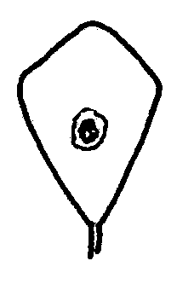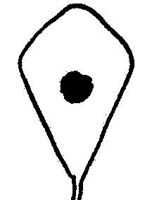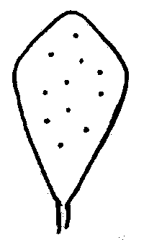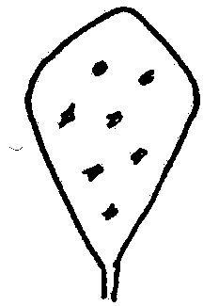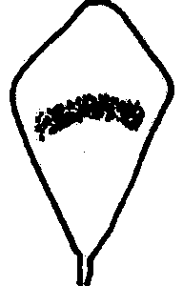

1 | 2 | 3 | 4 | 5
faded blotch | clear blotch | spotted | flecked | crescent

Ad. 3. Leaflet: position of marks on upper side
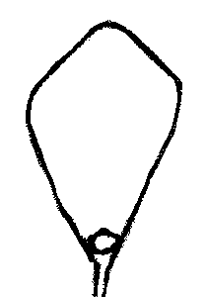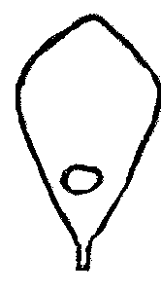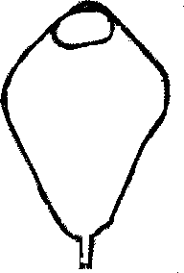
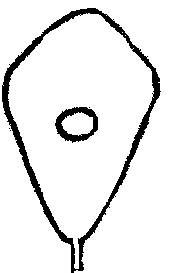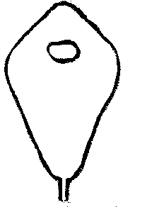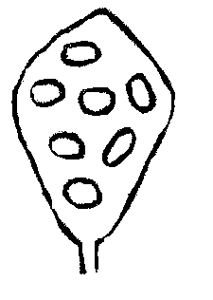
1 | 2 | 3 | 4 | 5 | 6
at base | towards base | central | towards apex | at apex | over whole surface

Ad. 6: Time of flowering

MG/B: The time of flowering of row plots should be assessed. Row plots are considered to have reached the time of flowering when 50% of the plants have at least 3 open flowers. From the row plant data, a mean date per variety is obtained.

MS/A: The time of flowering of each single plant should be assessed. A single plant is considered to have flowered when it has at least 3 open flowers. From the single plant data a mean date per plot and a mean date per variety are obtained.

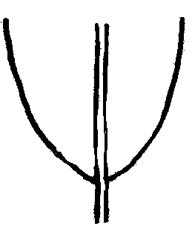Ad. 13: Leaflet: shape of base
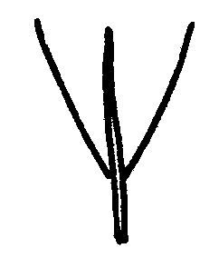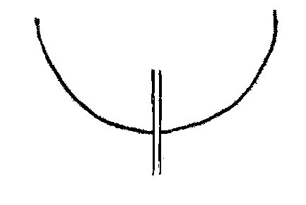

1 | 2 | 3
narrow acute | broad acute | obtuse

Ad. 14: Leaflet: shape of apex

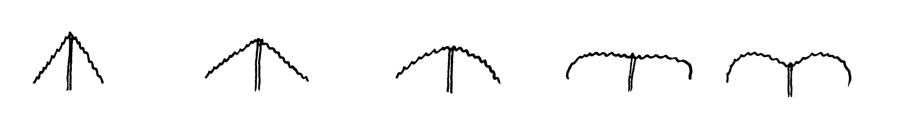
1 | 2 | 3 | 4 | 5
acute | obtuse | rounded | truncate | obcordate

Ad. 26: Flower: marks on calyx

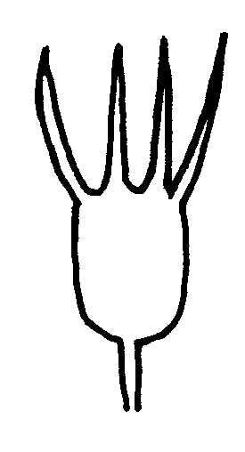 | 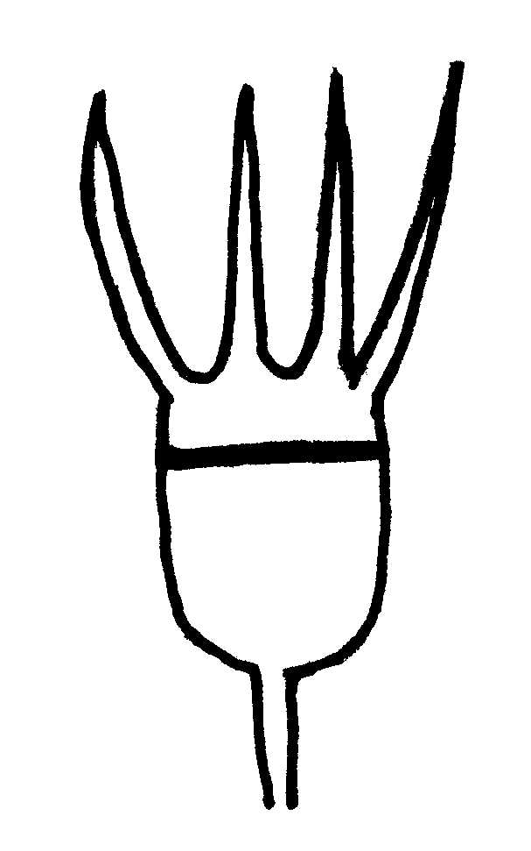 | 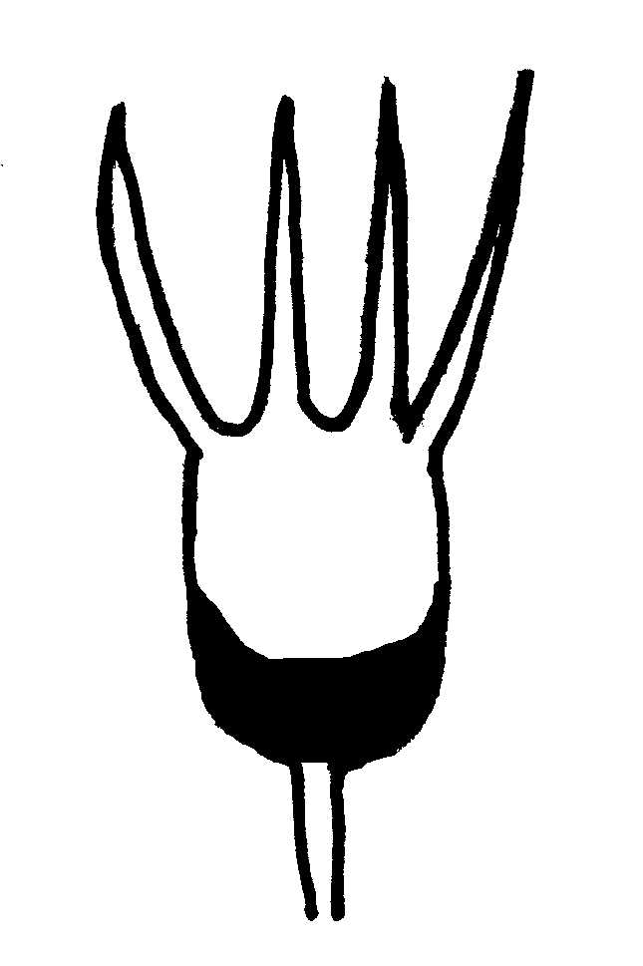
1 | 9
absent | present

Ad. 27: Time of physiological ripening of pods

Time of physiological ripening is when pods have reached full maturity and 50% of the plant has started to dry.

Ad. 29: Pod: shape

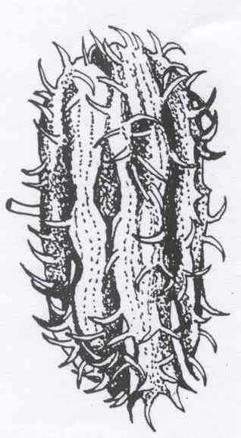 | 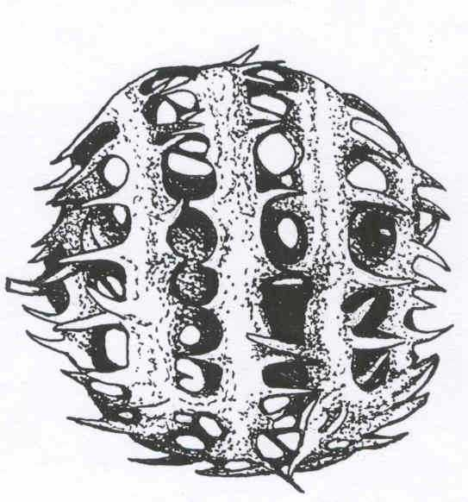 | 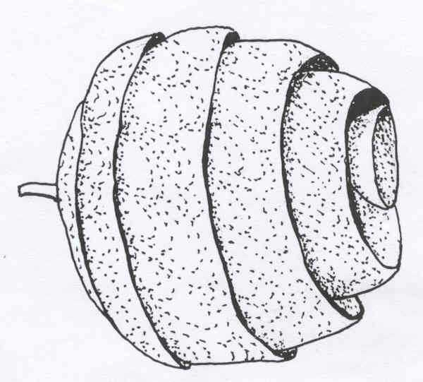
1 | 2
disk-shaped | globular

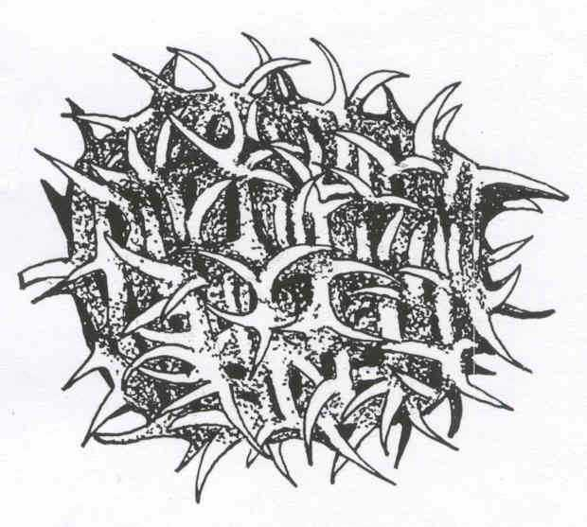 | 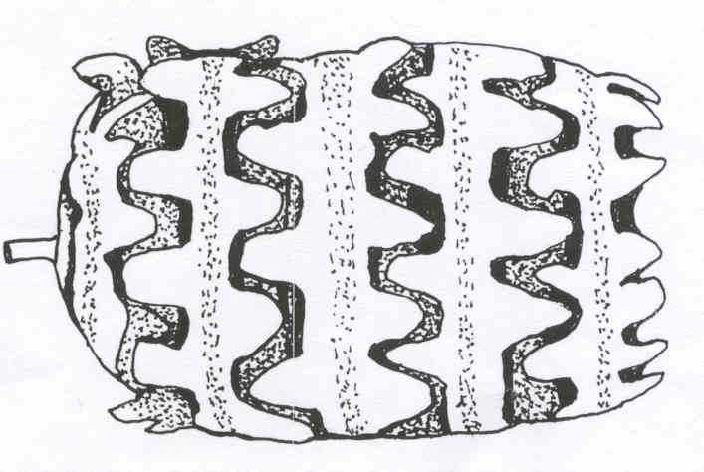 | 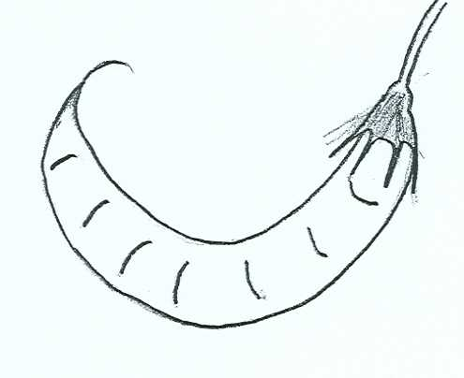
3 | 4 | 5
ovoid | cylindrical | sickle-shaped

Ad. 31: Excluding varieties with sickle-shaped pods: Pod: direction of whorls

Pods should be viewed from the proximal end.

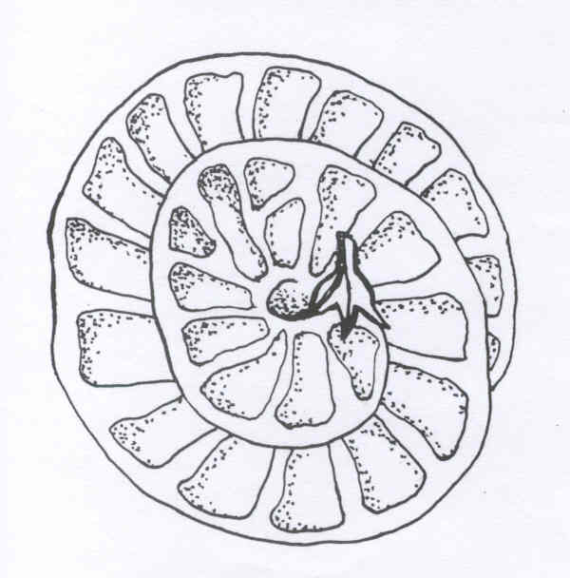
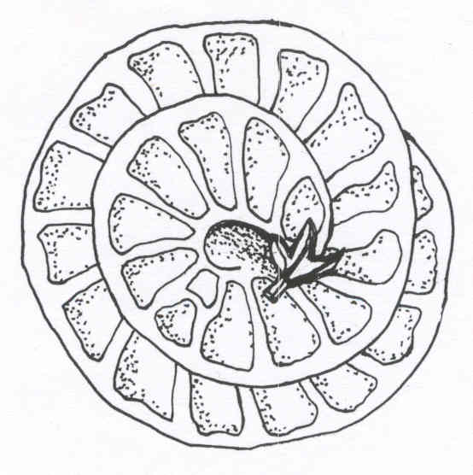

1 2
anti-clockwise clockwise

Ad. 32: Excluding varieties with sickle-shaped pods: Pod: number of whorls

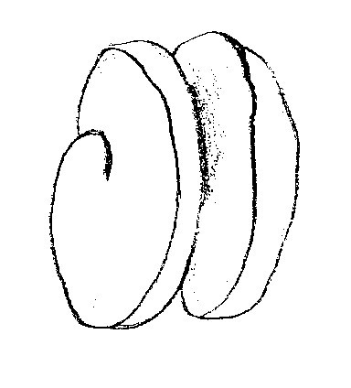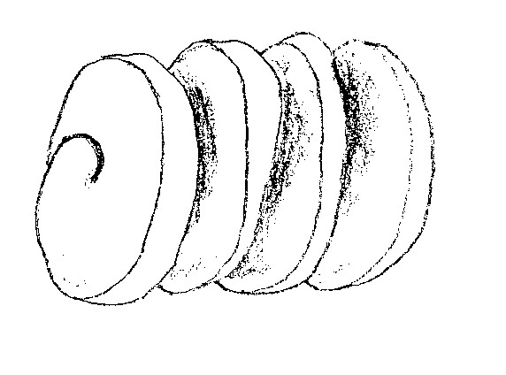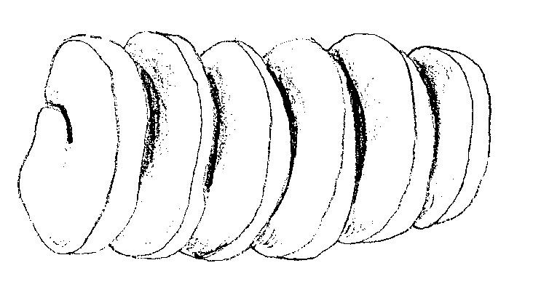
1 2 3
less than three three to five more than five

Ad. 33: Excluding varieties with sickle-shaped pods: Pod: texture of whorl edges

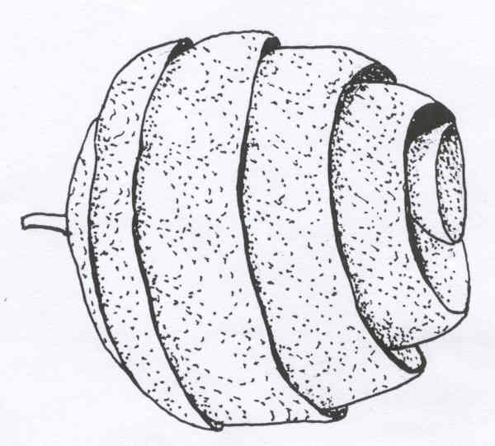
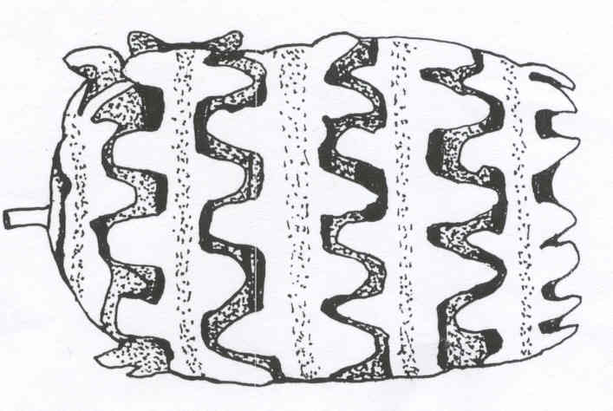
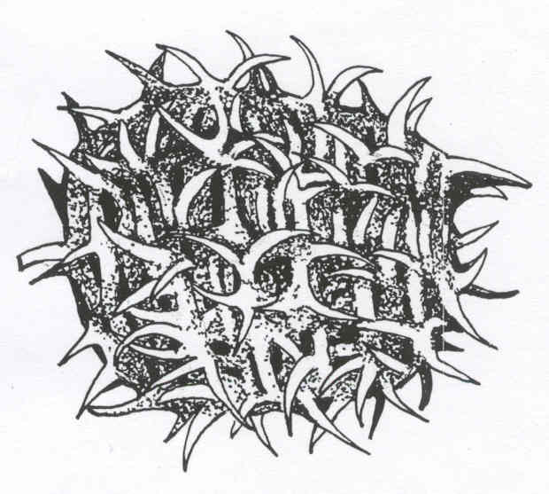

1 2 3
smooth tubercled spined

Ad. 35: Only varieties with spined texture of whorl edges: Pod: attitude of spines

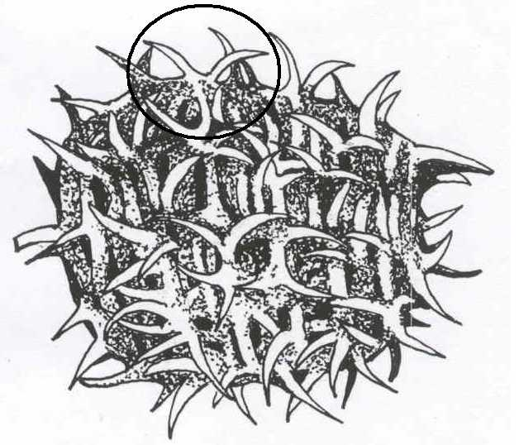
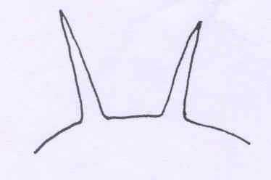 | 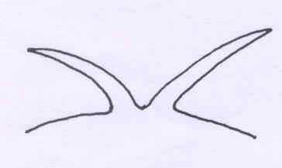 | 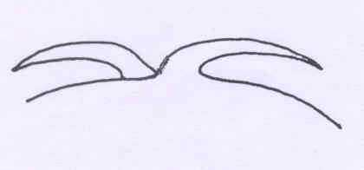
1 | 2 | 3
erect | oblique | adpressed

Ad. 36: Only varieties with spined texture of whorl edges: Pod: presence of apical hook on spines

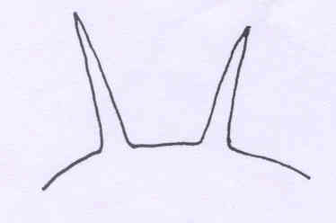
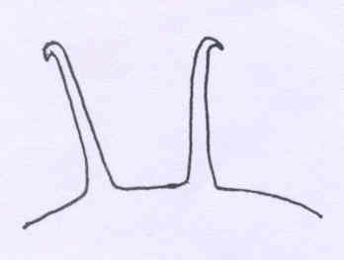

1 | 9
absent | present

Literature
IBPGR. Rome. 1991. Descriptors for annual Medicago.

Lesins, K.A. & Lesins, I. 1979. Genus Medicago (Leguminosae) A Taxogenetic study.

Small, E.; Jomphe, M. 1989. A synopsis of the Genus Medicago (Leguminosae). Canadian Journal of Botany 67: 3260-3294

Stirton, C.H. 1982. The genus Medicago (Leguminosae) in southern Africa. Bothalia 14(1): 27-35.

Technical Questionnaire
TECHNICAL QUESTIONNAIRE |  |  |  | Page {x} of {y} |  | Reference Number:
 |  |  |  |  |  | Application date:
 |  |  |  |  |  | (not to be filled in by the applicant)
TECHNICAL QUESTIONNAIRE
to be completed in connection with an application for plant breeders’ rights
1. Subject of the Technical Questionnaire
1.1 Botanical name |  |  | Medicago L. (excluding Medicago sativa L.)
1.2 Common Name |  |  | Medics
1.3 Species
(please complete)
2. Applicant
Name
Address
Telephone No.
Fax No.
E-mail address
Breeder (if different from applicant)
3. Proposed denomination and breeder’s reference
Proposed denomination
(if available)

Breeder’s reference
#4. Information on the breeding scheme and propagation of the variety

4.1 Breeding scheme

Variety resulting from:

4.1.1 Crossing

(a) controlled cross [ ]
(please state parent varieties)
(b) partially known cross [ ]
(please state known parent variety(ies))
(c) unknown cross [ ]

4.1.2 Discovery and development [ ]
(please state where and when discovered
and how developed)

4.1.3 Other [ ]
(please provide details)

4.2 Method of propagating the variety

5. Characteristics of the variety to be indicated (the number in brackets refers to the corresponding characteristic in Test Guidelines; please mark the note which best corresponds).

 | Characteristics |  |  |  |  |  | Example Varieties |  |  | Note
5.1  (1) | Leaflet: presence of marks
 | absent on both sides |  |  |  |  |  | Serena (M.p.),  Toreador (M.l.),  Tornafield (M.to.) |  |  | 1[ ]
 | present on upper side only |  |  |  |  |  | Jester (M.tr.),  Kelson (M.s.),  Santiago (M.p.) |  |  | 2[ ]
 | present on lower side only |  |  |  |  |  | Cyprus (M.tr.) |  |  | 3[ ]
 | present on both sides |  |  |  |  |  | Bokveld (M.p.),  Herald (M.l.),  Mogul (M.tr.),  Rivoli (M.to.) |  |  | 4[ ]
5.2  (2) | Leaflet: type of marks on upper side
 | faded blotch |  |  |  |  |  | Parabinga (M.tr.) |  |  | 1[ ]
 | clear blotch |  |  |  |  |  | Herald (M.to.),  Jester (M.tr.),  Polyanna (M.p.) |  |  | 2[ ]
 | spotted |  |  |  |  |  |  |  |  | 3[ ]
 | flecked |  |  |  |  |  | Bokveld (M.p.)  Borung (M.tr.) |  |  | 4[ ]
 | crescent |  |  |  |  |  | Santiago (M.p.) |  |  | 5[ ]
 | Characteristics |  |  |  |  |  | Example Varieties |  |  | Note
5.3  (6) | Time of flowering
 | very early |  |  |  |  |  | Caliph (M.tr.),  Serena (M.p.) |  |  | 1[ ]
 | early |  |  |  |  |  | Borung (M.tr.),  Santiago (M.p.),  Toreador (M.l.) |  |  | 3[ ]
 | medium |  |  |  |  |  | Cavalier (M.p.),  Rivoli (M.to.) |  |  | 5[ ]
 | late |  |  |  |  |  | Circle Valley (M.p.),  Jemalong (M.tr.) |  |  | 7[ ]
 | very late |  |  |  |  |  |  |  |  | 9[ ]
5.4  (16) | Leaflet: pubescence on upper side
 | absent |  |  |  |  |  | Circle Valley (M.p.),  Pavlovskaya 7 (M.f.),  Rivoli (M.to.) |  |  | 1[ ]
 | present |  |  |  |  |  | Harbinger (M.l.),  Kelson (M.s.),  Mogul (M.tr.) |  |  | 9[ ]
5.5  (18) | Leaflet: pubescence on lower side
 | absent |  |  |  |  |  | Circle Valley (M.p.),  Pavlovskaya 7 (M.f.) |  |  | 1[ ]
 | present |  |  |  |  |  | Harbinger (M.l.),  Kelson (M.s.),  Mogul (M.tr.),  Rivoli (M.to.) |  |  | 9[ ]
 | Characteristics |  |  |  |  |  | Example Varieties |  |  | Note
5.6  (29) | Pod: shape
 | disk-shaped |  |  |  |  |  | Toreador (M.l.),  Tornafield (M.to.) |  |  | 1[ ]
 | globular |  |  |  |  |  | Herald (M.l.),  Kelson (M.s.),  Rivoli (M.to.),  Sephi (M.tr.) |  |  | 2[ ]
 | ovoid |  |  |  |  |  | Cyprus (M.tr.),  Harbinger (M.l.) |  |  | 3[ ]
 | cylindrical |  |  |  |  |  | Paraggio (M.tr.) |  |  | 4[ ]
 | sickle-shaped |  |  |  |  |  | Pavlovskaya 7 (M.f.) |  |  | 5[ ]
5.7  (33) | Excluding varieties with sickle-shaped pods: Pod: texture of whorl edges
 | smooth |  |  |  |  |  | Kelson (M.s.),  Toreador (M.l.),  Tornafield (M.to.) |  |  | 1[ ]
 | tubercled |  |  |  |  |  | Herald (M.l.) |  |  | 2[ ]
 | spined |  |  |  |  |  | Harbinger (M.l.),  Paraggio (M.tr.) |  |  | 3[ ]
6. Similar varieties and differences from these varieties

Please use the following table and box for comments to provide information on how your candidate variety differs from the variety (or varieties) which, to the best of your knowledge, is (or are) most similar. This information may help the examination authority to conduct its examination of distinctness in a more efficient way.

Denomination(s) of variety(ies) similar to your candidate variety |  | Characteristic(s) in which your candidate variety differs from the similar variety(ies) |  |  | Describe the expression of the characteristic(s) for the similar variety(ies) |  |  | Describe the expression of the characteristic(s) for your candidate variety
Example |  | Pod: shape |  |  | globular |  |  | ovoid
Comments:

#7. Additional information which may help in the examination of the variety

7.1 In addition to the information provided in sections 5 and 6, are there any additional characteristics which may help to distinguish the variety?

Yes [ ] No [ ]

(If yes, please provide details)

7.2 Are there any special conditions for growing the variety or conducting the examination?

Yes [ ] No [ ]

(If yes, please provide details)

7.3 Other information

8. Authorization for release

(a) Does the variety require prior authorization for release under legislation concerning the protection of the environment, human and animal health?

Yes [ ] No [ ]

(b) Has such authorization been obtained?

Yes [ ] No [ ]

If the answer to (b) is yes, please attach a copy of the authorization.

9. Information on plant material to be examined or submitted for examination.

9.1 The expression of a characteristic or several characteristics of a variety may be affected by factors, such as pests and disease, chemical treatment (e.g. growth retardants or pesticides), effects of tissue culture, different rootstocks, scions taken from different growth phases of a tree, etc.

9.2 The plant material should not have undergone any treatment which would affect the expression of the characteristics of the variety, unless the competent authorities allow or request such treatment. If the plant material has undergone such treatment, full details of the treatment must be given. In this respect, please indicate below, to the best of your knowledge, if the plant material to be examined has been subjected to:

(a) Microorganisms (e.g. virus, bacteria, phytoplasma) Yes [ ] No [ ]

(b) Chemical treatment (e.g. growth retardant, pesticide) Yes [ ] No [ ]

(c) Tissue culture Yes [ ] No [ ]

(d) Other factors Yes [ ] No [ ]

Please provide details for where you have indicated “yes”.

……………………………………………………………

10. I hereby declare that, to the best of my knowledge, the information provided in this form is correct:

Applicant’s name

Signature Date

[End of document]

* These names were correct at the time of the introduction of these Test Guidelines but may be revised or updated. [Readers are advised to consult the UPOV Code, which can be found on the UPOV Website (www.upov.int), for the latest information]
# Authorities may allow certain of this information to be provided in a confidential section of the Technical Questionnaire.
# Authorities may allow certain of this information to be provided in a confidential section of the Technical Questionnaire.

