 |  | E  TG/221/1  ORIGINAL: English  DATE: 2005-04-06
INTERNATIONAL UNION FOR THE PROTECTION OF NEW VARIETIES OF PLANTS
GENEVA

 | ANTIRRHINUM*  UPOV Code: ANTIR_MAJ  (Antirrhinum majus L.) | *

GUIDELINES

FOR THE CONDUCT OF TESTS

FOR DISTINCTNESS, UNIFORMITY AND STABILITY

Alternative Names:*
Botanical name | English | French | German | Spanish
Antirrhinum majus (L.) | Antirrhinum,  Common snapdragon | Gueule de lion,  Gueule de loup,  Muflier | Löwenmaul | Boca de dragón

The purpose of these guidelines (“Test Guidelines”) is to elaborate the principles contained in the General Introduction (document TG/1/3), and its associated TGP documents, into detailed practical guidance for the harmonized examination of distinctness, uniformity and stability (DUS) and, in particular, to identify appropriate characteristics for the examination of DUS and production of harmonized variety descriptions.

ASSOCIATED DOCUMENTS

These Test Guidelines should be read in conjunction with the General Introduction and its associated TGP documents.

TABLE OF CONTENTS PAGE

1. Subject of these Test Guidelines 3
2. Material Required 3
3. Method of Examination 3
3.1 Number of Growing Cycles 3
3.2 Testing Place 3
3.3 Conditions for Conducting the Examination 3
3.4 Test Design 4
3.5 Number of Plants / Parts of Plants to be Examined 4
3.6 Additional Tests 4
4. Assessment of Distinctness, Uniformity and Stability 4
4.1 Distinctness 4
4.2 Uniformity 5
4.3 Stability 5
5. Grouping of Varieties and Organization of the Growing Trial 5
6. Introduction to the Table of Characteristics 6
6.1 Categories of Characteristics 6
6.2 States of Expression and Corresponding Notes 7
6.3 Types of Expression 7
6.4 Example Varieties 7
6.5 Legend 7
7. Table of Characteristics/Tableau des caractères/Merkmalstabelle/Tabla de caracteres 8
8. Explanations on the Table of Characteristics 8
8.1 Explanations covering several characteristics 16
8.2 Explanations for individual characteristics 16
9. Literature 19
10. Technical Questionnaire 20

Subject of these Test Guidelines
These Test Guidelines apply to all varieties of Antirrhinum majus L. of the family Scrophulariaceae.

Material Required
2.1 The competent authorities decide on the quantity and quality of the plant material required for testing the variety and when and where it is to be delivered. Applicants submitting material from a State other than that in which the testing takes place must ensure that all customs formalities and phytosanitary requirements are complied with.

2.2 The material is to be supplied in the form of seed or rooted cuttings.

2.3 The minimum quantity of plant material, to be supplied by the applicant, should be:

- seed-propagated varieties: 600 seeds;
- vegetatively propagated varieties: 30 rooted cuttings

2.4 In the case of seed, the seed should meet the minimum requirements for germination, species and analytical purity, health and moisture content, specified by the competent authority. In cases where the seed is to be stored, the germination capacity should be as high as possible and should, be stated by the applicant.

2.5 The plant material supplied should be visibly healthy, not lacking in vigor, nor affected by any important pest or disease.

2.6 The plant material should not have undergone any treatment which would affect the expression of the characteristics of the variety, unless the competent authorities allow or request such treatment. If it has been treated, full details of the treatment must be given.

Method of Examination

3.1 Number of Growing Cycles
The minimum duration of tests should normally be a single growing cycle.

3.2 Testing Place
Tests are normally conducted at one place. In the case of tests conducted at more than one place, guidance is provided in TGP/9 “Examining Distinctness”.

3.3 Conditions for Conducting the Examination
3.3.1 The tests should be carried out under conditions ensuring satisfactory growth for the expression of the relevant characteristics of the variety and for the conduct of the examination. In particular, unless otherwise indicated, all observation should be made on flowering plants at the time of full flowering.

3.3.2 Because daylight varies, color determinations made against a color chart should be made either in a suitable cabinet providing artificial daylight or in the middle of the day in a room without direct sunlight. The spectral distribution of the illuminant for artificial daylight should conform with the CIE Standard of Preferred Daylight D 6500 and should fall within the tolerances set out in the British Standard 950, Part I. These determinations should be made with the plant part placed against a white background.

3.4 Test Design
3.4.1 In the case of seed-propagated varieties, each test should be designed to result in a total of at least 40 plants.

3.4.2 In the case of vegetatively propagated varieties, each test should be designed to result in a total of at least 20 plants.

3.4.3 The design of the tests should be such that plants or parts of plants may be removed for measurement or counting without prejudice to the observations which must be made up to the end of the growing cycle.

3.5 Number of Plants / Parts of Plants to be Examined
3.5.1 In the case of seed-propagated varieties, unless otherwise indicated, all observations on single plants should be made on 20 plants or parts taken from each of 20 plants and any other observations made on all plants in the test.

3.5.2 In the case of vegetatively propagated varieties, unless otherwise indicated all observations on single plants should be made on 10 plants or parts taken from each of 10 plants and any other observations made on all plants in the test.

3.6 Additional Tests
Additional tests, for examining relevant characteristics, may be established.

Assessment of Distinctness, Uniformity and Stability

4.1 Distinctness
4.1.1 General Recommendations

It is of particular importance for users of these Test Guidelines to consult the General Introduction prior to making decisions regarding distinctness. However, the following points are provided for elaboration or emphasis in these Test Guidelines.

4.1.2 Consistent Differences

The differences observed between varieties may be so clear that more than one growing cycle is not necessary. In addition, in some circumstances, the influence of the environment is not such that more than a single growing cycle is required to provide assurance that the differences observed between varieties are sufficiently consistent. One means of ensuring that a difference in a characteristic, observed in a growing trial, is sufficiently consistent is to examine the characteristic in at least two independent growing cycles.

4.1.3 Clear Differences

Determining whether a difference between two varieties is clear depends on many factors, and should consider, in particular, the type of expression of the characteristic being examined, i.e. whether it is expressed in a qualitative, quantitative, or pseudo-qualitative manner. Therefore, it is important that users of these Test Guidelines are familiar with the recommendations contained in the General Introduction prior to making decisions regarding distinctness.

4.2 Uniformity
4.2.1 It is of particular importance for users of these Test Guidelines to consult the General Introduction prior to making decisions regarding uniformity. However, the following points are provided for elaboration or emphasis in these Test Guidelines:

4.2.2 For the assessment of uniformity, a population standard of 1% and an acceptance probability of at least 95 % should be applied. In the case of a sample size of 40 plants,
2 off-types are allowed. In the case of a sample size of 20 plants, 1 off-type is allowed.

4.3 Stability
4.3.1 In practice, it is not usual to perform tests of stability that produce results as certain as those of the testing of distinctness and uniformity. However, experience has demonstrated that, for many types of variety, when a variety has been shown to be uniform, it can also be considered to be stable.

4.3.2 Where appropriate, or in cases of doubt, stability may be tested, either by growing a further generation, or by testing a new seed or plant stock to ensure that it exhibits the same characteristics as those shown by the previous material supplied.

Grouping of Varieties and Organization of the Growing Trial
5.1 The selection of varieties of common knowledge to be grown in the trial with the candidate varieties and the way in which these varieties are divided into groups to facilitate the assessment of distinctness are aided by the use of grouping characteristics.

5.2 Grouping characteristics are those in which the documented states of expression, even where produced at different locations, can be used, either individually or in combination with other such characteristics: (a) to select varieties of common knowledge that can be excluded from the growing trial used for examination of distinctness; and (b) to organize the growing trial so that similar varieties are grouped together.

5.3 The following have been agreed as useful grouping characteristics:

(a) Plant: growth habit (characteristic 1)
(b) Only varieties with bushy plant growth habit: Plant: attitude of shoots (characteristic 2)
(c) Flower: form (characteristic 15)
(d) Upper lip: main color of upper side (characteristic 22) with the following groups:

Gr. 1: white
Gr. 2: yellow
Gr. 3: orange
Gr. 4: red
Gr. 5: pink
Gr. 6: purple

(e) Lower lip: main color of upper side of cusp (characteristic 26) with the following groups:

Gr. 1: white
Gr. 2: yellow
Gr. 3: orange
Gr. 4: red
Gr. 5: pink
Gr. 6: purple

5.4 Guidance for the use of grouping characteristics, in the process of examining distinctness, is provided through the General Introduction.

Introduction to the Table of Characteristics

6.1 Categories of Characteristics
6.1.1 Standard Test Guidelines Characteristics

Standard Test Guidelines characteristics are those which are approved by UPOV for examination of DUS and from which members of the Union can select those suitable for their particular circumstances.

6.1.2 Asterisked Characteristics

Asterisked characteristics (denoted by *) are those included in the Test Guidelines which are important for the international harmonization of variety descriptions and should always be examined for DUS and included in the variety description by all members of the Union, except when the state of expression of a preceding characteristic or regional environmental conditions render this inappropriate.

6.2 States of Expression and Corresponding Notes
States of expression are given for each characteristic to define the characteristic and to harmonize descriptions. Each state of expression is allocated a corresponding numerical note for ease of recording of data and for the production and exchange of the description.

6.3 Types of Expression
An explanation of the types of expression of characteristics (qualitative, quantitative and pseudo-qualitative) is provided in the General Introduction.

6.4 Example Varieties
Where appropriate, example varieties are provided to clarify the states of expression of each characteristic.

6.5 Legend
(*) Asterisked characteristic – see Chapter 6.1.2

QL: Qualitative characteristic – see Chapter 6.3
QN: Quantitative characteristic – see Chapter 6.3
PQ: Pseudo-qualitative characteristic – see Chapter 6.3

(a) – (c) See Explanations on the Table of Characteristics in Chapter 8.1

(+) See Explanations on the Table of Characteristics in Chapter 8.2

Table of Characteristics/Tableau des caractères/Merkmalstabelle/Tabla de caracteres

 |  |  |  |  |  |  | English |  |  |  | français |  |  |  |  |  | deutsch |  |  |  |  |  | español |  |  |  |  |  | Example Varieties/  Exemples/  Beispielssorten/  Variedades ejemplo |  |  |  |  |  | Note/  Nota
1.  (*)  (+) |  |  |  |  |  |  | Plant: growth habit |  |  |  | Plante: type de croissance |  |  |  |  |  | Pflanze: Wuchsform |  |  |  |  |  | Planta: porte
QL |  |  |  |  |  |  | single stem |  |  |  | tige unique |  |  |  |  |  | eintriebig |  |  |  |  |  | tallo único |  |  |  |  |  |  |  |  |  |  |  | 1
 |  |  |  |  |  |  | bushy |  |  |  | buissonnant |  |  |  |  |  | buschig |  |  |  |  |  | arbustivo |  |  |  |  |  |  |  |  |  |  |  | 2
2.  (*)  (+) |  |  |  |  |  |  | Only varieties with bushy plant growth habit: Plant: attitude of shoots |  |  |  | Variétés à type de croissance buissonnant seulement: Plante: port des rameaux |  |  |  |  |  | Nur Sorten mit buschiger Wuchsform: Pflanze: Haltung der Triebe |  |  |  |  |  | Sólo variedades con porte arbustivo: Planta: porte de las ramas
QN |  |  |  |  |  |  | upright |  |  |  | dressé |  |  |  |  |  | aufrecht |  |  |  |  |  | erecto |  |  |  |  |  |  |  |  |  |  |  | 1
 |  |  |  |  |  |  | semi upright |  |  |  | demi-dressé |  |  |  |  |  | halbaufrecht |  |  |  |  |  | semierecto |  |  |  |  |  |  |  |  |  |  |  | 3
 |  |  |  |  |  |  | horizontal |  |  |  | horizontal |  |  |  |  |  | waagerecht |  |  |  |  |  | horizontal |  |  |  |  |  |  |  |  |  |  |  | 5
 |  |  |  |  |  |  | semi drooping |  |  |  | demi-retombant |  |  |  |  |  | halbhängend |  |  |  |  |  | semicolgante |  |  |  |  |  |  |  |  |  |  |  | 7
 |  |  |  |  |  |  | drooping |  |  |  | retombant |  |  |  |  |  | hängend |  |  |  |  |  | colgante |  |  |  |  |  |  |  |  |  |  |  | 9
3.  (*) |  |  |  |  |  |  | Stem: length |  |  |  | Tige: longueur |  |  |  |  |  | Trieb: Länge |  |  |  |  |  | Tallo: longitud
QN |  |  |  |  |  |  | short |  |  |  | courte |  |  |  |  |  | kurz |  |  |  |  |  | corta |  |  |  |  |  | Lared |  |  |  |  |  | 3
 |  |  |  |  |  |  | medium |  |  |  | moyenne |  |  |  |  |  | mittel |  |  |  |  |  | media |  |  |  |  |  | Bridal Pink |  |  |  |  |  | 5
 |  |  |  |  |  |  | long |  |  |  | longue |  |  |  |  |  | lang |  |  |  |  |  | larga |  |  |  |  |  | Napoleon Red |  |  |  |  |  | 7
4. |  |  |  |  |  |  | Stem: anthocyanin coloration |  |  |  | Tige: pigmentation anthocyanique |  |  |  |  |  | Trieb: Anthocyan-färbung |  |  |  |  |  | Tallo: pigmentación antociánica
QN |  |  | (a) |  |  |  | absent or very weak |  |  |  | nulle ou très faible |  |  |  |  |  | fehlend oder sehr gering |  |  |  |  |  | ausente o muy débil |  |  |  |  |  |  |  |  |  |  |  | 1
 |  |  |  |  |  |  | weak |  |  |  | faible |  |  |  |  |  | gering |  |  |  |  |  | débil |  |  |  |  |  |  |  |  |  |  |  | 3
 |  |  |  |  |  |  | medium |  |  |  | moyenne |  |  |  |  |  | mittel |  |  |  |  |  | media |  |  |  |  |  |  |  |  |  |  |  | 5
 |  |  |  |  |  |  | strong |  |  |  | forte |  |  |  |  |  | stark |  |  |  |  |  | fuerte |  |  |  |  |  |  |  |  |  |  |  | 7
 |  |  |  |  |  |  | very strong |  |  |  | très forte |  |  |  |  |  | sehr stark |  |  |  |  |  | muy fuerte |  |  |  |  |  |  |  |  |  |  |  | 9
5. |  |  |  |  |  |  |  | Only varieties with bushy plant growth habit: Stem: position of branching |  |  |  | Variétés à type de croissance buissonnant seulement: Tige: localisation de la ramification |  |  |  |  |  | Nur Sorten mit buschiger Wuchsform: Trieb: Position der Verzweigung |  |  |  |  |  | Sólo variedades con porte arbustivo: Tallo: posición de las ramas
QL |  |  |  |  |  |  |  | upper half only |  |  |  | sur la moitié supérieure seulement |  |  |  |  |  | nur obere Hälfte |  |  |  |  |  | sólo mitad superior |  |  |  |  |  |  |  |  |  |  |  | 1
 |  |  |  |  |  |  |  | along entire stem |  |  |  | sur toute la longueur |  |  |  |  |  | ganze Pflanze |  |  |  |  |  | en la totalidad |  |  |  |  |  |  |  |  |  |  |  | 2
 |  |  |  |  |  |  |  | lower half only |  |  |  | sur la moitié inférieure seulement |  |  |  |  |  | nur untere Hälfte |  |  |  |  |  | sólo mitad inferior |  |  |  |  |  |  |  |  |  |  |  | 3
6. |  |  |  |  |  |  |  | Stem: number of primary branches |  |  |  | Tige: nombre de ramifications primaires |  |  |  |  |  | Trieb: Anzahl primärer Seitentriebe |  |  |  |  |  | Tallo: número de ramificaciones primarias
QN |  |  |  |  |  |  |  | few |  |  |  | rares |  |  |  |  |  | gering |  |  |  |  |  | bajo |  |  |  |  |  | Chihaya Yellow 1go |  |  |  |  |  | 3
 |  |  |  |  |  |  |  | medium |  |  |  | peu nombreuses |  |  |  |  |  | mittel |  |  |  |  |  | medio |  |  |  |  |  | Yapear |  |  |  |  |  | 5
 |  |  |  |  |  |  |  | many |  |  |  | nombreuses |  |  |  |  |  | groß |  |  |  |  |  | alto |  |  |  |  |  | Sankisupink |  |  |  |  |  | 7
7.  (*) |  |  |  |  |  |  |  | Leaf: length |  |  |  | Feuille: longueur |  |  |  |  |  | Blatt: Länge |  |  |  |  |  | Hoja: longitud
QN |  |  |  | (b) |  |  |  | short |  |  |  | courte |  |  |  |  |  | kurz |  |  |  |  |  | corta |  |  |  |  |  | Lared |  |  |  |  |  | 3
 |  |  |  |  |  |  |  | medium |  |  |  | moyenne |  |  |  |  |  | mittel |  |  |  |  |  | media |  |  |  |  |  | Bridal Pink |  |  |  |  |  | 5
 |  |  |  |  |  |  |  | long |  |  |  | longue |  |  |  |  |  | lang |  |  |  |  |  | larga |  |  |  |  |  | Iyonokurenai |  |  |  |  |  | 7
8.  (*) |  |  |  |  |  |  |  | Leaf: width |  |  |  | Feuille: largeur |  |  |  |  |  | Blatt: Breite |  |  |  |  |  | Hoja: anchura
QN |  |  |  | (b) |  |  |  | narrow |  |  |  | étroite |  |  |  |  |  | schmal |  |  |  |  |  | estrecha |  |  |  |  |  | Lared |  |  |  |  |  | 3
 |  |  |  |  |  |  |  | medium |  |  |  | moyenne |  |  |  |  |  | mittel |  |  |  |  |  | media |  |  |  |  |  | Bridal Pink |  |  |  |  |  | 5
 |  |  |  |  |  |  |  | broad |  |  |  | large |  |  |  |  |  | breit |  |  |  |  |  | ancha |  |  |  |  |  | Iyonokurenai |  |  |  |  |  | 7
9.  (*) |  |  |  |  |  |  |  | Leaf: variegation |  |  |  | Feuille: panachure |  |  |  |  |  | Blatt: Panaschierung |  |  |  |  |  | Hoja: variegación
QL |  |  |  | (b) |  |  |  | absent |  |  |  | absente |  |  |  |  |  | fehlend |  |  |  |  |  | ausente |  |  |  |  |  |  |  |  |  |  |  | 1
 |  |  |  |  |  |  |  | present |  |  |  | présente |  |  |  |  |  | vorhanden |  |  |  |  |  | presente |  |  |  |  |  | Dancing Flame |  |  |  |  |  | 9
10.  (*) |  |  |  |  |  |  |  | Only varieties with leaf variegation absent: Leaf: intensity of green color of upper side |  |  |  | Variétés sans panachure de la feuille seulement: Feuille: intensité de la couleur verte de la face supérieure |  |  |  |  |  | Nur Sorten mit fehlender Blattpanachierung: Blatt: Intensität der Grünfärbung der Oberseite |  |  |  |  |  | Sólo variedades sin variegación de hoja: Hoja: intensidad del color verde del haz
QN |  |  |  | (b) |  |  |  | light |  |  |  | claire |  |  |  |  |  | hell |  |  |  |  |  | claro |  |  |  |  |  |  |  |  |  |  |  | 3
 |  |  |  |  |  |  |  | medium |  |  |  | moyenne |  |  |  |  |  | mittel |  |  |  |  |  | medio |  |  |  |  |  | Lared |  |  |  |  |  | 5
 |  |  |  |  |  |  |  | dark |  |  |  | foncée |  |  |  |  |  | dunkel |  |  |  |  |  | oscuro |  |  |  |  |  | Yapear |  |  |  |  |  | 7
11. |  |  |  |  |  |  |  | Leaf: anthocyanin coloration on lower side |  |  |  | Feuille: pigmentation anthocyanique sur la face inférieure |  |  |  |  |  | Blatt: Anthocyan-färbung der Unterseite |  |  |  |  |  | Hoja: pigmentación antociánica del envés
QL |  |  |  | (b) |  |  |  | absent |  |  |  | absente |  |  |  |  |  | fehlend |  |  |  |  |  | ausente |  |  |  |  |  |  |  |  |  |  |  | 1
 |  |  |  |  |  |  |  | present |  |  |  | présente |  |  |  |  |  | vorhanden |  |  |  |  |  | presente |  |  |  |  |  |  |  |  |  |  |  | 9
12. |  |  |  |  |  |  |  | Leaf: pubescence |  |  |  | Feuille: pilosité |  |  |  |  |  | Blatt: Behaarung |  |  |  |  |  | Hoja: pubescencia
QN |  |  |  | (b) |  |  |  | absent or very weak |  |  |  | nulle ou très faible |  |  |  |  |  | fehlend oder sehr gering |  |  |  |  |  | ausente o muy débil |  |  |  |  |  | Yacan |  |  |  |  |  | 1
 |  |  |  |  |  |  |  | weak |  |  |  | faible |  |  |  |  |  | gering |  |  |  |  |  | débil |  |  |  |  |  | Balumwhite |  |  |  |  |  | 3
 |  |  |  |  |  |  |  | medium |  |  |  | moyenne |  |  |  |  |  | mittel |  |  |  |  |  | media |  |  |  |  |  | Apple Blossom |  |  |  |  |  | 5
 |  |  |  |  |  |  |  | strong |  |  |  | forte |  |  |  |  |  | stark |  |  |  |  |  | fuerte |  |  |  |  |  |  |  |  |  |  |  | 7
13. |  |  |  |  |  |  |  | Only varieties with single stem plant growth habit: Inflorescence: length |  |  |  | Variétés à type de croissance avec une tige unique seulement: Inflorescence: longueur |  |  |  |  |  | Nur Sorten mit eintriebiger Wuchsform: Blütenstand: Länge |  |  |  |  |  | Sólo variedades con porte de planta de tallo único: Inflorescencia: longitud
QN |  |  |  |  |  |  |  | short |  |  |  | courte |  |  |  |  |  | kurz |  |  |  |  |  | corta |  |  |  |  |  | Sankisupink |  |  |  |  |  | 3
 |  |  |  |  |  |  |  | medium |  |  |  | moyenne |  |  |  |  |  | mittel |  |  |  |  |  | media |  |  |  |  |  | Iyonokurenai |  |  |  |  |  | 5
 |  |  |  |  |  |  |  | long |  |  |  | longue |  |  |  |  |  | lang |  |  |  |  |  | larga |  |  |  |  |  | Napolean Red |  |  |  |  |  | 7
14.  (+) |  |  |  |  |  |  |  | Only varieties with single stem plant growth habit: Inflorescence: density |  |  |  | Variétés à type de croissance avec une tige unique seulement: Inflorescence: densité |  | Nur Sorten mit eintriebiger Wuchsform: Blütenstand: Dichte |  |  |  |  |  | Sólo variedades con porte de tallo único: Inflorescencia: densidad
QN |  |  |  |  |  |  |  | sparse |  |  |  | faible |  | locker |  |  |  |  |  | laxa |  |  |  |  |  |  |  |  |  |  |  | 3
 |  |  |  |  |  |  |  | medium |  |  |  | moyenne |  | mittel |  |  |  |  |  | media |  |  |  |  |  | Bridal Pink |  |  |  |  |  | 5
 |  |  |  |  |  |  |  | dense |  |  |  | forte |  | dicht |  |  |  |  |  | densa |  |  |  |  |  | Bridal White |  |  |  |  |  | 7
15.  (*)  (+) |  |  |  |  |  |  |  | Flower: form |  |  |  | Fleur: forme |  | Blüte: Form |  |  |  |  |  | Flor: forma
QL |  |  |  | (c) |  |  |  | zygomorph |  |  |  | zygomorphe |  | zygomorph |  |  |  |  |  | zigomorfa |  |  |  |  |  |  |  |  |  |  |  | 1
 |  |  |  |  |  |  |  | actinomorph |  |  |  | actinomorphe |  | aktinomorph |  |  |  |  |  | actinomorfa |  |  |  |  |  |  |  |  |  |  |  | 2
16.  (*) |  |  |  |  |  |  |  | Flower: type |  |  |  | Fleur: type |  | Blüte: Typ |  |  |  |  |  | Flor: tipo
QL |  |  |  | (c) |  |  |  | single |  |  |  | simple |  | einfach |  |  |  |  |  | sencilla |  |  |  |  |  |  |  |  |  |  |  | 1
 |  |  |  |  |  |  |  | double |  |  |  | double |  | gefüllt |  |  |  |  |  | doble |  |  |  |  |  |  |  |  |  |  |  | 2
17.  (*)  (+) |  |  |  |  |  |  |  | Flower: length |  |  |  | Fleur: longueur |  | Blüte: Länge |  |  |  |  |  | Flor: longitud
QN |  |  |  | (c) |  |  |  | short |  |  |  | courte |  | kurz |  |  |  |  |  | corta |  |  |  |  |  | Lared |  |  |  |  |  | 3
 |  |  |  |  |  |  |  | medium |  |  |  | moyenne |  | mittel |  |  |  |  |  | media |  |  |  |  |  | Bridal Pink |  |  |  |  |  | 5
 |  |  |  |  |  |  |  | long |  |  |  | longue |  | lang |  |  |  |  |  | larga |  |  |  |  |  | Napoleon Red |  |  |  |  |  | 7
18.  (*)  (+) |  |  |  |  |  |  |  | Flower: width |  |  |  | Fleur: largeur |  | Blüte: Breite |  |  |  |  |  | Flor: anchura
QN |  |  |  | (c) |  |  |  | narrow |  |  |  | étroite |  | schmal |  |  |  |  |  | estrecha |  |  |  |  |  | Lared |  |  |  |  |  | 3
 |  |  |  |  |  |  |  | medium |  |  |  | moyenne |  | mittel |  |  |  |  |  | media |  |  |  |  |  | Bridal Pink |  |  |  |  |  | 5
 |  |  |  |  |  |  |  | broad |  |  |  | large |  | breit |  |  |  |  |  | ancha |  |  |  |  |  |  |  |  |  |  |  | 7
19.  (+) |  |  |  |  |  | Corolla tube: length |  |  | Tube de la corolle: longueur |  |  |  |  |  |  | Kronenröhre: Länge |  |  |  |  |  | Tubo de la corola: longitud
QN |  | (c) |  |  |  | short |  |  | court |  |  |  |  |  |  | kurz |  |  |  |  |  | corta |  |  |  |  |  |  |  |  |  |  |  | 3
 |  |  |  |  |  | medium |  |  | moyen |  |  |  |  |  |  | mittel |  |  |  |  |  | media |  |  |  |  |  |  |  |  |  |  |  | 5
 |  |  |  |  |  | long |  |  | long |  |  |  |  |  |  | lang |  |  |  |  |  | larga |  |  |  |  |  |  |  |  |  |  |  | 7
20.  (+) |  |  |  |  |  | Upper lip: width |  |  | Labelle supérieur: largeur |  |  |  |  |  |  | Oberlippe: Breite |  |  |  |  |  | Labio superior: anchura
QN |  | (c) |  |  |  | narrow |  |  | étroit |  |  |  |  |  |  | schmal |  |  |  |  |  | estrecha |  |  |  |  |  | Lared |  |  |  |  |  | 3
 |  |  |  |  |  | medium |  |  | moyen |  |  |  |  |  |  | mittel |  |  |  |  |  | media |  |  |  |  |  | Bridal Pink |  |  |  |  |  | 5
 |  |  |  |  |  | broad |  |  | large |  |  |  |  |  |  | breit |  |  |  |  |  | ancha |  |  |  |  |  |  |  |  |  |  |  | 7
21. |  |  |  |  |  | Upper lip: conspicuousness of veins |  |  | Labelle supérieur: netteté des nervures |  |  |  |  |  |  | Oberlippe: Ausprägung der Adern |  |  |  |  |  | Labio superior: visibilidad de la nervadura
QN |  | (c) |  |  |  | absent or very weak |  |  | nulle ou très faible |  |  |  |  |  |  | fehlend oder sehr gering |  |  |  |  |  | ausente o muy débil |  |  |  |  |  |  |  |  |  |  |  | 1
 |  |  |  |  |  | weak |  |  | faible |  |  |  |  |  |  | gering |  |  |  |  |  | débil |  |  |  |  |  |  |  |  |  |  |  | 3
 |  |  |  |  |  | medium |  |  | moyenne |  |  |  |  |  |  | mittel |  |  |  |  |  | media |  |  |  |  |  |  |  |  |  |  |  | 5
 |  |  |  |  |  | strong |  |  | forte |  |  |  |  |  |  | stark |  |  |  |  |  | fuerte |  |  |  |  |  |  |  |  |  |  |  | 7
 |  |  |  |  |  | very strong |  |  | très forte |  |  |  |  |  |  | sehr stark |  |  |  |  |  | muy fuerte |  |  |  |  |  |  |  |  |  |  |  | 9
22.  (*) |  |  |  |  | Upper lip: main color of upper side |  |  |  |  | Labelle supérieur: couleur principale de la face supérieure |  |  |  |  | Oberlippe: Hauptfarbe der Oberseite |  |  |  |  |  | Labio superior: color principal de la cara superior
PQ |  |  |  | (c) |  |  |  | RHS Colour Chart  (indicate reference number) |  |  |  | Code de couleurs RHS (indiquer le numéro de référence) |  | RHS-Farbkarte (Nummer angeben) |  |  |  |  |  | Carta de Colores RHS (indíquese número de referencia)
23. |  |  |  |  | Upper lip: main color of lower side |  |  |  |  | Labelle supérieur: couleur principale de la face inférieure |  |  |  |  | Oberlippe: Hauptfarbe der Unterseite |  |  |  |  |  | Labio superior: color principal de la cara inferior
PQ |  |  |  | (c) |  |  |  | RHS Colour Chart  (indicate reference number) |  |  |  | Code de couleurs RHS (indiquer le numéro de référence) |  | RHS-Farbkarte (Nummer angeben) |  |  |  |  |  | Carta de Colores RHS (indíquese número de referencia)
24.  (+) |  |  |  |  |  | Lower lip: attitude of middle cusp lobe (relative to corolla tube) |  |  | Labelle inférieur: port du lobe de la pointe médiane (par rapport au tube de la corolle) |  |  |  | Unterlippe: Haltung des mittleren Zipfellappens (im Verhältnis zur Kronenröhre) |  |  |  |  |  | Labio inferior: porte del lóbulo central de la cúspide (en relación con el tubo de la corola)
QN |  | (c) |  |  |  | erect |  |  | dressé |  |  |  | aufrecht |  |  |  |  |  | erecto |  |  |  |  |  | Diana Pink |  |  |  |  |  | 1
 |  |  |  |  |  | semi erect |  |  | demi-dressé |  |  |  | halbaufrecht |  |  |  |  |  | semierecto |  |  |  |  |  |  |  |  |  |  |  | 3
 |  |  |  |  |  | horizontal |  |  | horizontal |  |  |  | waagerecht |  |  |  |  |  | horizontal |  |  |  |  |  | Sulte Redyel |  |  |  |  |  | 5
 |  |  |  |  |  | semi drooping |  |  | demi-retombant |  |  |  | halbüberhängend |  |  |  |  |  | semicolgante |  |  |  |  |  |  |  |  |  |  |  | 7
 |  |  |  |  |  | drooping |  |  | retombant |  |  |  | überhängend |  |  |  |  |  | colgante |  |  |  |  |  | Diana Dark Red |  |  |  |  |  | 9
25.  (+) |  |  |  |  |  | Lower lip: width of middle cusp lobe |  |  | Labelle inférieur: largeur du lobe de la pointe médiane |  |  |  | Unterlippe: Breite des mittleren Zipfellappens |  |  |  |  |  | Labio inferior: anchura del lóbulo central de la cúspide
QN |  | (c) |  |  |  | narrow |  |  | étroit |  |  |  | schmal |  |  |  |  |  | estrecha |  |  |  |  |  | Lared |  |  |  |  |  | 3
 |  |  |  |  |  | medium |  |  | moyen |  |  |  | mittel |  |  |  |  |  | media |  |  |  |  |  | Chihaya Yellow 1go |  |  |  |  |  | 5
 |  |  |  |  |  | broad |  |  | large |  |  |  | breit |  |  |  |  |  | ancha |  |  |  |  |  | Bridal Pink |  |  |  |  |  | 7
26.  (*)  (+) |  |  |  |  | Lower lip: main color of upper side of cusp |  |  |  |  | Labelle inférieur: couleur principale de la face supérieure de la pointe |  |  |  |  | Unterlippe: Hauptfarbe der Oberseite des Zipfels |  |  |  |  |  | Labio inferior: color principal de la cara superior de la cúspide
PQ |  |  |  | (c) |  |  |  | RHS Colour Chart  (indicate reference number) |  |  |  | Code de couleurs RHS (indiquer le numéro de référence) |  | RHS-Farbkarte (Nummer angeben) |  |  |  |  |  | Carta de Colores RHS (indíquese número de referencia)
27. |  |  |  |  | Lower lip: main color of lower side of cusp |  |  |  |  | Labelle inférieur: couleur principale de la face inférieure de la pointe |  |  |  |  | Unterlippe: Hauptfarbe der Unterseite des Zipfels |  |  |  |  |  | Labio inferior: color principal de la cara inferior de la cúspide
PQ |  |  |  | (c) |  |  |  | RHS Colour Chart  (indicate reference number) |  |  |  | Code de couleurs RHS (indiquer le numéro de référence) |  | RHS-Farbkarte (Nummer angeben) |  |  |  |  |  | Carta de Colores RHS (indíquese número de referencia)
28.  (*)  (+) |  |  |  |  | Lower lip: main color of upper side of base |  |  |  |  | Labelle inférieur: couleur principale de la face supérieure de la base |  |  |  |  | Unterlippe: Hauptfarbe der Oberseite der Basis |  |  |  |  |  | Labio inferior: color principal de la cara superior de la base
PQ |  |  |  | (c) |  |  |  | RHS Colour Chart  (indicate reference number) |  |  |  | Code de couleurs RHS (indiquer le numéro de référence) |  | RHS-Farbkarte (Nummer angeben) |  |  |  |  |  | Carta de Colores RHS (indíquese número de referencia)
29.  (*)  (+) |  |  |  |  | Lower lip: spot |  |  |  |  | Labelle inférieur: tache |  |  |  |  | Unterlippe: Fleck |  |  |  |  |  | Labio inferior: mancha
QL | (c) |  |  |  | absent |  |  |  |  | absente |  |  |  |  | fehlend |  |  |  |  |  | ausente |  |  |  |  |  |  |  |  |  |  |  | 1
 |  |  |  |  | present |  |  |  |  | présente |  |  |  |  | vorhanden |  |  |  |  |  | presente |  |  |  |  |  |  |  |  |  |  |  | 9
30. |  |  |  |  | Lower lip: size of spot |  |  |  |  | Labelle inférieur: taille de la tache |  |  |  |  | Unterlippe: Größe des Flecks |  |  |  |  |  | Labio inferior: tamaño de la mancha
QN | (c) |  |  |  | very small |  |  |  |  | très petite |  |  |  |  | sehr klein |  |  |  |  |  | muy pequeña |  |  |  |  |  |  |  |  |  |  |  | 1
 |  |  |  |  | small |  |  |  |  | petite |  |  |  |  | klein |  |  |  |  |  | pequeña |  |  |  |  |  |  |  |  |  |  |  | 3
 |  |  |  |  | medium |  |  |  |  | moyenne |  |  |  |  | mittel |  |  |  |  |  | media |  |  |  |  |  |  |  |  |  |  |  | 5
 |  |  |  |  | large |  |  |  |  | grande |  |  |  |  | groß |  |  |  |  |  | grande |  |  |  |  |  |  |  |  |  |  |  | 7
 |  |  |  |  | very large |  |  |  |  | très grande |  |  |  |  | sehr groß |  |  |  |  |  | muy grande |  |  |  |  |  |  |  |  |  |  |  | 9
31. |  |  |  |  |  |  |  | Lower lip: color of spot |  |  |  | Labelle inférieur: couleur de la tache |  | Unterlippe: Farbe des Flecks |  |  |  |  |  | Labio inferior: color de la mancha
PQ |  |  |  | (c) |  |  |  | RHS Colour Chart  (indicate reference number) |  |  |  | Code de couleurs RHS (indiquer le numéro de référence) |  | RHS-Farbkarte (Nummer angeben) |  |  |  |  |  | Carta de Colores RHS (indíquese número de referencia)
32. |  |  |  |  |  |  |  | Corolla tube: color of outer side |  |  |  | Tube de la corolle: couleur de la face externe |  | Kronenröhre: Farbe der Außenseite |  |  |  |  |  | Tubo de la corola: color de la cara externa
PQ |  |  |  | (c) |  |  |  | RHS Colour Chart  (indicate reference number) |  |  |  | Code de couleurs RHS (indiquer le numéro de référence) |  | RHS-Farbkarte (Nummer angeben) |  |  |  |  |  | Carta de Colores RHS (indíquese número de referencia)
33.  (+) |  |  |  |  | Only seed-propagated varieties: Time of beginning of flowering |  |  |  |  | Variétés reproduites par voie sexuée seulement: époque de début de la floraison |  |  |  |  | Nur samenvermehrte Sorten: Zeitpunkt des Blühbeginns |  |  |  |  |  | Sólo variedades de reproducción sexuada: Período de comienzo de la floración
QN | (c) |  |  |  | very early |  |  |  |  | très précoce |  |  |  |  | sehr früh |  |  |  |  |  | muy precoz |  |  |  |  |  |  |  |  |  |  |  | 1
 |  |  |  |  | early |  |  |  |  | précoce |  |  |  |  | früh |  |  |  |  |  | precoz |  |  |  |  |  |  |  |  |  |  |  | 3
 |  |  |  |  | medium |  |  |  |  | intermédiaire |  |  |  |  | mittel |  |  |  |  |  | media |  |  |  |  |  |  |  |  |  |  |  | 5
 |  |  |  |  | late |  |  |  |  | tardive |  |  |  |  | spät |  |  |  |  |  | tardía |  |  |  |  |  |  |  |  |  |  |  | 7
 |  |  |  |  | very late |  |  |  |  | très tardive |  |  |  |  | sehr spät |  |  |  |  |  | muy tardía |  |  |  |  |  |  |  |  |  |  |  | 9

Explanations on the Table of Characteristics

8.1 Explanations covering several characteristics
Characteristics containing the following key in the second column of the Table of Characteristics should be examined as indicated below:

(a) Observations on the stem to be made on the middle part of main stem
(b) Observations on the leaf to be made on leaves on the middle part of main stem
(c) Observations on the flower to be made on the second flower to open

8.2 Explanations for individual characteristics

Ad. 1: Plant: growth habit

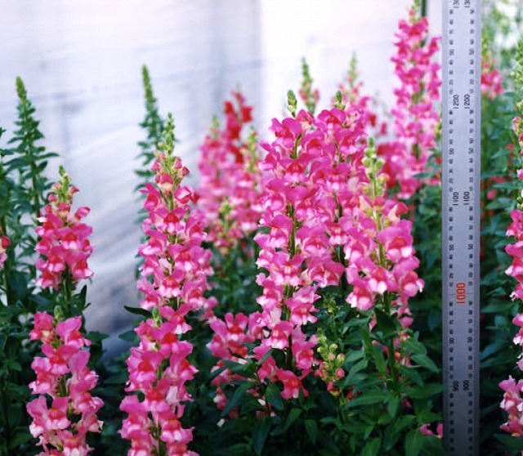 | 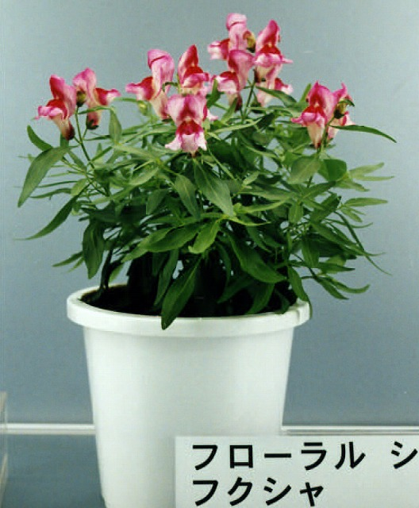
1 | 2
single stem | bushy

Ad. 2: Plant: attitude of shoots

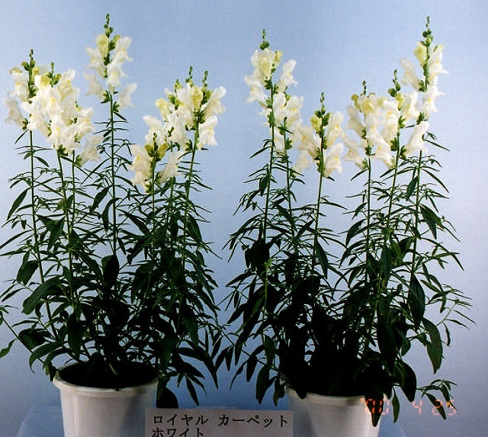 |  | 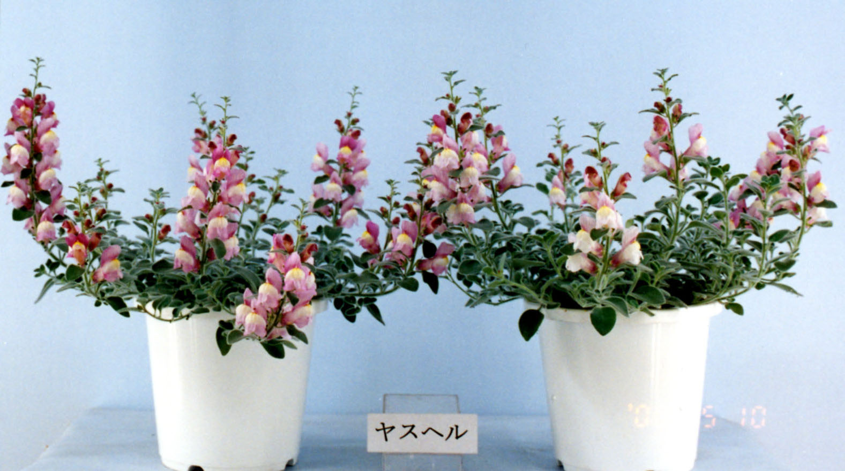 | 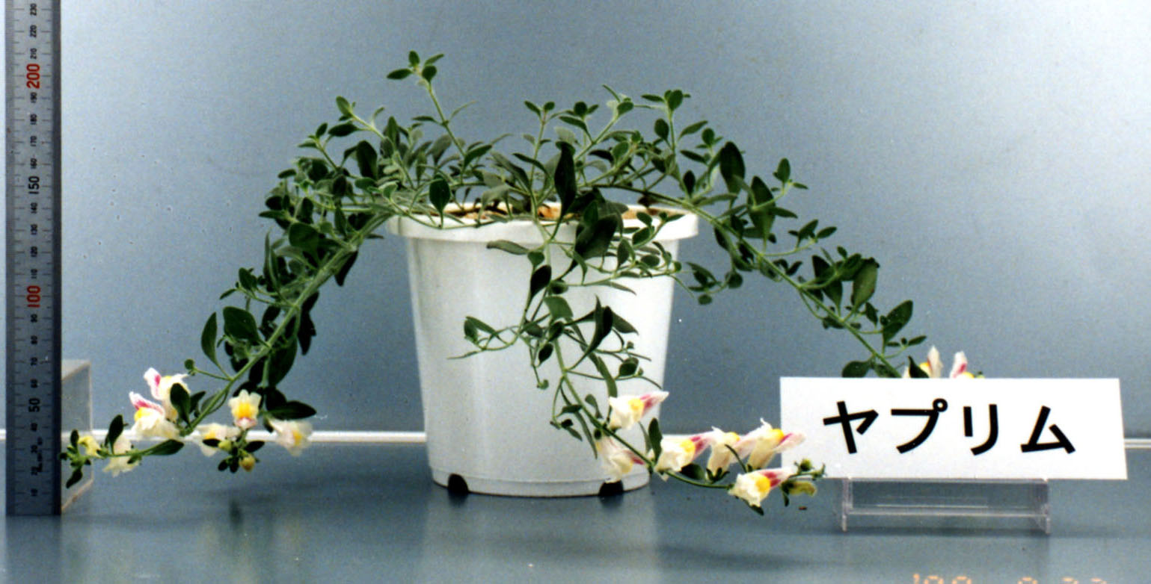 | 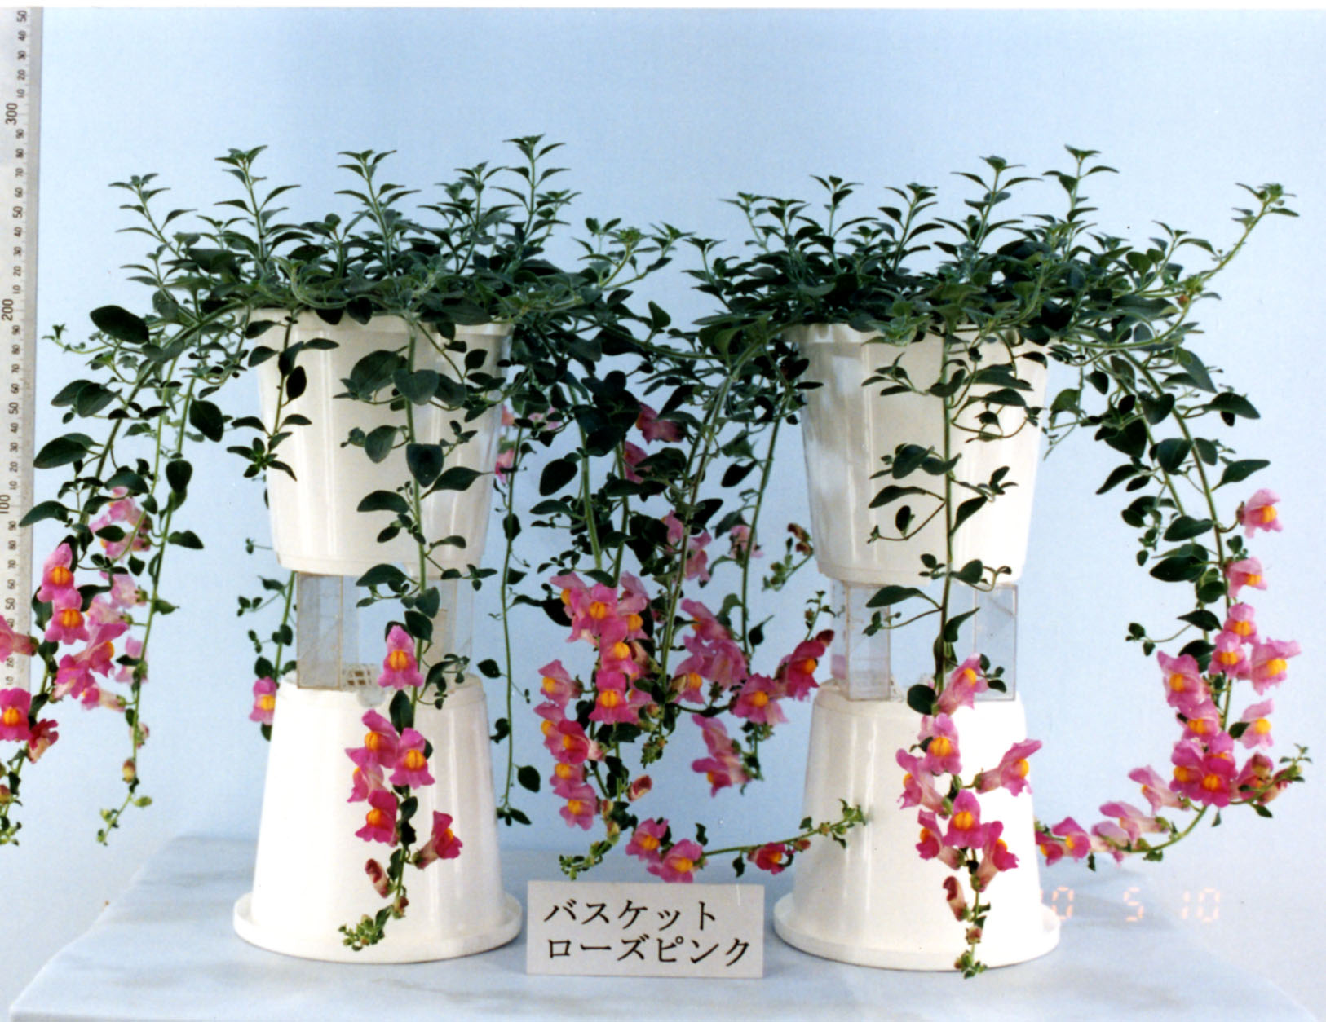
1 | 3 | 5 | 7 | 9
upright | semi upright | horizontal | semi drooping | drooping

Ad. 14: Inflorescence: density

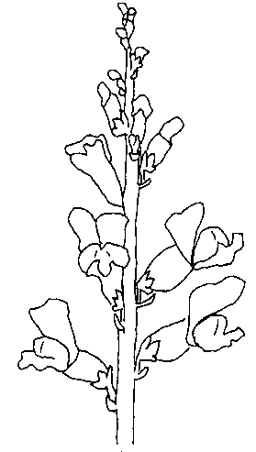 | 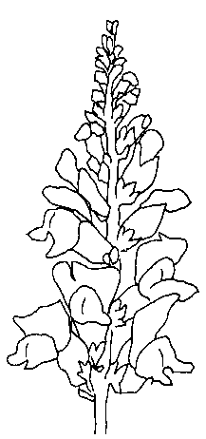 | 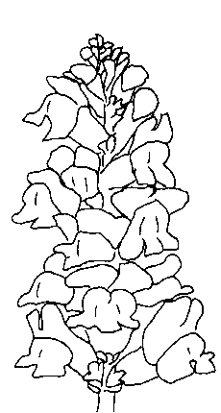
3 | 5 | 7
sparse | medium | dense

Ad. 15: Flower: form
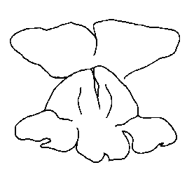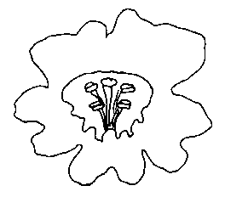
1 2
zygomorph actinomorph

Ad. 17: Flower: length
Ad. 18: Flower: width

length

width

Ad. 19: Corolla tube: length
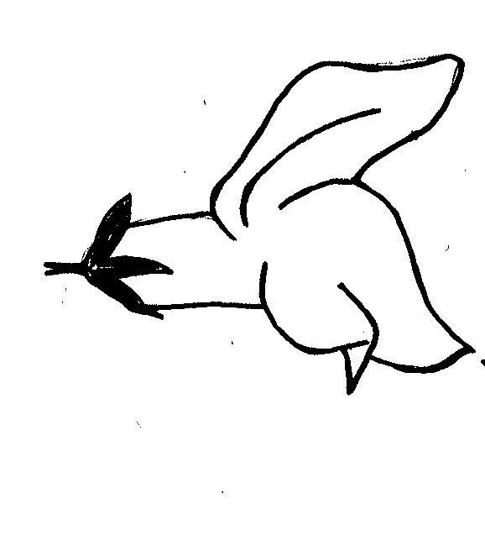
length

length

Ad. 20: Upper lip: width
Ad. 25: Lower lip: width of middle cusp lobe
Ad. 26: Lower lip: main color of upper side of cusp
Ad. 28: Lower lip: main color of upper side of base

width

width
Lower lip
cusp
Upper lip

base
lobe
width

lobes ss

Upper lip

Lower lip
base
cusp

width

Ad. 24: Lower lip: attitude of middle cusp lobe (relative to corolla tube)
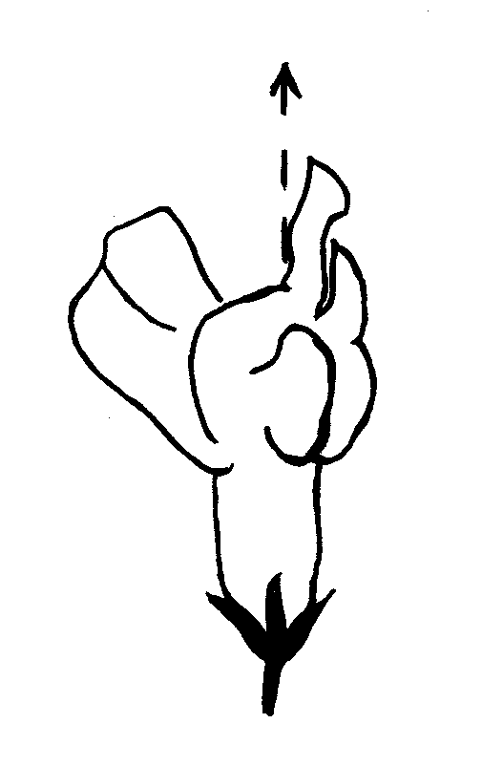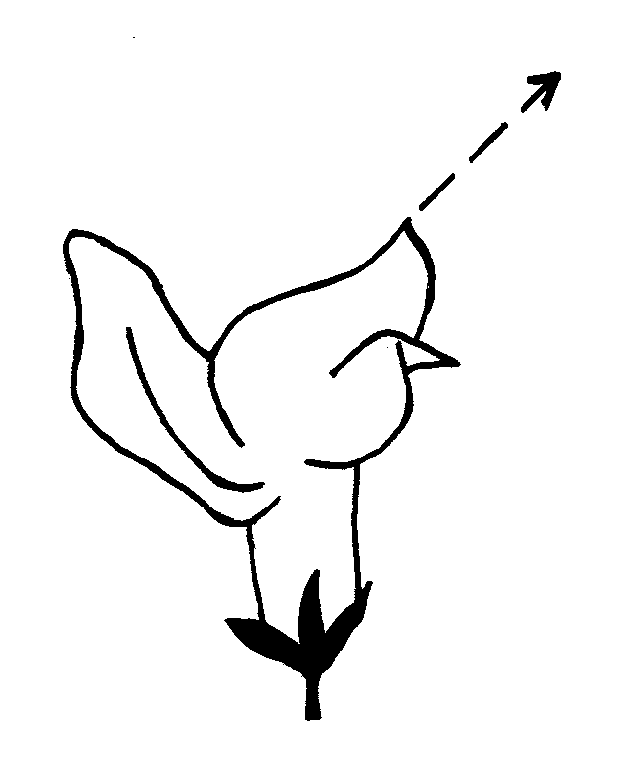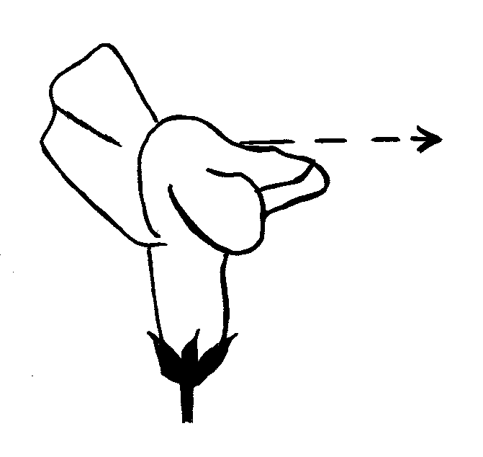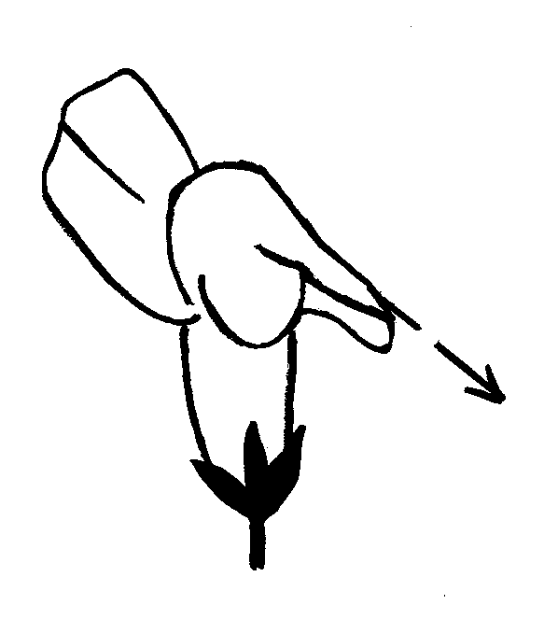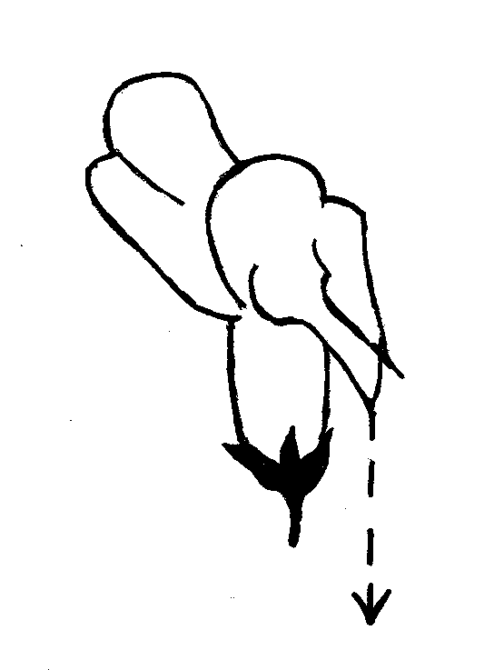
1 | 3 | 5 | 7 | 9
erect | semi erect | horizontal | semi drooping | drooping

Ad. 29: Lower lip: spot

Spot
spot

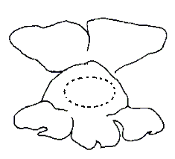

Ad. 33: Only seed-propagated varieties: Time of beginning of flowering

Time of beginning of flowering is when 50% of the plants have one fully open flower.

Literature

Encyclopedia of Horticulture, Vol. 1. pp. 193-195, Seibun-Do Shinkosha, Tokyo, Japan (Japanese)

The Grand Dictionary of Horticulture, Vol. 1. pp. 119-122, Shougakukan, Tokyo, Japan (Japanese)

Technical Questionnaire
TECHNICAL QUESTIONNAIRE |  |  |  | Page {x} of {y} |  | Reference Number:
 |  |  |  |  |  | Application date:
 |  |  |  |  |  | (not to be filled in by the applicant)
TECHNICAL QUESTIONNAIRE
to be completed in connection with an application for plant breeders’ rights

1. Subject of the Technical Questionnaire
1.1 Botanical name |  |  | Antirrhinum majus L.
1.2 Common name |  |  | Antirrhinum, Common snapdragon
2. Applicant
Name
Address
Telephone No.
Fax No.
E-mail address
Breeder (if different from applicant)
3. Proposed denomination and breeder’s reference
Proposed denomination
(if available)

Breeder’s reference
#4. Information on the breeding scheme and propagation of the variety

4.1 Breeding scheme

Variety resulting from:

4.1.1 Crossing

(a) controlled cross [ ]
(please state parent varieties)
(b) partially known cross [ ]
(please state known parent variety(ies))
(c) unknown cross [ ]

4.1.2 Mutation [ ]
(please state parent variety)

4.1.3 Discovery and development [ ]
(please state where and when discovered
and how developed)

4.1.4 Other [ ]
(please provide details)

4.2 Method of propagating the variety

4.2.1 Vegetative propagation

(a) cuttings [ ]
(b) in vitro propagation [ ]
(c) other (state method) [ ]

4.2.2 Seed

(a) self-pollinated [ ]
(b) hybrid [ ]
(c) other (please provide details) [ ]

4.2.3 Other [ ]

(please provide details)

5. Characteristics of the variety to be indicated (the number in brackets refers to the corresponding characteristic in Test Guidelines; please mark the note which best corresponds).

 | Characteristics |  |  |  |  |  | Example Varieties |  |  | Note
5.1  (1) | Plant: growth habit
 | single stem |  |  |  |  |  |  |  |  | 1[ ]
 | bushy |  |  |  |  |  |  |  |  | 2[ ]
5.2  (2) | Only varieties with bushy plant growth habit: Plant: attitude of shoots
 | upright |  |  |  |  |  |  |  |  | 1[ ]
 | semi upright |  |  |  |  |  |  |  |  | 3[ ]
 | horizontal |  |  |  |  |  |  |  |  | 5[ ]
 | semi drooping |  |  |  |  |  |  |  |  | 7[ ]
 | drooping |  |  |  |  |  |  |  |  | 9[ ]
5.3  (15) | Flower: form
 | zygomorph |  |  |  |  |  |  |  |  | 1[ ]
 | actinomorph |  |  |  |  |  |  |  |  | 2[ ]
5.4(i)  (22) | Upper lip: main color of upper side
RHS Colour Chart (indicate reference number)
................................................................................................................
5.4(ii)  (22) | Upper lip: main color of upper side
 | white |  |  |  |  |  |  |  |  | 1[ ]
 | yellow |  |  |  |  |  |  |  |  | 2[ ]
 | orange |  |  |  |  |  |  |  |  | 3[ ]
 | red |  |  |  |  |  |  |  |  | 4[ ]
 | pink |  |  |  |  |  |  |  |  | 5[ ]
 | purple |  |  |  |  |  |  |  |  | 6[ ]
 | other color (indicate) ………………………………………………… |  |  |  |  |  |  |  |  | 7[ ]
 | Characteristics |  |  |  |  |  | Example Varieties |  |  | Note
5.5(i)  (26) | Lower lip: main color of upper side of cusp
RHS Colour Chart (indicate reference number)
................................................................................................................
5.5(ii)  (26) | Lower lip: main color of upper side of cusp
 | white |  |  |  |  |  |  |  |  | 1[ ]
 | yellow |  |  |  |  |  |  |  |  | 2[ ]
 | orange |  |  |  |  |  |  |  |  | 3[ ]
 | red |  |  |  |  |  |  |  |  | 4[ ]
 | pink |  |  |  |  |  |  |  |  | 5[ ]
 | purple |  |  |  |  |  |  |  |  | 6[ ]
 | other color (indicate) ………………………………………………… |  |  |  |  |  |  |  |  | 7[ ]
6. Similar varieties and differences from these varieties

Please use the following table and box for comments to provide information on how your candidate variety differs from the variety (or varieties) which, to the best of your knowledge, is (or are) most similar. This information may help the examination authority to conduct its examination of distinctness in a more efficient way.

Denomination(s) of variety(ies) similar to your candidate variety |  | Characteristic(s) in which your candidate variety differs from the similar variety(ies) |  |  | Describe the expression of the characteristic(s) for the similar variety(ies) |  |  | Describe the expression of the characteristic(s) for your candidate variety
Example |  | Plant: attitude of shoots |  |  | semi upright |  |  | horizontal
Comments:

#7. Additional information which may help in the examination of the variety

7.1 In addition to the information provided in sections 5 and 6, are there any additional characteristics which may help to distinguish the variety?

Yes [ ] No [ ]

(If yes, please provide details)

7.2 Are there any special conditions for growing the variety or conducting the examination?

Yes [ ] No [ ]

(If yes, please provide details)

7.3 Other information

A representative color photograph of the variety should accompany the Technical Questionnaire.

8. Authorization for release

(a) Does the variety require prior authorization for release under legislation concerning the protection of the environment, human and animal health?

Yes [ ] No [ ]

(b) Has such authorization been obtained?

Yes [ ] No [ ]

If the answer to (b) is yes, please attach a copy of the authorization.

9. Information on plant material to be examined or submitted for examination.

9.1 The expression of a characteristic or several characteristics of a variety may be affected by factors, such as pests and disease, chemical treatment (e.g. growth retardants or pesticides), effects of tissue culture, different rootstocks, scions taken from different growth phases of a tree, etc.

9.2 The plant material should not have undergone any treatment which would affect the expression of the characteristics of the variety, unless the competent authorities allow or request such treatment. If the plant material has undergone such treatment, full details of the treatment must be given. In this respect, please indicate below, to the best of your knowledge, if the plant material to be examined has been subjected to:

(a) Microorganisms (e.g. virus, bacteria, phytoplasma) Yes [ ] No [ ]

(b) Chemical treatment (e.g. growth retardant, pesticide) Yes [ ] No [ ]

(c) Tissue culture Yes [ ] No [ ]

(d) Other factors Yes [ ] No [ ]

Please provide details of where you have indicated “yes”.

……………………………………………………………

10. I hereby declare that, to the best of my knowledge, the information provided in this form is correct:

Applicant’s name

Signature Date

[End of document]

* These names were correct at the time of the introduction of these Test Guidelines but may be revised or updated. [Readers are advised to consult the UPOV Code, which can be found on the UPOV Website (www.upov.int), for the latest information.]
*
# Authorities may allow certain of this information to be provided in a confidential section of the Technical Questionnaire.
# Authorities may allow certain of this information to be provided in a confidential section of the Technical Questionnaire.

