 |  | E  TG/217/2  ORIGINAL: English  DATE: 2006-04-05
INTERNATIONAL UNION FOR THE PROTECTION OF NEW VARIETIES OF PLANTS
GENEVA

 | CACTUS pear  and  XOCONOSTLES  UPOV Code: OPUNT_AMY; OPUNT_DUR; OPUNT_FIC; OPUNT_HEL; OPUNT_HYP; OPUNT_JOC; OPUNT_LAS; OPUNT_LEU; OPUNT_MAT; OPUNT_MEG; OPUNT_OLI; OPUNT_ROB; OPUNT_SPI; OPUNT_STR  Opuntia, Groups 1 & 2 | *

GUIDELINES

FOR THE CONDUCT OF TESTS

FOR DISTINCTNESS, UNIFORMITY AND STABILITY

^{Alternative Names:}*
Botanical name | English | French | German | Spanish
Opuntia, Group 1 | Cactus pear, Prickly pear | Figuier de Barbarie | Feigenkaktus | Chumbera, Nopal tunero, Tuna
Opuntia, Group 2 | Xoconostles | Xoconostles | Xoconostles | Xoconostles

The purpose of these guidelines (“Test Guidelines”) is to elaborate the principles contained in the General Introduction (document TG/1/3), and its associated TGP documents, into detailed practical guidance for the harmonized examination of distinctness, uniformity and stability (DUS) and, in particular, to identify appropriate characteristics for the examination of DUS and production of harmonized variety descriptions.

ASSOCIATED DOCUMENTS
These Test Guidelines should be read in conjunction with the General Introduction and its associated TGP documents.
TABLE OF CONTENTS PAGE

1. Subject of these Test Guidelines 3
2. Material Required 3
3. Method of Examination 3
3.1 Number of Growing Cycles 3
3.2 Testing Place 3
3.3 Conditions for Conducting the Examination 4
3.4 Test Design 4
3.5 Number of Plants / Parts of Plants to be Examined 4
3.6 Additional Tests 4
4. Assessment of Distinctness, Uniformity and Stability 4
4.1 Distinctness 4
4.1.1 General Recommendations 4
4.1.2 Consistent Differences 4
4.1.3 Clear Differences 4
4.2 Uniformity 5
4.3 Stability 5
5. Grouping of Varieties and Organization of the Growing Trial 5
6. Introduction to the Table of Characteristics 6
6.1 Categories of Characteristics 6
6.1.1 Standard Test Guidelines Characteristics 6
6.1.2 Asterisked Characteristics 6
6.2 States of Expression and Corresponding Notes 6
6.3 Types of Expression 6
6.4 Example Varieties 6
6.5 Legend 6
7. Table of Characteristics/Tableau des caractères/Merkmalstabelle/Tabla de caracteres 7
8. Explanations on the Table of Characteristics 22
8.1 Explanations covering several characteristics 22
8.2 Explanations for individual characteristics 23
8.3 Synonyms of Example Varieties 28
9. Literature 29
10. Technical Questionnaire 31

Subject of these Test Guidelines
These Test Guidelines apply to all varieties of the following Opuntia groups and species (Cactaceae):

Group 1: Cactus Pear
Opuntia amyclaea Tenore, O. ficus-indica (L.) Mill., O. streptacantha Lemaire, O. megacantha Salm-Dyck, O. duranguensis Britton et Rose, O. lasyacantha Pfeiffer, O. robusta Wendland, O. hyptiacantha Weber
Group 2: Xoconostles
Opuntia joconostle Weber, O. matudae Sheinvar, O. oligacantha Sheinvar, O. leucotrica DC, O. heliabravoana Sheinvar, O. spinulifera Sheinvar.

Material Required
2.1 The competent authorities decide on the quantity and quality of the plant material required for testing the variety and when and where it is to be delivered. Applicants submitting material from a State other than that in which the testing takes place must ensure that all customs formalities and phytosanitary requirements are complied with.

2.2 The material is to be supplied in the form of three-year-old plants or, if accepted by the competent authority, branches including three successive cladodes.

2.3 The minimum quantity of plant material, to be supplied by the applicant, should be:

5 three-year old plants, or if accepted by the competent authority,
7 branches which include 3 successive cladodes,
each sufficient to propagate 5 plants.

2.4 The plant material supplied should be visibly healthy, not lacking in vigor, nor affected by any important pest or disease.

2.5 The plant material should not have undergone any treatment which would affect the expression of the characteristics of the variety, unless the competent authorities allow or request such treatment. If it has been treated, full details of the treatment must be given.

Method of Examination

3.1 Number of Growing Cycles
The minimum duration of tests should normally be two independent growing cycles.

3.2 Testing Place
Tests are normally conducted at one place. In the case of tests conducted at more than one place, guidance is provided in TGP/9 “Examining Distinctness”.

3.3 Conditions for Conducting the Examination
The tests should be carried out under conditions ensuring satisfactory growth for the expression of the relevant characteristics of the variety and for the conduct of the examination. In particular, it is essential that the plants produce a satisfactory crop of fruit in each of the two growing cycles.

3.4 Test Design
3.4.1 Each test should be designed to result in a total of at least 5 plants.

3.4.2 The design of the tests should be such that plants or parts of plants may be removed for measurement or counting without prejudice to the observations which must be made up to the end of the growing cycle.”

3.5 Number of Plants / Parts of Plants to be Examined
Unless otherwise indicated, all observations should be made on 5 plants or parts taken from each of 5 plants. In the case of parts of plants, the number to be taken from each of the plants should be 2. In the case of fruit characteristics, the observations should be made on 20 fruits.

3.6 Additional Tests
Additional tests, for examining relevant characteristics, may be established.

Assessment of Distinctness, Uniformity and Stability

4.1 Distinctness

4.1.1 General Recommendations
It is of particular importance for users of these Test Guidelines to consult the General Introduction prior to making decisions regarding distinctness. However, the following points are provided for elaboration or emphasis in these Test Guidelines.

4.1.2 Consistent Differences
The differences observed between varieties may be so clear that more than one growing cycle is not necessary. In addition, in some circumstances, the influence of the environment is not such that more than a single growing cycle is required to provide assurance that the differences observed between varieties are sufficiently consistent. One means of ensuring that a difference in a characteristic, observed in a growing trial, is sufficiently consistent is to examine the characteristic in at least two independent growing cycles.

4.1.3 Clear Differences
Determining whether a difference between two varieties is clear depends on many factors, and should consider, in particular, the type of expression of the characteristic being examined, i.e. whether it is expressed in a qualitative, quantitative, or pseudo-qualitative manner. Therefore, it is important that users of these Test Guidelines are familiar with the recommendations contained in the General Introduction prior to making decisions regarding distinctness.

4.2 Uniformity
4.2.1 It is of particular importance for users of these Test Guidelines to consult the General Introduction prior to making decisions regarding uniformity. However, the following points are provided for elaboration or emphasis in these Test Guidelines:

4.2.2 For the assessment of uniformity, a population standard of 1% and an acceptance probability of at least 95% should be applied. In the case of a sample size of 5 plants, no off-types are allowed.

4.3 Stability
4.3.1 In practice, it is not usual to perform tests of stability that produce results as certain as those of the testing of distinctness and uniformity. However, experience has demonstrated that, for many types of variety, when a variety has been shown to be uniform, it can also be considered to be stable.

4.3.2 Where appropriate, or in cases of doubt, stability may be tested, either by growing a further generation, or by testing a new plant stock to ensure that it exhibits the same characteristics as those shown by the previous material supplied.

Grouping of Varieties and Organization of the Growing Trial
5.1 The selection of varieties of common knowledge to be grown in the trial with the candidate varieties and the way in which these varieties are divided into groups to facilitate the assessment of distinctness are aided by the use of grouping characteristics.

5.2 Grouping characteristics are those in which the documented states of expression, even where produced at different locations, can be used, either individually or in combination with other such characteristics: (a) to select varieties of common knowledge that can be excluded from the growing trial used for examination of distinctness; and (b) to organize the growing trial so that similar varieties are grouped together.

5.3 The following have been agreed as useful grouping characteristics:

(a) Cladode: color of areoles (characteristic 14);
- Fruit: thickness of peel (characteristic 44);
- Seed: size (characteristic 54);
- Flowering habit (characteristic 59);
(e) Time of harvest maturity (characteristic 60).

5.4 Guidance for the use of grouping characteristics, in the process of examining distinctness, is provided through the General Introduction.

Introduction to the Table of Characteristics

6.1 Categories of Characteristics

6.1.1 Standard Test Guidelines Characteristics
Standard Test Guidelines characteristics are those which are approved by UPOV for examination of DUS and from which members of the Union can select those suitable for their particular circumstances.

6.1.2 Asterisked Characteristics
Asterisked characteristics (denoted by *) are those included in the Test Guidelines which are important for the international harmonization of variety descriptions and should always be examined for DUS and included in the variety description by all members of the Union, except when the state of expression of a preceding characteristic or regional environmental conditions render this inappropriate.

6.2 States of Expression and Corresponding Notes
States of expression are given for each characteristic to define the characteristic and to harmonize descriptions. Each state of expression is allocated a corresponding numerical note for ease of recording of data and for the production and exchange of the description.

6.3 Types of Expression
An explanation of the types of expression of characteristics (qualitative, quantitative and pseudo-qualitative) is provided in the General Introduction.

6.4 Example Varieties
Where appropriate, example varieties are provided to clarify the states of expression of each characteristic. A table of synonyms of of the example varieties is provided in Chapter 8.3

6.5 Legend
(*) Asterisked characteristic – see Chapter 6.1.2

QL Qualitative characteristic – see Chapter 6.3
QN Quantitative characteristic – see Chapter 6.3
PQ Pseudo-qualitative characteristic – see Chapter 6.3

(a)-(e) See Explanations on the Table of Characteristics in Chapter 8.1

(+) See Explanations on the Table of Characteristics in Chapter 8.2

Table of Characteristics/Tableau des caractères/Merkmalstabelle/Tabla de caracteres
 |  | English | français | deutsch | español | Example Varieties  Exemples  Beispielssorten  Variedades ejemplo | Note/  Nota
1.  (+) |  | Plant: growth habit | Plante: port | Pflanze: Wuchsform | Planta: porte
PQ |  | upright | dressé | aufrecht | erguido | Cardón | 1
 |  | spreading | étalé | breitwüchsig | extendido | Chapeada, Cristalina | 2
 |  | decumbent | décombant | niederliegend | decumbente | Pabellón, Rojo Pelón | 3
 |  | drooping | retombant | überhängend | colgante | Sanjuanera | 4
2. |  | Plant: height | Plante: hauteur | Pflanze: Höhe | Planta: altura
QN |  | short | basse | niedrig | baja | Pico Chulo, Torreoja | 3
 |  | medium | moyenne | mittel | media | Esmeralda, Rojo Vigor | 5
 |  | tall | haute | hoch | alta | Oreja de Elefante | 7
3. |  | Plant: width | Plante: largeur | Pflanze: Breite | Planta: anchura
QN |  | narrow | étroite | schmal | estrecha | Copena F-1, Rojo Lirio | 3
 |  | medium | moyenne | mittel | media | Cristalina, Esmeralda | 5
 |  | broad | large | breit | ancha | Montesa, Reyna | 7
4.  (+) |  | Cladode: length | Cladode: longueur | Kladodium: Länge | Cladodio: longitud
QN | (a) | short | courte | kurz | corta | Pico Chulo, Sanjuanera, Tapón de Mayo | 3
 |  | medium | moyenne | mittel | media | Rojo Pelón, Tapón Aguanoso | 5
 |  | long | longue | lang | larga | Cristalina, Sangre de Toro | 7
5.  (+) |  | Cladode: width | Cladode: largeur | Kladodium: Breite | Cladodio: anchura
QN | (a) | narrow | étroite | schmal | estrecha | Pico Chulo, Rojo Lirio | 3
 |  | medium | moyenne | mittel | media | Milpa Alta, Cristalina | 5
 |  | broad | large | breit | ancha | Oreja de Elefante | 7
6. |  | Cladode: length/width ratio | Cladode: rapport longueur/largeur | Kladodium: Verhältnis Länge/Breite | Cladodio: relación longitud/anchura
QN | (a) | small | petit | klein | pequeña | Oreja de Elefante, Rojo Pelón | 3
 |  | medium | moyen | mittel | media | Miquihuana, Villanueva | 5
 |  | large | grand | groß | grande | Copena T-3, Reyna | 7
7.  (*)  (+) |  | Cladode: shape | Cladode: forme | Kladodium: Form | Cladodio: forma
PQ | (a) | narrow elliptic | elliptique étroite | schmal elliptisch | elíptico estrecho | Copena F-1, Tlaconopal | 1
 |  | medium elliptic | elliptique moyenne | mittel elliptisch | elíptico medio | Ixtapa | 2
 |  | broad elliptic | elliptique large | breit elliptisch | elíptico ancho | Milpa Alta | 3
 |  | circular | circulaire | kreisförmig | circular | Tapón Aguanoso | 4
 |  | rhombic | losangique | rautenförmig | rómbico | Atlixco, Trompa de Cochino | 5
 |  | narrow obovate | obovale étroite | schmal verkehrt eiförmig | oboval estrecho | Rubí Reyna | 6
 |  | broad obovate | obovale large | breit verkehrt eiförmig | oboval ancho | Fafayuca | 7
8.  (*) |  | Cladode: thickness | Cladode: épaisseur | Kladodium: Dicke | Cladodio: grosor
QN | (a) | thin | fine | dünn | delgado | Burrona, Copena T-2, Montesa | 3
 |  | medium | moyenne | mittel | medio | Memelo | 5
 |  | thick | épaisse | dick | grueso | Pico Chulo, Rubí Reyna | 7
9. |  | Cladode: color | Cladode: couleur | Kladodium: Farbe | Cladodio: color
PQ | (a) | yellow green | vert jaunâtre | gelbgrün | verde amarillento | Cristalina, Reyna, Rojo Pelón | 1
 |  | light green | vert clair | hellgrün | verde claro | Milpa Alta | 2
 |  | medium green | vert moyen | mittelgrün | verde medio | Blanca Pepina | 3
 |  | dark green | vert foncé | dunkelgrün | verde oscuro | Morado Jalpa, Roja San Martín | 4
 |  | bluish green | vert bleuâtre | bläulichgrün | verde azulado | Tapón de Mayo | 5
10. |  | Cladode: waxiness | Cladode: pruine | Kladodium: Wachsschicht | Cladodio: cerosidad
QN | (a) | very weak | très faible | sehr gering | muy débil | Tlaconopal | 1
 |  | weak | faible | gering | débil | Copena T-5 | 3
 |  | medium | moyenne | mittel | media | Cristalina | 5
 |  | strong | forte | stark | fuerte | Copo de Nieve | 7
11. |  | Cladode: pubescence of surface | Cladode: pilosité de la surface | Kladodium: Behaarung der Oberfläche | Cladodio: pubescencia de la superficie
QL | (a) | absent | absente | fehlend | ausente | Milpa Alta | 1
 |  | present | présente | vorhanden | presente | Cuaresmeño, Valterrilla | 9
12. |  | Cladode: undulation of margin | Cladode: ondulation du bord | Kladodium: Wellung des Randes | Cladodio: ondulación del margen
QL | (a) | absent | absente | fehlend | ausente | Reyna | 1
 |  | present | présente | vorhanden | presente | Bola de Masa, Oreja de Elefante | 9
13. |  | Cladode: number of areoles in central row | Cladode: nombre d’aréoles dans la rangée centrale | Kladodium: Anzahl Areolen in der mittleren Reihe | Cladodio: número de aréolas en la hilera central
QN | (a) | few | faible | gering | bajo | Cristalina, Pico Chulo, Tapón de Mayo | 3
 | (b) | medium | moyen | mittel | medio | Amarillo Plátano, Copena T-2, Rubí Reyna | 5
 |  | many | important | groß | alto | Villanueva, Rojo San Juan | 7
14.  (*) |  | Cladode: color of areoles | Cladode: couleur des aréoles | Kladodium: Farbe der Areolen | Cladodio: color de las aréolas
PQ | (a) | grey | grises | grau | gris | Milpa Alta, Reyna | 1
 | (b) | yellow brown | marron jaune | gelbbraun | marrón amarillento | Burrona | 2
 |  | brown | marron | braun | marrón | Chaveña | 3
 |  | black | noires | schwarz | negro | Cardón | 4
15.  (*) |  | Cladode: number of spines per areole | Cladode: nombre d’épines par aréole | Kladodium: Anzahl Stacheln pro Areole | Cladodio: número de espinas por aréola
QN | (a) | none or very few | aucune ou très rares | keine oder sehr wenige | ninguna o muy bajo | Pabellón, Rojo Pelón, Rojo Vigor | 1
 | (b) | few | rares | wenige | bajo | Rojo Lirio, Rojo San Martín | 3
 |  | medium | moyennes | mittel | medio | Cristalina, Esmeralda, Torreoja | 5
 |  | many | nombreuses | viele | alto | Sanjuanera, Villanueva | 7
 |  | very many | très nombreuses | sehr viele | muy alto | Reyna | 9
16. |  | Cladode: length of longest spine | Cladode: longueur de l’épine la plus longue | Kladodium: Länge des längsten Stachels | Cladodio: longitud de la espina más larga
QN | (a) | short | courte | kurz | corta | Memelo, Pico Chulo | 3
 | (b) | medium | moyenne | mittel | media | Fafayuca, Rubí Reyna | 5
 |  | long | longue | lang | larga | Tapón Aguanoso | 7
17. |  | Spine: main color | Épine: couleur principale | Stachel: Hauptfarbe | Espina: color principal
PQ | (a) | grey | grise | grau | gris | Cardona | 1
 | (b) | white | blanche | weiß | blanco | Reyna | 2
 |  | yellow | jaune | gelb | amarillo | Duraznillo, Tapón Aguanoso | 3
 |  | brown | marron | braun | marrón | Rosa de Castilla, San Pedreña | 4
18. |  | Spine: number of colors | Épine: nombre de couleurs | Stachel: Anzahl Farben | Espina: número de colores
QL | (a) | one | une | eine | uno | Reyna, Rosa de Castilla, Tapón Aguanoso | 1
 | (b) | two | deux | zwei | dos | Cardona, Chapeado, Cristalina | 2
19.  (+) |  | Spine: surface | Épine: surface | Stachel: Oberfläche | Espina: superficie
PQ | (a) | smooth | lisse | glatt | lisa | Amarillo | 1
 | (b) | grooved | cannelée | gerieft | acanalada | Reyna | 2
 |  | prickled | épineuse | beborstet | con púas | Tapón Aguanoso | 3
20.  (+) |  | Central spine: attitude | Aiguillon central: port | Zentraler Stachel: Haltung | Espina central: porte
QN | (a) | erect | érigé | aufrecht | erecto | Fafayuca | 1
 | (b) | semi-erect | demi-érigé | halbaufrecht | semierecto | Tuna Morada II | 3
 |  | horizontal | horizontal | waagerecht | horizontal | Cardón | 5
21. |  | Central spine: flexibility | Aiguillon central: flexibilité | Zentraler Stachel: Biegsamkeit | Espina central: flexibilidad
PQ | (a) | flexible | souple | biegsam | flexible | Cristalina | 1
 | (b) | firm | ferme | fest | firme | Reyna | 2
 |  | brittle | fragile | zerbrechlich | quebradiza | Burrona | 3
22.  (+) |  | Central spine: curvature (excluding base) | Aiguillon central: courbure (sauf la base) | Zentraler Stachel: Biegung (ohne Basis) | Espina central: curvatura (excluida la base)
PQ | (a) | absent | absente | fehlend | ausente | Burra, Sanjuanera | 1
 | (b) | present | présente | vorhanden | presente | Cardón de Castilla | 9
23.  (+) |  | Central spine: twisting | Aiguillon central: torsion | Zentraler Stachel: Verdrehung | Espina central: torsión
QL | (a) | absent | absente | fehlend | ausente | Burra, Burrona | 1
 | (b) | present | présente | vorhanden | presente | Rubí Reyna, Sanjuanera | 9
24. |  | Central spine: shape in dorsal view | Aiguillon central: forme en vue dorsale | Zentraler Stachel: Form in der dorsalen Ansicht | Espina central: forma en vista dorsal
QL | (a) | aciculate | en forme d'aiguille | nadelförmig | aciculada | Burra, Cuaresmeño | 1
 | (b) | narrow triangular | triangulaire étroite | schmal dreieckig | triangular estrecha | Montesa | 2
25. |  | Central spine: shape in cross section | Aiguillon central: forme en vue transversale | Zentraler Stachel: Form im Querschnitt | Espina central: forma en la sección transversal
PQ | (a) | elliptic | elliptique | elliptisch | elíptica | Amarilla | 1
 | (b) | circular | circulaire | rund | circular | Montesa | 2
 |  | triangular | triangulaire | dreieckig | triangular | Pachón | 3
26.  (*) |  | Cladode: number of glochides | Cladode: nombre de glochides | Kladodium: Anzahl von Widerhäkchen | Cladodio: número de gloquidas
QN | (a) | none or very few | aucune ou très rares | keine oder sehr wenige | ninguna o muy pocas | Rojo Pelón | 1
 | (b) | few | rares | wenige | pocas | Reyna | 2
 |  | many | nombreuses | viele | abundantes | Montesa, Tuna Mantequilla | 3
27. |  | Cladode: color of glochides | Cladode: couleur des glochides | Kladodium: Farbe der Widerhäkchen | Cladodio: color de las gloquidas
PQ | (a) | yellow | jaunes | gelb | amarillo | Tapón Aguanoso | 1
 | (b) | brown | marron | braun | marrón | Cristalina, Reyna, Rojo Pelón | 2
28. |  | Cladode: number of flowers | Cladode: nombre de fleurs | Kladodium: Anzahl Blüten | Cladodio: número de flores
QN | (a) | few | faible | gering | bajo | Copena Z-1, Fafayuca | 3
 |  | medium | moyen | mittel | medio | Cuaresmeño, Memelo | 5
 |  | many | élevé | groß | alto | Villanueva | 7
29.  (+) |  | Flower: length | Fleur: longueur | Blüte: Länge | Flor: longitud
QN | (c) | short | courte | kurz | corta | Copena Z-1, Pico Chulo | 3
 |  | medium | moyenne | mittel | media | Burrona, Colorada | 5
 |  | long | longue | lang | larga | Mango, Sanjuanera | 7
30.  (*) |  | Flower: color of perianth | Fleur: couleur du périanthe | Blüte: Farbe der Blütenhülle | Flor: color del perianto
PQ | (c) | greenish yellow | jaune verdâtre | grünlichgelb | amarillo verdoso | Cardón, Duraznillo | 1
 |  | yellow | jaune | gelb | amarillo | Tapón Macho | 2
 |  | brownish yellow | jaune brunâtre | bräunlichgelb | amarillo marrón | Rojo Pelón | 3
 |  | orange | orange | orange | anaranjado | Chapeada, Reyna | 4
 |  | orange red | rouge orangé | orangerot | rojo anaranjado | Roja San Martín, Tuna Rosa | 5
31.  (*)  (+) |  | Flower: color of style | Fleur: couleur du style | Blüte: Farbe des Griffels | Flor: color del estilo
PQ | (c) | green | vert | grün | verde | Duraznillo | 1
 |  | white | blanc | weiß | blanco | Montesa, Tapón de Mayo | 2
 |  | yellow | jaune | gelb | amarillo | Cardón Aguanoso | 3
 |  | pink | rose | rosa | rosa | Morada, Pico Chulo | 4
 |  | red | rouge | rot | rojo | Pabellón, Rojo Pelón | 5
32.  (+) |  | Flower: number of stigma lobes | Fleur: nombre de lobes du stigmate | Blüte: Anzahl Narbenlappen | Flor: número de lóbulos del estigma
QN | (c) | few | faible | gering | bajo | Atlixco, Burrona Larga | 3
 |  | medium | moyen | mittel | medio | Rubí Reyna, Villanueva | 5
 |  | many | élevé | groß | alto | Naranjón Legítimo | 7
33.  (+) |  | Flower: color of stigma lobe | Fleur: couleur du lobe du stigmate | Blüte: Farbe des Narbenlappens | Flor: color del lóbulo del estigma
QL | (c) | yellow | jaune | gelb | amarillo | Morada Jalpa | 1
 |  | green | vert | grün | verde | Cristalina, Reyna | 2
34.  (*) |  | Fruit: length | Fruit: longueur | Frucht: Länge | Fruto: longitud
QN | (d) | short | courte | kurz | corta | Amarilla Santa Inés, Sangre de Toro | 3
 |  | medium | moyenne | mittel | media | Fafayuca, Reyna | 5
 |  | long | longue | lang | larga | Burrona, Cristalina | 7
35.  (*) |  | Fruit: maximum diameter | Fruit: diamètre maximum | Frucht: maximaler Durchmesser | Fruto: diámetro máximo
QN | (d) | narrow | étroit | schmal | estrecho | Cambray, Memelo | 3
 | (e) | medium | moyen | mittel | medio | Reyna, Solferino | 5
 |  | broad | large | breit | ancho | Burrona, Cristalina, Tapón de Mayo | 7
36. |  | Fruit: ratio length/maximum diameter | Fruit: rapport longueur/diamètre maximum | Frucht: Verhältnis Länge/maximaler Durchmesser | Fruto: relación longitud/diámetro máximo
QN | (d) | small | petit | klein | pequeña | Rojo Papas, Tapón de Mayo | 3
 | (e) | medium | moyen | mittel | media | Burrona, Concha de Oro | 5
 |  | large | grand | groß | grande | Amarilla Plátano, Montesa | 7
37.  (+) |  | Fruit: shape in longitudinal section | Fruit: forme en section longitudinale | Frucht: Form im Längsschnitt | Fruto: forma en sección longitudinal
PQ | (d) | oblong | oblong | rechteckig | oblonga | Copena 17, Torreoja | 1
 |  | narrow elliptic | elliptique étroit | schmal elliptisch | elíptica estrecha | Rubí Reyna | 2
 |  | medium elliptic | elliptique moyen | mittel elliptisch | elíptica media | Reyna | 3
 |  | circular | circulaire | kreisförmig | circular | Cardón | 4
 |  | oblate | aplati | breitrund | achatada | Tapón de Mayo | 5
 |  | obovate | obovale | verkehrt eiförmig | oboval | Roja Jalpa | 6
38. |  | Fruit: density of areoles | Fruit: densité des aréoles | Frucht: Dichte der Areolen | Fruto: densidad de aréolas
QN | (b) | sparse | lâche | locker | baja | Cristalina, Rojo Jalpa | 3
 | (d) | medium | moyenne | mittel | media | Montesa, Reyna | 5
 |  | dense | dense | dicht | alta | Rojo Lirio, Torreoja | 7
39.  (*) |  | Fruit: number of glochides | Fruit: nombre de glochides | Frucht Anzahl Widerhäkchen | Fruto: número de gloquidas
QN | (b) | few | faible | gering | bajo | Tapón de Mayo | 3
 | (d) | medium | moyen | mittel | medio | Cristalina | 5
 |  | many | élevé | groß | alto | Montesa, Reyna, Rubí Reyna | 7
40.  (*) |  | Fruit: color of glochides | Fruit: couleur des glochides | Frucht: Farbe der Widerhäkchen | Fruto: color de las gloquidas
PQ | (b) | yellow | jaunes | gelb | amarillo | Blanca San José, Camueso, Tuna Mansa | 1
 | (d) | brown | marron | braun | marrón | Amarilla, Amarilla San Nicolás, Pico Chulo | 2
41.  (+) |  | Fruit: length of stalk | Fruit: longueur du pédoncule | Frucht: Länge des Stiels | Fruto: longitud del pedúnculo
QN | (d) | short | court | kurz | corta | Amarillo Plátano, Solferino | 3
 |  | medium | moyen | mittel | media | Montesa, Pico Chulo | 5
 |  | long | long | lang | larga | Cristalina | 7
42.  (+) |  | Fruit: depression of receptacle scar | Fruit: dépression de la cicatrice du réceptacle | Frucht: Einsenkung des Fruchtbodenansatzes | Fruto: depresión de la cicatriz del receptáculo
QN | (d) | absent or slightly depressed | nulle ou légèrement déprimée | fehlend oder leicht eingesenkt | ausente o ligeramente deprimida | Reyna, Torreoja | 1
 |  | moderately depressed | modérément déprimée | mäßig eingesenkt | moderadamente deprimida | Memelo, Pico Chulo | 2
 |  | strongly depressed | fortement déprimée | stark eingesenkt | fuertemente deprimida | Chapeada, Roja San Martín | 3
43. |  | Fruit: diameter of receptacle scar | Fruit: diamètre de la cicatrice du réceptacle | Frucht: Durchmesser des Fruchtbodenansatzes | Fruto: diámetro de la cicatriz del receptáculo
QN | (d) | small | petit | klein | pequeño | Copena 2, Tuna Rosa | 3
 |  | medium | moyen | mittel | medio | Amarillo Plátano, Cambray | 5
 |  | large | grand | groß | grande | Cristalina, Pico Chulo, Tapón de Mayo | 7
44.  (*) |  | Fruit: thickness of peel | Fruit: épaisseur de la peau | Frucht: Dicke der Schale | Fruto: espesor de la cáscara
QN | (d) | thin | fine | dünn | delgado | Amarilla San José, Montesa, Reyna | 3
 | (e) | medium | moyenne | mittel | medio | Rojo Lirio, Rojo Pelón, Tapón de Mayo | 5
 |  | thick | épaisse | dick | grueso | Caidilla Legítima | 7
45. |  | Fruit: weight of peel | Fruit: poids de la peau | Frucht: Gewicht der Schale | Fruto: peso de la cáscara
QN | (d) | light | léger | leicht | ligero | Roja Suanjuanera, Tuna Rosa | 3
 |  | medium | moyen | mittel | medio | Chapeada, Natalia | 5
 |  | heavy | lourd | schwer | pesado | Montesa, Torreoja | 7
46. |  | Fruit: weight of flesh | Fruit: poids de la chair | Frucht: Gewicht des Fleisches | Fruto: peso de la pulpa
QN | (d) | very light | très léger | sehr leicht | muy ligero | Cambray, Cuaresmeño | 1
 |  | light | léger | leicht | ligero | Morada, Zarca | 3
 |  | medium | moyen | mittel | medio | Fafayuca, Solferino | 5
 |  | heavy | lourd | schwer | pesado | Montesa, Rojo Pelón | 7
 |  | very heavy | très lourd | sehr schwer | muy pesado | Burrona, Cristalina | 9
47. |  | Fruit: ratio of weight of flesh/peel | Fruit: rapport poids de la chair/poids de la peau | Frucht: Verhältnis Gewicht des Fleisches/der Schale | Fruto: relación peso de la pulpa/peso de la cáscara
QN | (d) | small | petit | klein | pequeña | Cardón, Trompa de Cochino | 3
 |  | medium | moyen | mittel | media | Gavia, Tapón Aguanoso | 5
 |  | large | grand | groß | grande | Blanca San José, Rojo Pelón | 7
48. |  | Fruit: evenness of color of surface | Fruit: uniformité de la couleur de la surface | Frucht: Gleichmäßigkeit der Farbe der Oberfläche | Fruto: uniformidad del color de la superficie
QL | (d) | even | uniforme | gleichmäßig | uniforme | Burrona, Cristalina | 1
 |  | uneven | irrégulière | ungleichmäßig | irregular | Chapeado | 2
49.  (*) |  | Fruit: main color of surface | Fruit: couleur principale de la surface | Frucht: Hauptfarbe der Oberfläche | Fruto: color principal de la superficie
PQ | (d) | white | blanche | weiß | blanco | Blanca Platanillo | 1
 |  | light green | vert clair | hellgrün | verde claro | Gavia | 2
 |  | medium green | vert moyen | mittelgrün | verde medio | Esmeralda | 3
 |  | dark green | vert foncé | dunkelgrün | verde oscuro | Burrona, Reyna | 4
 |  | yellow | jaune | gelb | amarillo | Amarilla Plátano | 5
 |  | orange | orange | orange | anaranjado | Montesa, Pico Chulo | 6
 |  | pink | rose | rosa | rosa | Memelo | 7
 |  | medium red | rouge moyen | mittelrot | rojo medio | Rojo Pelón, Rubí Reyna | 8
 |  | dark red | rouge foncé | dunkelrot | rojo oscuro | Cardón | 9
 |  | purple | pourpre | purpurn | púrpura | Morada Jalpa, Roja San Martín, Tapón Aguanoso | 10
50.  (*) |  | Fruit: color of flesh | Fruit: couleur de la chair | Frucht: Farbe des Fleisches | Fruto: color de la pulpa
PQ | (d) | light green | vert clair | hellgrün | verde claro | Cristalina, Esmeralda, Reyna | 1
 |  | medium green | vert moyen | mittelgrün | verde medio | Burrona | 2
 |  | yellow | jaune | gelb | amarillo | Montesa | 3
 |  | orange | orange | orange | anaranjado | Pico Chulo | 4
 |  | pink | rose | rosa | rosa | Meloncillo Rosa, Memelo | 5
 |  | red | rouge | rot | rojo | Rojo Pelón, Rubí Reyna | 6
 |  | purple | pourpre | purpurn | púrpura | Liria, Morada Jalpa, Roja San Martín | 7
51. |  | Fruit: firmness of flesh | Fruit: fermeté de la chair | Frucht: Festigkeit des Fleisches | Fruto: firmeza de la pulpa
QN | (d) | soft | molle | weich | blanda | Memelo | 3
 |  | medium | moyenne | mittel | media | Cristalina | 5
 |  | firm | ferme | fest | firme | Fafayuca | 7
52. |  | Fruit: juiciness of flesh | Fruit: jutosité de la chair | Frucht: Saftigkeit des Fleisches | Fruto: jugosidad de la pulpa
QN | (d) | low | faible | gering | baja | Amarilla Plátano, Memelo | 3
 |  | medium | moyenne | mittel | media | Reyna | 5
 |  | high | forte | hoch | alta | Burrona, Cristalina, Fafayuca | 7
53.  (*) |  | Fruit: number of fully developed seeds | Fruit: nombre de graines complètement développées | Frucht: Anzahl vollentwickelter Samen | Fruto: número de semillas completamente desarrolladas
QN | (d) | few | faible | gering | bajo | Roja Sanjuanera | 3
 |  | medium | moyen | mittel | medio | Fafayuca, Solferino | 5
 |  | many | élevé | groß | alto | Tapón de Mayo, Cristalina | 7
54.  (*) |  | Seed: size | Graine: taille | Samen: Größe | Semilla: tamaño
QN | (d) | small | petite | klein | pequeño | Cardón, Cascarona, Curesmeño | 3
 |  | medium | moyenne | mittel | medio | Pico Chulo, Reyna | 5
 |  | large | grande | groß | grande | Blanca San José, Burrona, Chapeada | 7
55.  (*)  (+) |  | Fruit: number of abortive seeds | Fruit: nombre de graines avortées | Frucht: Anzahl verkümmerter Samen | Fruto: número de semillas abortivas
QN | (d) | none or very few | aucune ou très rares | keine oder sehr wenige | ninguna o muy pocas | Memelo, Solferino | 1
 |  | few | rares | wenige | pocas | Amarilla Plátano, Montesa | 3
 |  | medium | moyennes | mittel | media | Burrona, Chapeada, Cristalina | 5
 |  | many | nombreuses | viele | abundantes | Blanca Caldera | 7
 |  | very many | très nombreuses | sehr viele | muy abundantes | Blanca San José, Copena 2 | 9
56. |  | Fruit: total soluble solids | Fruit: teneur en matières solubles | Frucht: Gesamtgehalt an löslicher Trockensubstanz | Fruto: contenido total de sólidos solubles
QN | (d) | low | faible | gering | bajo | Duraznilla | 3
 | (e) | medium | moyenne | mittel | medio | Amarillo Plátano, Burrona | 5
 |  | high | forte | hoch | alto | Copena L-12, Fafayuca, Rojo Pelón | 7
57. |  | Fruit: acidity | Fruit: acidité | Frucht: Säure | Fruto: acidez
QN | (d) | low | faible | gering | baja | Blanca Larga | 3
 | (e) | medium | moyenne | mittel | media | Fafayuca | 5
 |  | high | élevée | hoch | alta | Blanca de Castilla | 7
58.  (*) |  | Time of beginning of flowering | Époque du début de la floraison | Zeitpunkt des Blühbeginns | Época de comienzo de la floración
QN |  | early | précoce | früh | temprana | Sanjuanera, Tapón Aguanoso | 3
 |  | medium | moyenne | mittel | media | Pico Chulo, Reyna, Rojo Pelón | 5
 |  | late | tardive | spät | tardía | Burrona, Charola, Cristalina | 7
59.  (*) |  | Flowering habit | Floraison | Blühverhalten | Tipo de floración
QL |  | once flowering | fleurit une fois | einmal blühend | una floración | Cristalina, Reyna, Rojo Pelón | 1
 |  | twice flowering | fleurit deux fois | zweimal blühend | dos floraciones | Cuaresmeño | 2
60.  (*)  (+) |  | Time of harvest maturity | Époque de maturité de récolte | Zeitpunkt der Erntereife | Época de madurez para la cosecha
QN |  | very early | très précoce | sehr früh | muy temprana | Tapón de Mayo | 1
 |  | early | précoce | früh | temprana | Tapón Aguanoso | 3
 |  | medium | moyenne | mittel | media | Montesa, Pico Chulo, Reyna | 5
 |  | late | tardive | spät | tardía | Burrona, Esmeralda, Fafayuca | 7
 |  | very late | très tardive | sehr spät | muy tardía | Charola, Chaveña | 9
61. |  | Duration of harvesting period of fruit | Durée de la période de récolte du fruit | Dauer der Periode der Fruchternte | Duración del período de cosecha del fruto
QN |  | short | courte | kurz | corta | Chapeada, Torreoja | 3
 |  | medium | moyenne | mittel | media | Pico Chulo, Reyna | 5
 |  | long | longue | lang | larga | Burrona | 7

Explanations on the Table of Characteristics

8.1 Explanations covering several characteristics
Characteristics containing the following keys in the second column of the Table of Characteristics should be examined as indicated below:

- Cladodes: Unless otherwise stated all observations on the cladode should be made on mature cladodes, one to two years old.

- Areoles, spines and glochides: Unless otherwise stated, all observations on the areole, spine and glochide should be made on intact cladodes or intact fruits as appropriate.

- Flower: Unless otherwise stated all observations on the flower should be made at the peak of flowering time. All observations on the flower should be made at the first day of opening.

- Fruit: All observations on the fruit should be made on 20 intact fruits which are fully mature for consumption.

- Fruit diameter/thickness of peel/acidity/total soluble solids: The observations of fruit diameter, thickness of peel, acidity and total soluble solids should be made in the middle part of the fruit. For total soluble solids the middle part of the fruit must be used with the help of a refractometer.

8.2 Explanations for individual characteristics
Ad. 1: Plant: growth habit

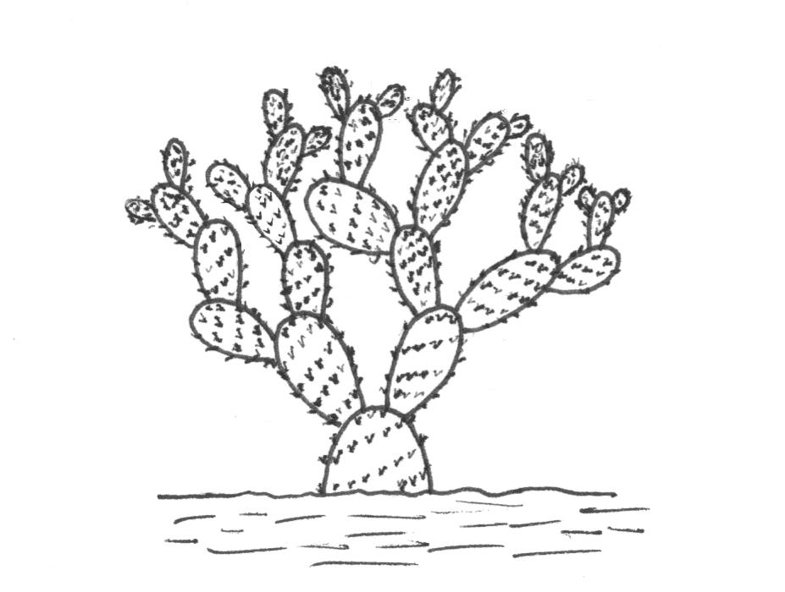 | 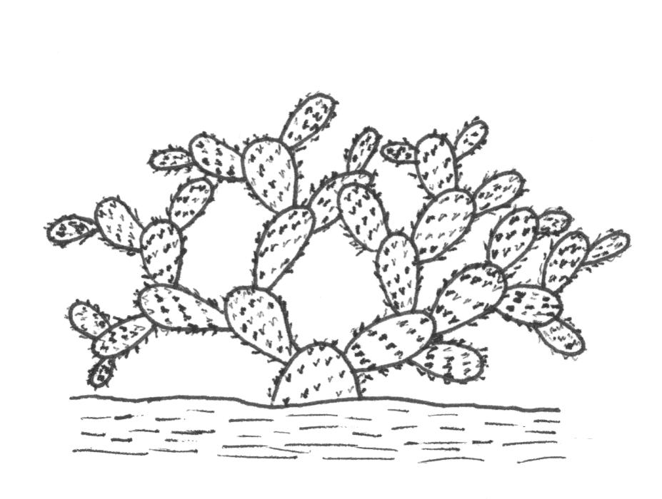 | 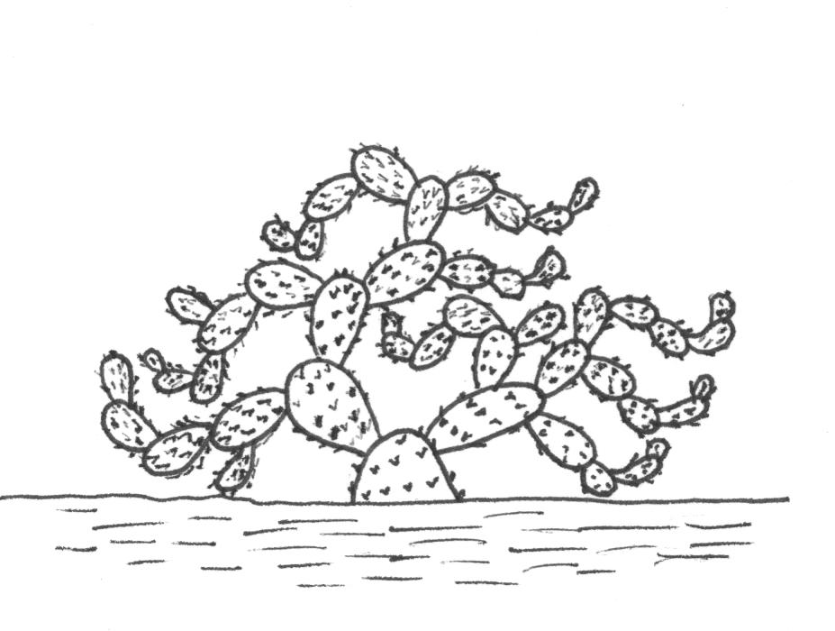
1 | 2 | 3
upright | spreading | decumbent

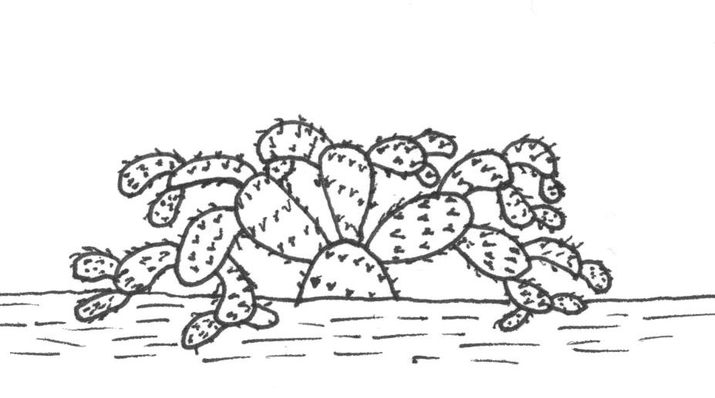
4
drooping

Ad. 4: Cladode: length
Ad. 5: Cladode: width

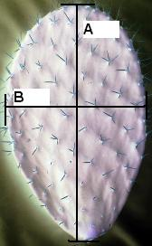
A= length
B= width
Ad. 7: Cladode: shape

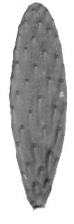 | 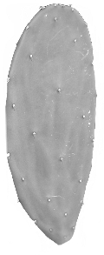 | 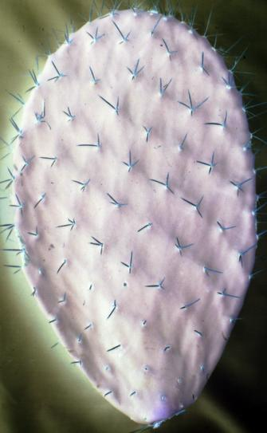 | 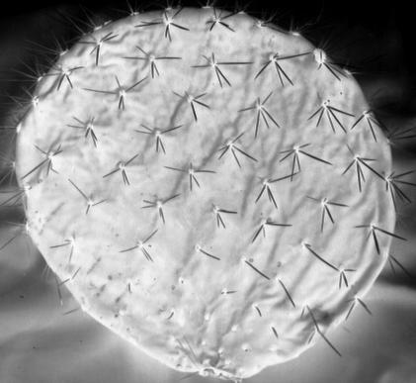
1 | 2 | 3 | 4
narrow elliptic | medium elliptic | broad elliptic | circular

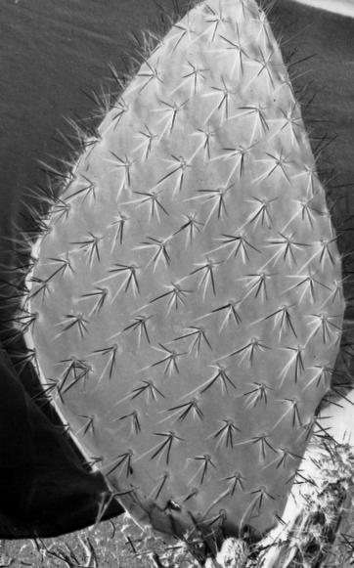 | 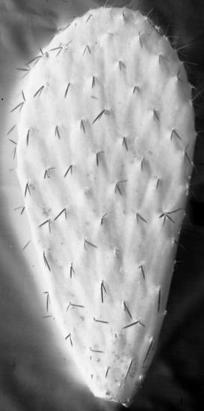 | 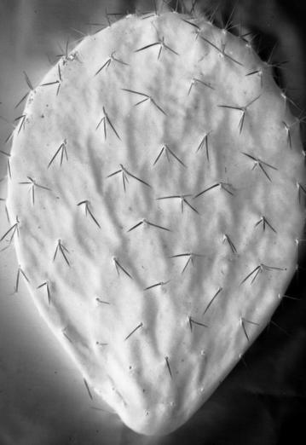
5 | 6 | 7
rhombic | narrow obovate | broad obovate

Ad. 19: Spine: surface

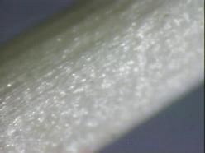 | 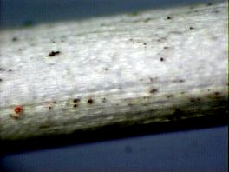 | 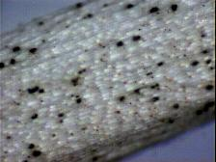
1 | 2 | 3
smooth | grooved | prickled

Ad. 20: Central spine: attitude

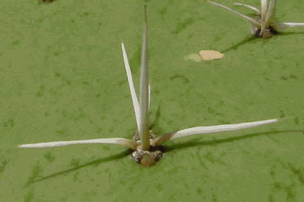 | 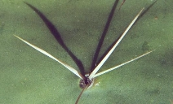 | 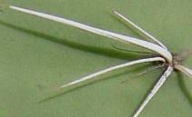
1 | 3 | 5
erect | semi-erect | horizontal
Ad. 22: Central spine: curvature (excluding base)

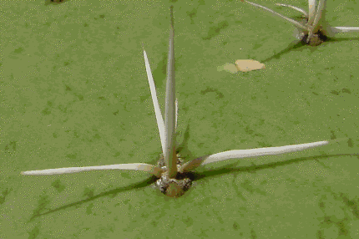 | 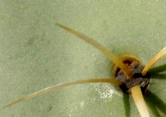
1 | 9
absent | present

Ad. 23: Central spine: twisting

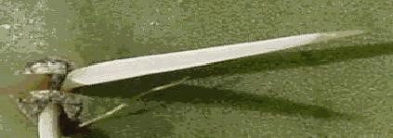 | 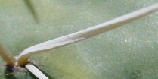
1 | 9
absent | present

Ad. 29: Flower: length
Ad. 31: Flower: color of style
Ad. 32: Flower: number of stigma lobes
Ad. 33: Flower: color of stigma lobe

stigma-lobe  (32-33) |  | style  (31) | Flower: length  (29)

Ad. 37: Fruit: shape in longitudinal section

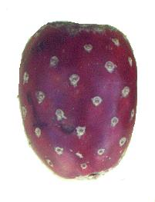 | 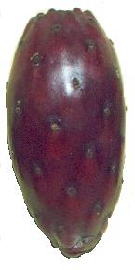 | 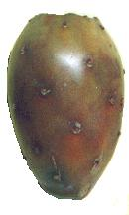
1 | 2 | 3
oblong | narrow elliptic | medium elliptic
4 | 5 | 6
circular | oblate | obovate

Ad. 41: Fruit: length of stalk

3 | 5
short | medium
7
long

Ad. 42: Fruit: depression of receptacle scar

 | 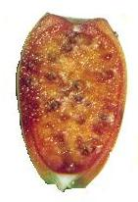
1 | 2 | 3
absent or slightly depressed | moderately depressed | strongly depressed
Ad. 55: Fruit: number of abortive seeds

Absolute number to be observed, rather than the proportion in relation to the number of fully developed seeds.

Ad. 60: Time of harvest maturity

The time of harvest should be considered to be when the fruit flesh has reached a stable total soluble solids content, measured with a refractometer.

8.3 Synonyms of Example Varieties
Example Varieties | Synonym(s)
Reyna | Alfajayucan, Tuna Blanca, Taxa-kähä
Montesa | Amarrilla Montesa, Monteza, Amarilla Huesona, Miquihuana
Esmeralda | COPENA XXA
Fafayuca | Fafayuco, Octubreña
Torreoja | Torrioja, Frida, Frieda, COPENA XXXA
Milpa Alta | Tuna Morada
Pico Chulo | Naranjona, Apastillada, Copo de Oro
Tuna Mansa | Blanca

Literature
Barrientos P., F. 1984. “Der Anbau von Feigenkakteen (Opuntia spp.) in Mexico”. Nutzung von Kakteen und ihre Problematik. Justus-Liebig Universität Giessen. Reihe I, Band. 11: 27-38.

Barrientos P., F.; Muratalla L., A.; Barrientos P., A.F. 1992. “New hybrids of Opuntia”. In: Mabry, T. J.; Nguyen, H.T., Dixon, R.A. and Bonness, M.S. IC² Institute, University of Texas. Austin, Texas, USA. pp. 243-251.

Chessa, I.; Niedu, G., 1997. “Descriptors for cactus pear (Opuntia spp.)”. CACTUESNET, FAO – Universitá degli Studi di Reggio Calabria. Rome, Italy. 39 p.

Gallegos V., C.; Blanco, F.; Noriega A., M.G., 1994. “Establecimiento de una colección de nopal (Opuntia spp.) en el CRUCEN, Zacatecas, México”. Revista Geografía Agrícola 20: 137-141.

Gallegos V., C.; Valdez C., R.D.; Blanco M., F., 1996. “Evaluación y seguimiento de la colección de nopal (Opuntia spp.) en el CRUCEN, Zacatecas”. In: R. Ortega P., E. Guízar N., E. Estrada M. y E. Cedillo P., Herbarios y Colecciones de Recursos Fitogenéticos de la Universidad Autónoma Chapingo: Antecedentes, Situación Actual y Perspectivas. SGI-DGA-Universidad Autónoma Chapingo. Chapingo, México. pp 69-80.

Granados S., D.; Castañeda P., A.D., 1991. “El Nopal, importancia, fisiología, genética e importancia frutícola”. Editorial Trillas, México D.F. 227 p.

Mondragón J., C.; Fernández M., M.R.; Rodríguez A., J.; Flores V., C.A., 1995. “Propuesta de descriptor para el registro de nopal”. In: E. Pimienta B., C. Neri L., A. Muñoz U. y F. M. Huerta Martínez. Conocimiento y Aprovechamiento del Nopal. VI Congreso Nacional y IV Congreso Internacional. Universidad de Guadalajara. Guadalajara, Jal. pp 127-131.

Muñoz, U. A., 1995. “Estudio anatómico, morfológico y citológico de seis variables de nopal tunero del Altiplano Potosino-Zacatecano”. Tesis profesional, Colegio de Postgraduados, Montecillo, Texcoco. México. pp 10-15, 30.

Peralta M., V.M., 1983. “Caracterización fenológica y morfológica de formas de nopal (Opuntia spp.) de fruto (tuna) en el Altiplano Potosino-Zacatecano”. Tesis Profesional. Universidad Autónoma de Aguascalientes. Aguscalientes, Ags. México 88 p.

Pimienta-Barrios, E., 1990. “El Nopal Tunero”. Universidad de Guadalajara. Guadalajara, Jalisco. México. 246 p.

Pimienta-Barrios, E.; Loera-Quezada, M.; López-Amezcua, L. O., 1993. “Estudio anatómico comparativo en colectas del subgénero Opuntia”. Agrociencia Serie Fitociencia 4(3): 7-21.

Reyes A., J.A.; Aguirre R., J.R., 1999. “Etnobotánica de Opuntia en la Altiplanicie Meridional de México”. Instituto de Investigación de Zonas Desérticas, Universidad Autónoma de San Luis Potosi, S.L.P., México. 2 p.

Reyes A., J.A., 1999. “Taller sobre morfología de Opuntia”. VIII Congreso Nacional y VI Internacional sobre el Conocimiento y Aprovechamiento del Nopal. Universidad Autónoma de San Luis Potosí. San Luis Potosí, S. L. P., México. 8 p.

Rodríguez S., E., 1992. “Caracterización de formas de nopal tunero en la Zacatecana, Guadalupe, Zac.” Tesis Profesional. Facultad de Agronomía, Universidad Autónoma de Zacatecas. Zacatecas. Zac. 69 p.

Rodríguez S., E.; Nava C., A., 1999. “Nopal, Riqueza Agroecológica de México”. COSNET, DGETA, Secretaría de Educación Pública. México, D. F. 160 p.

Scheinvar, L., 1999. “Biosistemática de los xoconostles mexicanos y su potencial económico”. In: J.R. Aguirre R. y J.A. Reyes A. (eds.).VIII Congreso Nacional y VI Internacional sobre conocimiento y aprovechamiento del nopal. Universidad Autónoma de San Luis Potosí. San Luis Potosí, S.L.P., México. pp. 255-274.

Technical Questionnaire
TECHNICAL QUESTIONNAIRE |  |  |  | Page {x} of {y} |  | Reference Number:
 |  |  |  |  |  | Application date:
 |  |  |  |  |  | (not to be filled in by the applicant)
TECHNICAL QUESTIONNAIRE
to be completed in connection with an application for plant breeders’ rights

1. Subject of the Technical Questionnaire
1.1 Botanical Name |  |  | Opuntia, Group 1  Please state species: |  |  |  |  |  | [ ]
Common Name |  |  | Cactus Pear
1.2 Latin Name |  |  | Opuntia, Group 2  Please state species: |  |  |  |  |  | [ ]
Common Name |  |  | Xoconostles
2. Applicant
Name
Address
Telephone No.
Fax No.
E-mail address
Breeder (if different from applicant)
3. Proposed denomination and breeder’s reference
Proposed denomination
(if available)

Breeder’s reference
#4. Information on the breeding scheme and propagation of the variety

4.1 Breeding scheme

Variety resulting from::

4.1.1 Crossing

(a) controlled cross [ ]
(please state parent varieties)
(b) partially known cross [ ]
(please state known parent variety(ies))
(c) unknown cross [ ]

4.1.2 Mutation [ ]
(please state parent variety)

4.1.3 Discovery and development [ ]
(please state where and when discovered
and how developed)

4.1.4 Other [ ]
(please provide details)

4.2 Method of propagating the variety

4.2.1 Vegetative propagation

(a) cuttings [ ]
(b) other (state method) [ ]

4.2.2 Other [ ]
(please provide details)

5. Characteristics of the variety to be indicated (the number in brackets refers to the corresponding characteristic in Test Guidelines; please mark the note which best corresponds).
 | Characteristics |  |  |  |  |  | Example Varieties |  |  |  | Note
5.1  (14) | Cladode: color of areoles
 | grey |  |  |  |  |  | Milpa Alta, Reyna |  |  |  | 1[ ]
 | yellow brown |  |  |  |  |  | Burrona |  |  |  | 2[ ]
 | brown |  |  |  |  |  | Chaveña |  |  |  | 3[ ]
 | black |  |  |  |  |  | Cardón |  |  |  | 4[ ]
5.2  (44) | Fruit: thickness of peel
 | thin |  |  |  |  |  | Amarilla San José, Montesa, Reyna |  |  |  | 3[ ]
 | medium |  |  |  |  |  | Rojo Lirio, Rojo Pelón, Tapón de Mayo |  |  |  | 5[ ]
 | thick |  |  |  |  |  | Caidilla Legítima |  |  |  | 7[ ]
5.3  (54) | Seed: size
 | small |  |  |  |  |  | Cardón, Cascarona, Curesmeño |  |  |  | 3[ ]
 | medium |  |  |  |  |  | Pico Chulo, Reyna |  |  |  | 5[ ]
 | large |  |  |  |  |  | Blanca San José, Burrona, Chapeada |  |  |  | 7[ ]
 | Characteristics |  |  |  |  |  | Example Varieties |  |  |  | Note
5.4  (59) | Flowering habit
 | once flowering |  |  |  |  |  | Cristalina, Reyna, Rojo Pelón |  |  |  | 1[ ]
 | twice flowering |  |  |  |  |  | Cuaresmeño |  |  |  | 2[ ]
5.5  (60) | Time of harvest maturity
 | very early |  |  |  |  |  | Tapón de Mayo |  |  |  | 1[ ]
 | early |  |  |  |  |  | Tapón Aguanoso |  |  |  | 3[ ]
 | medium |  |  |  |  |  | Montesa, Pico Chulo, Reyna |  |  |  | 5[ ]
 | late |  |  |  |  |  | Burrona, Esmeralda, Fafayuca |  |  |  | 7[ ]
 | very late |  |  |  |  |  | Charola, Chaveña |  |  |  | 9[ ]
6. Similar varieties and differences from these varieties
Please use the following table and box for comments to provide information on how your candidate variety differs from the variety (or varieties) which, to the best of your knowledge, is (or are) most similar. This information may help the examination authority to conduct its examination of distinctness in a more efficient way.
Denomination(s) of variety(ies) similar to your candidate variety |  | Characteristic(s) in which your candidate variety differs from the similar variety(ies) |  |  | Describe the expression of the characteristic(s) for the similar variety(ies) |  |  | Describe the expression of the characteristic(s) for your candidate variety
Example |  | Fruit: length |  |  | short |  |  | medium
Comments:

#7. Additional information which may help in the examination of the variety

7.1 In addition to the information provided in sections 5 and 6, are there any additional characteristics which may help to distinguish the variety?

Yes [ ] No [ ]
(If yes, please provide details)

7.2 Are there any special conditions for growing the variety or conducting the examination?

Yes [ ] No [ ]
(If yes, please provide details)

7.3 Other information

A representative color photograph of the variety should accompany the Technical Questionnaire.

8. Authorization for release

(a) Does the variety require prior authorization for release under legislation concerning the protection of the environment, human and animal health?

Yes [ ] No [ ]

(b) Has such authorization been obtained?

Yes [ ] No [ ]

If the answer to (b) is yes, please attach a copy of the authorization.

9. Information on plant material to be examined or submitted for examination.

9.1 The expression of a characteristic or several characteristics of a variety may be affected by factors, such as pests and disease, chemical treatment (e.g. growth retardants or pesticides), effects of tissue culture, different rootstocks, scions taken from different growth phases of a tree, etc.

9.2 The plant material should not have undergone any treatment which would affect the expression of the characteristics of the variety, unless the competent authorities allow or request such treatment. If the plant material has undergone such treatment, full details of the treatment must be given. In this respect, please indicate below, to the best of your knowledge, if the plant material to be examined has been subjected to:

(a) Microorganisms (e.g. virus, bacteria, phytoplasma) Yes [ ] No [ ]

(b) Chemical treatment (e.g. growth retardant, pesticide) Yes [ ] No [ ]

(c) Tissue culture Yes [ ] No [ ]

(d) Other factors Yes [ ] No [ ]

Please provide details for where you have indicated “yes”.

10. I hereby declare that, to the best of my knowledge, the information provided in this form is correct:

Applicant’s name

Signature Date

[End of document]

* These names were correct at the time of the introduction of these Test Guidelines but may be revised or updated. [Readers are advised to consult the UPOV Code, which can be found on the UPOV Website (www.upov.int), for the latest information.]
# Authorities may allow certain of this information to be provided in a confidential section of the Technical Questionnaire.
# Authorities may allow certain of this information to be provided in a confidential section of the Technical Questionnaire.

